Virginia Tech Transportation Institute
Human Factors in CMV ADS
Simulator Sickness Questionnaire- Administered after initial 5-minute test drive.
Date: __________ Driver ID #______________
Please answer each of the statements in the table using the scale below. Circle whole numbers only.
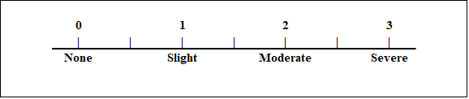
SYMPTOM | RATING
General Discomfort
Fatigue
Headache
Eye Strain
Difficulty Focusing
Increased Salivation
Dry Mouth
Sweating
Nausea
Difficulty Concentrating
Fullness of Head
Blurred Vision
Dizzy (eyes open)
Dizzy (eyes closed)
Vertigo
Stomach Awareness
Burping
Simulator Sickness Score: ______________

Periodic Simulator Health Checks
These questions will be asked between periodically throughout the study while participants take short breaks. These help identify if the participant does not feel the negative effects of simulator sickness.
Verbally ask the participant:
Are you feeling any of the following symptoms?
Nausea
General Discomfort
Stomach Awareness
Increased Salivation
Sweating
Difficulty Concentrating
Dizziness
Eyestrain
If yes to one or more: Ask the participant if they would like to take a short break (10-15 minutes), or if they need to leave. If possible, have the participant look at something far in the distance, at least 20 feet away.
If not: Ask them if they are ready to continue

