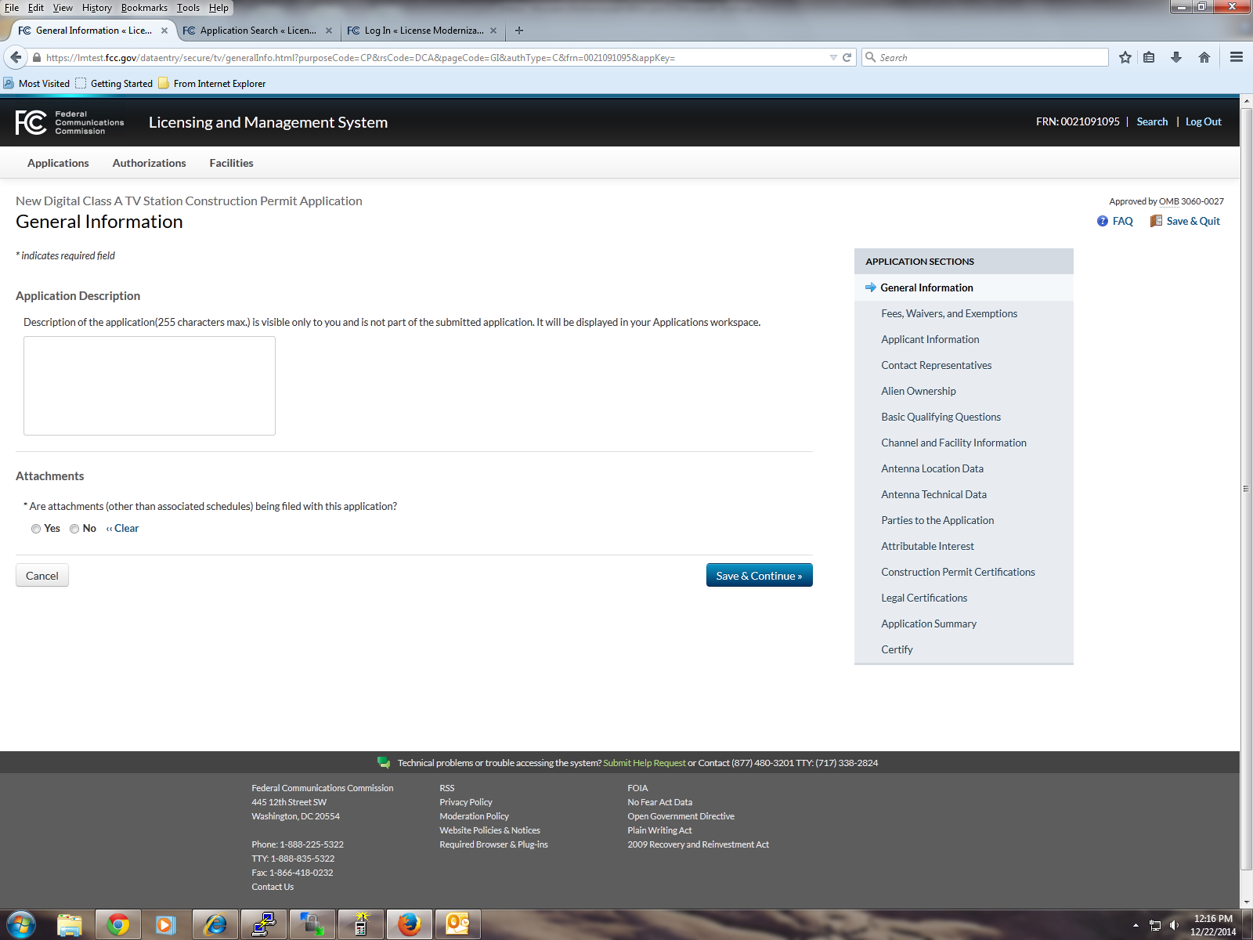

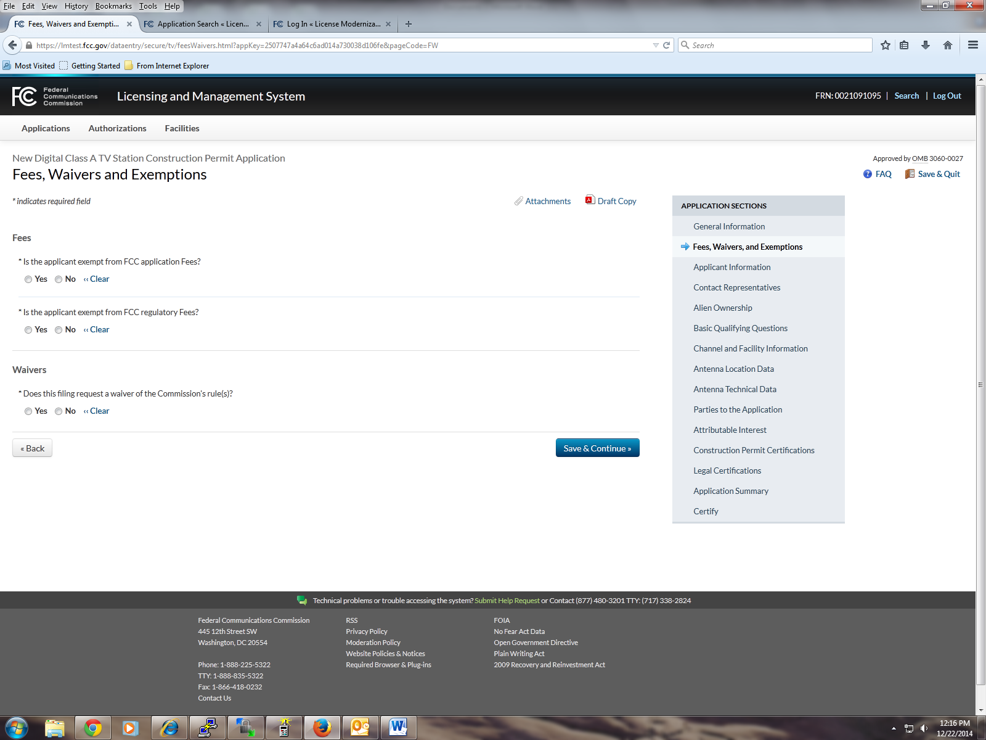

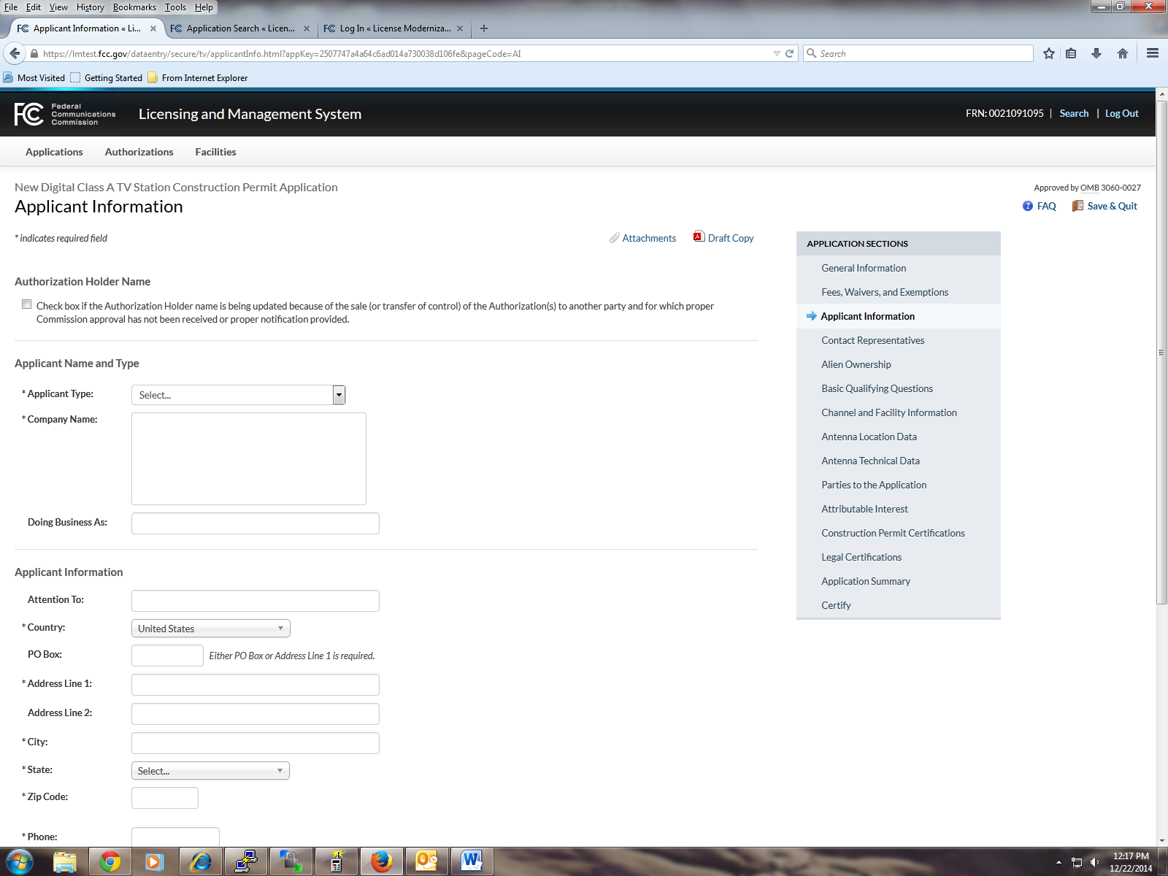

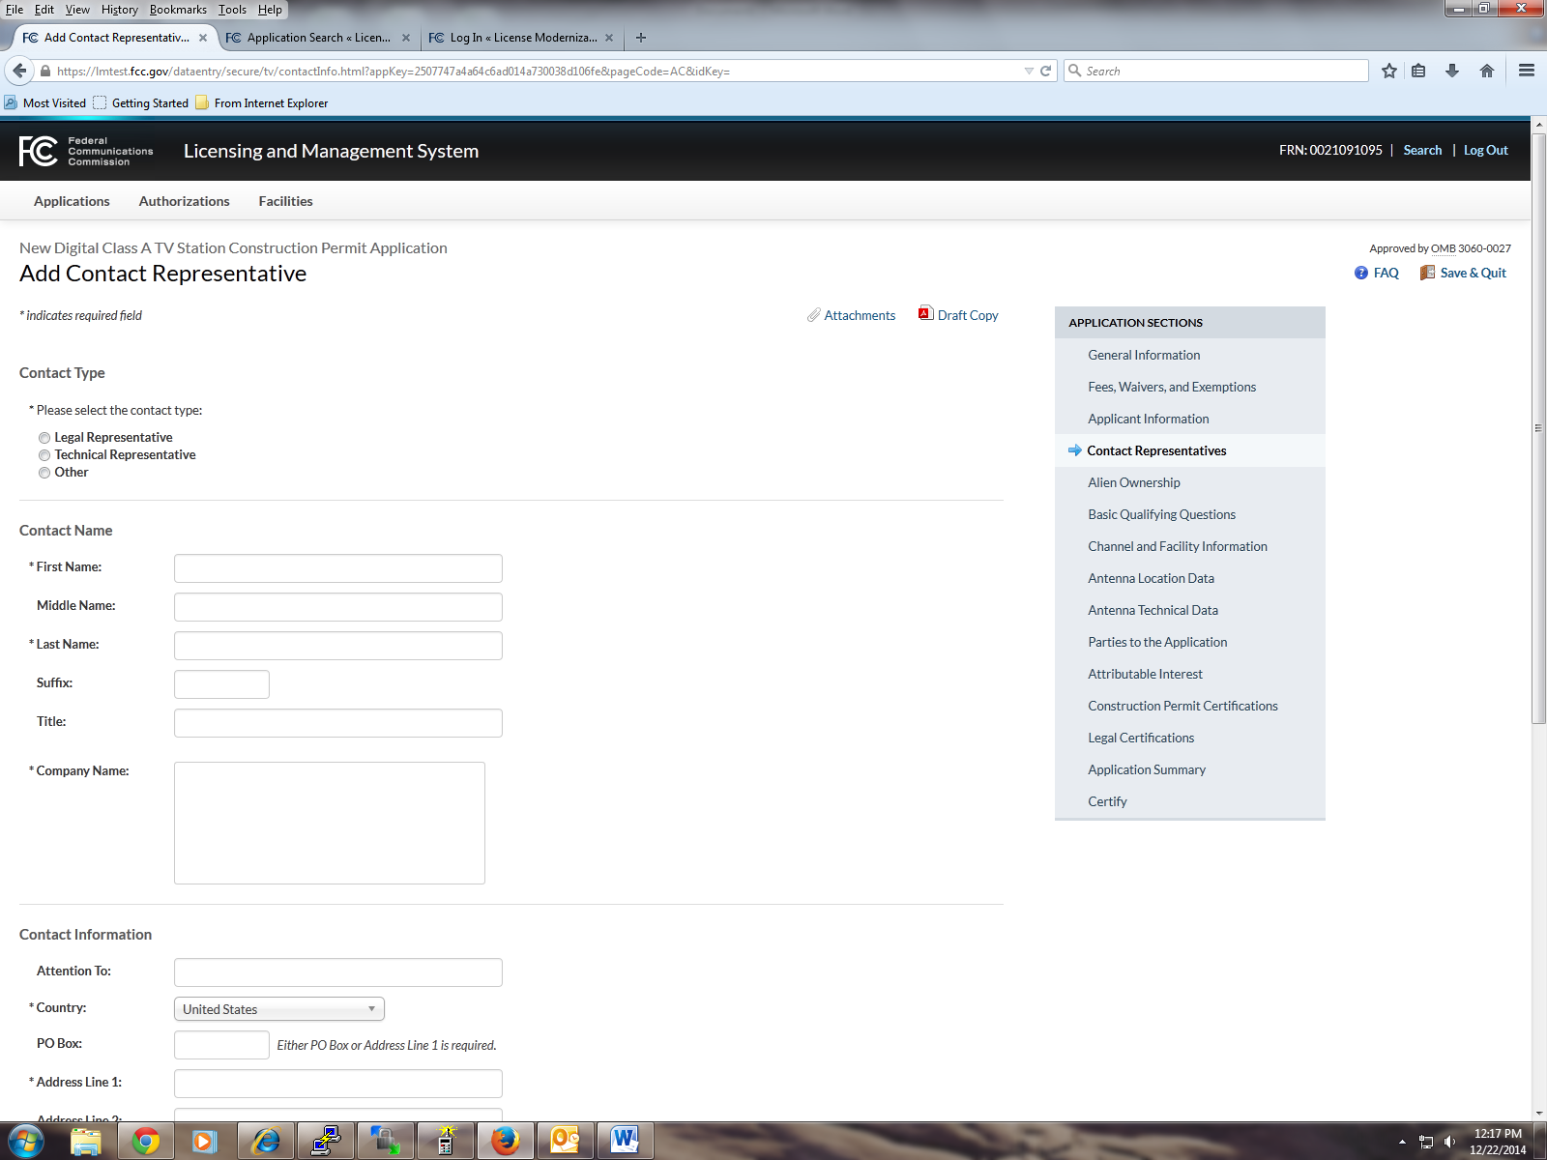

Alien Ownership screen

1) Is the applicant a foreign government or the representative of any foreign government as specified in Section 310(a) of the Communications Act?

2) Is the applicant an alien or the representative of an alien? (Section 310(b)(1))

3) Is the applicant a corporation, or non-corporate entity, that is organized under the laws of any foreign government? (Section 310(b)(2))

4) Is the applicant an entity of which more than one-fifth of the capital stock, or other equity or voting interest, is owned of record or voted by aliens or their representatives or by a foreign government or representative thereof or by any entity organized under the laws of a foreign country? (Section 310(b)(3))

5) Is the applicant directly or indirectly controlled by any other entity of which more than one-fourth of the capital stock, or other equity or voting interest, is owned of record or voted by aliens, their representatives, or by a foreign government or representative thereof, or by any entity organized under the laws of a foreign country? (Section 310(b)(4))

6) Has the applicant received a declaratory ruling(s) under Section 310(b)(4) of the Communications Act?

6a) Enter the citation of the applicable declaratory ruling by DA/FCC number, FCC Record citation, release date, or any other identifying information.

7) Has there been any change in the applicant's foreign ownership since issuance of the declaratory ruling(s) cited in response to Question 6?

8) Does the applicant certify that it is in compliance with the terms and conditions of the foreign ownership declaratory ruling(s) cited in response to Question 6?

9) In connection with this application, is the applicant filing a foreign ownership Petition for Declaratory Ruling pursuant to Section 310(b)(4) of the Communications Act

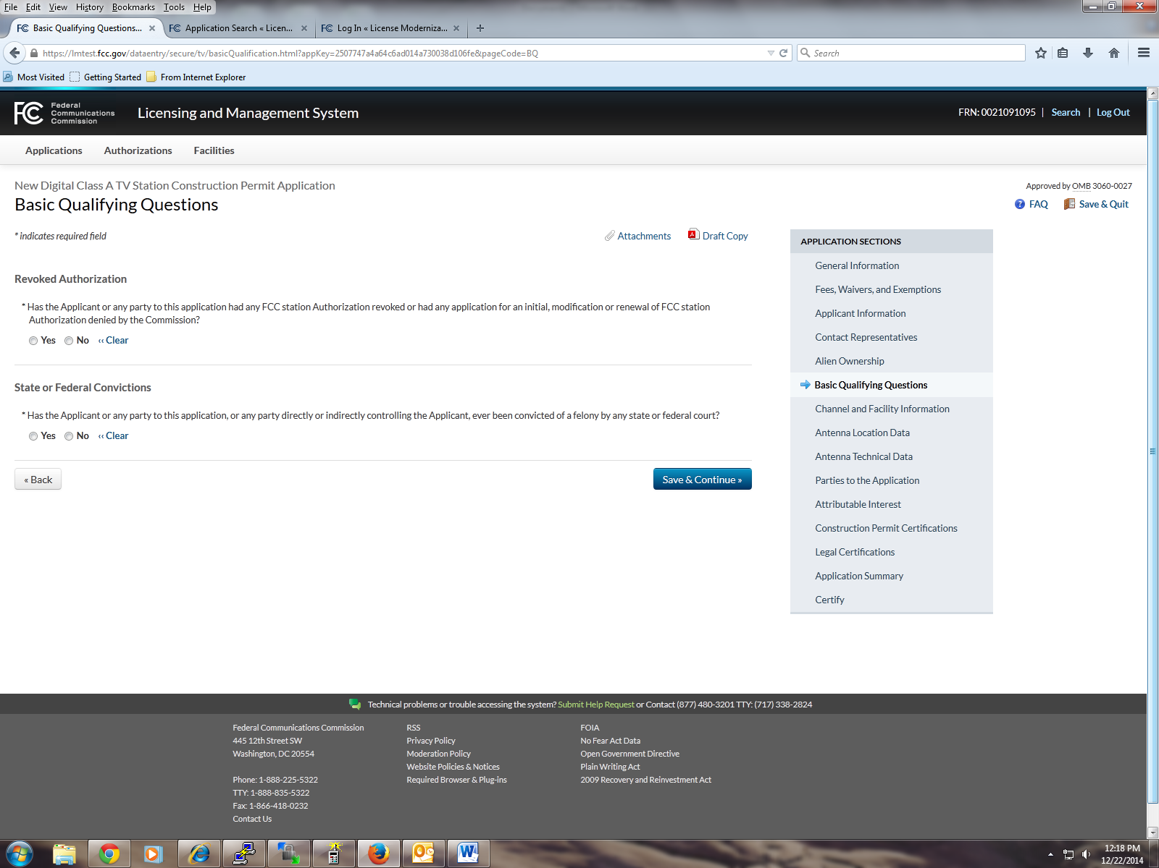

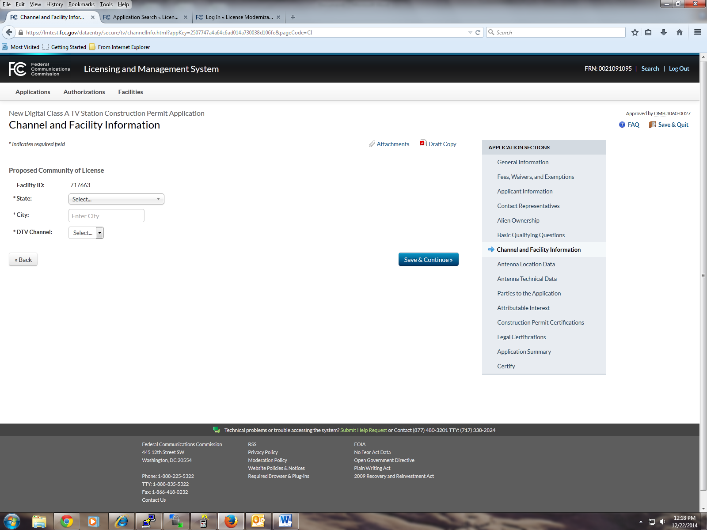

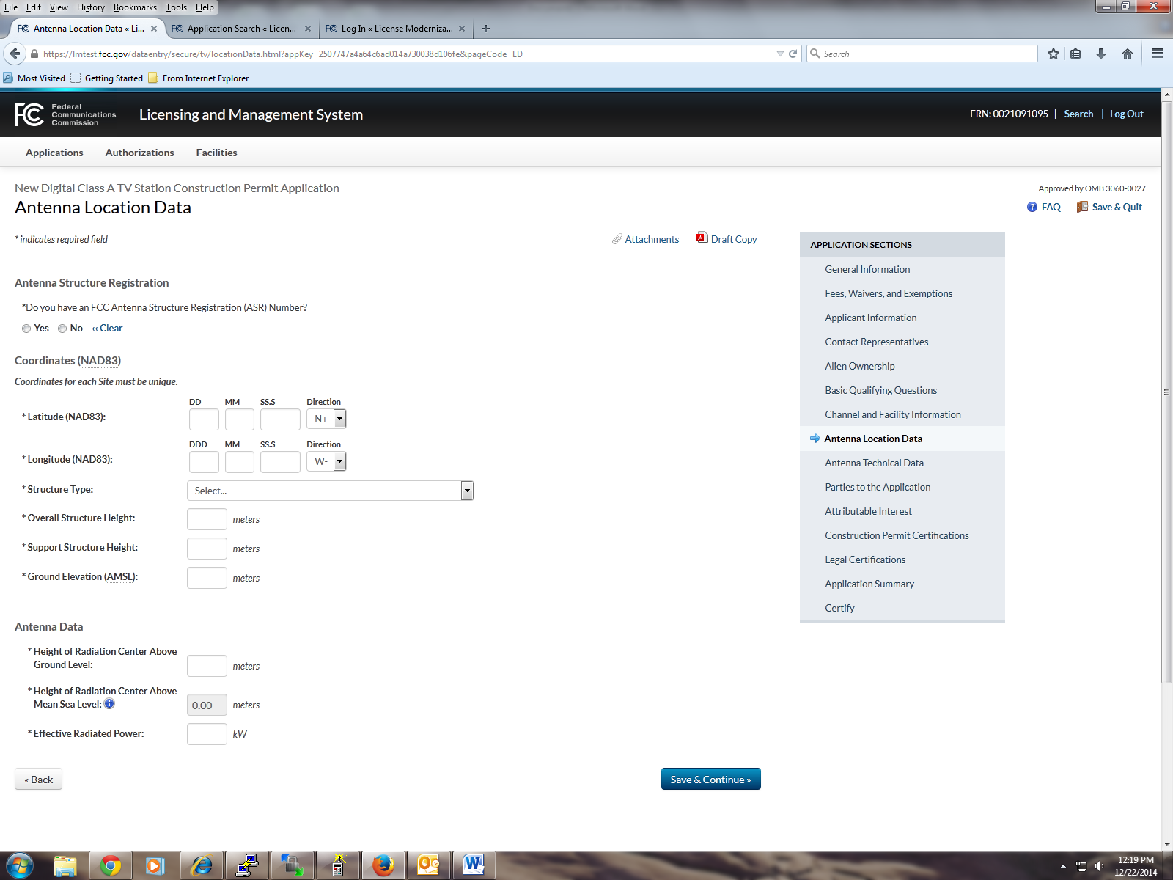

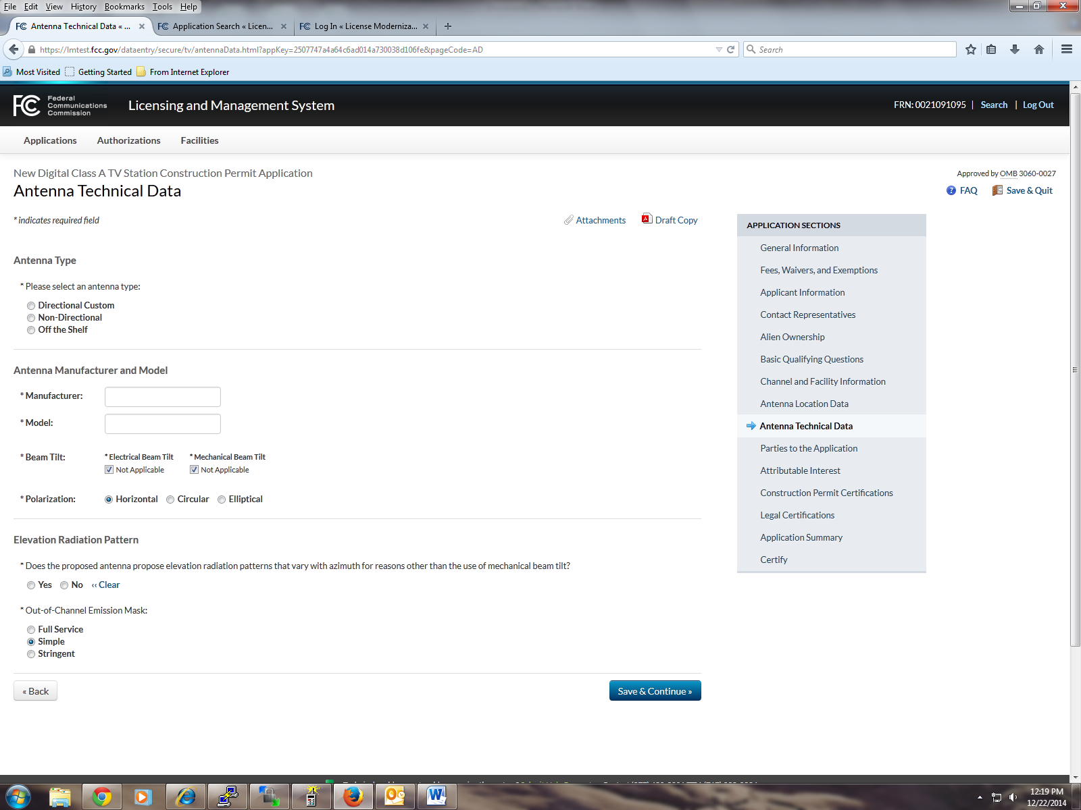

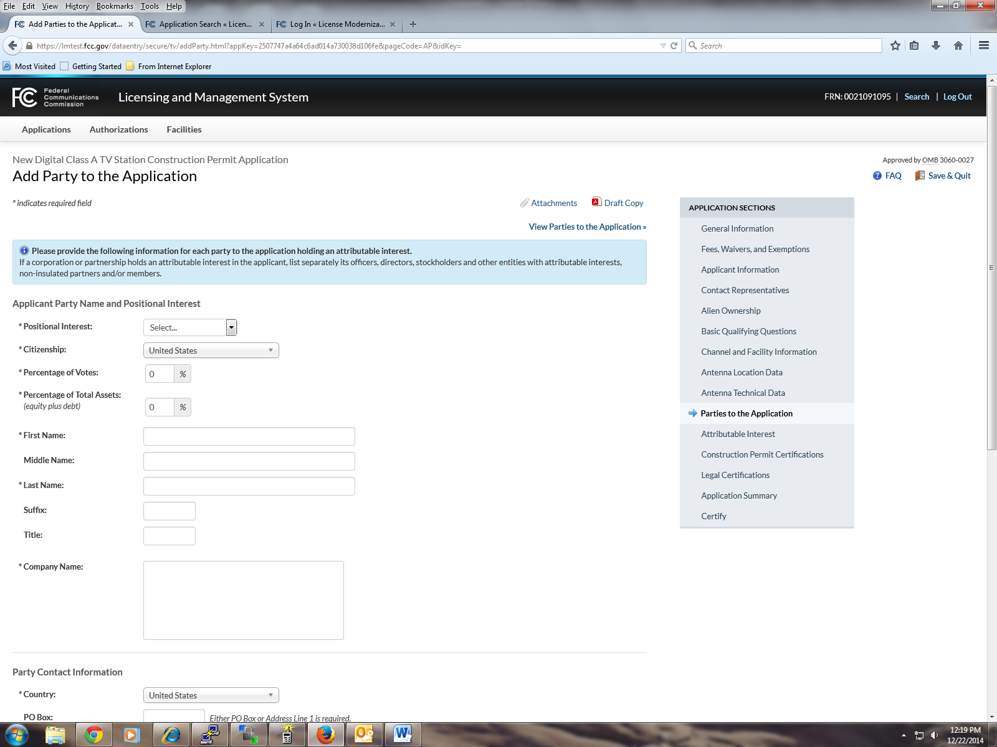

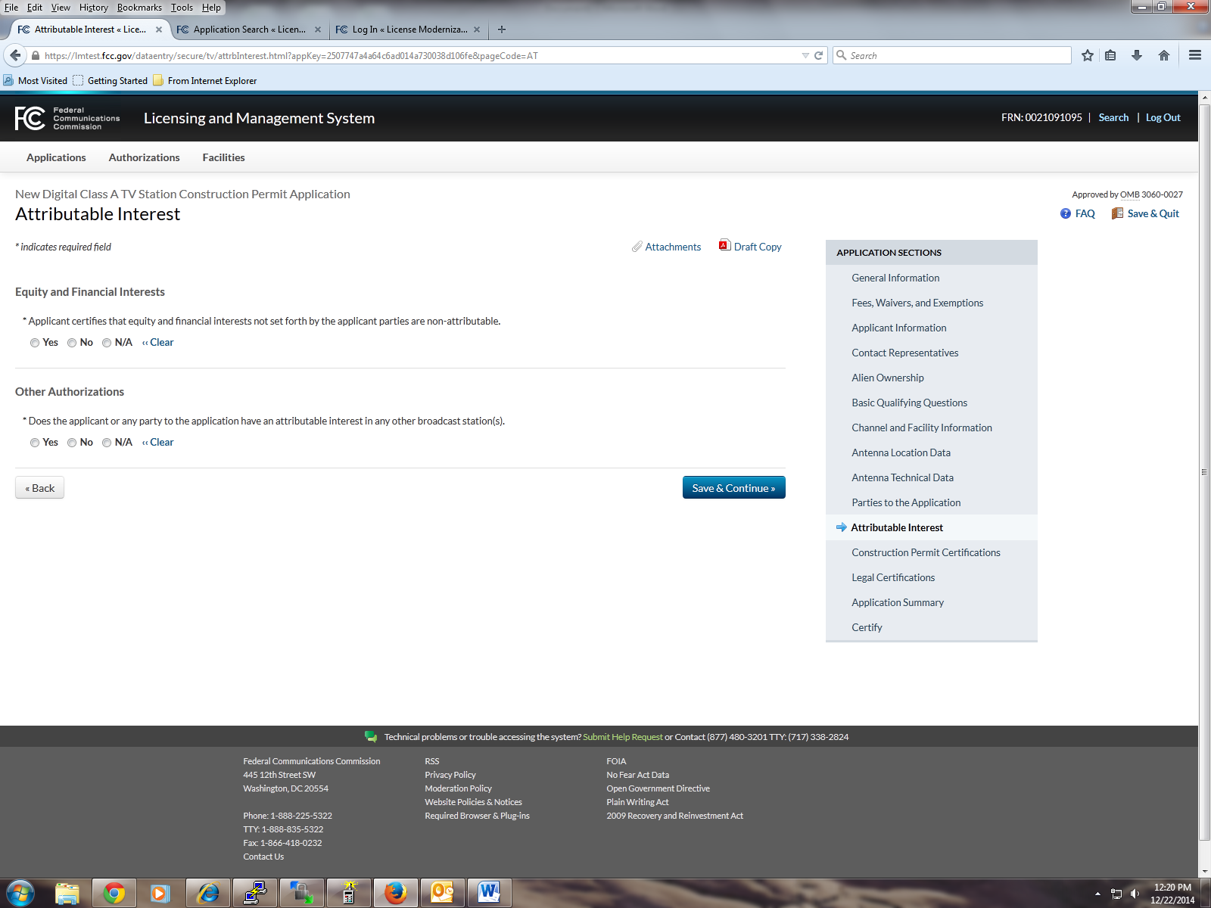

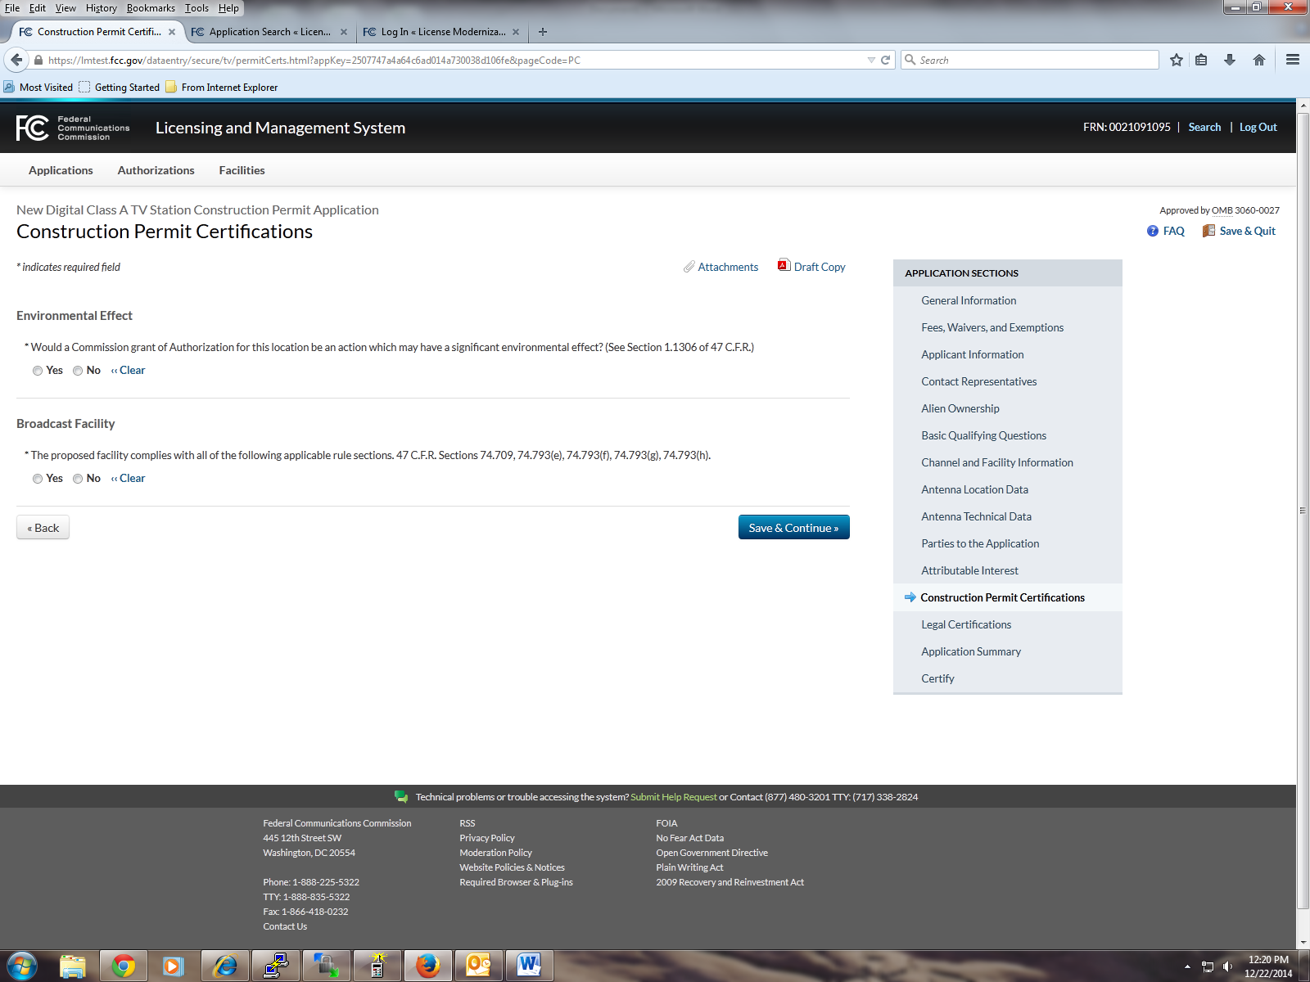

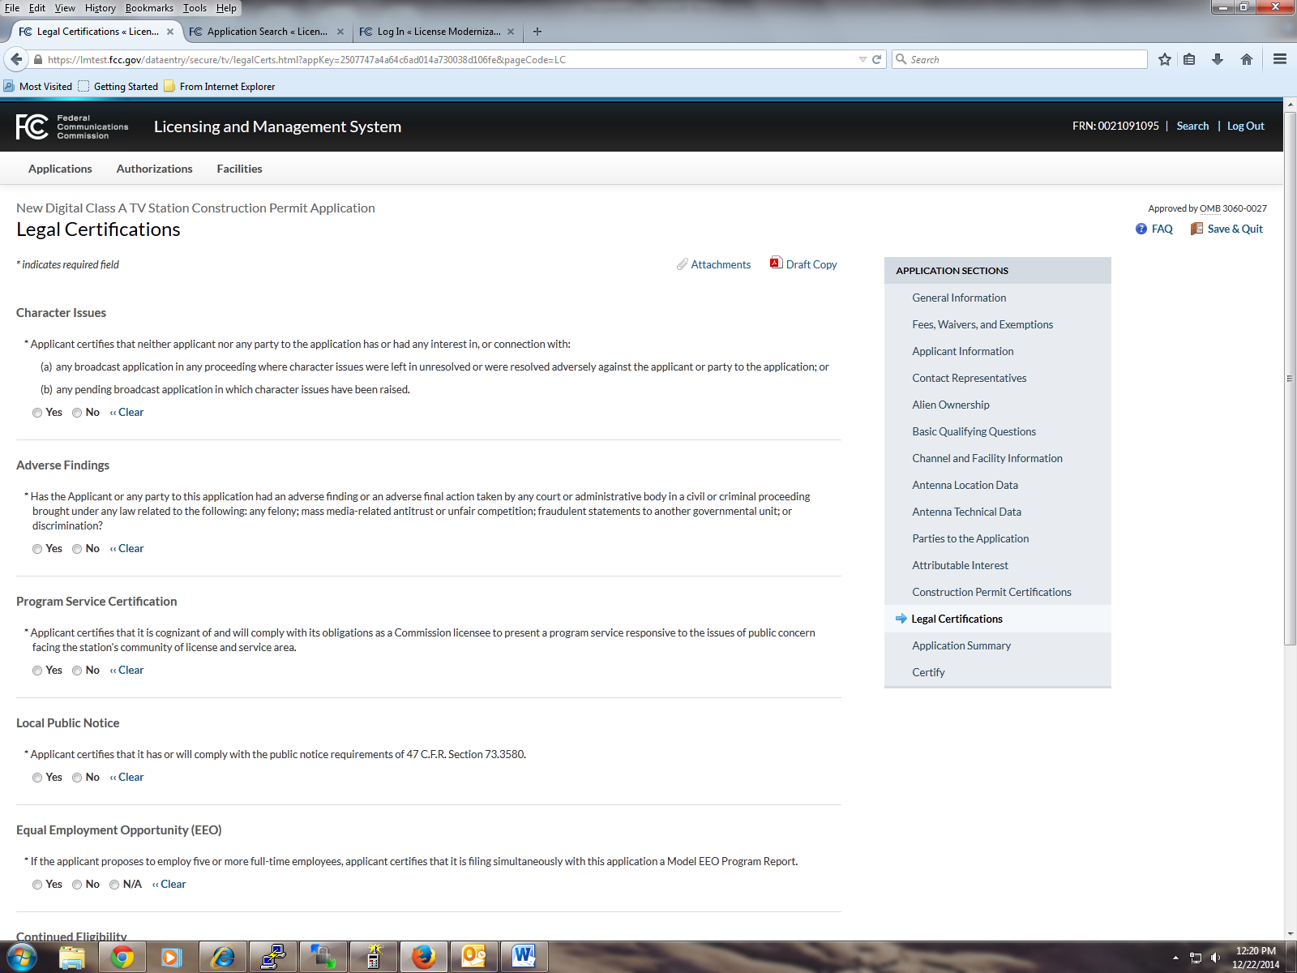

Certification

General Certification
Statements
The Applicant waives any claim to the use of any particular
frequency or of the electromagnetic spectrum as against the
regulatory power of the United States because of the
previous use of the same, whether by authorization or
otherwise, and requests an Authorization in accordance with
this application (See Section 304 of the Communications Act
of 1934, as amended.).
The Applicant certifies that neither the Applicant nor any
other party to the application is subject to a denial of Federal
benefits pursuant to §5301 of the Anti-Drug Abuse Act of
1988, 21 U.S.C. §862, because of a conviction for
possession or distribution of a controlled substance. This
certification does not apply to applications filed in services
exempted under §1.2002(c) of the rules, 47 CFR . See
§1.2002(b) of the rules, 47 CFR §1.2002(b), for the definition
of "party to the application" as used in this certification
§1.2002(c). The Applicant certifies that all statements made
in this application and in the exhibits, attachments, or
documents incorporated by reference are material, are part
of this application, and are true, complete, correct, and made
in good faith.
Authorized Party to Sign FAILURE TO SIGN THIS APPLICATION MAY RESULT IN
DISMISSAL OF THE APPLICATION AND FORFEITURE
OF ANY FEES PAID
Upon grant of this application, the Authorization Holder may
be subject to certain construction or coverage requirements.
Failure to meet the construction or coverage requirements
will result in automatic cancellation of the Authorization.
Consult appropriate FCC regulations to determine the
construction or coverage requirements that apply to the type
of Authorization requested in this application.
WILLFUL FALSE STATEMENTS MADE ON THIS FORM
OR ANY ATTACHMENTS ARE PUNISHABLE BY FINE
AND/OR IMPRISONMENT (U.S. Code, Title 18, §1001)
AND/OR REVOCATION OF ANY STATION
AUTHORIZATION (U.S. Code, Title 47, §312(a)(1)),
AND/OR FORFEITURE (U.S. Code, Title 47, §503).

I certify that this application includes all required and relevant
attachments.
I declare, under penalty of perjury, that I am an authorized
representative of the above-named applicant for the
Authorization(s) specified above.

FCC NOTICE TO INDIVIDUALS REQUIRED BY THE
PAPERWORK REDUCTION ACT
We have estimated that each response to this collection of
information will take 225 – 6 hours. Our estimate includes the time to
read the instructions, look through existing records, gather and
maintain the required data, and actually complete and review the
form or response. If you have any comments on this burden
estimate, or on how we can improve the collection and reduce
the burden it causes you, please e-mail them to pra@fcc.gov or
send them to the Federal Communications Commission, AMDPERM,
Paperwork Reduction Project (3060-0932),
Washington, DC 20554. Please DO NOT SEND
COMPLETED APPLICATIONS TO THIS ADDRESS.
Remember - you are not required to respond to a collection of
information sponsored by the Federal government, and the
government may not conduct or sponsor this collection, unless it
displays a currently valid OMB control number of if we fail to
provide you with this notice. This collection has been assigned
an OMB control number of 3060-0932.
THE FOREGOING NOTICE IS REQUIRED BY THE
PAPERWORK REDUCTION ACT OF 1995, P.L. 104-13,
OCTOBER 1, 1995, 44 U.S.C. Section 3507.

