DRY BEAN INQUIRY – DECEMBER 1, 2022
OMB No. 0535-0002
Approval Expires:xx/xx/20xx
Project Code: xxx
SurveyId:
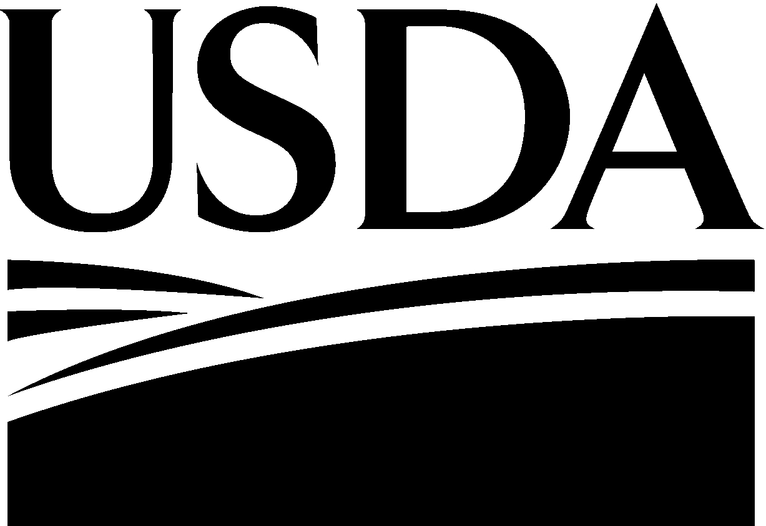
United States Department of Agriculture

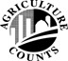
USDA/NASS
NATIONAL AGRICULTURAL STATISTICS SERVICE

Mountain Region
P.O. Box 150969
Lakewood, CO 80215-0969
Phone: 1-800-392-3202
Fax: 1-855-415-3687
E-mail: nassrfomtr@nass.usda.gov

Please make corrections to name, address and ZIP Code, if necessary.
The information you provide will be used for statistical purposes only. Your responses will be kept confidential and any person who willfully discloses ANY identifiable information about you or your operation is subject to a jail term, a fine, or both. This survey is conducted in accordance with the Confidential Information Protection and Statistical Efficiency Act of 2018, Title III of Pub. L. No. 115-435, codified in 44 U.S.C. Ch. 35 and other applicable Federal laws. For more information on how we protect your information please visit: https://www.nass.usda.gov/confidentiality. Response to this survey is voluntary.

According to the Paperwork Reduction Act of 1995, an agency may not conduct or sponsor, and a person is not required to respond to, a collection of information unless it displays a valid OMB control number. The valid OMB control number is 0535-0213. The time required to complete this information collection is estimated to average 10 minutes per response, including the time for reviewing instructions, searching existing data sources, gathering and maintaining the data needed, and completing and reviewing the collection of information.

- In 2022, did this operation or the individual(s) printed above plant dry edible beans?
1200 1 ☐ Yes - Continue ₃ ☐ Go to Conclusion

DRY BEANS
Acres
200

.
201

.

- How many total acres of dry beans were planted for harvest in 2022?....................................

a. Of these (Item 1) acres, how many acres were harvested in 2022?............................

- What was the average pounds per acre or total hundredweight harvested on a clean basis for the 2022 dry bean crop?....................
Pounds per Acre or Total Hundredweight

402
Hundredweight Sold
309

- What was the total quantity of the 2022 dry bean crop sold on a clean basis?.........................
1402
Total Dollars Received or Dollars per Hundredweight
- What was the total dollars received or price per hundredweight on a clean basis for the 2022 dry bean crop?............................................
604
.
205

CONCLUSION
COMMENTS:

Survey Results: To receive the complete results of this survey on the release date go to www.nass.usda.gov/Surveys/Guide_to_NASS_Surveys/.
To have a brief summary emailed to you at a later date, please enter your email address.
9990
1095

Would you rather have a brief summary mailed to you at a later date? 1 ☐ Yes 3 ☐ No

Respondent Name: | 9911  Phone: | 9910  Date: | MM | DD | YY
Thank you for your help

OFFICE USE ONLY
Response |  | Respondent |  | Mode |  | Enum. | Eval. | Change | Office Use for POID
1-Comp 2-R  - Inac  - Office Hold 5-R – Est  - Inac – Est  - Off Hold – Est | 9901 | 1-Op/Mgr 2-Sp  3-Acct/Bkpr 4-Partner  9-Oth | 9902 | - PASI (Mail)  - PATI (Tel)  - PAPI (Face-to- Face)  6-Email 7-Fax 19-Other | 9903 | 9998 | 9900 | 9985 | 9989  - -
 |  |  |  |  |  |  |  | R. Unit | Optional Use
 |  |  |  |  |  |  |  | 9921 | 9907 | 9908 | 9906 | 9916
S/E Name

