Project Code 128 QID 060041 DEALERS |  | OMB No. 0535-0002 Approval Expires xx/xx/20xx
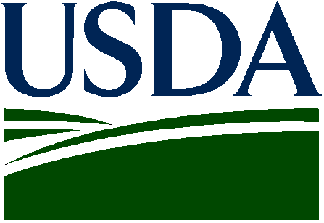 | NON-OIL SUNFLOWER  Acreage and Yield  2018 - Final |  |  |  | 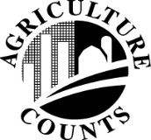 | NATIONAL  AGRICULTURAL STATISTICS  SERVICE
Please Mail by  December 8 |  |  |  | USDA/NASS  Northern Plains Region  100 Centennial Mall North Rm 263  Lincoln, NE 68508  Phone: 1-800-582-6443  Fax: 1-855-270-2720  E-mail: NASSRFONPR@nass.usda.gov
The 20xx final estimates of planted and harvested acres, yield and production of non-oil sunflower will soon be prepared. To help us prepare the estimates, please complete the following table.

The information you provide will be used for statistical purposes only. Your responses will be kept confidential and any person who willfully discloses ANY identifiable information about you or your operation is subject to a jail term, a fine, or both. This survey is conducted in accordance with the Confidential Information Protection and Statistical Efficiency Act of 2018, Title III of Pub. L. No. 115-435, codified in 44 U.S.C. Ch. 35 and other applicable Federal laws. For more information on how we protect your information please visit: https://www.nass.usda.gov/confidentiality. Response is voluntary.

PLEASE REPORT FOR YOUR OPERATION

20xx CONTRACTED ACRES
(Include acres contracted through agents)
STATE | ACRES  PLANTED | ACRES HARVESTED  AND TO BE HARVESTED | YIELD PER HARVESTED  ACRE (Lbs)
North Dakota
Minnesota
South Dakota
Nebraska
Kansas
Colorado
Oklahoma
Texas
Other (___________________)

Reported by: ______________________________________________________ Date: _______________________________________

According to the Paperwork Reduction Act of 1995, an agency may not conduct or sponsor, and a person is not required to respond to, a collection of information unless it displays a valid OMB control number. The valid OMB number is 535-0002. The time required to complete this information collection is estimated to average 10 minutes per response, including the time for reviewing instructions, searching existing data sources, gathering and maintaining the data needed, and completing and reviewing the collection of information.

