Attachment B

Department of Commerce
United States Census Bureau
OMB Information Collection Request
Annual Integrated Economic Survey
OMB Control Number 0607-XXXX

Electronic Instrument Selected Screen Shots

Welcome Screen
Burden Statement

Welcome Screen
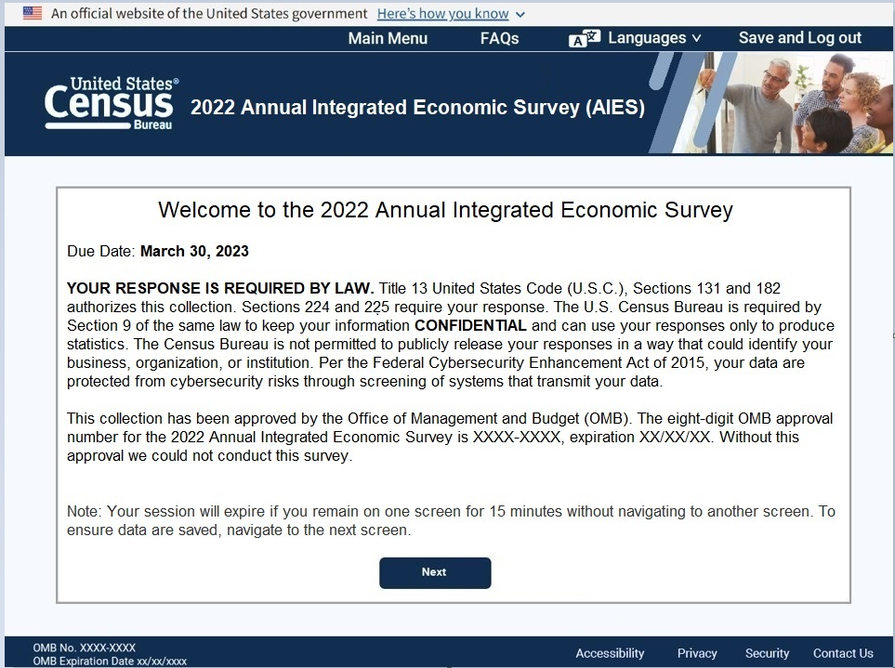

Burden Statement
