MBDA National Minority Enterprise Awards Program Requirements –

Non substantive Change Justification.

0640-0025

The changes are to the language for the eligibility information – the original language is out of date and not entirely consistent with the MBDA Act, because the MBDA Act was passed after the PRA approval in 2021.

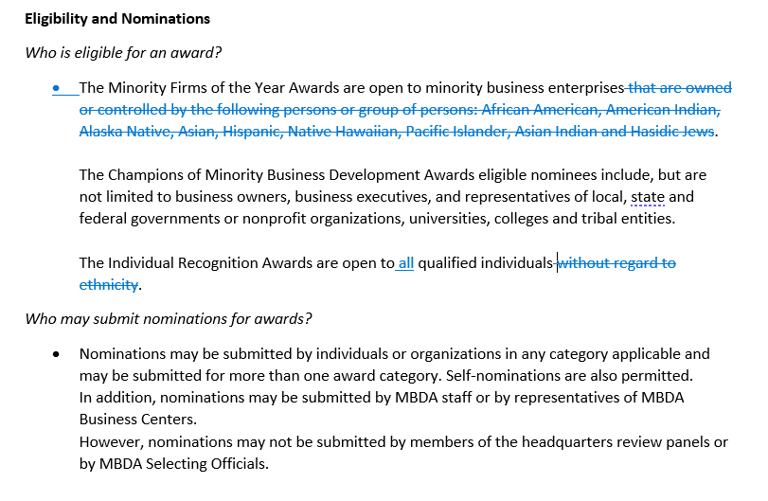

The additional non substantive change is that MBDA is adding an additional award category.

**Norman Y. Mineta Trailblazer Award** – *Presented to an individual who has played an integral role in overcoming adversity by seeking out strategic partnerships to overcome barriers and exemplifying the spirit of collaboration and mentorship to aspiring business leaders and entrepreneurs.*

**Nomination Questions:**

* Tell us about the strategic partnership(s) formed and/or collaborative initiatives created.
* Describe what led to form your strategic partnership(s) and/or collaborative initiatives.
* What changes, if relevant, were made due to the strategic partnership(s) or collaborative initiatives?
* Describe the impact of the strategic partnership(s) on minority business and entrepreneurship community.
* How was the impact measured?