Optimizing Brain Health by Reducing PTSD

We know that you are busy and also want to help improve the SOF enterprise.
- How much time do you have to commit to the survey
Less than 10 minutes
More than 10 minutes

Demographics and Military Service Characteristics Form
- How would you describe your current role in the SOF community?
Operator
Enabler
Leadership
Healthcare provider
Policy maker
Administration / Support

- Have you ever been an operator or enabler? (branching logic will be used in that only the operators and enablers will receive the self-report measures). YES NO

- (If yes to item 3, then get item 4. If no to item 3, then skip logic will be used). For which component did you complete selection?
Air Force Special Operations Command (AFSOC)
Army Special Operations Command (USASOC)
Marine Special Operations Command (MARSOC)
Naval Special Warfare Command (NSW)

- Which of the following best describes your status in SOF:
Active Duty Military Member
Reservist or National Guard
GS employee
Contractor

- What is your age?
Under 20
20-29
30-39
40-49
50-59
- or above

- What is your gender? Female Male Transgender, non-binary, or another gender

8. What is the highest level of education you have completed?
12 years or less of school (no diploma)
High School or GED
Some college education
Bachelor's degree (BA, BS, AB, etc.)
Master's degree (MA, MS, MSW, etc.)
Professional school degree (MD, DO, PT, OT, DDC, JD, etc.)
Doctoral degree (PhD, EdD, etc.)

9. Marital status (choose all that apply)
Married
In relationship but not married
Divorced
Widowed
Not in a relationship, never married
- What is your Race? (choose all that apply)
Alaskan Native
American Indian
Asian
Black / African American
Native Hawaiian or Other Pacific Islander
White / Caucasian
Other

- What is your Ethnicity?
Hispanic or Latino
Not Hispanic or Latino

11. What component do you belong?
HQ USSOCOM
Air Force Special Operations Command (AFSOC)
Marine Special Operations Command (MARSOC)
Army Special Operations Command (USASOC)
Naval Special Warfare Command (NSW)
Joint Special Operations Command (JSOC)
Theater Special Operations Command (SOCEUR, SOCPAC, SOCKOR, SOCAFRICA, SOCCENT, SOCSOUTH, SOCNORTH)

12. What is your military occupational specialty code (i.e., MOS / AFSC / Designator)? ______
- NA, I’m a GS employee or contractor

13. What is/was your rank? ______ or NA, I’ve never served in the military.

14. How many years of active military service do you have? ______ or NA, I’ve never served in the military.

15. How many years have you been assigned to SOF? ______

16. What location are you assigned to? ______

17. How many combat deployments have you completed? ______
Perceived Stigma and Barriers to Care (PSBC)

Please rate each of the possible concerns that might affect your decision to receive mental health counseling or services if you ever had a problem (e.g. PTSD).

1 (Strongly Disagree), 2 (Disagree), 3 (Neither agree or Disagree) 4 (Agree), 5 (Strongly Agree)

- It would be too embarrassing.
- It would harm my career.
- Members in my unit might have less confidence in me.
- My unit leadership might treat me differently.
- My leaders would blame me for the problem.
- I would be seen as weak.
- I don’t know where to get help.
- I don’t have adequate transportation.
- It is difficult to schedule an appointment.
- There would be difficulty getting time off work for treatment.
- Mental health care costs too much money.

Barriers and Facilitators of Mental Health Treatment for SOF
Please rate each of the possible concerns that might affect your decision to receive mental health counseling or services if you ever had a problem (e.g. PTSD).
1 (Strongly Disagree), 2 (Disagree), 3 (Neither agree or Disagree) 4 (Agree), 5 (Strongly Agree)
Barriers
- SOF are too resilient to develop PTSD.
- It is better not to think about past painful events.
- I have trouble recognizing what I am feeling.
- Treatment would not be effective.
- I have bigger problems than my mental health.
- If I got treatment it might negatively impact my clearance.
- I won't be able to manage my emotions if I started thinking about what I've been through.
- If I start therapy, I will no longer be allowed to deploy.
- If I take medications for a mental health problem, I will no longer be allowed to deploy.
- Mental health providers only want to put me on medications.
- Wait times are too long to get mental health treatment.
- Leadership states they are supportive of seeking treatment as a public gesture but they are not actually supportive.
- I don't trust that my mental health treatment will be confidential.
- People outside the SOF community cannot understand us.
- People with PTSD are dangerous.
- People have implied that I did immoral or unethical things on deployment.
- I am worried about investigations.
- My friends or family have reacted negatively toward me after I got home from deployment.

Facilitators
- My mental health is causing me to be less effective than I want to be.
- I have the time in my schedule to get mental health care.
- Getting treatment can make me more successful at my job.
- I understand the value of a healthy mind.
- People can benefit from treatment.
- There are trustworthy providers I can go to if I need to talk.
- USSOCOM has good programs in place that I can use for my mental health needs (i.e. POTFF).
- USSOCOM policy protects me if I need to get mental health care.
- I feel comfortable getting treatment on base.
- I feel comfortable getting treatment from the VA.
- Virtual and telehealth treatment options have helped me get access to treatment
- Residential programs, such as National Intrepid Center of Excellence (NiCoE), that offer treatment for physical and mental health in a condensed time frame are helpful.
- Having providers in close proximity to our campus is beneficial.
- Leaders have encouraged me to get treatment.
- I want to get treatment to be a better parent.
- My family supports me in seeking treatment.
- A teammate performed better because he got treatment.
- Getting treatment could improve my relationships with my family.
- Civilians are understanding when SOF personnel have PTSD.
- A teammate encouraged me to get treatment.

Mental Health Service Use.

- Do you think you could benefit from mental health treatment, including therapy, counseling, or medications, right now?
(Skip logic will be used.) If the participants answers “no” to item 1, then they will be skipped to item 3. If the participant answers “yes” to item 1, the following questions will be asked:
- How many years have you been dealing with mental health symptoms?
(answer choices: <1 year, 1-3 years, 4-7 year, 8+ years).
- Have you used any mental health services during your time in the service? For example, working with a psychologist, social worker, military family life consultant, etc.
(Skip logic will be used). If the participants answers “no” to item 3, the measure will be considered complete. If the participant answers “yes” to item 3 the following questions will be asked the next 2 questions.
- What mental health services did you use you in the past year? (check all that apply)
(answer choices: Psychologist, psychiatrist, social worker, military family life consultant, counselor, Chaplain)
- Which mental health services have you used at any time in your military career? (check all that apply)
(answer choices: Psychologist, psychiatrist, social worker, military family life consultant, counselor, Chaplain)

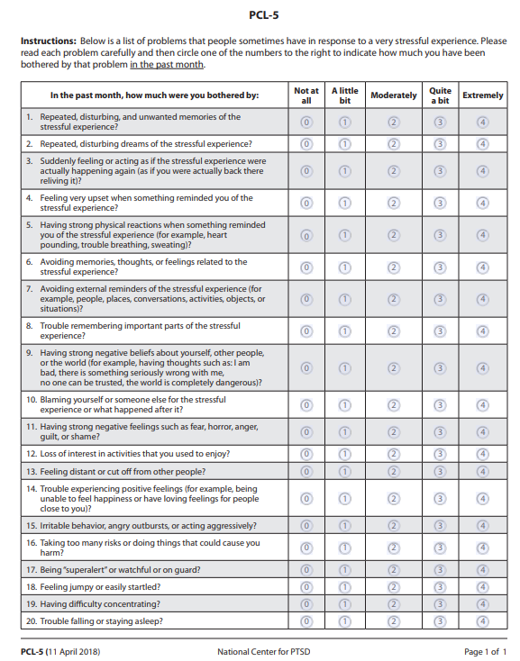
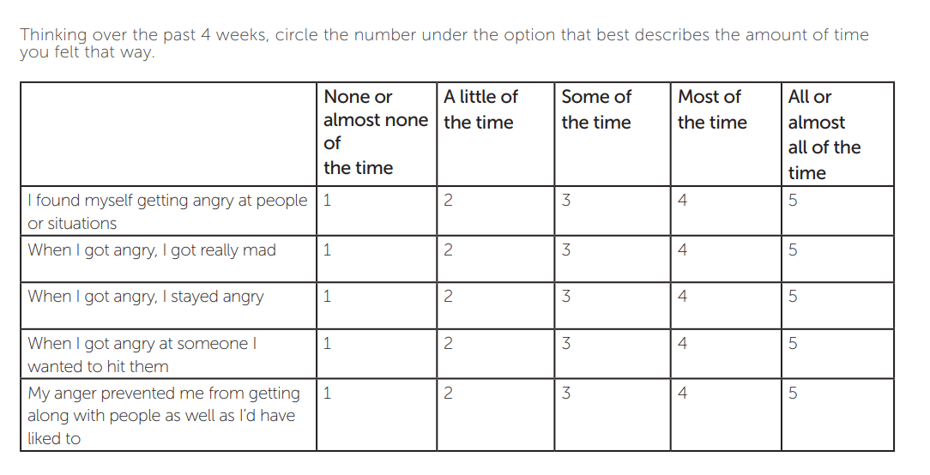
DAR-5
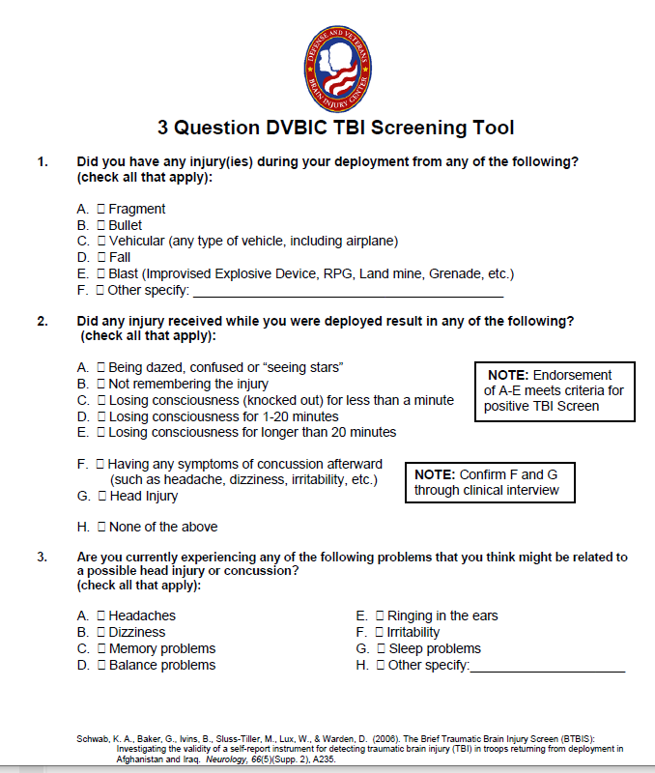
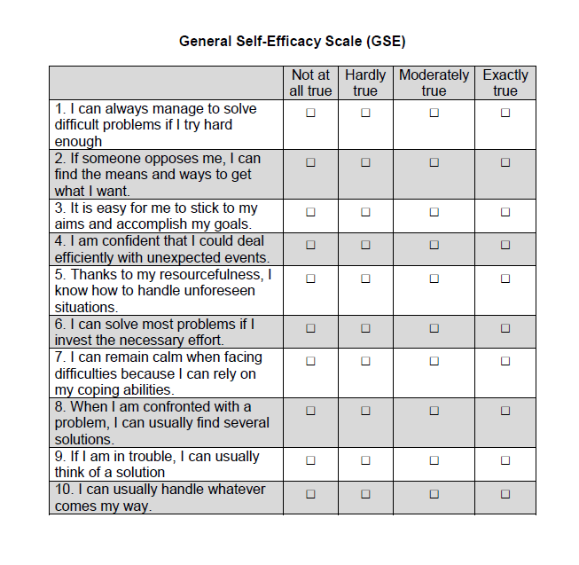

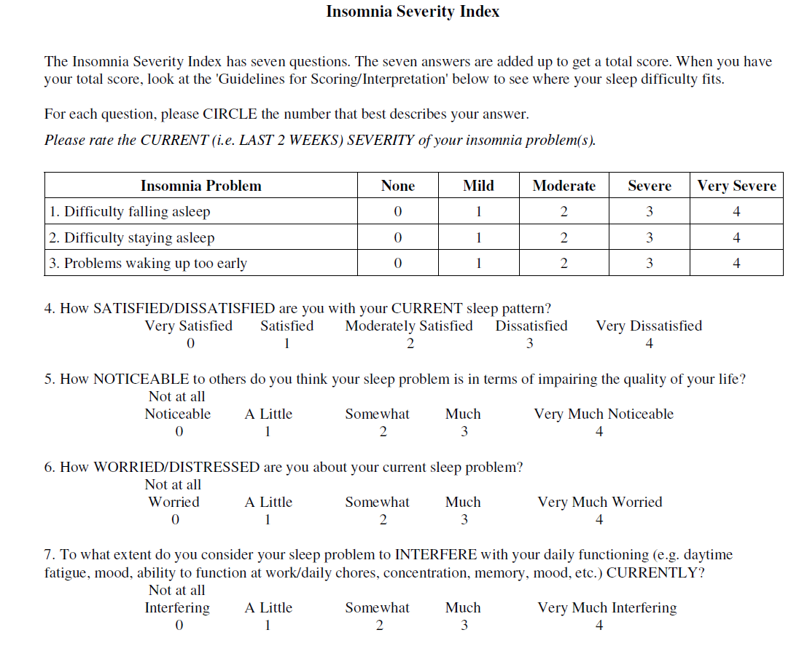

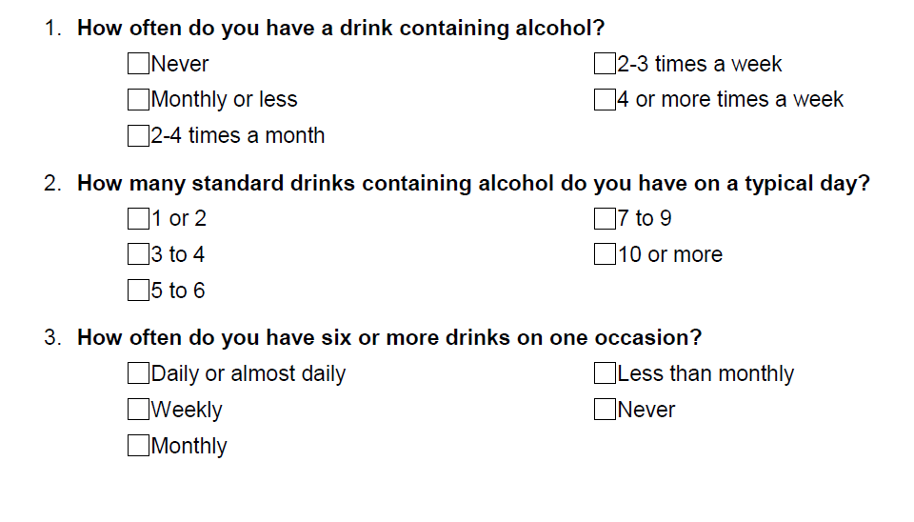
AUDIT-C (skip logic will be used if item1 = “never”, then skip items 2-3).

Thank you for your time and expertise. We are going to be conducting interviews with SOF operators and enablers to generate solutions to overcome the barriers to getting mental health treatment.
Can the study team contact you for an interview? YES NO
If you would like to provide your opinions and expertise on how to best improve PTSD treatment for the SOF community, please leave your name and telephone number below. _____________________________________________________________
If you have any additional comments about this survey, you can also leave those below.
_____________________________________________________________

