PROJECT FIRSTLINE TRAINING REPORTING GUIDELINES
Where to Report | We are using Qualtrics to report training and educational activities.  Link to reporting (select the “training and educational activity” form): https://projectfirstline.gov1.qualtrics.com/jfe/form/SV_8cAqRmZePdi9606
What to Report | We encourage you to think broadly about what activities to report. We are interested in capturing not only traditional trainings (e.g. interactive trainings of groups of people, asynchronous trainings on learning management systems, tele-mentoring), but also other activities with educational components (e.g. Q&A events, roundtable discussions).  The specific questions that are asked in Qualtrics follow this chart. You will be asked to report this information for each training event held in the reporting period, so having any records of attendance and other specifics about the event on hand is advisable.
When to Report | Frequency: Monthly  The link remains open continuously, so you can access it anytime. Please specify which period you are reporting for in the form.  The deadline will be the 15th of the month (or the following Monday if the 15th falls on a weekend). The table below provides examples for the upcoming reporting periods.  Reporting Period Reporting Deadline  March 1-31, 2021 April 15, 2021  April 1-30, 2021 May 16, 2021  May 1-31, 2021 June 15, 2021
Qualtrics Survey Tips | You can enter data one at a time immediately after an event, or you can enter all events together at the end of the month if preferred.  Answers are saved automatically as you move from screen to screen. You can continue to enter new event information at any time as long as you have not submitted your report. As you move through the Qualtrics survey, answers on each page are saved automatically each time you click “NEXT” and move to the following page. If you close your browser before you have completed entering all information for an event, your answers should still be there when you return to the survey later.  Clicking “SUBMIT” indicates you are finished with all reporting for the period. After completion of data entry for each event, you will be asked whether you are complete in entering your data for the reporting period.  - If you do not have additional events to enter, click “Yes” and select “Next” and then “Submit”.  - If you do have additional events to enter (now or at a later time), click “No” and select “Next”. The form will then be refreshed for you to enter data for your next event. If you are not ready to enter the information, then simply close out of the Qualtrics tab at this point (your information will be saved automatically) and return to the form later using the Project Firstline Training Events Qualtrics link.
What if I have questions? | Direct all questions about reporting to Jessica Waechter at qrl2@cdc.gov.

Project Firstline Training and Educational Activity Reporting

This tool was developed to gather information that will help us understand who we, collectively, are reaching, how we are doing so, how Project Firstline materials are being leveraged, and insights into the value of this work. Below are the items that will be requested when your staff enter the Qualtrics system.

- What is the name of your organization? (Dropdown selection)
☐ American Academy of Pediatrics
☐ American Health Care Association
☐ American Medical Association
☐ American Nurses Association
☐ Asian and Pacific Islander American Health Forum
☐ Health Research & Educational Trust
☐ National Association of County and City Health Officials
☐ National Council of Urban Indian Health
☐ National Hispanic Medical Association
☐ National Indian Health Board
☐ National Network of Public Health Institutes

- I am reporting training or educational activity occurring within (Dropdown selection):
☐ March 1 – March 31, 2021
☐ April 1 – April 30, 2022
☐ May 1 – May 31, 2022
☐ June 1 – June 30, 2022
☐ July 1 – July 31, 2022
☐ August 1 – August 31, 2022

- To receive an emailed report of your answers from this event, please enter your email here: ______________________________________

- Did you have a training or educational event held between [insert response from item 2] that you wish to report on?

☐ Yes ☐ No

- What was the name of the [first, second, third…] training or educational event held between January 1 – March 31, 2021 that you wish to report on?
(Note: This will be the name we use to refer to the event throughout the rest of the form. It can be a shorthand description if there is no formal name for the event; if the event is part of a series, please use the name of the series)

_________________________________________________________________________

- What was the date of the event? (If the event is part of a series, input the start date)

- Please give a brief description of the event (e.g. interactive webinar that reviewed videos and had facilitated discussion; ECHO tele-mentoring series; Q&A session held via zoom and reposted for asynchronous viewing on YouTube afterwards): _________________________________________________________________________

- Was this a “train the trainer” event? (i.e. training individuals who will then turn around and train others. The primary purpose of the training should be to formally prepare individuals to be trainers for future training sessions if “yes” is selected.)
☐ Yes ☐ No

- Please describe the type of event:
☐ Live event
☐ Live, recorded and then posted for later viewing
[If selected, prompt for additional info]
Where was the recording posted?
☐ Our organization’s website
☐ YouTube
☐ Learning Management System
☐ Other (please specify):__________________

☐ Asynchronous only event (e.g. self-paced video viewing on LMS, social media, or website)
[If selected, prompt for additional info]
Where was the recording posted?
☐ Our organization’s website
☐ YouTube
☐ Learning Management System
☐ YouTube
☐ Other (please specify):__________________

☐ Other (please describe): __________________________________

- Was this a one-time event or a series?
(Consider your event a series if the same group of people, more or less, are attending the various sessions in the series.)
☐ One-time event
☐ A series (e.g. ECHO tele-mentoring series)

- Which language was used in the training event? (select all that apply)
For all partners except APIAHF, the menu will appear this way:
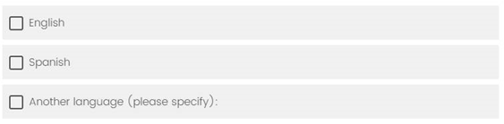

For APIAHF, the menu will appear this way:
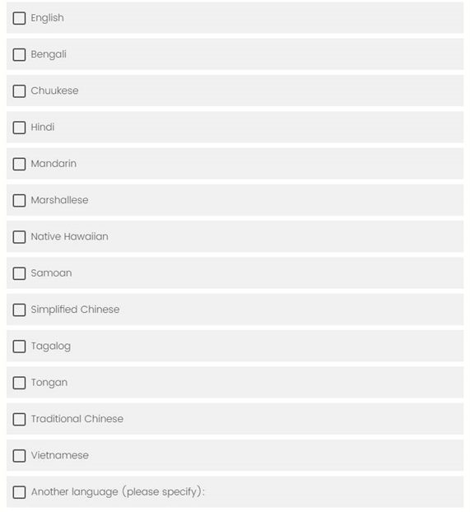

- Which infection control themes and topics were covered in the event? (select all that apply)
Please indicate any that do not logically fall within the categories below in “other”. If you are unsure, you may also specify within “other” and we can categorize for you.
☐ Goal of infection control
☐ Microbiology Basics (i.e. basic science of germs—viruses, bacteria, & fungi)
☐ Source Control (e.g. universal masking)
☐ Spread of infections (i.e. transmission)
☐ Personal Protective Equipment (PPE)
☐ Hand Hygiene
☐ Crisis Standards of Care
☐ Triage and Screening
☐ Engineering controls (e.g. ventilation, barriers)
☐ Environmental infection control (e.g. cleaning and disinfection, waste disposal, UV lights)
☐ Vaccination and injection safety
☐ SARS-CoV-2 variants and mutations
☐ Other topics covered (please specify): __________________________________

- Total length of event in hours. For short events, you may use decimals/fractions (e.g. 30 min = 0.5 hours; 15 min = 0.25 hours; 5 min = 0.08 hours). Please estimate if you do not know the exact number of hours attended.

- What Project Firstline materials developed by the CDC were used to plan or implement this event? (select all that apply)
☐ Facilitator’s toolkit
☐ CDC developed Project Firstline videos (e.g. Inside Infection Control vlog)
☐ Other Project Firstline Materials: ______________________________
☐ None were used

- What was the total attendance at the event? Please estimate if you do not know the exact number in attendance ____

- Indicate professional roles in attendance, specifying number of individuals in attendance for each provider type. If you do not know the exact attendance by practitioner type, please estimate. [a prompt occurs for number in attendance for each professional role selected]
☐ Physician
☐ Physician assistant
☐ Advanced practice nurse (e.g. nurse practitioner)
☐ Registered nurse (RN)
☐ Licensed practical nurse (LPN)
☐ Nursing/medical assistant
☐ Dentist/dental hygienist
☐ Technician (e.g., radiology, surgical, pharmacy, etc.)
☐ Therapist (e.g., physical, occupational, respiratory, etc.)
☐ Pharmacist
☐ Environmental/facility services (e.g. EVS staff, facility managers, facility engineers)
☐ Social & community services (e.g. social workers, community health workers, residential/outpatient mental health treatment staff)
☐ Healthcare administrator (e.g. clinic or hospital directors, CEOs)
☐ Non-clinical staff (e.g. HR personnel, marketing/communications staff, quality/patient safety staff, clerical staff)
☐ Emergency medical technician/paramedic
☐ Laboratory staff
☐ Public health professional
☐ Other (please specify): __________________________________

☐ We were unable to collect this metric for participants

- Indicate workplace settings represented by participants, by clicking the box and specifying the number of individuals in attendance representing each workplace setting. If you do not know the exact attendance by setting, please estimate. [a prompt occurs for number in attendance for each setting selected]
☐ Acute care hospital
☐ Critical access hospital
☐ Long-term acute care hospital or inpatient rehabilitation facility
☐ Skilled nursing facility (nursing home)
☐ Assisted living facility
☐ Pharmacy
☐ Dental facility
☐ Home health
☐ Health department
[if selected, prompt to specify further]
☐ State health department
☐ Territorial health department
☐ Local health department
☐ Tribal health department
☐ Dialysis facility (outpatient)
☐ Outpatient/ambulatory care—not dialysis (e.g. medical, surgical, behavioral health clinic)
☐ Other (please specify): _____________________________________

☐ We were unable to collect this metric for participants

- Please provide the following data for the question “Would you recommend this training to others?”:
Total number of responses for this question (exclude missing data): ___
Number of “Yes” responses: ___
Number of “No” responses: ___
Number of “Not sure” responses: ___

☐ We were unable to collect this metric for participants

- Please provide the following data for the question “Has your understanding of [insert topic] improved after this training?”:
Total number of responses for this question (exclude missing data): ___
Number of “Yes” responses: ___
Number of “No” responses: ___
Number of “Not sure” responses: ____

☐ We were unable to collect this metric for participants

- Please provide the following data for the question “What state, territory, or IHS region do you work?” specifying number of individuals in attendance representing each state. [a prompt occurs for number in attendance with for each state selected via check box]

- IHS Area – National
- IHS Area – Alaska
- IHS Area – Albuquerque
- IHS Area – Bemidji
- IHS Area – Billings
- IHS Area – California
- IHS Area – Great Plains
- IHS Area – Nashville
- IHS Area – Navajo
- IHS Area – Oklahoma
- IHS Area – Phoenix
- IHS Area – Portland
- IHS Area – Tucson
- Alabama
- Alaska
- American Samoa
- Arizona
- Arkansas
- California
- Colorado
- Connecticut
- Delaware
- District of Columbia
- Federated States of Micronesia
- Florida
- Georgia
- Guam
- Hawaii
- Idaho
- Illinois
- Indiana
- Iowa
- Kansas
- Kentucky
- Louisiana
- Maine
- Marshall Islands
- Maryland
- Massachusetts
- Michigan
- Minnesota
- Mississippi
- Missouri
- Montana
- Nebraska
- Nevada
- New Hampshire
- New Jersey
- New Mexico
- New York
- North Carolina
- North Dakota
- Northern Mariana Islands
- Ohio
- Oklahoma
- Oregon
- Palau
- Pennsylvania
- Puerto Rico
- Rhode Island
- South Carolina
- South Dakota
- Tennessee
- Texas
- Utah
- Vermont
- Virgin Islands
- Virginia
- Washington
- West Virginia
- Wisconsin
- Wyoming
- N/A: Outside of the U.S.
☐ We were unable to collect this metric for participants

(Optional) If you collect other metrics (e.g. pre-post test questions, poll questions embedded in trainings, demographics, etc.) about [event name] that are not reported elsewhere in this survey that provide useful information on participants reached or training effectiveness, please summarize below. You do not need to share the results or outcomes; rather, we want to know questions asked or type of metric collected. We may circle back at a later date to learn if your organization is willing to share the actual data with CDC Project Firstline staff. This is completely optional and only intended to better inform CDC about additional outcomes and indicators that inform program improvement and success.

Description
Optional Metric 1
Optional Metric 2
Optional Metric 3
Optional Metric 4
Optional Metric 5

(Optional) Please provide any additional you would like us to know about [event name]: ____________________________________________________________________________
____________________________________________________________________________

Are you complete in entering your training data for the reporting period of [reporting period selected]?
☐ Yes
☐ No

If “No”, and you have more events to report, click "Next." Then your screen will refresh and you will see the start of the survey again. You can either enter the next event now or come back to the link before the end of the reporting period.

[Survey Closeout Message appears if Yes is selected for previous question]

Thank you for sharing information about your organization’s training and educational activities for Project Firstline! Your information will be used to assess the reach of Project Firstline and summarize activities occurring across the partnership.

