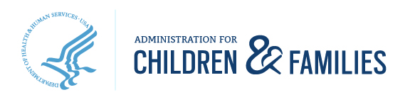
330 C Street, S.W., Washington DC 20201 | www.acf.hhs.gov
To: State and Territory Child Care Licensing Administrators, Child Care Licensing Staff, and Licensed and License-Exempt Child Care Providers
From: Katie Hamm, Deputy Assistant Secretary for Early Childhood Development, Administration for Children and Families, U.S. Department of Health and Human Services
Date: September 8, 2022
Re: Support for research project to better understand child care licensing
I am writing to encourage you to take part in research about child care licensing that is funded by the Administration for Children and Families. [For more information, see The Role of Licensing in Early Care and Education (TRLECE).]
The Office of Planning, Research, and Evaluation (OPRE), which is part of the Administration for Children and Families in the U.S. Department of Health and Human Services, is working with Child Trends and ICF to conduct several research studies over the next year or so to understand the strengths and challenges of the child care licensing system from multiple perspectives, including those of licensed and licensed-exempt providers, front line licensing staff, and licensing administrators. The primary goals of these descriptive studies are to fill gaps in the literature and build the field’s knowledge about the components of the licensing system, the licensing workforce, and provider perceptions of the licensing system.
I hope you will support this important effort by responding to their surveys and interview invitations.
Child care licensing is an understudied part of the early childhood system. It is important to learn more about licensing and its role in supporting providers, children, and families in order to continue improving licensing systems across the nation. The information from this research project will be shared broadly and will inform the work of the Administration for Children and Families and the TRLECE team. Additionally, state and territory licensing administrators may use the findings to inform changes to licensing policies or practices.
Sincerely,
Katie Hamm
Deputy Assistant Secretary for Early Childhood Development

