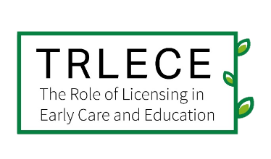
The Role of Licensing in
Early Care and Education (TRLECE)

Purpose of this project
The TRLECE project seeks to strengthen the field’s understanding of child care licensing systems which play a critical role in supporting positive outcomes for providers, families, and children. TRLECE is sponsored by the Office of Planning, Research, and Evaluation of the Administration for Children and Families in the U.S. Department of Health and Human Services. The project is being conducted by Child Trends and ICF.

Study activities
We’re working on a few studies over the next year that will help state and territory administrators, policy makers, and researchers better understand child care licensing systems from the perspectives of licensing administrators, front-line child care licensing staff, and child care providers. We plan to contact you at three points during our study. The boxes below provide an overview. We are also conducting a public request for child care licensing documents related to licensing unit procedures. You can send materials directly to TRLECE@childtrends.org and view the request here.
Our request: your supply of information about child care licensing front-line staff

Purpose:
- We’re conducting a nationwide survey of all front-line licensing staff and need your help to identify and reach your state/territory’s front-line staff.
1—Late 2022
Our request: your participation in a licensing administrator survey
Purpose:
- We’re conducting a nationwide survey of licensing administrators and will request your participation in a short 20-minute survey to help us learn about you and your team, factors influencing licensing decisions, your perceptions of strengths and challenges of the licensing unit, and ideas to improve licensing systems.
2—Early 2023
Our request: your review of a state/territory public profile documenting key features of your state/territory licensing system
Purpose:
- We’re developing a public database that will highlight some key features of every state and territory licensing system. We hope that you will review this information for accuracy before we make it publicly available.
- Note that some of the information from the Early 2023 survey (box 2) will be included in this database.
3—Mid 2023
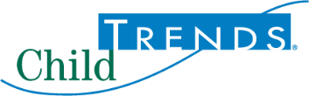
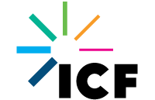

Questions? | Contact us at TRLECE@childtrends.org

An agency may not conduct or sponsor, and a person is not required to respond to, a collection of information unless it displays a currently valid OMB control number. The OMB number and expiration date for the information collection in box 1 are OMB #: 0970-0356, Exp: 02/29/2024.
The OMB number for the described information collection is 0970-0XXX and the expiration date is XX/XX/XXXX.

