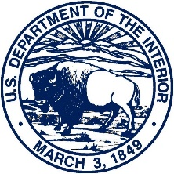 | United States Department of the Interior  FISH AND WILDLIFE SERVICE  Office of Law Enforcement  National Eagle and Wildlife Property Repository  6550 Gateway Road, Bldg. 128  Commerce City, CO 80022 |  | 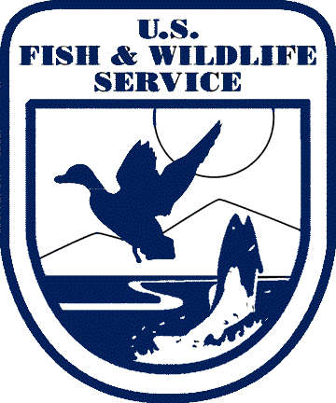
In Reply Refer to:
FWS/R6

FWS/OLE
Date

Tribal Enrollment Office
(Address)

Subject: Native American Eagle Parts/Feather Permits Now Processed by National Eagle Repository
Dear Tribal Enrollment Officer:
We are requesting that tribal enrollment offices inform tribal members that the National Eagle Repository will be processing all eagle feather permit applications. A permit is required for Native Americans to order eagle feathers and parts from the National Eagle Repository. To date, the Native American Religious Purposes permit applications have been processed by the regional Migratory Bird Permit Offices. Those permits were then forwarded from the regional Migratory Bird Permit Office to the National Eagle Repository, and the National Eagle Repository processed the order request.
During the 2018 tribal consultation on potential changes to 50 CFR 22.22 regulations, Tribes identified eagle feather permit process as confusing and slow. As a result of the consultation, the Service identified how to streamline the permitting process by designating the National Eagle Repository to process eagle feather permit applications through a policy change.
Effective October 1, 2021, the National Eagle Repository will process all eagle feather permit applications. This includes all new applications, amendments (e.g. name change, contact information), and re-orders. Tribal members should submit permit applications (Form 3-200-15a) directly to the National Eagle Repository, rather than to the regional Migratory Bird Management Offices. Applications submitted using our online application portal (www.fws.gov/ePermits) will automatically be directed to the National Eagle Repository, so there is no change to the online application process for tribal members.
In support of Service outreach efforts, we are requesting that your tribal enrollment office inform tribal members that the National Eagle Repository will be processing all eagle feather permit actions and should be contacted with any eagle feather permit questions. If you have any questions or for further information, please contact the National Eagle Repository at:
National Eagle Repository
6550 Gateway Road, RMA, Bldg. 128
Commerce City, CO 80022
(303) 287-2110
www.fws.gov/eaglerepository
repository@fws.gov
Sincerely,

Gregory J. Langer
Supervisory Wildlife Repository Specialist, National Eagle Repository

