Visitor Perceptions of Climate Change Study
Fish and Wildlife Service On-site, Initial Contact

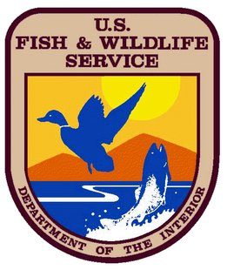

Paperwork Reduction Act and Privacy Act Statements:
The National Park Service is authorized by 54 U.S.C. 100702 and the U.S. Fish and Wildlife Service is authorized by the National Wildlife Refuge System Administration Act of 1966 (16 U.S.C. 668dd–668ee) to collect this information. This collection involves a visitor survey to understand visitor perceptions and concerns about climate change to guide communication and engagement efforts. Your responses to this collection are completely voluntary and will remain anonymous. You can end the process at any time and will not be penalized in any way for choosing to do so. Data collected will only be reported in aggregates and no individually identifiable responses will be reported. A Federal agency may not conduct or sponsor, and you are not required to respond to, a collection of information unless it displays a currently valid OMB Control Number. Your response is not required to obtain or retain a benefit. OMB has approved this collection of information and assigned control number XXXX-XXXX. The expiration date is XXXXXXX

Estimated Burden Statements:
Public reporting for this collection of information is estimated to be about 1 minute per contact. Send comments regarding this burden estimate or any other aspect of this collection of information, including suggestions for reducing this burden, to the Information Collection Clearance Officer, National Park Service, 12201 Sunrise Valley Dr. (MS-242), Reston, VA 20192 or Service Information Clearance Officer, Fish and Wildlife Service, U.S. Department of the Interior, 5275 Leesburg Pike, MS: PRB (JAO/3W), Falls Church, VA 22041-3803, or via email at Info_Coll@fws.gov.

OMB Control #: 1024-XXXX
Expiration Date: XX/XX/XXXX
Initial Contact Script:
Hello, I am a student from Slippery Rock/Northern Michigan University working with the National Park Service and Fish Wildlife Service conducting visitor surveys at [this refuge]. This survey is about visitors’ perceptions of climate change at [this refuge] and takes about 7 minutes to complete. Your participation is completely voluntary and anonymous, and you can stop taking the survey at any time. Are you at least 18 years of age or older? [If yes, continue…] Would you be willing to help the Fish and Wildlife Service better understand visitors’ opinions by taking this survey?

[If yes, hand tablet to complete survey.]

If no… hard refusal: end contact
If no… soft refusal: Thank you, instead could you answer three quick questions today?

