Submission of eDNA data to the USGS Nonindigenous Aquatic Species (NAS) database is a two-step process. Users interested in the process can review the database’s goals for incorporation of eDNA data at https://nas.er.usgs.gov/eDNA/default.aspx. Users interested in submission of eDNA data will be directed to the pre-screening form (https://nas.er.usgs.gov/eDNA/prescreening.aspx), which gathers very basic information about the study and eDNA data the user would like to contribute. On initial page load of the pre-screening form, the user is presented with a pop-up notification containing the Paperwork Reduction Act and Privacy Act statements (see below; number contained in the pop-up is currently a placeholder)

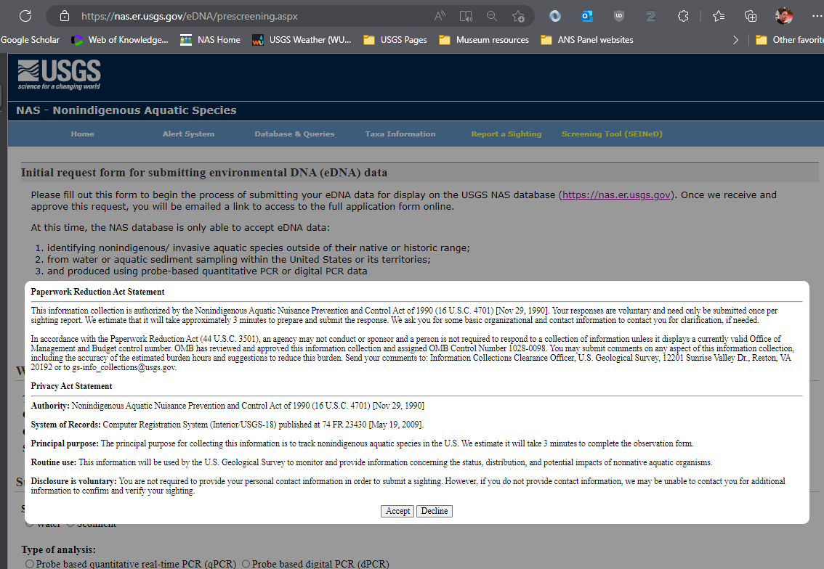
This pop-up contains the OMB control number, but not the expiration date. When the user clicks on the ‘Accept’ button, the user can then interact with the form. The following screenshots show the content of the form. When the user completes the form and scrolls to the bottom of the page, the OMB Control Number and the expiration date (both placeholders currently) are visible:
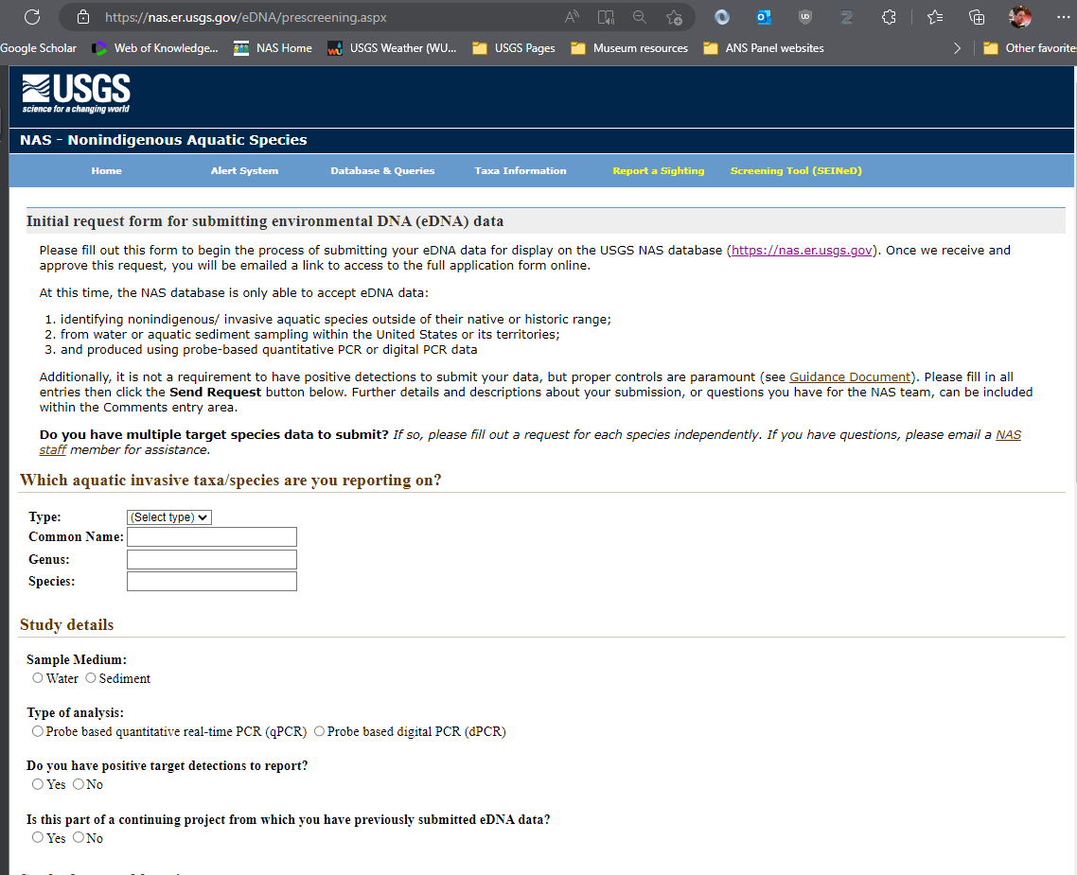
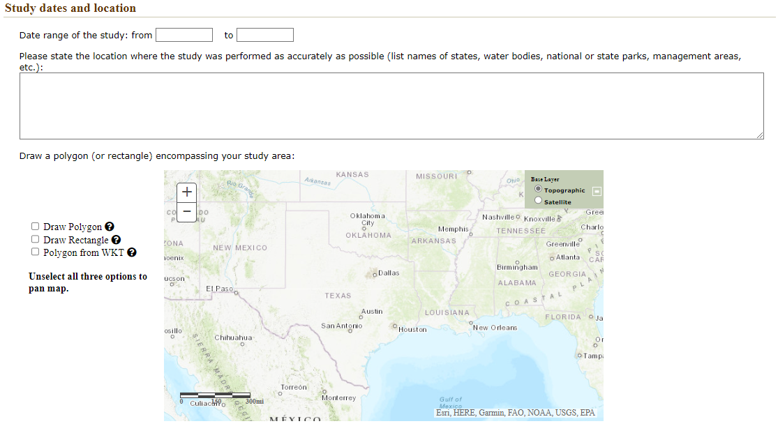
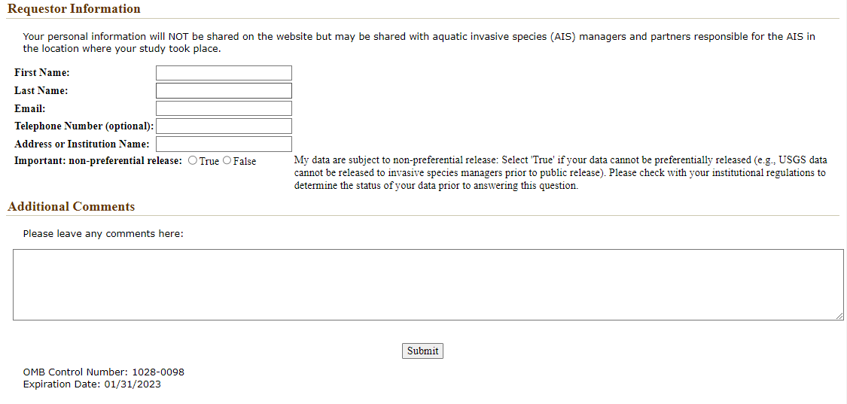

Upon successful completion and submission of the prescreening form, the user is presented with a notification, and receives an automated email describing the review and submission process. Data from this form is entered into a table in the NAS Database for a staff member to quickly review and approve/deny for the second, full application form.
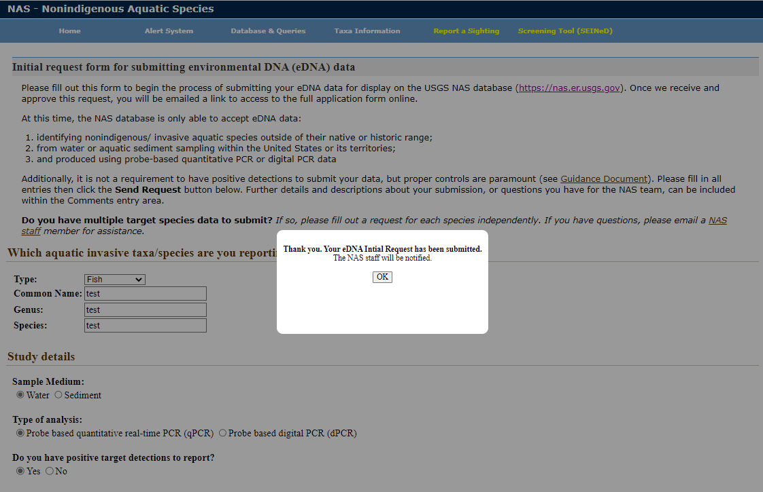
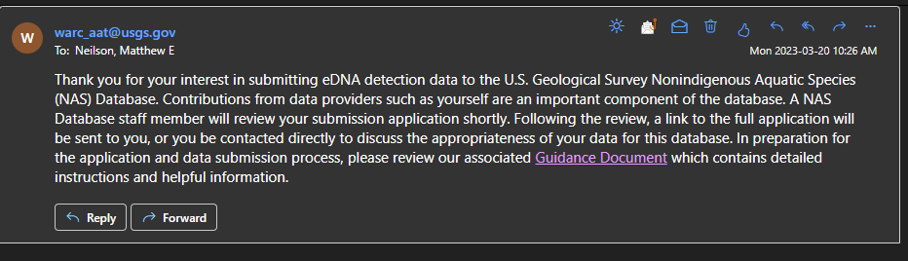
After the pre-screen form is reviewed by a NAS staff member the user then receives a second email containing a unique link to the full submission form (https://nas.er.usgs.gov/eDNA/fullApplication.aspx), which captures detailed metadata about the eDNA data the user would like to submit. The user is again presented with a pop-up notification containing the Paperwork Reduction Act and Privacy Act statements (number is screenshot is currently a placeholder)
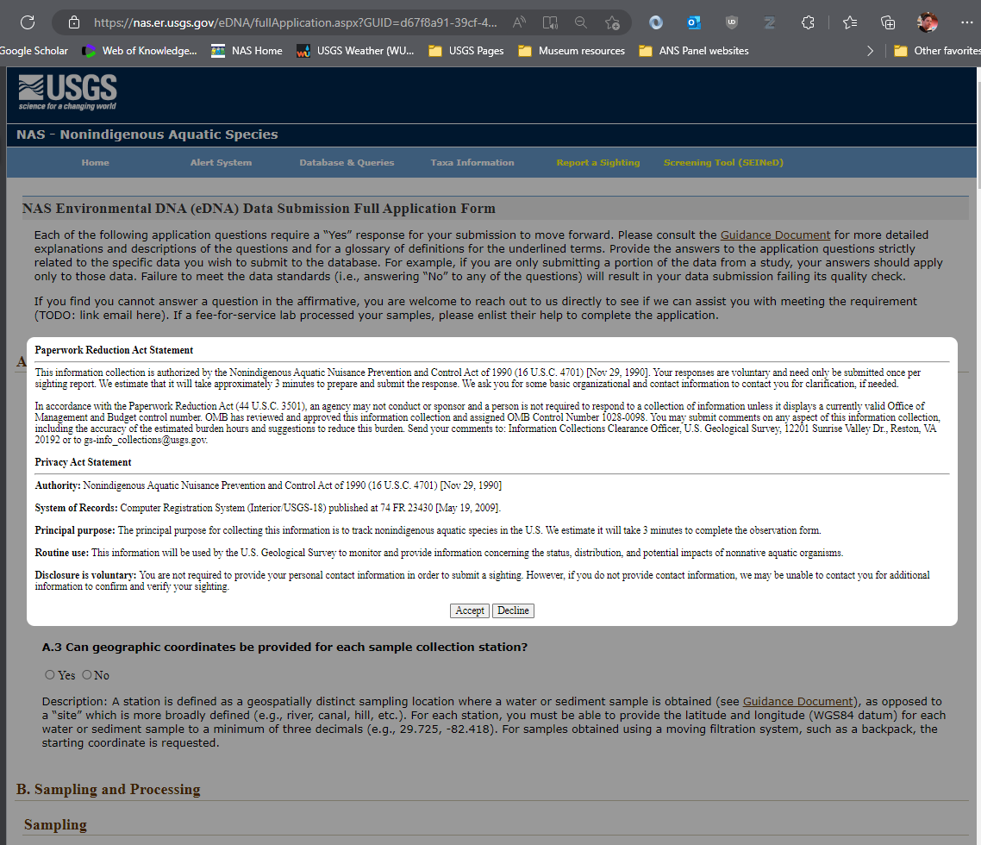
This pop-up contains the OMB control number, but not the expiration date. When the user clicks on the ‘Accept’ button, the user can then interact with the form. The following screenshots show the content of the form. When the user completes the form and scrolls to the bottom of the page, the OMB Control Number and the expiration date (both placeholders currently) are visible:

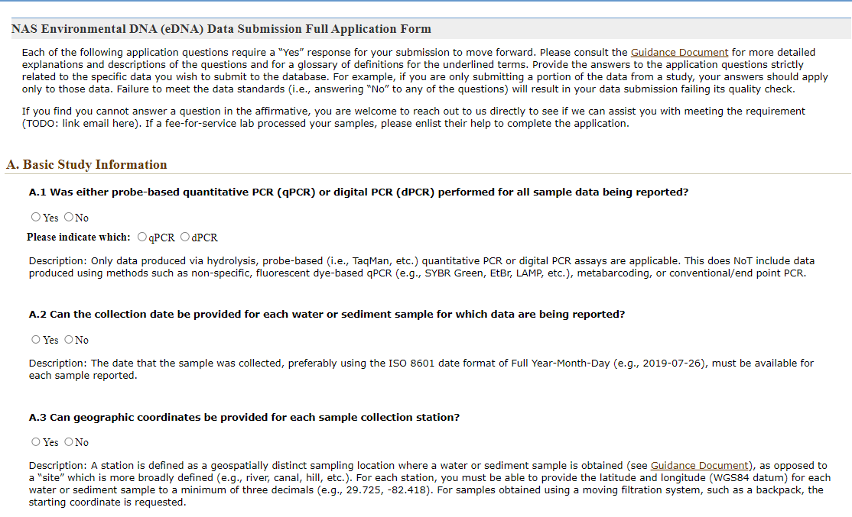
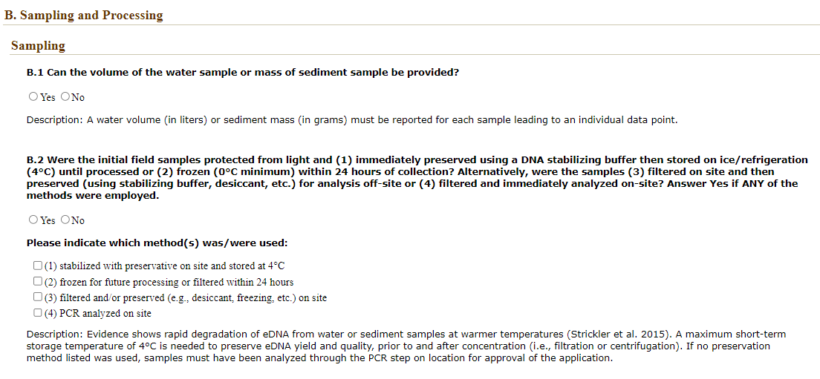
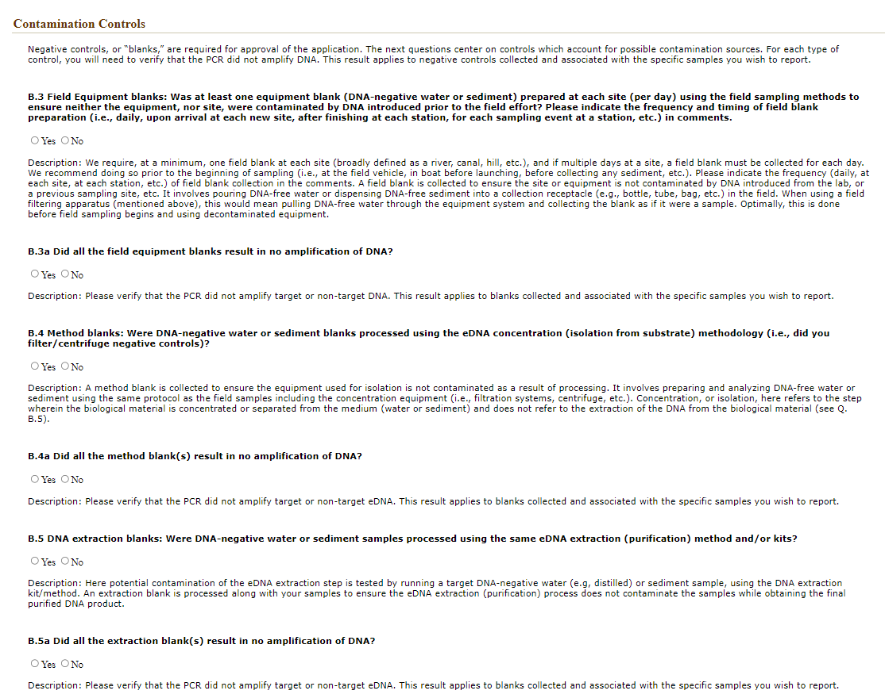
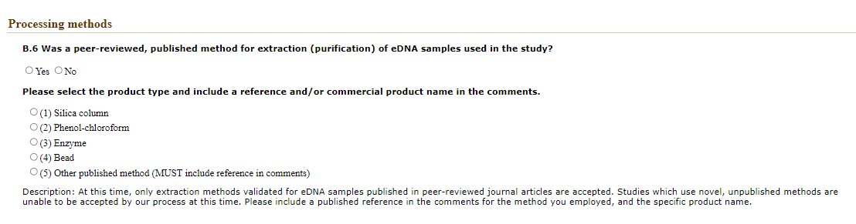
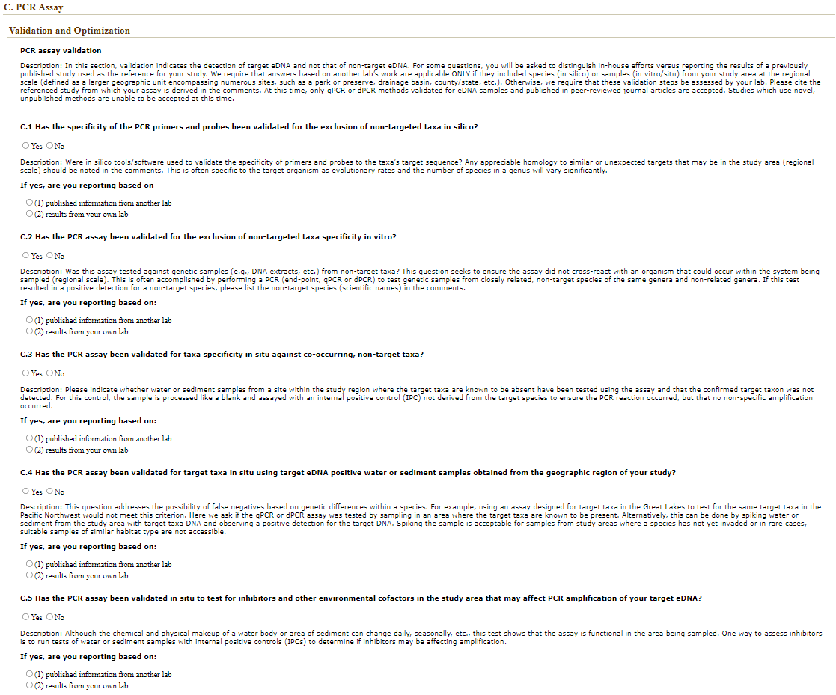

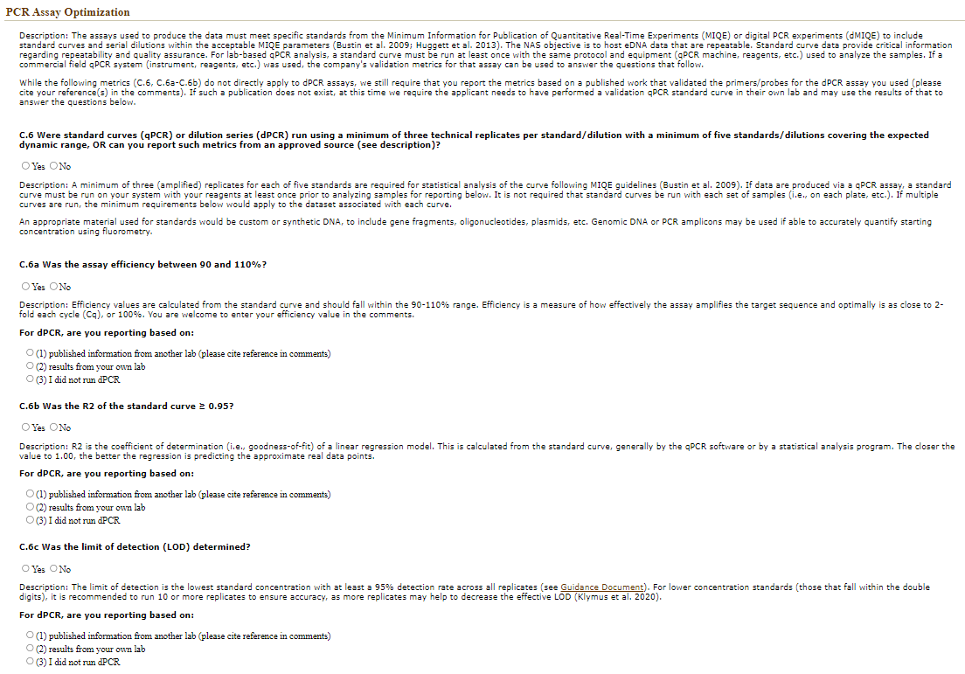
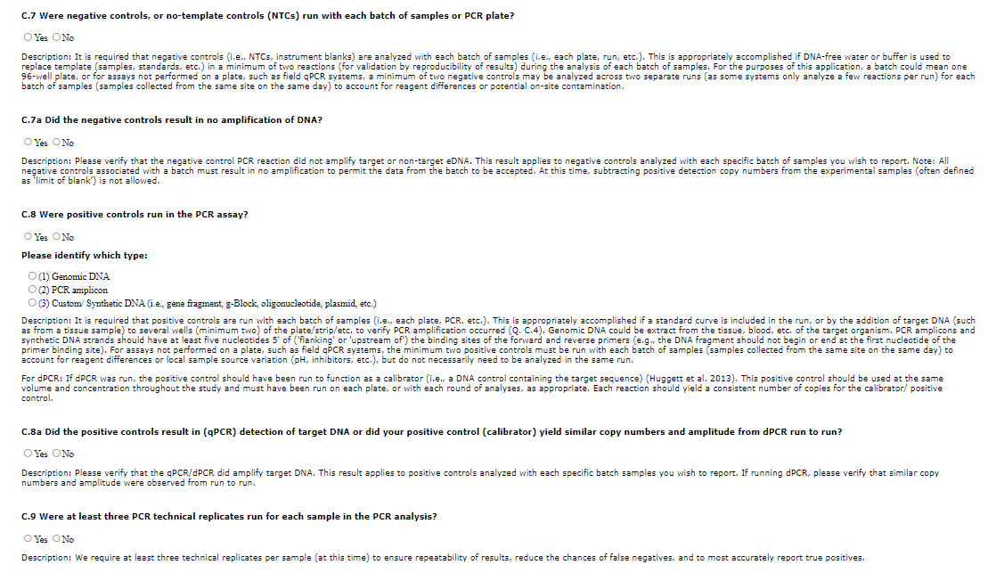
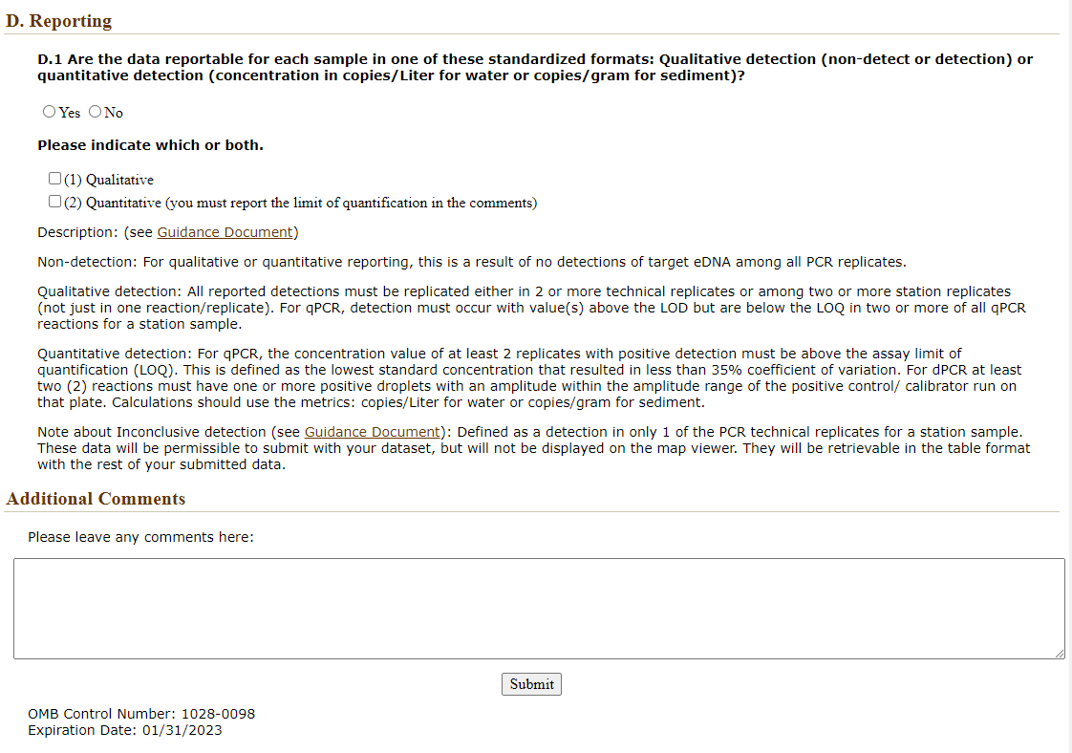

Upon submission of full application form, the form data is evaluated based on automated rules: if all questions are answered in the affirmative (indicating that the eDNA data meets with the previously established standards for submission), the user is shown a pop-up notification containing a link to the data template file, the submission guidance document, and a unique URL for submission of their dataset
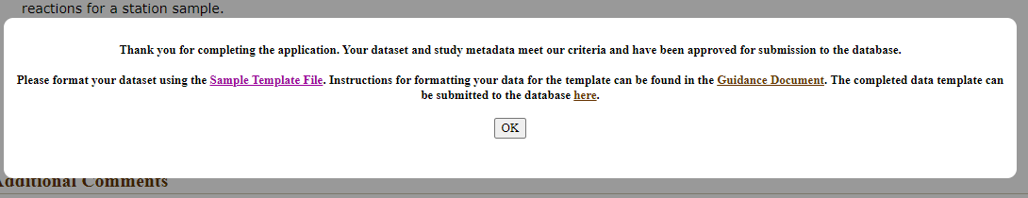
The user also receives an email containing the same links
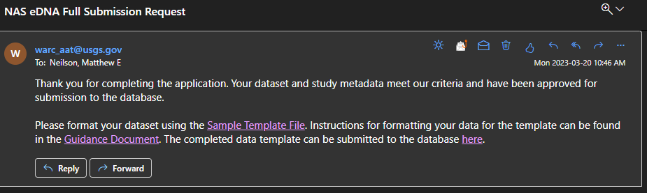
The sample template file page contains two versions of the template: one with annotations on the field names and sample data, and one just containing field names. No OMB control number is displayed on this page, nor is a pop-up containing the PRA and Privacy Act statements presented (as the user has been shown this information twice during the submission process).
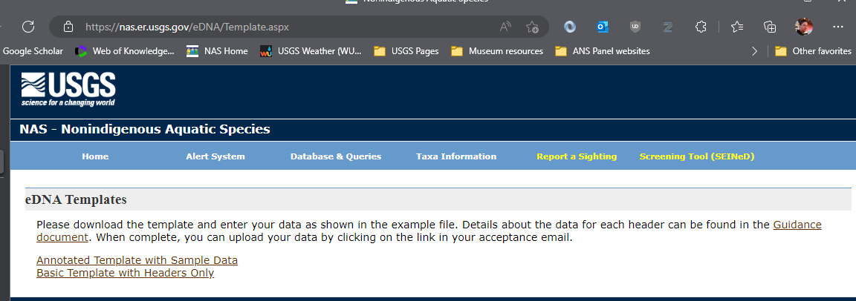
After the user formats their data according to the data submission template, the user can upload their dataset to the NAS database using a unique URL present in the acceptance email (see above)
