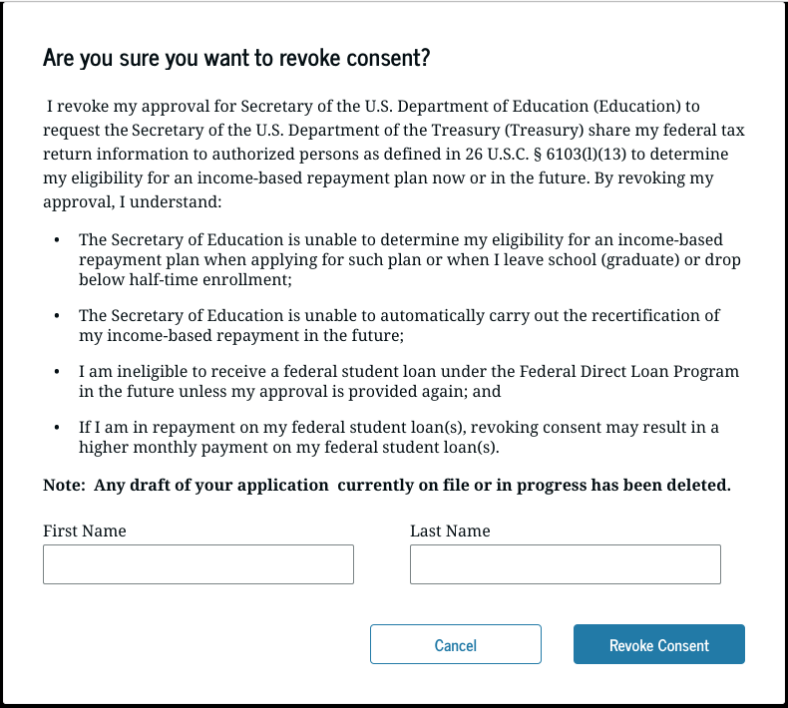

This is a screenshot of the modal that will display on [www.StudentAid.gov](http://www.StudentAid.gov) in settings when a user indicates they would like to digitally revoke consent. Note: This is placeholder language, not final.