Supporting Statement

for

Information Collection Request

**Emissions Certification and Compliance Requirements for**

**Nonroad Compression-ignition Engines and On-highway Heavy Duty Engines**

**(Revision)**

EPA ICR Number 1684.21 OMB Control Number 2060-0287

42 USC 7521 § 206 (b)(1)

42 USC 7521 § 207(b)

42 USC 7521 § 213(d)

42 USC 7521 § 217

40 CFR Parts 85-86, 89 and 94

40 CFR Part 1027, 1033

40 CFR Parts 1036-1037

40 CFR Part 1039

40 CFR Part 1042-1043

40 CFR Part 1045

40 CFR Part 1060

40 CFR Part 1065-1066

40 CFR Part 1068

49 CFR 535

March 2023

Certification and Compliance Division

Office of Transportation and Air Quality

Office of Air and Radiation

U.S. Environmental Protection Agency

**1. Identification of the Information Collection**

**1(a) Title and Number of the Information Collection**

Emissions Certification and Compliance Requirements for Nonroad Compression-ignition Engines and On-highway Heavy Duty Engines (Revision); EPA ICR Number 1684.21; OMB Control Number 2060-0287

**1(b) Short Characterization**

Under Title II of the Clean Air Act (42 U.S.C. 7521 et seq.; CAA), EPA is charged with issuing certificates of conformity for engine prototypes that comply with applicable emission standards. Such a certificate must be issued before engines produced after these prototypes may be legally introduced into commerce. Table 1 below lists EPA regulations pertaining to the industries covered by this ICR.

**Table 1**

**Nonroad CI and Heavy-duty Emissions Regulations**

|  |  |
| --- | --- |
| Industry | 40 CFR[1] Part |
| Nonroad Compression-Ignition (NRCI) Engines and Equipment | 89*[2], 1039* |
| Marine Compression-Ignition Engines (Marine CI) | 94*, 1042*, 1043* |
| Locomotives, locomotive engines and remanufacturing kits | 92*, 1033* |
| Heavy-Duty (HD) Engines | 85*, 86 |
| Greenhouse Gas Requirements for HD Engines | 1036* |
| Greenhouse Gas Requirements for HD Vehicles | 1037* |
| Evaporative Requirements | 1060 |
| Testing Provisions | 1065 |
| General Provisions – apply to most nonroad categories | 1068 |
| Fees, as applicable to the above industries | 1027 |

Each model year, engine and vehicle manufacturers wishing to sell their products in the US must obtain a certificate of conformity with criteria pollutant[3] standards. HD engines and vehicles also need to comply with evaporative, greenhouse gas (GHG) emissions[4] and fuel economy standards. The fuel economy data is shared with the National Highway Transportation Safety Agency, which administers the program. There are also recordkeeping requirements. To apply, manufacturers submit descriptions of their planned production engines, detailed descriptions of emission control systems and test data. This information is organized by "engine family" groups expected to have similar emission characteristics.

Engine manufacturers electing to participate in the Average, Banking and Trading (AB&T) Program must submit information regarding the calculation, actual generation and usage of credits in an initial report, end-of-the-year report and final report. These reports are used for certification and enforcement purposes. Manufacturers must also maintain records for eight years on the engine families included in the program.

The Act also mandates EPA to verify that engine manufacturers have successfully translated their certified prototypes into mass produced engines, and that these engines comply with emission standards throughout their useful lives. Some respondents are required to test a sample of engines as they leave the assembly line. The Production Line Testing (PLT) Program is a self-audit program that allows manufacturers to monitor compliance with statistical certainty while minimizing the cost of correcting errors through early detection. Through Selective Enforcement Audits (SEAs) or similar programs, EPA verifies that test data submitted by manufacturers is reliable and that testing is performed according to EPA regulations. Compliance with emission regulations throughout the useful life of an engine is verified through the In-use Testing (In-use) Programs under which engines are tested after they have served a portion of their useful lives. Not all programs apply to all industries included in this collection.

Engine and equipment manufacturers who chose to participate in TPEM must submit annual reports and keep records. Equipment manufacturers must also notify EPA of their intent to participate prior to introducing any TPEM engines/equipment into the US market.

This information is collected by the Compliance Division (CD) within the Office of Transportation and Air Quality, Office of Air and Radiation, U.S. Environmental Protection Agency (EPA). HD certification and fuel economy data is collected in conjunction with and shared with the National Highway Traffic Safety Administration (NHTSA) for use in their fuel economy programs. All information collected could be used by the Office of Enforcement and Compliance Assurance (OECA) and the Department of Justice for enforcement purposes. Non-confidential portions of the applications are disclosed in EPA’s website and may be used by trade associations, environmental groups, and the public. The information is usually submitted in an electronic format and stored in CD's databases.

It has been estimated that a total of 568 engine, vehicle and equipment manufacturers will respond to this collection with an approximate cost of $30,785,471. Please note that some burden and cost tables referenced in this document are found in the accompanying Excel file.

**2. Need for and Use of the Collection**

**2(a) Need/Authority for the Collection**

EPA's emission programs are statutorily mandated; the agency does not have discretion to cease these functions. The data required is necessary to comply with Title II of the Clean Air Act (42 U.S.C. 7521 et seq.; “CAA” or “the Act”), as amended. The Act charges EPA with developing standards for compounds deemed ‘pollutants’ as defined by the CAA itself, and issue certificates of conformity for those engines and motor vehicle designs that comply with those standards. Such a certificate must be issued before engines and vehicles may be legally introduced into commerce. Section 206(a) of the CAA (42 USC 7521) states:

"The Administrator shall test, or require to be tested in such manner as he deems appropriate, any new motor vehicle or new motor vehicle engine submitted by a manufacturer to determine whether such vehicle or engine conforms with the regulations prescribed under §202 of this Act. If such vehicle or engine conforms to such regulations, the Administrator shall issue a certificate of conformity upon such terms, and for such period (not in excess of one year) as he may prescribe."

This charge also applies to nonroad engines and equipment, pursuant to §213(d) of the CAA. The Supreme Court’s decision in *Massachusetts v. Environmental Protection Agency*, 549 U.S. 497 (2007), extended it to greenhouse gases (GHGs) when it ruled that GHGs are in fact pollutants under the CAA.

Therefore, engine and vehicle manufacturers may not legally introduce their product into U.S. commerce unless EPA has certified that their vehicles and engines comply with applicable emission standards. To ensure compliance with the CAA, EPA reviews product information and manufacturers' test results. The agency may also test some vehicles and engines to verify data provided by manufacturers at certification. There are also some regulatory requirements for nonroad equipment manufacturers.

Section 206(b)(1) of the Act authorizes EPA to inspect and require testing of new vehicles and engines to: (1) verify that a manufacturer's final products comply with EPA standards; (2) assure that the correct parts are installed correctly in each engine; and (3) audit the manufacturer's testing process to ensure testing is being done correctly. The PLT and SEA Programs fulfill these requirements by inspecting and testing engines taken directly from the assembly line and/or existing fleets, and by auditing the engine manufacturer's testing procedures and facilities. Section 207(b) of the CAA mandates the establishment of methods and testing procedures to ascertain whether certified engines in actual use in fact comply with applicable emission standards throughout their useful lives. The In-Use Testing and similar programs are implemented in response to that mandate.

49 USC 32902 requires the National Highway Traffic Safety Administration (NHTSA), in consultation with the Department of Energy and the EPA, to prescribe each model year average fuel economy standards. Under 49 USC 32907, manufacturers are required to submit reports to both NHTSA and EPA demonstrating how they plan to comply with applicable average fuel economy standards.

**2(b) Practical Utility/Users of the Data**

EPA uses the information requested under this collection to implement a three-stage compliance assurance system established by the CAA, and for enforcement purposes. First, certification information is needed to verify that the proper prototype engines have been selected to represent each engine/vehicle family (group of engines/vehicles expected to have similar emission characteristics), and that the necessary testing has been performed. Based on this information, EPA issues a certificate of conformity. However, prototypes are often hand-built and not typical of assembly line engines. Information collected under the PLT and similar programs is used to verify that manufacturers have successfully translated their prototypes into mass-produced engines. Engines are taken directly from the assembly line and tested. Lastly, in-use testing is designed to determine if engines and vehicles maintained in accordance with the manufacturer's instructions still emit at acceptable levels after a prescribed number of years of actual use. If a family of engines or vehicles is found not to comply, manufacturers are required to recall the family.

Flexibility programs such as AB&T and TPEM ease the burden of EPA regulations on regulated parties who choose to participate.

The information will be received and used by various divisions within CD and NHTSA. In instances of noncompliance, the information may be used by the EPA’s and NHTSA’s enforcement offices and the Department of Justice. Non-confidential portions of the information submitted to CD are available to and used by importers, environmental groups, members of the public and state and local government organizations.

**3. Nonduplication, Consultations and Other Collection Criteria**

**3(a) Nonduplication**

The information requested under this ICR is required by statute. Because of its specialized nature, and the fact that most of it must be submitted to EPA before engines and vehicles can be sold, the information collected is not available from any other source. Furthermore, some of the data requested, such as sales volumes or certain engine designs, may be proprietary in nature, and thus claimed as confidential business information (CBI) by manufacturers. Therefore, EPA can only obtain the information if it is submitted by its owners.

**3(b) Public Notice Required Prior to ICR Submission to OMB**

An announcement of the public comment period for this ICR revision was published in the Federal Register (88 FR 5334) on January 27, 2023, which can be accessed through the Federal Register's website at <http://www.gpoaccess.gov/fr/index.html>. One comment was received in duplicate which unfortunately is not responsive to this ICR revision.

The comment was submitted by Mr. Tony Tareski, a graduate student at the University of Denver, on February 15, 2023. It refers to a proposal to lower criteria pollutants emitted by the American trucking industry with costs of $4.7 billion. The commenter expresses their support for such proposal but questions their impact on the US supply chain and logistics sector. EPA believes that the commenter is referring to the HD2027 rule, which in fact amended certain HD emissions certification and compliance provisions for criteria pollutants was published in the Federal Register (88 FR 4466) on January 24, 2023; and is covered under EPA ICR Number 2621.01; OMB Control Number 2060-NEW. That FR notice, published just three days before the first FR notice for this collection EPA ICR Number 1684.21, opened a 30-day public comment period (Docket ID No. EPA-HQ-OAR-2019-0055) concurrent with the 60-day comment period for this collection. It should be further noted that this collection does not cover any proposal, only existing provisions. Therefore, EPA believes that the commenter submitted their comment to the incorrect docket.

.

**3(c) Consultations**

In updating the information collections in this request, EPA used data gathered in consultations with the regulated industry during the development of burden estimates for this and previous ICRs as well as during the implementation of the programs covered by this collection.

* Ms. Ingrid Santos,

Volvo Penta

[Ingrid.Santos@Volvo.com](mailto:Ingrid.Santos@Volvo.com)

* Mr. Jim Priest,

Detroit Diesel Corporation

[jim.priest@daimlertruck.com](mailto:jim.priest@daimlertruck.com)

* David McCowan

FPT Industrial

[david.mccown@ivecogroup.com](mailto:david.mccown@ivecogroup.com)

**3(d) Effects of Less Frequent Collection**

The CAA states that emission certification must be done on a yearly basis (CAA 206(a)(1)), coinciding with the industry's 'model year.' Major product changes typically occur at the start of a model year. For these reasons, a collection frequency of less than a model year is not possible. However, when an engine design is "carried over" to a subsequent model year, the amount of new information required is substantially reduced.

For practical reasons, PLT reports are submitted on a quarterly basis. Manufacturers are required to test up to one percent of their production at random to ensure that mass produced engines comply with emission requirements. If a problem is found, manufacturers must correct it and might need to recall engines that have already been sold. Engine manufacturing companies update their internal production volume reports every quarter. By conducting this quality control testing also on a quarterly basis, manufacturers are able to learn about and address any problems early, before the start of the next quarter's production, thus minimizing costs.

In-use testing and SEA information is collected on occasion, when EPA orders testing of a particular engine or audits a particular manufacturer.

AB&T and TPEM data is collected annually, once manufacturers elect to participate in those programs, also to correspond with manufacturing cycles and to make data collection and compliance verification more manageable for both EPA and respondents.

**3(e) General Guidelines**

Certification, ABT, and end-of-the-year report related records must be maintained for eight years. Note that respondents may “store these records in any format and on any media, as long as [respondents] can promptly send us organized, written records in English if we ask for them" [for example in 1039.250(d), 1042.250(d)]. For HD engines, "records may be retained as hard copy or reduced to microfilm, ADP film, etc., depending on the manufacturer's record retention procedure, provided that in every case all the information contained in the hard copy is retained" [(86.000-7(a)(3)]. These recordkeeping requirements stem, in large part, from the statutory requirement to warrant some items for long periods of time. In addition, the manufacturers must comply with requirements to recall vehicles and engines failing to meet emission standards during their useful lives. However, data related to routine testing such as test cell temperatures and relative humidity readings, must only be kept for one year after a certificate of conformity is issued.

Manufacturers are required to submit confidential business information such as sales projections and certain sensitive technical descriptions (Please see section 4(b)(i) for reference). This information is kept confidential in accordance with the Freedom of Information Act, EPA regulations at 40 CFR Part 2, and class determinations issued by EPA's Office of General Counsel. Also, non-proprietary information submitted by manufacturers is held as confidential until the specific vehicle or engine to which it pertains is available for purchase.

For practical reasons, PLT reports are submitted on a quarterly basis. Manufacturers are required to test some engines at random to ensure that mass produced engines comply with emission requirements. If a problem is found, manufacturers must correct it and might need to recall engines that have already been sold. Engine manufacturing companies update their internal production volume reports every quarter. By conducting this quality control testing also on a quarterly basis, manufacturers can learn about and address any problems early, before the start of the next quarter's production, thus minimizing costs.

Under an SEA, manufacturers are required to submit test results and information within five working days after all engines ordered to be tested have been tested. The items requested are all readily available or generated during the SEA. For nonroad engines, a report on the test results must be submitted within 30 days (see Section 1068.450). The information is requested in less than thirty days so that EPA can verify the accuracy and validity of the emission data and expeditiously reach a conclusive audit decision. An expeditious audit decision allows the manufacturer to quickly release the tested vehicles or engines for introduction into commerce.

No other general guideline is exceeded by this information collection.

**3(f) Confidentiality**

Manufacturers are allowed to assert a claim of confidentiality over information provided to EPA. Confidentiality is provided in accordance with the Freedom of Information Act and EPA regulations at 40 CFR Part 2. For further detail, refer to section 3(e).

**3(g) Sensitive Questions**

No sensitive questions are asked in this information collection.

**4. Respondents and Information Requested**

**4(a) Respondents/SIC Codes**

Respondents are manufacturers of heavy-duty and non-road engines, vehicles and equipment within various North American Industry Classification System (NAICS) codes. Respondents to NRCI, locomotive, and marine CI requirements fall in the following categories:

333618 Other Engine Equipment Manufacturing

333111 Farm Machinery and Equipment Manufacturing

333112 Lawn and Garden Tractor Manufacturing

333120 Construction Machinery Manufacturing

336312 Gasoline Engine and Engine Parts Manufacturing

336611 Manufacturers of Marine Vessels;

811310 Engine Repair and Maintenance

Companies responding to HD requirements are “companies that manufacture, sell, or import into the United States new heavy-duty engines and new Class 2b through 8 trucks, including combination tractors, all types of buses, vocational vehicles including municipal, commercial, recreational vehicles, and commercial trailers as well as 3/4-ton and 1-ton pickup trucks and vans. The heavy-duty category incorporates all motor vehicles with a gross vehicle weight rating of 8,500 lbs. or greater, and the engines that power them, except for medium-duty passenger vehicles already covered by the greenhouse gas standards and corporate average fuel economy standards issued for light-duty model year 2017-2025 vehicles.”[5] Regulated categories and entities include the following” North American Industry Classification System (NAICS) codes as published in the Federal Register, 81 FR 73478:

**Table 2**

**HD Respondents NAICS Codes**

| Category | NAICS code | Examples of potentially affected entities |
| --- | --- | --- |
| Industry | 336111 | Motor Vehicle Manufacturers, Engine Manufacturers, Truck Manufacturers, Truck Trailer Manufacturers. |
|  | 336112 |  |
|  | 333618 |  |
|  | 336120 |  |
|  | 336212 |  |
| Industry | 541514 | Commercial Importers of Vehicles and Vehicle Components. |
|  | 811112 |  |
|  | 811198 |  |
| Industry | 336111 | Alternative Fuel Vehicle Converters. |
|  | 336112 |  |
|  | 422720 |  |
|  | 454312 |  |
|  | 541514 |  |
|  | 541690 |  |
|  | 811198 |  |

**4(b) Information Requested**

This section summarizes the reporting and recordkeeping requirements of the various programs included in this collection as well as the tools used to collect that information. Information and recordkeeping requirements are similar across industries and programs (e.g., certification, AB&T, etc.), although some requirements have been tailored to address differences in engines/vehicle type or industry-specific practices. We offer some regulatory references or citations to assist the reader in locating the requirements in the Code of Federal Regulations (CFR). However, please note that the list of citations is not meant to be exhaustive.

The programs in this information collection implement a three-stage process envisioned in the Clean Air Act with regards emissions from mobile sources: engines, vehicles, and equipment. The three-stage process starts with the certification program, where EPA issues certificates of conformity to those engines/vehicles that meet emissions requirements[6]. Programs such as AB&T provide manufacturers with flexibility to meet those requirements. For step-by-step guide on how to submit applications for certification and compliance reports, visit:

* For all nonroad industries (NRCI, Marine CI, Locomotives): <https://www.epa.gov/ve-certification/certification-and-compliance-nonroad-vehicles-and-engines>
* For Onroad industries (HD engines and vehicles): <https://www.epa.gov/ve-certification/certification-and-compliance-onroad-vehicles-and-engines>

To apply for a certificate, manufacturers must describe prototypes of their products and supply test data to demonstrate compliance with applicable standards. This information is organized by engine or vehicle groups called “families” and by model year. Engines or vehicles that are subject to multiple regulations may need to obtain more than one certificate. Some data items may be kept in the respondents’ records and submitted upon request.

Obtaining a certificate of conformity, however, is not the end of the road, but the beginning. The Clean Air Act requires EPA to verify that the manufacturer successfully translated their prototypes into mass-produced engines or vehicles and that those engines/vehicles comply with standards throughout their useful life. Programs such as Production Line Testing (PLT), In-use Testing and Selective Enforcement Audits (SEAs) accomplish that as described in this section. Not all programs apply to all industries and specific requirements vary depending on the characteristics of each engine/vehicle family.

EPA may deny an application for certification, revoke, suspend or void a certificate for an engine family for which the manufacturer [1039.255(c) and 1042.255(c), 1068.601]:

* Refuses to comply with any testing or reporting requirement
* Submits false or incomplete information
* Submits inaccurate test data
* Fails to update an application to include all engine models being produced,
* Fails to supply information requested by the agency
* Fails to keep records or does not produce them when asked by EPA

Should EPA deny or revoke a certificate, the affected manufacturer may request a hearing within 30 days of the EPA's decision. The request must be in writing, include a description of the manufacturer's objections and data to support the objections. Hearings will be conducted using the procedures specified in 40 CFR Part 1068, Subpart G.

Most of the information is collected electronically through EPA’s Engines and Vehicles Compliance Information System (EV-CIS), formerly known as VERIFY, through webforms, XML files or Excel-based templates/forms, as described in Section 5(b), Collection Methodology and Management**,** and Appendix A of this document. Forms used in this collection are mentioned in the sections that follow. For a complete list of forms associated with this collection, please see section 5(b).

**(4)(b)(i) Data Items**

*(4)(b)(i)(1) Pre-model year reports – HD GHG Engines and Vehicles Only*

NHTSA’s regulations at 49 CFR 535.8(b) require manufacturers of HD pickups and vans subject to fuel economy standards to provide pre-model year reports prior to submitting their first application for certification. The information can be submitted during a voluntary annual certification preview meeting with EPA and NHTSA. Pre-model year reports providing “early estimates demonstrating how [a manufacturer’s] fleet(s) would comply with GHG emissions and fuel consumption standards.” The information is needed to help construct an annual testing plan. Each pre-model report must include the following:

* Make and model designations and attribute-based values of each unique vehicle subconfiguration in the manufacturer’s fleet
* Emission and fuel consumption fleet average for each configuration
* Estimated production volumes by vehicle configuration, test group and fleet
* Expected emissions and fuel consumption test results and fleet average performance
* The list of Class 2b-3 cab-complete vehicles and the method used to certify them
* The list of Class 4 and 5 incomplete and complete vehicles and the method used to certify them
* List of loose engines included in the heavy-duty pickup and van category and the list of vehicles used to derive target standards
* Copy of any notices sent to the engine manufacturer about using their compliant engines in excluded vehicles
* An AB&T plan including plans to resolve any credit deficit that may occur. AB&T is described in section (4)(b)(i)(3) below.

*(4)(b)(i)(2) Certification – All Industries*

To apply for a certificate, manufacturers must describe prototypes of their products and supply test data to demonstrate compliance with applicable standards. This information is organized by "engine or vehicle family." An engine or vehicle family is a group of engines/vehicles expected to have similar emission characteristics. Specific criteria for establishing these families, sometimes referred to as test groups, is outlined in each industry’s standard setting part.[7] For example, for HD GHG engines and vehicles, the criteria are found in §1036.230 (engines) and §1037.230 (vehicles). Vehicle families may be further subdivided in sub-families and configurations. Each manufacturer identifies the worst-case scenario among its families and test groups and selects them for actual testing.

Certificates are issued on a “model year” (MY) basis. A model year refers to the manufacturers' annual production period, or a calendar year if the manufacturer does not have a model year. Engine families need to be certified each model year. Manufacturers must indicate whether they are applying for a “50-state” certificate, a “49-state” certificate (engines/vehicles are don’t comply with California’s emissions requirements) or a “California-only” certificate (for engine families that are to be sold only in California).

In some industries, there are more than one type of manufacturer. For example, in the locomotive industry manufacturers of locomotives, locomotive engines and locomotive remanufacturers must obtain certificates of conformity with emission standards. As appropriate, we’ve highlighted the most important differences in reporting and recordkeeping requirements for each category.

Most engine families are only certified for emissions of criteria pollutants such as carbon monoxide, nitrogen oxides, hydrocarbons, and particulate matter. However, certain HD engines, nonroad CI and marine CI engine families that will be fueled with volatile liquid fuels other than conventional diesel must obtain two certificates of conformity: (1) an Exhaust Emissions (criteria pollutants) Certificate under the applicable standard setting part; and (2) an Evaporative Certificate[8] under Part 1060. Medium- and Heavy-duty engines and vehicles (collectively referred to in this document as HD GHG engines/vehicles) are also subject to fuel consumption and GHG emissions standards for carbon dioxide (CO2), nitrous oxides (N2O), hydrofluorocarbons (HFC) and methane (CH4). Manufacturers of HD GHG engines regulated under Part 1036 obtain (1) a certificate of conformity with GHG emissions requirements, (2) an Exhaust Emissions Certificate under Part 85, and (3) comply with NHTSA’s fuel economy requirements. HD GHG Vehicle manufacturers must obtain a HD GHG certificate under Part 1037 and comply with fuel economy requirements.

For Marine CI Category 3 engines, reporting and recordkeeping requirements vary according to its characteristics as well as the vessel in which the engine is installed. Based on those characteristics, engine or vessel manufacturers may need to obtain between one and three certificates of conformity:

1. Exhaust Emissions Certificate under 40 CFR 1042 – all engines sold or installed in vessels that navigate US waters must be covered by a Part 1042 certificate. Must be obtained annually.
2. IMO Certificate – demonstrates compliance with international standards, codified for the US at 40 CFR Part 1043. Required for commercial engines/vessels which travel beyond US territorial waters. Must be obtained at least once. Recertification is only necessary if the engine design undergoes changes that affect emissions.
3. Evaporative Certificate – required for engines that will be fueled with volatile liquid fuels other than conventional diesel. Must be obtained annually.

The burden associated with certifying a given engine or vehicle family is usually reduced after the first production year (model year), because certification data and information from previous years can be "carried over" if no significant changes have occurred. For instance, an engine family certified in MY 2018 can be certified in MY 2019 and subsequent years by "carrying over" the test data used in the 2018 application if no significant emissions-related changes have occurred to the engine family between model years. EPA may also allow manufacturers to "carry across" data from HD certification to NRCI certification and vice-versa for engine families they produce for both markets if there are no significant differences between the HD and NRCI versions of the engine family. Allowing manufacturers to "carry over" and "carry across" data saves manufacturers the cost of testing both families.

Manufacturers may make changes to one or more engine/vehicle models within a family at any time during the model year (‘running changes’). These running changes may significantly affect the engine models, and therefore, the engine family's emission levels. For this reason, all engine emissions compliance programs run on a model year basis.

Engine manufacturers must label all engines. The label must identify each engine and state the engine family name, the fuel(s) the engine is certified to run on, the engine useful life and category, if applicable. Other language applies if the engine is being certified under a special provision or exempted under any of the programs discussed here. Under certain circumstances, nonroad equipment or vessels must also be labeled. Manufacturers are also required to provide warranties and owner’s manuals to consumers.

An application fee must be paid per engine family per model year. This fee, which is recalculated every year, is requested under the authority of Section 217 of the CAA and the Independent Offices Appropriation Act (31 U.S.C. 9701) to ensure that the motor vehicle emissions compliance program is self-sustaining to the extent possible. Fees are collected electronically at [www.pay.gov](http://www.pay.gov) or by mail using the Nonroad Fee Filing Form, Form 3520-29. The fee filing form is covered under ICR 2080.05, OMB Control Number 2060-0545. Additional information is available at <https://www.epa.gov/vehicle-and-engine-certification/fees-information-motor-vehicle-and-engine-compliance-program-mvecp> and in section 6(b)(ii) of this supporting statement.

The following is a summary of data items requested for certification-related activities and recordkeeping. Other data items may be listed in the regulations. EPA regulations provide that the Agency may also require additional information as needed to evaluate the application for certification and determine compliance with various requirements.

* Statement of compliance
* Identification and description of the basic engine design including, but not limited to, the engine family specifications (fuel, cooling medium, etc.)
* Explanation of how the emission control system operates
* Fuel System Type and Components
* Useful Life Period.
* Deterioration Factors
* Intended Service Class
* Projected Sales
* Estimated Production Period
* Sales Area
* Plant Contact and Location
* Program Information
* Family Emission Limits
* Nonroad Engine Equipment Types
* Detailed description and justification of each auxiliary emission control device (AECD), and how they affect emissions
* Description of all adjustable parameters, their adjustable ranges and methods employed to prevent tampering, etc.
* Detailed drawings and descriptions of the various emissions-related components
* Description of the test equipment and fuel to be used
* Description of the test procedures to be used to establish the durability data or the exhaust emission deterioration factors
* All test data obtained by the manufacturer on each test engine
* Statement of the useful life
* Statement of the alternative useful-life period and a brief synopsis of the justification, if applicable
* Maintenance information
* Description of the provisions taken to prevent tampering with emission control computer instructions
* Proposed test fleet selection and the rationale for the test fleet selection
* Special or alternate test procedures, if applicable
* Period of operation necessary to accumulate service hours on test engines and stabilize emission levels
* Fee Filing Form
* If EPA submits a written request for an explanation of good engineering judgment, manufacturers must provide a written description of the judgment in question within 15 working days, unless otherwise specified
* Additional information may be submitted is the manufacturer requests a special provision

For Heavy-duty engines only [Exhaust emissions certification – for GHG and fuel economy requirements, see section (4)(b)(i)(2)(A) below]:

* For evaporative families: a description of any unique procedures required to perform evaporative and/or refueling tests, and a description of the method used to develop those unique procedures
* Canister working capacity, canister bed volume, and fuel temperature profile for the running loss test
* Maximum nominal fuel tank capacity
* Certification standard
* Weight category
* Identification of those families that will not comply with cold temperature CO standards
* For families incorporating an emission control diagnostic system: a full and detailed description of its functional characteristics, the method of detecting malfunctions, and provisions taken to prevent tampering
* For methanol-fueled vehicles: whether the vehicle is flexible or dedicated, and the fuel for which the vehicle was designed

For Marine CI engines only:

* All information required for EPA to interpret all messages and parameters broadcast on an engine's controller area network
* Information about the engine family's compliance with the Not-to-Exceed (NTE) Standards
* Manufacturers who wish to “dress” or “marinize” a land-based engine for use as a propulsion engine on a vessel must label the marinized engine (1042.605(e)). If an original engine manufacturer marinizes its own engines, it must notify EPA in the certification application (1042.605(g)(1)). An original engine manufacturer may be required to submit emissions data on engines marinized by someone else [1042.605(g)(2)]
* For branded engines, the company whose trademark the applicant will use. (1042.640(2)(b))
* If the respondent modifies its own engines for use on a vessel, it must notify us in the certification application (1042.605(g)(1))

For Locomotives only:

|  |  |  |
| --- | --- | --- |
| * A description of the locomotive design, or of the basic locomotive design on which the engine or remanufactured system will be used, as applicable. * A list of distinguishable configurations (models) to be included in the family. | | |
| * A description of the test equipment and fuel proposed to be used. | | |
| * All test data obtained by the manufacturer or remanufacturer on each test engine or locomotive. | |
| * At the Administrator's request, the manufacturer or remanufacturer must supply such additional information as may be required to evaluate the application. | |
| * If, after a review, EPA determines additional testing is required, the manufacturer or remanufacturer must provide required test data within 30 days or cease production of the affected locomotives or engines. |

*Running Changes:*

Manufacturers may make changes to a certified engine or add an engine model to an already certified engine family, which are referred to as running changes. Running changes are submitted using the same electronic format used to apply for a certificate and include:

● Notification of changes made to the application and/or request for amendment of the application

● Full description of the change to be made

● Engineering evaluations or data showing that engines as modified or added will comply with all applicable emission standards

● Determination of whether the original test fleet selection is still appropriate, and proposed new test fleet selections, if applicable

● Upon request, test data on the engine changed or added

● Supporting documentation, test data and engineering evaluations as appropriate to demonstrate that all affected engines will still meet applicable emission standards

*Certification Recordkeeping:*

Manufacturers must keep the following certification-related records for eight years [86.094-7(a)(3), 89.124-96(b), 1039.250(c) and 94.215(a)(3)] except routine emission records. Manufacturers must keep routine emission records for only one year.

General records:

● Identification and description of all engines for which testing is required

● Description of emission control systems

● Description of test procedures

Individual Family Records:

● Copies of all the applications submitted

● Brief history of all test engines and running changes

● Complete records of all emission tests performed

● Description of service accumulation, including dates and number of hours/mileage accumulated

● Record and description of all maintenance and other servicing performed

● Record and description of each test performed to diagnose engine or emission control system performance

● Brief description of any significant events affecting the vehicle

● Production figures for each engine family by assembly plant (Nonroad CI)

● List of engine identification numbers for all engines produced (Nonroad CI)

● Actual U.S. sales volume

● Routine emission test data.

HD GHG Manufacturers must keep copies of all the applications, application supporting information required to be kept but not submitted (1036.205), and any other information sent to us for eight years [1036.250(d) and 1037.250(d)]. Routine emission records must be kept for only one year [1036.250(c) and 1037.250(c)].

*Deterioration Factor (DF) Verification Program (SCR-equipped HD and NR engines only):*

At certification, deteriorated emissions levels are calculated to determine whether an engine will meet emissions standards throughout its useful life. General requirements for DF demonstrations for heavy-duty highway diesel engines are found at 86.004-26, 86.004-28, 86.096-24 and 1036.241. However, a recent DF test program conducted by the Engine Manufacturers Association (EMA) raised concerns that DFs calculated using the methods traditionally approved by EPA may not reflect emissions in the real world. In fact, a review of the results showed that actual tailpipe emissions from SCR-equipped engines were significantly higher than expected. As a result, in 2020 EPA and the California Air Resource Board issued guidance[9] instructing manufacturers to validate their calculated DFs.

A DF validation program must be approved in advanced and may be conducted in stages starting three years after an engine family was first certified or the DF first calculated. DFs can be carried across multiple engine families; therefore, DF validation results apply to the same families as the initial DF.

Manufacturers must submit the following information:

* DF Validation test plan for advanced approval
  + Engine family name, parent model and UL in hours or years, among other engine family characteristics
  + Model year in which the engine family was first certify or of the initial DF determined
  + List of engine families the initial DF applies to
  + Engine duty cycle
  + Testing option selected by manufacturer from five offered in the guidance
  + Testing methodology and other relevant facts such as when and where the tests will be conducted
  + If engines in actual use will be used for the demonstration, a list of candidates, the hours of service they’ve accumulated and any service history (voluntary)
* DF validation test results
* If a test engine needs unscheduled maintenance:
  + Request for advance approval such maintenance
  + Explanation of the problem/failure encountered
  + Engine inspection plan to determine cause of the problem/failure
  + After approval of the plan and engine inspection, the results of the inspection
* If an engine fails DF validation:
  + Plan to run a new DF determination for agency approval

*(4)(b)(i)(2)(A) HD GHG Engine & Vehicle Manufacturers*

Manufacturers that must comply with HD GHG and fuel economy requirements have additional certification data requirements found at 1036.205 and 1037.205. In general terms, the requested data items provide a complete description of the engine/vehicle family to be certified, its emissions profile and methods used/requested for demonstrating compliance, whether the engine/vehicle family is participating in ABT, etc. Some items are unique to certain types of engines or vehicles. GHG and fuel economy data is collected through EV-CIS and shared. Some respondents may elect to submit some fuel economy data through NHTSA’s CAFÉ database or in writing [535.8(a)(6)].

Under 1036.210, 1037.210 and 1037.211, manufacturers may seek a preliminary approval or determination by submitting a draft application. They may also amend their applications, even after a certificate has been issued, to include new or modified engine configurations and for other reasons (1036.225 and 1037.225).

HD GHG Engine Certification (1036.2015):

* Description of the engine family specifications and basic emission control parameters
* Description of test equipment and procedures
* Emission-related installation instructions
* Description of the engine emissions label
* Information about family emissions limits for GHG emissions
* Deterioration factors
* Emissions test data to show compliance
* Statement of Compliance
* Other applicable information, such as request for exemptions
* For imported engines/equipment:
  + A description of normal imports practices
  + Identity of agents authorized to import
  + The location of a US test facility where SEAs could be conducted
* Information related to vehicle certification under Part 1037, if application
* Per NHTSA requirements, equivalent fuel consumption values from CO2 emissions test results
* Some additional information required by other subparts, such as declaring whether the company is a small business

HD GHG Vehicle certification (1036.2015):

* Description of the vehicle family specifications and basic emission control parameters
* Explanation of how the emission control system operates, including but not limited to auxiliary emission control devices, fuel components
  + Describe modeling inputs such as speed limiters and automatic engine shutdown systems
* Descriptions of:
  + Engineering analysis related to air compressor compliance
  + Idle-reduction technology
  + Configuration and basic design of hybrid systems
  + Test equipment and procedures used
  + The emissions control label
  + Adjustable parameters
* If power train testing was performed, report CO2 and NOx emission levels
* Identify, if applicable:
  + Engine family name of any auxiliary power units in tractors
  + Useful life
  + Emission standards/FEL used
* Certain information for vehicles subject to air conditioning standards
* Test fuel specs, if applicable
* Maintenance instructions and warranty
* Projected production
* An agent of service in the US
* Some additional information required by other subparts and/or for specific types of vehicles, such as declaring whether the company is a small business

*(4)(b)(i)(2)(B) Rebuilders & Aftermarket Part Manufacturers*

Manufacturers or rebuilders of aftermarket engine parts for nonroad CI engines are not required to apply for certificates of conformity but must keep information that shows how their parts or service affect emissions. EPA may test engines and equipment to investigate potential defeat devices or may require the manufacturer to complete this testing. Manufacturers may need to provide information regarding test programs, engineering evaluations, design specifications, calibrations, on-board computer algorithms, and design strategies. (See Section 1068.110)

The following records must be kept for at least two years after rebuilding an engine and must be accessible for EPA's review. Records may be based on engine families rather than individual engines if that is a normal business practice.

● Hours of operation (or mileage, as appropriate) at the time of the rebuild

● Work completed on the engine or any emission-related control components, including a listing of parts and components used

● Engine parameter adjustments

● Emission-related codes or signals responded to and rests

*(4)(b)(i)(2)(C) Alternative Fuel Converters*

Aftermarket fuel conversion systems allow gasoline or diesel vehicles to operate on alternative fuels such as natural gas, propane, alcohol, or electricity. Use of clean alternative fuels opens new fuel supply choices and can help consumers address concerns about fuel costs, energy security, and emissions. EPA is responsible for ensuring that all vehicles and engines sold in the United States, including aftermarket conversions, meet emission standards. Regulations pertaining to alternative fuel conversions are codified at 40 CFR Part 85, Subpart F. Engines can be converted when they are new or nearly new (beginning of useful life), sometime between the second year of use and the end of their useful life (intermediate age) or after their intended useful lives has ended (outside of useful life).

Alternative fuel converters must obtain certificates of conformity with emission standards. However, the amount of information collected from beginning-of-useful-life converters is reduced as converters may group multiple engine families into a larger one. Engine families must share certain characteristics before they can be combined. Converters of new engines submit their certification applications through EC-VIS in the same manner as other HD engine manufacturers. They must also comply with HD GHG requirements and evaporative requirements, as applicable. Those programs are addressed in earlier in this section.

The burden for converters of intermediate age engines is even lower. Instead of testing their converted engines, they can submit a simplified On-Board Diagnostics testing demonstration instead of a full certification application. Converters of engines outside their useful life also benefit from a reduced burden. Converters can simply submit an On-Board Diagnostics (OBD) scan tool test report and a detailed technical description of the conversion system sufficient in detail for EPA to confirm the conversion system’s ability to maintain or improve on emission levels in the converted engine. EPA has developed Forms 5900-338 and 5900-259 for converters of intermediate age and outside-of-useful-life engines use EPA, respectively, to submit their applications.

*Summary of data items:*

For all engine conversions:

* Expanded conversion engine families
* New engine label requirement describing OEM engine family, mileage, and date

For intermediate-age and outside useful-life age vehicles (25%):

* Online notification and test result report rather than application for certification
* An engineering judgement “demonstration” for intermediate age and outside useful life conversions
* OBD scan tool report showing results of an OBD scan tool test procedure
* A statement that the OBD system remains fully functional in the converted engine.
* Intermediate age and outside useful life engine families will not be required to pay a certification fee.

*(4)(b)(i)(2)(D) Confirmatory Testing*

From time to time, EPA may conduct confirmatory testing. When there is reason to believe that a compliance issue may exist with the emissions data submitted at certification, EPA may, at its own expense, purchase or rent engines/vehicles and test them. Manufacturers may be notified about this testing in advance and may be required to explain discrepancies found between EPA test data and data submitted by the manufacturer.

*(4)(b)(i)(3) Production Reports*

Most manufacturers must submit an Annual Production Report identifying the number of engines or vehicles produced by engine family, by gross power, by displacement, by fuel system, or by other categories. For all industries except HD GHG engines and vehicles, the report is due within 45 days after the end of the model year and must be submitted using Form 5900-90. The data is then electronically uploaded into the Compliance Database. HD GHG manufacturers’ deadline is 90 days after the end of the model year. Production is reported by serial number/vehicle identification number and engine/vehicle configuration. Vehicle manufacturers must include subfamily identifiers and must report uncertified vehicles sold to secondary vehicle manufacturers. We may waive this requirement for small engine manufacturers, while small vehicle manufacturers may omit this requirement altogether. Engine manufacturers may combine this report with their AB&T reports. HD GHG reports are submitted directly to EC-VIS’ HD GHG module.

*(4)(b)(i)(4) Averaging, Banking and Trading (AB&T)*

AB&T is a tool allow HD engine and vehicle manufacturers to introduce into the US market engines that emit above emissions limits provided other cleaner engines compensate for the additional emissions. Engine manufacturers may earn positive credits for engine families that emit below an established family emissions limit and then use those credits to obtain certification for engine families that emit above the limits. The overall credit balance, also called ‘average’, is calculated based on credit generation/usage by engine family and how many units of each engine model were sold during the year. That average must be zero or above at the end of the year, meaning that the participant’s overall production meets or exceeds the emissions limits. Credits may be banked for use in subsequent years or traded among participants. Credits must be calculated by pollutant and by type of engine and vehicle, among other criteria. Participation in AB&T is voluntary.

Participants must indicate in each engine family’s certification application whether that family is participating in AB&T. Then, the following year, they must submit two reports which include all the participating engine families: an end-of-the-year report (draft report due by March 31) and a final report (due by September 30). AB&T reports provide data on the number of credits used or generated by each engine family; and verify that participants have a zero or above credit balance at the end of each model year. Manufacturers have 270 days after the end of the model year to correct any mistakes found in the credit balance calculations. If the initial report shows a negative balance, EPA may disallow the correction [(1036.730(f)(2), 1037.730(f)(2), etc.]. If credits are sold or purchased, a trade report must be submitted within 90 days of the transaction [(1036.730(d) and 1037.730(d)].

Since all new locomotives and locomotive engines are required to meet both the line-haul and switch duty-cycle standards, manufacturers and remanufacturers can participate in separate line-haul and switch ABT programs. They cannot, however, use credits generated under one program to satisfy the requirements of the other. Credits can only be generated for NOx and PM. Only manufacturers and remanufacturers of new locomotives and new locomotive engines manufactured or remanufactured in the 1999 model year or later can participate.

Reports are submitted through EV-CIS using the following forms:

|  |  |
| --- | --- |
| * AB&T Report for Nonroad Compression Ignition Engines, Form Number 5900-125 * AB&T Report for Heavy-duty On-highway Engines (not for GHG credits), Form Number5900-134 |  |
| * AB&T Report for Marine Compression-ignition Engines, Form Number 5900-125 * AB&T Report for Locomotives, Form Number 5900-274. |  |

*Summary of AB&T data items:*

* With application for certification:
  + Intent to include this specific engine family in the ABT program
  + Declaration that participation in this program will not cause the applicable emission standard to be exceeded (have negative credit balance)
  + Family emission limit
  + Projected applicable production volumes for the model year
* Reports:
  + Values required to calculate credits
  + Projected number of credits generated/used
  + If credits are generated, the designated use of the credits involved or if credits are used, the source of those credits
* Trade Reports [example: 1036.730 (d) and 1037.730(d)]:
* The identity of the traders and brokers
* Copy of the trade contracts
* How the credits will be used

*AB&T Recordkeeping:*

ABT records are to be kept for eight years [86.094-7(c)(3), 89.210-96(d), 1039.735(b), 94.308(d), 1033.735(b), 1036.735, 1037.735, and 1042.735(b)]:

● EPA Engine Family

● Engine Identification Number

● Engine build date and model year

● Power Rating

● Purchaser and Destination

● Assembly Plant

● Family Emission Limit

● Useful Life

● Projected and actual production model

For families (other than HD GHG engines/vehicles) participating in trading, the following records must be kept quarterly.

● Actual quarterly and cumulative applicable production/sales volume

● Value required to calculate credits

● Resulting type and number of credits generated/required

● How and where credit surpluses are dispersed

● How and through what means credit deficits are met

For HD GHG families, manufacturers may not use credits if the following information is not kept. Records can be stored in any format as long as they are readily available for inspection upon request.

* EPA Engine Family
* Copies of all reports submitted
* FELs and a list of engine identification numbers those FELs apply to
* Engine/vehicle purchasers and destination

*(4)(b)(i)(5) Production-Line Testing (PLT) and Product Verification*

Of the industries covered under this ICR, only Marine CI engines, evaporative families and locomotives are subject to PLT or similar programs. PLT requires engine manufacturers to test a sample of production engines to ensure that they in fact have the same emissions profile as the prototype tested for certification.

*(4)(b)(i)(5)(A) Marine CI PLT*

Under Part 1042, marine CI engine manufacturers must test “one engine or one percent of the projected US-directed production volume for all their Category 1 or Category 2 engine families” [1042.310(a)(1) and (2)]. Manufacturers may request a reduced rate for carryover engines families which have consistently passed PLT testing on each of the preceding two years. Small volume manufacturers and engine families with projected productions of less than 100 units may be exempted from PLT [1042.301 (a)(1) and (2)].

For category 1 and 2 engines, PLT testing is conducted quarterly, and respondents must report their PLT results within 45 days after the end of each quarter (1042.345(a)). Every Category 3 engine must be tested for NOx emissions either at its vessel’s sea trial or within the first 300 hours of operation, whichever comes first. This is due to the low volume of Category 3 engine families (most consist of between one and four engines). If an engine fails PLT or the manufacturer fails to comply with reporting requirements, EPA may revoke or suspend that engine family’s certificate [1042.301(b), 1042.302(a)]. Manufacturers may request alternative testing methods for PLT under 1042.301(d)(3) or 1042.302(e).

EPA may audit engine manufacturers' PLT testing procedures. During an audit, manufacturers are required to allow EPA officials to enter into facilities where engines are being manufactured, stored, or tested and where records may be located. Manufacturers are also expected to afford reasonable assistance (such as clerical or translation services, photocopying, etc.) to EPA personnel conducting the audit. PLT audit failures and hearing requests are handled in the same manner as SEAs failures and hearings.

Information requested under the PLT testing program consists mainly of test results, a description of the engines tested and the conditions under which the tests took place. PLT Reports are submitted electronically using Forms 5900-297 (CumSum) or Form 5900-298 (non-CumSum). Records must be kept for 8 years [1042.350(b)].

*(4)(b)(i)(5)(B) Evaporative Family Product Verification*

Evaporative families are subject to Product Verification under Part 1060, Subpart D. Manufacturers are required to use good engineering judgement to verify compliance, which may include testing. While there are no reporting requirements, manufacturers must make the information available [1060.301(b)] and provide samples for testing (1060.310) upon request from EPA.

*(4)(b)(i)(5)(C) Locomotive PLT*

Only manufacturers of freshly manufactured locomotive engines are subject to PLT testing requirements. Remanufacturers, however, must conduct audits under 1033.335. However, if EPA has reason to believe that there are problems with a remanufacturer's production, the Agency can extend PLT testing requirement to that remanufacturer.

Under PLT, each calendar quarter, manufacturers must conduct testing on a sample of locomotives or locomotive engines taken directly from the assembly line. The required sample size for an engine family (as long as there are no failures), is the lesser of 5 tests per year or one percent of the projected annual production [1033.310(b)]. Two additional tests must be performed for each failed test. Respondents may request a reduction in sample size for carry-over families that have successfully completed PLT in the two previous years. Some engine families may not have production in some quarters or the sample size may be reached before the end of the year, so some respondents may submit less than four reports per engine family per year.

Per 1033.320(e), within 45 days of the end of each quarter, manufacturers must report the information listed below using form 5900-135. Locomotive PLT reports are submitted using the PLT Report for Locomotives, EPA Form Number 5900-135.

Records, also listed below, must be kept for eight years after completion of all testing [1033.325(b)]. Under 1033.325(d), EPA may require manufacturers and remanufacturers to submit or retain additional information not specifically listed here.

* The location and description of the test facilities where testing was conducted.
* Total production and sample size for each engine family.
* Applicable standards and/or FELs.
* A description of the test locomotives or locomotive engines.

For each test conducted:

* Description of the test locomotive or locomotive engine, including engine family and configuration, year, make, built date, engine ID number, etc.;
* Location(s) where service accumulation was conducted and description of accumulation procedure and schedule, if applicable;
* Test number, date, test procedure used, initial test results before and after rounding, final test results, etc.;
* Complete description of any adjustment, modification, repair, preparation, maintenance, and testing which was performed on the test locomotive or locomotive engine; and
* Any other information the Administrator may request.
* For each failed locomotive or locomotive engine, a description of the remedy and test results for all retests.
* The date of the end of the locomotive or locomotive engine manufacturer's model year production for each engine family tested.
* A statement of compliance, found at 1033.320(e)(7) signed and endorsement by an authorized representative of the manufacturer or remanufacturer.
* Upon request, manufacturers must also submit:
* Projected production for each configuration within each engine family for which certification has been requested and/or approved; and/or
* Number of locomotives or engines, by configuration and assembly plant, scheduled for production.

Recordkeeping requirements for the PLT Program:

* A description of all testing equipment used or can be used for PLT
* For each PLT conducted: date, time, and location of each test or audit.
* The method by which the green engine factor was calculated or the number of hours of service accumulated
* The names of all supervisory personnel involved
* A record and description of any adjustment, repair, preparation or modification performed on test locomotives or locomotive engines
* Shipping information including dates and locations, if applicable
* A complete record of all emission tests or audits performed (except tests performed directly by EPA)
* A brief description of any significant events during testing not otherwise described, including engine damage during shipment.

*(4)(b)(i)(5)(C)(i) Remanufacturer Installation Audit Program*

Each calendar quarter, remanufacturers must audit the installation of locomotives covered by its certificate(s) of conformity for proper components, component settings, and component installations on randomly chosen locomotives in an engine family. Within 45 days of the end of each quarter, remanufacturers must report the following information [1033.335(g)] using the Locomotive Installation Audit Report, EPA Form Number 5900-273:

|  |
| --- |
| * The location and description of the test facilities where the audit was conducted. |
| * Total production and sample size for each engine family. |
| * Applicable standards and/or FELs. |
| * For each audit conducted: A description of the audit locomotive or locomotive engine, including engine family and configuration, year, make, built date, engine ID number, etc., and any other information the Administrator may request. |
| * For each failed locomotive or locomotive engine, a description of the remedy and test results for all retests. |
| * A statement found at 1033.335(g)(6) signed and endorsement by an authorized representative of the manufacturer or remanufacturer. |

*(4)(b)(i)(5)(C)(ii) Failed PLT Testing*

When a locomotive or locomotive engine fails PLT or an audit, the certificate of conformity issued to that locomotive or locomotive engine family is suspended, effective from the time the testing of that locomotive or locomotive engine is completed. The affected manufacturer or remanufacturer must then remedy the nonconformity, retest or re-audit, and submit reports with the following information:

* A description of the remedy and new test or audits results.
* The reason for the failure, the remedies and the date when the remedies will be implemented.
* A demonstration that the failed engine family does in fact conform.
* Manufacturers and remanufacturers may request a hearing.
* Within 30 days, the interested party must file two copies of their written request, which must include:
  + A statement as to which configuration(s) within a family is to be the subject of the hearing.
  + A concise statement of the issues to be raised by the manufacturer or remanufacturer at the hearing.
  + A statement specifying reasons why the manufacturer or remanufacturer believes it will prevail on the merits of each of the issues raised.
  + A summary of the evidence which supports the manufacturer's or remanufacturer's position on each of the issues raised.

*(4)(b)(i)(6) In-Use Testing*

The In-use Program seeks to verify that engines comply with emission standards throughout their useful lives, as mandated in the CAA. There are two types of in-use testing programs: (1) Manufacturer-run testing, where EPA orders engine manufacturers to in-use test at their expense certain engine families; and (2) EPA-run testing where the agency locates and tests engines at its own expense.

*(4)(b)(i)(6)(A) Manufacturer-run In-Use Testing*

Of the industries covered by this ICR, this program only applies to locomotives and HD engines/vehicles. Per 40 CFR Part 86, Subsection T, every year EPA issues in-use test orders to a number of manufacturers and engine families. A minimum of five engines/vehicles per engine family are tested. Once manufacturers have collected test data, locomotive manufacturers submit data using the locomotive in-use template, EPA Form Number 5900-93. HD manufacturers submit data (criteria pollutant only) via EV-CIS.

*(4)(b)(i)(6)(B) EPA-run In-Use Testing*

EPA may also run in-use testing programs, at its own expense. For industries under an EPA-run In-use Testing Program, there is no specific requirement for manufacturers to conduct in-use testing, submit information or keep in-use records. However, EPA may perform in-use testing on any marine CI engine (Part 1042, Subpart E), evaporative family (Part 1060, Subpart E) or any HD GHG engine (Part 1036, Subpart E) or vehicle (Part 1037, Subpart E).

HD engine manufacturers may request that the EPA use a higher FEL for in-use testing, subject to the rules governing FEL changes (1036.625). This option is not available to HD vehicle manufacturers.

EPA-run in-use testing programs are conducted at the National Vehicle and Fuel Emissions Laboratory (NVFEL). Engines or vehicles obtained by EPA for in-use testing purposes are leased from businesses or other government entities which EPA locates through either: (1) potential fleet owners/lessees in registration lists; (2) engine manufacturer-supplied customer lists; and/or (3) existing contacts that have provided EPA with valuable information in the past.

EPA contracts out most of the work related to finding the necessary vehicles/engines. EPA staff directs a contractor to locate heavy-duty vehicles with specific engine families. The contractor then calls fleet facilities to locate vehicles that meet the criteria and specifications outlined by EPA staff. Once potential sources are identified and leased for EPA’s in-use testing program, EPA staff install a mobile emission measurement equipment. On-road testing is conducted with the contractor assistance onsite at NVFEL. Within a typical year, about 200 vehicles/engines from different industries are leased and tested. Testing for each one of those vehicles/engines lasts about 2 weeks (8 hours per day). The driving conditions and information gathered may vary depending on the issues relevant to the type of heavy-duty vehicle selected and tested. After testing, the emissions measurement equipment is removed and the vehicle is returned to the owner.

While EPA contacts fleet owners to locate vehicles/engines, in most cases there is no communication with the engine/equipment manufacturer unless a compliance issue is found. Since EPA compensates the fleet owners for the use of their vehicles/engines as any other customer would, the activities associated with this program are considered customary business practices.

*(4)(b)(i)(7) Selective Enforcement Audits (SEAs)*

During an SEA, EPA visits the facilities where a manufacturer’s testing is conducted. The primary purpose of a SEAs is to verify that the laboratory’s testing methods comply with EPA regulations. Only Nonroad CI, HD engine and HD vehicle manufacturers’ laboratories are subject to SEAs. Marine CI engine manufactures are not since they are subject to a robust PLT program.

EPA collects the information needed for SEAs in two stages: First, a limited number of manufacturers are asked to submit their production plans for a specified period of time, as described below. EPA uses this "pre-audit" information to efficiently determine which manufacturers and engine models to audit. After a manufacturer has been chosen, EPA issues a test order specifying which engine models and configurations will be tested. Testing is then performed on engines coming out of the assembly line under the observation of EPA staff. When all required testing is completed, manufacturers submit a report containing all testing results. This "audit" information is then used to determine compliance with applicable emission standards.

Per 89.505 (d), 86.1005-90(d), and 1068.450, EPA can request manufacturers to submit additional SEA information or keep records not specifically listed in this section. SEA data requirements can be found at Part 1068 Subpart E for nonroad CI engines and Part 86 Subpart K for HD Engines.

Upon EPA's request, engine manufacturers must submit the following information regarding engine production. This information is used by EPA as pre-audit data under the SEA Program to determine which engines will be audited.

● Projected U.S. sales data for each engine configuration and engine family

● Number of engines, by configuration and assembly plant, scheduled for production within the time period designated by EPA

● Number of engines, by configuration and assembly plant, storage facility or port facility, scheduled to be stored during the time period designated by EPA

● Number of engines, by configuration and assembly plant, produced during the designated period that are complete for introduction into commerce

Within 30 days after all tests ordered by EPA are completed, manufacturers must submit a report with the following information:

● Testing facilities' location and description

● Applicable standards or compliance levels against which the engines were tested

● Deterioration factors for the selected configurations

● Description of the engine and the method used to select its emission-related components.

For each test conducted:

● Test engine description

● Location where service accumulation was conducted and a description of the procedure

● Test information, raw results, which includes emission figures for all measured pollutants, for both valid and invalid test results

● A complete description of any modification, repair, preparation, maintenance and/or testing performed on the engine not previously reported. This must include the results of any emission measurements, regardless of the procedure or type of equipment

● If an engine was deleted from the test sequence by authorization of EPA, the reason to delete it

● Brake-specific fuel consumption values for all valid and invalid tests

● Any other information requested by EPA

● Statement of compliance and endorsement

● For nonroad CI engines, a report on each failed engine

● Request for re-testing of failed engines, if applicable

● For nonroad CI engines, an authorized representative of the company must sign the statement under Section 1068.450(c) to accompany reports.

*Recordkeeping*

Records must be kept for one year after all ordered tests have been completed. Records may be kept in any media, according to the manufacturer's procedures, provided that in every case all the information contained in the hard copy is kept. Note that EPA may review manufacturer records at any time.

General records: a description of all test equipment used, including the information submitted with the audit report described above.

Individual records for each audit:

● If a nonroad CI engine was shipped for testing, the date of shipping, the associated storage or port facility, and the date the engine arrived at the testing facility

● Date, time and location of each test

● Any records related to an audit that are not in the written report for nonroad CI engines

● Number of hours accumulated in each engine when testing began

● Names of all supervisory personnel involved

● Detail records of all repairs performed prior/after EPA's authorization

● Date engine was shipped and date it was received

● Complete record of all tests performed including worksheets and other documentation

● Brief description of any significant event that occurred during the audit

● For nonroad CI engines, a manufacturer must be able to provide projected or actual production for an engine family, which includes each assembly plant

● Copy of the trace for each test

● Description of the equipment in each test cell that can be used to perform SEA testing

During a SEA, manufacturers are required to allow EPA officials to enter into facilities where engines are being manufactured, stored, or tested and where records may be located. Manufacturers are also expected to afford reasonable assistance (such as clerical or translation services, photocopying, etc.) to EPA personnel conducting the audit. When an engine family fails an audit, the certificate of conformity issued to that engine family may be revoked or suspended, in whole or in part, effective no later than 10 days after failure. A certificate may be suspended for other reasons including refusal by the engine manufacturer to allow EPA to gain access to the appropriate facilities. The affected manufacturer must then remedy the nonconformity, retest or re-audit. In any of these cases, the affected manufacturer must submit a report describing the reason for the noncompliance and the remedy to be implemented, among other items appropriate to each case. Section 86.1012 explains revocation of certificates for heavy-duty, on-highway engines. Section 1068.445 includes the corresponding provisions for NRCI engines.

If the affected manufacturer disagrees with EPA's determination to revoke a certificate of conformity, the manufacturer may request a public hearing. Under the SEA Program and the Marine CI PLT Audit Program, a request for public hearing must be filed within 15 days after the revocation and must include the following information.

● Statement regarding which configuration(s) within a family is to be the subject of the hearing

● Concise statement of the issues to be raised by the manufacturer at the hearing

● Statement specifying reasons why the manufacturer believes it will prevail on the merits of each of the issues raised

● Summary of the evidence which supports the manufacturer's position on each of the issues raised

*(4)(b)(i)(8) Defects and Recalls*

All certificate holders “must investigate in certain circumstances whether engines/equipment that have been introduced into U.S. commerce under your certificate have incorrect, improperly installed, or otherwise defective emission-related components or systems. This includes defects in design, materials, or workmanship” (1068.501). Part 1068, Subpart F describes the process applicable to most certified engines/vehicles/equipment. For older engines/vehicles/equipment, a similar but slightly different process may apply under the applicable standard setting part.

Manufacturers of defect HD engines used to submit their defects and recall reports under Part 85, Subparts S and T using the following Adobe Reader-based forms:

* Form 590-301 – HD Defect Information Reports
* Form 590-300 – HD Voluntary Emissions Recall Reports VERRs, and
* Form 590-302 – HD VER Quarterly Reports

However, EPA recently created a module within EV-CIS where manufacturers can submit the data using webforms (screens) or XML files in the same way as they submit their applications for certification. Therefore, the Adobe-Reader forms are no longer in use. Since the system is new and some manufacturers may still need/want to use the forms, we are not requesting discontinuing these forms just yet.

*Investigation Reports*

Manufacturers are required to start an investigation when their data indicates that an emission-related defect may exist in a substantial number of properly maintain engines. If the number of engines/equipment that have a possible defect reach a threshold specified in Section1068.501(e), the manufacturer must investigate. The thresholds are based on the family’s projected sales. Under Parts 85-94, the regulations generally trigger defect reporting requirement at 25 engines or more (10 for locomotives), and do not regulate the investigation phase.

During the investigation phase, manufacturers must submit mid-year (by June 30) and end-of-year (by December 31) reports to describe the methods used and the status of the investigation. The reports must explain progress made and conclusions reached, including:

* Description of the defect and the engines that have it
* Estimates of the number or percentage of affected engines/equipment per class or category
* Estimate of the defect’s impact on emissions
* A plan for addressing the defect or an explanation of the reasons that the defect does not need to be addressed

*Defect Information Reports (DIRs)*

If the investigation shows that the number of defective engines/equipment in fact meet the threshold, the manufacturer most submit a Defect Information Report (DIR) within 21 days after learning that the threshold has been met. (Under Parts 85-94, the deadline is usually 15 working days.) These requirements apply only to engines that have already been sold to the public and remain in effect for five years after the model year in which the engine was certified. For engines subject to Part 1068, the requirements apply for the entire useful life of the engine or five years after the end of the model year, whichever is longer [40 CFR 1068.501(b)(4)].

Data items requested in Defect Information Reports include:

* The manufacturer's corporate name
* A description of the defect
* A description of the class or category of engines
* Number of vehicle or engines estimated or known to have the defect and explanation of derivation.
* The address of the plant(s) where they were produced
* Evaluation of the emissions impact and any drivability problems it might cause
* Available emissions data related to the defect
* Indication of any anticipated manufacturer follow-up

*Recalls and Voluntary Recalls*

After a manufacturer determines that the applicable threshold was met, the manufacturer may choose to recall the engines or EPA may order a recall. (For simplicity, we are referring to all recall reports as VERRs, a widely used name, regardless of whether the recall was voluntary or mandated.) Under Part 1068.505(c), manufacturers have 60 days to submit a remedial plan (VERR).

For other industries, if the recall involves 25 engines or more (one for locomotives), they must notify EPA about the recall within 15 days of the date they first started to notify engine owners.

Information items requested in VERRs include:

* A description of the class or category of engines being recalled
* A description of the modifications or repairs made to correct the defects
* A description of the method being used to identify and contact the owners
* A description of any conditions for eligibility for repair and any reasons for the conditions
* A description of the procedure to be followed by the owner to obtain repairs and where the repairs can be obtained
* If repairs are not being performed at dealers, a description of who will perform the repairs and where the defect will be remedied
* Copies of the letters of notification to be sent to the vehicle owners
* A description of the system for assuring an adequate supply of parts is available for the repairs and that they are performed in a timely manner.
* Copies of all necessary instructions to be sent to the persons who are to perform the repairs
* A description of the impact of the proposed changes on fuel consumption, drivability, and safety of the engines
* A sample of any labels to be applied to the participant engines identifying the recall being performed

*Recall Progress Reports*

VERR Quarterly Progress Reports (VERR updates) document the progress of voluntary (or mandated) recalls. Manufacturers must submit VERR updates for six consecutive quarters following the beginning of any recall campaign, or until all engines have been inspected, whichever comes first (Part 85.1904(b), Part 92.404(b) & Part 1068.525(b)). These reports must be submitted no later than 25 working days after the end of each calendar quarter.

For all industries, VERR updates generally include:

* Recall campaign number
* Date of owner notification and completion
* Number of engines known or estimated to be affected by the defect
* Number of or engines brought in and inspected as part of the campaign
* Number of engines found to have the defect after inspection
* Number of engines actually receiving repair
* Number of engines determined to be unavailable due to exportation, theft, scrapping or other reasons
* Number of engines determined to be ineligible because of improper maintenance or use
* Copies of any service bulletins sent to dealers which relate to the defect that had not previously been reported
* Copies of all communications transmitted to vehicle owners which relate to the defect to be corrected not previously submitted
* Revisions to any of the information previously submitted
* Vehicle owner contact information upon request

*Defects & Recalls Recordkeeping Requirements*

Defect and recall records must be kept for at least five years after the last report was submitted. Locomotive and locomotive engine manufacturers under Part 92 however, must keep these records for eight years. Records may be kept in any format, as long as they are readily available and EPA can inspect them:

* A paper copy of written reports
* The names and addresses of vehicle or engine owners who were notified\
* For every engine or piece of equipment state whether it was inspected, disqualified or repaired

*(4)(b)(i)(9) Transition Program for Equipment Manufacturers (TPEM)*

When EPA establishes new regulations with tighter engine emission standards, engine manufacturers often need to change the design of their engines to achieve the emissions reductions required by the new standards. Consequently, equipment manufacturers may also need to redesign their products to accommodate these engine design changes. Sometimes, equipment manufacturers, many of whom are small businesses, have trouble making the necessary adjustments by the effective date of the regulations. To provide equipment manufacturers with some flexibility in complying with the regulations, EPA created the Transition Program for Equipment Manufacturers (TPEM)[10].

Under the program, equipment manufacturers were able to delay compliance with the new standards for up to seven years if they comply with certain limitations. Participation in the program was voluntary. Participating equipment manufacturers and engine manufacturers who provide the noncompliant engines were required to keep records and report the number of exempted pieces of equipment/engines that they produced under the program.

TPEM was available only to NRCI equipment manufacturers under 1039.625 and 1039.626, has expired for all power categories[11]. Therefore, the collection of information related to TPEM has ceased and EPA is discontinuing most of its forms. However, EPA is keeping the annual reporting forms in case a participant needs to submit a missing report, as follows:

Annual Reports: Equipment manufacturers and importers were required to report, by March 31st, the number of pieces of equipment they had exempted/imported under the program the year before in each engine power category using the following forms:

* TPEM Equipment Manufacturer Notification, Form number 5900-242
* TPEM Importer Notification, Form number In Progress

Every year, within 30 days of the end of the model year, engine manufacturers supplying noncompliant engines under the provisions of TPEM must report the number of engines produced by engine model, purchaser or shipping destination, or other categories that EPA may require. The information was submitted using the TPEM Engine Manufacturer Report Form, number 5900-241.

Bond Calculations and Waiver Requests: For imported TPEM equipment, equipment manufacturers or importers may need to post a bond “to cover any potential enforcement actions under the CAA” (1039.626(a)(9)). NRCI engine manufacturers who also manufacture equipment abroad may request a bond waiver if their US assets exceed $10 million (1039.626(a)(9)(ii)(B)). EPA has developed a simple worksheet that importers can use to calculate the amount of the bond or apply for a bond waiver: TPEM Bond Worksheet, Form number 5900-239.

The following forms are being this continued with this action:

* Statement to Comply - Form number In Progress
* TPEM Hardship Relief Prescreening Questionnaire, Form number 5900-465
* TPEM Hardship Relief Application Questionnaire, Form number 6900-02

*TPEM Recordkeeping Requirements*

Equipment manufacturers must keep records of all exempt equipment sufficient to demonstrate compliance for at least five full years after the final year in which allowances are available for each power category (1039.625(h)). These records must be made available to EPA upon request.

* Equipment and engine model numbers [1039.625(h)(1)]
* Serial numbers
* Dates of manufacture
* Engine rated power
* Sufficient information to verify compliance [1039.625(g)]

*(4)(b)(i)(10) Special Compliance Provisions*

Some provisions address special or unusual situations. These provisions are generally found at Part 1039 Subpart G, 1042 Subpart G, and/or Part 1068 Subparts C & D. For example, EPA regulations afford respondents the opportunity to exempt their products (avoid certification) when the engines are to be used in certain circumstances, such as:

* National Security Exemptions (NSEs, 1042.635, 1068.225) – Agencies of the US Federal Government related to national defense may exempt engines without request if the engines are used in armored and/or specialized vessels. Engine manufacturers may request a NSE if it is endorsed by a defense-related Federal Agency.
* Testing Exemptions for engines to be used in research, investigations, demonstrations or training
* Engines used for display only
* Manufacturer-owned engines
* Emergency applications
* Branded engines
* Competition engines, among others

Some of these exemptions do not require any reporting, but most require labeling and recordkeeping. With very few exceptions, engines exempted under any of these provisions must not be made available for sale in the US. To request an exemption, the requester submits a letter explaining why they need the exemption and, upon approval, must label the exempted engines accordingly.

Under certain circumstances, an engine manufacturer may ask EPA to allow the use of a replacement engines. A replacement engine is a newly manufactured engine that complies with the standards in effect at the time the engine being replaced was built. A replacement engine may only be used if the engine manufacturer determines that no engine certified to current standards, regardless of who manufactures it, is suitable to repower the vessel. Manufacturers who build replacement engines must notify EPA using EPA Form 6900-5414, keep records and label the engines accordingly.

When an engine undergoes a major overhaul, or is ‘rebuilt,’ the rebuilder must keep certain records for two years and make them available to EPA if the agency asks for them (1068.120(k)). The records may be kept on an engine family basis, as opposed to a per engine basis, if that is more consistent with the business’ practices (1068.120(3)). The records must include (1068.120(j)):

* The number of hours of operation or mileage at the time of rebuild.
* The work done on the engine and/or emissions components
* A description of any engine parameters adjustments
* A list of any emission-related codes or signals that the rebuilder responded to.

Section 1042.660 establishes reporting and recordkeeping requirements for owners and operators of marine CI vessels. EPA, however, has decided not to implement those requirements. The agency does not collect or solicit these reports and has no plans to implement this reporting requirement in the next three years.

HD GHG manufacturers may request credit for the use of Innovative Technologies which reduce CO2 emissions (Part 1036.610 and 1037.610). Interested manufacturers must submit a request with the following information:

* Detailed description of the technology
* Proposed test plan
* A recommendation as to how to use the application of this provisions (the improvement-factor method or the separate credit method)
* EPA may require a letter from the engine manufacturer if they can also claim credits for the same technology
* EPA may seek public comments on the request

Manufacturers from all industries may need to submit information when involved in an enforcement case. The information needed in an enforcement case, most of which has been described in this ICR and included in recordkeeping requirements, varies according to the characteristics of each case. Part 1068, Subpart B provides a list of prohibited acts, a description of potential violations and the different actions the US government may take if a respondent is found in violation of the regulations.

**4(b)(ii) Respondent Activities**

In general terms, the activities respondents carry out under the programs included in this collection are similar. As applicable, respondents:

* Review the regulations and guidance documents
* Prepare and submit pre-model year reports or related production data for certification applications (HD GHG)
* Develop engine or vehicle “test” or “family” groups
* Test engines and vehicles for compliance with emission and fuel consumption standards
* Gather, analyze and submit test results
* Submit Applications for Certification
* Label certified vehicles
* Prepare and submit carryover applications or running changes
* Prepare compliance plans and reports, as needed
* Monitor production numbers
* Prepare and submit annual production reports and AB&T reports
* Request exemptions and exclusions as needed
* Organize, store and maintain records

**5. The Information Collected--Agency Activities, Collection Methodology, and Information Management**

**5(a) Agency Activities**

As part of the implementation of the programs included in this ICR, EPA officials carry out the following activities:

* Review and interpret regulations, provide guidance
* Review pre-model reports, evaluate test plans and credit projections
* Meet with respondents as requested
* Review certification applications for completeness and accuracy
* Verify that the correct engines and vehicles have been selected and tested
* Evaluate test and related technical documents
* Determining if "carry over" of data from a previous model year is appropriate or if new testing will be required
* Issue appropriate certificates of conformity
* Collect and review the various reports described in this ICR
* Determine compliance with all regulatory programs and provisions
* Review credit balances under AB&T
* Conduct confirmatory testing and in-use testing
* Monitor compliance, investigate potential violations and refer findings to the appropriate enforcement office
* Store, file and maintain data
* Answer questions from manufacturers, other government agencies, Congress and the public
* Periodically perform maintenance or enhance certification and compliance databases as needed
* Make data available to the public and maintain public websites
* Answer FOIA requests, including analyzing and managing requests for confidentiality
* Collaborate with NHTSA on HD GHG, including sharing data and providing access to databases
* Work with other federal agencies, such as Customs or the Justice Department, as needed

**5(b) Collection Methodology and Management**

All certification and fuel economy data are collected electronically via the Engine and Vehicle Compliance Information System (EV-CIS), EPA’s web-based engine and vehicle emissions database formerly known as VERIFY. To use EC-VIS, respondents must request an account at <https://www.epa.gov/vehicle-and-engine-certification/how-register-verify-system>; and receive a manufacturer code (three-letter code that identifies their company).

For step-by-step information on how to submit applications for certification and compliance reports, visit:

* For all nonroad industries (NRCI, Marine CI, Locomotives): <https://www.epa.gov/ve-certification/certification-and-compliance-nonroad-vehicles-and-engines>
* For Onroad industries (HD engines and vehicles): <https://www.epa.gov/ve-certification/certification-and-compliance-onroad-vehicles-and-engines>

EV-CIS provides convenient options for respondents to submit information. Respondents may use the system’s webforms (see Appendix A for screenshots), or by submit XML or .cvs files. XML and .cvs files are a convenient way of submitting data, as it allows respondents to dump data from their own systems into a file and submit it to EC-VIS without having to fill out individual screens or forms.

Files submitted into EC-VIS are stored in its ‘Document Module. When a certification application has been received, EV-CIS notifies the assigned EPA certification representative that a certification application has been receives and is pending review. If the application complies with the CAA and applicable regulations, the certification application is approved, and a certificate of conformity issued. HD GHG documents are stored in a database within EC-VIS that is shared with NHTSA. Non-confidential portions of all applications for certification are available to the public at <https://www.epa.gov/compliance-and-fuel-economy-data/annual-certification-data-vehicles-engines-and-equipment>.

EPA has also developed Excel-based templates for most Compliance Programs (AB&T, PLT, and In-use Testing, and Annual Production Reports) and TPEM as listed in Table 3 below. They can be downloaded from EPA’s website at <https://www.epa.gov/vehicle-and-engine-certification/certification-and-compliance-nonroad-vehicles-and-engines>. Once completed, engine manufacturers must use their EV-CIS’ accounts to upload the templates into Document Module. The reports are then retrieved from the Document Module and uploaded into the Compliance Database for analysis and storage. TPEM templates can be found at <https://www.epa.gov/vehicle-and-engine-certification/transition-program-equipment-manufacturers-tpem> and submitted via email to [TPEM-CI@epa.gov](mailto:TPEM-CI@epa.gov). An EPA contractor receives the forms and uploads them into the TPEM Tracking System, a section of the Compliance Database, where EPA staff analyzes them as needed to ensure compliance with the CAA and applicable regulations.

**Table** **3**

**Forms Related to ICR 1684.21**

|  |  |
| --- | --- |
| Form | Number |
| HD/NR Engine Manufacturer Annual Production Report | 5900-90 |
| §1065 Emissions Laboratory Audit Checklist | 5900-613 |
| AB&T Report for Nonroad Compression Ignition Engines | 5900-125 |
| AB&T Report for Heavy-duty On-highway Diesel Engines | 5900-134 |
| AB&T Report for Heavy-duty On-highway Gasoline Engines and Vehicles | 5900-614 |
| AB&T Report for Locomotives | 5900-274 |
| AB&T Report for Marine Compression-ignition Engines | 5900-125 |
| PLT Report for Marine CI CumSum | 5900-297 |
| PLT Report for Marine CI Non-CumSum | 5900-298 |
| PLT Report for Locomotives | 5900-135 |
| Locomotive Installation Audit Report | 5900-273 |
| In-use Testing for Locomotives | 5900-435 |
| In-use Testing for Non-Road Engines | 5900-93 |
| Replacement Engine Exemption Report | 6900-5414 |
| HD Defect Information Reports | 5900-301 |
| HD Voluntary Emissions Recall Reports VERRs | 5900-300 |
| HD VER Quarterly Reports | 5900-302 |
| HD Alternative Fuel Conversions of Intermediate Age | 5900-338 |
| HD Alternative Fuel Conversions Outside of Useful Life | 5900-259 |
| TPEM Equipment Manufacturer Report | 5900-240 |
| TPEM Engine Manufacturer Report | 5900-241 |
| TPEM Importers Annual Report | 5900-431 |
| TPEM Bond Worksheet | 5900-239 |

Some forms associated with the Transition Program for Equipment Manufacturers (TPEM), as listed in Table 4, are being retired since the program expired in December 2020, as prescribed in 1039.625. However, EPA is keeping the TPEM reporting templates and the bonding calculation worksheet as they may still be needed.

**Table 4**

**Forms Being Discontinued with this ICR 1684.21**

|  |  |
| --- | --- |
| TPEM Equipment Manufacturer Notification | 5900-242 |
| TPEM Importers Notification | 5900-430 |
| TPEM Statement to Comply | 5900-432 |
| TPEM Hardship Relief Application Questionnaire | 5900-465 |
| TPEM Hardship Relief Prescreening Questionnaire | 6900-02 |

**5(c) Small Entity Flexibility**

EPA regulations include many flexibilities designed to address the needs of small businesses. This section discusses some of them. For example, some small HD engine manufacturers may use optional procedures outlined in 40 CFR part 86, subpart A to demonstrate compliance with the exhaust standards and specific emission requirements. These optional procedures, which reduce the burden associated with durability data requirements, testing, determination of deterioration factors and certification test data, is available to HD alternative fuel converters with US sales of fewer than 10,000 units. Small HD engine manufacturers in general are exempt from some reporting and recordkeeping requirements associated to the certification of evaporative families [86.098-14, 86.098-22(m)]. Also, section 86.1008-2001 provides a reduced SEA testing schedule for heavy-duty engine manufacturers with projected U.S. sales of 30,000 engines or less.

Small businesses are exempt from HD HGH standards and other GHG requirements until 2022[12]. While larger companies started complying with Phase 1 standards in 2011 and are subject to Phase 2 standards starting in 2021, EPA exempted small business from Phase 1 standards altogether and delayed compliance with Phase 2 standards by one year until 2022 [1036.150(c) and 1037.150(d)]. Then, small businesses will also enjoy simplified certification requirements and other flexibilities. For example, under 1036.250, small engine manufacturers may omit the annual production report. Qualifying small manufacturers producing engines that run on any fuel other than gasoline, E85, or diesel fuel may delay complying with every later standard by one model year.

Per 1037.150 (d), small HD GHG vehicle manufacturers must submit, every year, a detailed written description of how that manufacturer meets the Small Business Administration’s size definitions of small business as described in 13 CFR § 121.201. This description must be submitted before vehicles excluded from the standards in this way can be introduced into commerce. There are also labeling requirements.

Per 1042.301(a)(1), small volume manufacturers of marine CI engines may be exempt from PLT requirements. Engine families of fewer than 100 units may also be exempt from PLT requirements (1042.301(a)(2)).

Any manufacturer with the following characteristics may be granted a reduction in the certification application fee: (1) the certificate is to be used to sell engines within the United States; and (2) the full fee exceeds 1% of the aggregate projected retail sales price of all vehicles covered by the certificate of conformity. Although this is a provision available to all manufacturers, it is beneficial to small manufacturers. Furthermore, EPA does provide avenues to lower costs such as allowing the carry-over of data from one model year to the next and the use of alternative methods to demonstrate compliance.

The Transition Program for Equipment Manufacturers (TPEM; 1039.625) is based on recommendations made by the panel convened for the August 1998 rule under the Small Business Regulatory Enforcement Fairness Act of 1996 (SBREFA). TPEM’s small volume allowance is intended to address the needs of small businesses with a limited product line. The percent-of-production allowance requires equipment manufacturers to use certified engines in a portion of their production. The small volume allowance eliminates that requirement and allows equipment manufacturers to exempt up to 200 pieces of equipment without using certified engines at all. Regulations at 1039.625 (m) and 1068.255 provide additional flexibilities for small volume manufacturers through hardship relief.

Under other programs included in this ICR, the information being requested is the minimum needed to effectively conduct and maintain integrity of the required certification and enforcement programs. Further measures to simplify reporting for small businesses do not appear prudent or necessary.

**5(d) Collection Schedule**

Collection frequency depends on the program. For certification, engine manufacturers decide when to submit their applications. That schedule is largely determined by the manufacturer's marketing and production plans. Running changes and corrections are submitted as the need arises. Production reports are submitted once a year, while AB&T reports are submitted twice a year. PLT reports are submitted quarterly, as manufacturers update their own production records. In-use testing and SEA information is submitted on occasion, when EPA orders tests or audits a manufacturer. Defect investigations start on occasion, when a certain event triggers the need for it; but once the investigation starts, biannual reports are required.

**6. Estimating the Burden and Cost of the Collection**

**6(a) Estimating Respondent Burden**

Burden estimates were taken from previous ICRs and adjusted to reflect comments from fewer than ten respondents consulted by EPA [see Section 3(c)]. Tables 5 through 13 in the accompanying Excel file summarize the respondents’ overall burden associated with this ICR. The tables are discussed in detail in sections 6(b)(ii) and 6(d) below.

**6(b) Estimating Respondent Costs**

**6(b)(i) Estimating Burden Hours**

To estimate labor costs, EPA used the Bureau of Labor Statistics' (BLS) 2021 National Industry-specific Occupational Wage Estimates. Labor costs for all industries except those related to Marine CI PLT where taken from the Engine, Turbine and Power Transmission Equipment Manufacturing Industry estimates, NAICS 333600, available at [Engine, Turbine, and Power Transmission Equipment Manufacturing - May 2021 OEWS Industry-Specific Occupational Employment and Wage Estimates (bls.gov)](https://www.bls.gov/oes/current/naics4_333600.htm#17-0000). The EPA used mean hourly rates increased by a factor of 2.1 to account for benefits and overhead, as listed in Table 15 below.

**Table 15**

**Labor Costs Estimates for All Industries Except Marine CI**

|  |  |  |  |
| --- | --- | --- | --- |
| **Occupation** | **SOC Code Number** | **Mean Hourly Rate** | **Mean Hourly Rate (Including benefits and Overhead)** |
| Mechanical Engineers | 17-2141 | $47.24 | $99.20 |
| Engineering Managers | 11-9041 | $76.88 | $161.45 |
| Lawyers | 23-1011 | $105.90 | $222.39 |
| Mechanical Engineering Technicians | 17-3027 | $32.57 | $68.40 |
| Truck Drivers, Heavy and Tractor-Trailer | 53-3032 | $21.87 | $45.93 |
| Engine and Other Machine Assemblers | 51-2031 | $20.76 | $43.60 |
| Secretaries, Except Legal, Medical and Executive | 43-6014 | $23.97 | $50.34 |

Table 14(b) lists the labor costs estimates used in Marine CI-specific burden estimates, such as Marine CI PLT, taken from the Deep Sea, Coastal, and Great Lakes Water Transportation estimates, NAICS 483100, available at [Deep Sea, Coastal, and Great Lakes Water Transportation - May 2021 OEWS Industry-Specific Occupational Employment and Wage Estimates (bls.gov)](https://www.bls.gov/oes/current/naics4_483100.htm#17-0000).

**Table 15(b)**

**Labor Costs Estimates for Marine CI PLT**

|  |  |  |  |
| --- | --- | --- | --- |
| **Occupation** | **SOC Code Number** | **Mean Hourly Rate** | **Mean Hourly Rate (Including benefits and overhead)** |
| Mechanical Engineers | 17-2141 | $45.77 | $96.12 |
| Engineering Managers | 11-9041 | $50.96 | $107.02 |
| Lawyers | 23-1011 | $91.79 | $192.76 |
| Motorboat Mechanics & Service Technicians | 49-3051 | $27.99 | $58.78 |
| Ship and Boat Captains & Operators | 53-5020 | $45.89 | $96.37 |
| Installation Workers | 49-9090 | $24.52 | $51.49 |
| Secretaries/Administrative Assistants, Except Legal, Medical and Executive | 43-6014 | $24.62 | $51.70 |

**6(b)(ii) Estimating Capital and Operations and Maintenance Costs**

Operation and Maintenance (O&M) costs for all programs are listed in Tables 5 through 14 in the accompanying Excel file. Wherever possible, estimates where developed using current costs. Where it was not practicable to obtain a new estimate, EPA used estimates developed in previous years and corrected them for inflation using the Bureau of Labor Statistic’s Consumer Price Index Inflation Calculator. The calculator can be found at <http://www.bls.gov/data/inflation_calculator.htm>.

Emissions testing is the largest cost in this collection. Many respondents are large companies which manufacture engines for two or more of the industries covered in this and other ICRs and have already invested in developing their own test cells. Engine manufacturers that have in-house testing facilities use them for all their certification and compliance testing needs as well as for research and development. The cost of maintaining these laboratories have been estimated at $96,925 per year (adjusted for inflation) and includes the cost of test fuels, calibration gases and equipment. Small companies with just a few engine families contract out testing services all around the world. Table 16 lists the estimated cost of outsourcing emissions testing. Since manufacturers carry over emissions data from one model year to the next, this cost has been annualized over the approval period requested for this ICR (3 years). EPA does not expect any new engine manufacturers to build their own emission testing laboratories in the next three years. Therefore, capital costs are excluded from this ICR.

**Table 16**

**Various Testing Costs**

|  |  |  |
| --- | --- | --- |
| Test | Estimated Cost per New Certification Application | Annualized Cost |
| HD & NRCI | $57,204 | $19,068 |
| Evaporative | $9,625 | $3,208 |
| Marine CI | $64,322 | $21,441 |
| IMO | $14,317 | $4,772 |
| Locomotives | $58,655 | $19,552 |
| GHG Vehicles: | $42,893 | $14,298 |
| Coefficient of Drag (CD) which includes:  - Coast Down Testing | $5,935 | $1,978 |
| - Wind Tunnel Testing | $76,638 | $25,546 |
| - Cfd (initial drawing) | $19,157 | $6,386 |
| - Cfd (layers) | $1,915 | $638 |
| Tire Testing ISO 28580 | $1,149 | $383 |

EPA has also accounted for testing and other costs associated with DF Validation requirements. Because of DF carry-across provisions and since DF validation has been in place since 2020, EPA believes that manufacturers have already validated most of their engine families’ DFs. Moving forward, EPA estimates that 15 manufacturers will perform, in average, two DF validations per year, for a total of 30 DF validation tests.

Engine manufacturers are required to pay a fee with every certification application. This fee is requested under the authority of the CAA Section 217. Table 17 below lists the schedule of fees for calendar year 2024. This schedule was published on March 13, 2023, Document Number CISD-18-02, which can be found at <https://dis.epa.gov/otaqpub/display_file.jsp?docid=57481&flag=1>. The fees rule provides for a reduction in fee when "the full fee exceeds 1.0 percent of the projected aggregate retail price of all vehicles or engines covered by that certificate" (69 FR 26226, May 11, 2004). The reduced fee must not exceed one percent of the aggregate retail price of the vehicles and engines covered by the certificate.

**Table 17**

**Certification Fees**

|  |  |
| --- | --- |
| Type of Certificate | Certification Fee |
| NRCI Engines | $2,741 |
| Heavy-Duty Engines: | |
| Federal Certificate | $66,477 |
| California-only Certificate | $563 |
| Evaporative-only Certificate | $563 |
| Marine CI, including IMO | $563 |
| Locomotives | $563 |
| HD GHG Engines and Vehicles | No Fee |
| HD Alternative Fuel Conversions (Intermediate/Outside Useful Life) | No Fee |

Other O&M Costs associated with this information collection include electronic data storage, photocopying, shipping expenses, calls, and travel where applicable.

**6(b)(iii) Capital/Start Up Costs**

There are no capital or start-up costs associated with the revision of this ICR. (See 6(b)(ii) for details.)

**6(b)(iv) Annualizing capital costs**

There are no capital costs associated with the revision of this ICR. (See 6(b)(ii) for details.)

**6(c) Estimating Agency Burden**

Table 18 summarizes the EPA’s and NHTSA’s estimated burden associated with this collection. The Compliance Division (CD), Office of Transportation and Air Quality, administers emissions certification and compliance programs. Within CD, the Diesel Engine Compliance Center (DECC), with offices in Washington, DC and Ann Arbor, MI, administers all nonroad programs. HD programs are split between the DECC, the Gasoline Engine Compliance Center (GECC) and the Light-duty Vehicle Center. IT support is provided by the Data Analysis and Information Center. Approximately 20 CD employees dedicate most of their time (80% average) to the activities covered by this ICR at an estimated annual labor cost of $4,399,072 (which includes a 160% multiplier over base wages to account for benefits and overhead). Other EPA employees provide part-time or indirect support for these activities. These include administrative assistants, IT personnel, agency lawyers at the Office of General Counsel (OGC) and the Office of Enforcement and Compliance Activities (OECA), contract managers, and upper management, among others. A similar labor mix of approximately 10 NHTSA employees also work in activities related to this collection.

**Table 18**

**Agency Burden and Costs**



EPA and NHTSA contract out certain activities such as testing support, processing of reports, and help desks that answer questions from the public and the regulated industry. Table 18 also lists the approximate contract expenses related to the programs in this collection. Overall government costs amount to approximately $6,089,130.

**6(d) Estimating the Respondent Universe and Total Burden and Cost**

To estimate the respondent universe, EPA examined response levels in recent years. Wherever possible, we based our estimates on model year 2021 or 2022 data. This section discusses burden estimates as shown in Tables 5-14 in the accompanying Excel file. Please refer to section (4)(b)(i) – Data items, for a discussion of the various programs and information requirements quantified here.

*6(d)(i) Certification Estimates (see also Tables 5-7, Excel file)*

The certification program is the basis for all other programs described in this collection. As discussed in previous sections, engine and vehicle manufacturers (respondents) in various industries divide their production in ‘engine families’ according to criteria established in each industry’s standard setting part (see Table 1 on page 2). Manufacturers then apply for certification for each engine family they wish to sell in the United States. Responses to other compliance programs such as AB&T and PLT are determined by the number of engine families in each industry and their characteristics.

Table 19 below shows the estimated number participants and engine families/cert applications received in or around MY 2021 per industry and application type. Many manufacturers certify engines/vehicles in more than one industry. Therefore, the real total of certification respondents is lower than the sum of manufacturers in each industry. While the number of manufacturers varied in some of the industries, the total number of unique respondents remained at 103 (after removing duplicates across industries). All industries except Alternative Fuels are part of Information Collection (IC) #1, Certification[13]. Alternative Fuel respondents (Table 12 in the Excel file) are accounted for in IC#2, Alternative Fuel Conversions.

**Table 19**

**Certification Response Levels Per Respondent Type**

|  |  |  |  |  |  |  |  |
| --- | --- | --- | --- | --- | --- | --- | --- |
| Industry | # of Manufacturers (Cert IC only) | # Engine Families | New Engine Families | Carry-Over Applications | % Carry-Over | ABT | PLT |
| NRCI | 37 | 541 | 50 | 491 | 91% | ~33 manufacturers submit AB&T reports | N/A |
| HD Engines Gas & Diesel (Exhaust Emissions) | 16 | 58 | 16 | 42 | 72% | N/A |
| HD Evaporative | 9 | 15 | 4 | 11 | 73% | N/A |
| HD GHG Engines | 7 | 37 | 2 | 35 | 95% | N/A |
| HD GHG Vehicles | 42 | 139 | 6 | 133 | 96% | N/A |
| Alt Fuel | 8 | 16 | 10 | 6 | 38% | N/A |
| MCI  Categories 1-3 | 29 | 193 | 20 | 173 | 90% | 10 manufacturers 71 reports |
| IMO Only | 2 | 2 | 0 | 2 | 100% | N/A |
| Locomotives | 15 | 61 | 18 | 43 | 70% | 14 manufacturers 17 reports |
| Totals1: | 103 | 1062 | 126 | 936 | 88% |  |  |
| 1Many companies certify engines/vehicles in more than one industry. Therefore, the real total of certification respondents (# of manufacturers) is lower than the sum of manufacturers in each industry. | | | | | | | |

There are two important changes from the previous ICR (1684.20) that affect burden:

1. The number of NRCI engine families increased 46%, in comparison to the last ICR review (1684.20) from 370 families to 541. This is sharp and unexpected increase. However, only 50 applications were new engine families and thus required testing.
2. Reliance on carry-over applications continues to increase consistent with previous iterations of this ICR. As discussed in section (4)(b)(i)(2) Certification – All Industries, manufacturers may “carry-over” testing and certification data from one year to the next, which greatly reduces cost and burden. A carry-over cert application is basically identical to the one submitted the previous year except for the model year designator, production dates and total production estimates. The overall percentage of carry-over applications rose from 80% to 88%.

*6(d)(ii) Other Data Worth Highlighting (see also Tables 5 through 13, Excel file)*

PLT [Tables 8(a) and 8(b)] – The recent HD2027 rule simplified PLT requirements for Marine CI. At the time these estimates were developed, the rule was not final yet. Therefore, this ICR describes the existing program. Burden reductions in overall burden associated with the new rule are accounted for in the rule’s ICR (EPA Number 2621.02; OMB Control Number 2060-NEW). We will merge the portions of ICR 2621.02 related to Marine CI into this ICR in a subsequent revision.

In-use testing [Tables 9(a) and 9(b) in Excel file]- As discussed in section 4(b)(i)(6), there are two types of in-use testing programs. One program is run by the engine manufacturers, the other by EPA. Per 40 CFR Part 86, Subsection T, every year on average, EPA orders 6 manufacturers to test one engine family each. A minimum of five engines per engine family must be tested. HD engine manufacturers who receive test orders must find HD trucks in actual use. The engines must have been maintained according to the manufacturer’s instructions and must have been on the road for a certain portion of their useful lives. Manufactures then installs equipment that measures real time emissions as the truck is driven. Some manufacturers pay an incentive to truck owners in return for letting them use their fleet. The incentive is voluntary and not mandated by EPA. However, we have accounted for this expense ($1,000 per truck) in our estimates.

EPA also in-use tests, at its own expense, approximate 6 engines per year in the industries included in this ICR. These tests are conducted by contractors in cooperation with EPA staff. EPA reviews the test results and analyzes the data to ascertain whether engines in fact comply with emission standard throughout their useful life, as prescribed by the Clean Air Act. No communication is established with the manufacturer unless there is a failure. The trucks/equipment used for these tests are leased from private fleets. EPA pays the going rate for those leases as any other customer would, thus rendering all activities associated with this program customary business practices. Therefore, no burden has been added to this collection request.

Selective Enforcement Audits (SEAs, Table 5, row 36, in Excel file)- EPA plans to conduct two SEAs per year in the sectors included in this collection request. For the purposes of this ICR, EPA has accounted for one audit in a company with its own in-house laboratory and one audit with a manufacturer who outsources testing.

Defect Reports (Table 10 in Excel file) - Engine manufacturers need to submit defect-related reports only when they learn that a significant number of properly maintained engines are affected by the same defect. Therefore, not all manufacturers that obtain certificates of conformity with emission regulations will submit defects reports every year. Based on response levels during past years, EPA expects to receive approximately 128 reports annually, (67 defects and investigation reports, and 61 voluntary emission recall/remediation reports) from 35 respondents during the next three years.

TPEM (Table 13 in Excel file) – TPEM has ended for all power categories. However, EPA is including burden as if we expected to receive two annual reports (one form an equipment manufacturer and another from an engine manufacturer) to accommodate late filers. We have also included recordkeeping burden for 40 respondents as TPEM participants are required to keep records for five years after the end of their participation. This is a sharp decrease in the number of participants (from a 107 to 42) and annual responses (from 142 to 2). See section (4)(b)(i)(9) TPEM for details.

Special Compliance Provisions (Table 14 in Excel file) – As discussed in section (4)(b)(i)(10), there are regulatory provisions for a variety of special circumstances, from testing and display exemptions to national security. EPA’s Imports and TPEM Help Desks, which also handle those provisions, receive about 3,272 questions from manufacturers and the public every year. This number is consistent with our last ICR revision.

*(6)(d)(iii) Total Number of Reports per Respondent*

The number of reports each respondent submits per year varies depending on several factors, such as: (1) number of engine families certified each model year and their projected production, (2) the requirements of any compliance program each family must comply with, (3) the number of corrections to the application for certification needed throughout the year; and (4) whether the respondent elects to participate in TPEM or other special provisions, such as testing or display exemptions. As shown in Table 20 below, the total number of responses for this collection has been calculated at 2,437 (up from 2,206 due to the increase in NRCI cert applications and running changes received in recent years) by a total of 568 respondents for an average of 4.3 responses per respondent of .

**Table 20  
Total Estimated Number of Reports**



**6(e) Bottom Line Burden Hours and Cost Tables**

**6(e)(i) Respondent Tally**

**Table 21**

**Respondent Tally per IC**

6.

**(ii) The Agency Tally**

Number of Respondents:

Total Hours Per Year: 59,904

Total Labor Cost: $4,859,720

Total Annual Capital Costs: $0

Total Annual O&M Costs: $787,000

Total Costs: $6,089,130

**6(f) Change in Burden**

There is a net decrease of 19,671 hours in the total estimated burden for ICR 1684.21 from the burden currently identified in the OMB Inventory of Approved ICR Burdens of 161,725 for the previous ICR 1684.20. Table 21 below shows the change in the number of responses, burden, and costs in this ICR and the reasons for those changes:

1. A 99% decrease (14,547 hours) in burden in IC # 3, TPEM, as the program has ended. However, EPA is accounting for 2 annual reports in case we get late filers and recordkeeping burden for 40 past respondents as records must be kept for 5 years after the end of the program.
2. Correction of a mistake in the certification burden calculations (Table 5 of the Supporting Statement for ICR 1684.20). In that revision, EPA used the wrong number of running changes (1,080) to calculate the frequency (cell M30 in Excel file) with which they are submitted (11.6) by respondents (93). The correct number of running changes was 218 running changes (as documented in Table 20 of the same Excel file, cell D4) submitted by 103 respondents for a frequency of 2.1.
3. Increase proportion of carry-over applications to new applications. 88% of all engine families certified are now carry-over families, up from 80% in the previous revision. Carry-over applications use test data and documents from previous years and thus carry considerably less burden and expense.

**Table 22**

**Change Burden per IC**



**6(g) Burden Statement**

The annual public reporting and recordkeeping burden for this collection of information is approximately 58 hours per response. Burden means the total time, effort, or financial resources expended by persons to generate, maintain, retain, or disclose or provide information to or for a federal agency. This includes the time needed to review instructions; develop, acquire, install, and utilize technology and systems for the purposes of collecting, validating, and verifying information, processing and maintaining information, and disclosing and providing information; adjust the existing ways to comply with any previously applicable instructions and requirements; train personnel to be able to respond to a collection of information; search data sources; complete and review the collection of information; and transmit or otherwise disclose the information. An agency may not conduct or sponsor, and a person is not required to respond to, a collection of information unless it displays a currently valid OMB control number. The OMB control numbers for EPA's regulations are listed in 40 CFR Part 9 and 48 CFR Chapter 15.

To comment on the Agency's need for this information, the accuracy of the provided burden estimates, and any suggested methods for minimizing respondent burden, including the use of automated collection techniques, EPA has established a public docket for this ICR under Docket ID No. EPA-HQ-OAR-2007-1182, which is available for online viewing at [www.regulations.gov](http://www.regulations.gov), or in person viewing at the Air and Radiation Docket in the EPA Docket Center (EPA/DC), WJC Federal Building West, Room 3334, 1301 Constitution Avenue, NW, Washington, D.C. The EPA Docket Center Public Reading Room is open from 8:30 a.m. to 4:30 p.m., Monday through Friday, excluding legal holidays. The telephone number for the Reading Room is (202) 566-1744, and the telephone number for the Air and Radiation Docket is (202) 566-1742. An electronic version of the public docket is available at [www.regulations.gov](http://www.regulations.gov). This site can be used to submit or view public comments, access the index listing of the contents of the public docket, and to access those documents in the public docket that are available electronically. When in the system, select “search,” then key in the Docket ID Number identified above. Also, you can send comments to the Office of Information and Regulatory Affairs, Office of Management and Budget, 725 17th Street, NW, Washington, DC 20503, Attention: Desk Office for EPA. Please include the EPA Docket ID No. EPA-HQ-OAR-2007-1182 and OMB control number 2060-0287 in any correspondence.

**Appendix A**

**EV-CIS Certification Modules**

**Screenshots**

Log-in and action selection screens:

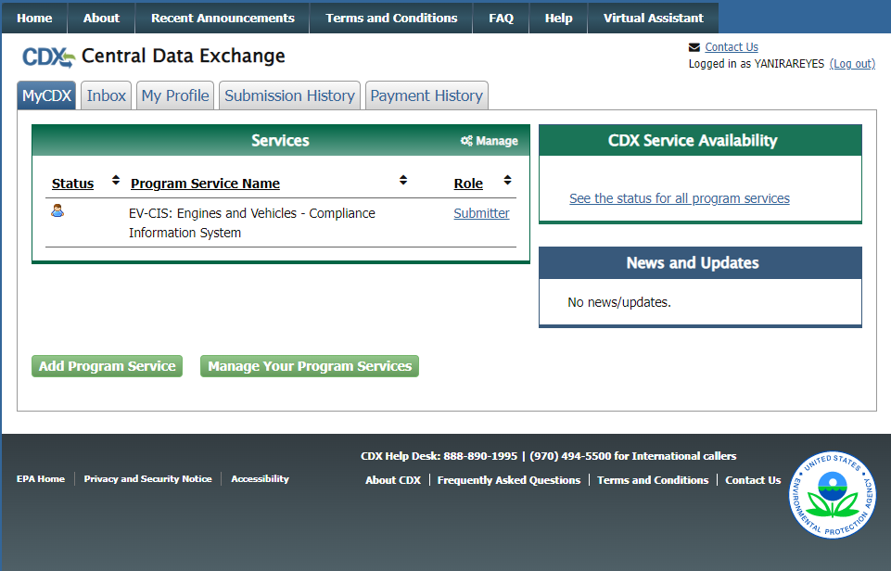



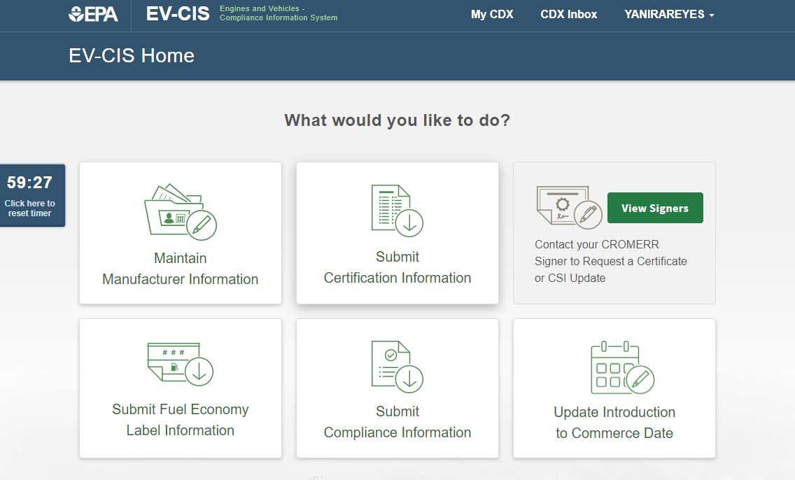



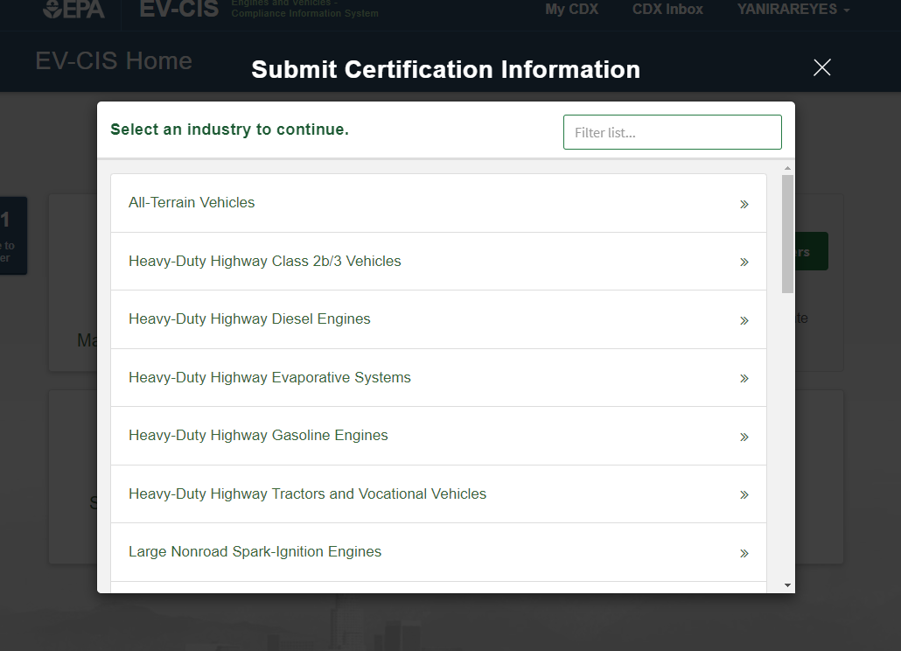

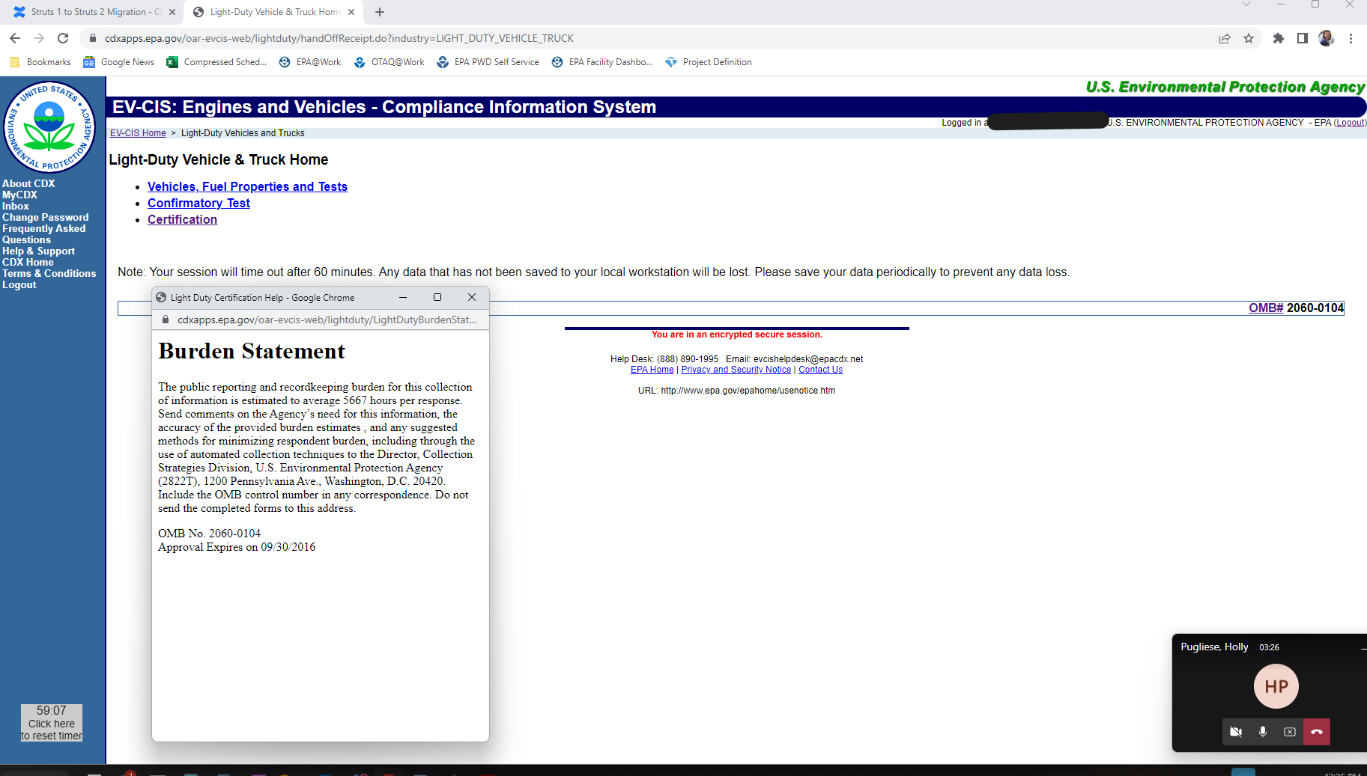

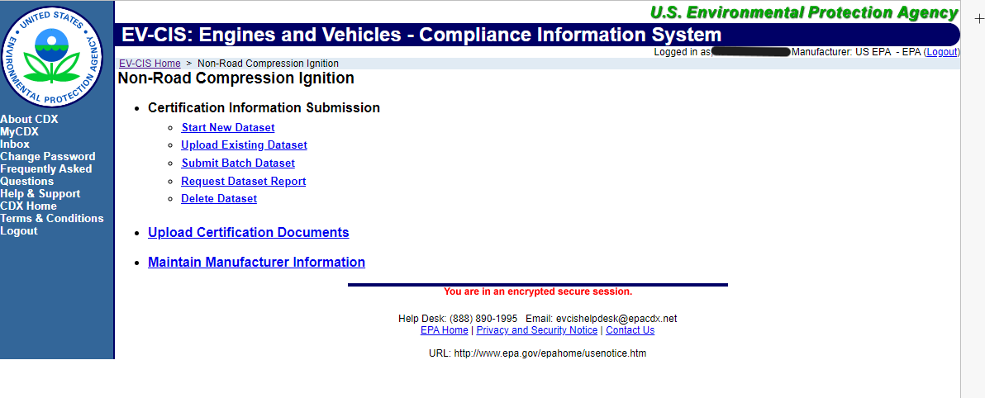

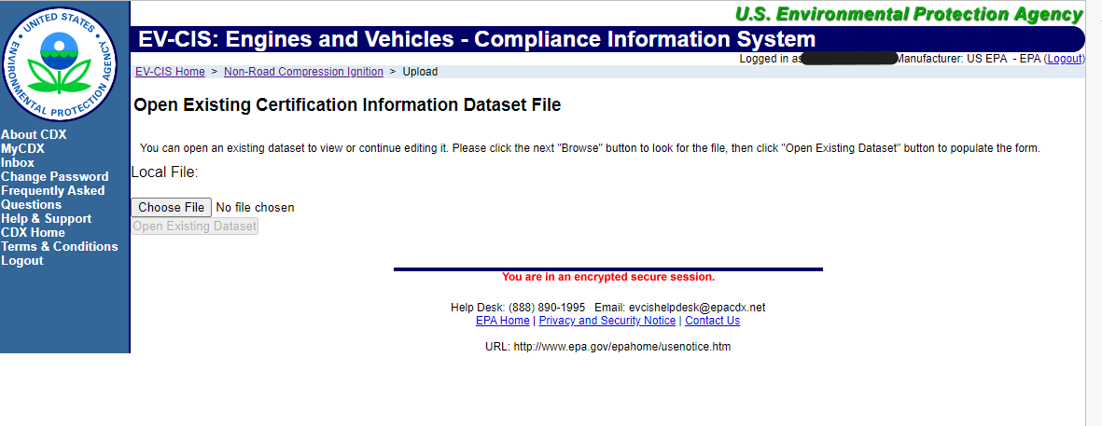

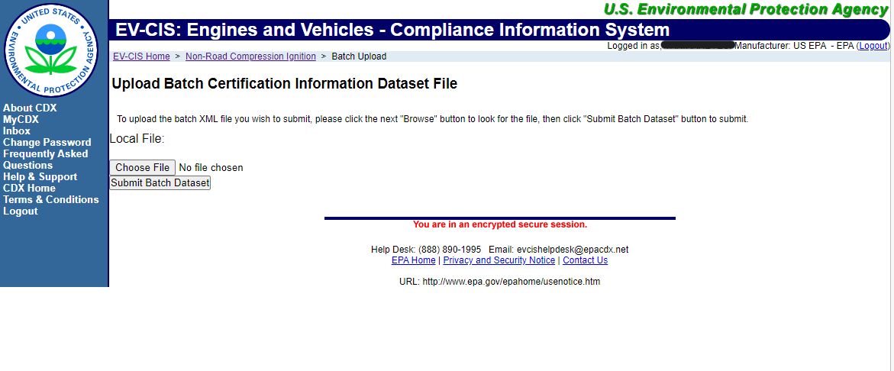

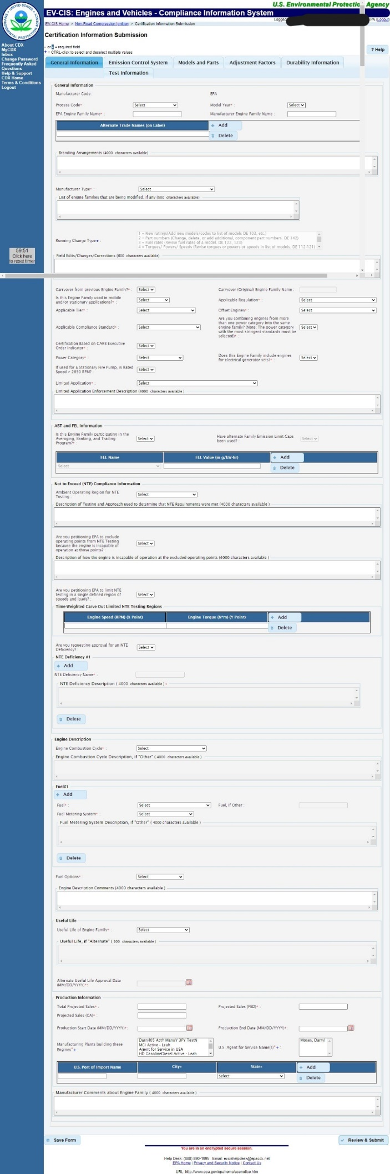

Certification Application Screens

If not uploading a dataset, manufacturers may use these screens to apply for a certificate of conformity. The application includes, as seen in the tabs on top:

* General Engine Family Information
* Emissions Control System
* Models & Parts
* Adjustment Factors
* Durability Information (DFs)
* Test Information

These sample screens are from the NRCI but are very similar for each industry. For a list of data elements, see section 4(b) – Information Requested

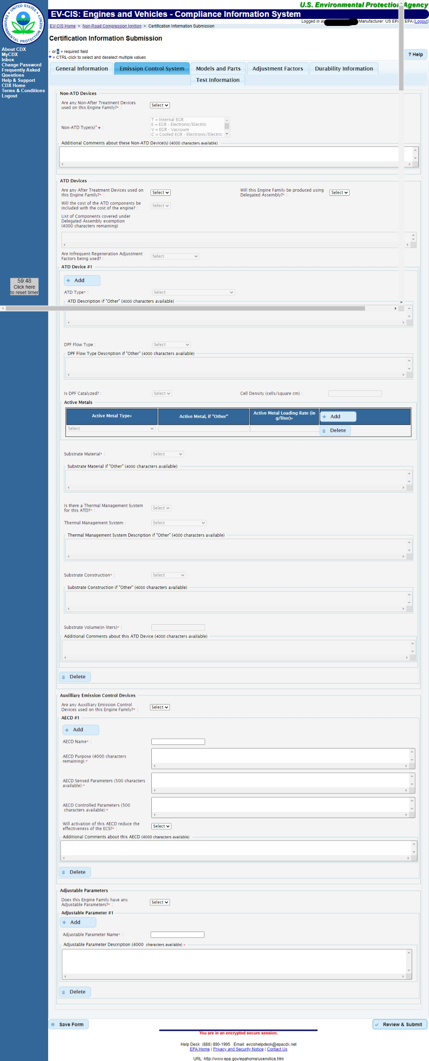

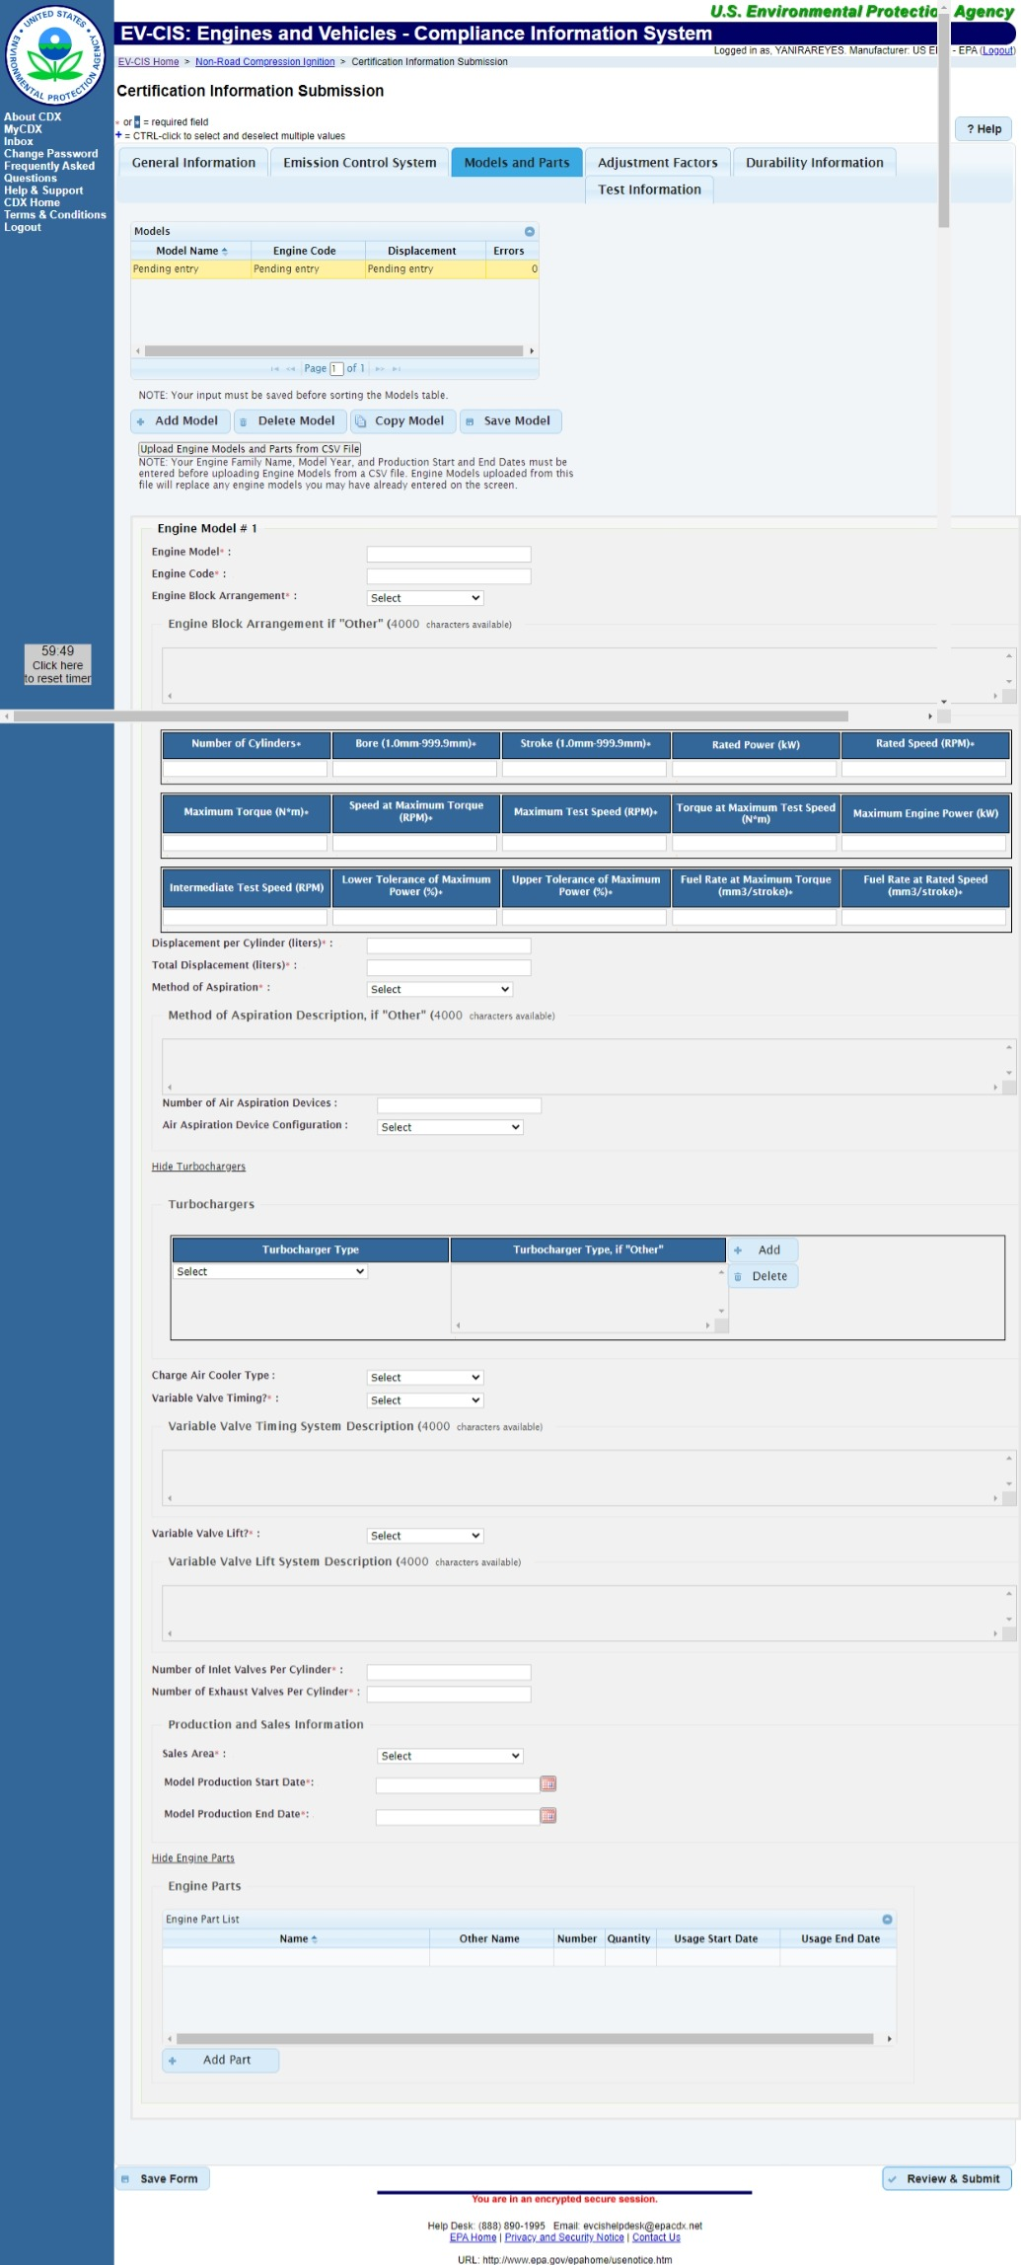

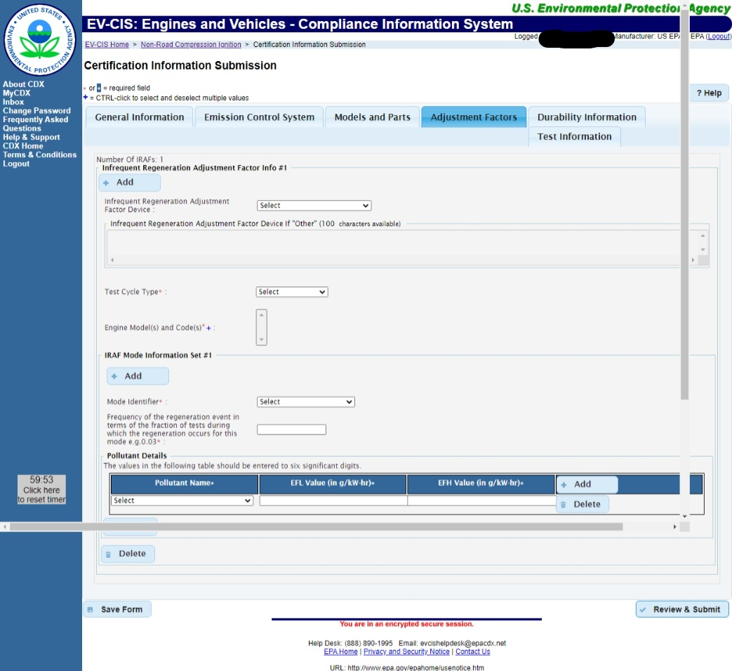

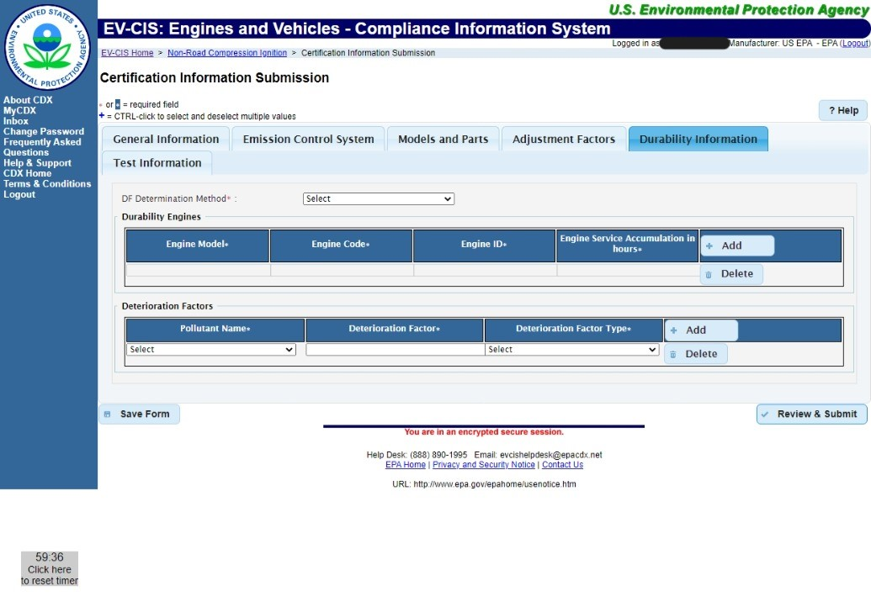

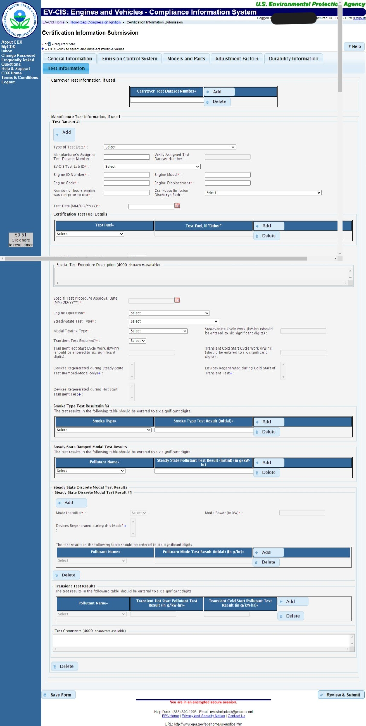

Compliance Reports Main Screen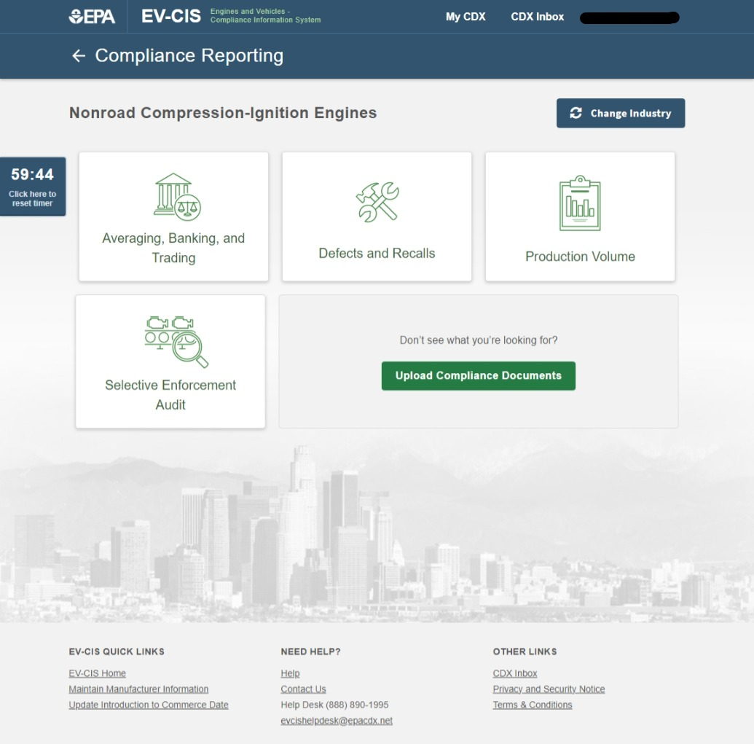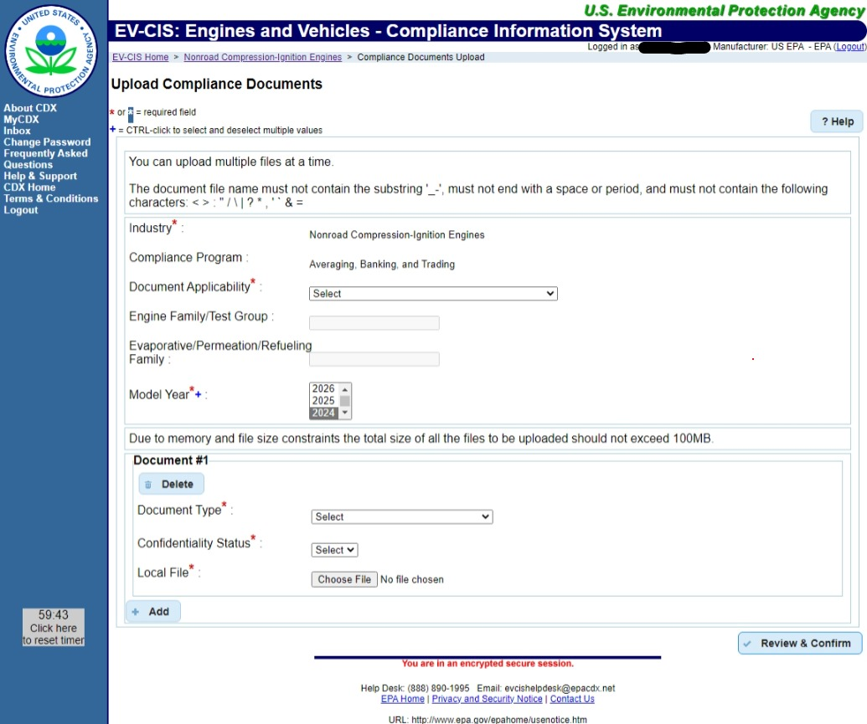

1. Code of Federal Regulations (CFR)
2. Each Part marked with an asterisk (*) is a standard setting part, or a part in the CFR that defines emission standards for a type of engine and/or piece of equipment.
3. Criteria pollutants regulated in HD/NR programs include hydrocarbons (HC), carbon monoxide (CO), nitrogen oxides (NO2), and particulate matter. <https://www.epa.gov/criteria-air-pollutants>.
4. Carbon dioxide (CO2), methane (CH4), nitrous oxide (N2O), and hydrofluorocarbons (HFC).
5. Table and text are excerpts from the Final Rule as published on in the Federal Register, 81 FR 73478, on October 25, 2016.
6. For an overview of EPA’s Certification and Compliance for Vehicles and Engines, please visit <https://www.epa.gov/ve-certification>.
7. For a list of standard setting parts, please refer to Table 1 in Section 1(b).
8. Evaporative families of NRCI and Marine CI engines are considered “spark-ignition” engines for the purposes of evaporative certification (1060.01) and are therefore excluded from this ICR. Only the criteria pollutant families are included here. The burden associated with NRCI and Marine CI evaporative families is included in ICR 1695.11, OMB number 2060-0338.
9. U.S. EPA. "Guidance on Deterioration Factor Validation Methods for Heavy-Duty Diesel Highway Engines and Nonroad Diesel Engines equipped with SCR." CD-2020-19 (HD Highway and Nonroad). November 17, 2020; and California Air Resources Board, “Methods to Validate On-Road Heavy-Duty Diesel and Offroad Diesel Engine Deterioration Factors for CARB Approval,” ECC 2020-07, November 24, 2020
10. <https://www.epa.gov/vehicle-and-engine-certification/transition-program-equipment-manufacturers-tpem>
11. <https://www.epa.gov/sites/production/files/2016-09/documents/tpem-availability-2016-09.pdf>
12. It should be noted that even while they are not subject to GHG emission standards, small businesses are still subject to criteria pollutant standards and must supply fuel maps to vehicle manufacturers.
13. See Table 20 in section 6(d) for an IC breakdown.