PUBLIC SAFETY INTERFERENCE (PSIX) COMPLAINT SUBMISSION NARRATIVE and SCREENSHOTS
Submitting a PSIX Complaint
For users who are submitting complaints on behalf of a public safety entity, first responder, police, fire, law enforcement or a federal agency for radio interference to a telecommunications service used by public safety entities, first responders, police, fire, law enforcement or a federal agency they will go through the Public Safety Interference intake portal located here:
PRODUCTION: https://fccprod.service-now.com/psix-esix?id=psix_form

OMB Control No. 3060-1230 Estimated time per response: 0.5 hours (30 minutes)
OMB Edition Date [Month 2020]

Form Section 1 – Public Safety
The first step in submitting the Public Safety Interference form will be to verify you are submitting a complaint involving radio interference to a telecommunications service used by public safety entities, first responders, police, fire, law enforcement or a federal agency. Users will click “Yes” or “No”, then press the “Next” button. If a user chooses “No”, they will be redirected to a separate resource page for Radio Frequency Service Complaints Other Than Public Safety Interference.

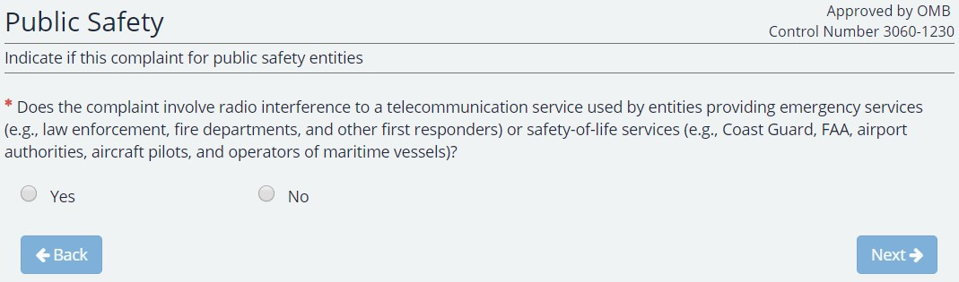

Form Section 2 – Verification
The next step in the form will be to verify that the user is submitting this complaint on behalf of a public safety entity, first responder, police, fire, law enforcement or a federal agency. Users will not be able to move forward to the next section of the form until the checkbox is checked and the user presses the “Next” button.

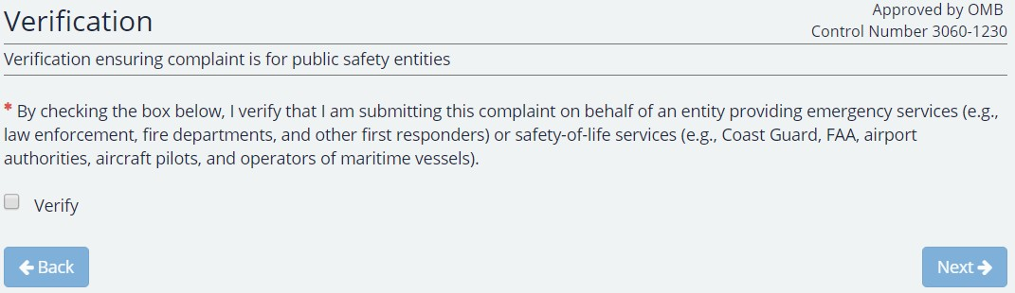

Form Section 3 – Complainant Information
In this form section, users will enter the contact and address information for the person who is filling out the form or who they are filling it out on behalf of. Fields marked with a red asterisk (*) are mandatory and a user may not navigate to the next form section until these fields are entered. The zip code field is a five-digit numeric zip code and the phone number field is a ten-digit phone number field in the format 000-000-0000. The email field shall be entered in the format “xxx@xxx.xxx” to be valid.

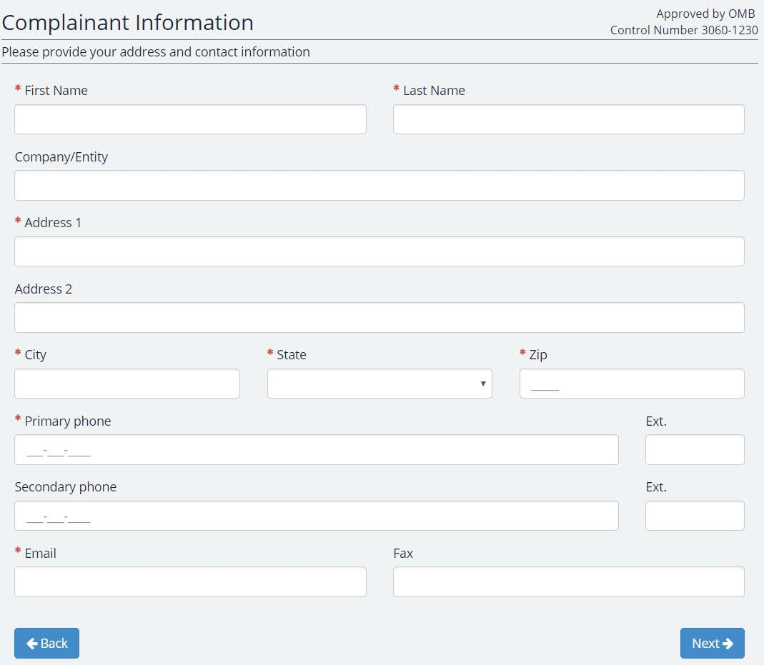

Form Section 4 – Interference Information
The next section is the interference information form section. Here, the user will enter information regarding the service which is experiencing interference and what is causing this. In addition, there are optional fields for Call Sign and Frequency Range. If the user does not see their service which is experiencing the interference under the provided choice list, there is a link which reads “Service not listed? Click here.” Clicking this link will redirect the users to a separate resource page for Radio Frequency Service Complaints Other Than Public Safety Interference.
Service Experiencing Interference – The type of radio service that is receiving the interference.
Interference Type – The service type that is suspected to be causing the interference.

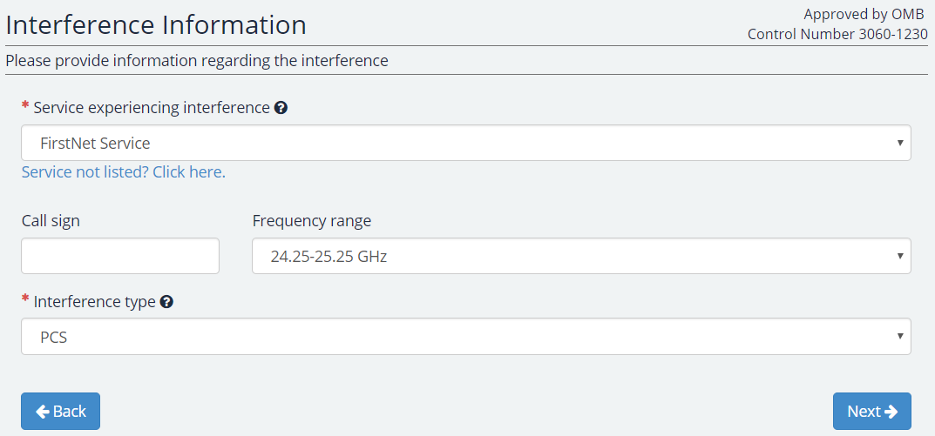

Form Section 5 – Interference Location
The next section is to identify the geographic location of the site that is experiencing the interference. Here, the user will have the option to enter address information, latitude and longitude information, or both. If the interference location is the same as the complainant’s location, the user should check the box for “Interference Location is the Same Address as Provided in the Complainant Information Section.” If the user wishes to enter latitude and longitude information, they should check the box for “Enter latitude and longitude information instead of, or in addition to, address information.” In addition, there is also an option to convert decimal coordinates to DMS via the integrated conversion tool. To access this menu, press the link that reads “click here to use a conversion tool” located above the latitude and longitude fields.

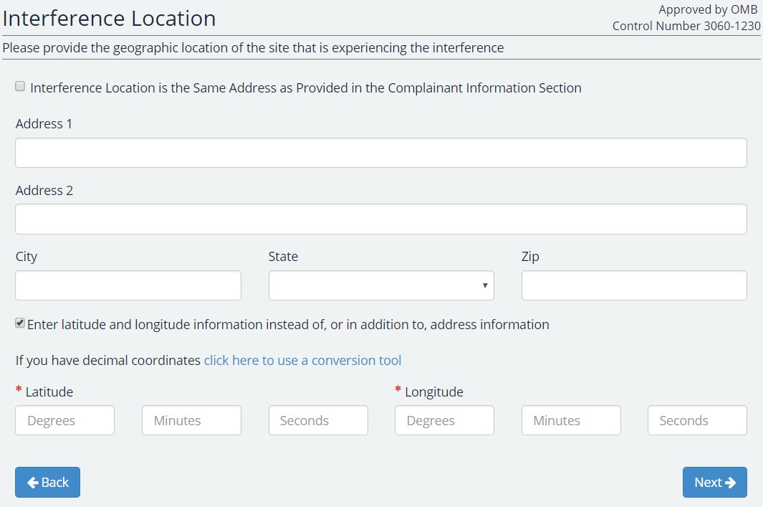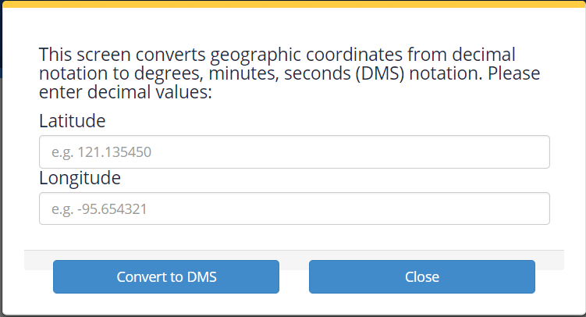

Form Section 6 – Identity of Alleged Violator
The next section is to identify the geographic location and any contact information for the suspect source producing the interference. Here, the user will have the option to enter address information, latitude and longitude information, or both. If the source of the interference is unknown, the user should check the box for “Unknown source of interference”. If the user wishes to enter latitude and longitude information, they should check the box for “Enter latitude and longitude information instead of, or in addition to, address information.” In addition, there is also an option to convert decimal coordinates to DMS via the integrated conversion tool. To access this menu, press the link that reads “click here to use a conversion tool” located above the latitude and longitude fields.

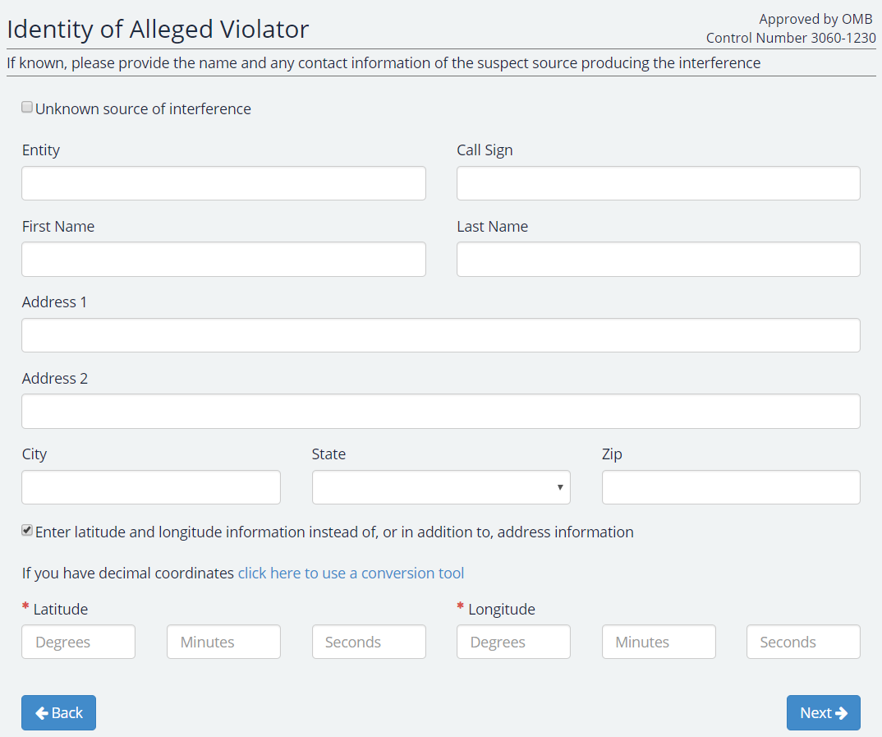

Form Section 7 – Interference Source Location
This section is to identify, if known, the location of the suspected source appearing to be the origin of the interference. The first question that appears on this form is asking if the user knows the location of the suspected source appearing to be the origin of the interference.

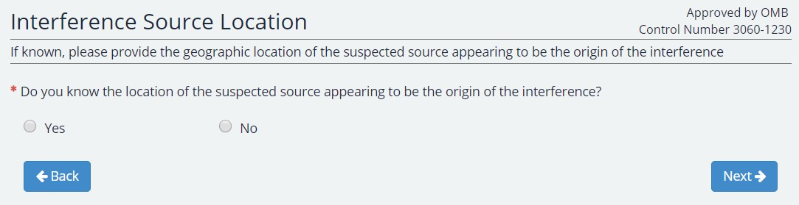

Selecting “No” will enable to user to move forward to the next section of the form. Selecting “Yes” will prompt the user another question about whether the location of the interference source is different from the location where the interference is experienced.

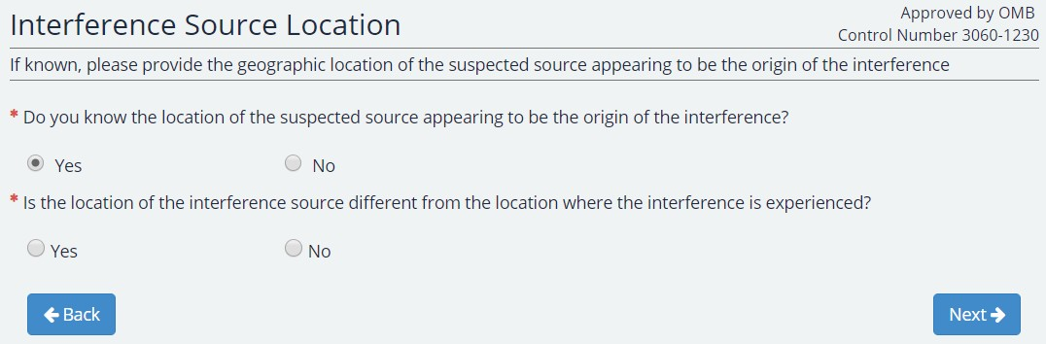
Selecting “No” will enable to user to move forward to the next section of the form. Selecting “Yes” will prompt the user for address and/or latitude longitude information.

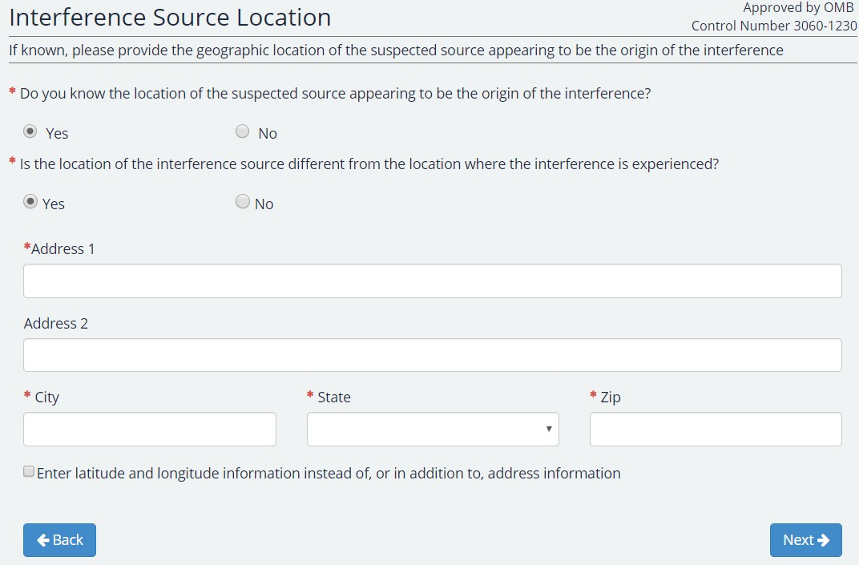

Form Section 8 – Interference Description
This form section is meant to capture information regarding the nature of the interference itself to assist the FCC team in determining the course of action required.

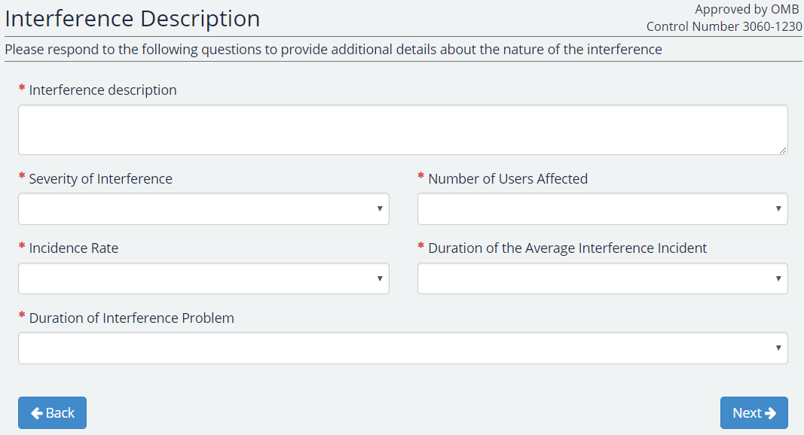

Form Section 9 – Additional Information
This form section is to capture additional information. If remedial action has been taken, the system will prompt the user to describe such actions. If the complainant alleges this matter to be one which is a threat to life and safety needing expedited response, than they may choose to flag it as such here.

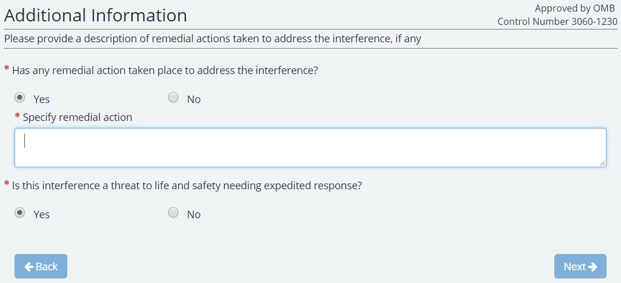

Form Section 10 – Review and Submit
After completing all form sections, users will be taken to the Review and Submit section. In this section, users may review the information entered and make edits as necessary. Once the complainant reviews all the information, they will click the submit button and be able to file the complaint.

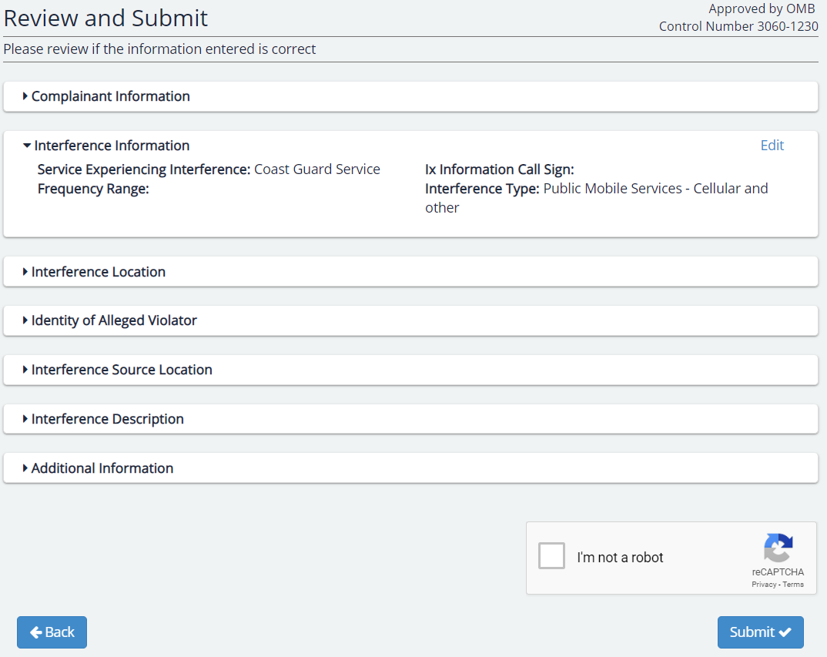

We have estimated that your response to this collection of information will take 0.5 hours or 30 minutes. Our estimate includes the time to read the instructions, look through existing records, gather and maintain required data, and actually complete and review the form or response. If you have any comments on this estimate, or on how we can improve the collection and reduce the burden it causes you, please write the Federal Communications Commission, Office of Managing Director, AMD-PERM, Washington, DC 20554, Paperwork Reduction Act Project (3060-1230). We will also accept your PRA comments via the Internet if you send an e-mail to PRA@fcc.gov.
Please DO NOT SEND COMPLETED [SURVEYS, APPLICATION FORMS, ETC] TO THIS ADDRESS. You are not required to respond to a collection of information sponsored by the Federal government, and the government may not conduct or sponsor this collection, unless it displays a currently valid OMB control number and/or we fail to provide you with this notice. This collection has been assigned an OMB control number of 3060-1230.
THIS NOTICE IS REQUIRED BY THE PAPERWORK REDUCTION ACT OF 1995, PUBLIC LAW 104-13, OCTOBER 1, 1995, 44 U.S.C. SECTION 3507.

