1. Public-facing Careers at TVA screen.

1a. Full screen
(NOTE: A photo carousel that appears on the actual screen has been removed from the screenshot for the purposes of this document.)
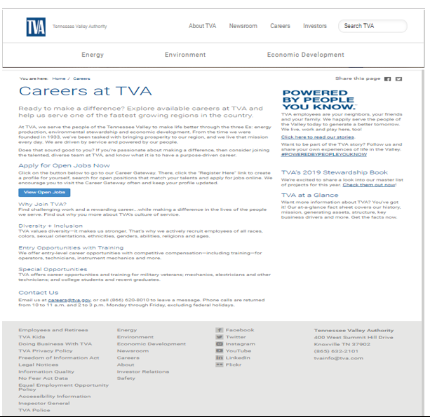

1b. Top of screen showing web site URL
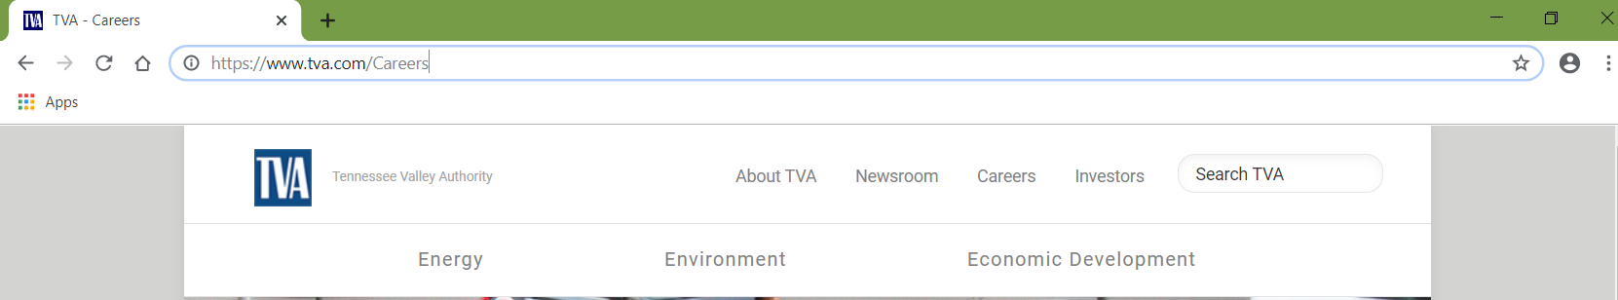

1c. Middle of screen showing link to job applicant Welcome screen (View Open Jobs button)
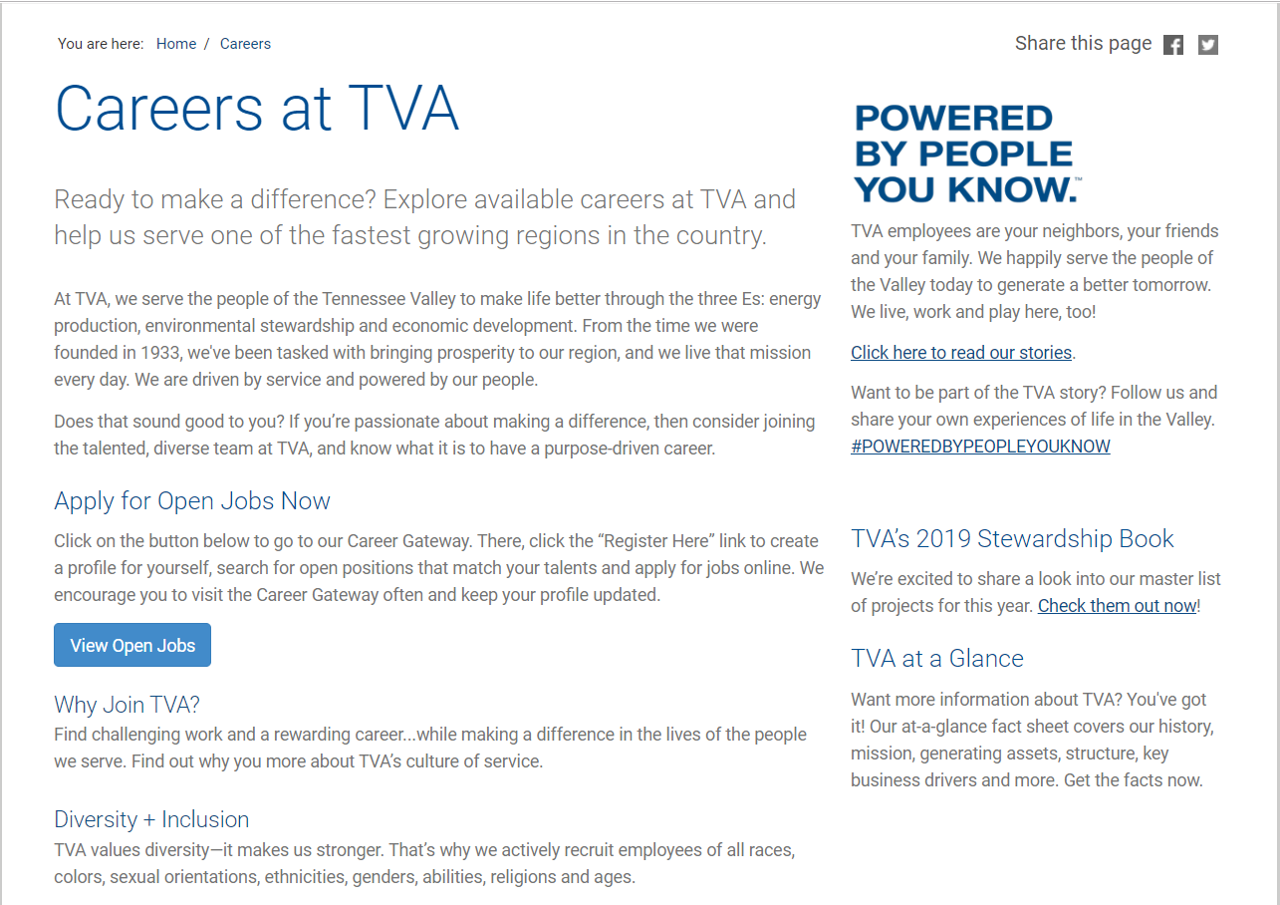

1d. Bottom of screen showing link to TVA Privacy Policy screen
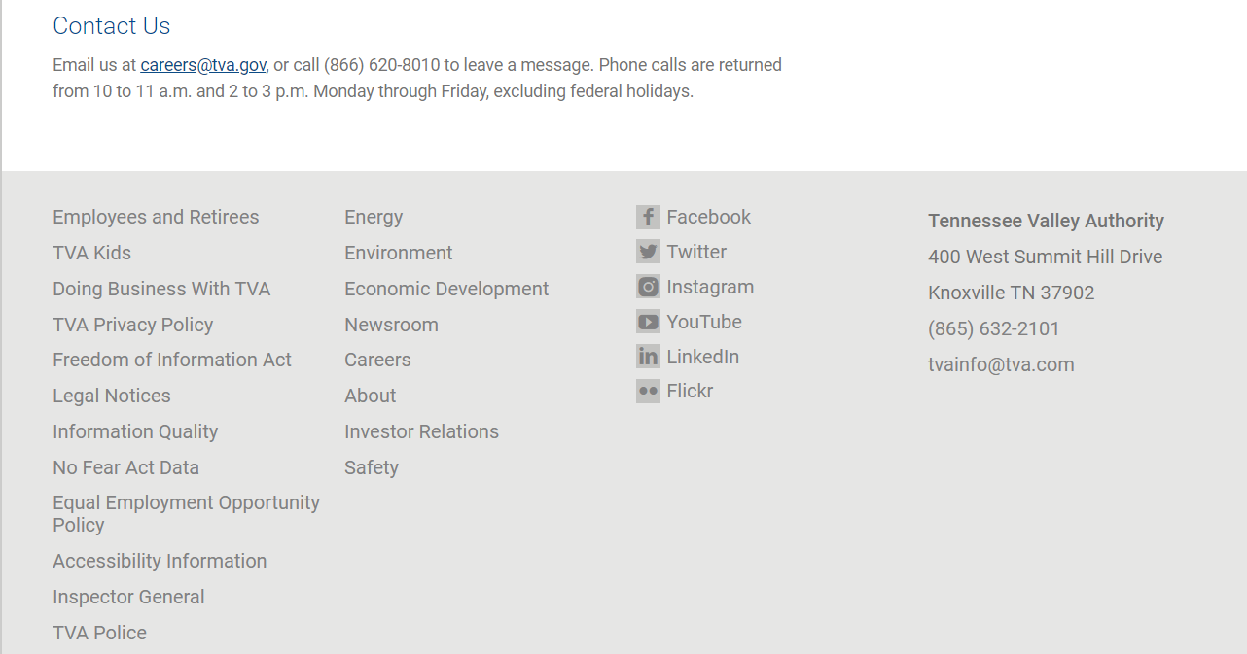

1e. TVA's Privacy Policy screen
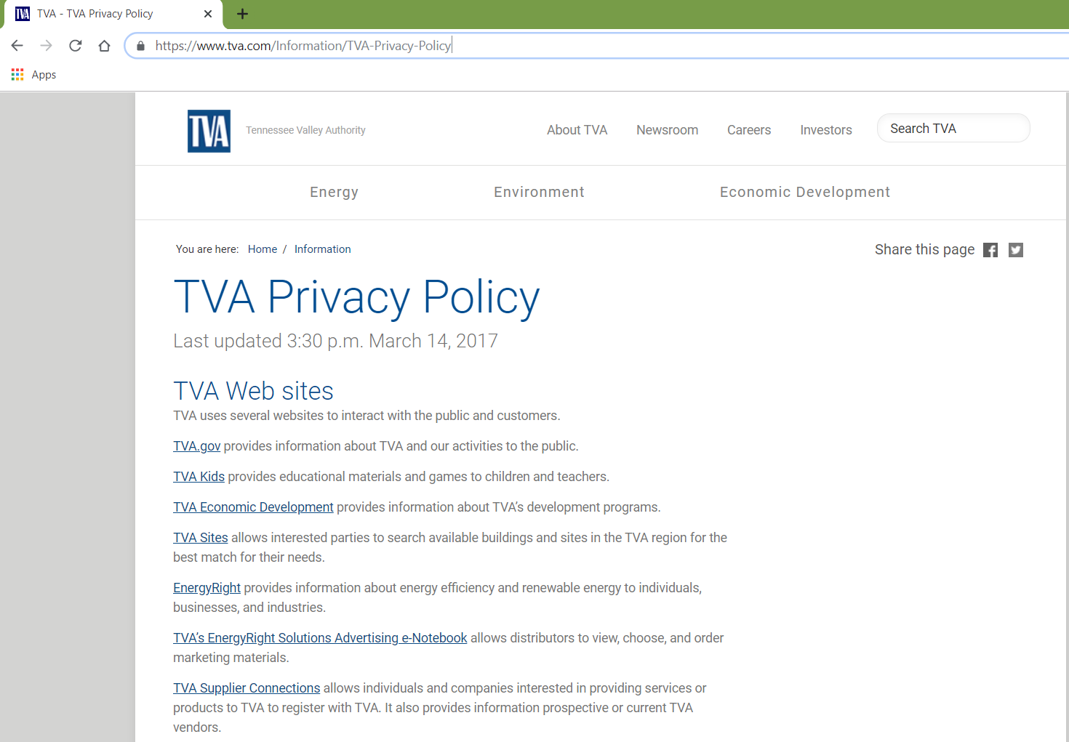
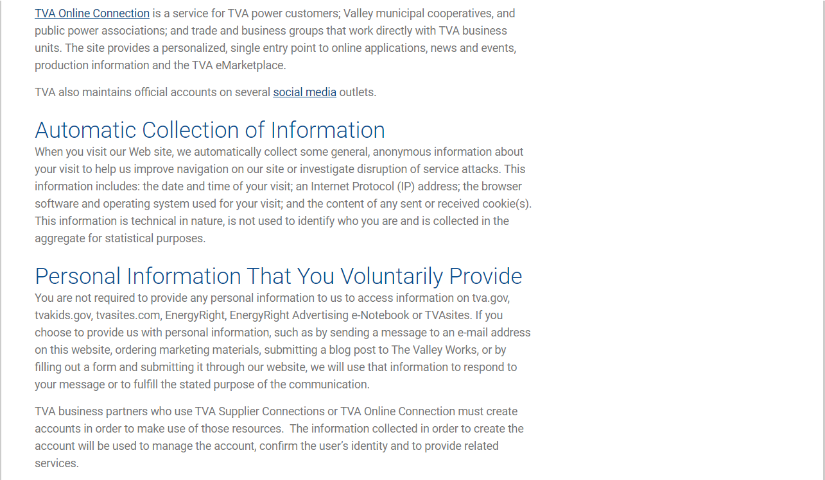
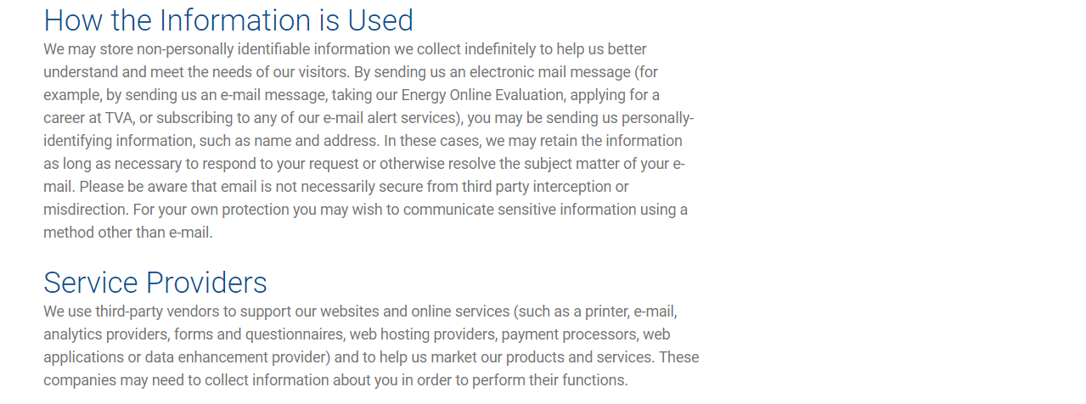
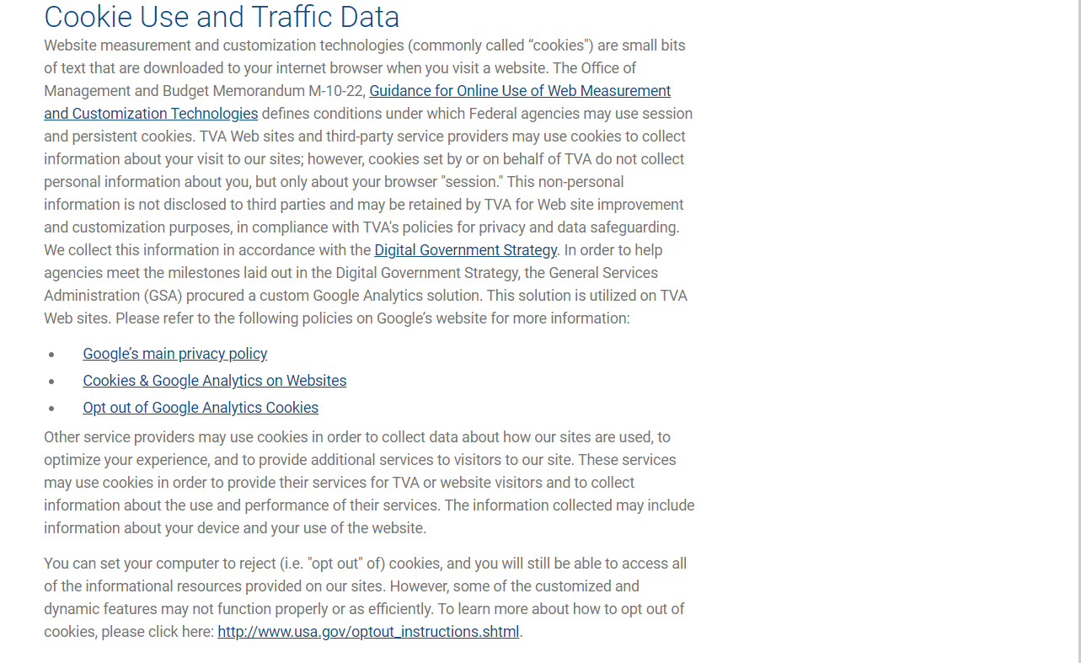
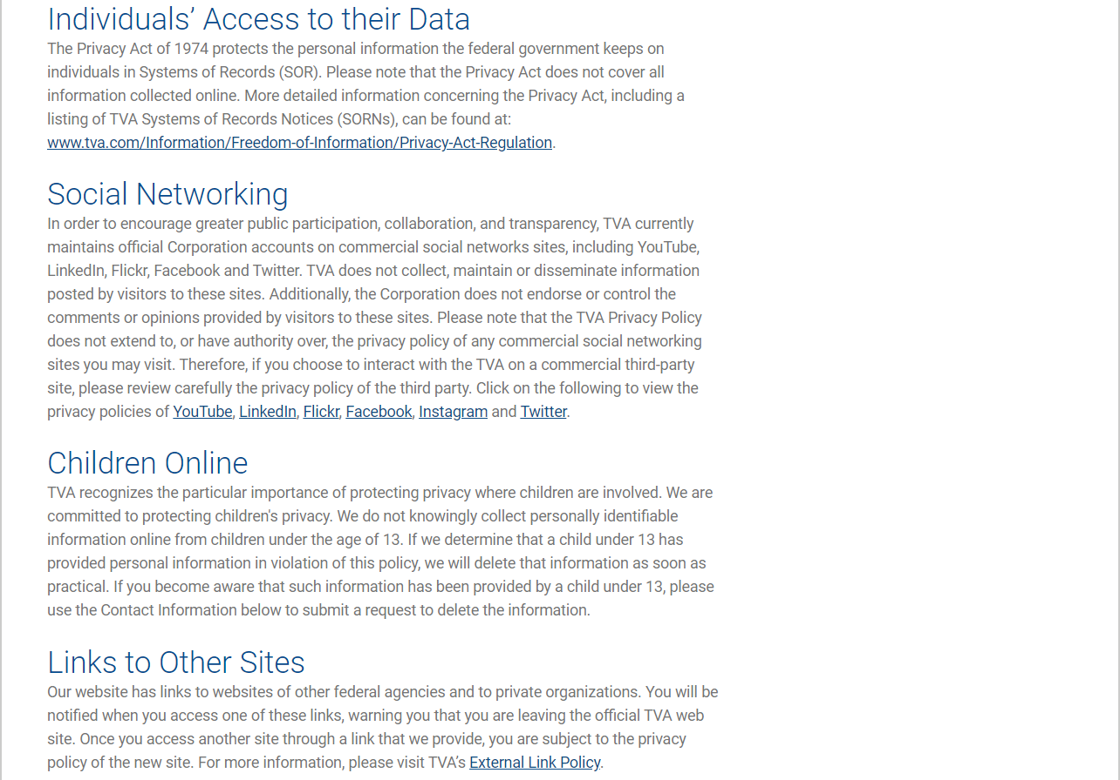
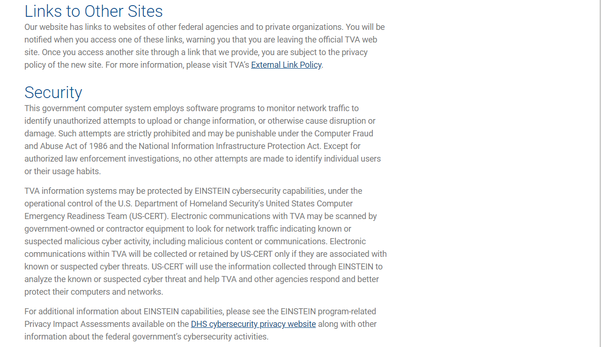
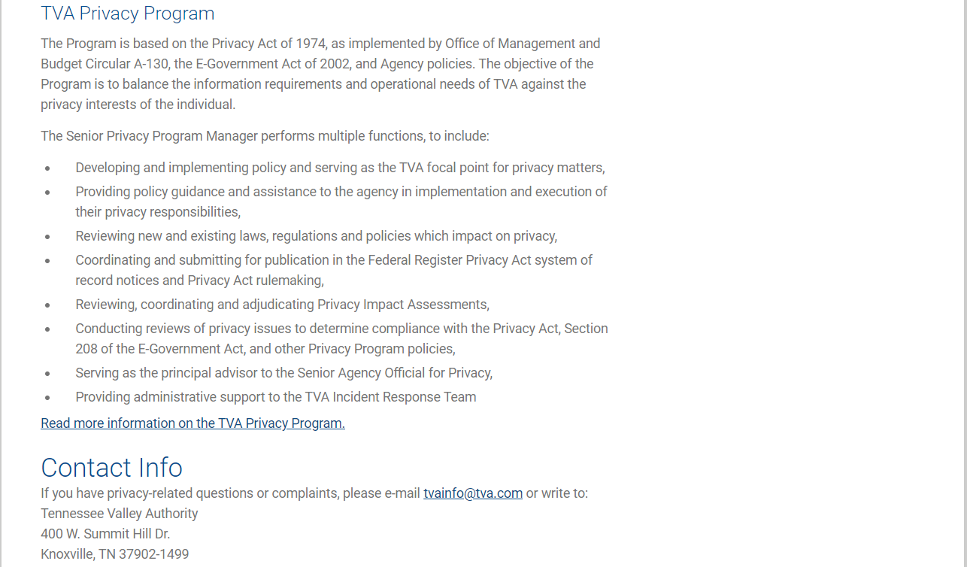
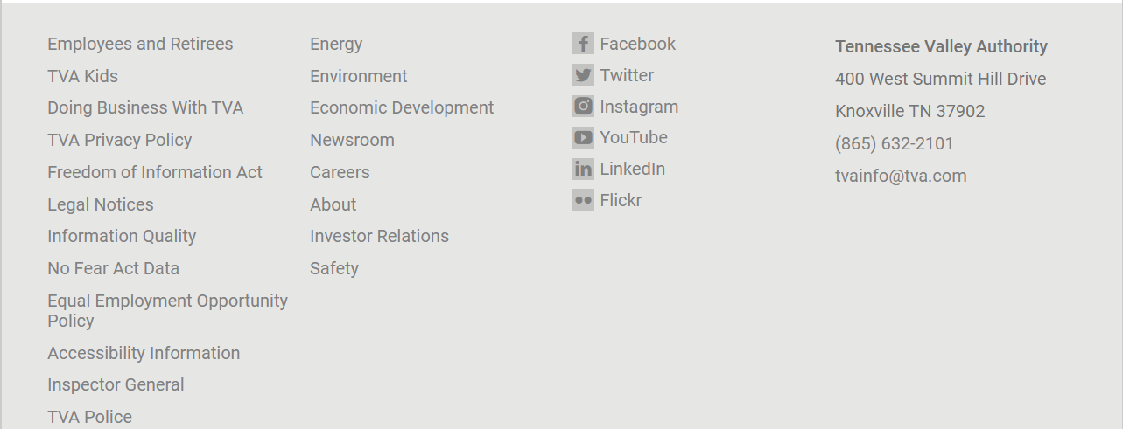

1f.Close-up of the Link to More Information on the TVA Privacy Program screen
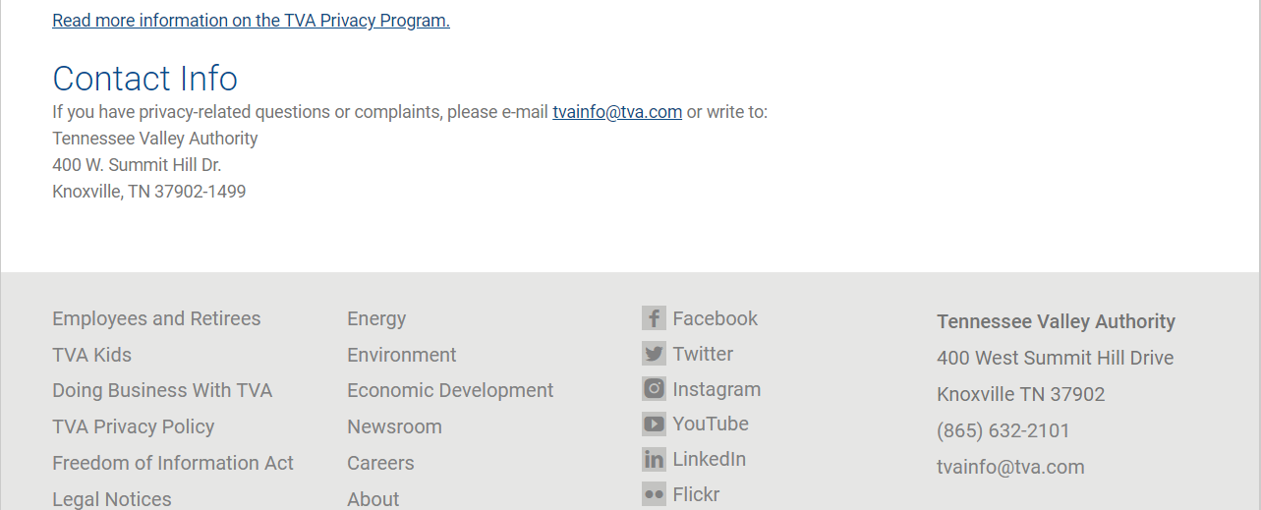

1g. About the TVA Privacy Program screen contents
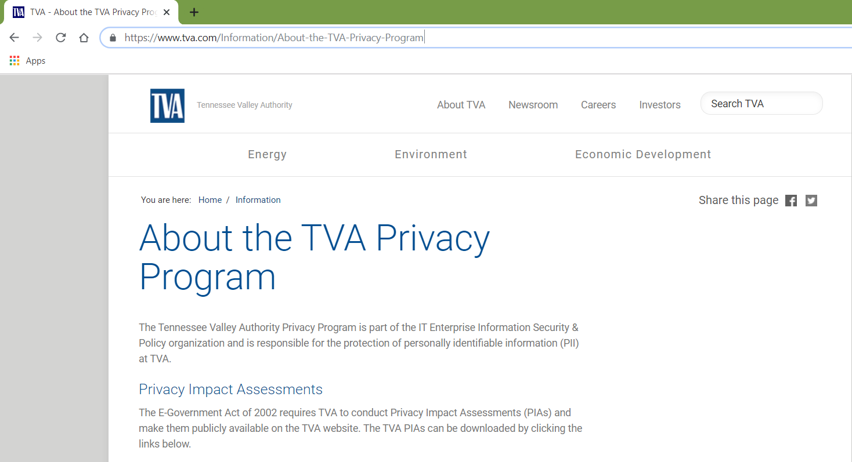
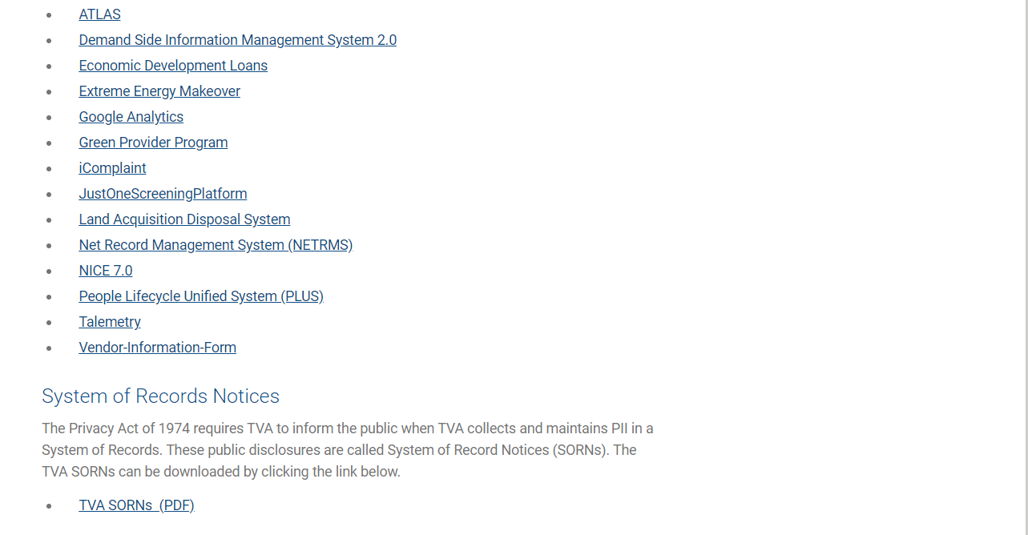
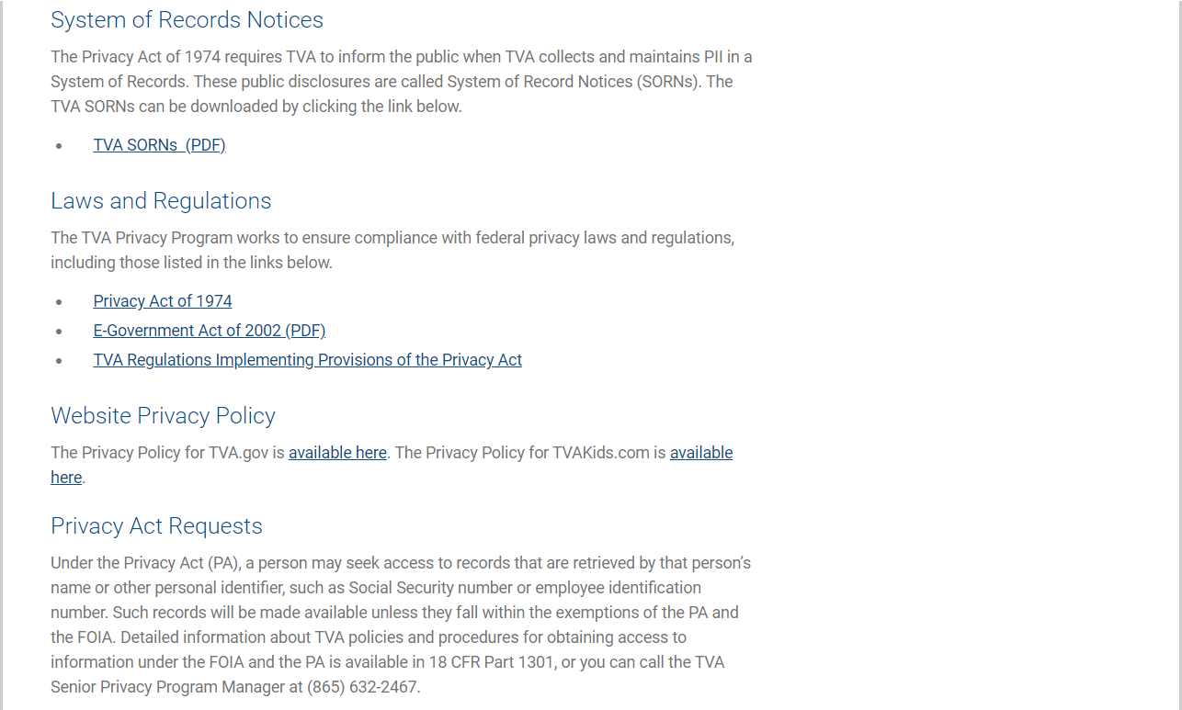
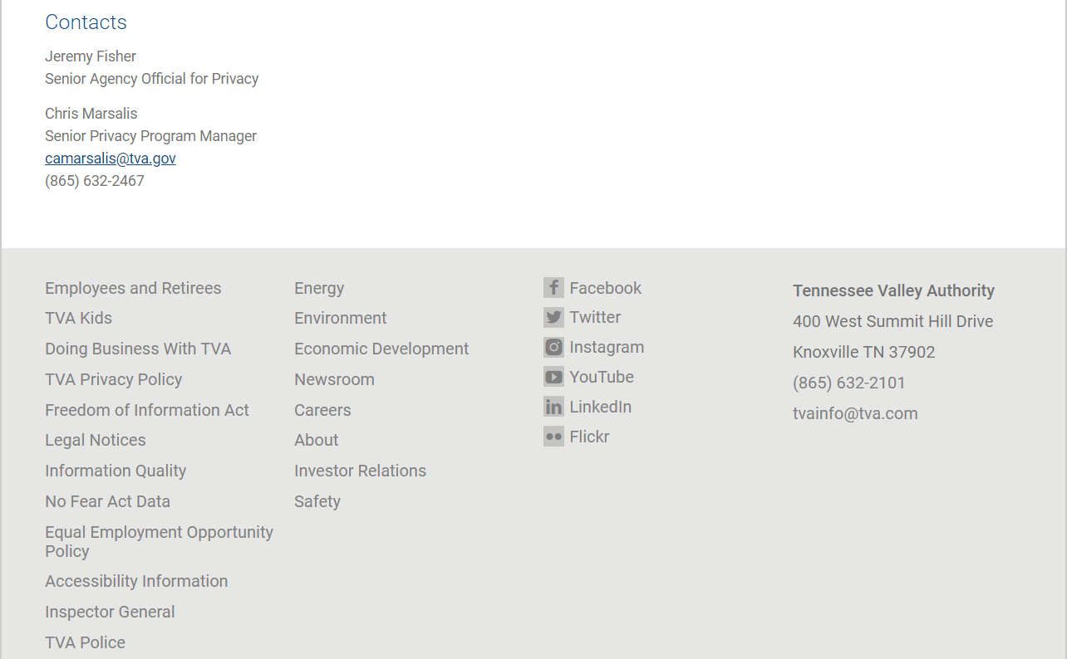

2. Applicant Landing screen. This is where the applicant lands when he clicks the View Open Jobs button on the public-facing Careers at TVA screen.
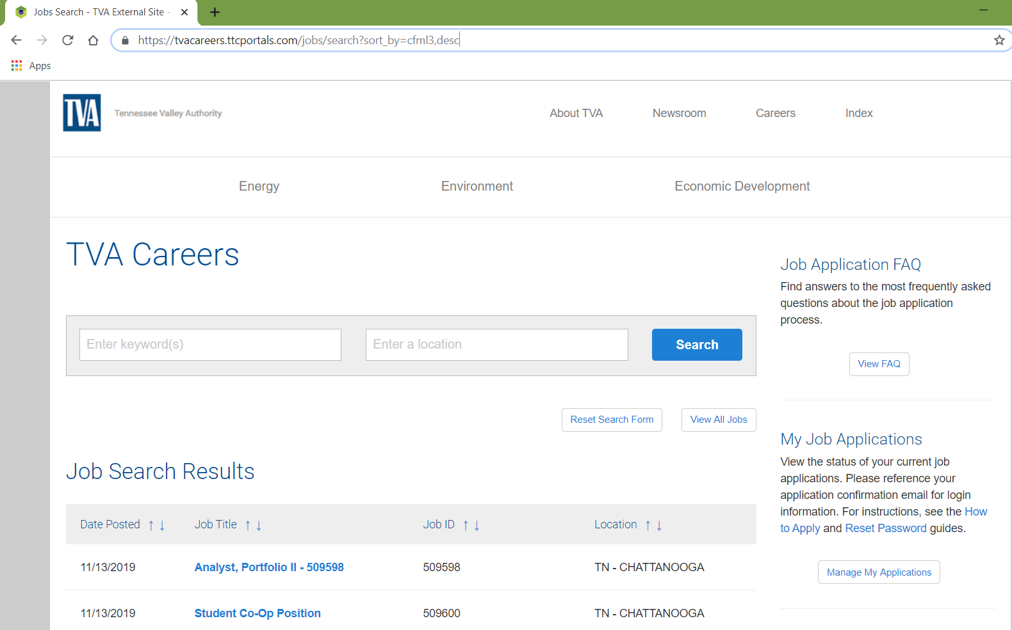
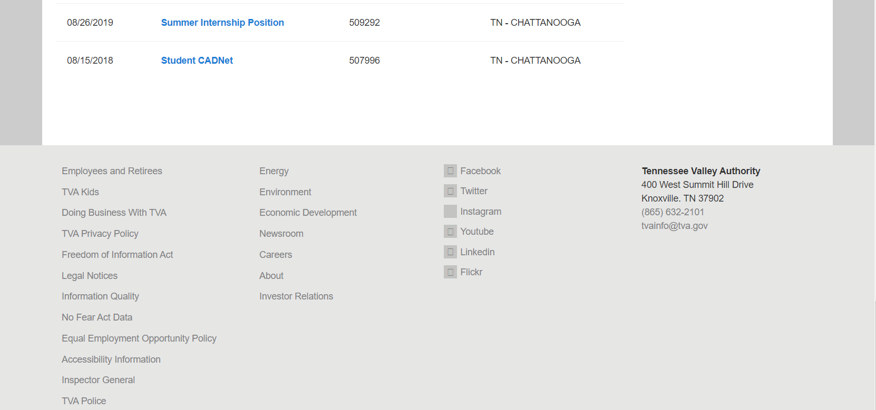

3. The applicant applies for a job opening.

NOTE: If the applicant chooses to apply for more than one TVA job, the applicant's entries on the online Application Form for one posting are not automatically carried over to the application form for a different posting. The applicant must answer the required Application Form questions each time (s)he submits a new application form.

3a. The applicant clicks a job posting title and is redirected to the job details page that is specific to that job opening. (Screenshots of the job details have been omitted here because the job posting details are specific to each job.)

The information below is displayed at the bottom of the details page for every job posting.
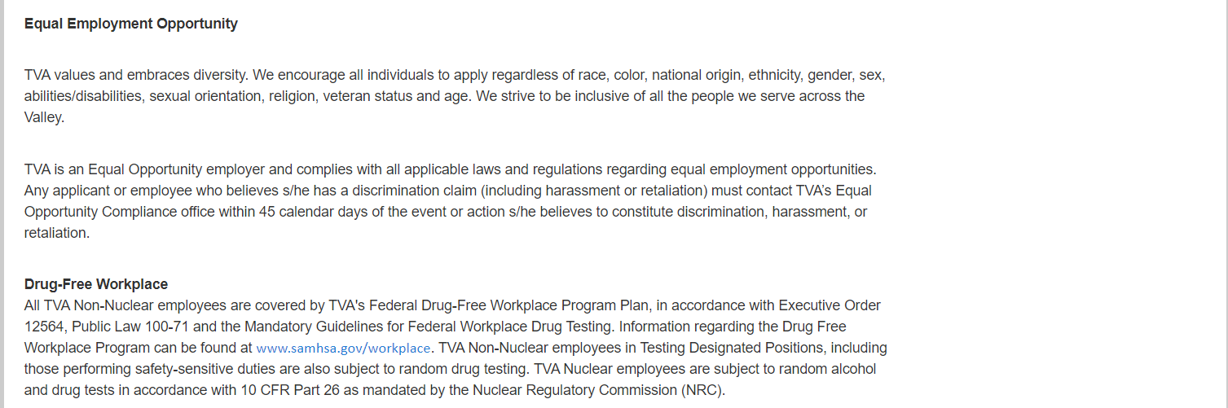
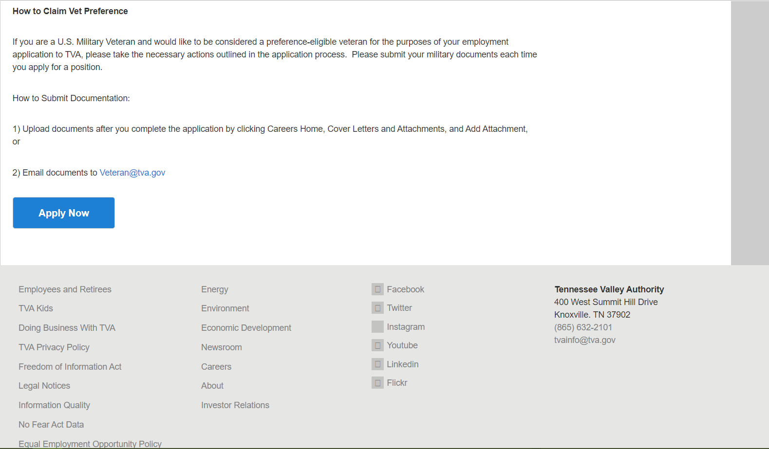

3b. The applicant clicks the Apply Now button and Application Form Step 1 (Terms and Agreements) of pops up. Note the OMB Details displayed in the center of the screen (highlighted by a red box in this document for ease of viewing).

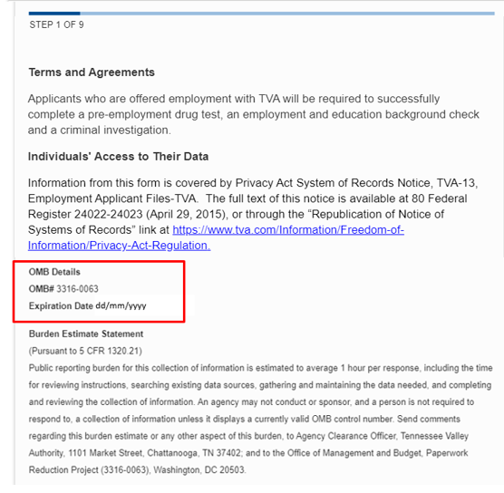
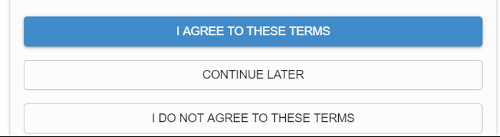

3c. The applicant clicks the I AGREE TO THESE TERMS button and is redirected to Step 2 (Apply) to upload his/her resume.
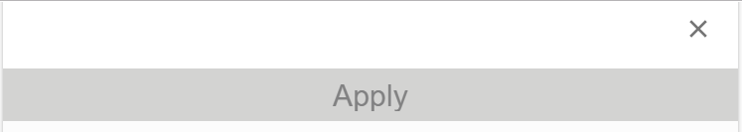
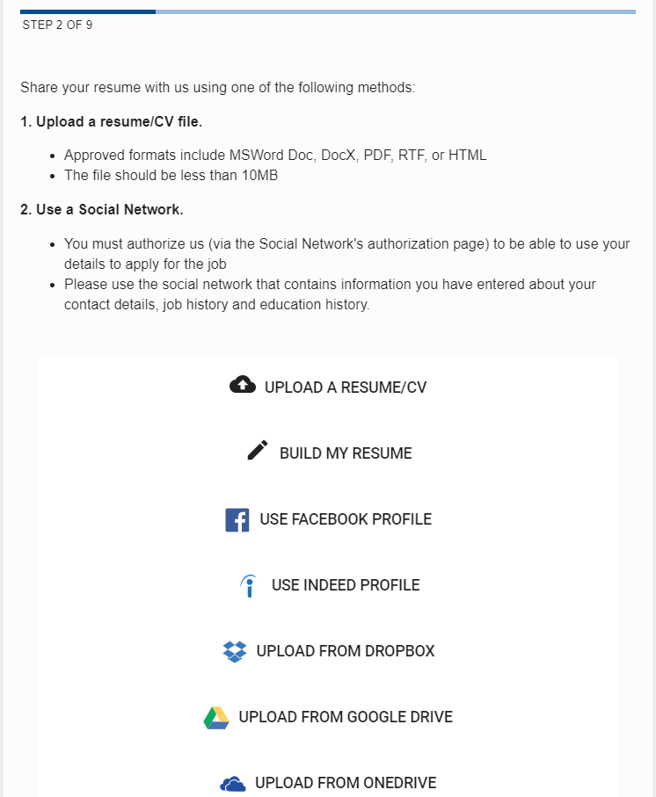


3d. When the applicant uploads a resume, the system automatically extracts information from the uploaded resume to pre-populate the Contact Details on the application form. The first screen for Step 3 (Review) is displayed so the applicant can review the pre-populated Contact information and make necessary additions and/or corrections.

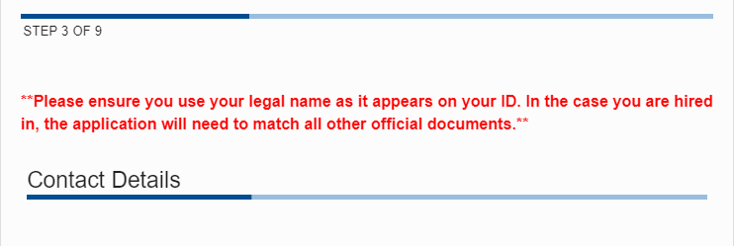
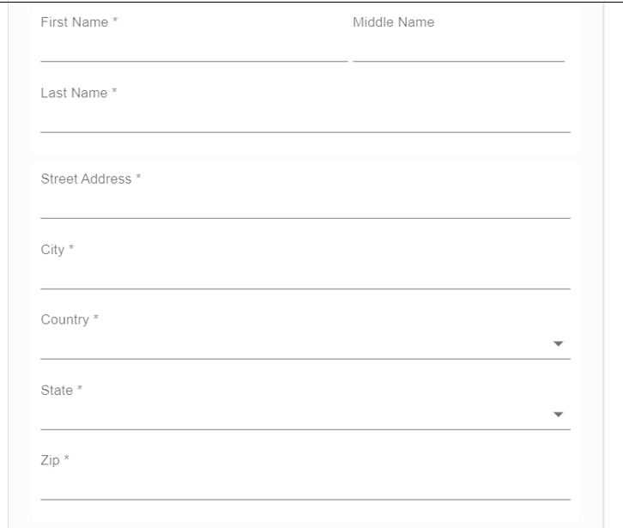
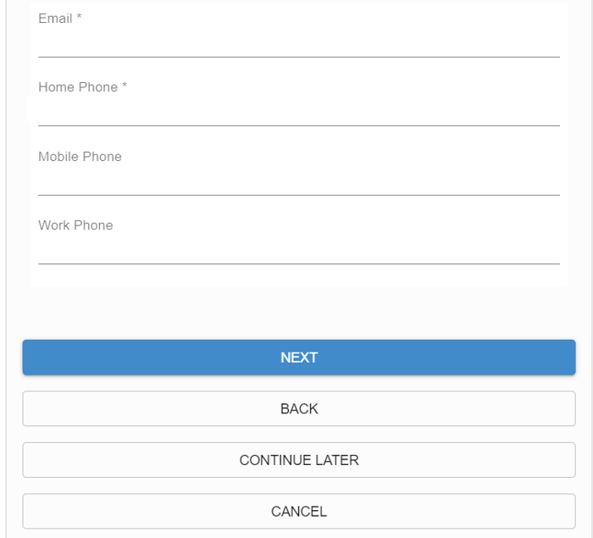

3e. When the applicant clicks the NEXT button, the system automatically extracts information from the uploaded resume to pre-populate the Work History on the application form. The next screen for Step 3 (Review) is displayed so the applicant can review the pre-populated Work History information and make necessary additions and/or corrections.
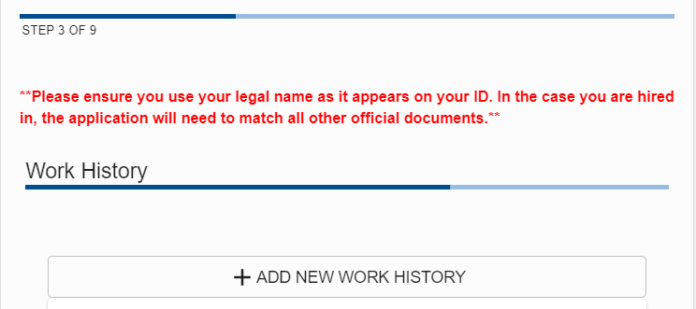
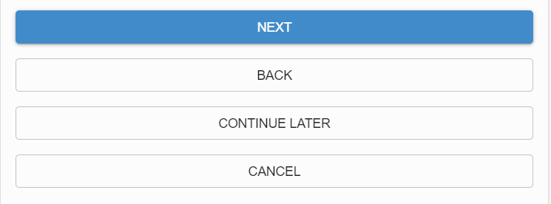

3f. When the applicant clicks the NEXT button, the system automatically extracts information from the uploaded resume to pre-populate the Education History on the application form. The next screen for Step 3 (Review) is displayed so the applicant can review the pre-populated Education History information and make necessary additions and/or corrections.
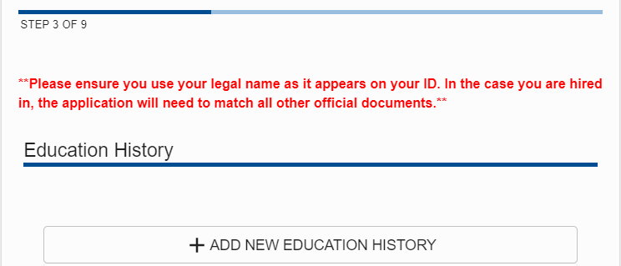

3g. When the applicant clicks the NEXT button, the screen for Step 4 (Questions) is displayed for the applicant to fill out.

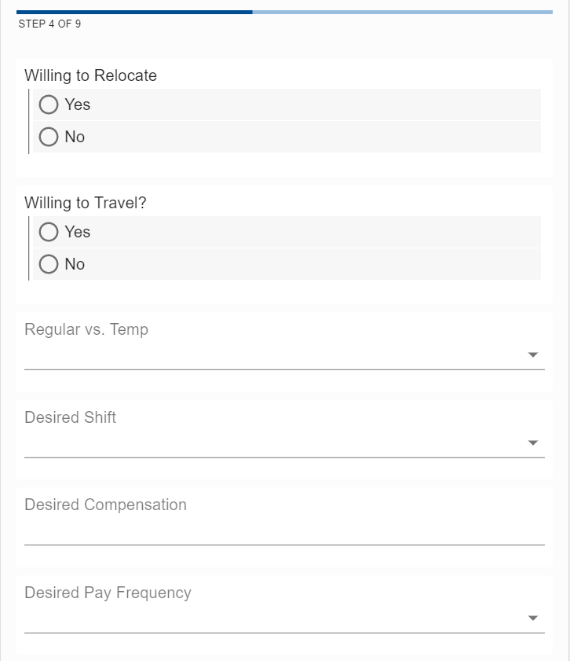
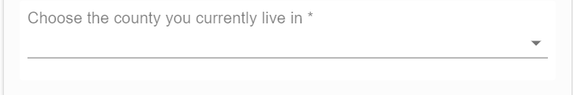

3h. When the applicant clicks the NEXT button, the screen for Step 5 (Questions 2) is displayed for the applicant to fill out.

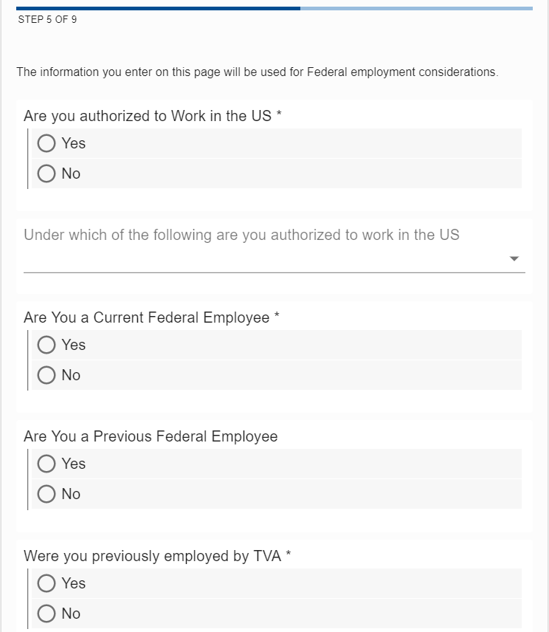
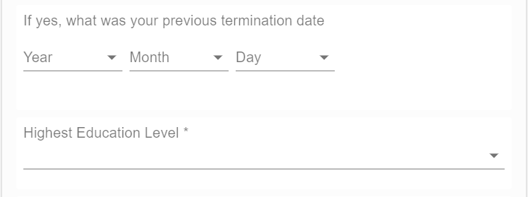
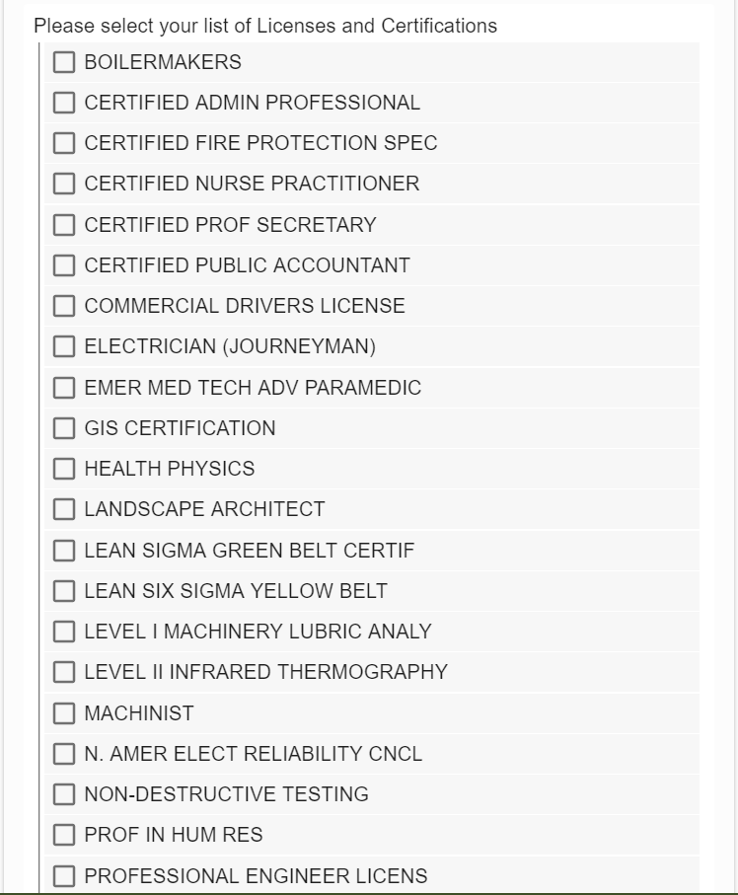
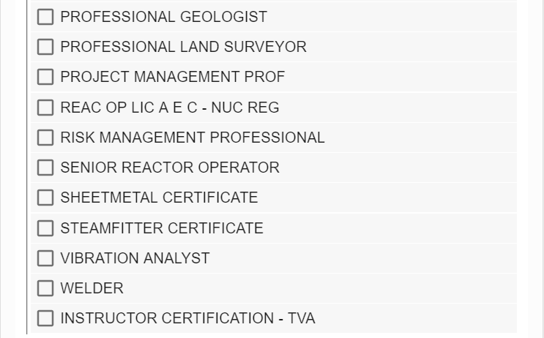
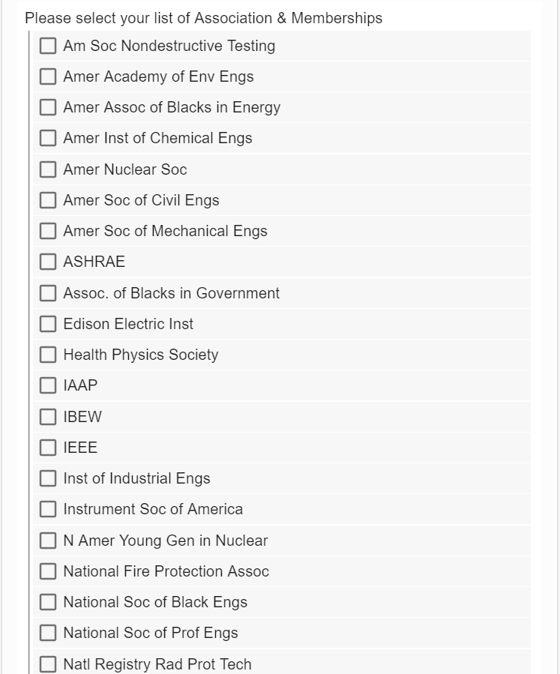
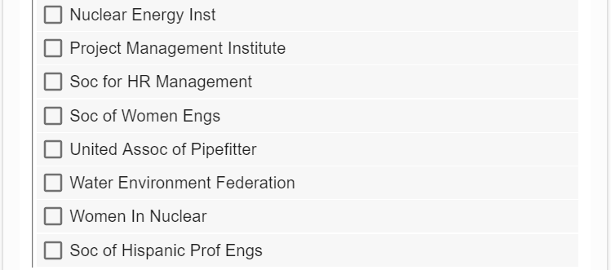
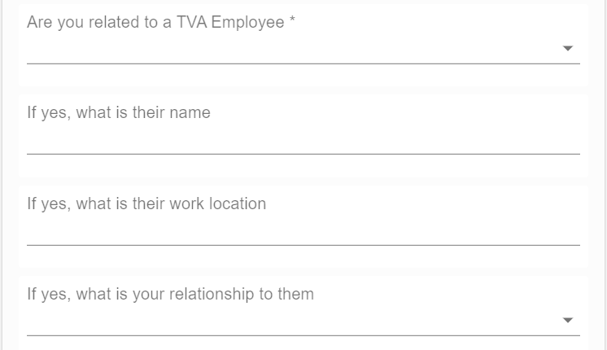

3i. When the applicant clicks the NEXT button, the screen for Step 6 (Questions 3) is displayed for the applicant to fill out.

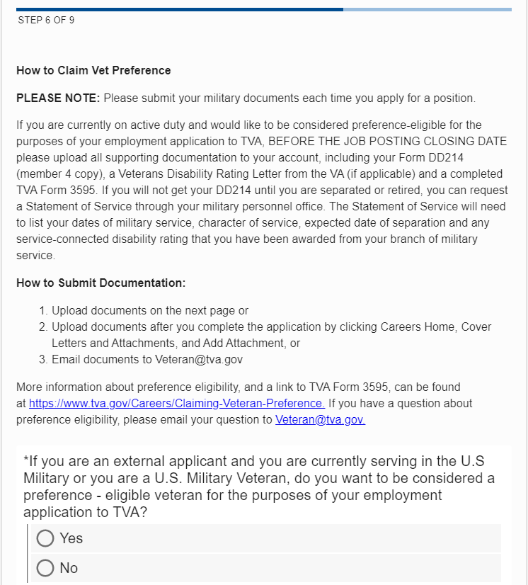
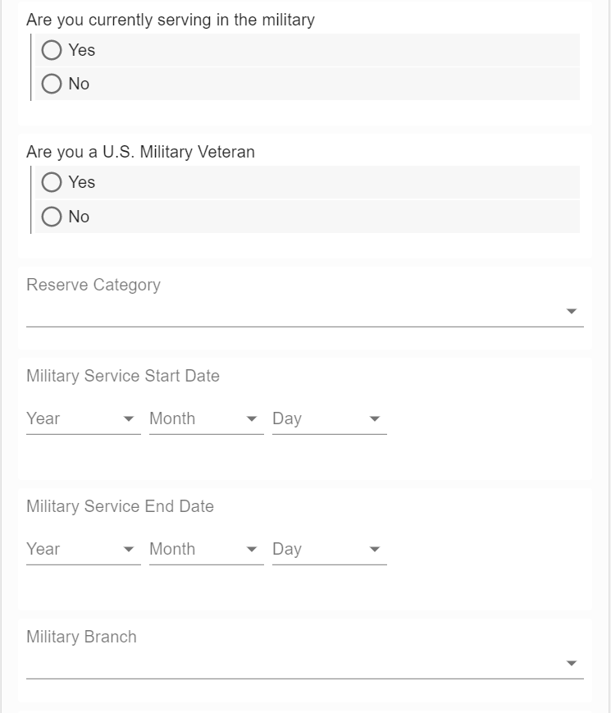
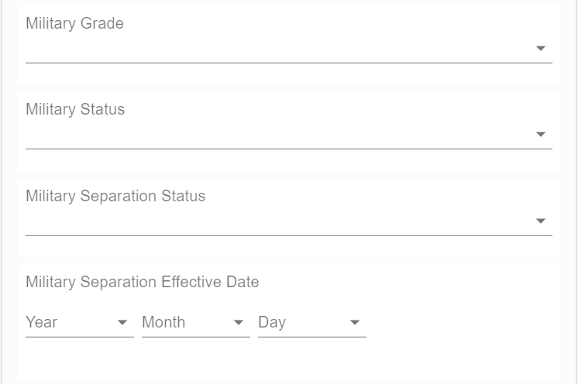

3j. When the applicant clicks the NEXT button, the screen for Step 7 (Self-Identification Questions) is displayed for the applicant to fill out.
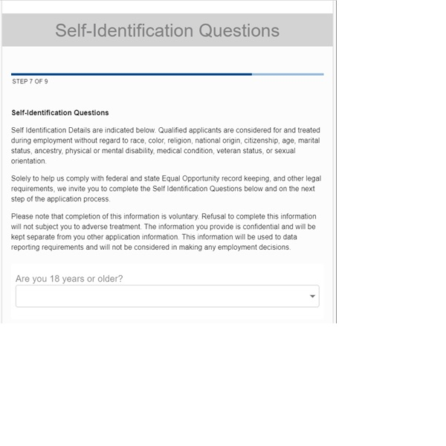
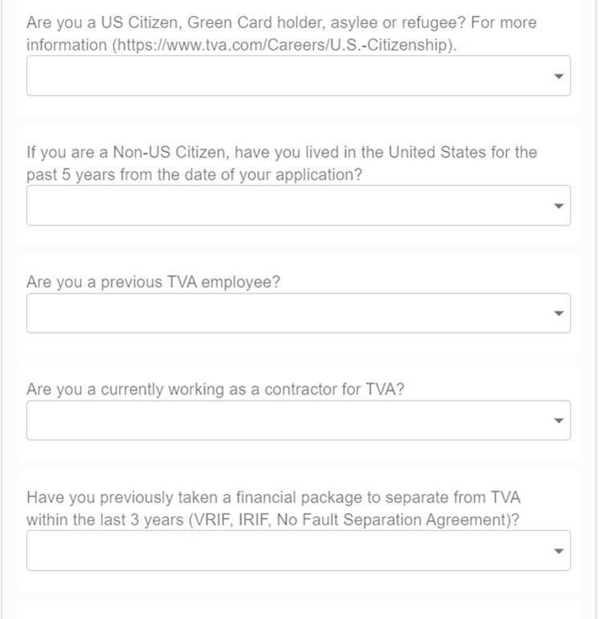
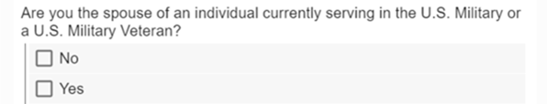

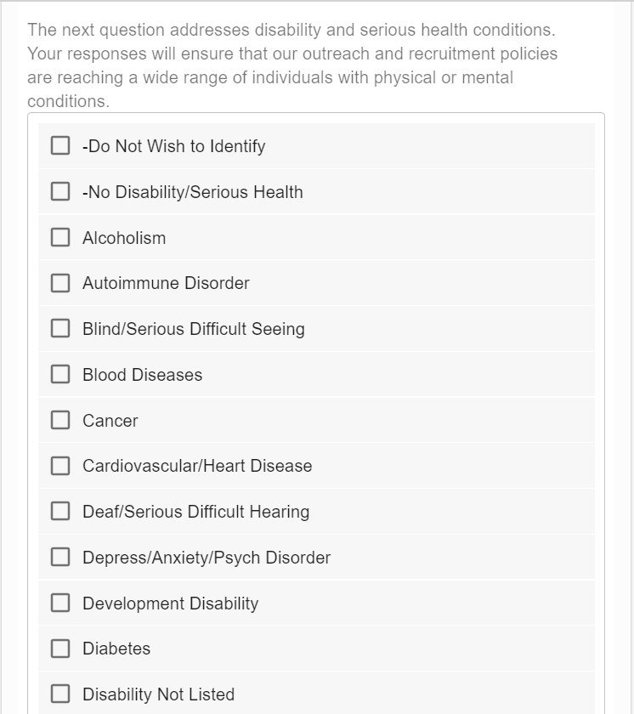
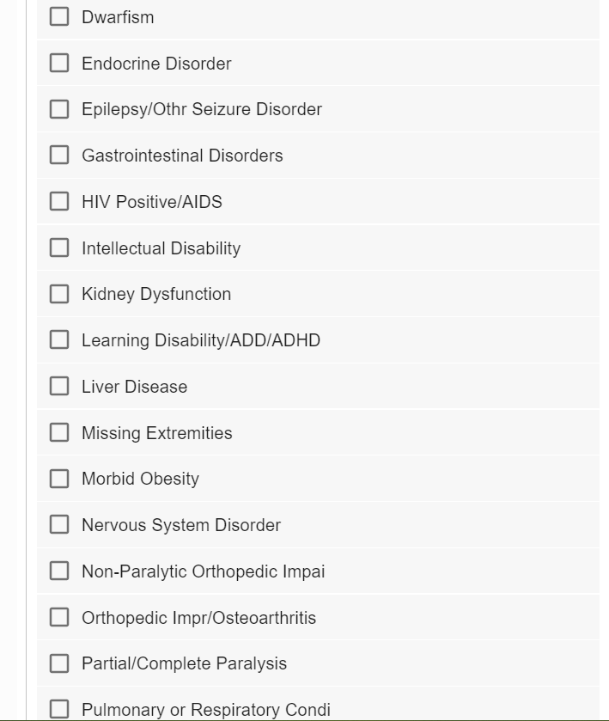
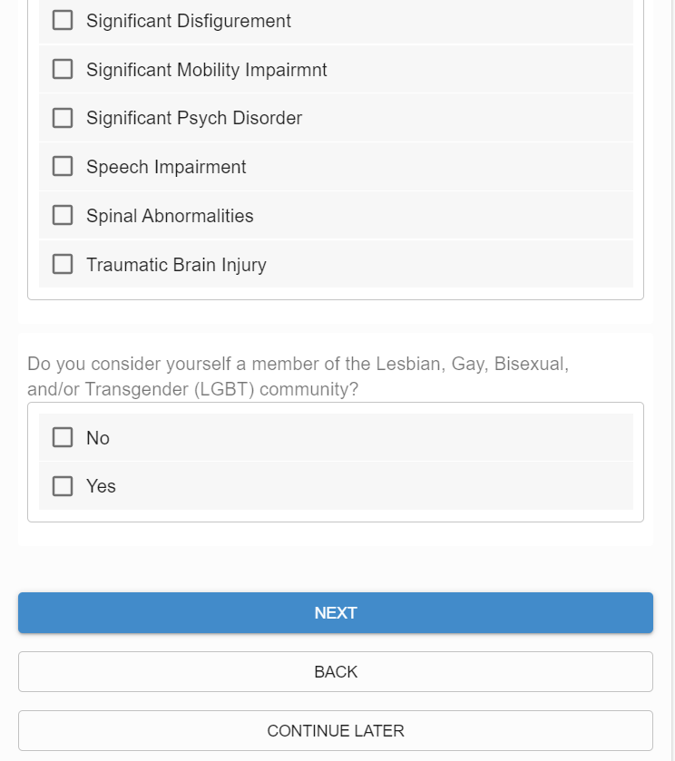

3k. When the applicant clicks the NEXT button, the screen for Step 8 (Additional Documents) is displayed for the applicant to upload any additional documents (s)he wants to submit with the application form.

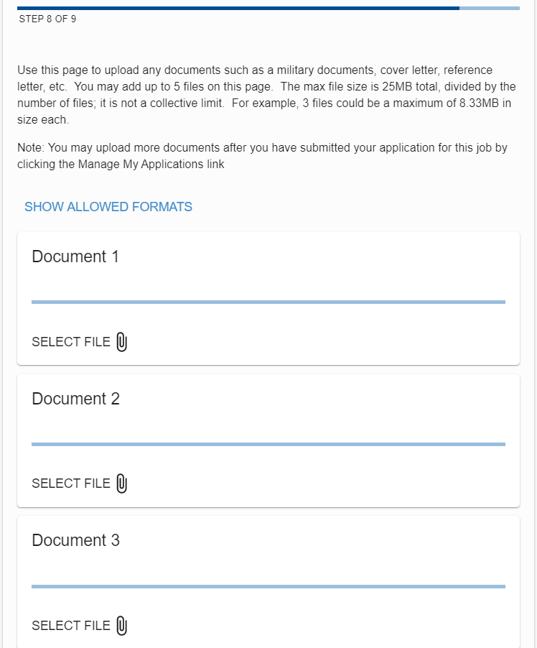
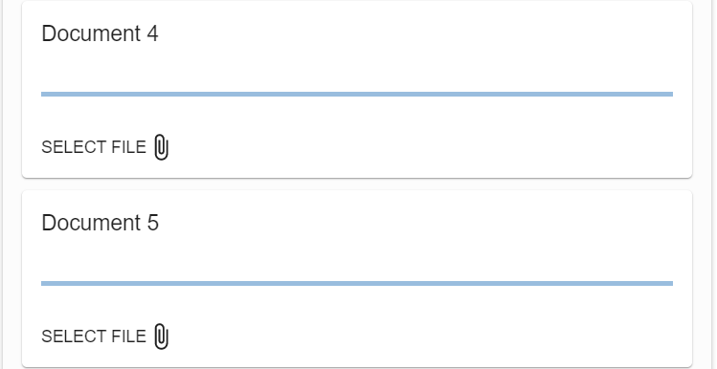

3l. When the applicant clicks the NEXT button, the screen for Step 9 (Final Page) is displayed for the applicant to fill out optional self-identification details and submit the form for processing by TVA's Talent Acquisition members.

