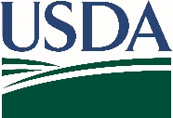
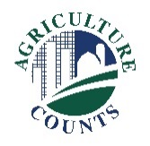
United States Department of Agriculture
National Agricultural Statistics Service

What do I do next?
Complete your survey in one of the following ways:
Online at agcounts.usda.gov through the Respondent Portal. Online reporting is fast and secure. You just need your unique survey code on the enclosed form to begin.

By mail or fax. Complete the questionnaire and mail it back in the prepaid return envelope provided or fax it to 855-415-3687.

December 19, 2022

Why am I getting this letter?

Enclosed is your January 2023 Catfish Production Survey. Your participation is important. This survey collects information on water acreage, inventory, and sales. The information helps evaluate conditions from year to year and promote programs designed to ensure the viability of catfish producers. Please complete and return the questionnaire at your earliest convenience.

If we do not receive your completed questionnaire by December 27, we may contact you for an interview.

We recommend you respond online through the new Respondent Portal. On the portal, you can complete your surveys, track upcoming surveys, access data visualizations and reports of interest, link to other USDA agencies, and more.

The information you provide will be used for statistical purposes only. In accordance with federal law, your responses will be kept confidential and will not be disclosed in identifiable form. We will publish the survey data February 10, 2023, in the Catfish Production report available at www.nass.usda.gov/publications.

Thank you for your participation and support of our programs and U.S. agriculture. If you have any questions, please contact us at 888-424-7828. For more information on catfish surveys and reports, visit www.nass.usda.gov/Surveys/Guide_to_NASS_Surveys/Catfish_Production.

Sincerely,

Joseph L. Parsons
Chair, Agricultural Statistics Board

Enclosure

