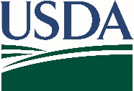
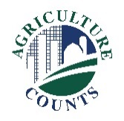
United States Department of Agriculture
National Agricultural Statistics Service
Alabama Field Office

What do I do next?
Complete your survey in one of the following ways:
Online at agcounts.usda.gov through the Respondent Portal. Online reporting is fast and secure. You just need your unique survey code on the enclosed form to begin.

By mail or fax. Complete the questionnaire and mail it back in the prepaid return envelope provided or fax it to 855-415-3687.

December 19, 2022

Why am I getting this letter?

Enclosed is your 2023 Trout Production Survey. Your participation is important. This annual survey collects information on sales, losses, and distributed fish. The information helps evaluate conditions from year to year and promote programs designed to ensure the viability of trout producers. Please complete the questionnaire at your earliest convenience.

If we do not receive your completed questionnaire by January 17, 2023, we may contact you for an interview.

We recommend you respond online through the new Respondent Portal. On the portal, you can complete your surveys, track upcoming surveys, access data visualizations and reports of interest, link to other USDA agencies, and more.

The information you provide will be used for statistical purposes only. In accordance with federal law, your responses will be kept confidential and will not be disclosed in identifiable form. We will publish the survey data February 27, 2023, in the Trout Production report available at www.nass.usda.gov/publications.

Thank you for your participation and support of our programs and U.S. agriculture. If you have any questions, please contact us at 888-424-7828. For more information on the trout survey and report, visit www.nass.usda.gov/Surveys/Guide_to_NASS_Surveys/Trout_Production.

Sincerely,

Joseph L. Parsons
Chair, Agricultural Statistics Board

Enclosure

