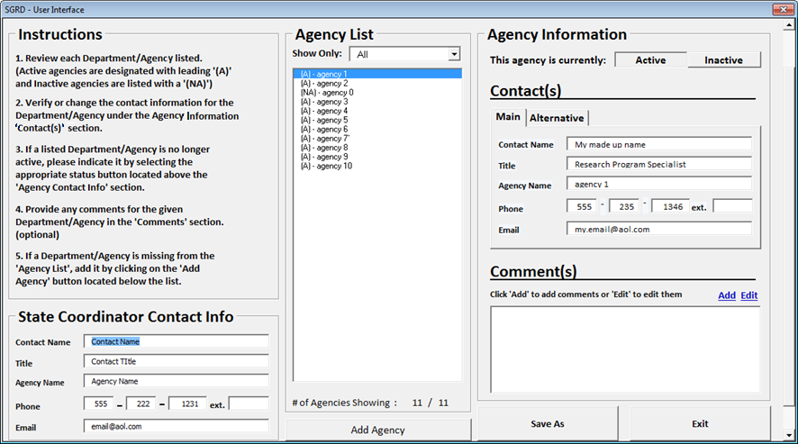
Attachment B2

Attachment A

OMB Number
This collection has been approved by the Office of Management and Budget (OMB). The eight-digit
OMB approval number is 0607-0933. Without this approval, we could not conduct this survey.
Authority and Confidentiality
Title 13 United States Code, Section 8(b) and Title 42 United States Code, Sections 1861-76 (National
Science Foundation Act of 1950, as amended) authorizes the Census Bureau to conduct this
collection on behalf of the National Science Foundation and to request your voluntary assistance.
These data are subject to provisions of Title 13, United States Code, Section 9(a) exempting data that
are customarily provided in public records from rules of confidentiality.
Burden Estimate Statement
Public reporting burden for this collection of information is estimated to average 1 hour per
response. Send comments regarding this burden estimate or any other aspect of this collection of
information, including suggestions for reducing this burden to: ECON Survey Comments 0607-0933,
U.S. Census Bureau, 4600 Silver Hill Road, Room EMD-6K064, Washington, DC 20233. You may email
comments to ECON.Survey.Comments@census.gov. Be sure to use ECON Survey Comments
0607-0933 as the subject.

