Training Provider and Participant Questionnaire
Location of Issue:
Training_Provider
Recommendation:
Reformat way to enter training providers and programs to ensure grantees save data. A number of grantees didn’t enter information in correctly and it resulted in their information not being recorded.
Impact on Burden:
None. Simply reformatting to simplify the process for grantees.
Old New (agreed on as of 3/14)
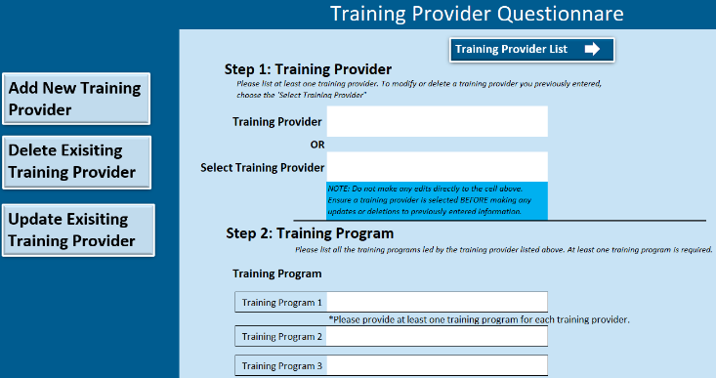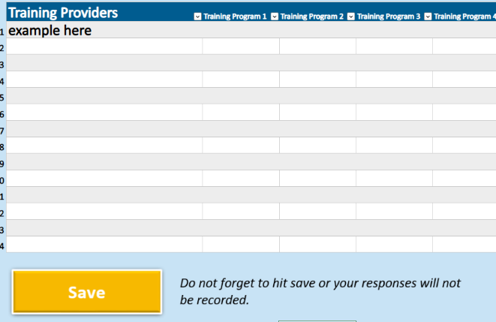
---
Location of Issue:
Institutional_Information à Job Prep Supports Provided
Recommendation:
Remove question because the question is later asked in the tab Career and job preparation in greater detail.
Burden:
Reduces burden by removing the question.
Old: (agreed on as of 3/14)
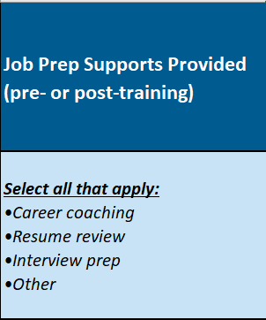

---
Location of Issue:
Institutional_Information à Other Supplementary Costs
Recommendation:
Remove question because the question because there are many cost related questions with overlapping amounts that could lead to double counting. Additionally, this does not give us much insight into what these costs are other than that they are supplementary to tuition. Further recommendation is to adapt the Program Tuition Cost to item to include both tuition and all required costs to attend the participate in the program.
Burden:
Reduces burden by removing the question.
Old: New (agreed on as of 3/15/2023)
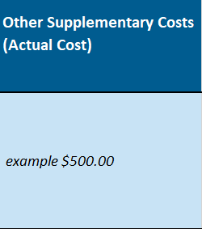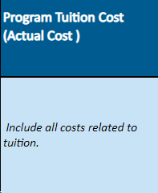
---
Location of Issue:
Institutional_Information_cont à How many of your participants report using new skills acquired
Recommendation:
Edit question because it is asking two questions, but there is only one response possible. We ask what skills were acquired and how many acquired those skills. It is most appropriate to just ask what skills were acquired, because the number of participants acquiring those skills would not differ significantly from number who engaged in training.
Burden:
No change. It simply clarifies the question for grantees.
Old:
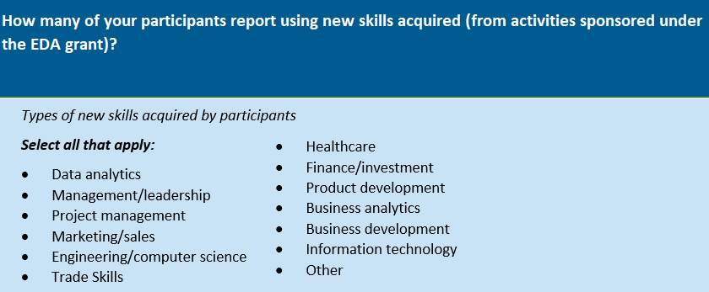
New: Agreed on as of 3/15/2023
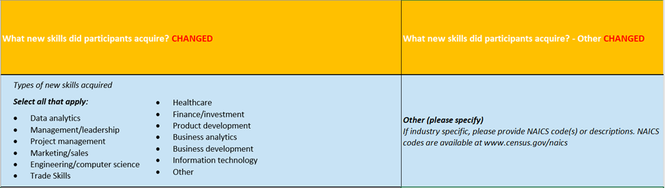
---
Location of Issue:
Earn and Learn
Recommendations:
Remove three categories from the Earn and Learn model as they are not applicable to GJC participants. The three categories are Transitional Jobs, Cooperative, and Practicums, Residences, or Fellowships
Burden:
No change simplifies options for Earn and Learn models.
Old:
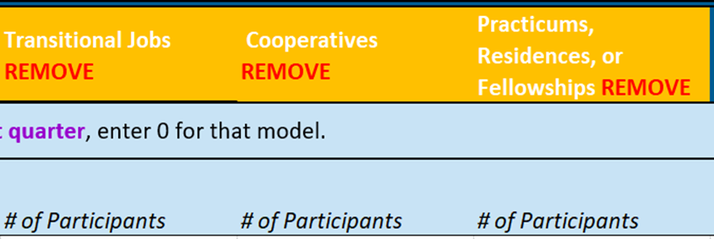
Location of Issue:
Career and job preparation
Recommendations:
Simplify the format to first ask for what services the training programs provides and them ask them to rank the five most effective services. Currently, the format asks to have all nine services ranked, which may or may not apply to that training program resulting in numerous empty responses and uncertainty as to which services the program provides.
Burden:
Reduces burden by asking to rank only five instead of nine.
Old:

New: Agreed on as of 3/15/2023

---
Location of Issue:
Wraparound Service
Recommendation:
Edit questions to more clearly reflect what wraparound services are being provided with GJC funds and what wraparound services are being provided with leveraged funds/external funds. Currently, the questions are confusing and hard to differentiate between the two questions. The questions would be more clearly broken into “What wraparound services were provided with GJC funding” and “What wraparound services were provided with leveraged funding/other external funding.”
Burden:
No change. It simply clarifies the question for grantees.
Old:
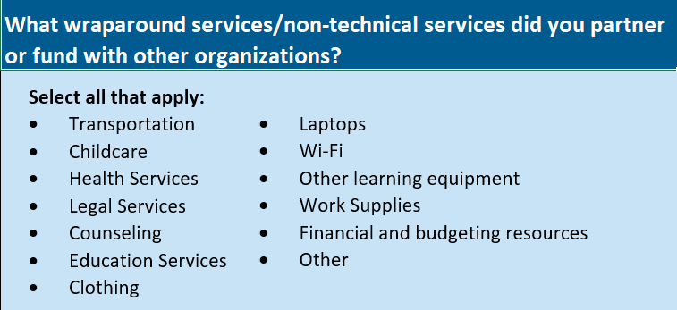
New: agreed on as of 3/15/2023
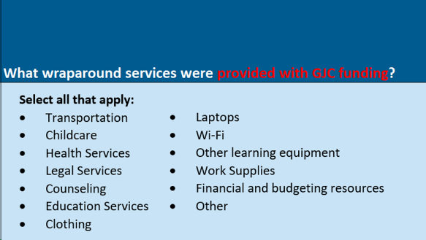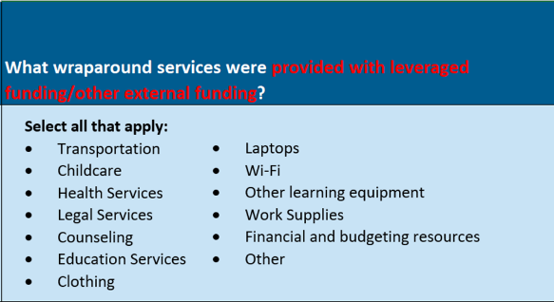
---
Location of Issue:
Overview à What is the total institutional cost spent per participant from recruitment to placement?
Recommendation:
Remove question because there are numerous questions about cost that are overlapping and could result in double counting or contradicting figures. Should we want to calculate this figure we still could by dividing the “Total Program Cost” by the number of participants.
Burden:
Reduces burden by removing the question.
Old: agreed on as of 3/15/2023


