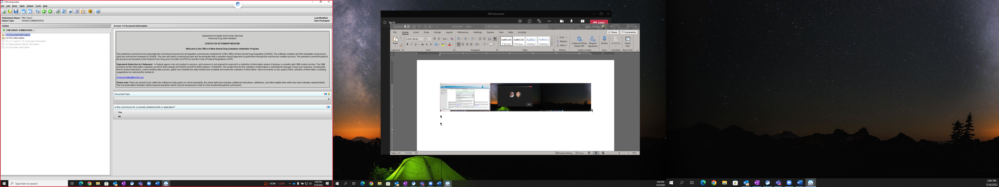

**Paperwork Reduction Act Statement** – A Federal agency may not conduct or sponsor, and a person is not required to respond to a collection of information unless it displays a currently valid OMB control number. The OMB control numbers for this collection of information include 0910-0032 (expires 8/31/2025) and 0910-0669 (expires 11/30/2025). The burden time for this collection of information is estimated to average 5 hours per response, including the time to review instructions, search existing data sources, gather and maintain the data needed and complete and review the collection of information The OMB control number for MUMS Designation is 0910-0605 (expires 01/31/2026). The burden time for this collection of information is estimated to average 4 hours per response, including the time to review instructions, search existing data sources, gather and maintain the data needed and complete and review the collection of information. Send comments on any aspect of these collections of information, including suggestions for reducing the burden to: [cvmesubmitter@fda.hhs.gov](mailto:cvmesubmitter@fda.hhs.gov)