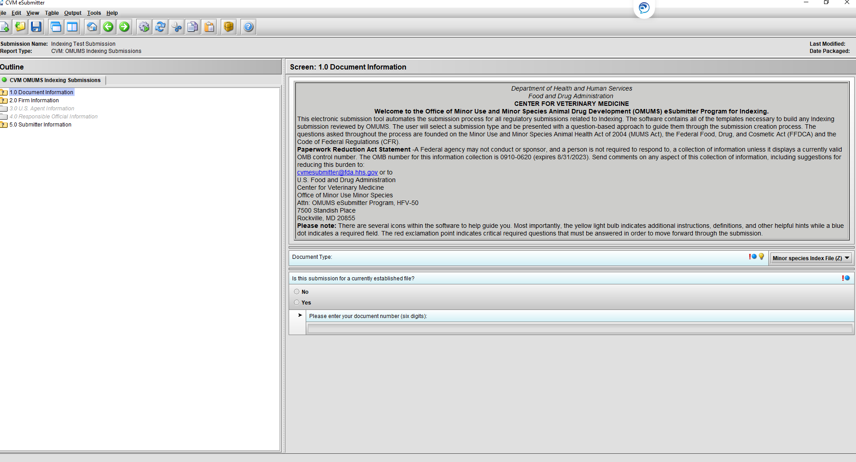

**Paperwork Reduction Act Statement** – A Federal agency may not conduct or sponsor, and a person is not required to respond to a collection of information unless it displays a currently valid OMB control number. The OMB control number for this collection of information is 0910-0605 (expires 01/31/2026). The burden time for this collection of information is estimated to average 16.954 hours per response, including the time to review instructions, search existing data sources, gather and maintain the data needed and complete and review the collection of information. Send comments on any aspect of these collections of information, including suggestions for reducing the burden to: [cvmesubmitter@fda.hhs.gov](mailto:cvmesubmitter@fda.hhs.gov) or to: