Study Title: Assessing Physiological, Neural and Self-Reported Response to Tobacco Education Messages

Study Screener

FOR INTERNAL PURPOSES

- Group 1: 25 13-17 year olds who are susceptible(a) to or experimenting with e-cigarettes(b)
- Group 2: 25 18-24 year olds who are susceptible(a) to or experimenting with e-cigarettes(b)
- Group 3: 25 13-17 year olds who are susceptible(c) to or experimenting with cigarettes(d)
- Group 4: 25 18-24 year olds who are susceptible(c) to or experimenting with cigarettes(d)

- Participants who are susceptible to e-cigarettes have never tried e-cigarettes and answer anything other than “definitely not” to any of the screener questions: “Do you think you will smoke a vaping product or vape in the next year?”; “Do you think that you will try a vaping product or vape soon?” or “If one of your best friends were to offer you a vaping product or vape, would you smoke it?”
- Participants who are experimenting with e-cigarettes have ever tried e-cigarettes
- Participants susceptible to cigarettes have never tried cigarettes and answer anything other than “definitely not” to any of the screener questions: “Do you think you will smoke a cigarette in the next year?”; “Do you think that you will try a cigarette soon?” or “If one of your best friends were to offer you a cigarette, would you smoke it?”
- Participants experimenting with cigarettes have ever tried smoking cigarettes but report smoking less than 100 cigarettes in their lifetime.

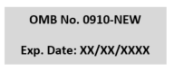
We have to ask you a few questions to determine if you are eligible to participate in this study. Do you agree to answer these screening questions?
Yes, I agree to answer these screening questions.

No, I do not agree to answer these screening questions.

[if answer is “no”, terminate and provide thank you message.]

Start of Block: CERSI screener

Paperwork Reduction Act Statement: According to the Paperwork Reduction Act of 1995, an agency may not conduct or sponsor, and a person is not required to respond to a collection of information unless it displays a valid OMB control number. The valid OMB control number for this information collection is XXX. The time required to complete this information collection is estimated to average 5 minutes per response, including the time for reviewing instructions, searching existing data sources, gathering and maintaining the data needed, and completing and reviewing the collection of information. Send comments regarding this burden estimate or any other aspects of this collection of information, including suggestions for reducing burden to PRASTAFF@fda.hhs.gov.

Thanks for your interest in participating in this survey. Given the sensitive nature of some of the questions in the survey, we recommend you move to a private area.
To see if you are eligible, we need to ask you some questions about yourself. However, keep in mind that we will not share the answers with anyone.

Q1 How old are you? [Base: All participants] Less than 13 years old [Exit survey]
- years old [Continue to Q2]
- years old [Continue to Q2]
- years old [Continue to Q2]
- years old [Continue to Q2]
- years old [Continue to Q2]
- years old [Continue to Q2]
- years old [Continue to Q2]
- years old [Continue to Q2]
- years old [Continue to Q2]
- years old [Continue to Q2]
- years old [Continue to Q2]
- years old [Continue to Q2]
Over 24 years old [Exit survey]

Q2 Have you ever tried cigarette smoking, even one or two puffs? [Base: Q1=13-24] Yes
No
Don't Know
Prefer not to answer [Exit survey]

Q3 How many cigarettes have you smoked in your entire life? A pack usually has 20 cigarettes in it. [Base:Q2=Yes & Q1=13-24]
- or more puffs but never a whole cigarette
- cigarette
- to 10 cigarettes (about 1/2 pack total)
11 to 20 cigarettes (about 1/2 pack to 1 pack)
21 to 50 cigarettes (more than 1 pack but less than 3 packs)
51 to 99 cigarettes (more than 2 1/2 packs but less than 5 packs) 100 or more cigarettes (5 packs or more) [Exit survey]
Don't know [Exit survey]
Prefer not to answer [Exit survey]

Q5 Do you think you will smoke a cigarette in the next year? [Base: Q1=13-24 & Q2=No or
Don't know] Definitely yes Probably yes Probably not Definitely not Don't know
Prefer not to answer [Exit survey]

Q6 Do you think that you will try a cigarette soon? [Base: Q1=13-24 & Q2=No] Definitely yes
Probably yes Probably not Definitely not Don't know
Prefer not to answer [Exit survey]

Q7 If one of your best friends were to offer you a cigarette, would you smoke it? [Base: Q1=13- 24 & Q2=No or Don't know]
Definitely yes Probably yes Probably not Definitely not Don't know
Prefer not to answer [Exit survey]

The next questions are about vaping products like e-cigarettes, vape pens, JUULs, mods, or other personal vaporizers. These products are battery-powered and produce vapor or aerosol instead of smoke. Vapes typically use a nicotine liquid, although the amount of nicotine can vary, and some may not contain any nicotine at all.

Please do NOT include vapes with marijuana, THC, or CBD when answering these questions.

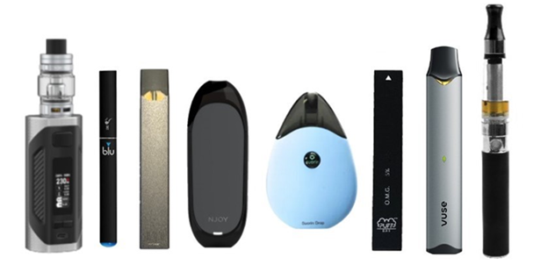

Q8 Have you ever used a vaping product or vape, even one or two times? [Base: 13-24 year olds]
Yes No
Don't know
Prefer not to answer [Exit survey]

Q9 Do you think you will try a vaping product or vape in the next year? [Base:Q1=13-24 & Q8=No or Don't know]
Definitely yes Probably yes Probably not Definitely not Don't know
Prefer not to answer [Exit survey]

Q10 Do you think that you will try a vaping product soon? [Base:Q1=13-24 & Q8=No or Don't
know] Definitely yes Probably yes Probably not Definitely not Don't know
Prefer not to answer [Exit survey]

Q11 If one of your best friends were to offer you a vaping product or vape, would you try it? [Base:Q1=13-24 & Q8=No or Don't know]
Definitely yes Probably yes Probably not Definitely not Don't know
Prefer not to answer [Exit survey]

[Exit survey if Q9, Q10 & Q11 = Definitely not]

