Attachment A: Application Screenshots

Note: The pages and the fields inside each page are conditional based on various selections the state makes as they work through the form. What you see below are all of the possible pages and options fleshed out in full, though what a state would actually encounter would be a subset of what you see here, based on their submission type and other information.

Submission type
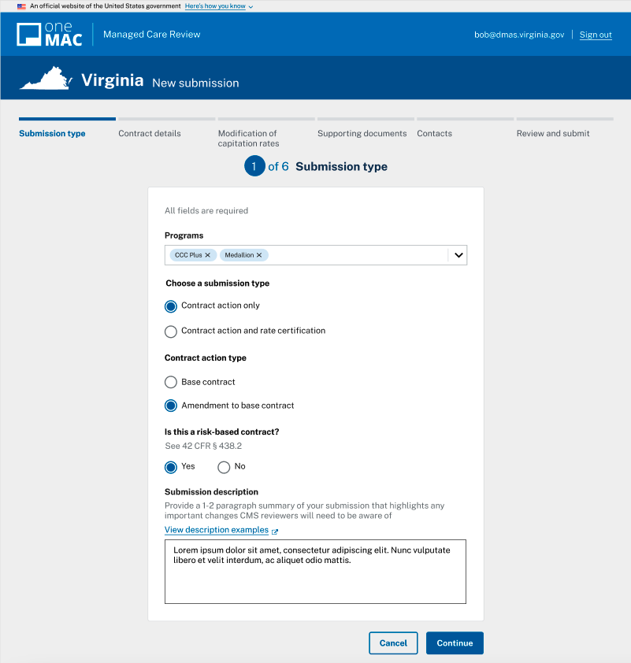

Contract details (1 of 3)
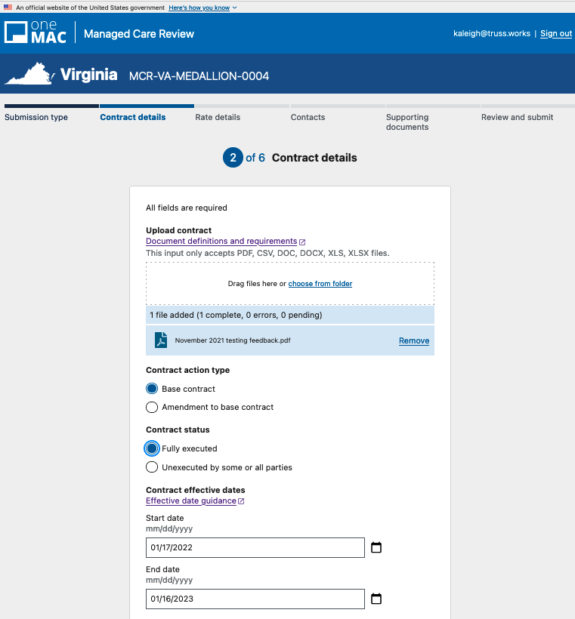

Contract details (2 of 3)
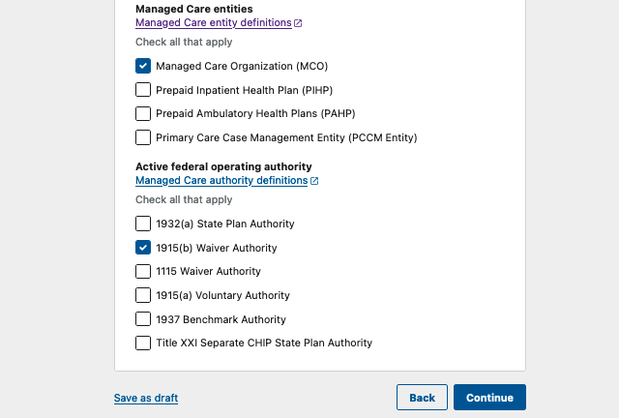

Contract details (3 of 3)
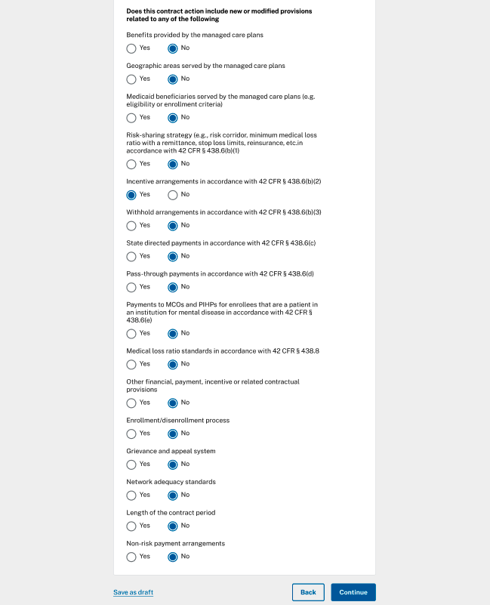

Modification of capitation rates
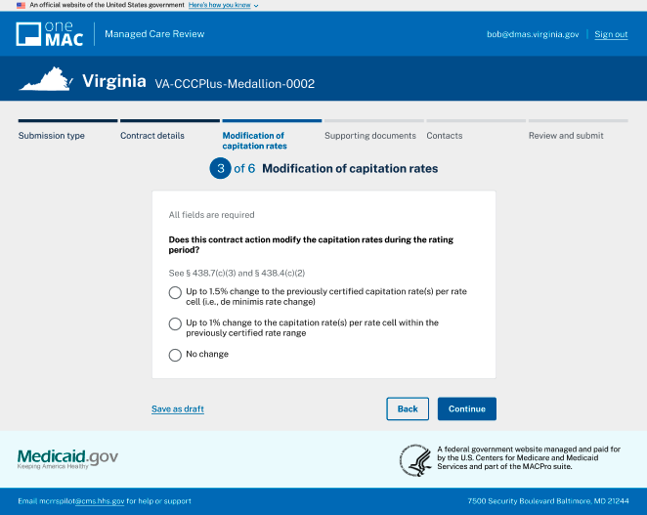

Rate details (1 of 2)

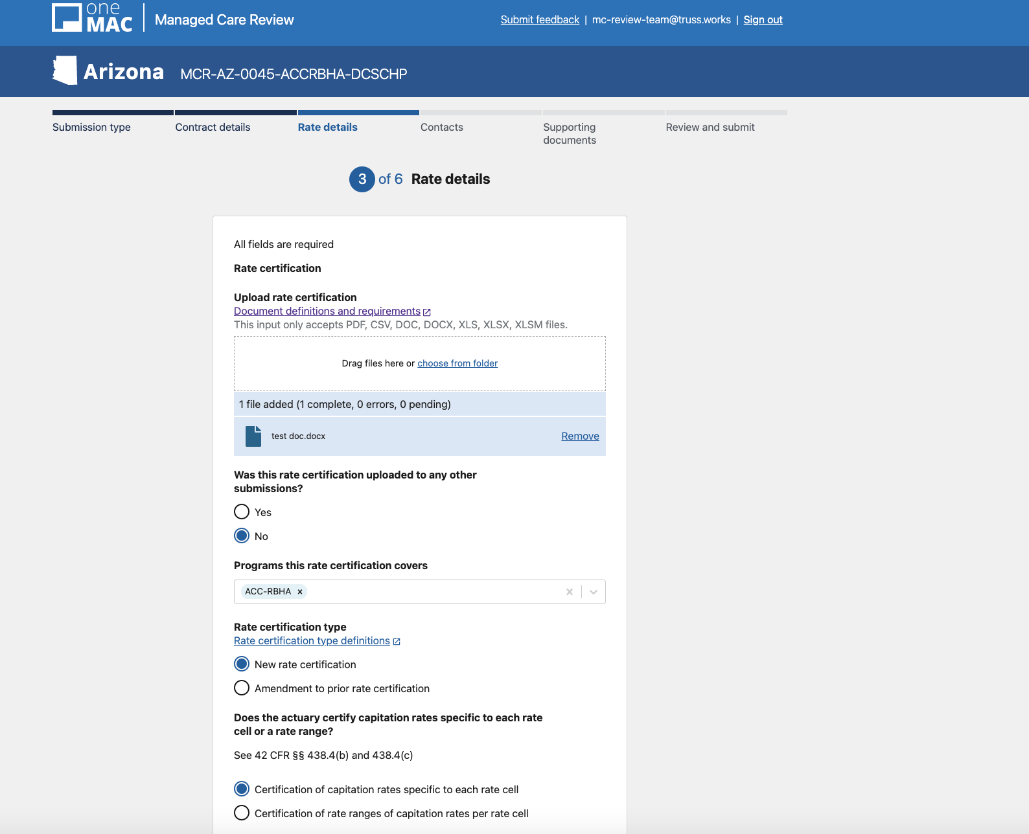

Rate details (2 of 2)

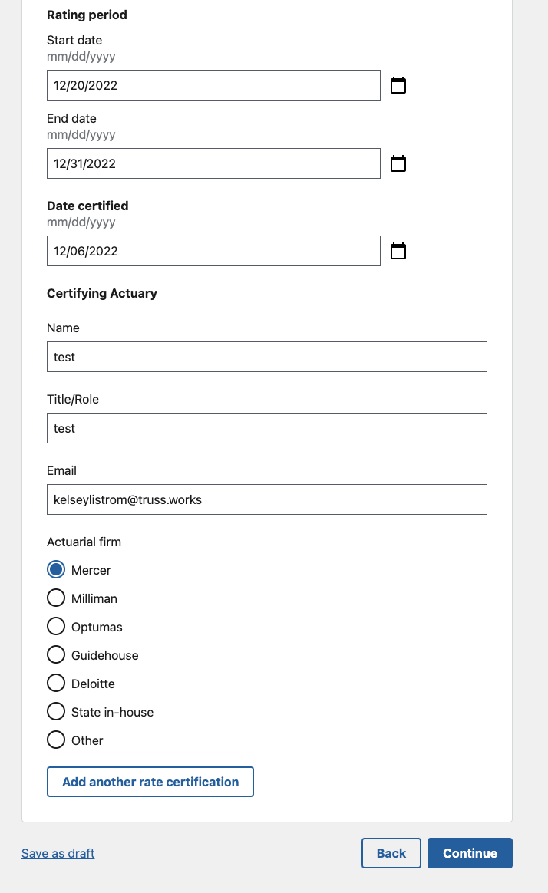

Contacts (1 of 1)

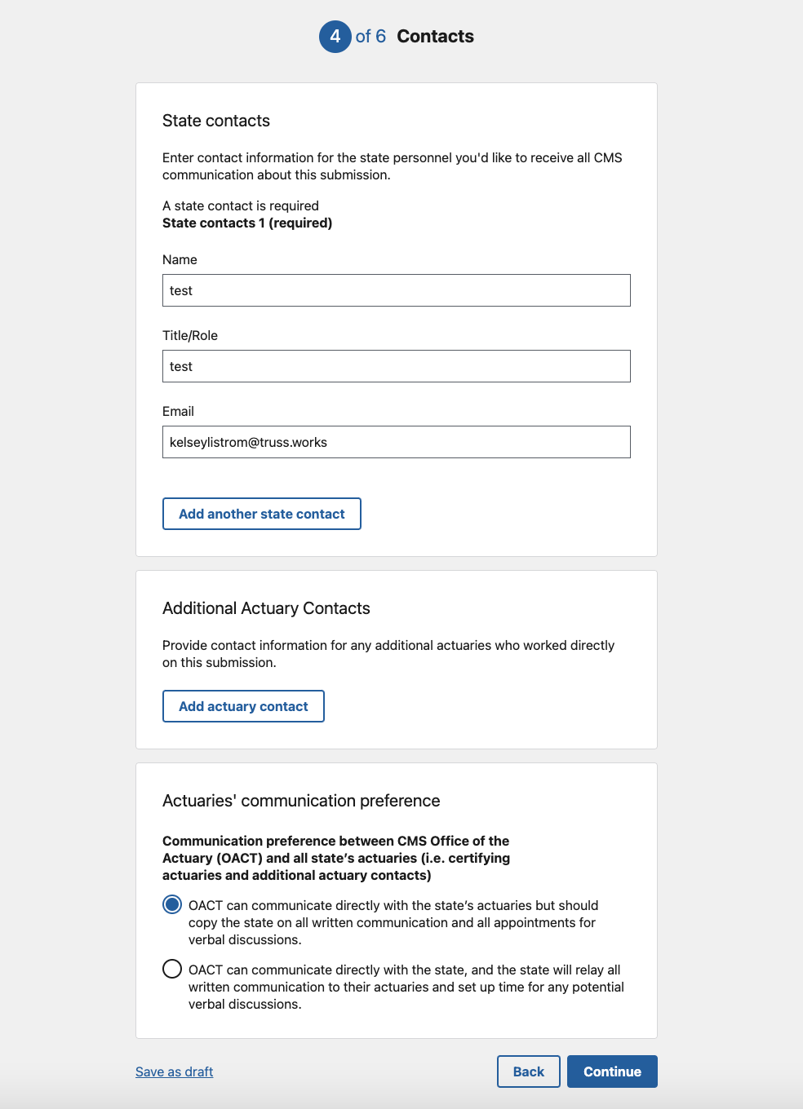

Supporting documents
