**SEP UI Mockups**

Landing Page with no prior SEP occurrences

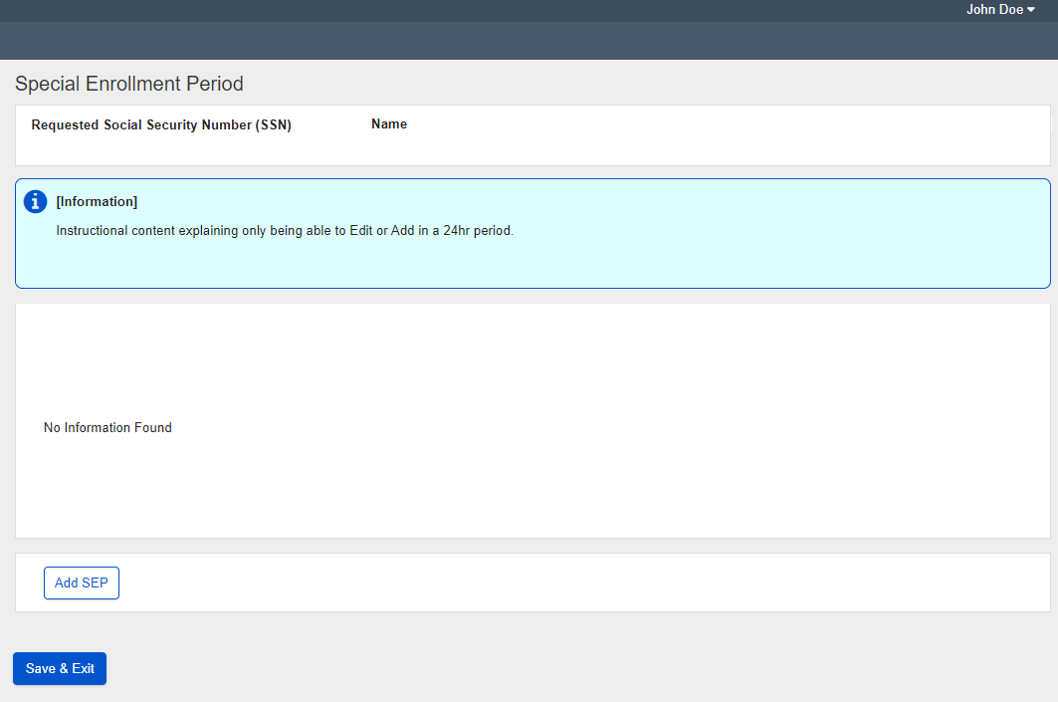

Add SEP Page prior to SEP selection

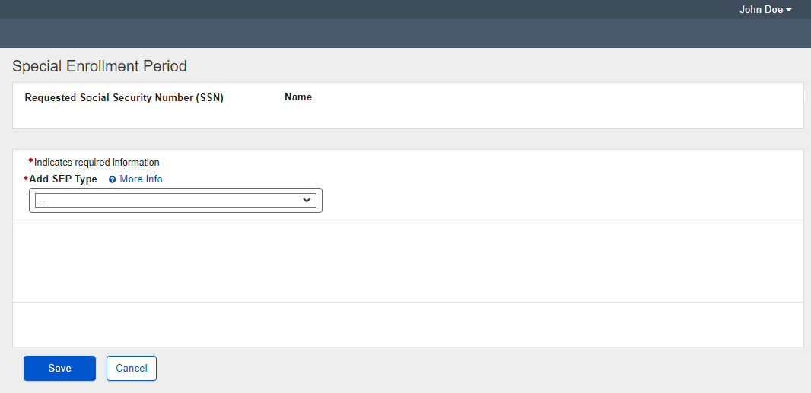

Add SEP with International Volunteer Selected

