PLEASE READ THIS FIRST:

Thank you for visiting [Insert Name] National Wildlife Refuge and taking time to participate in this study! We hope that you enjoyed your time at the refuge. The U.S. Fish and Wildlife Service is conducting this survey to learn more about hunters and their experiences in order to improve hunting opportunities on the refuge. For this survey, we are interested in hearing about your experiences during the Fall 20##/ Winter 20## hunting season.

- How many times did you hunt on this refuge during the 20##/20## hunting season?
- Once
- 2-4 times
- 5-10 times
- More than 10 times
- I didn’t hunt the refuge during the 20##/20## hunting season. [if selected, respondent is sent to the end of the survey]

- [STATION CAN PICK-LIST SPECIES] During the 20##/20## hunting season which species did you hunt on the refuge? Please select all species hunted, regardless of whether or not you harvested an animal. Note that the example species lists are not exhaustive and not all refuges allow hunting for all species listed. (Mark all that apply.)
  - Big game (deer, bear, moose, fall turkey, feral hog, etc.)
  - Small game (rabbit, squirrel, coyote, etc.)
  - Migratory birds / waterfowl (ducks, geese, dove etc.)
  - Upland game (pheasant, quail, grouse etc.)
  - Turkey (fall season only)

Big Game Questions [OPTIONAL, station can pick-list species]
(Respondent will be asked these questions if they check the corresponding box in question #2)

- [OPTIONAL] Please indicate which of the following you hunted, regardless of whether or not you harvested an animal. (Mark all that apply.)
  - Deer
  - Moose
  - Bear
  - Fall Turkey
  - Feral Hog
  - Other (Specify) __________________________________________________________________

- [OPTIONAL] Please indicate your big game harvest, if any, by checking the box next to the species you harvested.
  - Deer (if checked respondent will see the questions below)
    - How many deer did you harvest?
      - Number of juvenile males: _____
      - Number of adult males: _____
      - Number of juvenile females: _____
      - Number of adult females: _____
    - What method(s) of take did you use? (Mark all that apply.)
    - Rifle
    - Archery
    - Muzzleloader
    - Shotgun
    - Other (specify) _______________________
  - Moose (if checked respondent will see the questions below)
    - How many moose did you harvest?
      - Number of juvenile males: _____
      - Number of adult males: _____
      - Number of juvenile females: _____
      - Number of adult females: _____
    - What method(s) of take did you use? (Mark all that apply.)
    - Rifle
    - Archery
    - Muzzleloader
    - Shotgun
    - Other (specify) _______________________
  - Bear (if checked respondent will see the questions below)
    - How many bears did you harvest?
      - Number of subadult males: _____
      - Number of adult males: _____
      - Number of subadult females: _____
      - Number of adult females: _____
    - What method(s) of take did you use? (Mark all that apply.)
    - Rifle
    - Archery
    - Muzzleloader
    - Shotgun
    - Other (specify) _______________________
  - Fall Turkey (if checked respondent will see the questions below)
    - How many fall turkey did you harvest?
      - Number of juvenile males (jakes): _____
      - Number of adult males (toms): _____
      - Number of females (hens): _____
    - What method(s) of take did you use? (Mark all that apply.)
    - Rifle
    - Archery
    - Muzzleloader
    - Shotgun
    - Other (specify) _______________________
  - Feral Hog (if checked respondent will see the questions below)
    - How many feral hogs did you harvest?
      - Number of juvenile males: _____
      - Number of adult males: _____
      - Number of juvenile females: _____
      - Number of adult females: _____
    - What method(s) of take did you use? (Mark all that apply.)
    - Rifle
    - Archery
    - Muzzleloader
    - Shotgun
    - Other (specify) _______________________
  - Other species
Specify species harvested: _________________________________________

- [OPTIONAL] What units did you hunt on the refuge when hunting big game? (Mark all that apply.)
  - STATION CREATES A PICKLIST FOR UNITS

- [OPTIONAL] Please indicate your level of agreement with the following statement: I support a system that manages the number of big game hunters on the refuge? (Circle one number.)

Strongly Disagree | Disagree | Somewhat Disagree | Neither Agree nor Disagree | Somewhat Agree | Agree | Strongly Agree
1 | 2 | 3 | 4 | 5 | 6 | 7

- [OPTIONAL] What is your preferred method for managing the number of big game hunters on the refuge? (Mark only one option.)
- A random lottery
- Limited parking
- First come – first served
- Other (Specify) __________________________________________________________________
- I do not support managing the number of big game hunters on the refuge
Small Game Questions [OPTIONAL, station can pick-list species]
(respondent will be asked these questions if they check the corresponding box in question #2)

- [OPTIONAL] Please indicate which of the following you hunted, regardless of whether or not you harvested an animal. (Mark all that apply.)
  - Rabbit / Hare
  - Squirrel
  - Fox
  - Coyote
  - Crow
  - Bobcat
  - Other (Specify) __________________________________________________________________

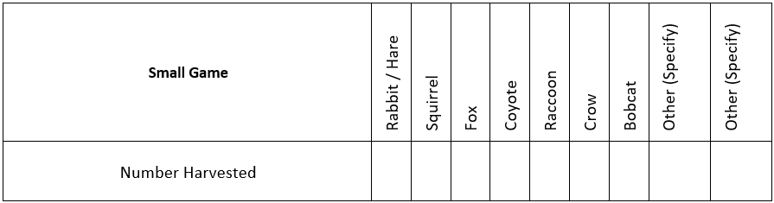
- [OPTIONAL] Fill in the table(s) below to indicate your harvest, if any.

- [OPTIONAL] What units did you hunt on the refuge when hunting small game? (Mark all that apply.)
  - STATION CREATES A PICKLIST FOR UNITS

- [OPTIONAL] What methods did you use to hunt small game on the refuge? (Mark all that apply.)
- Rifle
- Archery
- Muzzleloader
- Shotgun
- Other (Specify) __________________________________________________________________

- [OPTIONAL] Please indicate your level of agreement with the following statement: I support a system that manages the number of small game hunters on the refuge? (Circle one number.)

Strongly Disagree | Disagree | Somewhat Disagree | Neither Agree nor Disagree | Somewhat Agree | Agree | Strongly Agree
1 | 2 | 3 | 4 | 5 | 6 | 7

- [OPTIONAL] What is your preferred method for managing the number of small game hunters on the refuge? (Mark only one option.)
- A random lottery
- Limited parking
- First come – first served
- Other (Specify) __________________________________________________________________
- I do not support managing the number of small game hunters on the refuge

Migratory Birds / Waterfowl Questions [OPTIONAL, station can pick-list species]
(respondent will be asked these questions if they check the corresponding box in question #2)

- [OPTIONAL] Please indicate which of the following you hunted, regardless of whether or not you harvested an animal. (Mark all that apply.)
  - Ducks
  - Geese / Brant / Swan
  - Rail / Snipe / Coot / Gallinule
  - Dove
  - Woodcock
  - Other (Specify) _________________________________________________________________

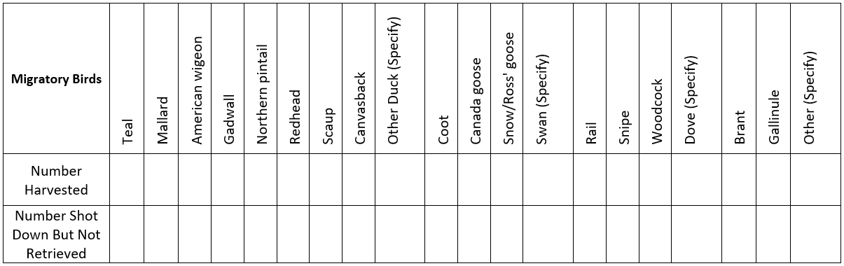
- [OPTIONAL] Fill in the table(s) below to indicate your harvest, if any.

- [OPTIONAL] What units did you hunt on the refuge when hunting migratory birds/waterfowl? (Mark all that apply.)
- STATION CREATES A PICKLIST FOR UNITS

- [OPTIONAL] Please indicate your level of agreement with the following statement: I support a system that manages the number of migratory bird/waterfowl hunters on the refuge? (Circle one number.)

Strongly Disagree | Disagree | Somewhat Disagree | Neither Agree nor Disagree | Somewhat Agree | Agree | Strongly Agree
1 | 2 | 3 | 4 | 5 | 6 | 7

- [OPTIONAL] What is your preferred method for managing the number of migratory bird/waterfowl hunters on the refuge? (Mark only one option.)
- A random lottery
- Limited parking
- First come – first served
- Other (Specify) __________________________________________________________________
- I do not support managing the number of migratory bird/waterfowl hunters on the refuge

Upland Game Questions [OPTIONAL, station can pick-list species]
(respondent will be asked these questions if they check the corresponding box in question #2)

- [OPTIONAL] Please indicate which of the following you hunted, regardless of whether or not you harvested an animal. (Mark all that apply.)
  - Pheasant
  - Bobwhite quail
  - Partridge
  - Chukar
  - Grouse
  - Other (Specify) _____________________________________________________________

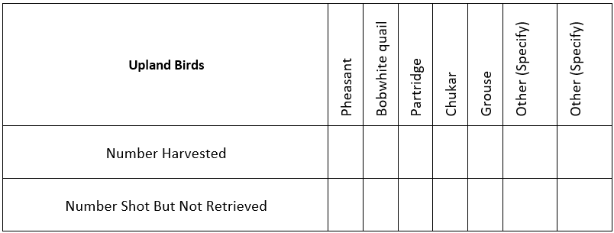
- [OPTIONAL] Fill in the table(s) below to indicate your harvest, if any.

- [OPTIONAL] What units did you hunt on the refuge when hunting upland game? (Mark all that apply.)
- STATION CREATES A PICKLIST FOR UNITS

- [OPTIONAL] Please indicate your level of agreement with the following statement: I support a system that manages the number of upland game hunters on the refuge? (Circle one number.)

Strongly Disagree | Disagree | Somewhat Disagree | Neither Agree nor Disagree | Somewhat Agree | Agree | Strongly Agree
1 | 2 | 3 | 4 | 5 | 6 | 7

- [OPTIONAL] What is your preferred method for managing the number of upland game hunters on the refuge? (Mark only one option.)
- A random lottery
- Limited parking
- First come – first served
- Other (Specify) __________________________________________________________________
- I do not support managing the number of upland game hunters on the refuge

All Respondents Answer the Following Questions

[OPTIONAL] We would like to know about any safety concerns or regulation violations you witnessed on the refuge during this past season.

- [OPTIONAL] Did you observe any of the following regulation violations, rule violations, or safety concerns while hunting on the refuge? (Mark all that apply.)
- Hunting within a safety zone or closed area (for example, hunting too close to a building)
- Hunters not wearing hunter orange where required
- Hunting from or across a trail
- Shooting outside of legal hunting hours
- Exceeding allowed bag limit
- Harvesting species outside of season
- Not retrieving game (wanton waste)
- Illegal bait site
- Hunting too close together
- Other (Specify) __________________________________________________________________

Please tell us a little more about your experience hunting on the refuge during this past season.

- How crowded did other hunters make you feel while hunting on the refuge? (Circle one number.)

Not at all Crowded |  | Slightly Crowded |  | Moderately Crowded |  | Extremely Crowded
1 | 2 | 3 | 4 | 5 | 6 | 7

- Did you experience any of the following with other hunters? (Mark all that apply.)
- Disruption as a result of other hunters having a hunting style that differed from your own (for example, someone hunting through your area while you were in a tree stand or someone jump shooting ducks near you while you were in a blind)
- Disruption as a result of someone pursuing different species
- Other hunters using my tree stand or blind
- Harassment
- Other (Specify) __________________________________________________________________

- How crowded did non-hunting refuge visitors (for example, bird watchers, walkers/hikers) make you feel while hunting on the refuge? (Circle one number.)

Not at all Crowded |  | Slightly Crowded |  | Moderately Crowded |  | Extremely Crowded
1 | 2 | 3 | 4 | 5 | 6 | 7

- Did you experience any of the following from non-hunting refuge visitors? (Mark all that apply.)
- Noise disturbance
- Harassment
- Flushing wildlife
- Non-hunters being in a hunting-only area
- Disruption from non-hunters’ dog(s)
- Other (Specify) __________________________________________________________________

- Where did you obtain information about hunting regulations for this refuge? (Mark all that apply.)
- Refuge website
- Other official permitting website
- From state information sources
- Refuge hunt brochure
- Refuge kiosk / signage
- Code of Federal Regulations
- From speaking with refuge staff
- From other hunters
- Couldn’t find this information
- Didn’t look for this information
- Other (Specify) __________________________________________________________________

- How easy were the regulations to understand? (Circle one number.)

Very Difficult |  | Difficult |  | Easy |  | Very Easy
1 | 2 | 3 | 4 | 5 | 6 | 7

- Please rate your level of agreement with the following statements. (Circle one number for each statement.)

 | Strongly Disagree | Disagree | Somewhat Disagree | Neither Agree nor Disagree | Somewhat Agree | Agree | Strongly Agree
This refuge is the only place available for me to hunt | 1 | 2 | 3 | 4 | 5 | 6 | 7
Disturbance from other hunters detracted from the quality of my experience | 1 | 2 | 3 | 4 | 5 | 6 | 7
Disturbance from non-hunting refuge visitors detracted from the quality of my experience | 1 | 2 | 3 | 4 | 5 | 6 | 7
Overall, I had a high-quality experience hunting on this refuge | 1 | 2 | 3 | 4 | 5 | 6 | 7
I am likely to hunt this refuge again | 1 | 2 | 3 | 4 | 5 | 6 | 7

- [OPTIONAL] Are you interested in the refuge hosting any of the following focused hunting opportunities: (Mark one option for each.)

Youth/novice hunts | □ Yes | □ No
Veteran only hunts | □ Yes | □ No
Disabled hunter hunts | □ Yes | □ No
Women only hunts | □ Yes | □ No
Mentored hunts | □ Yes | □ No

- [OPTIONAL] Please rate your level of agreement with the following statement. The following accessible infrastructure met my needs: (Circle one number for each or mark the box if the infrastructure type is not applicable to you.)

 | Strongly Disagree | Disagree | Somewhat Disagree | Neither Agree nor Disagree | Somewhat Agree | Agree | Strongly Agree | Not applicable to me
Accessible blinds | 1 | 2 | 3 | 4 | 5 | 6 | 7 | □
Ramps | 1 | 2 | 3 | 4 | 5 | 6 | 7 | □
Handicap parking | 1 | 2 | 3 | 4 | 5 | 6 | 7 | □

- Overall, how satisfied were you with hunting on this refuge during this past season? (Circle one number.)

Extremely Dissatisfied | Moderately Dissatisfied | Slightly Dissatisfied | Neutral | Slightly Satisfied | Moderately Satisfied | Extremely Satisfied
1 | 2 | 3 | 4 | 5 | 6 | 7

- We are interested in knowing the main reasons why you hunt. Please indicate your top three reasons for hunting. (Mark three.)
- Food
- Trophy opportunities
- Exercise
- Spending time with family and/or friends
- Tradition
- Spending time outside
- Seeing/viewing wildlife
- Other (Specify) ______________________________________________________________

We would like to know your zip code so we can have a better understanding of where people are travelling from to hunt on this refuge.

- What is the zip code for your primary residence?
_______________

Thank you for completing the survey.

There is space on the next page for any additional comments you
may have regarding hunting on this refuge.

NOTICES

PAPERWORK REDUCTION ACT STATEMENT

In accordance with the Paperwork Reduction Act (44 U.S.C. 3501 et seq.), the U.S. Fish and Wildlife Service collects information related to inform future hunt plan development, identify safety concerns that need attention, and better understand hunter preference in order to improve visitor experience, and to respond to requests made under the Freedom of Information Act and the Privacy Act of 1974. Information requested in this form is purely voluntary. According to the Paperwork Reduction Act of 1995, an agency may not conduct or sponsor and a person is not required to respond to a collection of information unless it displays a currently valid OMB control number. OMB has approved this collection of information and assigned Control No. 1018-####.

ESTIMATED BURDEN STATEMENT

We estimate public reporting for this collection of information to average 20 minutes, including time for reviewing instructions, gathering and maintaining data and completing and reviewing the form. Direct comments regarding the burden estimate or any other aspect of the form to the Service Information Clearance Officer, Fish and Wildlife Service, U.S. Department of the Interior, 5275 Leesburg Pike, MS: PRB (JAO/3W), Falls Church, VA 22041-3803, or via email at Info_Coll@fws.gov. Please do not send your completed survey to this address.

