OMB Control Number: xxxx  
Expiration Date: xxxx  
  
This interview is being conducted by the U.S. Geological Survey – Water Resources Mission Area. Thank you for participating in this interview. Your participation in this interview is voluntary.  We estimate that the interview will last 60 minutes.  Your responses will give us important information about the type of water resource management decisions you make and the considerations those decisions entail.   
  
**Privacy Act Statement:** You are not required to provide your contact information in order to submit your survey response. However, if you do not provide contact information, we may not be able to contact you for additional information to verify your responses. If you do provide contact information, this information will not be shared with any other organization and will only be used to initiate follow-up communication about this project if needed. The records for this collection will be maintained in the appropriate Privacy Act System of Records identified as [DOI Social Networks (Interior/USGS-8) published at 76 FR 44033, 7/22/2011]. Paperwork Reduction Act statements: [16 U.S.C. 1a7] authorized collection of this information. This information will be used by the U.S. Geological Survey to better serve the public. Response to this request is voluntary. We estimate that it will take 10 minutes to prepare and respond to this collection. We will not distribute responses associated with you as an individual. We ask you for some basic contact information to help us interpret the results and, if needed, to contact you for clarification.   
  
  
**The Paperwork Reduction Act** of 1995 (44 U.S.C. 3501), states that an agency may not conduct or sponsor, and you are not required to respond to a collection of information unless it displays a currently valid OMB control number and expiration date. You may submit comments on any aspect of this collection. Please note that comments submitted in response to this collection are public record. Comments on this collection should be sent to the Clearance Office at gs-info_collections@usgs.gov.

**Institutional Resiliency Interview Question Guide**

We will interview individuals within a range of water management institutions (federal, state, local, and Tribal) to better understand: 1) how individuals responsible for these different decision types characterize resilience for their immediate institution and their larger hydrologic system, 2) how manager definitions of resilience confirm or diverge from our *a priori* resilience framework of responding, monitoring, anticipating, and learning, and 3) how constraints and flexibilities within each of these decision categories reduce or contribute to institutional resilience as both we and the interviewee have defined it. The data gathered from the interviews will be used to develop metrics of institutional resiliency by which water resource institutions can be assessed.

***Set 1 – Background and Context***

*Objective: Gain a better understanding of interviewee background and perspective on system in which they operate, in order to uncover tacit knowledge they may bring to their decision-making. Explore immediate (organizational/brick-and-mortar) and broader (ecological/socio-cultural) water management contexts through conceptual modeling exercise.*

1.1 Tell me a little about your position with [*organization*] and how you came to work here.

Probe: Have you worked in other water management contexts (different sectors, regions, or roles) prior to your job here?

1.2 In your own words, can you describe [*organization’s*] essential functions when it comes to water management?

Probe: Who are your primary constituents?

Probe: What is your organization’s jurisdiction (geographic or sectoral)?

1.3. Tell me a bit about how things run in [*organization*]on a daily basis, throughout the year.

Probe: Are there cyclical/seasonal changes in the system (ecological, climatological, political, etc.) that are known and expected to impact how [*organization*] operates?

Probe: How do those daily operations fit into the organization’s essential functions?

Probe: How are daily operations designed to achieve organization’s long-term goals?

*For question 1.4 an online whiteboard will be used (see figure on following page) to walk participant through an exercise visualizing the different layers of the technical, socio-cultural and ecological system in which they and their organization work*. *After completing exercise, participant’s preferred language can be used throughout remainder of interview to refer to different scales or sectors of the comprehensive system they develop.*

1.4 What other water management actors, institutions or socio-cultural structures (state or federal regulations, collaborative decision-making bodies, private utilities, etc.) play a role in managing water resources for the system in which you work?

Probe: How do those other actors impact the organizational mission of [*organization*]and your work as a water manager?

Probe: Are there any water management actors, institutions, or socio-cultural structures that support your water management decisions?

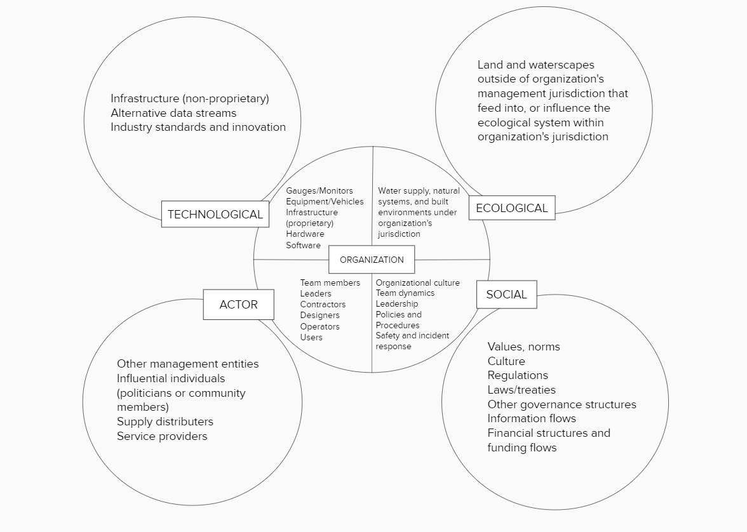

Figure : Organizational template to be used in question 1.4

***Set 2 – Resilience***

*Objective: Explore how interviewee defines and operationalizes resilience for different levels of the system in which they operate (both organizational/brick-and-mortar and ecological/socio-cultural as described in diagramming exercise).*

***Brief intro for interviewer to provide to interviewee:*** *We have now talked a little bit about both the specific function of* [*organization*] *and the larger ecological and socio-cultural systems in which* [*organization*] *operates. I am now going to ask you some questions related to the idea of resiliency and would like you to answer each (if possible) in relation to both scales. Does that make sense?*

2.1 What does resilience mean to you, when thinking about both *X* [*organization*] and the ecological/socio-cultural system in which [*organization*] operates?

2.2 Describe the range of conditions you would call “normal or baseline” for the purposes of your work and/or your organization’s essential functions.

Probe: Is there a specific equilibrium point (i.e., supply=demand, input=withdraw, etc.) you are aimed at achieving, or is there a range of acceptable fluctuation?

Probe: How do you know when conditions have shifted outside that range or beyond that point?

2.3 Based on your definition, what are some of the ways you think both [*organization*] and the larger ecological/socio-cultural system successfully achieve resilience?

Probe: Is there anything missing (i.e., processes, relationships, information, modifications to physical infrastructure, etc.) that you believe would increase resilience?

2.4 From your perspective, are there aspects of either [*organization*] or the larger ecological/socio-cultural system currently hindering achievement of resilience?

Probe: <**Gauge interviewee comfort level for this topic before asking follow-up probe**.> What would it take, from your perspective, to change those?

***Set 3 – Decision Making***

*Objective: Understand the constraints and flexibilities for decision-making experienced or observed by the interviewee, and how those factors influence the achievement of resilience at organizational and system levels.*

***Brief intro for interviewer to provide to interviewee:*** You recently took a survey that asked you to indicate how much you agree with different statements about the kinds of decisions you make in your work. For this study, we interested in three categories of water management decisions; operational, strategic, and regulatory [*short description of each – paraphrased from information in intro*]. We recognize that most people make decisions in the course of their work that could fall into any of those categories, or a combination of several, but will primarily make one type of decision on a regular basis. Based on your responses we understand most of your decisions to be [*operational, strategic, regulatory*]. Do you agree?*

For this final set of questions, I am going to ask you about the decisions you make for your job. We would like you to think about your answers primarily in relation to your [*operational, strategic, regulatory*] decisions, but if there is information you would like to provide that would be more relevant to other types of decisions you make we can discuss that as well.

**\****If they disagree with how we characterized their decision-making, we will ask them to self-identify among the three options [operational, strategic, or regulatory] and use that identity for the remaining questions. At the end, we will ask them if there is someone else in their organization that we could talk to who might better represent the category of decision-maker we assigned them to originally***.**

3.1 Can you give me some examples of the kinds of decisions you typically make in the course of your work?

Probe: What are the easiest decisions you typically make? Can you explain why they are easy?

Probe: Can you tell me about a particularly difficult decision you had to make and what made it difficult?

3.2 How would you describe your typical process for making these different decisions when conditions are “normal” [remind them of how they defined “normal” earlier in interview]?

Probe: What is the role of: external input from others, monitoring data, policy or procedure, etc.

Probe: How do you overcome the challenges you face when making difficult decisions [i.e., the difficulties mentioned in previous question, or other impediments such as uncertainty, competing objectives, risk perception, etc.]

3.3 How does your decision-making process change when conditions shift to “abnormal?”

Probe: Do the factors listed above still play a role, and if so, what is it?

Probe: Do your approaches to resolving uncertainty or balancing tradeoffs change?

3.4 In what ways do the [*operational, strategic, regulatory*] decisions that you make contribute (or are intended to contribute) to resilience – as you defined it – for both your organization and the larger ecological/socio-cultural system?

Probe: What are the aspects of your organization or the larger ecological/socio-cultural system that enable you to make those decisions? [i.e., organizational structure, institutional culture, readily available and reliable data, supportive stakeholders, critical partnerships, etc.]

3.5 Are there [*operational, strategic, regulatory*] decisions that you wish you could make that you believe would contribute to resilience?

Probe: What prevents you from making those decisions [i.e., are there flip-sides to the enabling factors mentioned above that, instead, constrain decision space]?

***Wrap-up***

*Objective: Allows the interview participant to tell us anything they have not yet had the opportunity to discuss and identify others we should speak to.*

Is there anything else you would like to share about your role or decision-making as a water manager that we have not already discussed?

Is there anyone else in your organization you think we should talk to? **<especially if they identified with a different decision type than we assigned to them>**