SHOT Show Survey: Partial Point of Contact States

Privacy Act Statement
Authority: The collection of this information is authorized under Title 34 U.S.C. § 10211, 44 U.S.C. § 3101, and the general record keeping provision of the Administrative Procedures Act (5 U.S.C. § 301). Completing the survey and providing your contact information is voluntary.
Principal Purpose: The purpose of this survey is to gather feedback regarding your experience with the National Instant Criminal Background Check System (NICS). If provided, your contact information will be used to contact you regarding your submitted success stories or other NICS experiences.
Routine Uses: All surveys will be maintained in accordance with the Privacy Act of 1974. Information on the survey may be disclosed with your consent, and may be disclosed without your consent as permitted by all applicable routine uses as published in the Federal Register (FR), including the routine uses for the FBI Online Collaboration Systems (JUSTICE/FBI-004), published at 82 FR 57291 (Dec. 4, 2017), and the routine uses for the Next Generation Identification System (JUSTICE/FBI-009), 84 Fed. Reg. 54182 (October 9, 2019). Routine uses may include sharing information with other federal, territorial, state, local, and tribal criminal justice agencies.

Pursuant to Paperwork Reduction Act requirements, this collection has been assigned the following control number by the Office of Management and Budget (OMB): xxxx-xxxx. This OMB control number expires 12/31/2021.
__________________________________________________________________________

15 Questions – 5 minutes
- I am an FFL who… [multiple choice]
  - Uses NICS E-Check or Phones
  - Uses XML
  - Resides in a Partial POC state
  - Resides in a full POC state
- Please enter your RDS Key (i.e. First 3 and last 5 numbers of the FFL number)
[Text box. Validation set to 8 numeric characters. PII.]

Or your Business Name [Text box. PII.]
- On average, how many federal background checks does your business location submit in one month?
  - 1 – 49
  - 50 – 99
  - 100 – 249
  - 250 – 499
  - 500 +
- How many employees at your business submit background checks (per location, if multiple)?
  - 1
  - 2 – 5
  - 6 – 10
  - 11 – 20
  - > 20
- How long has the FFL you are associated with been in business?
  - Less than 1 year
  - 2 – 5 years
  - 6 – 9 years
  - 10 – 19 years
  - More than 20 years
  - Not sure
- What is your age?
  - Under 18
  - 18 – 24
  - 25 – 34
  - 35 – 44
  - 45 – 54
  - Over 55
- Are you currently registered, or have ever been registered, for NICS E-Check?
  - Yes
  - Yes, but I stopped using it
  - No
- How often do you submit a background check using NICS E-Check versus calling in a check?
  - 100% E-Check
  - 75% E-Check / 25% Call Center
  - 50% E-Check / 50% Call Center
  - 25% E-Check / 75% Call Center
- Overall, how satisfied are you with NICS E-Check?
  - Very satisfied
  - Somewhat satisfied
  - Neutral
  - Somewhat dissatisfied
  - Very dissatisfied
- Rank (1 to 5) how easy it is for you to complete the following tasks using NICS E-Check. 1 is very easy, 5 is very difficult.
__ Submit a Search
__Retrieve a Status
__Check NTN History
__Resetting a Password
__Unlocking User Accounts

- What is your preferred Internet Browser?
  - Internet Explorer
  - Apple Safari
  - Mozilla Firefox
  - Google Chrome
  - Other: _________________
- What device(s) do you use to submit background checks and how often do you use each?

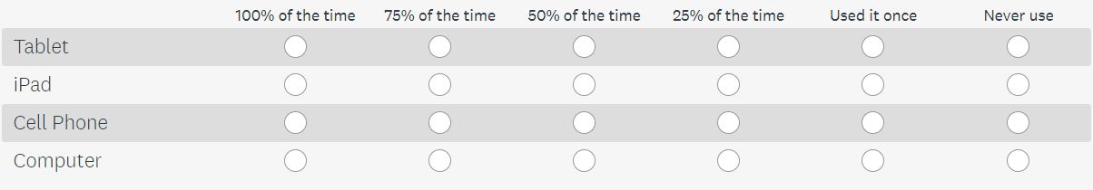

- If NICS made E-Check mobile-friendly (i.e. the website was designed for small screens), how often would you submit background checks using the devices below?
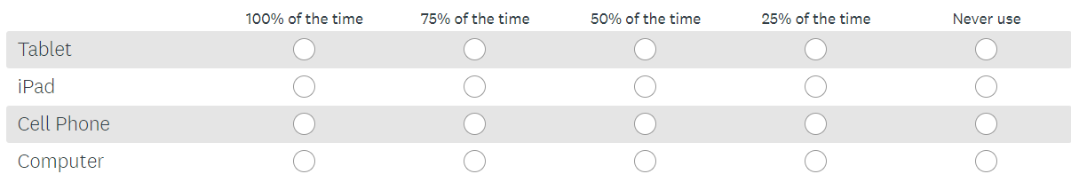
- How responsive have NICS Customer Service Representatives been to your questions and concerns with E-Check?
  - Extremely responsive
  - Very responsive
  - Somewhat responsive
  - No so responsive
  - Not responsive at all
  - Not applicable

