 | U.S. Department of Labor  Employment and Training Administration  Office of Job Corps | ETA FORM 658  OMB Control No. 1205-0030  Expiration Date:

Allotment Request Data Entry Screen – ETA 658
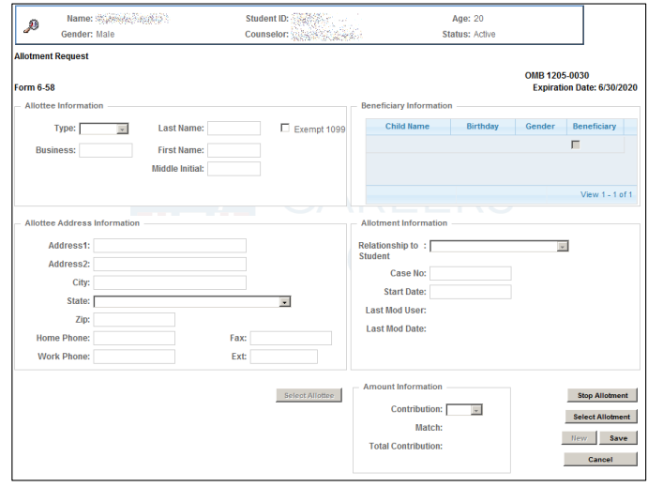

Paperwork Reduction Act Public Burden Statement: Persons are not required to respond to this collection of information unless it displays a currently valid OMB control number. Respondents' obligation to complete this form is required to obtain or retain benefits (P.L. 113-128). Public reporting burden is estimated to average 3 minutes per response, including the time for reviewing instructions, searching existing data sources, gathering and maintaining the data needed, and completing and reviewing the collection of Information. Send comments regarding this burden estimate to the U.S. Department of Labor, Division of Adult Services, Room S-4209, Washington, D.C. 20210 (Paperwork Reduction Project 1205-0030). Please do not submit completed forms to this address.

