IDCF/BLSCompdata Web-Lite Authentication

This application uses the Web-Lite authentication (Schedule Number with Captcha) to allow the respondents to upload data files.

Login Page:
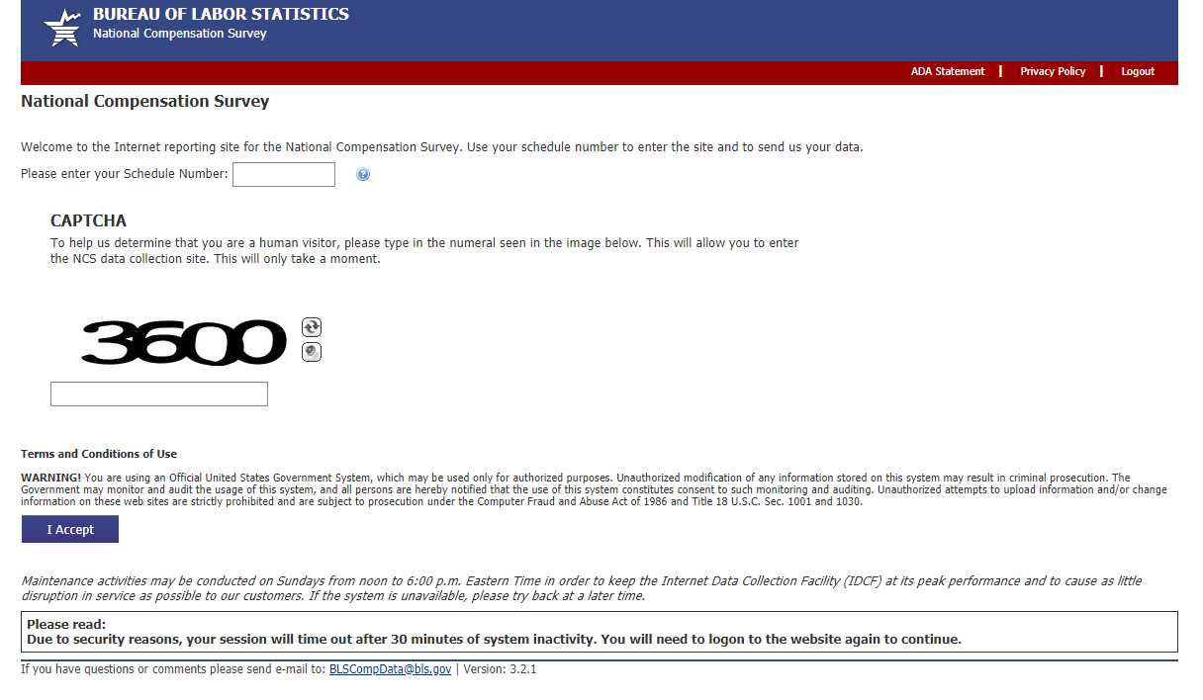

Welcome Page: this page displays the CIPSEA and OMB Statements. Only one CIPSEA statement is used for all schedules in this application (no government CIPSEA statement is displayed).
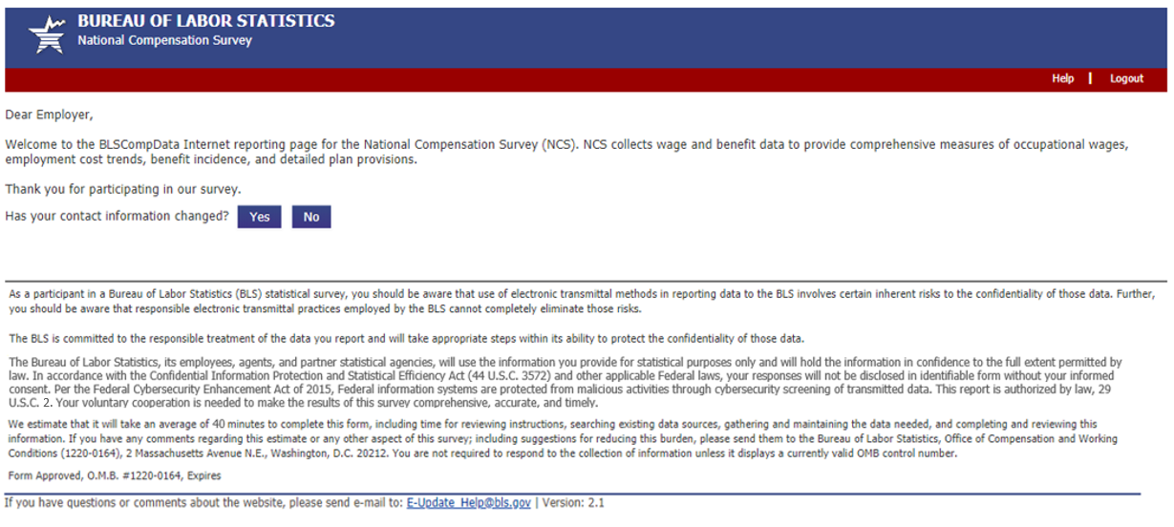

Enter Respondent Information Page: respondent isn’t required to provide information
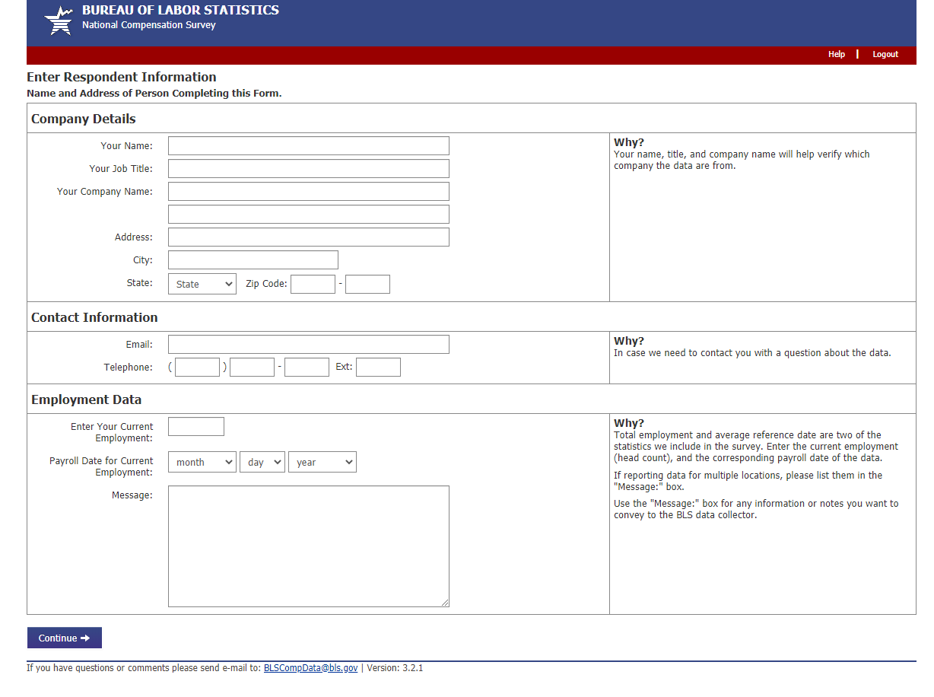
Select Files Page: respondent can upload one or more files. The total size of the files cannot exceed 35 MB.
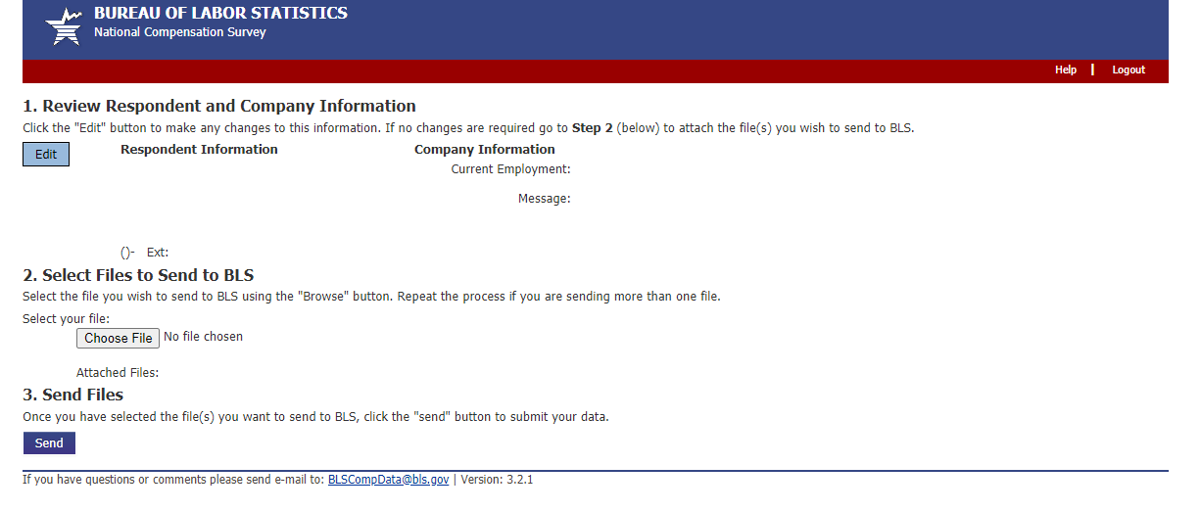
**File Transfer – Upload File(s) page** - This page is part of the File Transfer application that is used by all surveys that upload files in the IDCF environment.
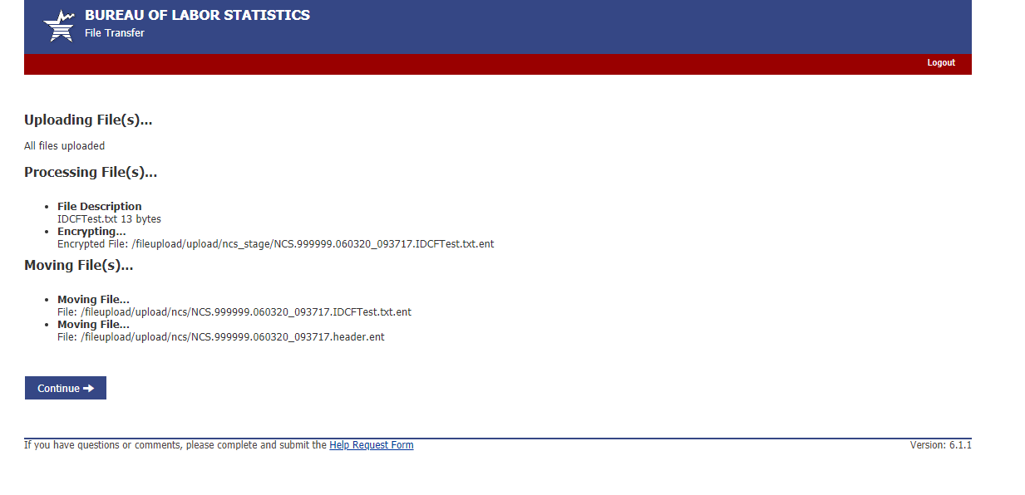
Confirmation/Thank You Page:
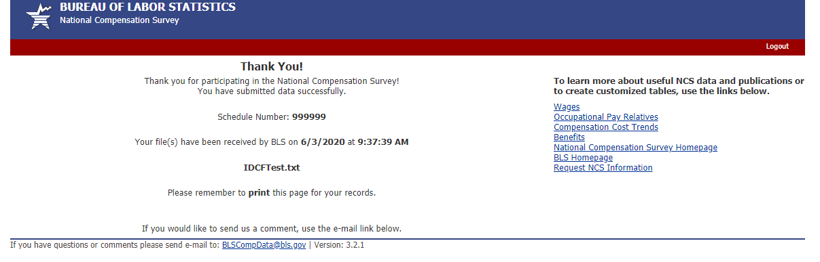

ADA Statement Page:
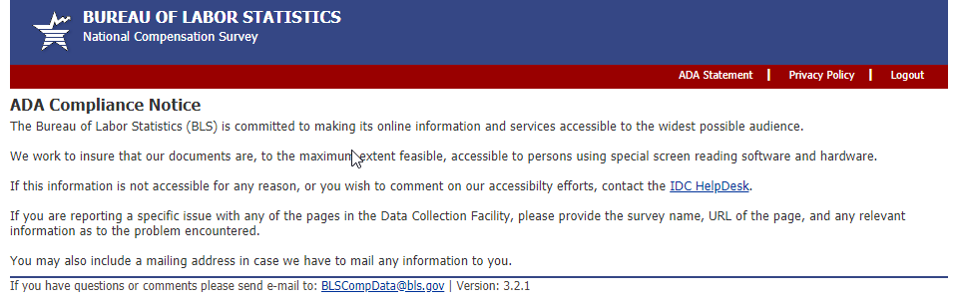
Privacy Policy Page:
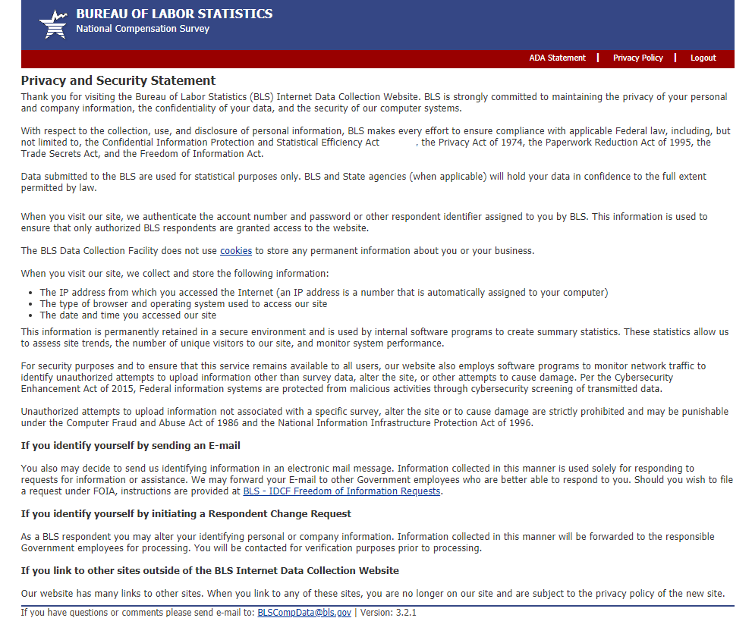
Cookies Page:
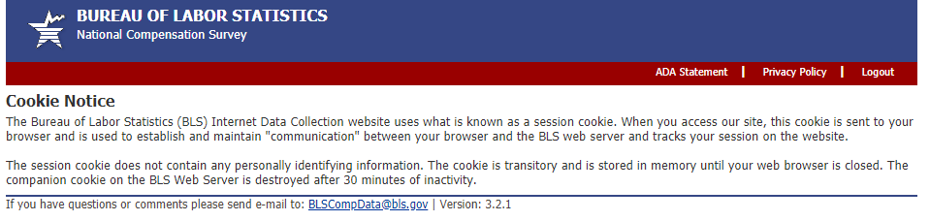

FOIA Page:
