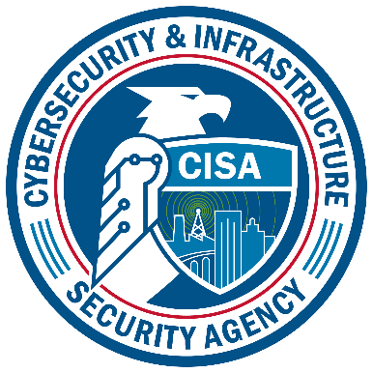
CFATS Helpdesk Form
For inclusion within ICR 1670-0007
Cybersecurity and Infrastructure Security Agency

Paperwork Reduction Act Statement
In accordance with the Paperwork Reduction Act, no one is required to respond to a collection of information unless it displays a valid Office of Management and Budget (OMB) Control Number. The valid OMB Control Number for this information collection is 1670-0007. The time required to complete this information collection is estimated to average 0.1167 hours per response, including the time for reviewing instructions, searching existing data sources, gathering, and maintaining the data needed, and completing and reviewing the collection of information.

Privacy Notice
Authority: 6 U.S.C. §§ 621-29 (Protecting and Securing Chemical Facilities from Terrorist Attacks Act of 2014) and the Chemical Facility Anti-Terrorism Standards, 6 C.F.R. Part 27 authorize the collection of this information.
Purpose: The purpose of this collection is to respond to your questions and provide technical support for the Chemical Facility Anti-Terrorism Standards (CFATS) Program.
Routine Use: The Personally Identifiable Information (PII) you provide will be used by and disclosed to DHS personnel, contractors and other agents, including but not limited to other Federal, state, and local officials; and to answer your questions, provide technical support, or refer inquiries to another appropriate Federal agency or official.
Disclosure: Providing PII is voluntary; however, failure to provide any of the information requested may prevent the Chemical Facility Anti-Terrorism Standards (CFATS) Helpdesk from providing assistance or answering your questions.

CFATS Helpdesk Form
In order to expedite the handling of your request, please provide the following information. We are required to collect the information requested prior to providing an answer to questions that are received at the helpdesk for tracking purposes only.

If you are a covered facility, please provide your facility ID. If you have completed the registration process but do not know your coverage status, please include the registration form ID number that may be found in the registration email or on the printed form located below the barcode.

The information collected is secured as required by the Department of Homeland Security and cannot be accessed by any outside sources.

