*NATIONAL CENTER FOR EDUCATION STATISTICS NATIONAL ASSESSMENT OF EDUCATIONAL PROGRESS*

*National Assessment of Educational Progress (NAEP) 2024*

*Appendix J1*

*2024 Student Questionnaires*

*OMB# 1850-0928 v.29*



March 2023

Appendix J1 provides the student survey questionnaires that will be administered in 2024. Grades 4 and 8 Core, Math, and Reading questionnaires were previously approved in 2022 (OMB# 1850-0928 v.28), and any changes to the items from the 2022 administration are reflected in summary tables. Additionally, grade 8 Science and grade 12 Core, Math, and Reading were previously approved in 2019 (OMB# 1850-0928 v.15), and any changes to the items from the 2019 administration are reflected in summary tables.

Updates to the student survey questionnaires, including new COVID-19 SQs, will be available in this document in Amendment #2 by May 2023. Draft NIES questionnaires will be included in Amendment #2 and final questionnaires will be in Amendment #3 (July 2023). Note that all login screens contained in this document will be updated with the most current OMB clearance expiration date before administration.

Table of Contents

Student Questionnaires

**Student Login Screen** 3

**Appendix J1-1**: Operational Grade 4 (Core) 4

**Appendix J1-2**: Operational Grade 8 (Core) 8

**Appendix J1-3**: Operational Grade 12 (Core) 15

**Appendix J1-4**: Operational Grade 4 (Mathematics) 23

**Appendix J1-5**: Operational Grade 8 (Mathematics) 28

**Appendix J1-6**: Summary of Changes Operational Grade 12 (Mathematics) 35

**Appendix J1-7**: Operational Grade 12 (Mathematics) 36

**Appendix J1-8**: Operational Grade 4 (Reading) 45

**Appendix J1-9**: Operational Grade 8 (Reading) 50

**Appendix J1-10**: Operational Grade 12 (Reading) 56

**Appendix J1-11**: Operational Grade 8 (Science) 63

**Appendix J1-12**: Operational Grade 4 (Debrief) 68

**Appendix J1-13**: Operational Grade 8 and 12 (Debrief) 69

### **Student Login Screen**

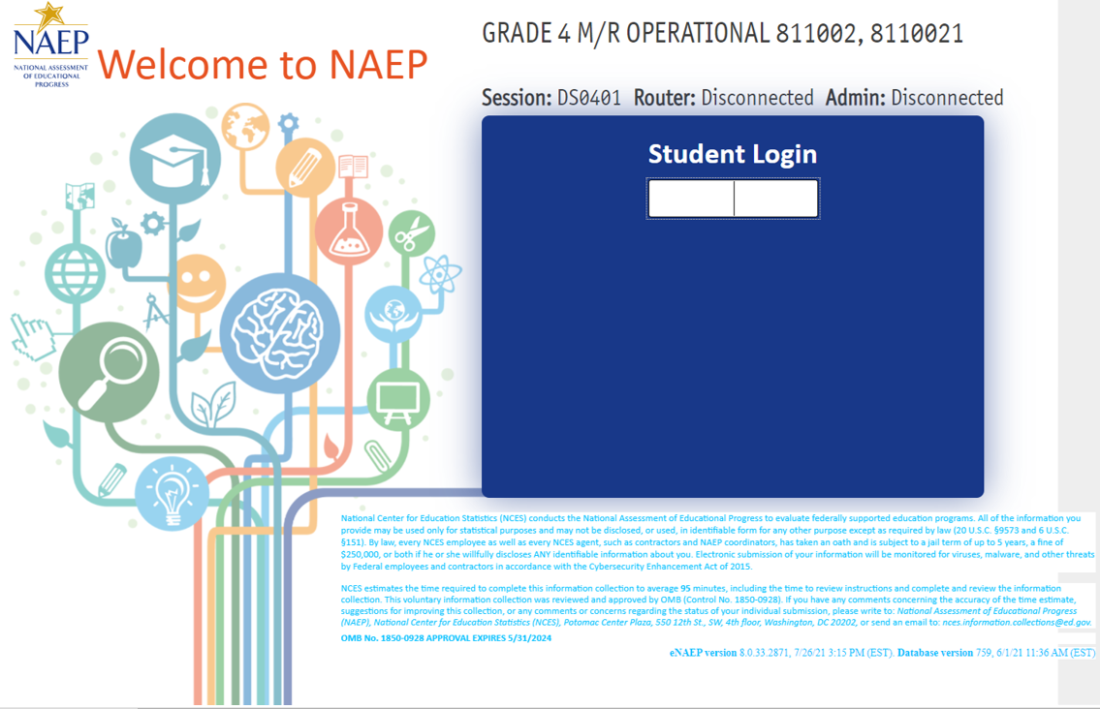

### **Appendix J1-1**: Operational Grade 4 (Core)

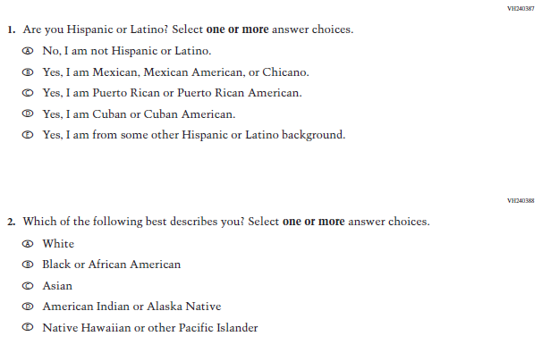

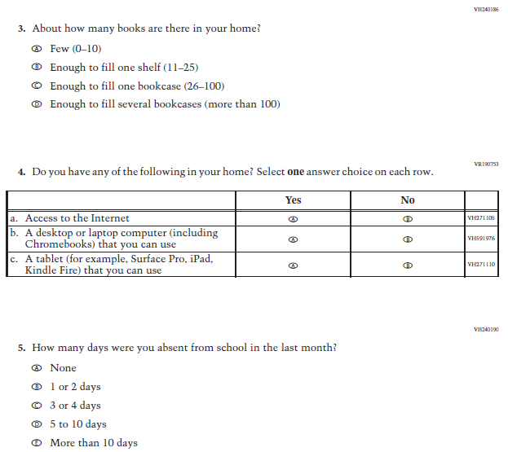

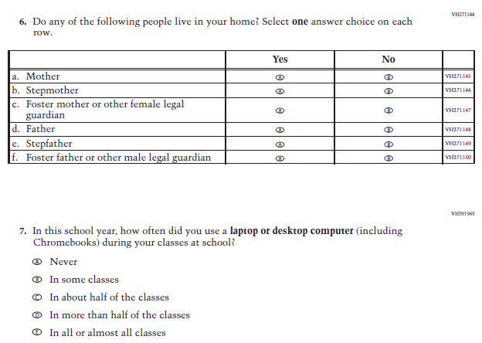

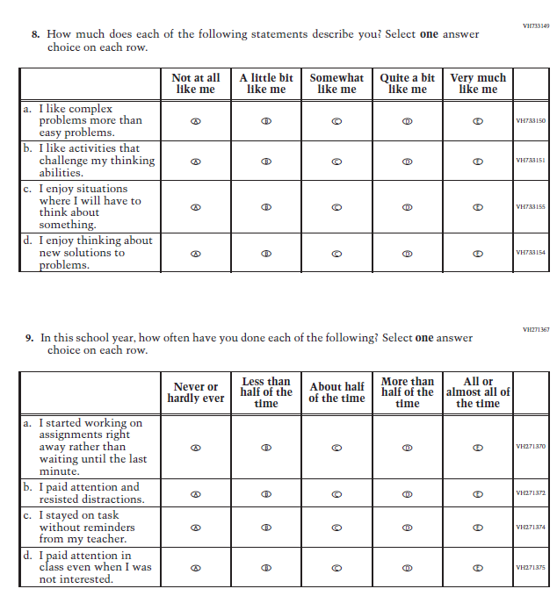

### **Appendix J1-2**: Operational Grade 8 (Core)

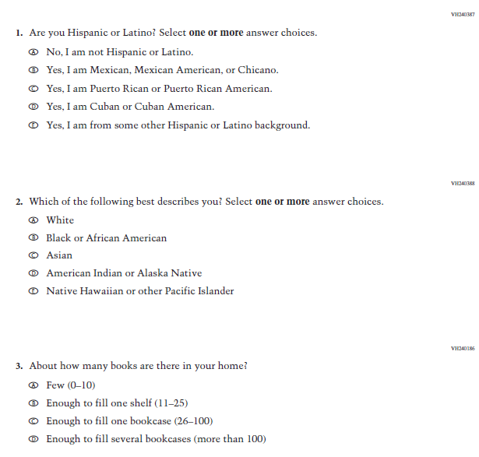

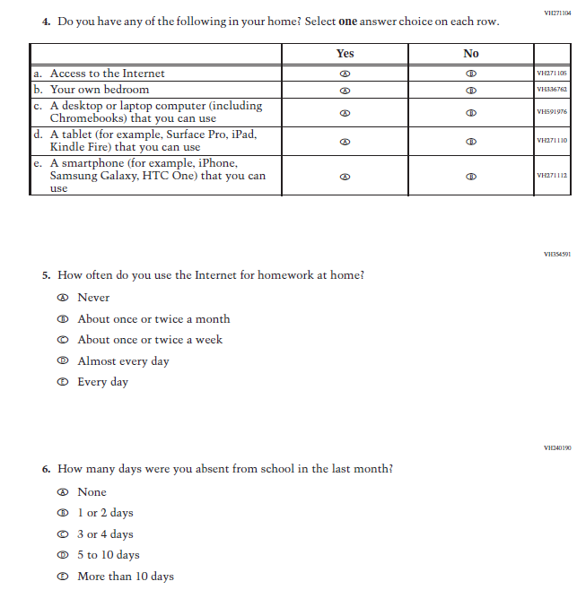

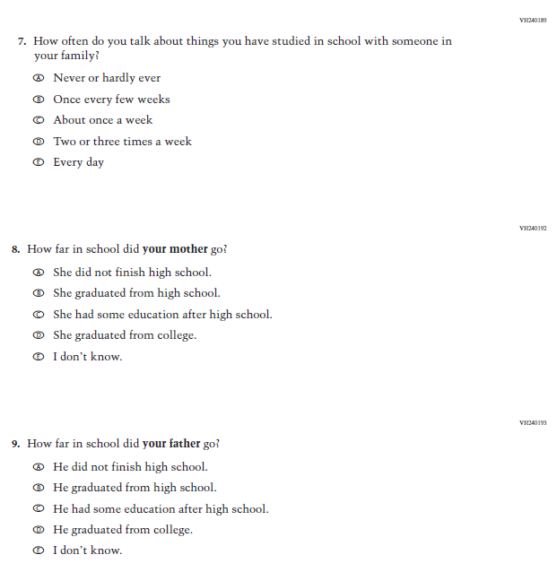

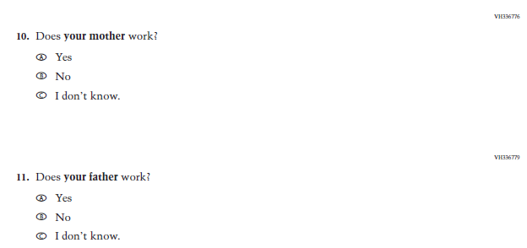

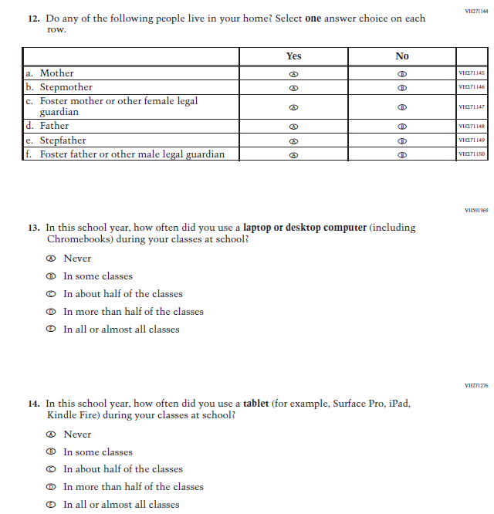

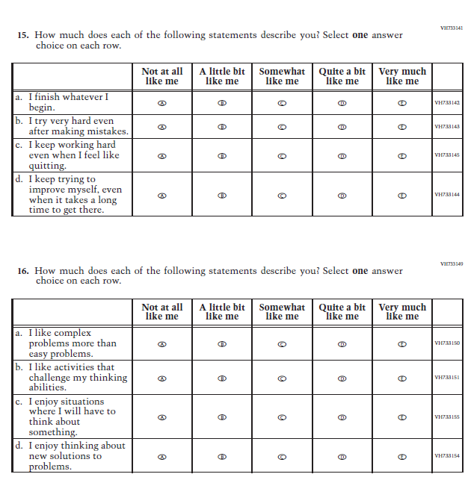

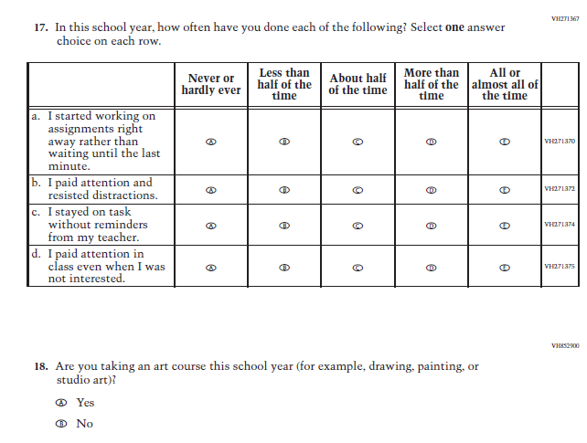

### **Appendix J1-3**: Operational Grade 12 (Core)













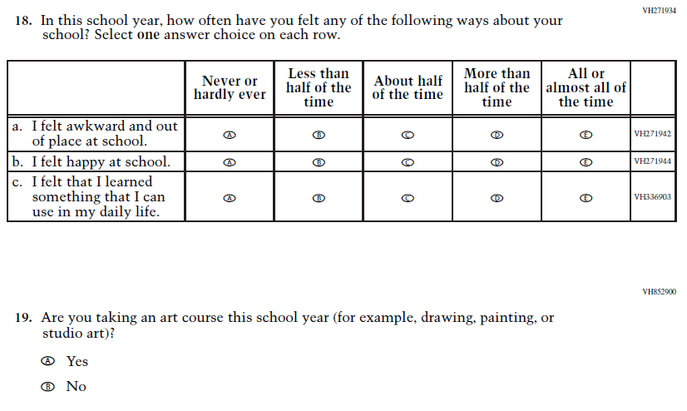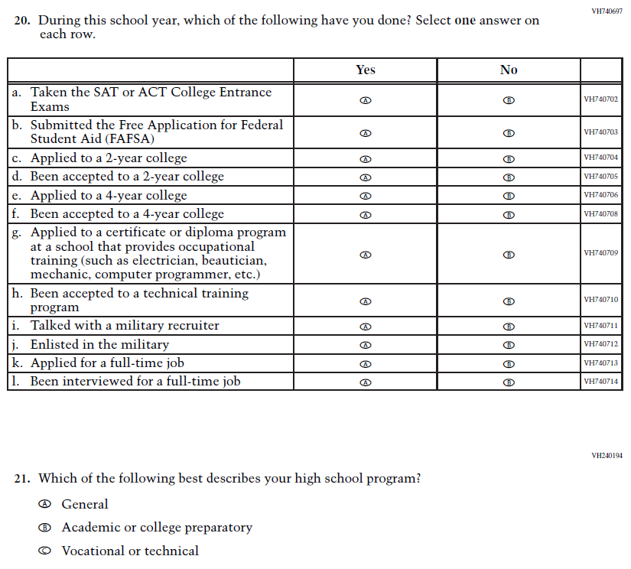

### **Appendix J1-4**: Operational Grade 4 (Mathematics)

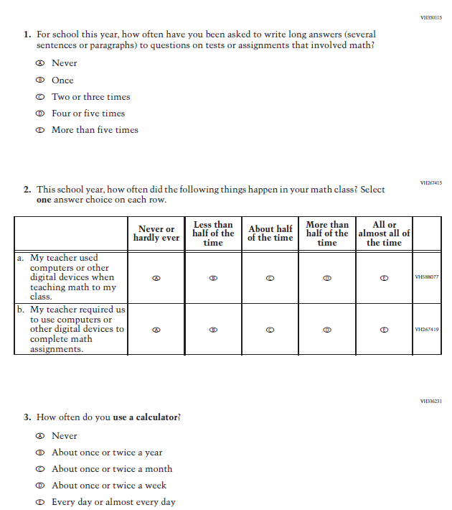

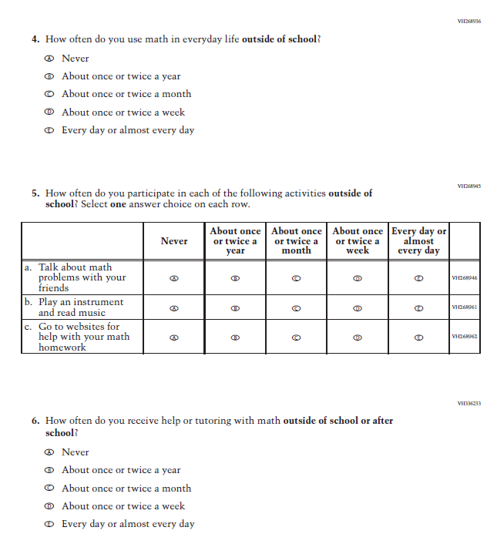

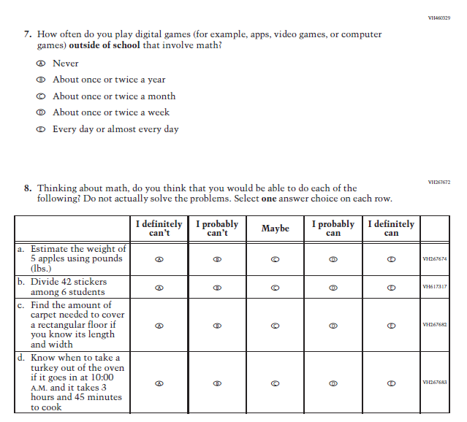

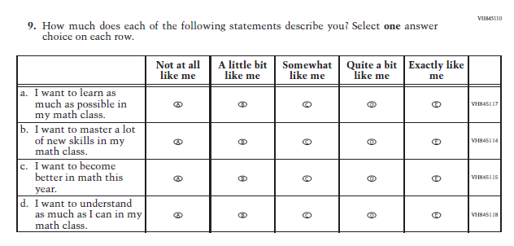

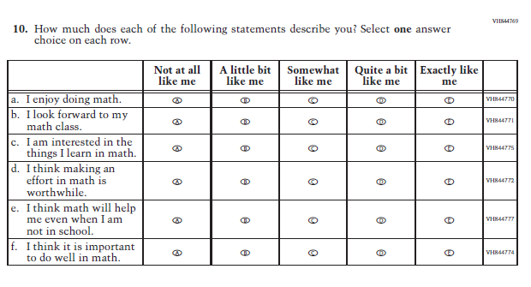

### **Appendix J1-5**: Operational Grade 8 (Mathematics)

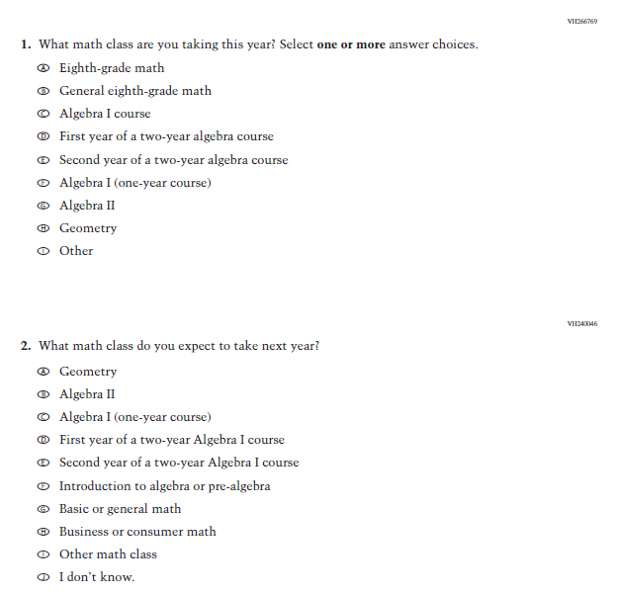

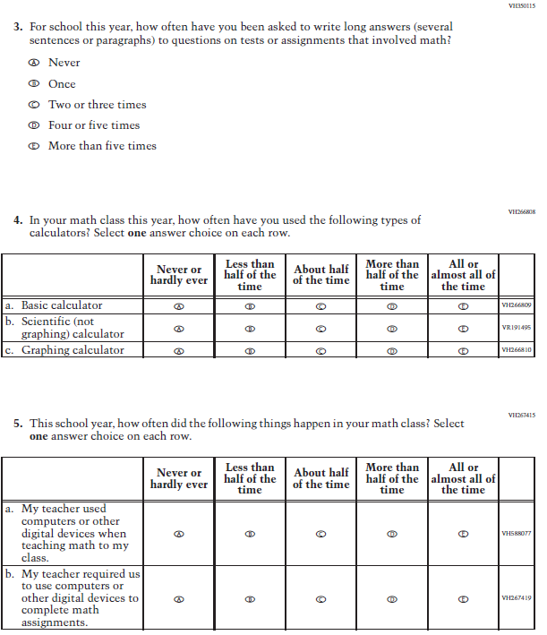

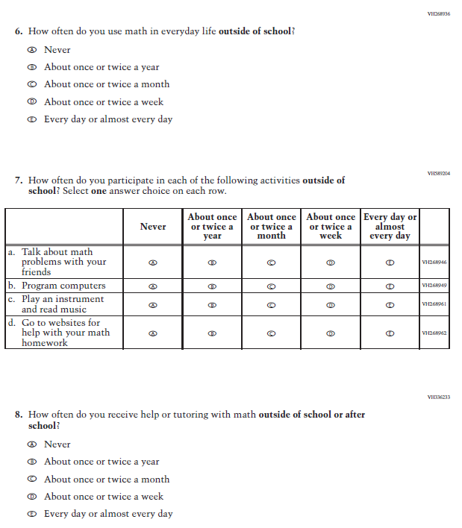

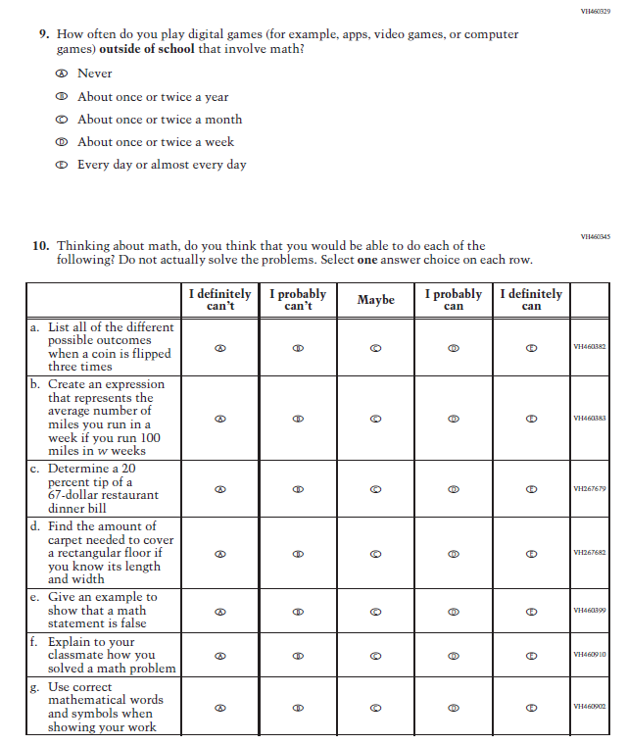

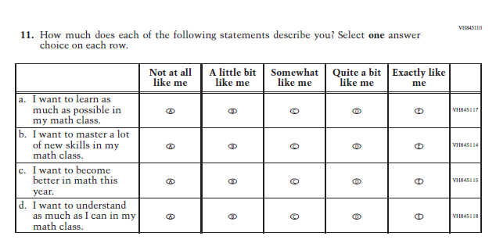

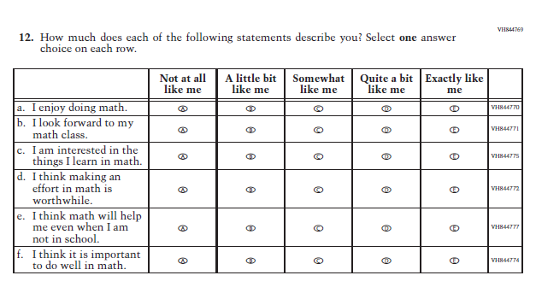

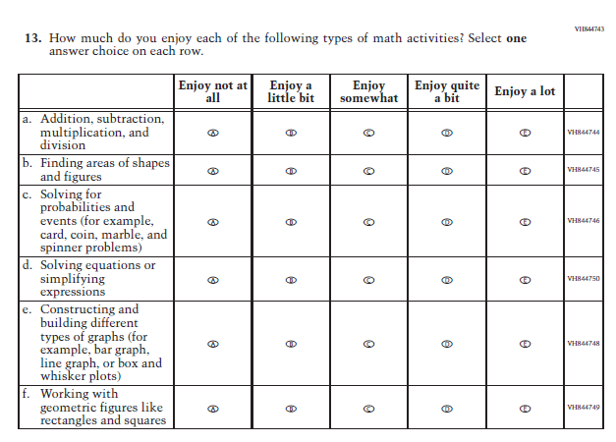

### **Appendix J1-6**: Summary of Changes Operational Grade 12 (Mathematics)

|  |  |  |  |
| --- | --- | --- | --- |
| **2024 Operational Grade 12 Mathematics Student** | | | |
| **Previous Item** | **2024 Item** | **D/A/ R/NC+** | **Rationale** |
| (2019 Grade 12) | **Issue:** Resources for Learning and Instruction | R | SubItem “b.” added to match the Grade 8 Item that was administered in 2022. |

### **Appendix J1-7**: Operational Grade 12 (Mathematics)

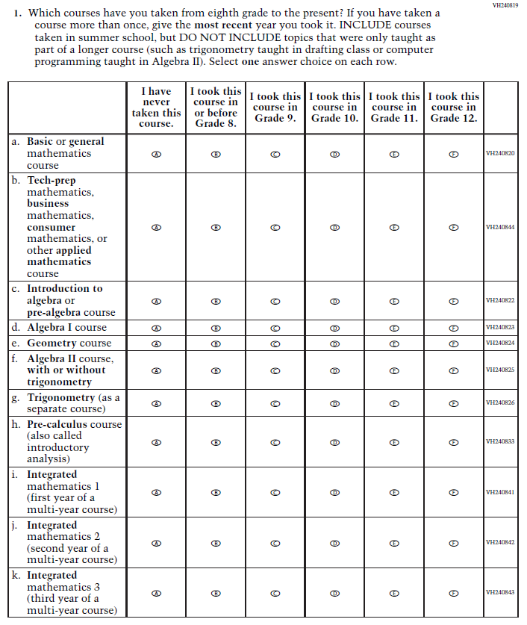

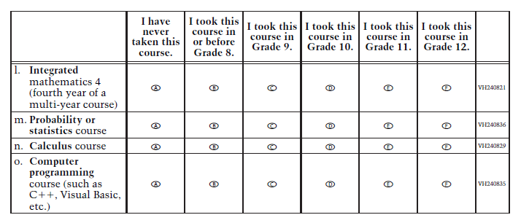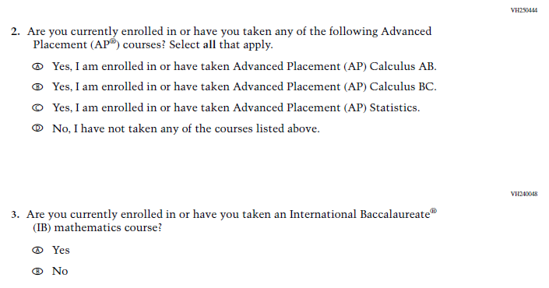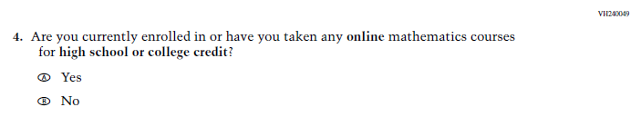

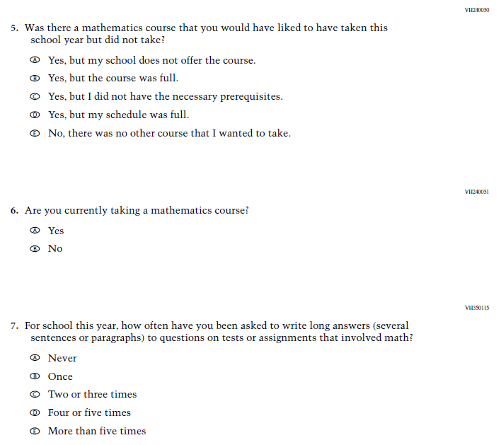

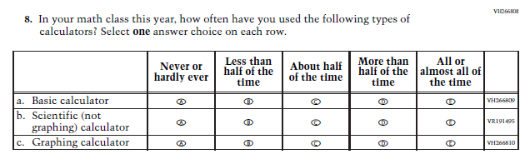

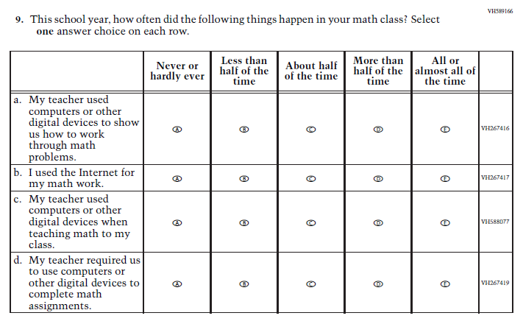

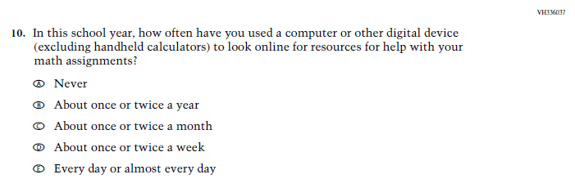

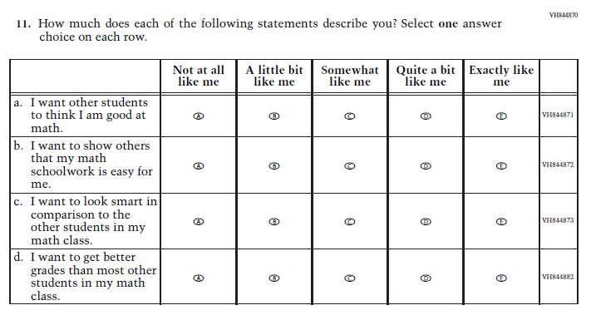

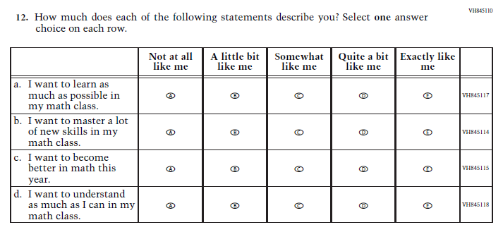

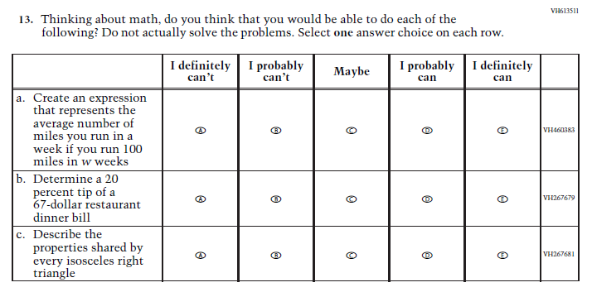

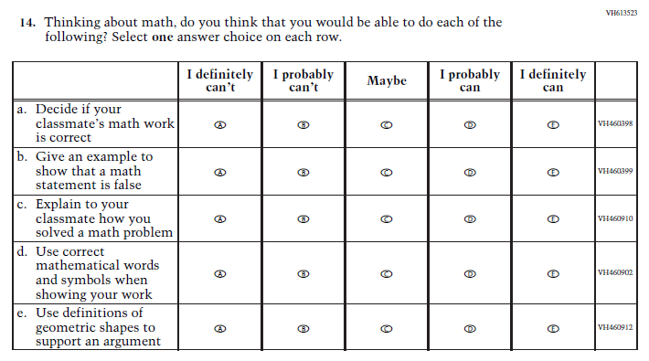

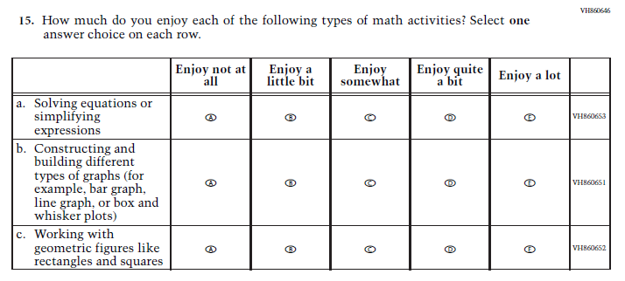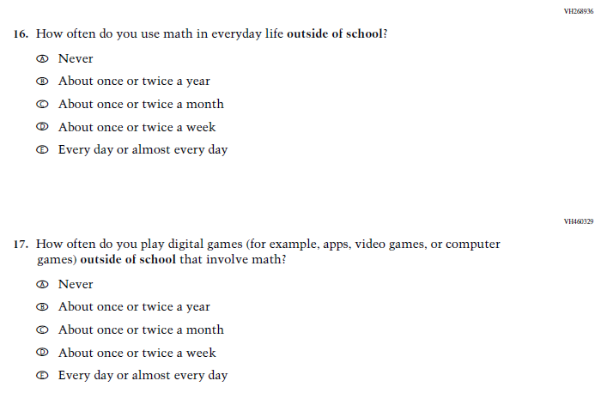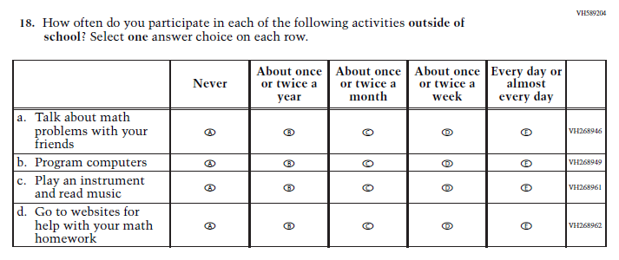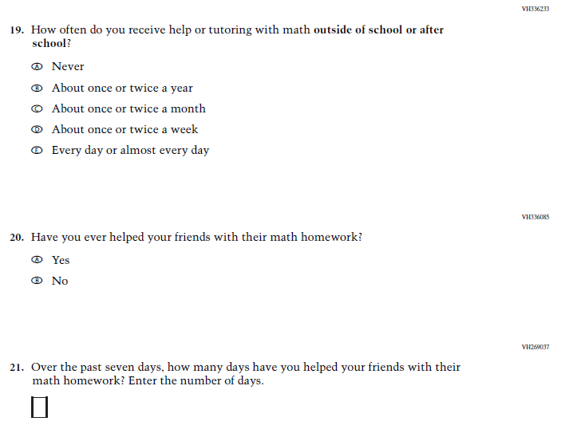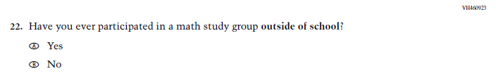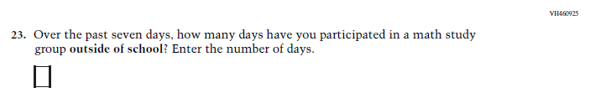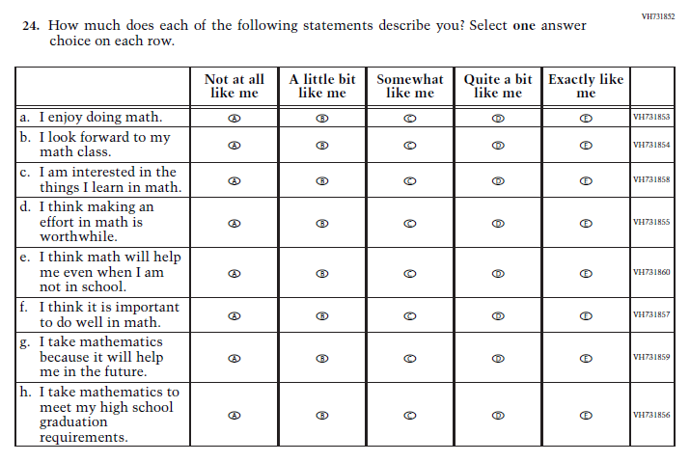

### **Appendix J1-8**: Operational Grade 4 (Reading)

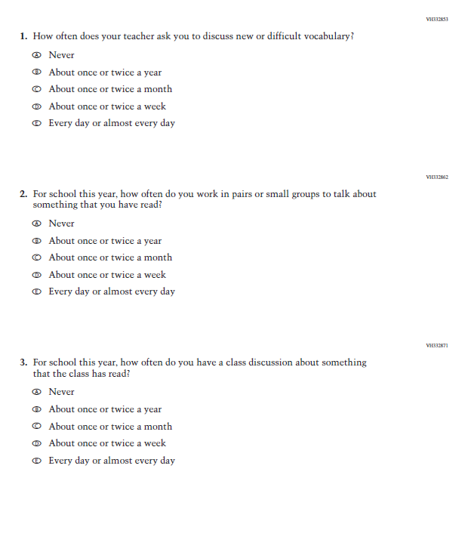

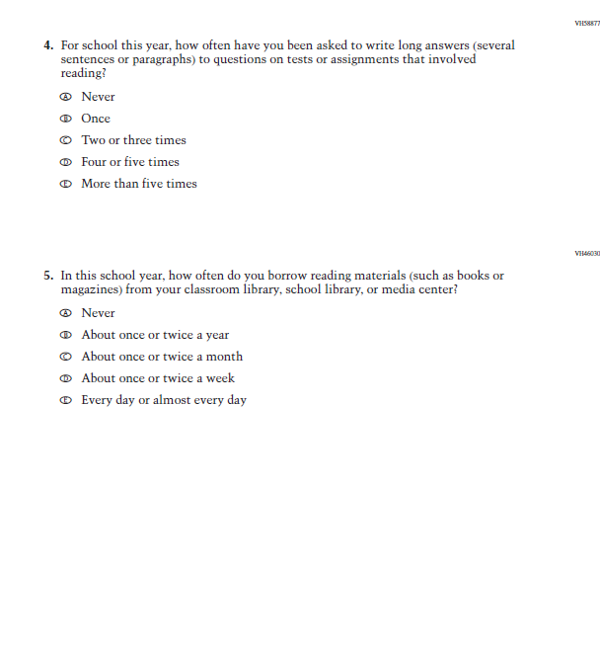

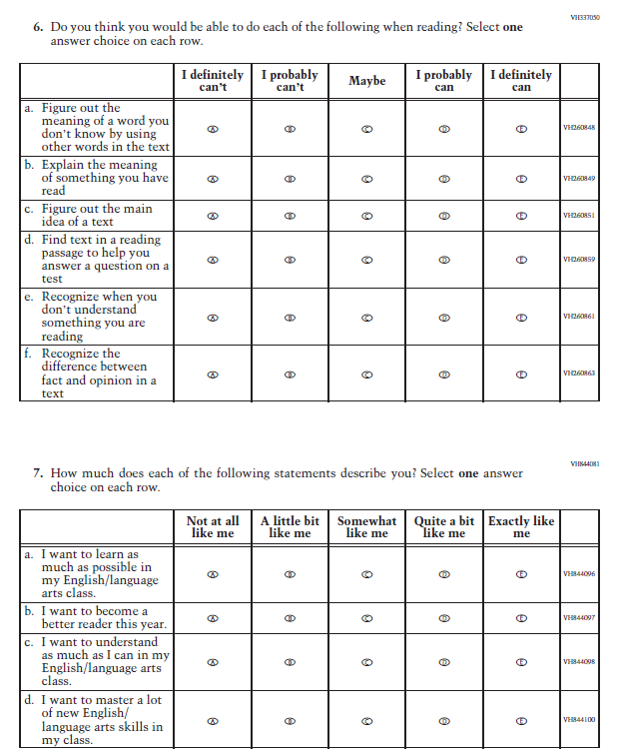

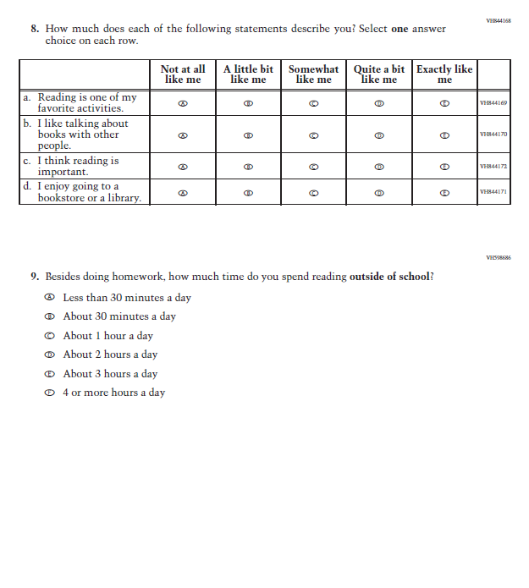

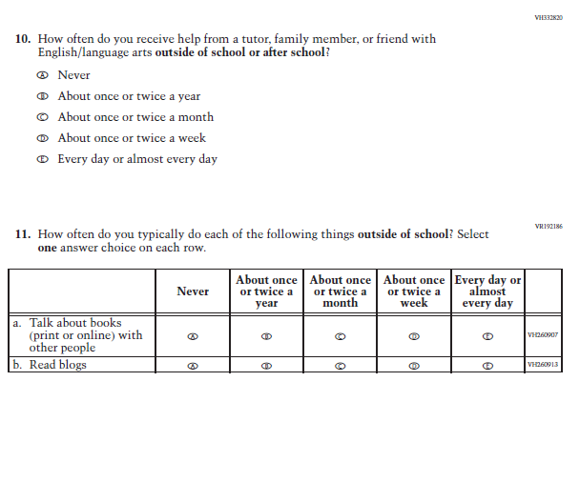

### **Appendix J1-9**: Operational Grade 8 (Reading)

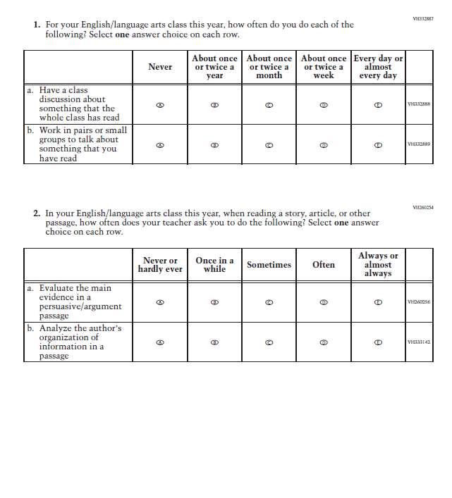

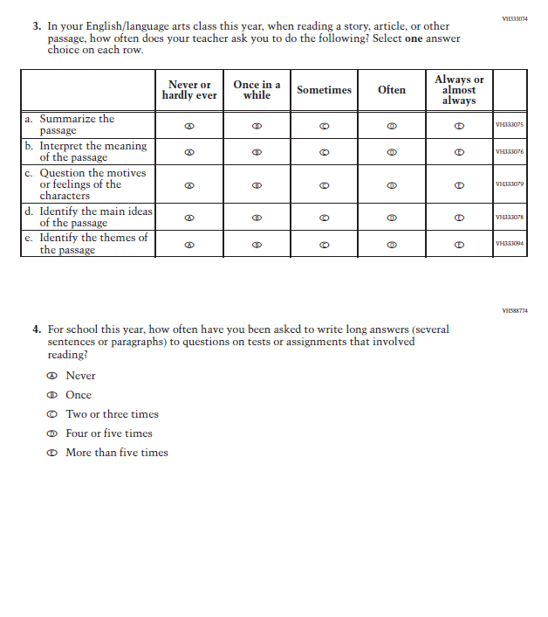

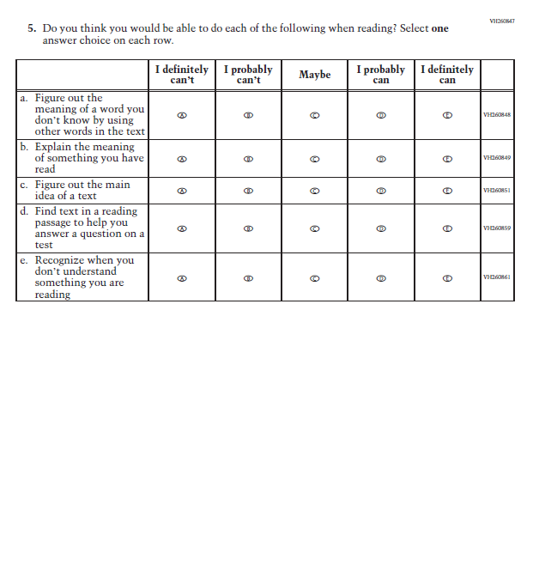

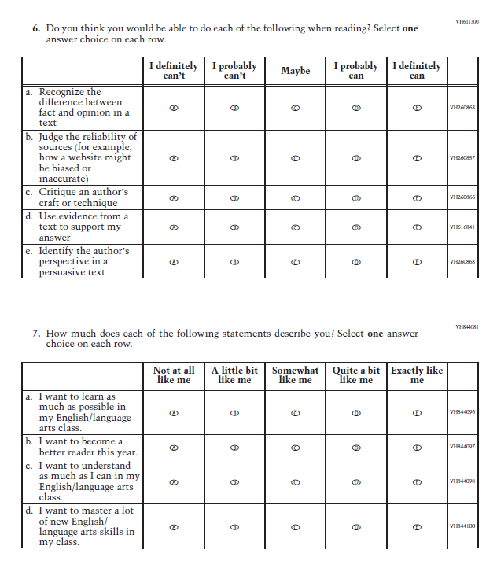

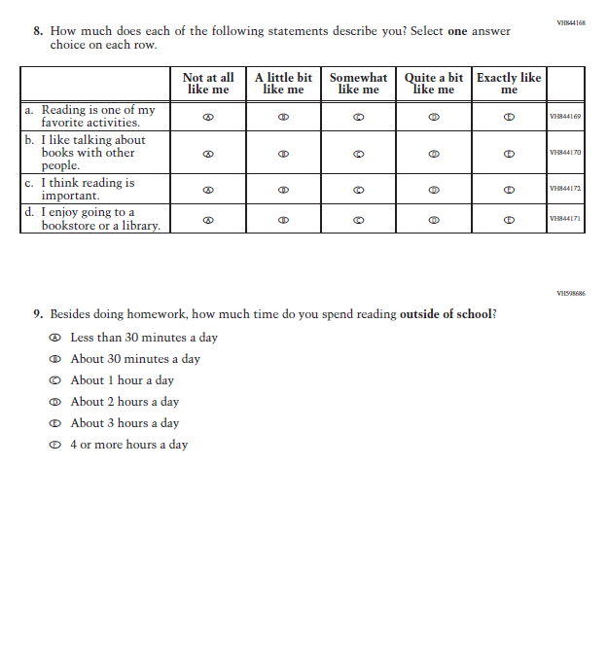

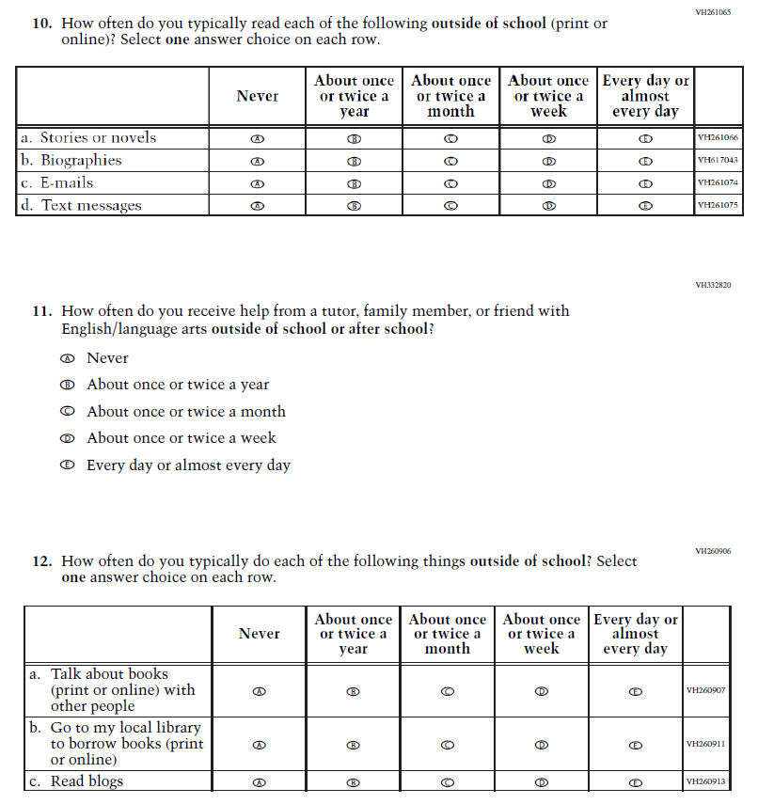

### **Appendix J1-10**: Operational Grade 12 (Reading)

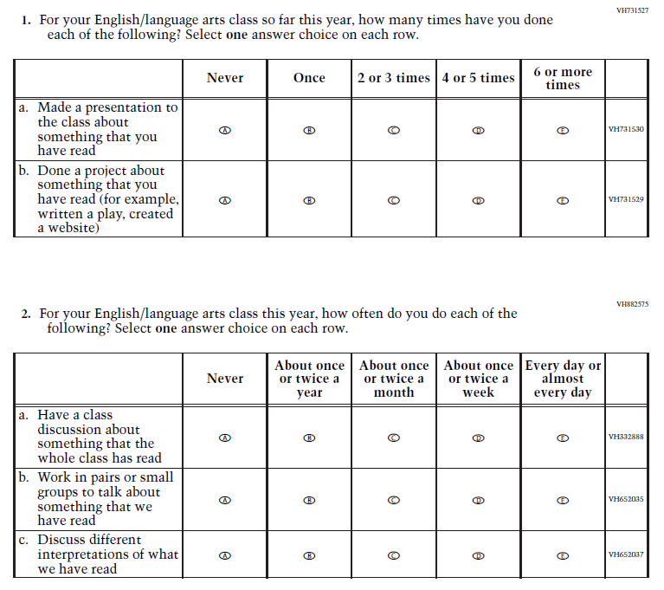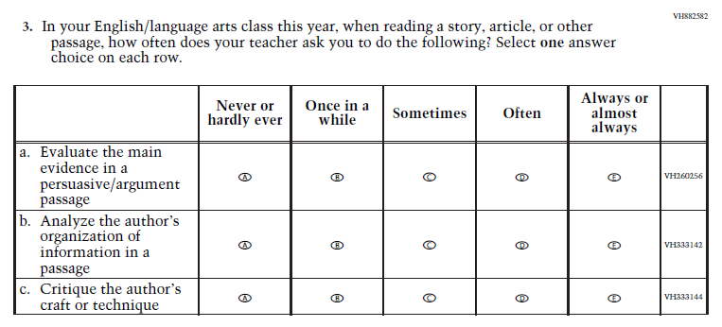

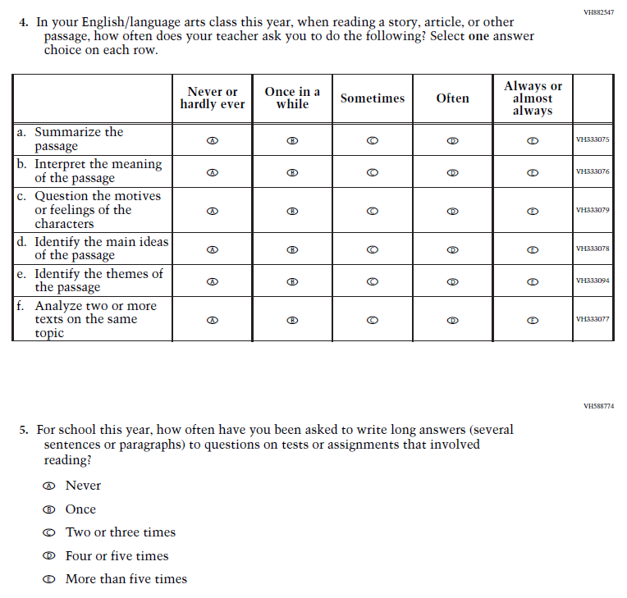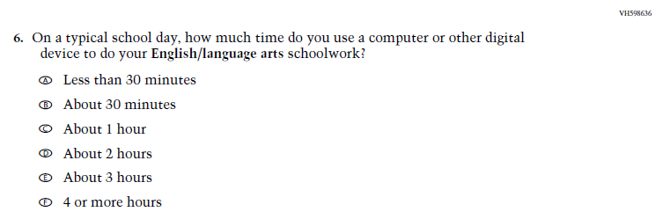

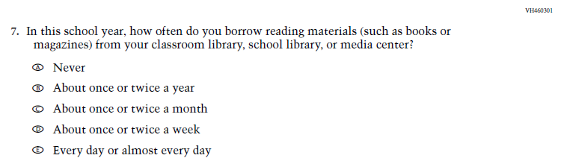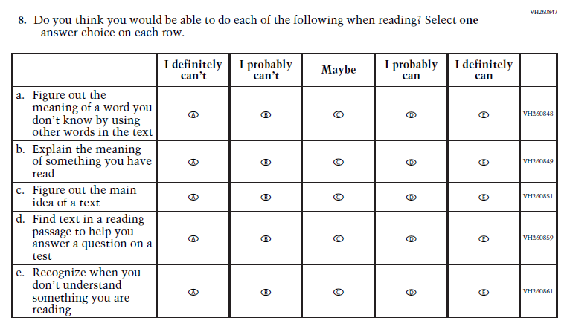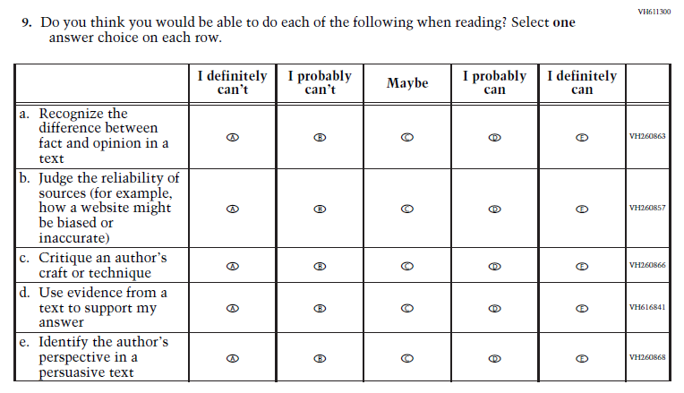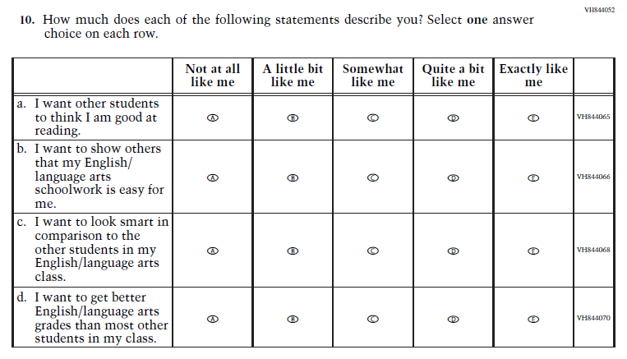

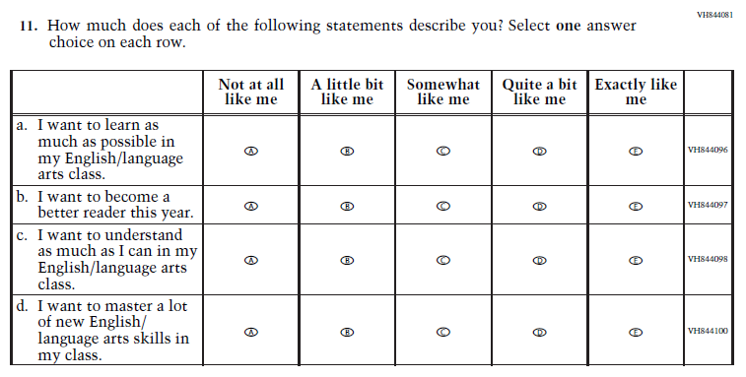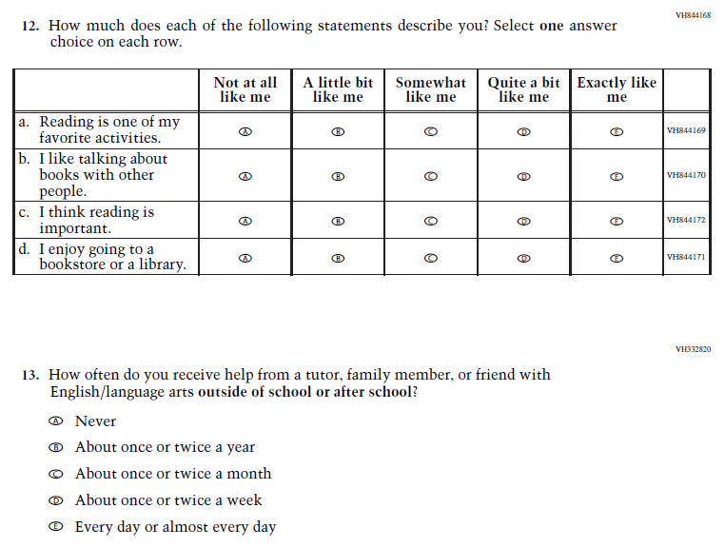

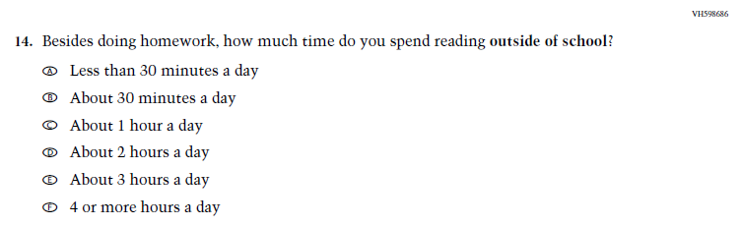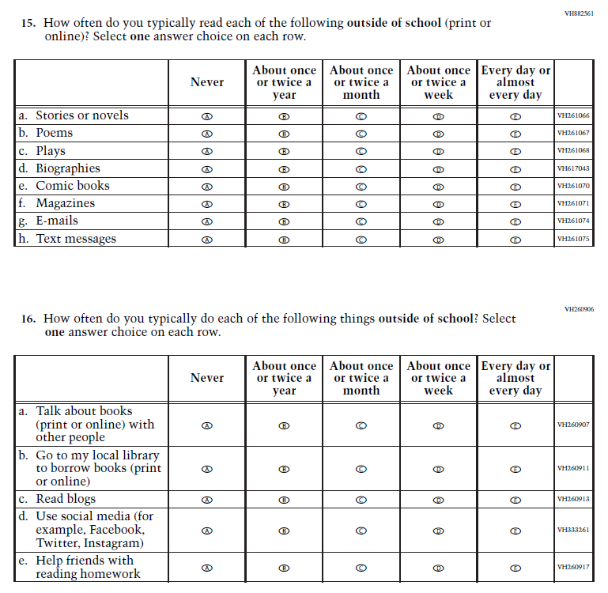

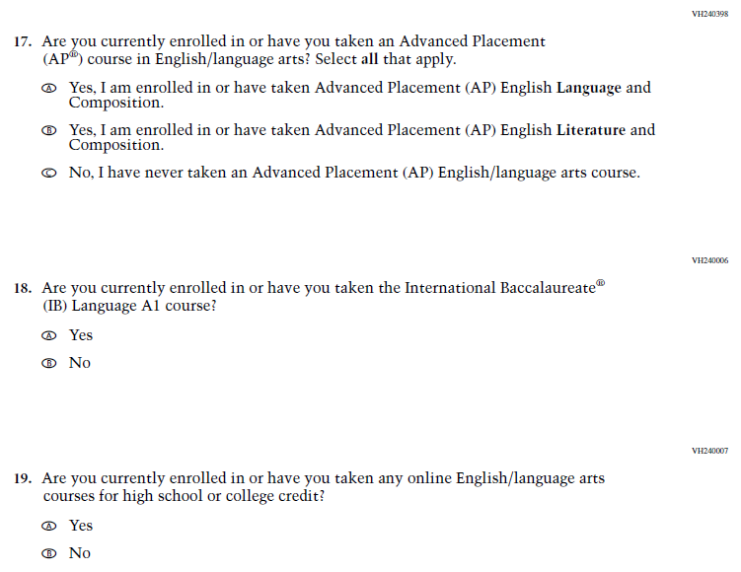

### **Appendix J1-11**: Operational Grade 8 (Science)

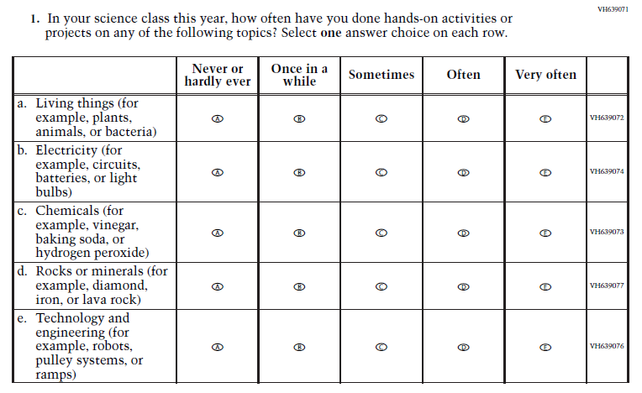

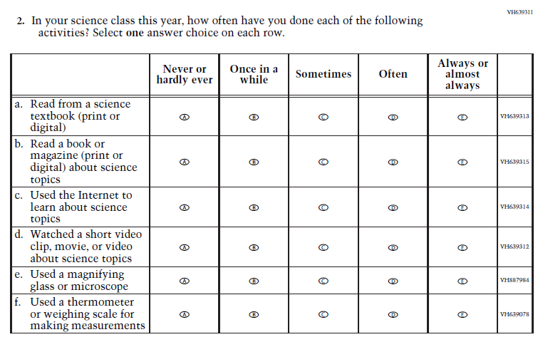

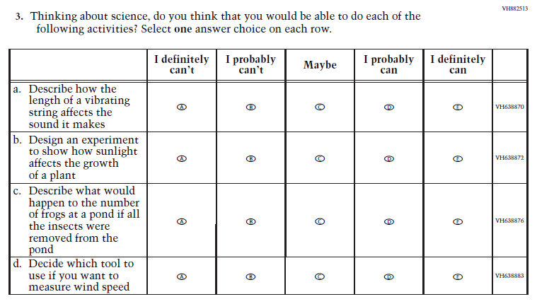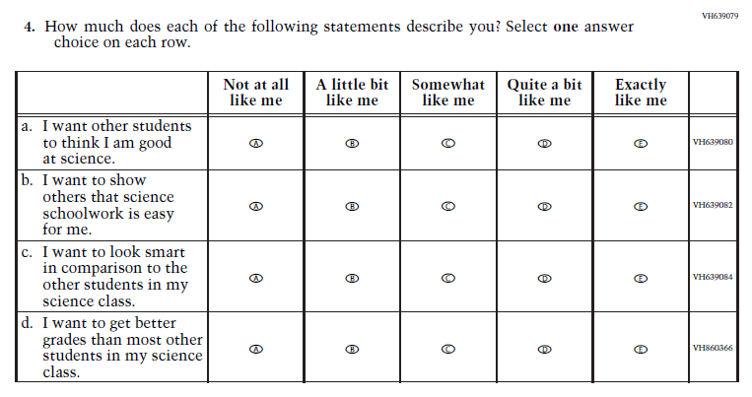

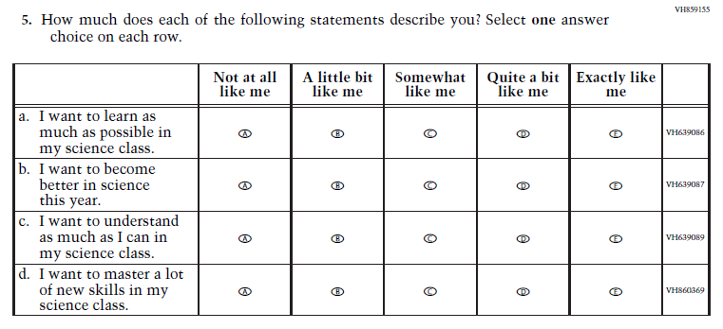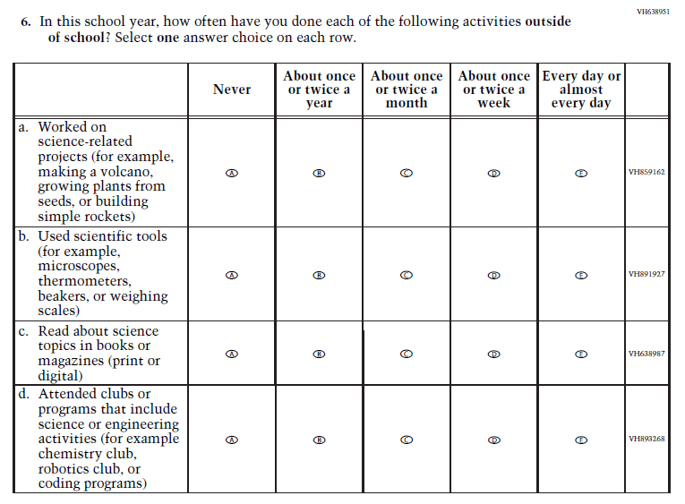

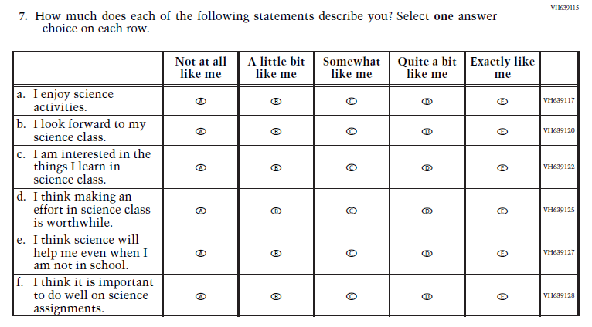

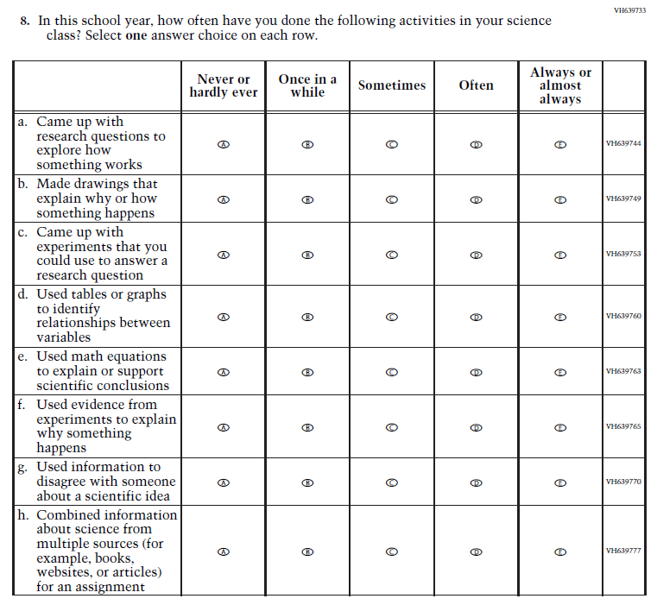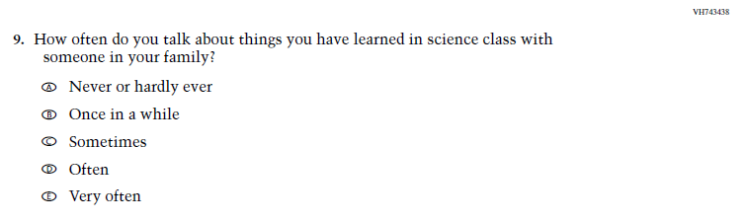

### **Appendix J1-12**: Operational Grade 4 (Debrief)

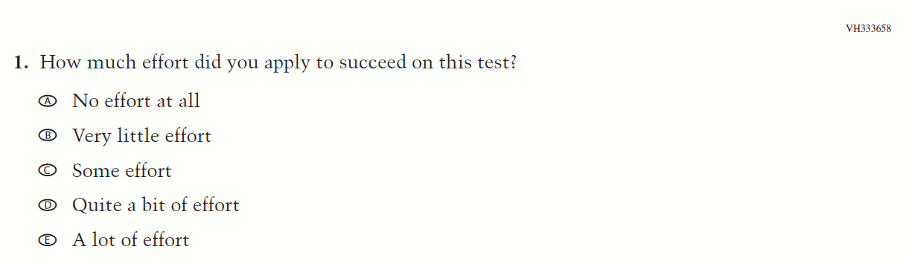

### **Appendix J1-13**: Operational Grade 8 and 12 (Debrief)

