*NATIONAL CENTER FOR EDUCATION STATISTICS NATIONAL ASSESSMENT OF EDUCATIONAL PROGRESS*

*National Assessment of Educational Progress (NAEP)2024*

*Appendix J2*

*2024 Teacher Questionnaires*

*OMB# 1850-0928 v.29*

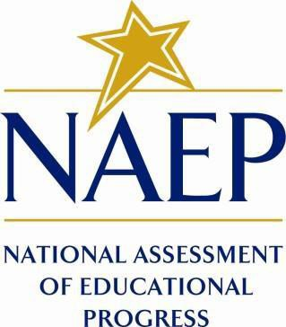

March 2023

Appendix J2 provides the teacher survey questionnaires that will be administered in 2024. Grades 4 and 8 Core, Math, and Reading questionnaires were previously approved in 2022 (OMB# 1850-0928 v.28), and any changes to the items from the 2022 administration are reflected in summary tables. Additionally, grade 8 Science was previously approved in 2019 (OMB# 1850-0928 v.15), and any changes to the items from the 2019 administration are reflected in summary tables.

Updates to the teacher survey questionnaires, including new COVID-19 SQs and a planned revision to the gender measure for teachers, will be available in this document in Amendment #2 by May 2023. Draft NIES questionnaires will be included in Amendment #2 and final questionnaires will be in Amendment #3 (July 2023). Note that all login screens and paper booklet covers contained in this document will be updated with the most current OMB clearance expiration date before administration.

Table of Contents

Teacher Questionnaires

**Sample Teacher Questionnaire Login Screens** 3

**Sample Teacher Questionnaire Booklet Covers** 4

**Appendix J2-1**: Operational Grade 4 (Core) 5

**Appendix J2-2**: Summary of Changes Operational Grade 8 (Core) 14

**Appendix J2-3**: Operational Grade 8 (Core) 15

**Appendix J2-4**: Operational Grade 4 (Mathematics) 26

**Appendix J2-5**: Operational Grade 8 (Mathematics) 34

**Appendix J2-6**: Operational Grade 4 (Reading) 43

**Appendix J2-7**: Operational Grade 8 (Reading) 50

**Appendix J2-8**: Operational Grade 8 (Science) 57

### **Sample Teacher Questionnaire Login Screens**

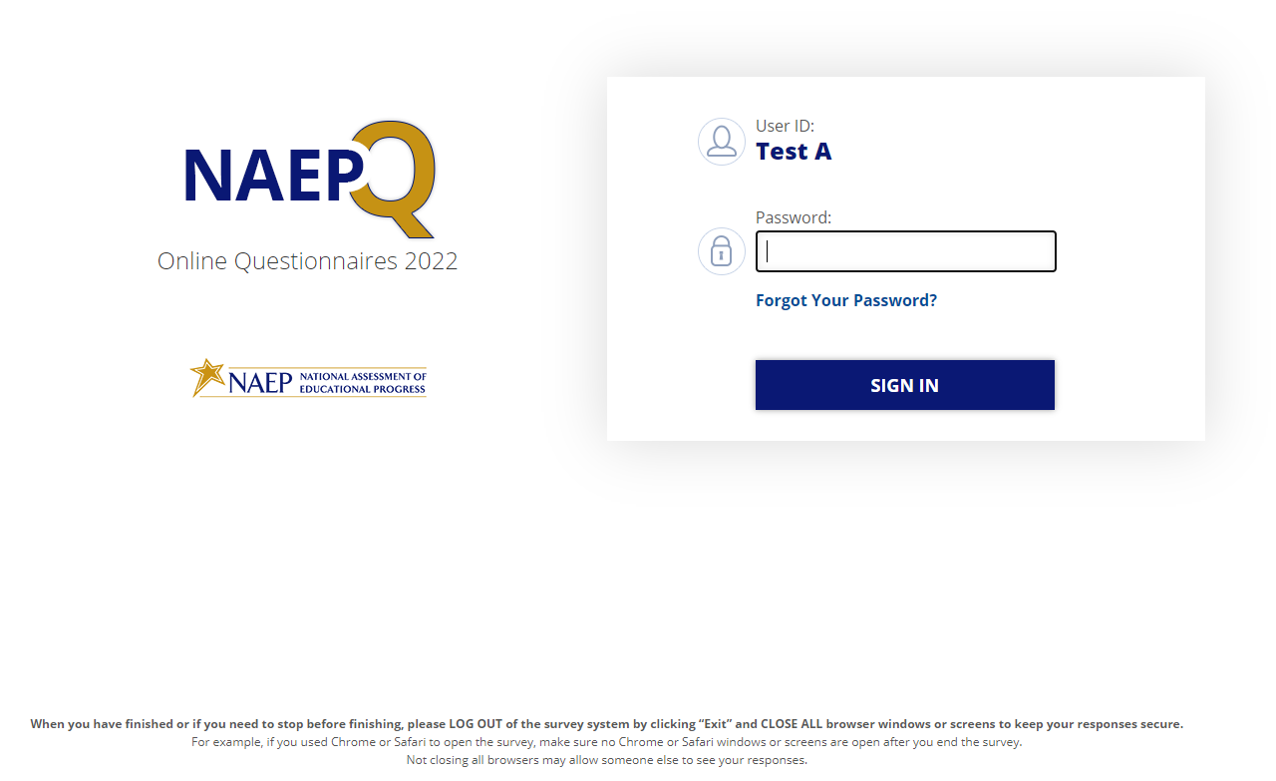

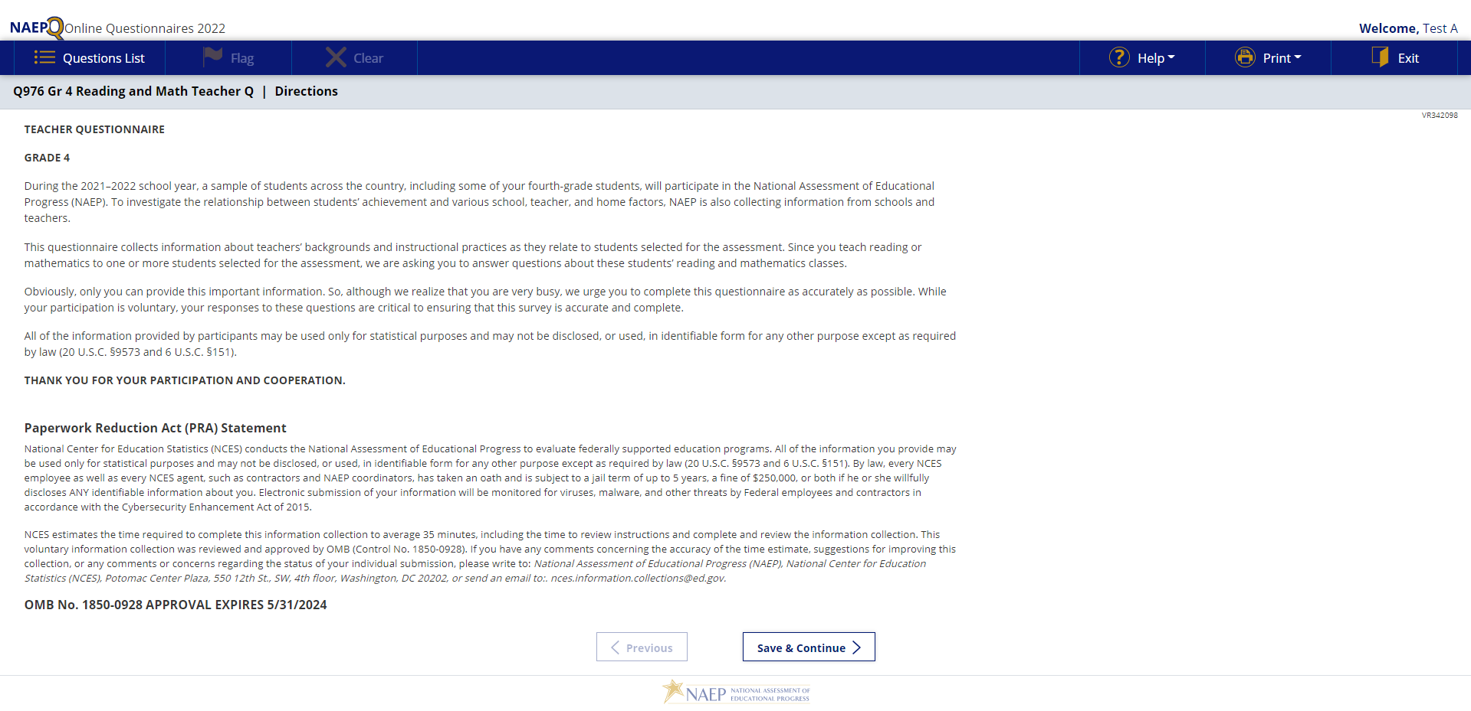

### **Sample Teacher Questionnaire Booklet Covers**

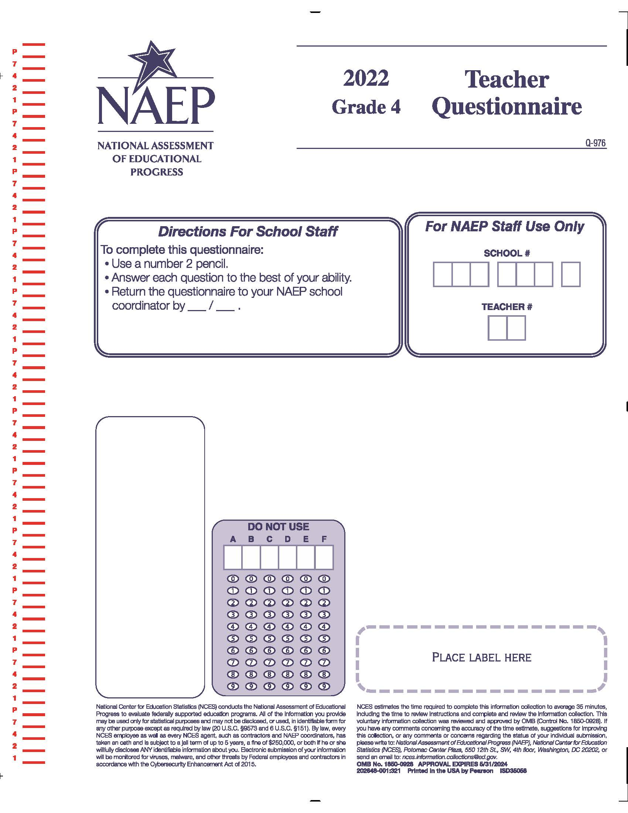

### **Appendix J2-1**: Operational Grade 4 (Core)

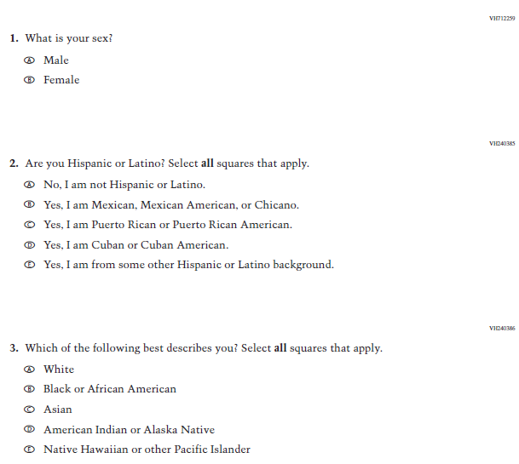

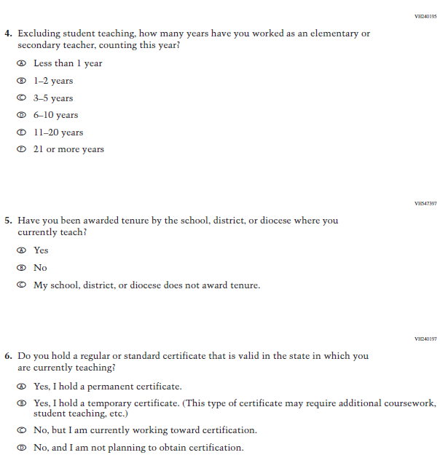

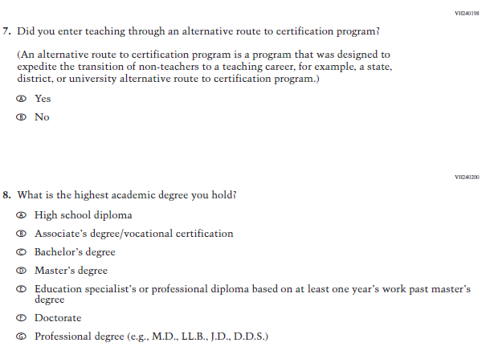

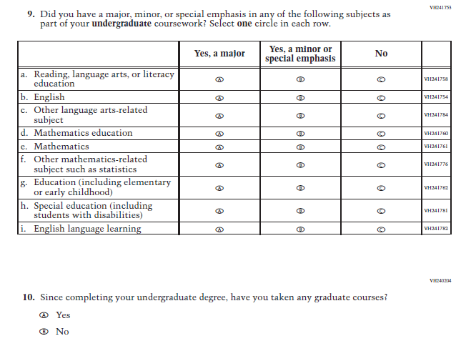

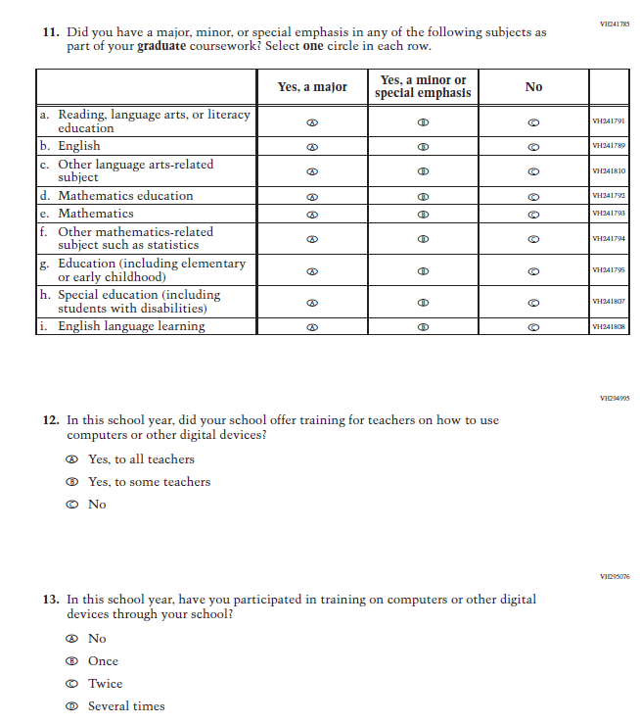

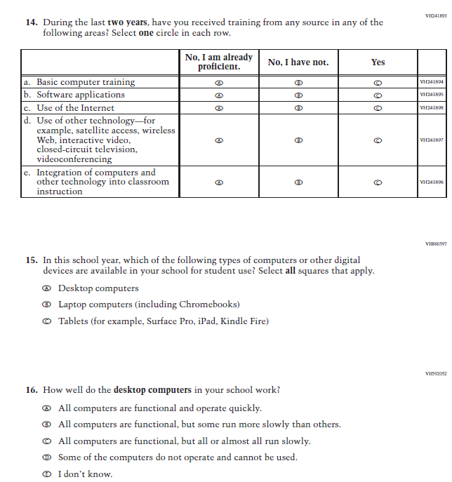

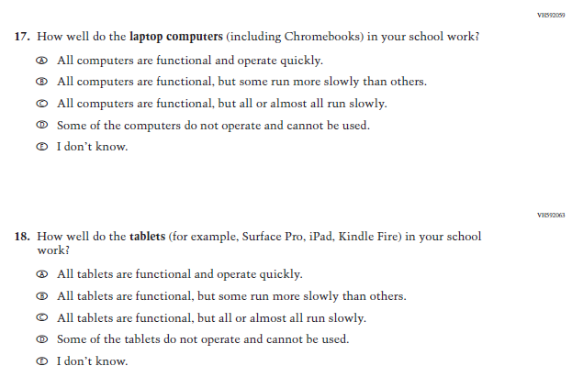

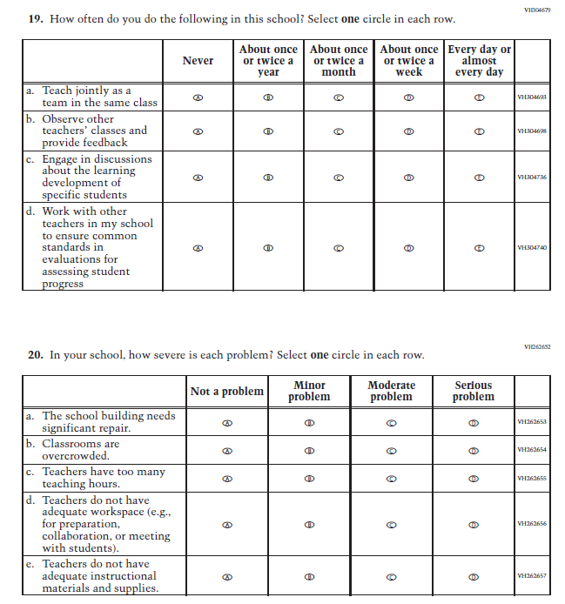

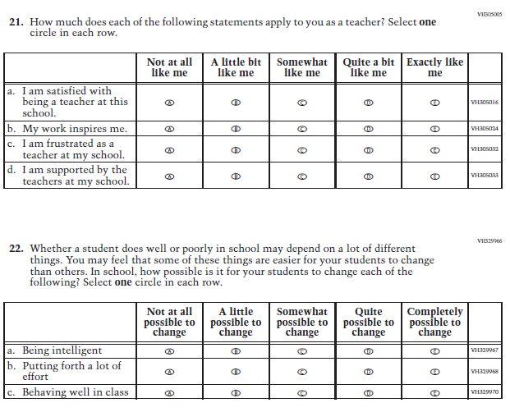

### **Appendix J2-2**: Summary of Changes Operational Grade 8 (Core)

|  |  |  |  |
| --- | --- | --- | --- |
| **2024 Operational Grade 8 Core Teacher** | | | |
| **Previous Item** | **2024 Item** | **D/A/ R/NC+** | **Rationale** |
| (2022 Grade 8) |  | R | The 2022 version of the Item, which references Social Studies, was replaced with the Item that references Science. Social Studies is not in the 2024 NAEP Assessment. Science is being administered at Grade 8. |

### **Appendix J2-3**: Operational Grade 8 (Core)

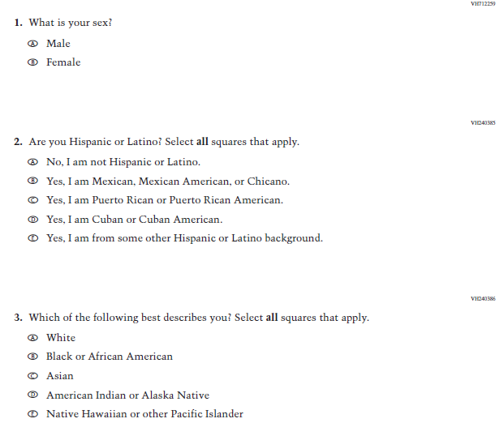

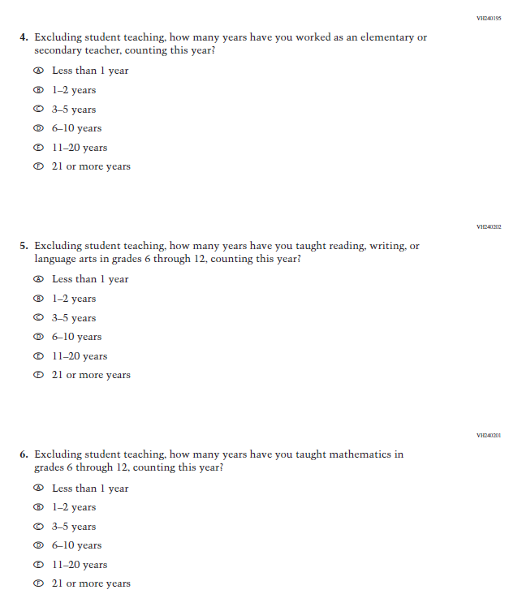

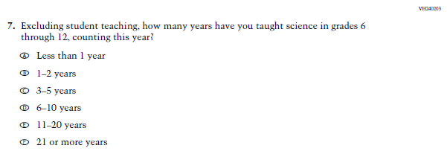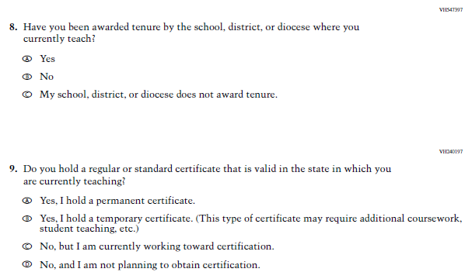

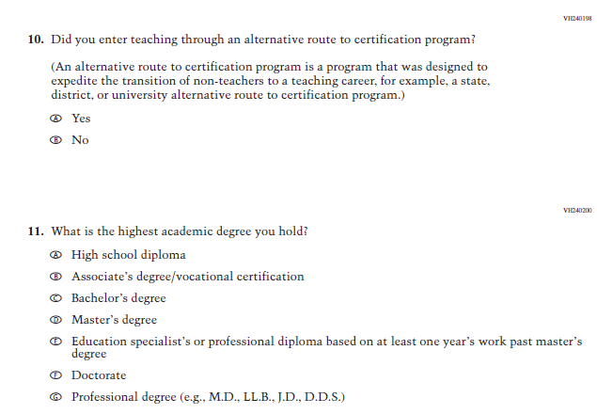

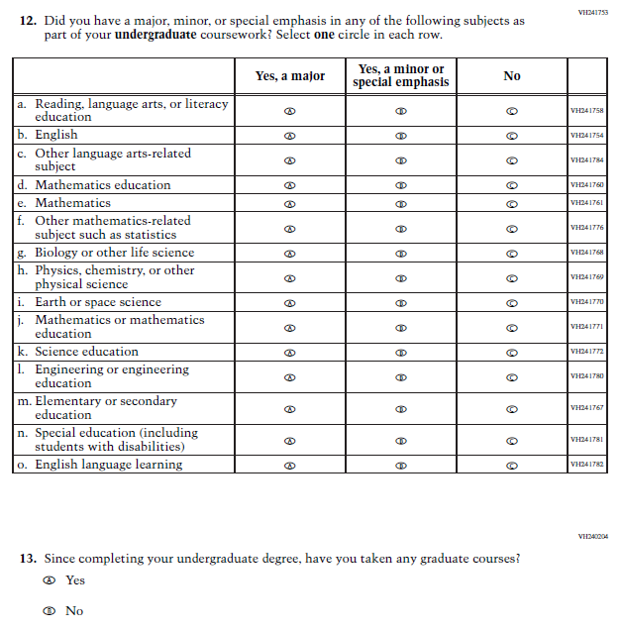

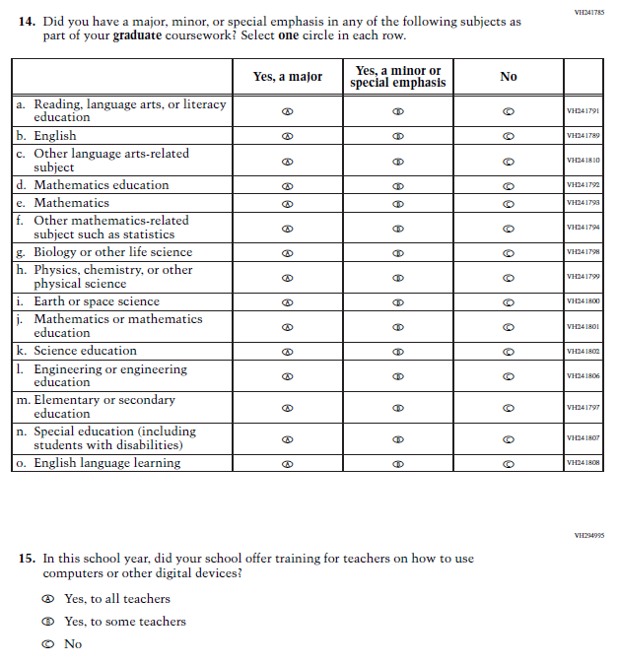

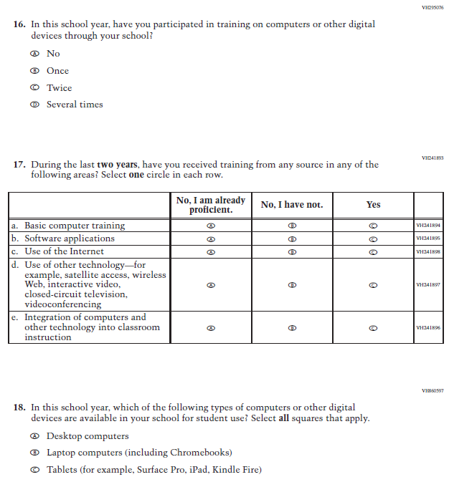

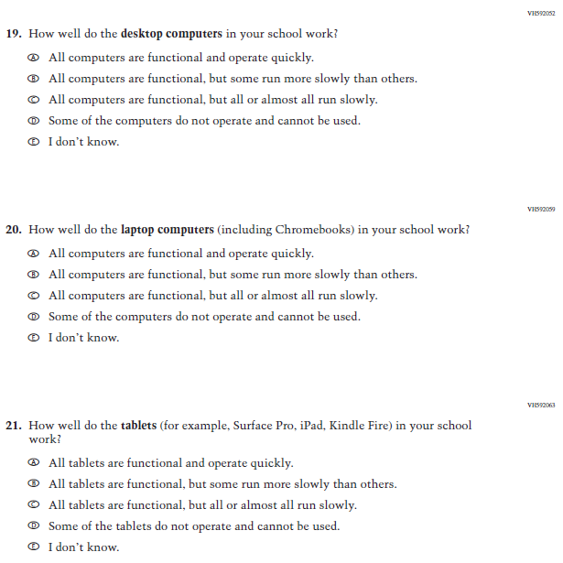

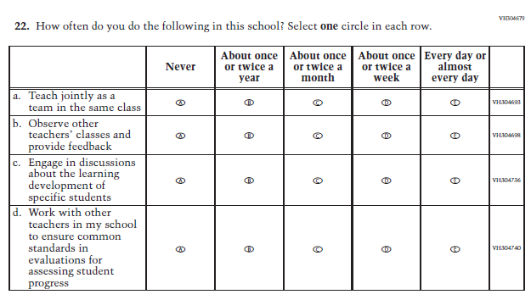

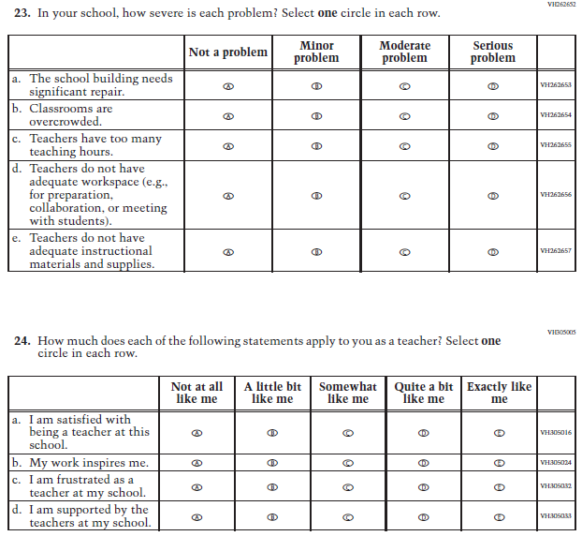

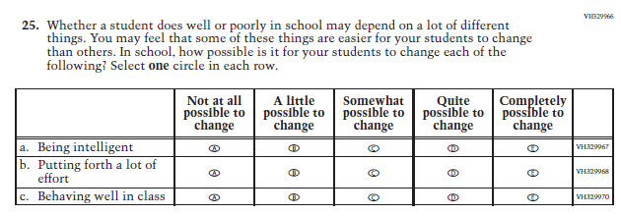

### **Appendix J2-4**: Operational Grade 4 (Mathematics)

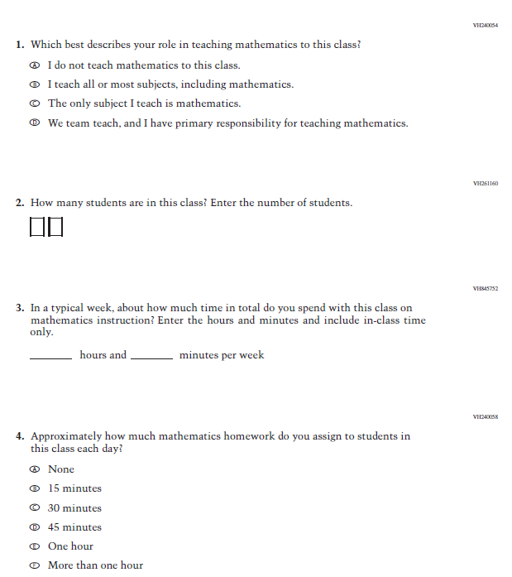

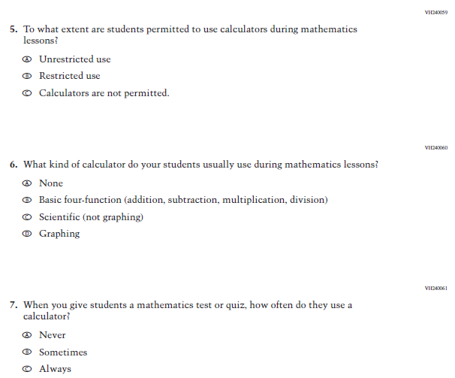

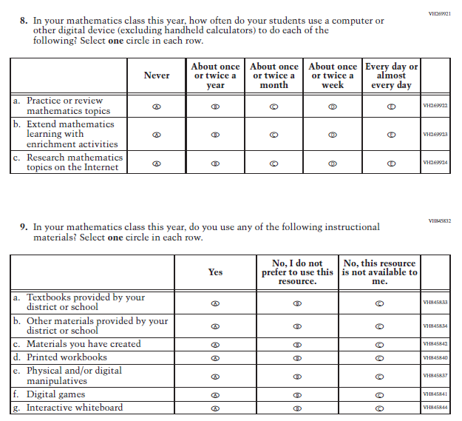

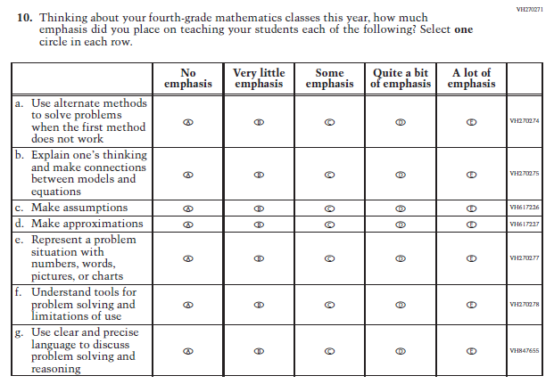

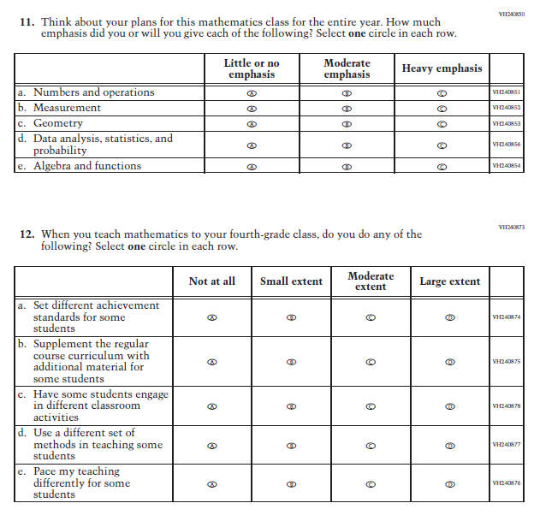

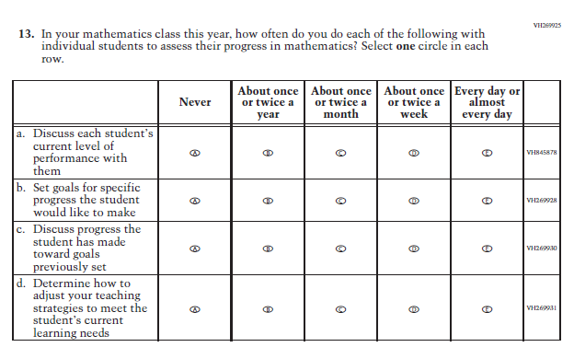

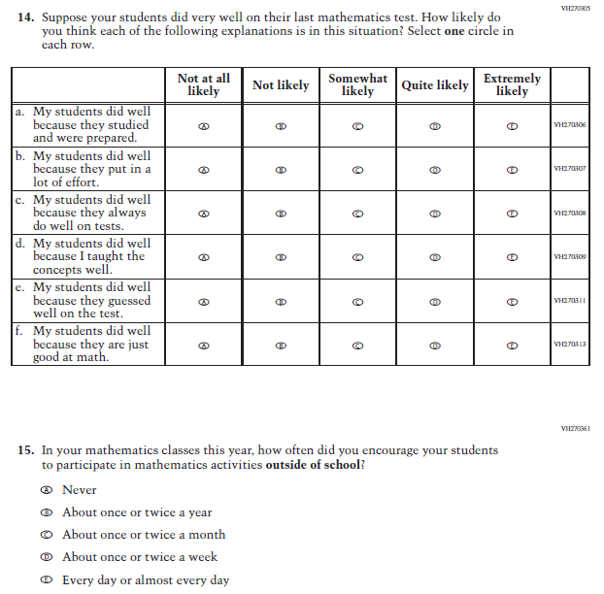

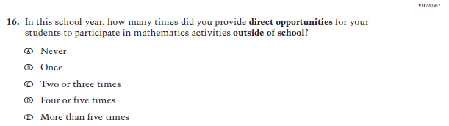

### **Appendix J2-5**: Operational Grade 8 (Mathematics)

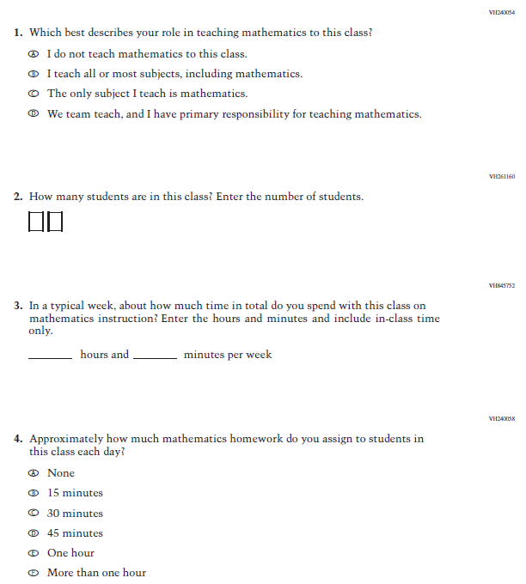

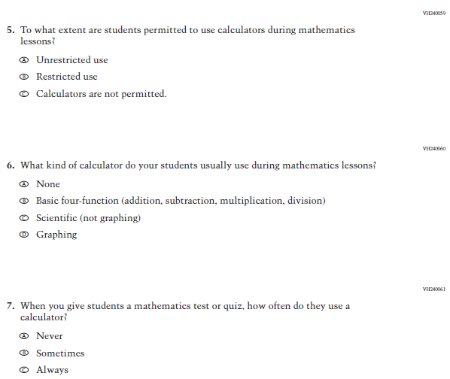

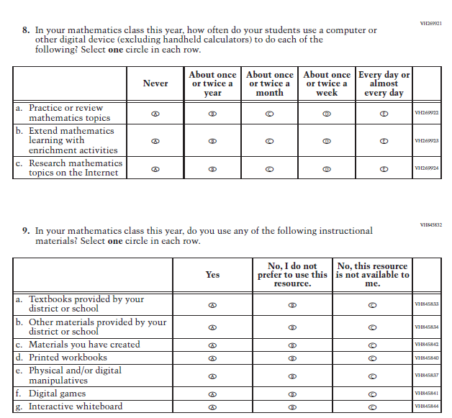

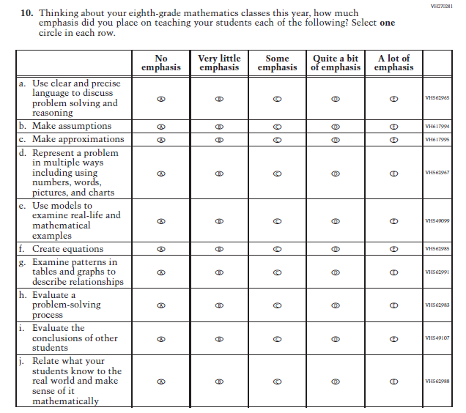

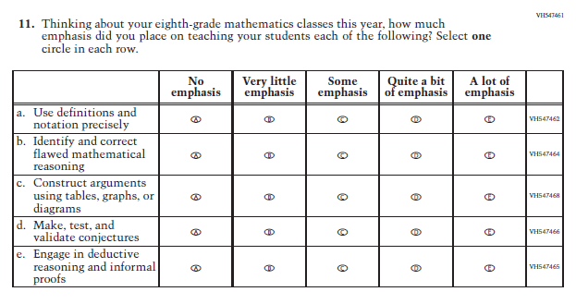

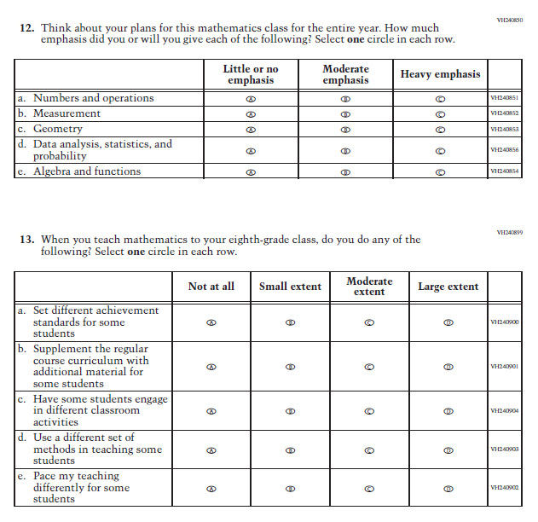

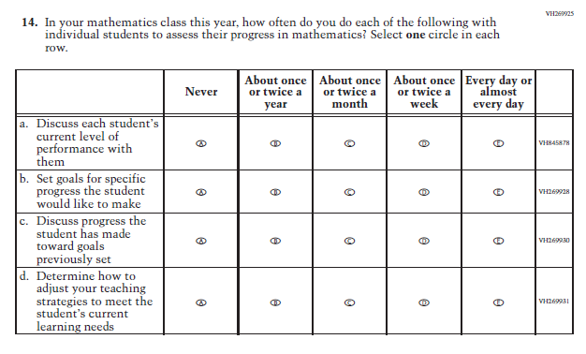

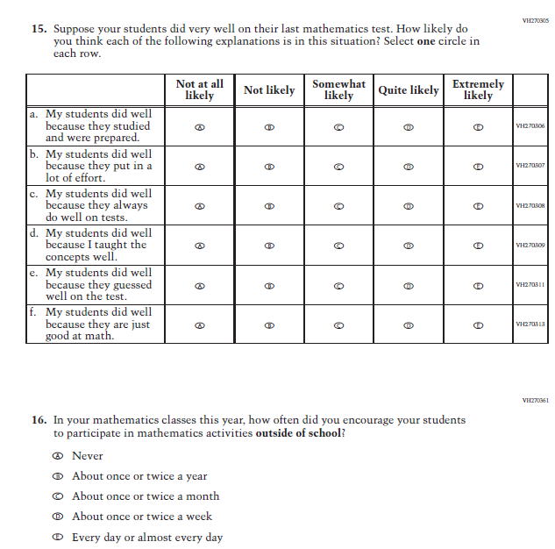

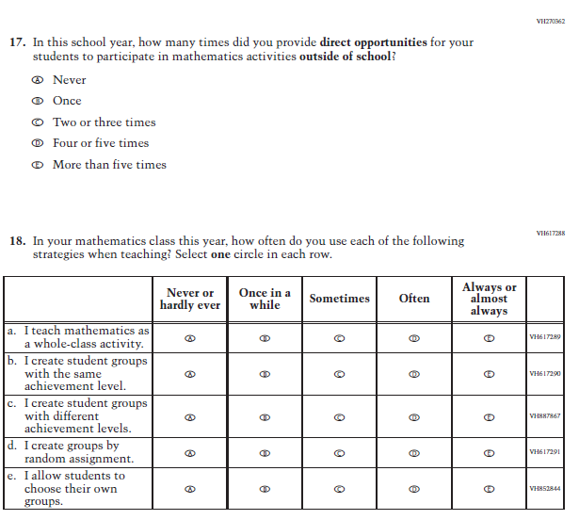

### **Appendix J2-6**: Operational Grade 4 (Reading)

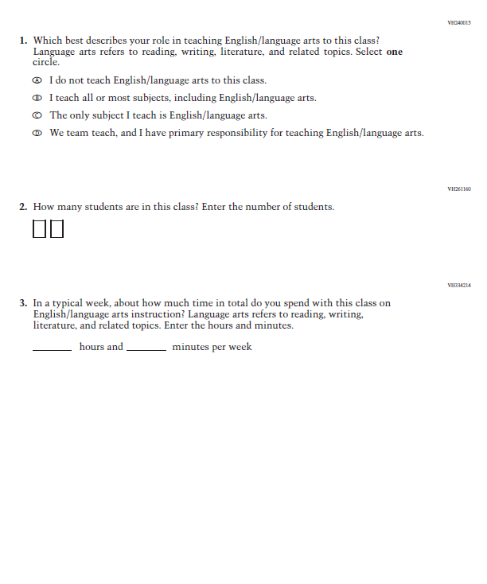

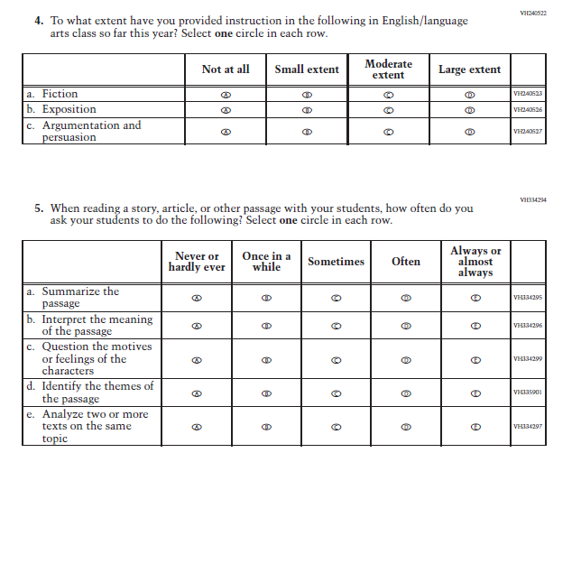

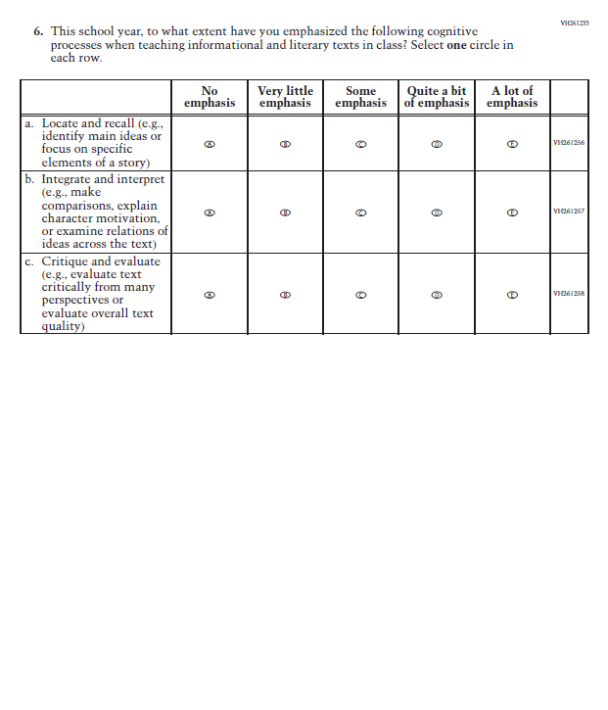

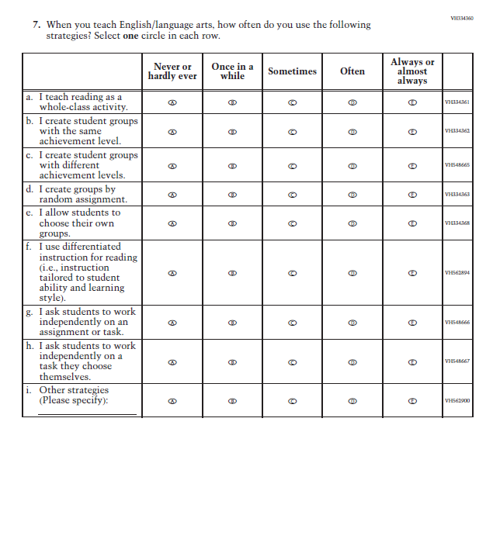

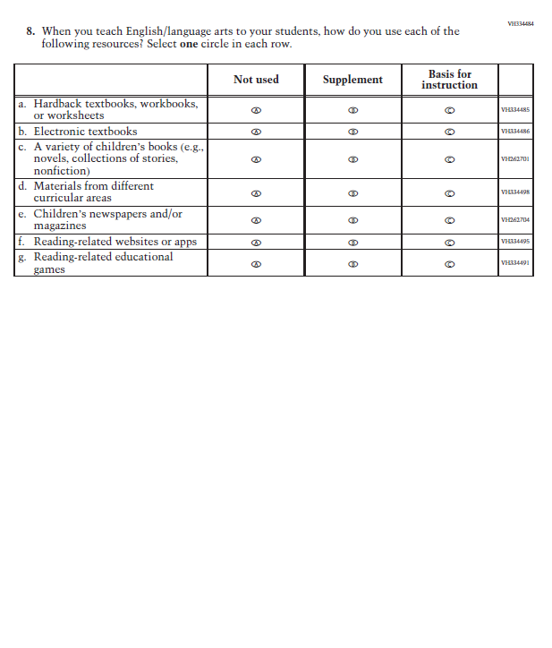

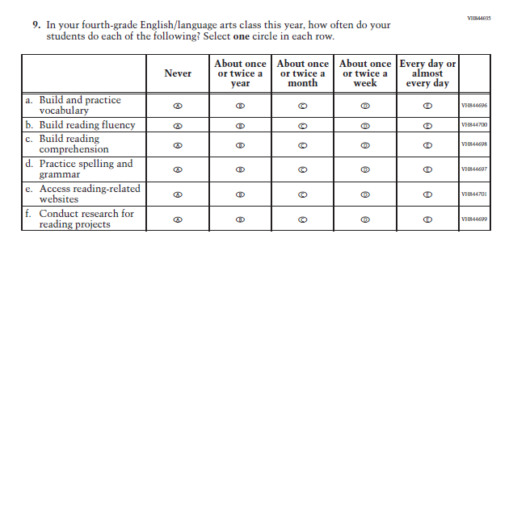

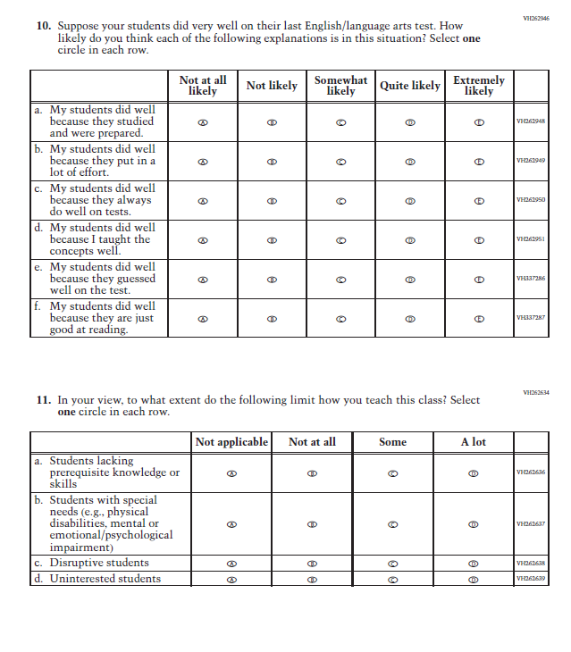

### **Appendix J2-7**: Operational Grade 8 (Reading)

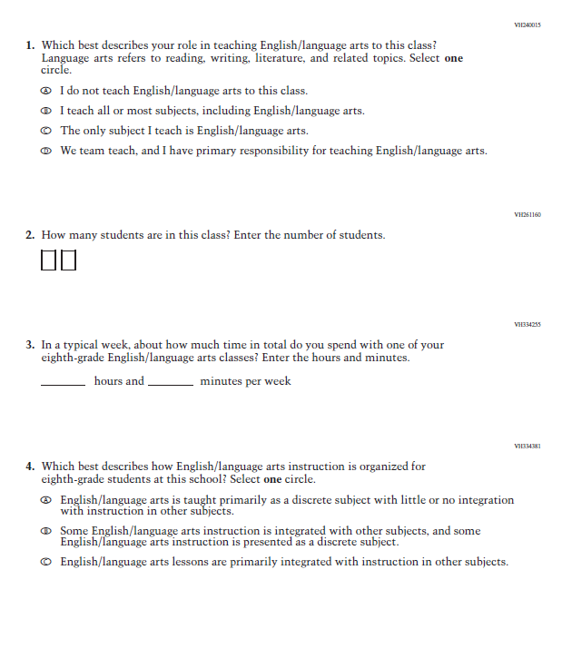

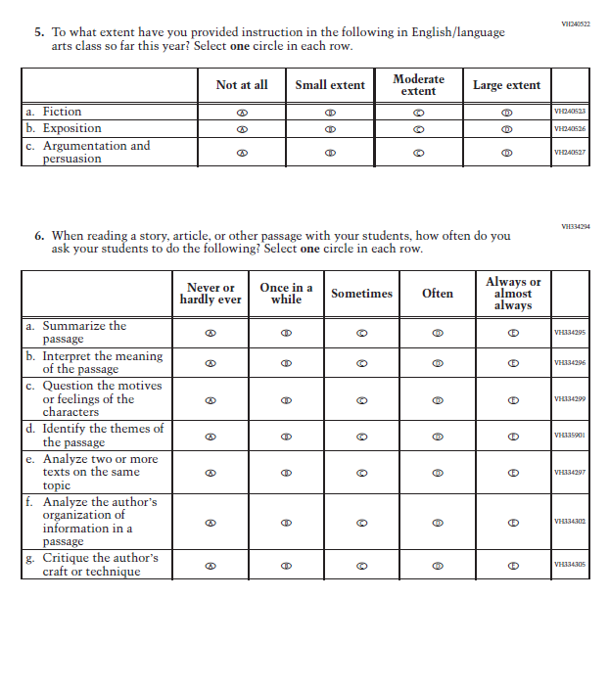

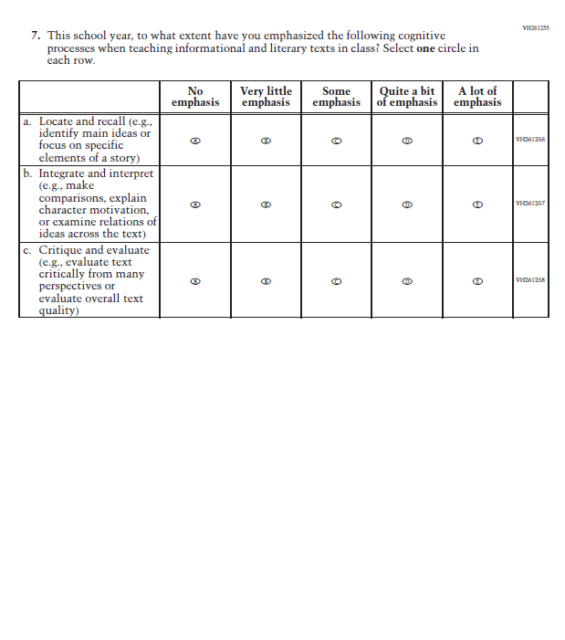

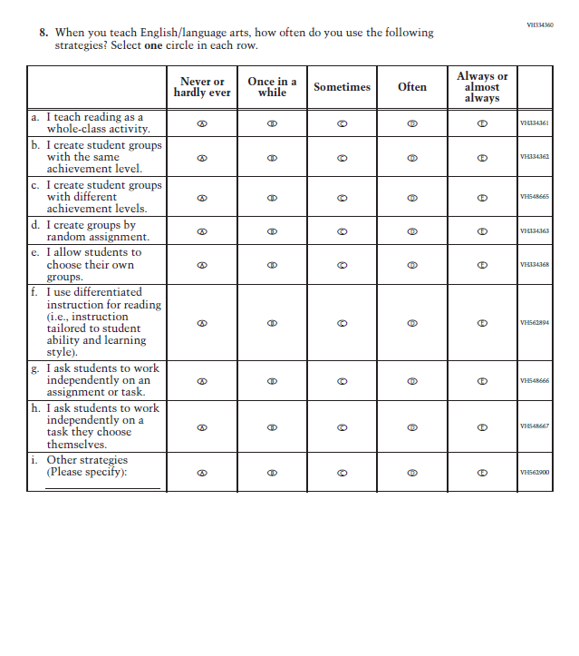

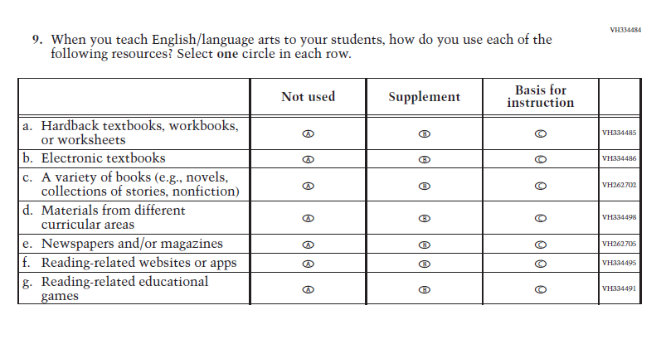

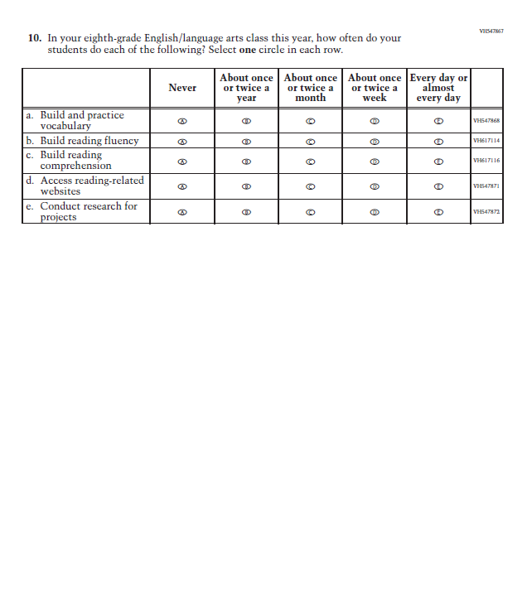

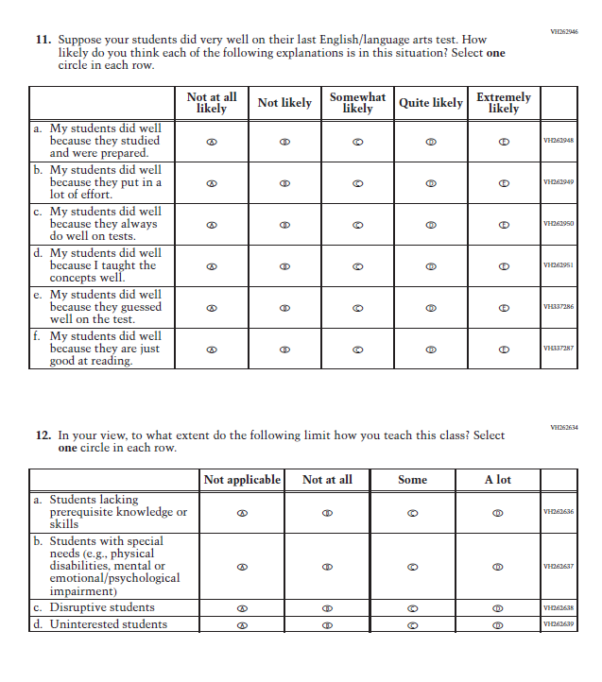

### **Appendix J2-8**: Operational Grade 8 (Science)

