*NATIONAL CENTER FOR EDUCATION STATISTICS NATIONAL ASSESSMENT OF EDUCATIONAL PROGRESS*

*National Assessment of Educational Progress (NAEP) 2024*

*Appendix J3*

*2024 School Questionnaires*

*OMB# 1850-0928 v.29*

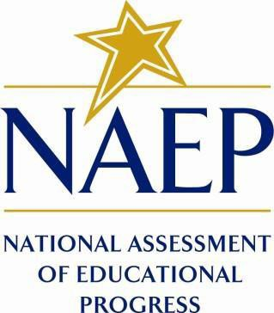

March 2023

Appendix J3 provides the school survey questionnaires that will be administered in 2024. Grades 4 and 8 Core, Math, Reading, and Charter School questionnaires were previously approved in 2022 (OMB# 1850-0928 v.28), and any changes to the items from the 2022 administration are reflected in summary tables. Additionally, grade 8 Science and grade 12 Core, Math, and Reading were previously approved in 2019 (OMB# 1850-0928 v.15), and any changes to the items from the 2019 administration are reflected in summary tables.

Updates to the school survey questionnaires, including new COVID-19 SQs, will be available in this document in Amendment #2 by May 2023. Draft NIES questionnaires will be included in Amendment #2 and final questionnaires will be in Amendment #3 (July 2023). Note that all login screens and paper booklet covers contained in this document will be updated with the most current OMB clearance expiration date before administration.

Table of Contents

School Questionnaires

**School Administrator Questionnaire Login Screen** 3

**Sample School Questionnaire Booklet Covers** 4

**Appendix J3-1**: Operational Grade 4 (Core) 5

**Appendix J3-2**: Operational Grade 8 (Core) 14

**Appendix J3-3**: Summary of Changes Operational Grade 12 (Core) 23

**Appendix J3-4**: Operational Grade 12 (Core) 24

**Appendix J3-4**: Operational Grade 4 (Mathematics) 34

**Appendix J3-5**: Operational Grade 8 (Mathematics) 38

**Appendix J3-6**: Operational Grade 12 (Mathematics) 42

**Appendix J3-7**: Operational Grade 4 (Reading) 48

**Appendix J3-8**: Operational Grade 8 (Reading) 52

**Appendix J3-9**: Operational Grade 12 (Reading) 56

**Appendix J3-10**: Operational Grade 8 (Science) 60

**Appendix J3-11**: Operational Grade 4, 8, and 12 Charter School 64

### **School Administrator Questionnaire Login Screen**

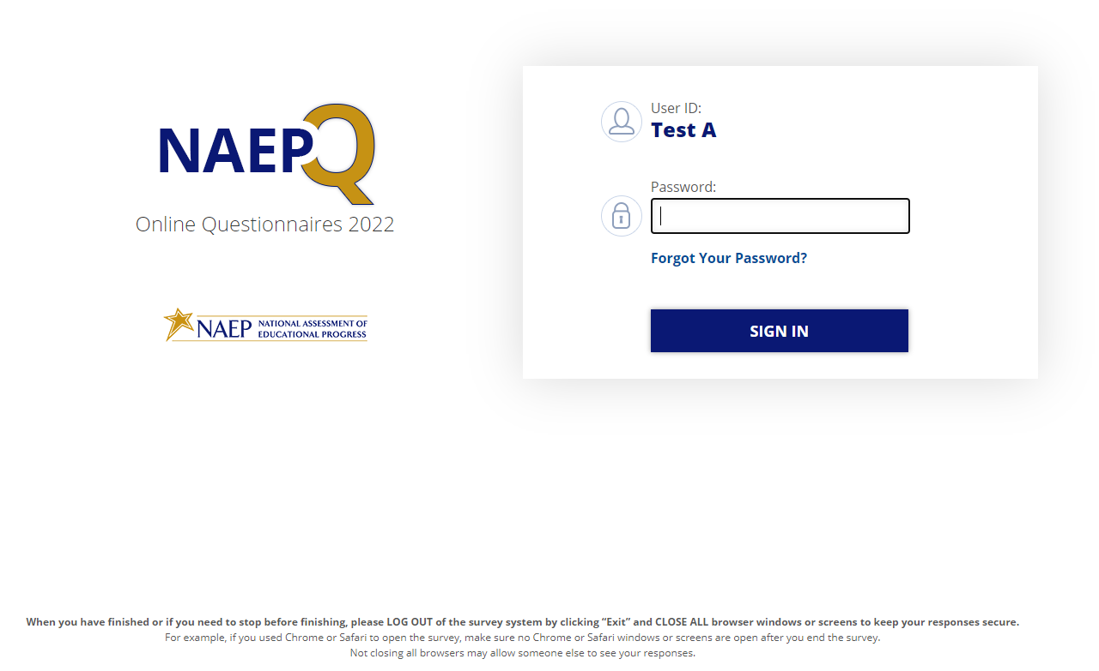

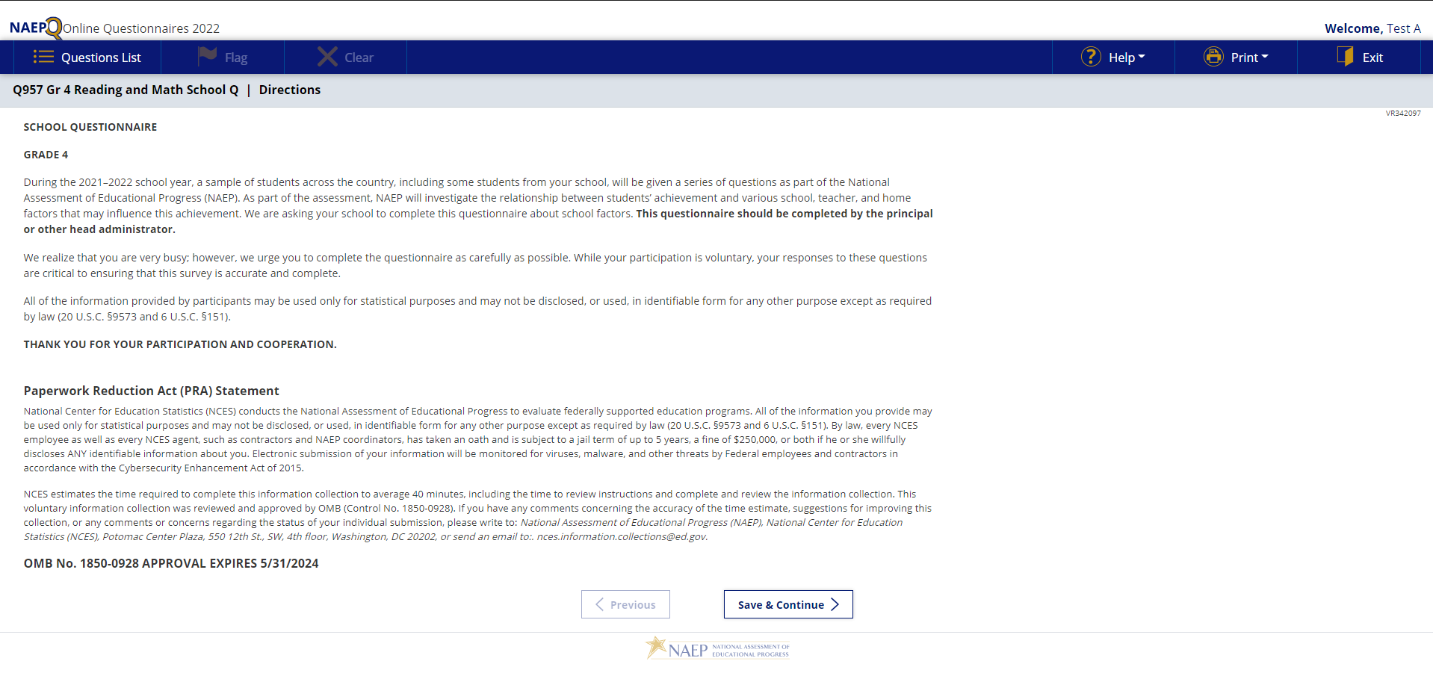

### **Sample School Questionnaire Booklet Covers**

### **Appendix J3-1**: Operational Grade 4 (Core)

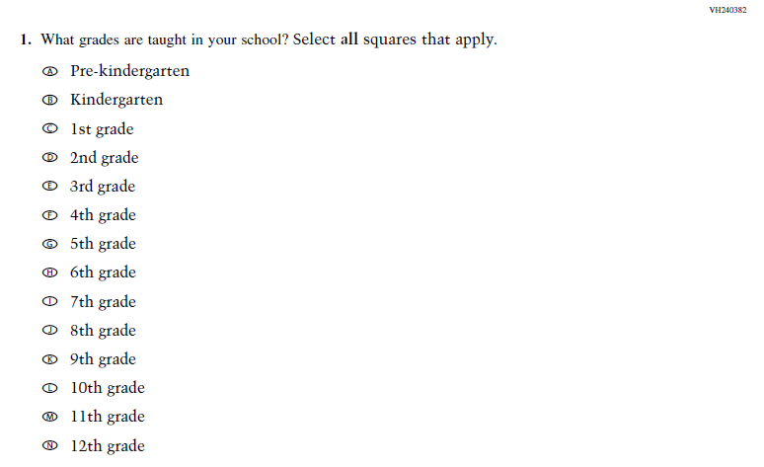

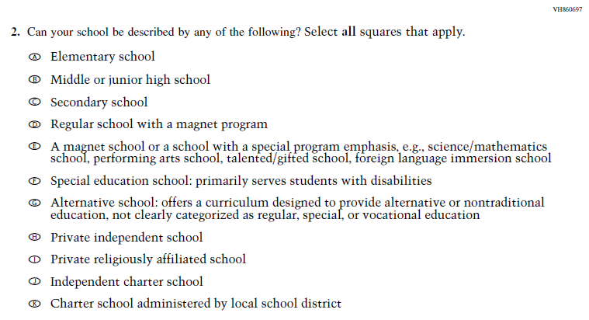

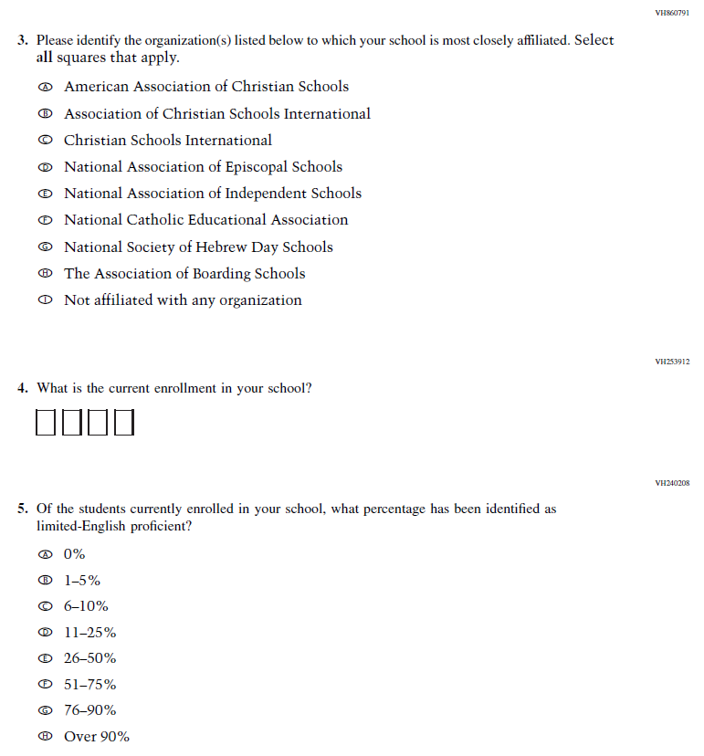

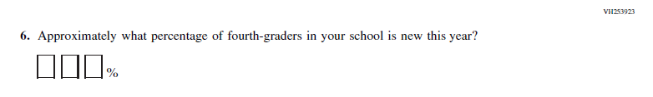

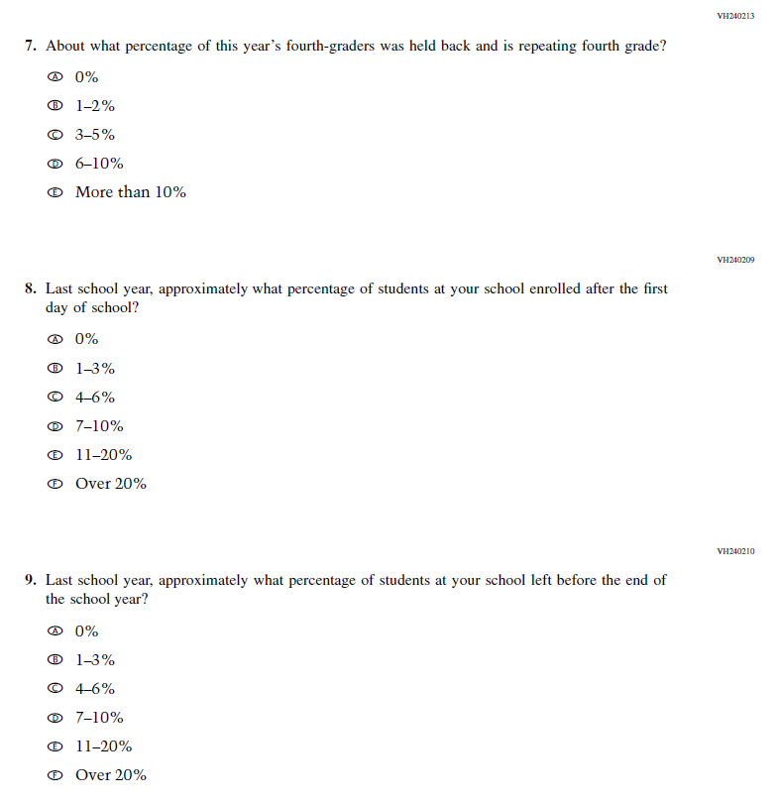

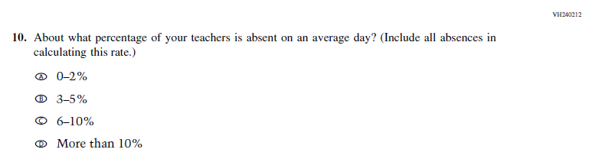

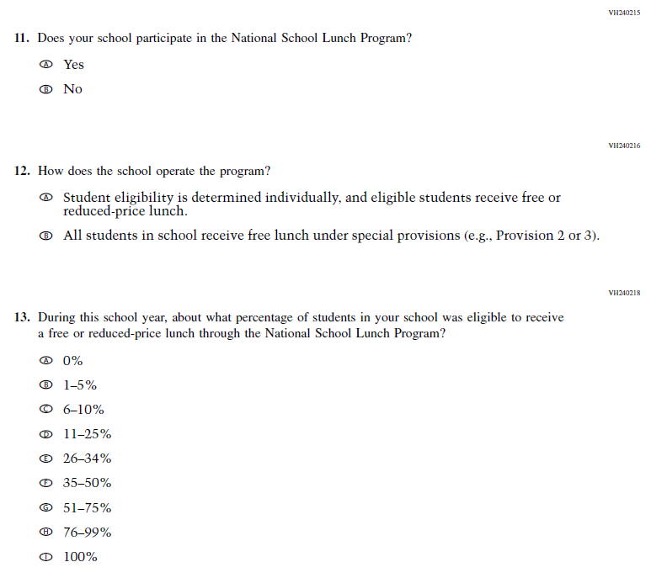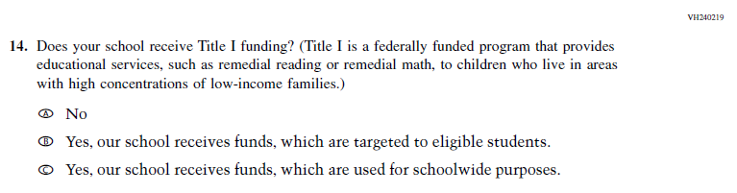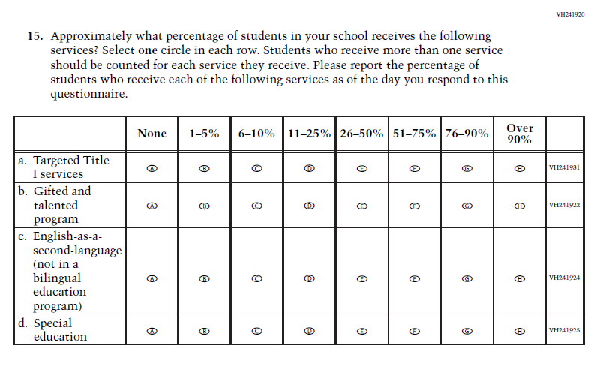

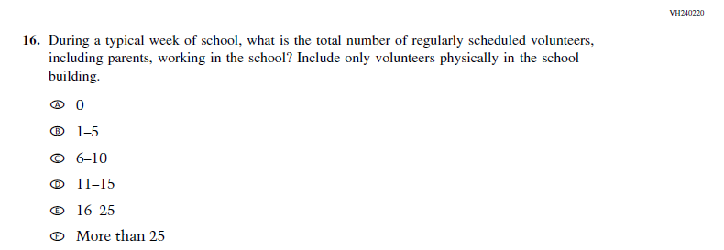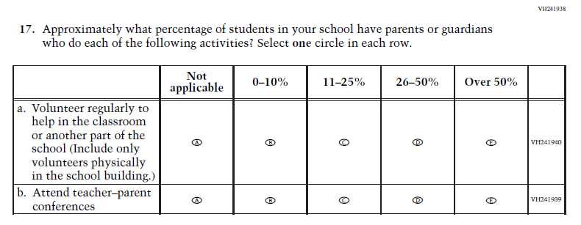

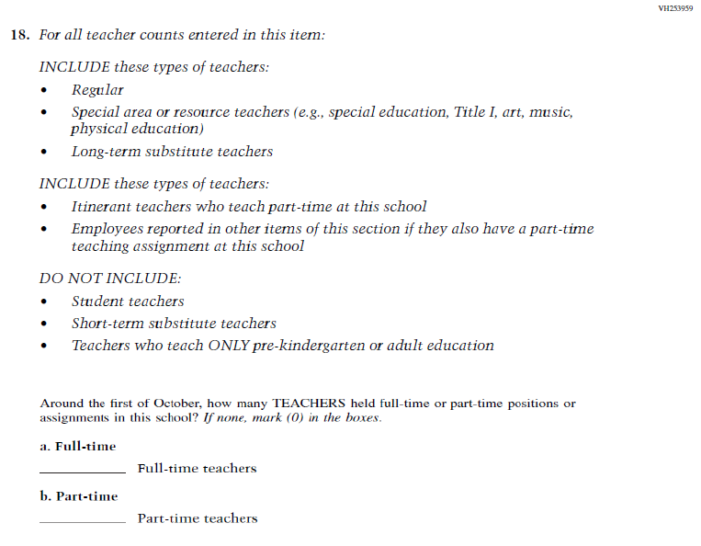

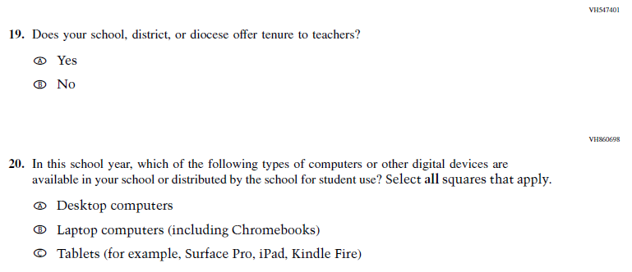

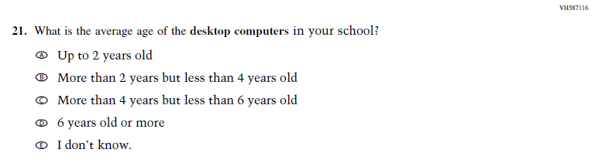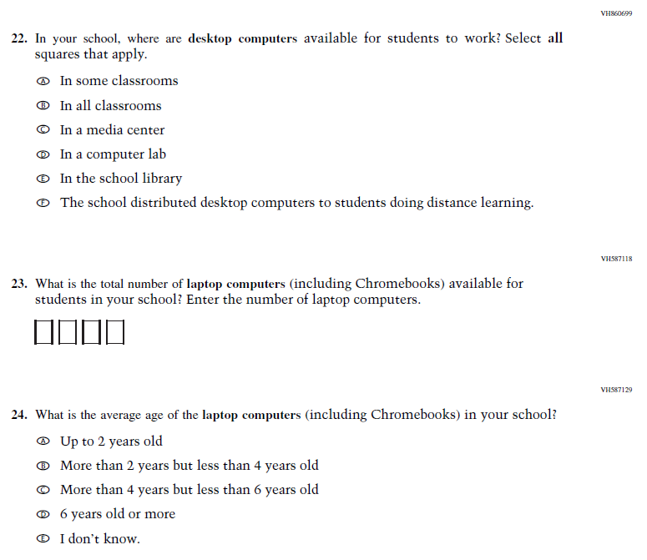

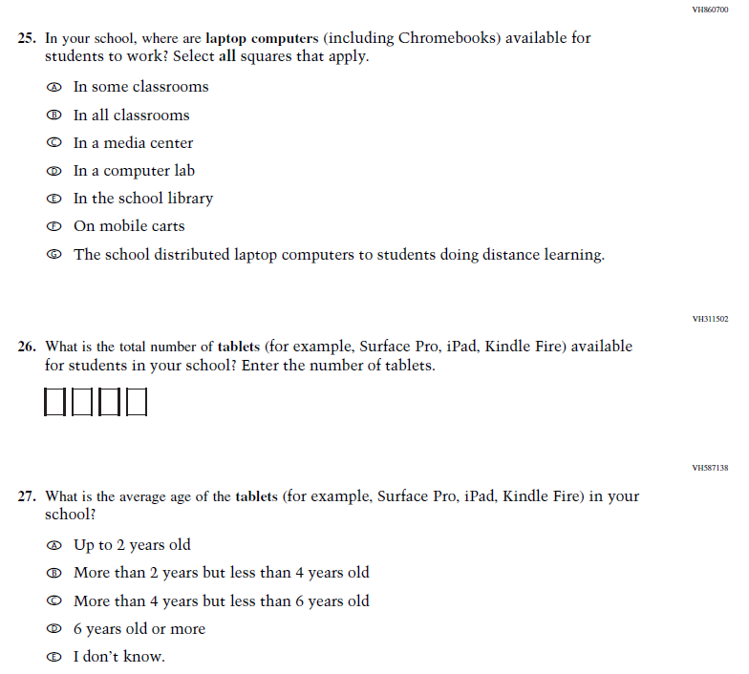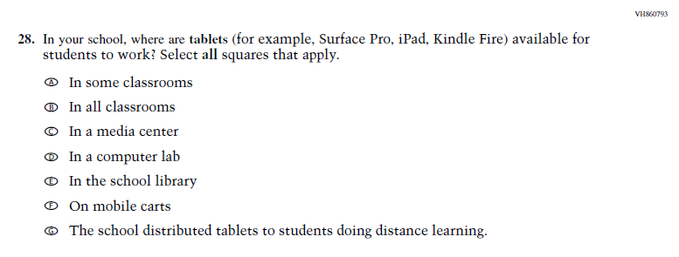

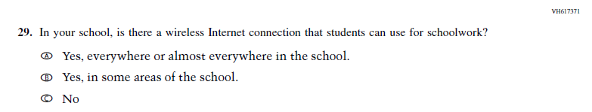

### **Appendix J3-2**: Operational Grade 8 (Core)

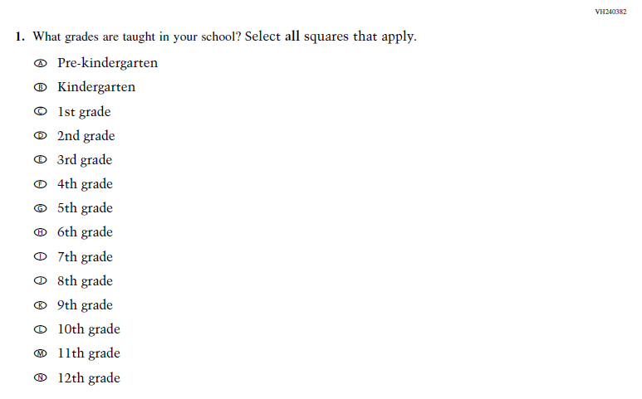

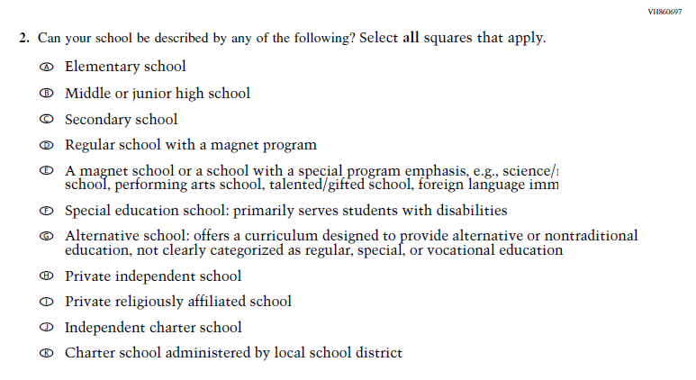

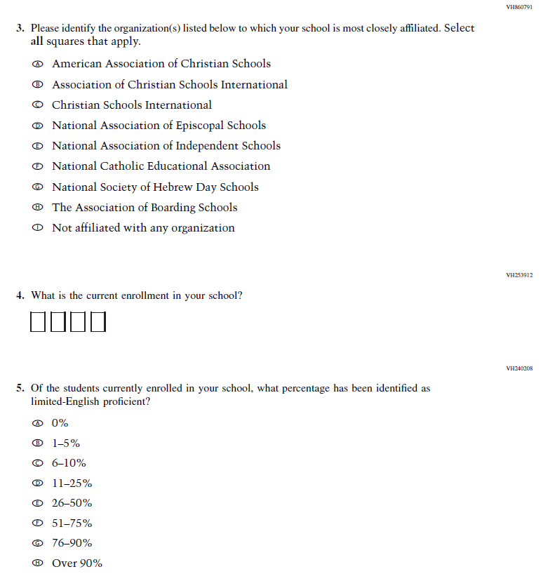

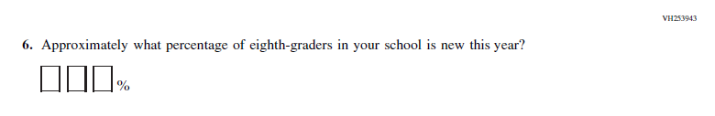

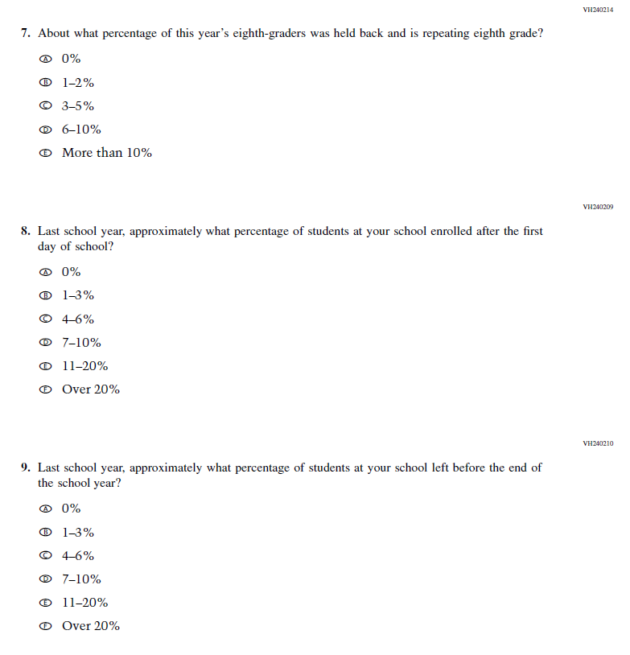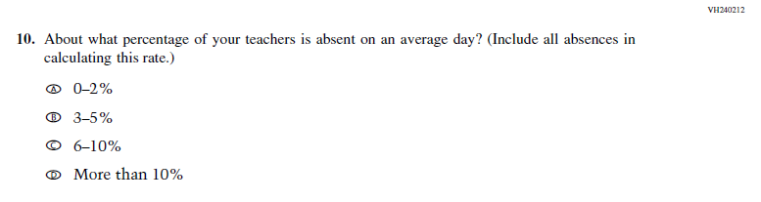

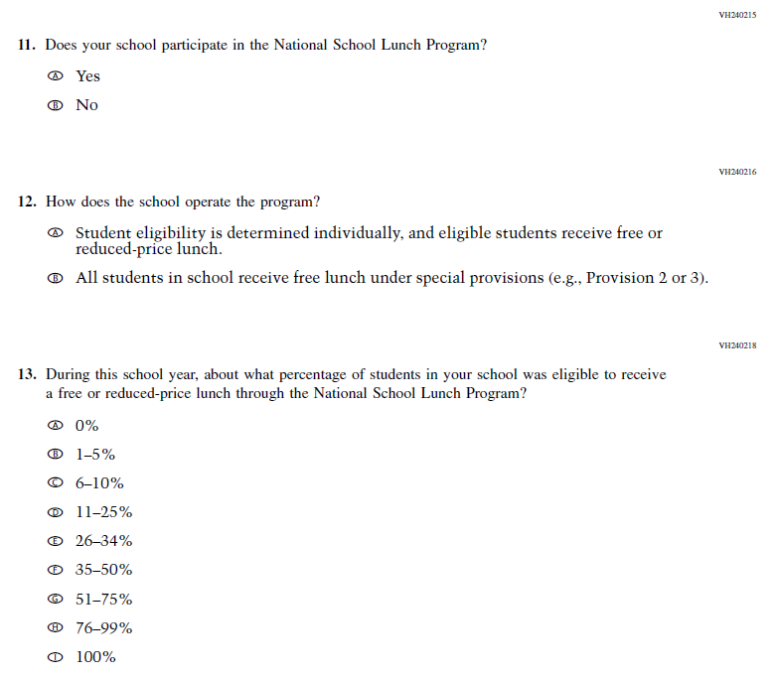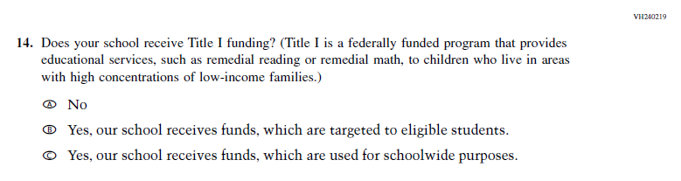

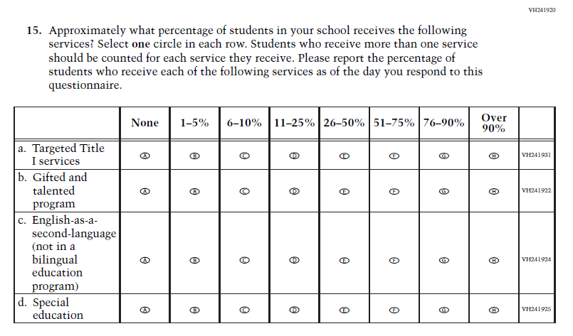

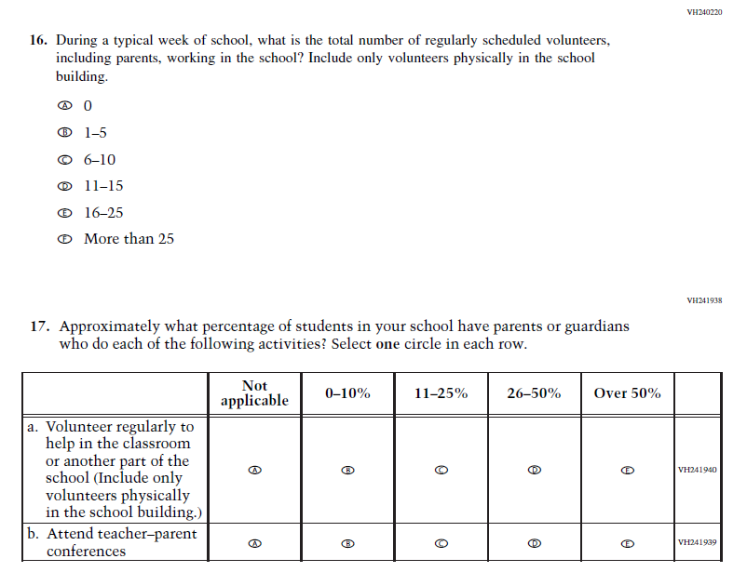

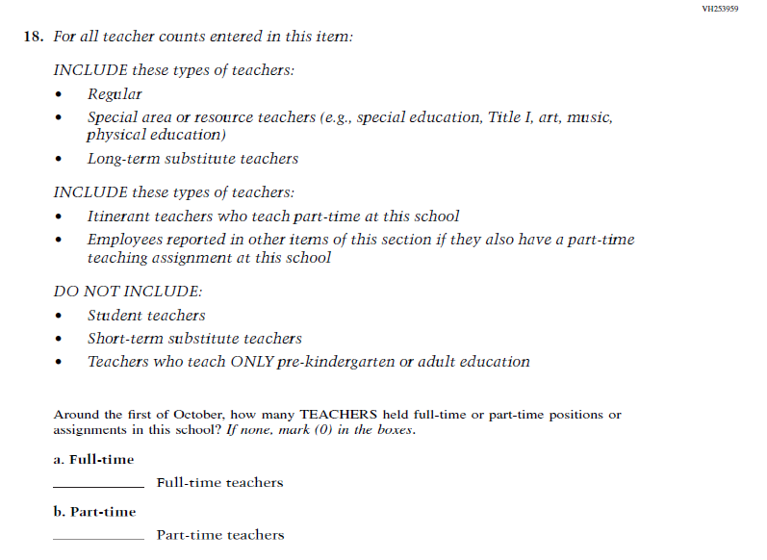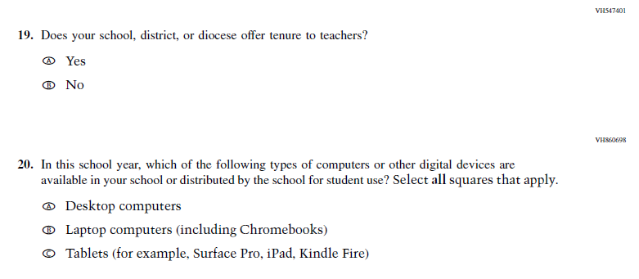

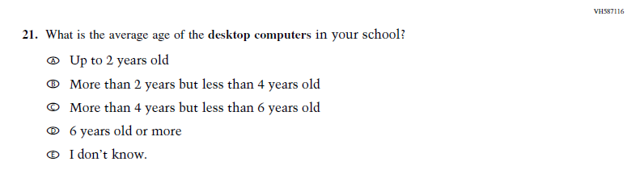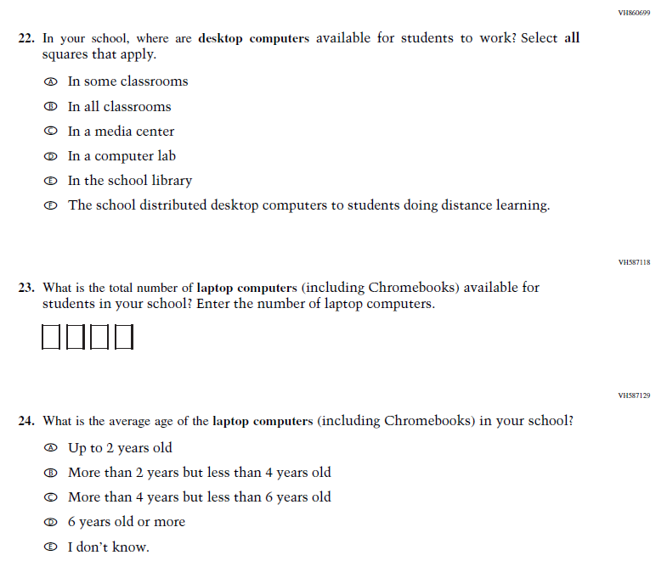

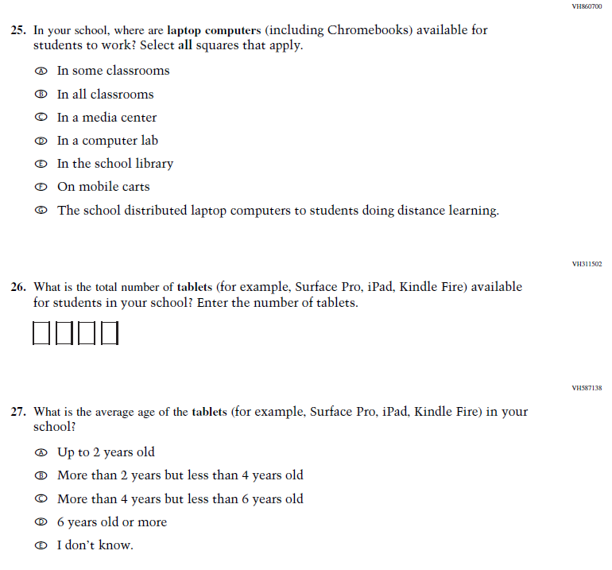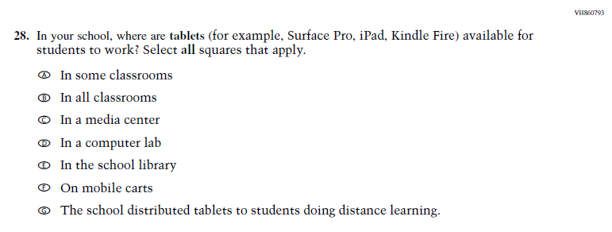

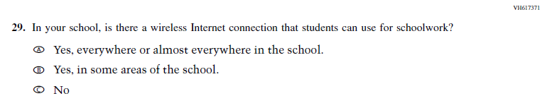

### **Appendix J3-3**: Summary of Changes Operational Grade 12 (Core)

|  |  |  |  |
| --- | --- | --- | --- |
| **2024 Operational Grade 12 Core School** | | | |
| **Previous Item** | **2024 Item** | **D/A/ R/NC+** | **Rationale** |
| (2019 Grade 12) | N/A | D | This Item was dropped so Grade 12 matches Grades 4 and 8, which were administered in 2022. |

### **Appendix J3-4**: Operational Grade 12 (Core)





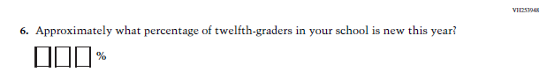

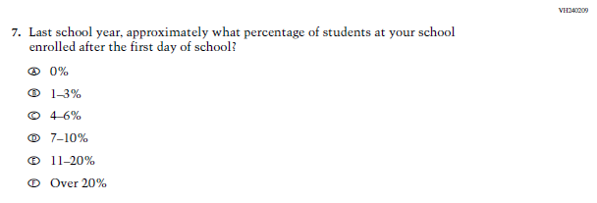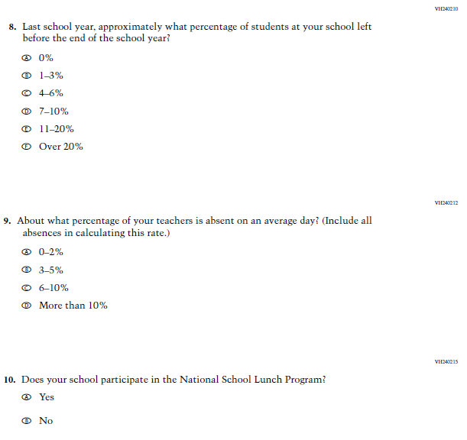

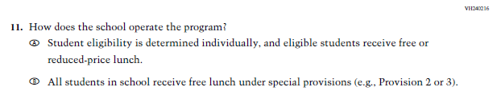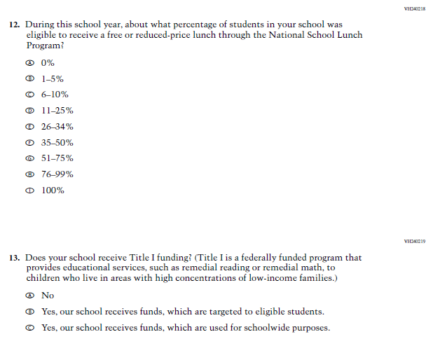

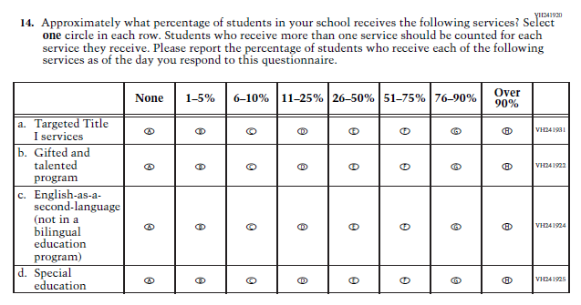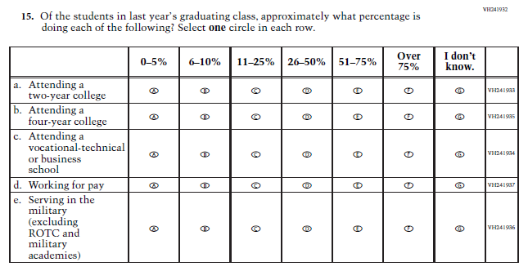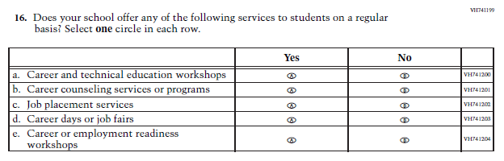

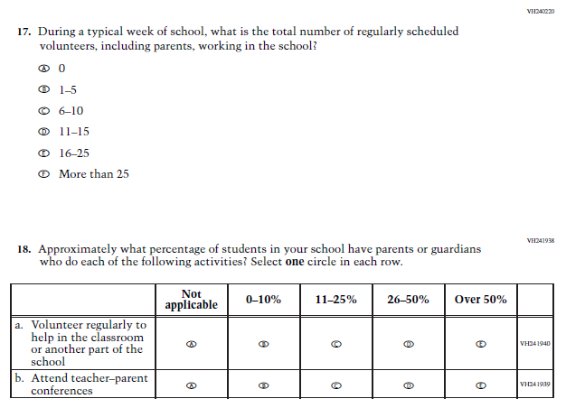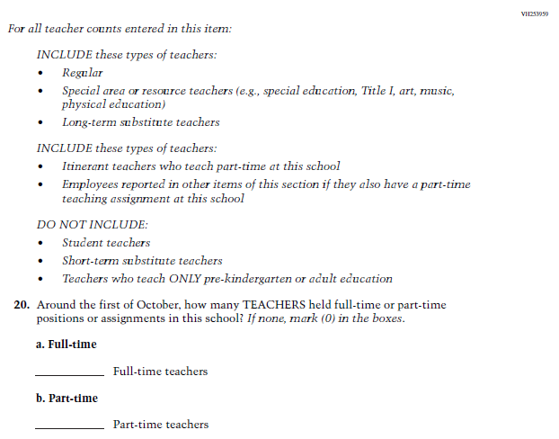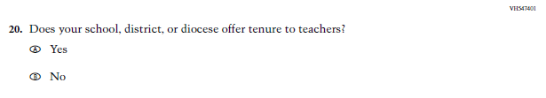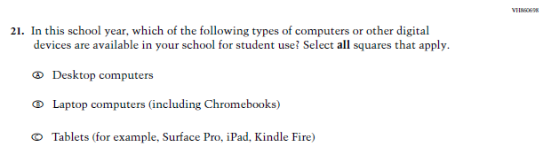

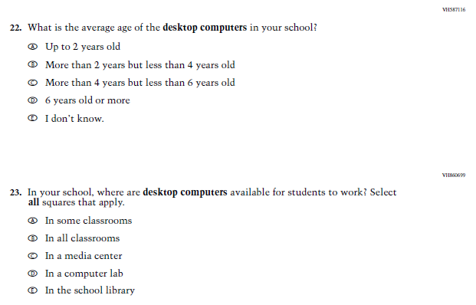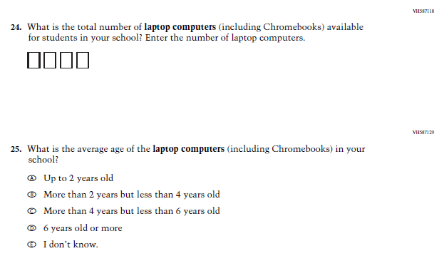

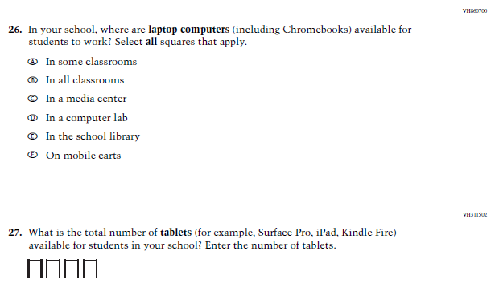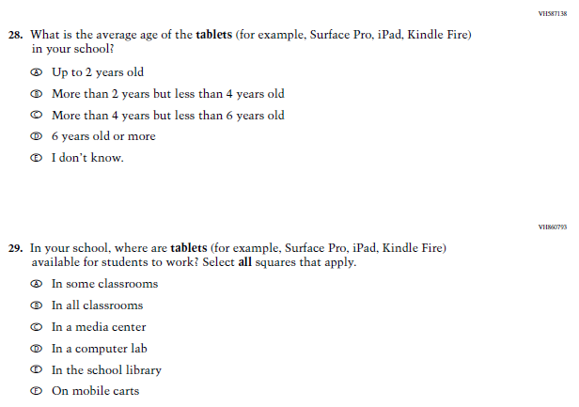

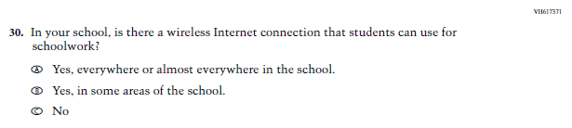

### **Appendix J3-4**: Operational Grade 4 (Mathematics)

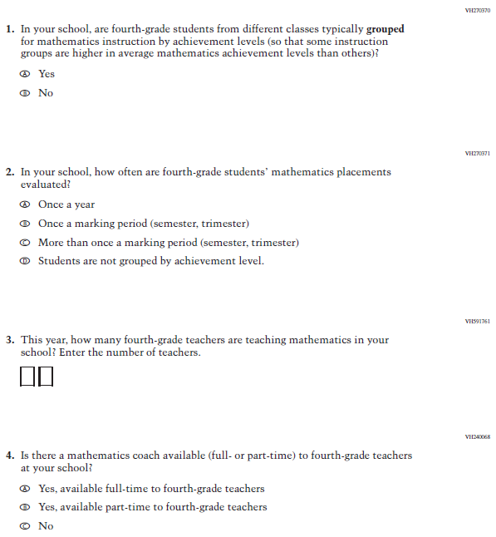

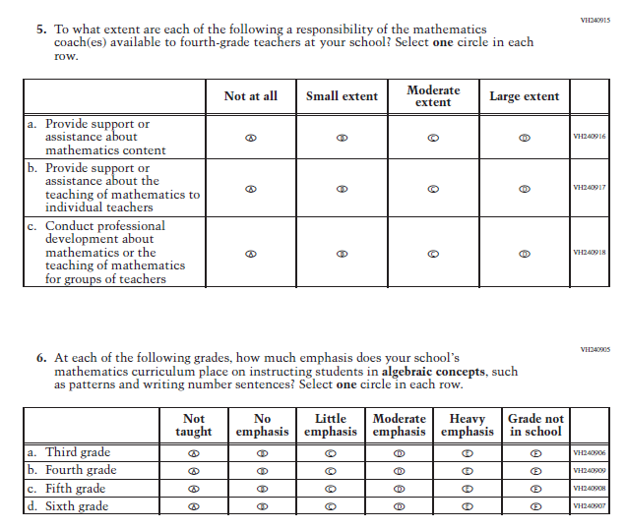

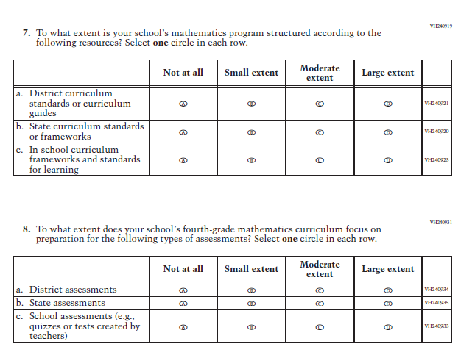

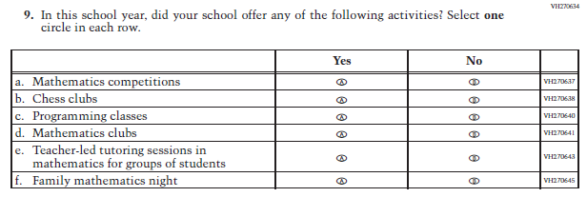

### **Appendix J3-5**: Operational Grade 8 (Mathematics)

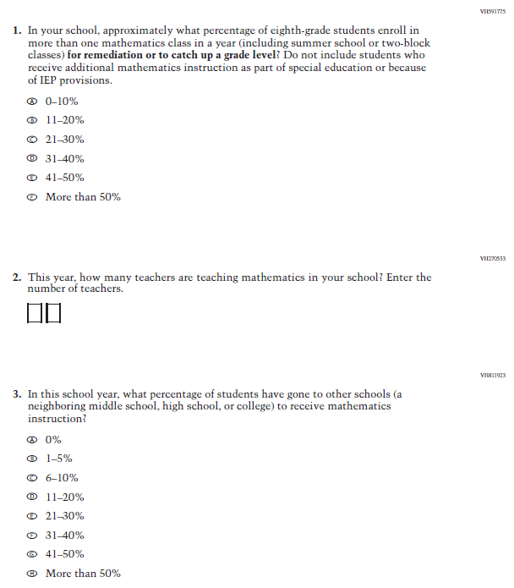

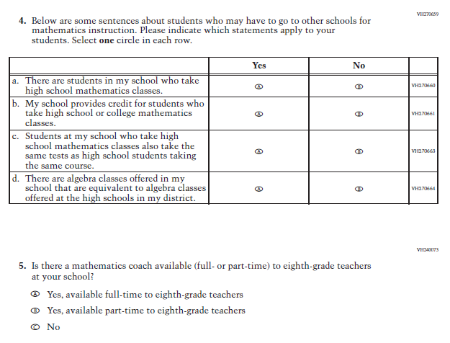

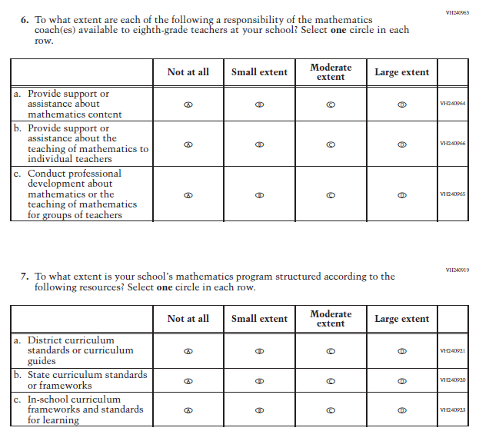

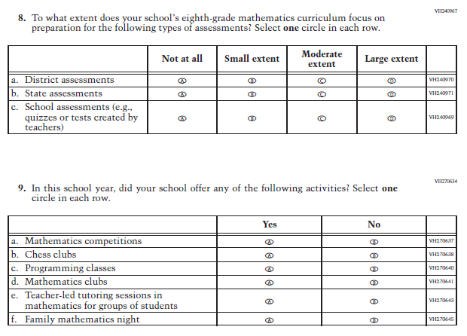

### **Appendix J3-6**: Operational Grade 12 (Mathematics)

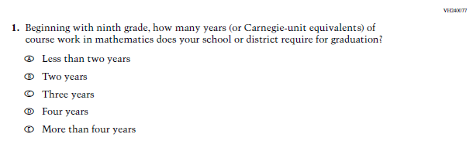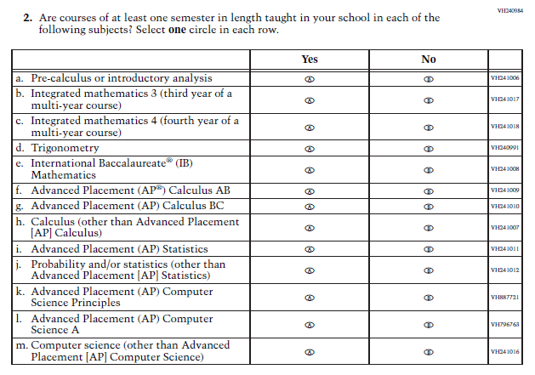

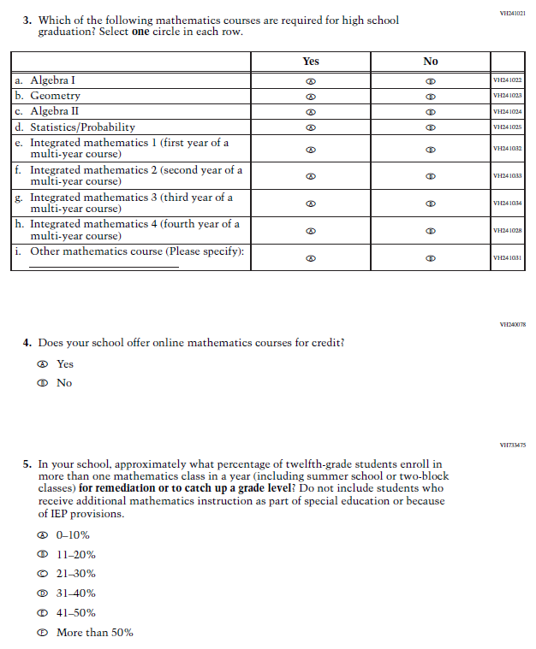

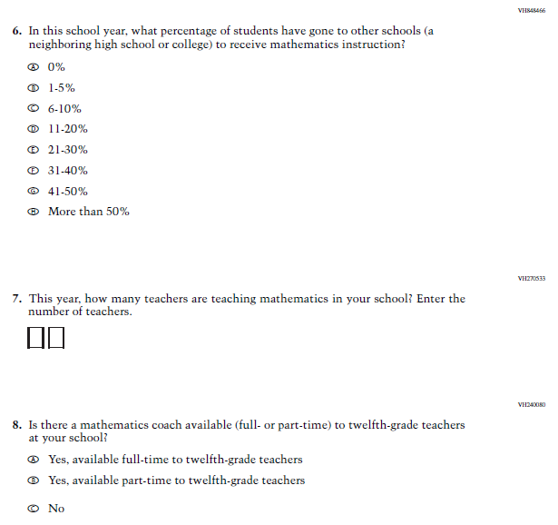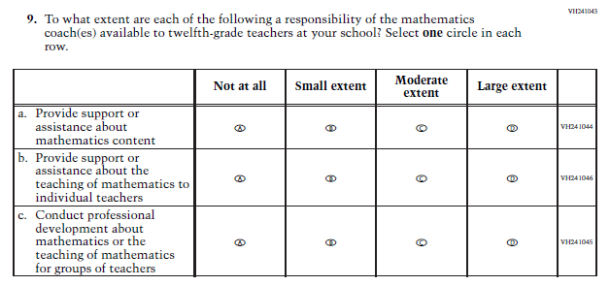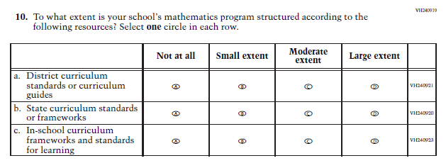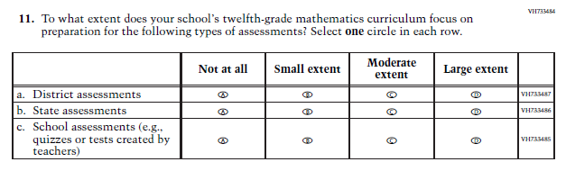

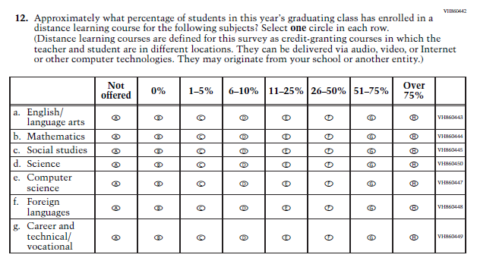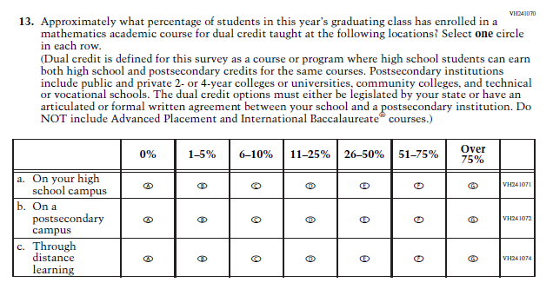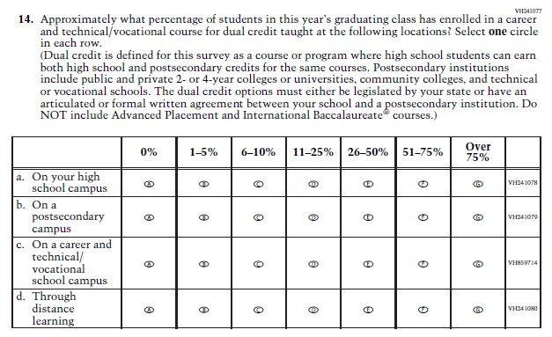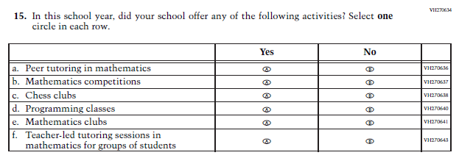

### **Appendix J3-7**: Operational Grade 4 (Reading)

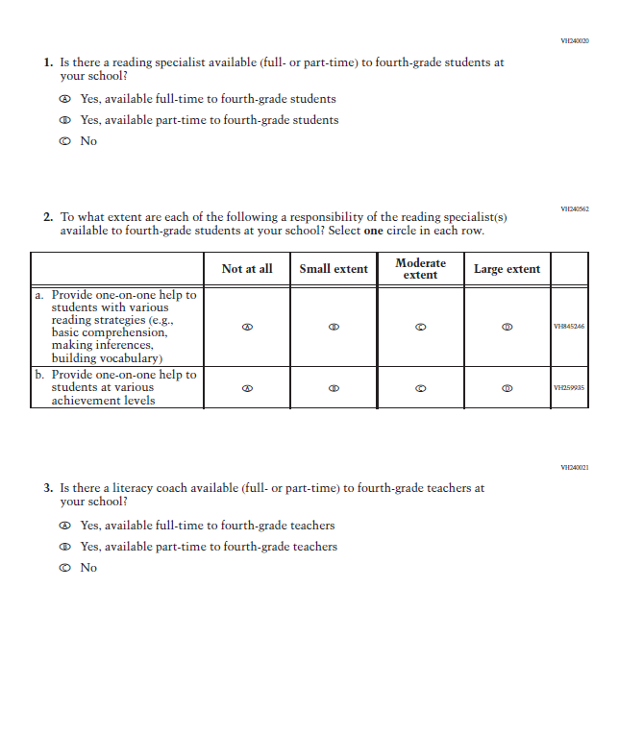

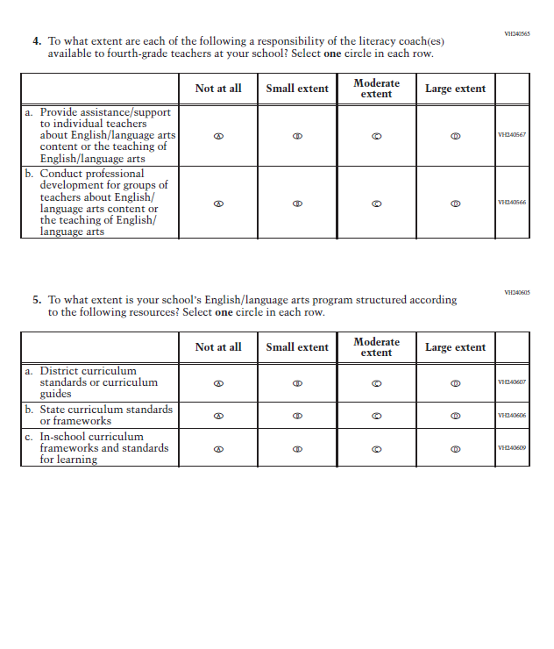

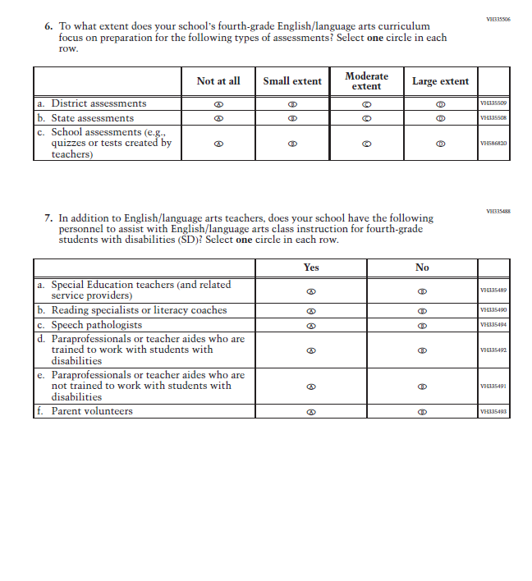

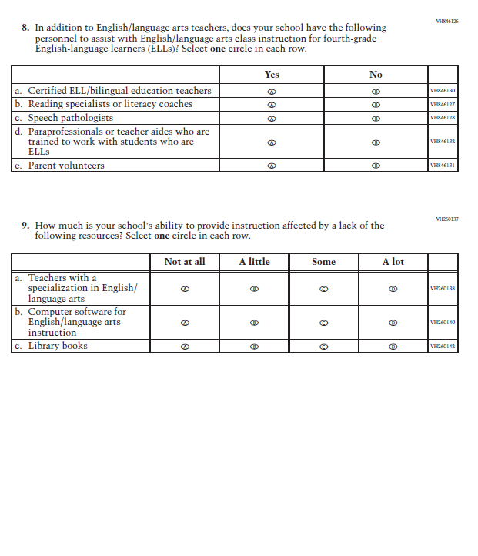

### **Appendix J3-8**: Operational Grade 8 (Reading)

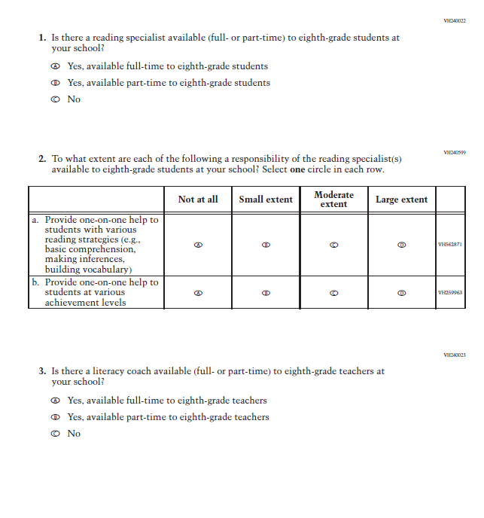

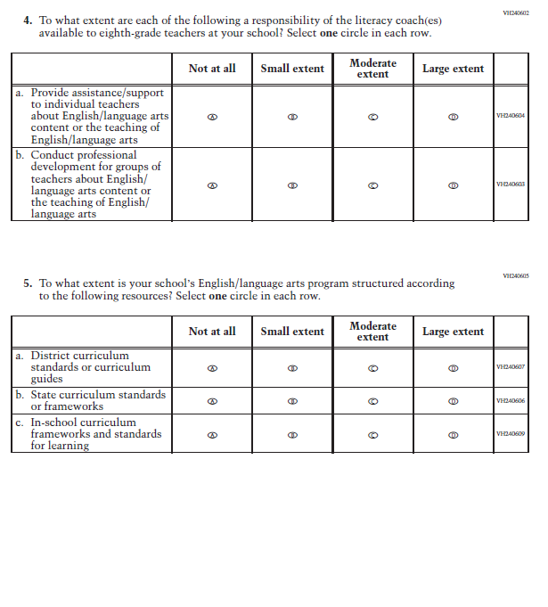

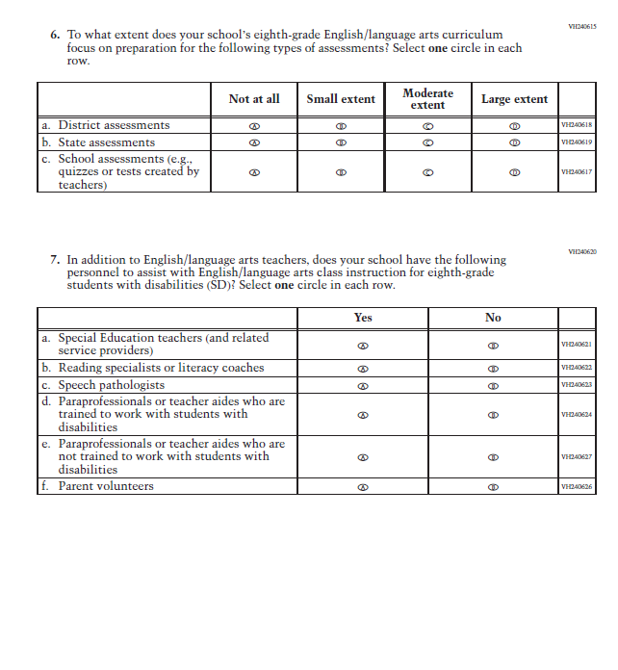

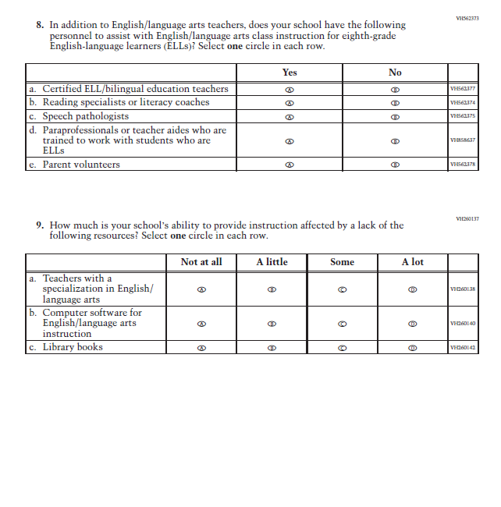

### **Appendix J3-9**: Operational Grade 12 (Reading)

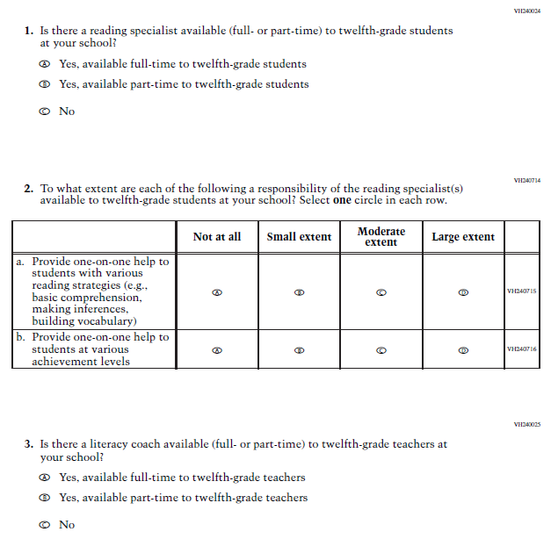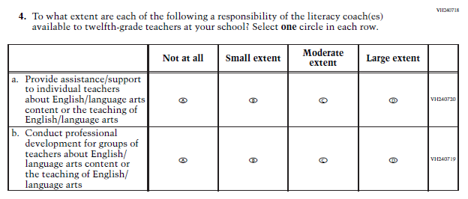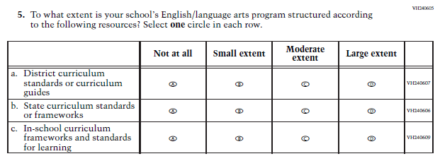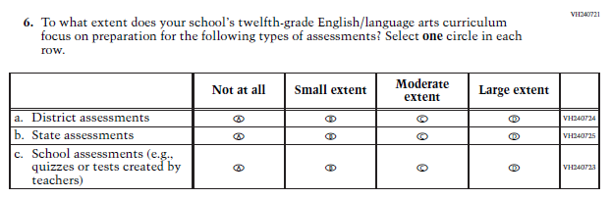

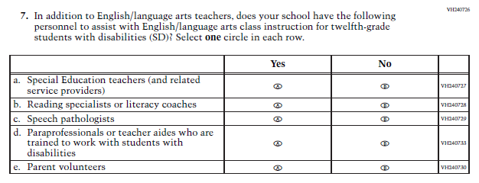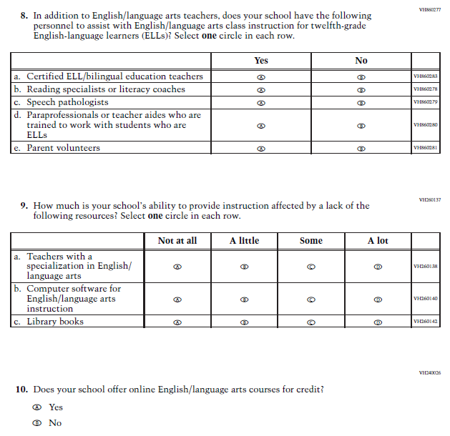

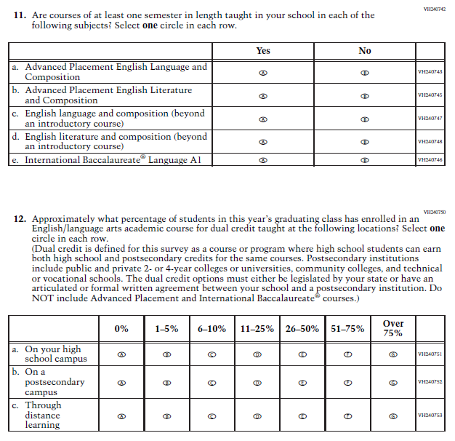

### **Appendix J3-10**: Operational Grade 8 (Science)

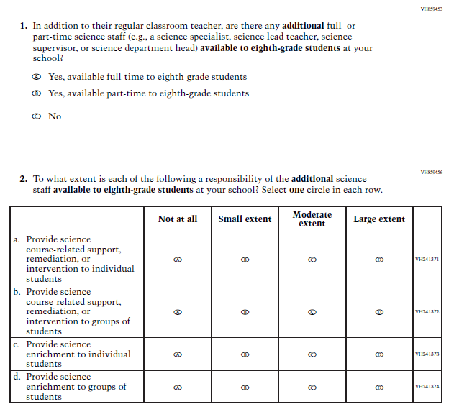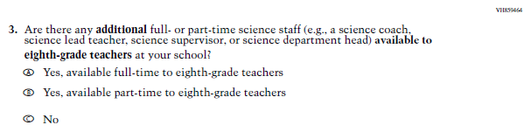

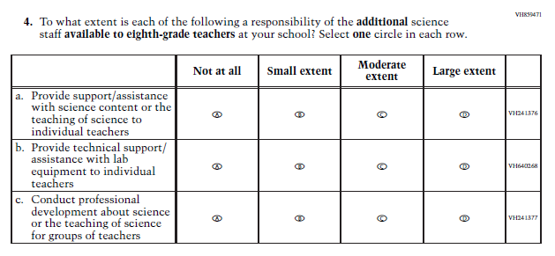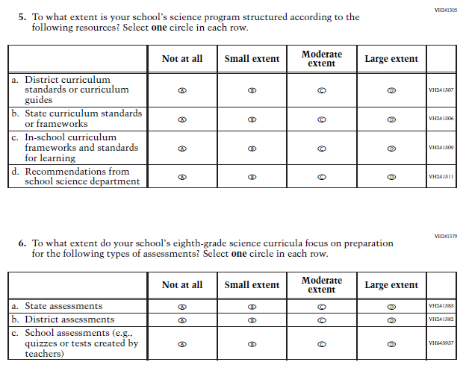

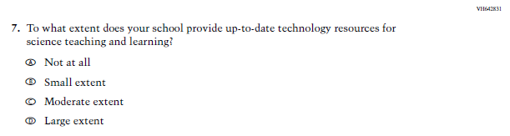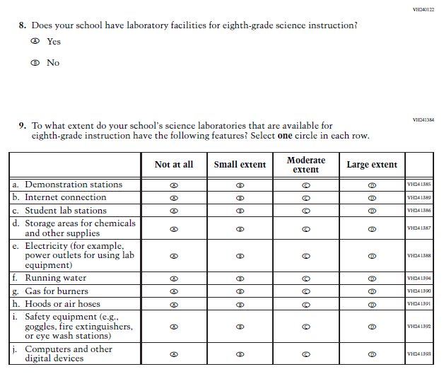

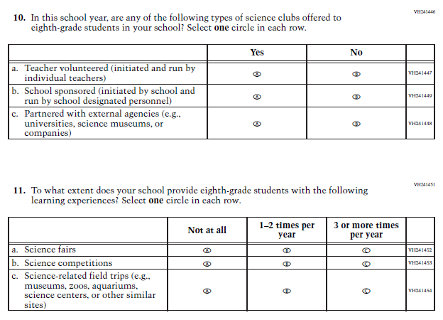

### **Appendix J3-11**: Operational Grade 4, 8, and 12 Charter School

