NATIONAL CENTER FOR EDUCATION STATISTICS NATIONAL ASSESSMENT OF EDUCATIONAL PROGRESS

National Assessment of Educational Progress (NAEP)
2024

Appendix J-S

2024 Spanish Questionnaires

OMB# 1850-0928 v.29



March 2023

Appendix J-S provides Spanish student, teacher, and school survey questionnaires that will be administered in 2024. Grades 4 and 8 Core, Math, and Reading questionnaires were previously approved in 2022 (OMB# 1850-0928 v.28), and any changes to the items from the 2022 administration are reflected in summary tables. Additionally, grade 8 Science was previously approved in 2019 (OMB# 1850-0928 v.15), and any changes to the items from the 2019 administration are reflected in summary tables.
Updates to the survey questionnaires, including new COVID-19 SQs, will be available in this document in Amendment #2 by May 2023. Note that all login screens and paper booklet covers contained in this document will be updated with the most current OMB clearance expiration date before administration.

Table of Contents
Student Login Screen 4
Appendix J-1-s: Spanish Translations of Student Questionnaires 5
Appendix J-1a-s-BL: Summary of Changes Operational Grade 4 CORE 6
Appendix J-1a-s-BL: Operational Grade 4 CORE 7
Appendix J-1b-s-PR: Summary of Changes Operational Grade 4 CORE 11
Appendix J-1b-s-PR: Operational Grade 4 CORE 12
Appendix J-1c-s-BL: Summary of Changes Operational Grade 8 CORE 16
Appendix J-1c-s-BL: Operational Grade 8 CORE 17
Appendix J-1d-s-PR: Summary of Changes Operational Grade 8 CORE 24
Appendix J-1d-s-PR: Operational Grade 8 CORE 25
Appendix J-1e-s-BL: Operational Grade 4 Mathematics 32
Appendix J-1f-s-PR: Operational Grade 4 Mathematics 36
Appendix J-1g-s-BL: Operational Grade 8 Mathematics 40
Appendix J-1h-s-PR: Operational Grade 8 Mathematics 47
Appendix J-1i-s-BL: Operational Grade 4 Reading 54
Appendix J-1j-s-BL: Operational Grade 8 Reading 59
Appendix J-1k-s-BL: Operational Grade 8 Science 66
Appendix J-1l-s-BL: Operational Grade 4 Debrief 75
Appendix J-1m-s-PR: Operational Grade 4 Debrief 76
Appendix J-1n-s-BL: Operational Grade 8 Debrief 77
Appendix J-1n-s-PR: Operational Grade 8 Debrief 78
Sample Teacher Login Screen 79
Sample Teacher Questionnaire Booklet Cover 80
Appendix J-2-s: Spanish Translations of Teacher Questionnaires 81
Appendix J-2a-s-PR: Summary of Changes Operational Grade 4 CORE 82
Appendix J-2a-s-PR: Operational Grade 4 CORE 83
Appendix J-2b-s-PR: Summary of Changes Operational Grade 8 CORE 93
Appendix J-2b-s-PR: Operational Grade 8 CORE 94
Appendix J-2c-s-PR: Operational Grade 4 Mathematics 104
Appendix J-2d-s-PR: Operational Grade 8 Mathematics 113
Sample School Administrator Login Screen 123
Sample School Questionnaire Booklet Covers 124
Appendix J-3-s: Spanish Translations of School Questionnaires 125
Appendix J-3a-s-PR: Operational Grade 4 CORE 126
Appendix J-3b-s-PR: Operational Grade 8 CORE 137
Appendix J-3c-s-PR: Operational Grade 4 Mathematics 148
Appendix J-3d-s-PR: Operational Grade 8 Mathematics 152

Student Login Screen

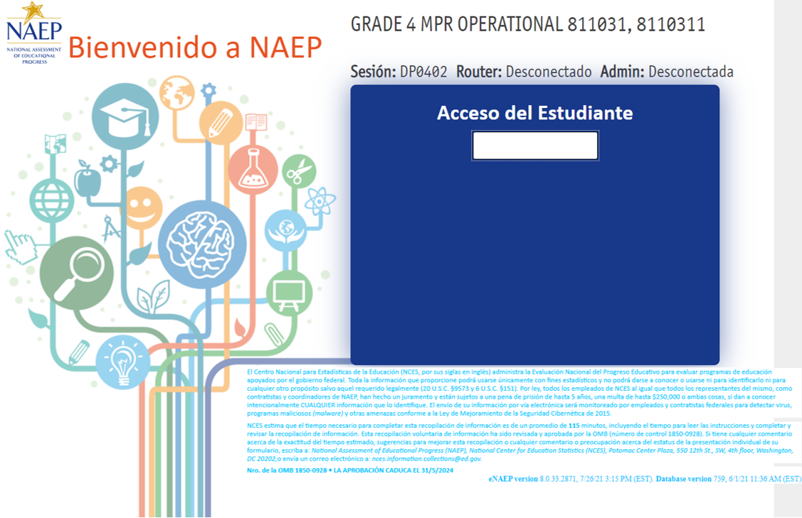

Appendix J-1-s: Spanish Translations of Student Questionnaires

Appendix J-1a-s-BL: Summary of Changes Operational Grade 4 CORE
2024 Operational Grade 4 Core Student – Bilingual
Previous item | 2024 item | D/A/R/NC+ | Rationale
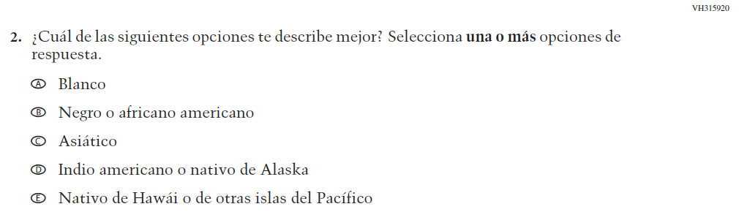  (2022 Operational Grade 4 Student Core - Bilingual) | 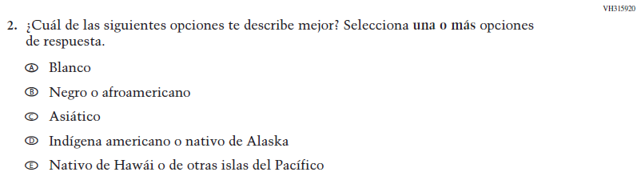  Issue: Race/Ethnicity | R | Revised options b and d to align with categories used by the 2020 Census Bureau

Appendix J-1a-s-BL: Operational Grade 4 CORE
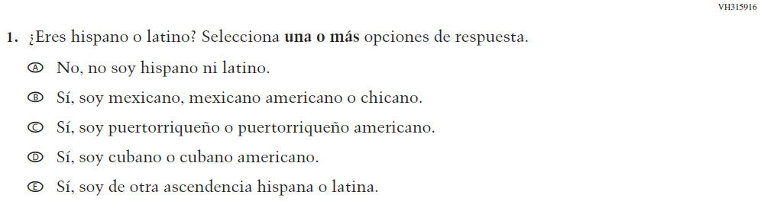

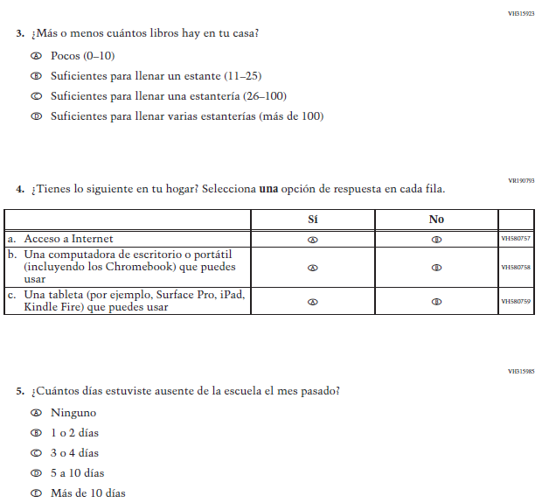

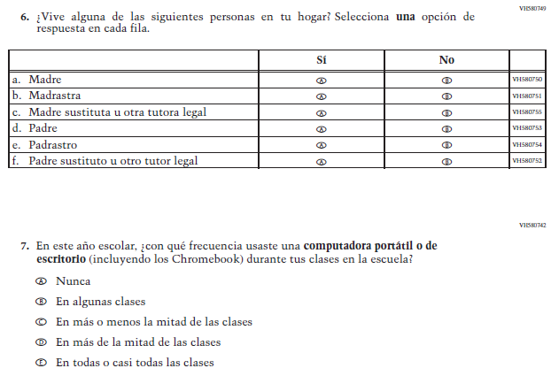

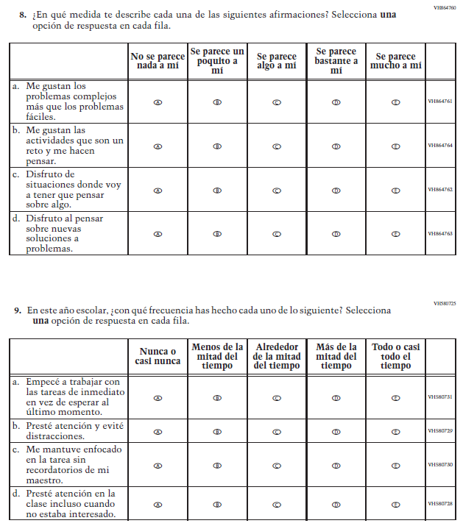

Appendix J-1b-s-PR: Summary of Changes Operational Grade 4 CORE
2024 Operational Grade 4 Core Student – Puerto Rico

Previous item | 2024 item | D/A/ R/NC+ | Rationale
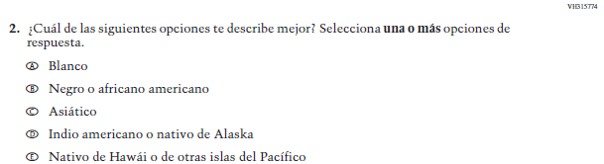  (2022 Operational Grade 4 Student Core – Puerto Rico) | 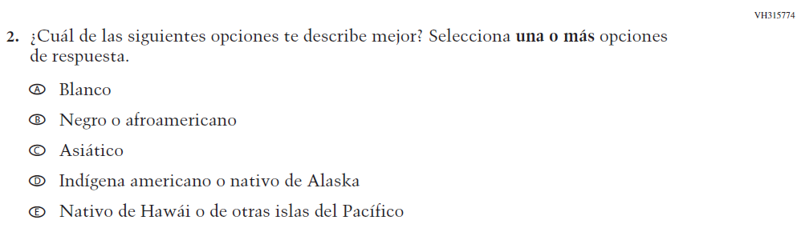  Issue: Race/Ethnicity | R | Revised options b and d to align with categories used by the 2020 Census Bureau

Appendix J-1b-s-PR: Operational Grade 4 CORE

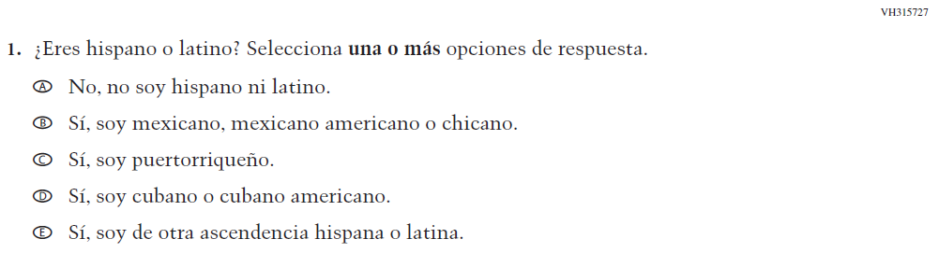

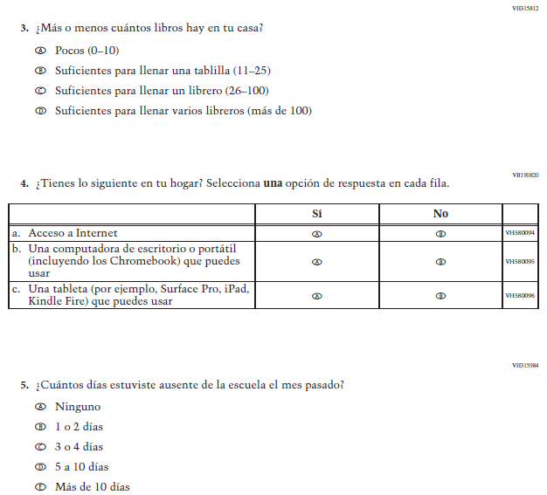

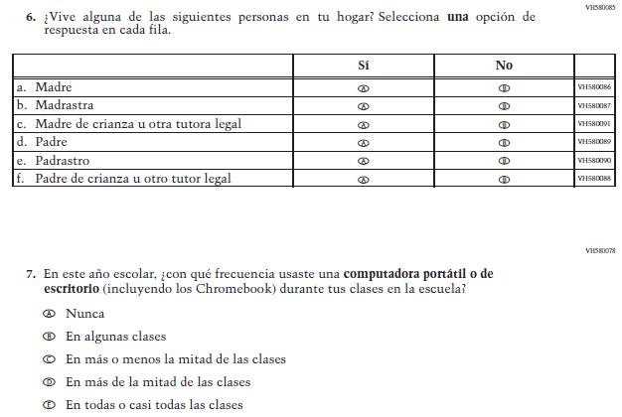

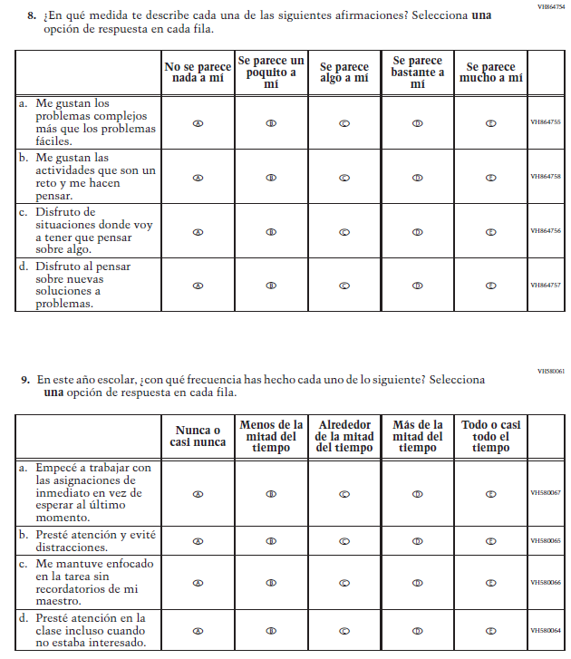

Appendix J-1c-s-BL: Summary of Changes Operational Grade 8 CORE

2024 Operational Grade 8 Core Student – Bilingual
Previous item | 2024 item | D/A/R/NC+ | Rationale
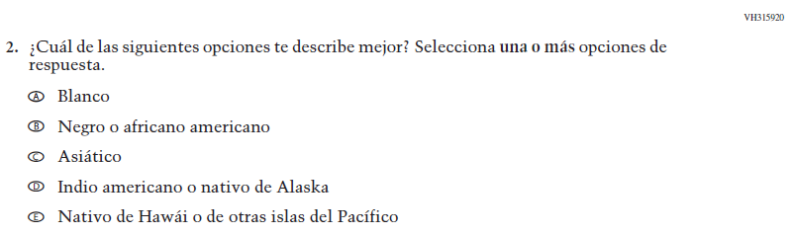  (2022 Operational Grade 8 Student Core - Bilingual) | Issue: Race/Ethnicity | R | Revised options b and d to align with categories used by the 2020 Census Bureau

Appendix J-1c-s-BL: Operational Grade 8 CORE

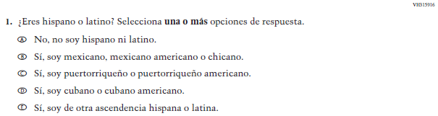

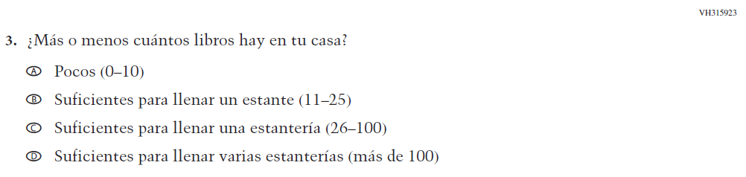

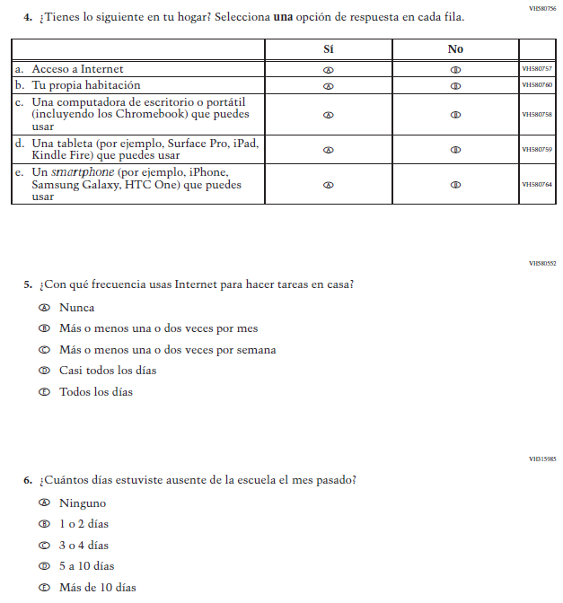

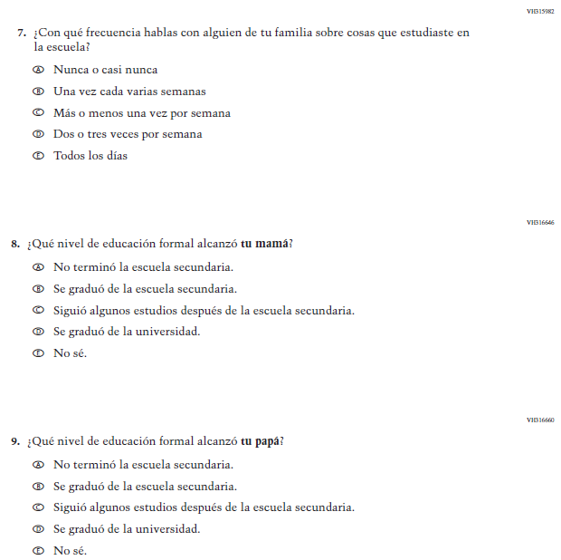

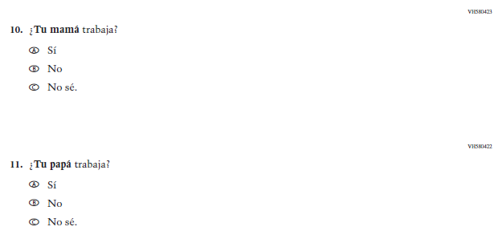

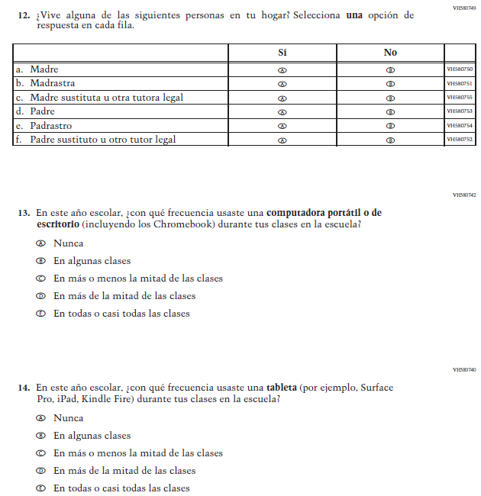

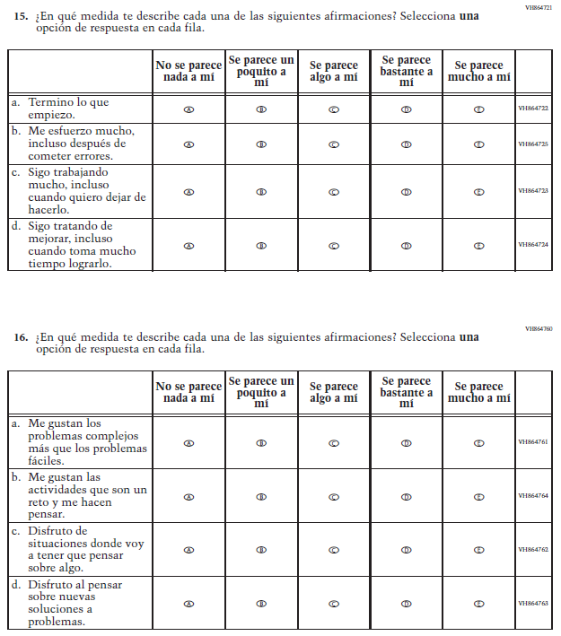

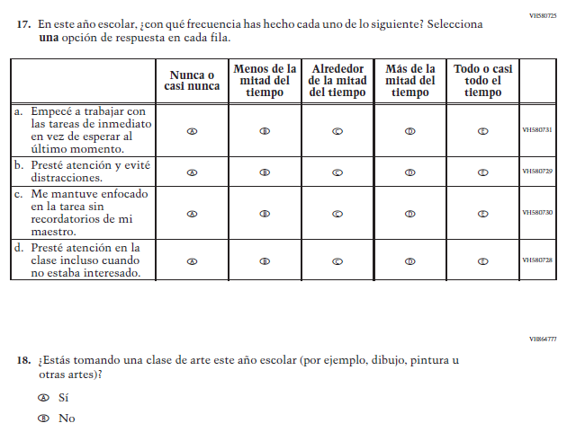

Appendix J-1d-s-PR: Summary of Changes Operational Grade 8 CORE

2024 Operational Grade 8 Core Student – Puerto Rico

Previous item | 2024 item | D/A/ R/NC+ | Rationale
(2022 Operational Grade 8 Student Core – Puerto Rico) | Issue: Race/Ethnicity | R | Revised options b and d to align with categories used by the 2020 Census Bureau

Appendix J-1d-s-PR: Operational Grade 8 CORE
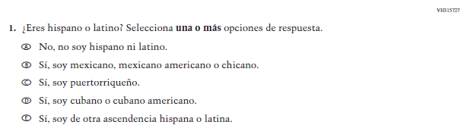

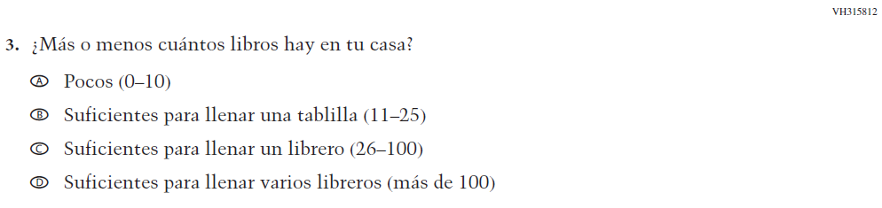
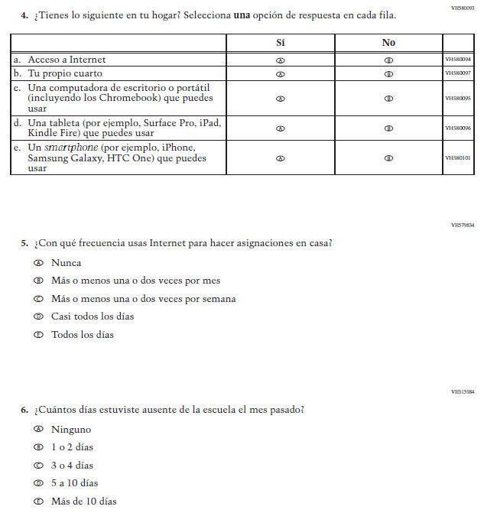

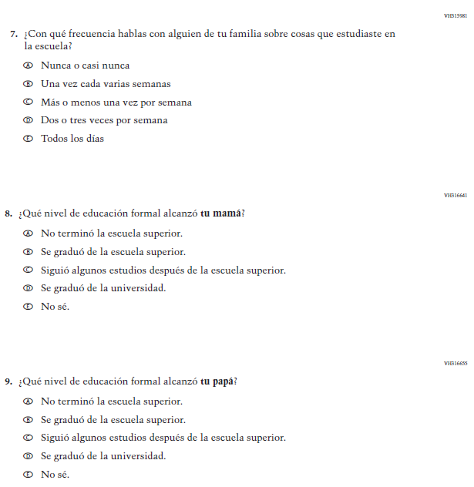

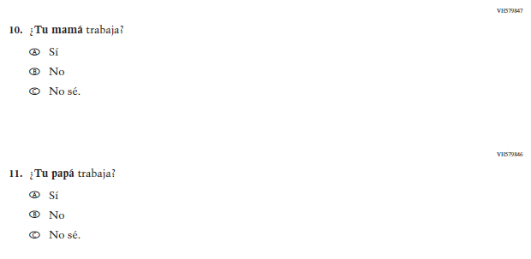

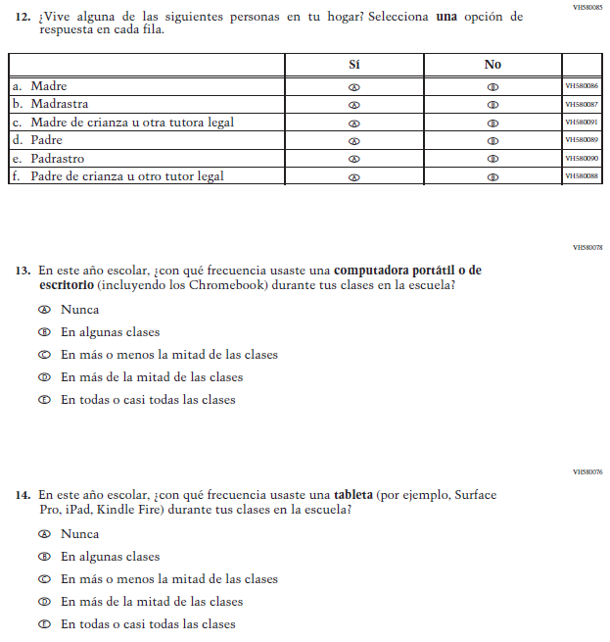

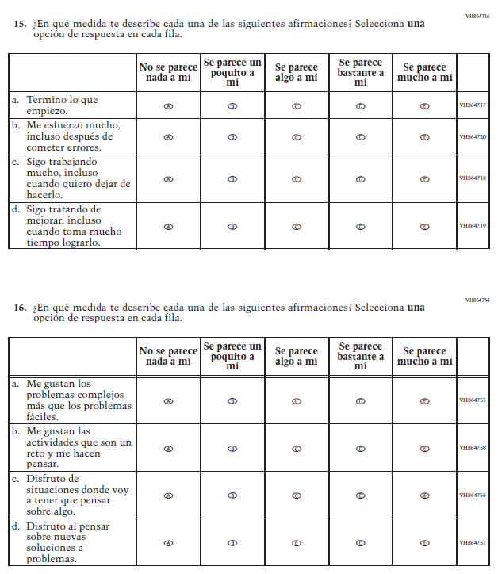

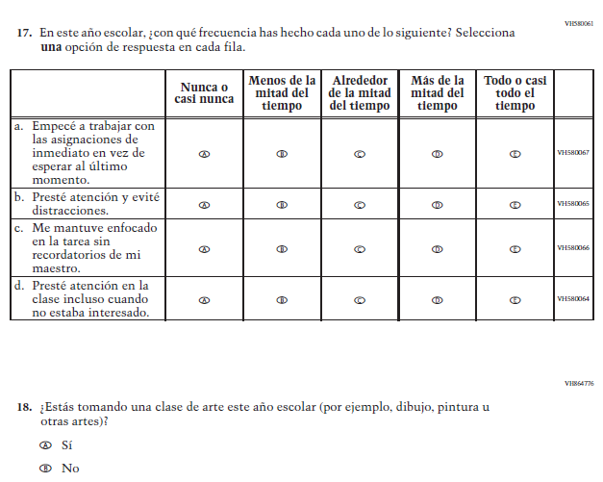

Appendix J-1e-s-BL: Operational Grade 4 Mathematics
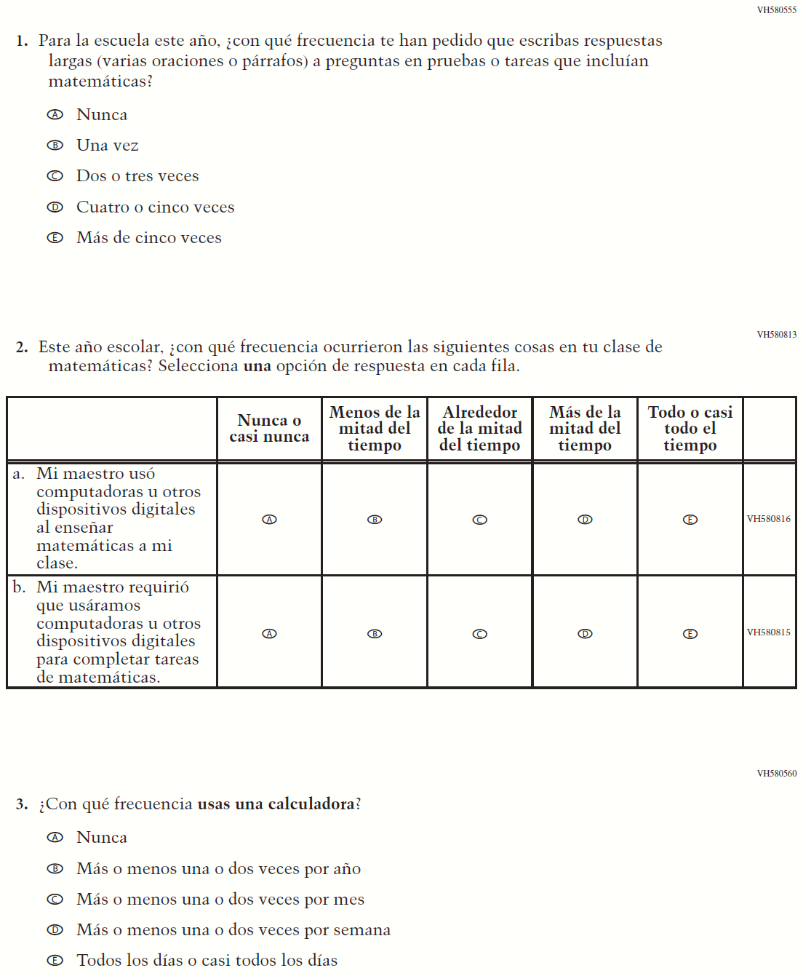

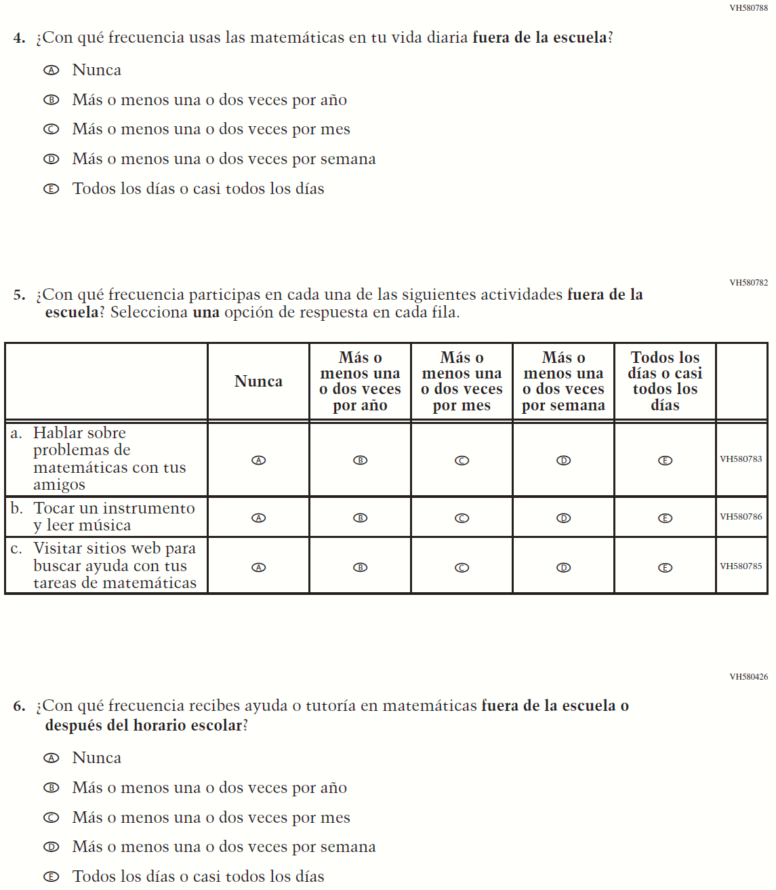

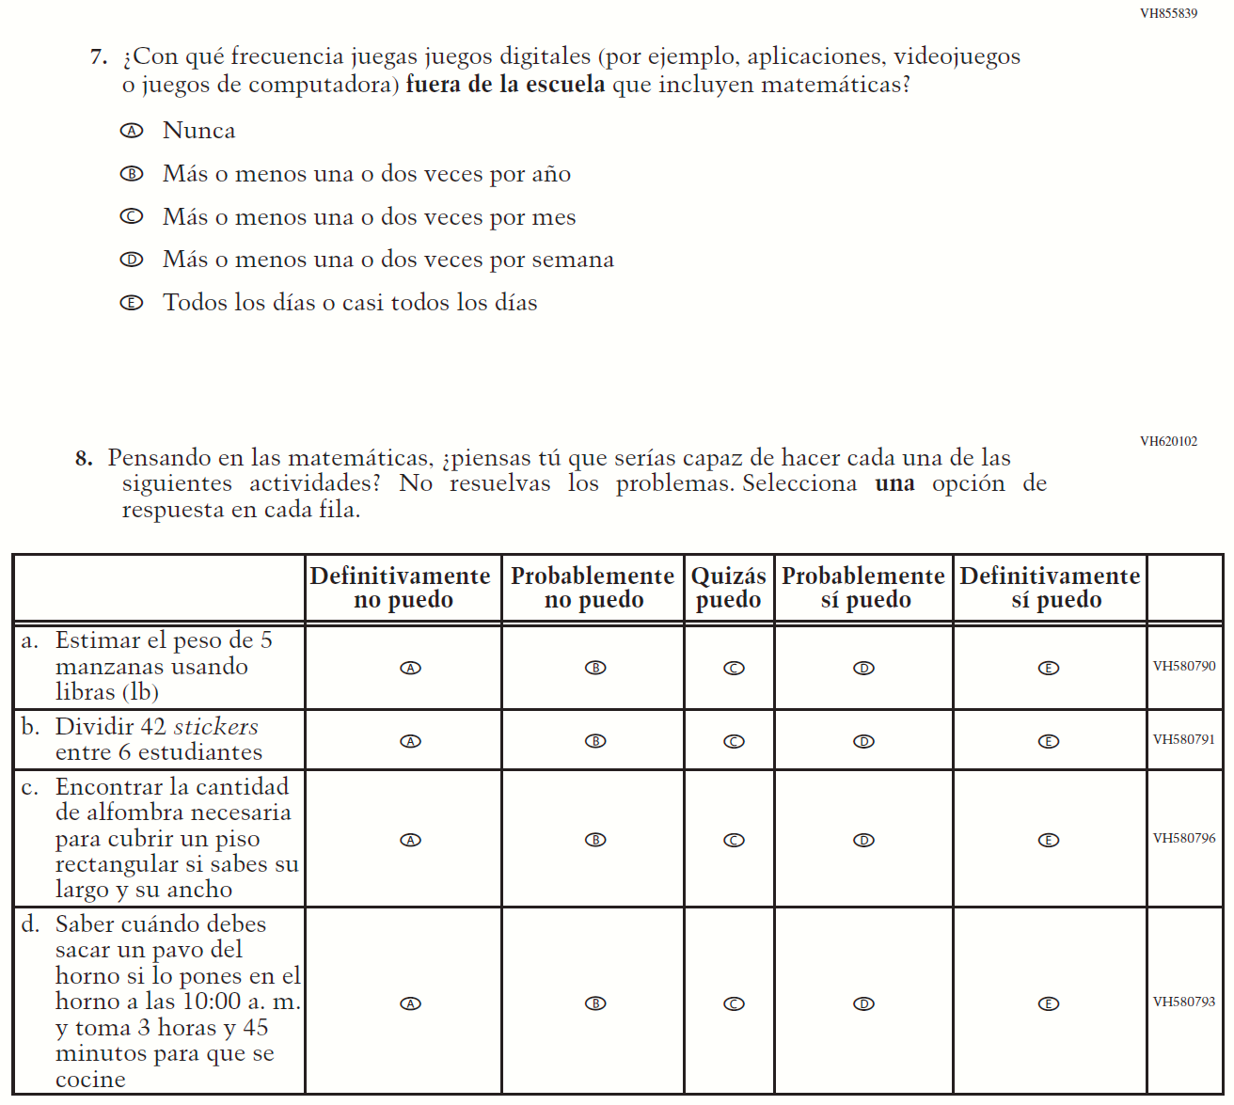

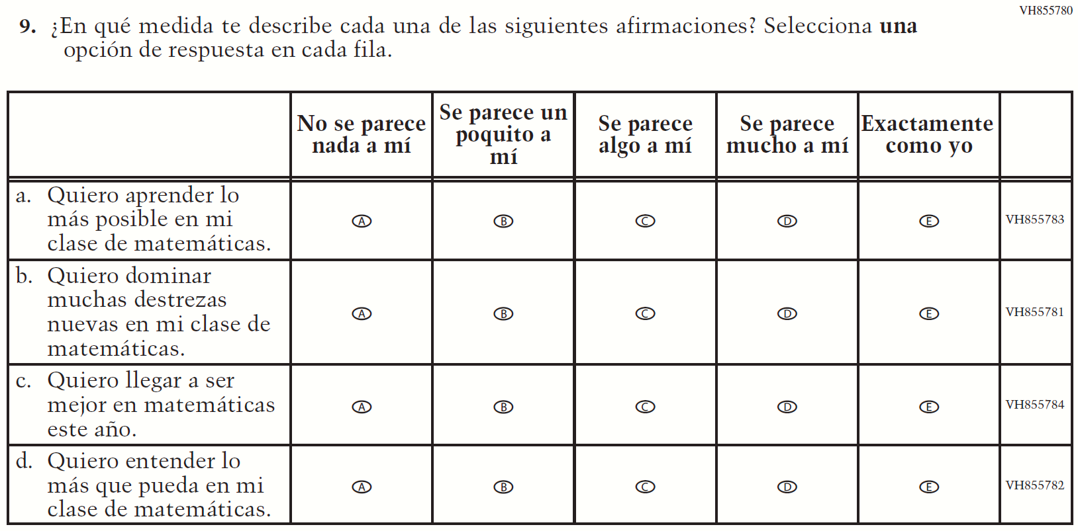

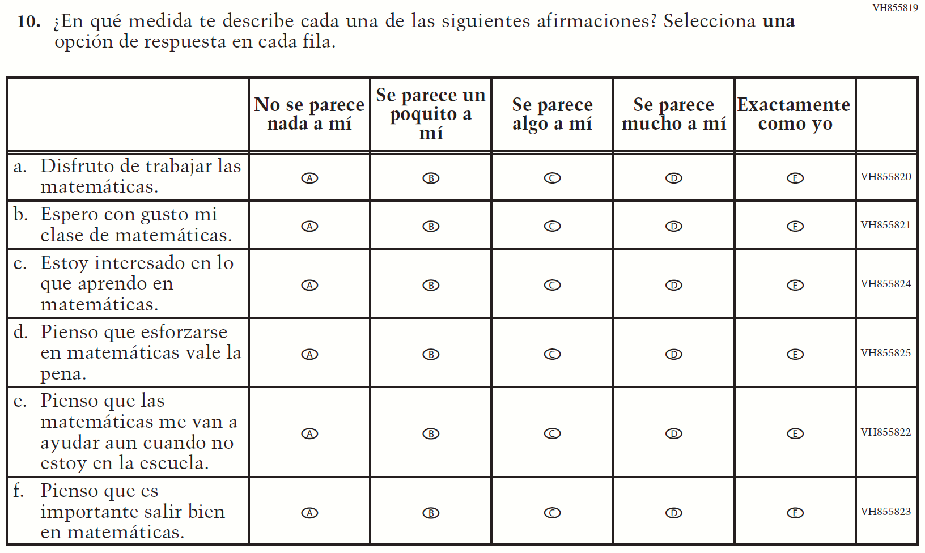

Appendix J-1f-s-PR: Operational Grade 4 Mathematics
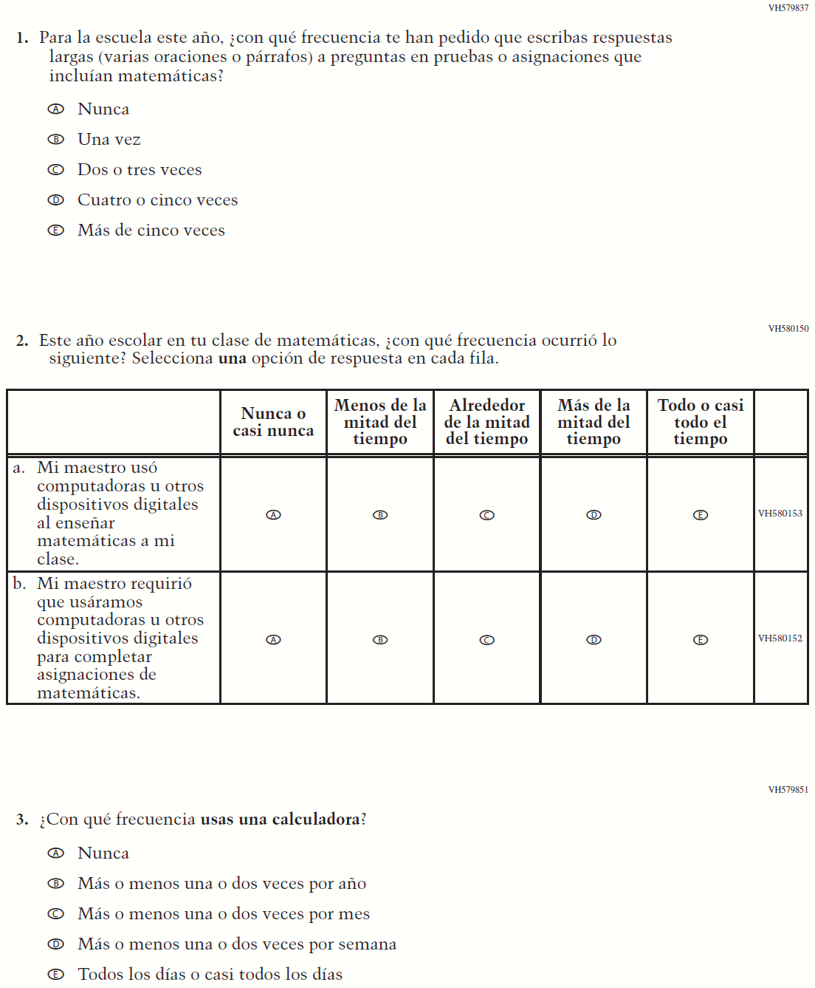

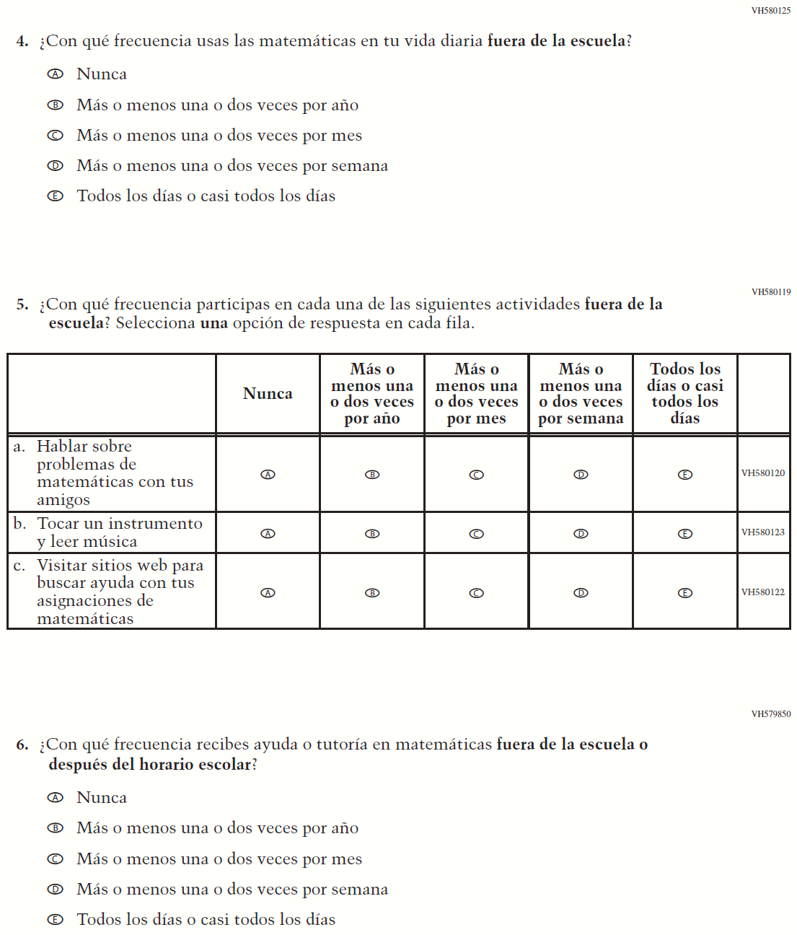

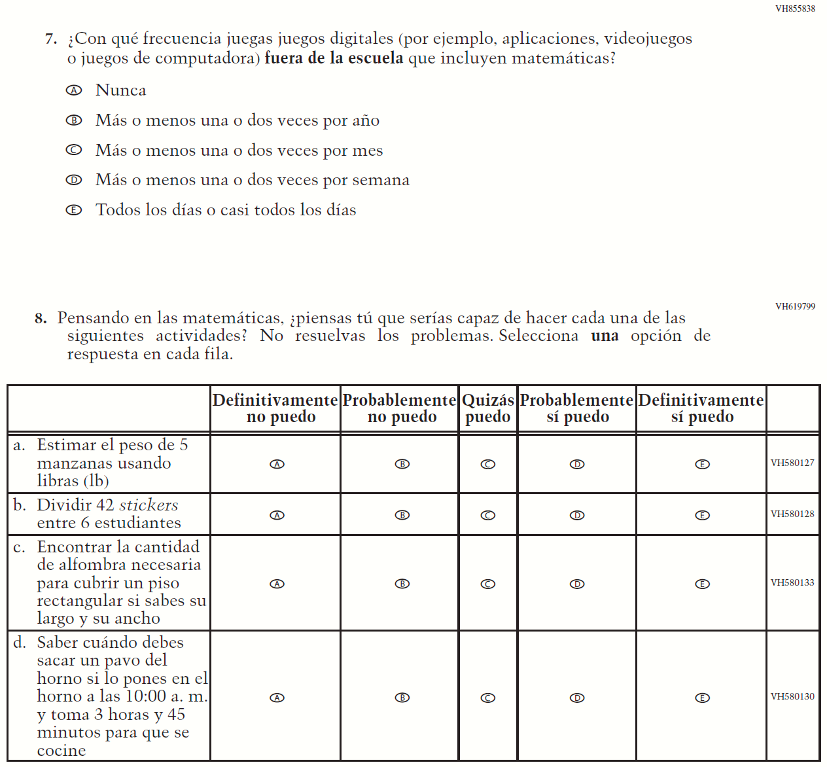

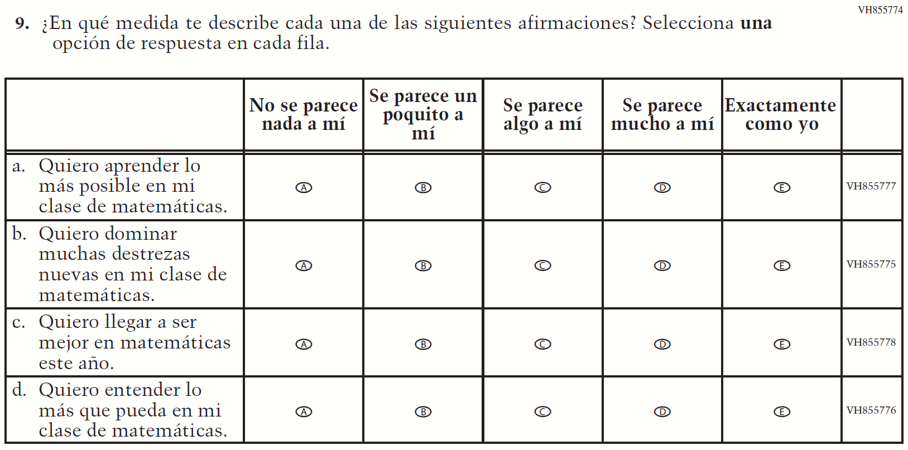

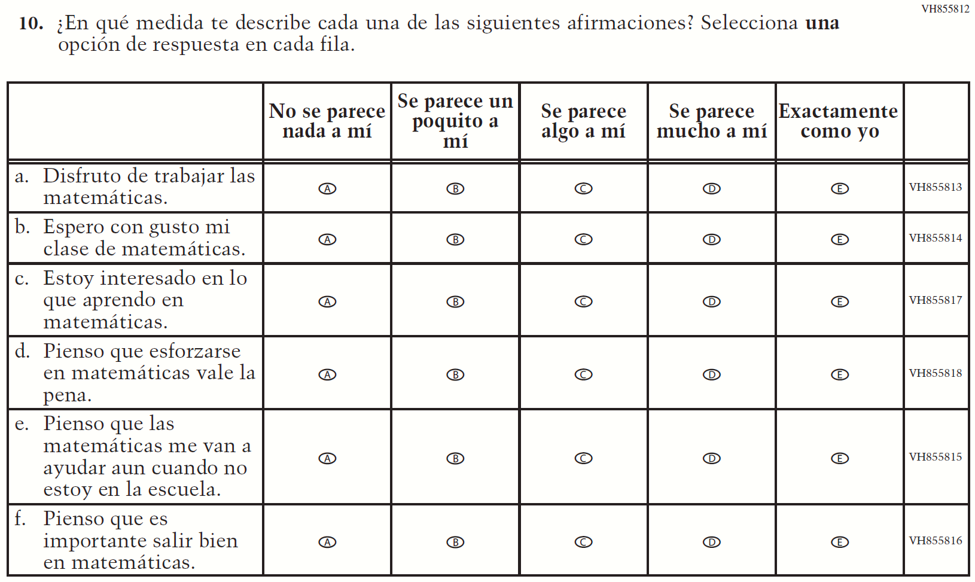

Appendix J-1g-s-BL: Operational Grade 8 Mathematics
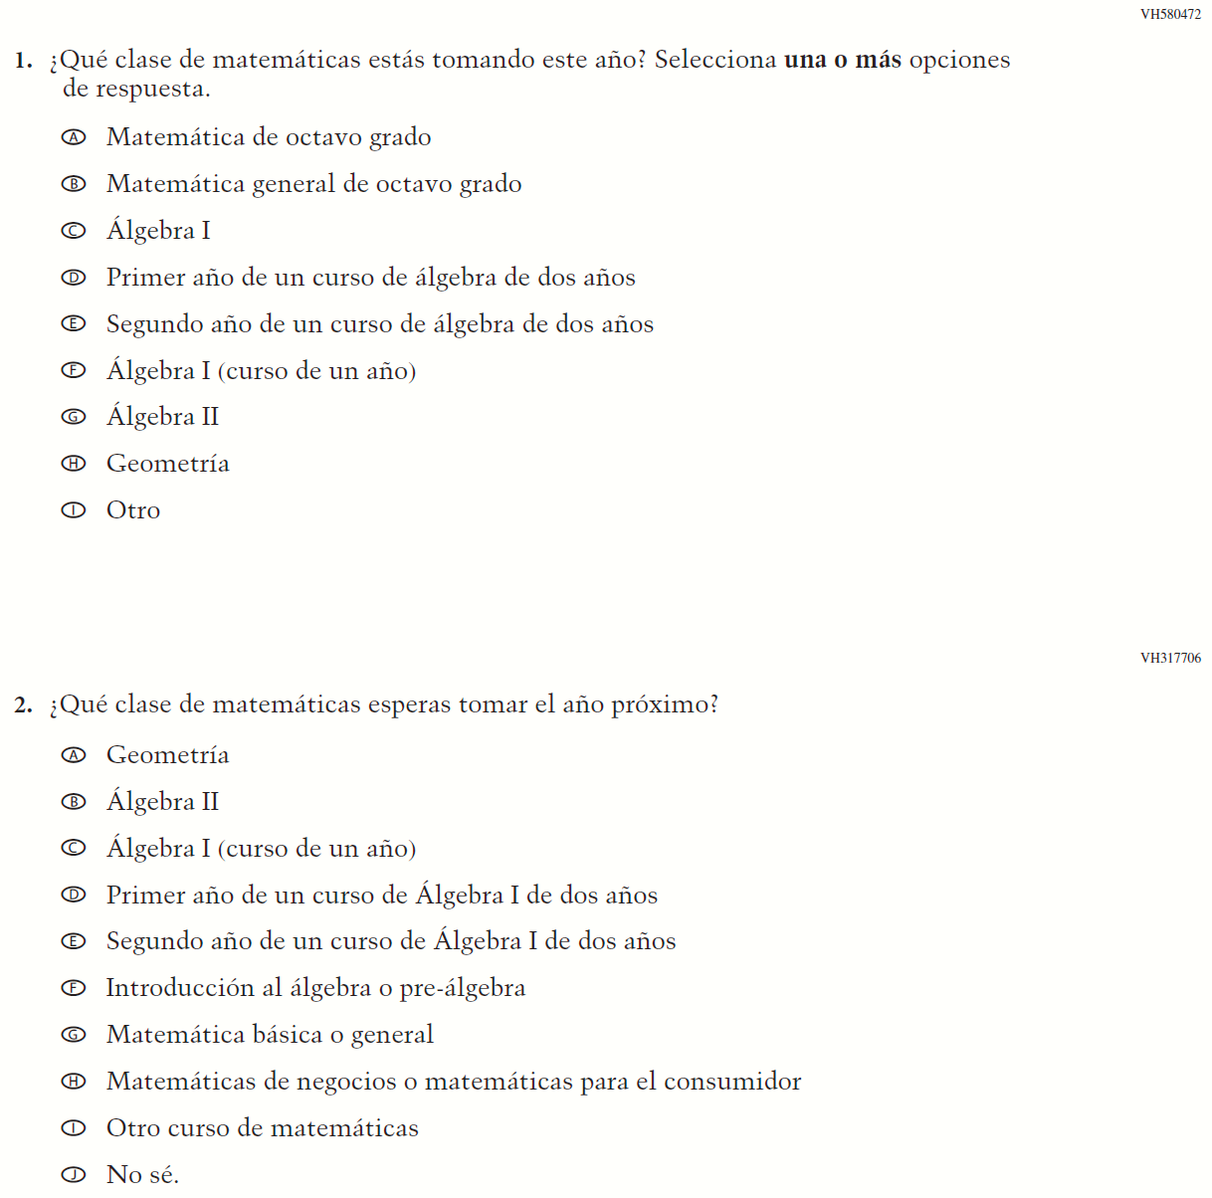

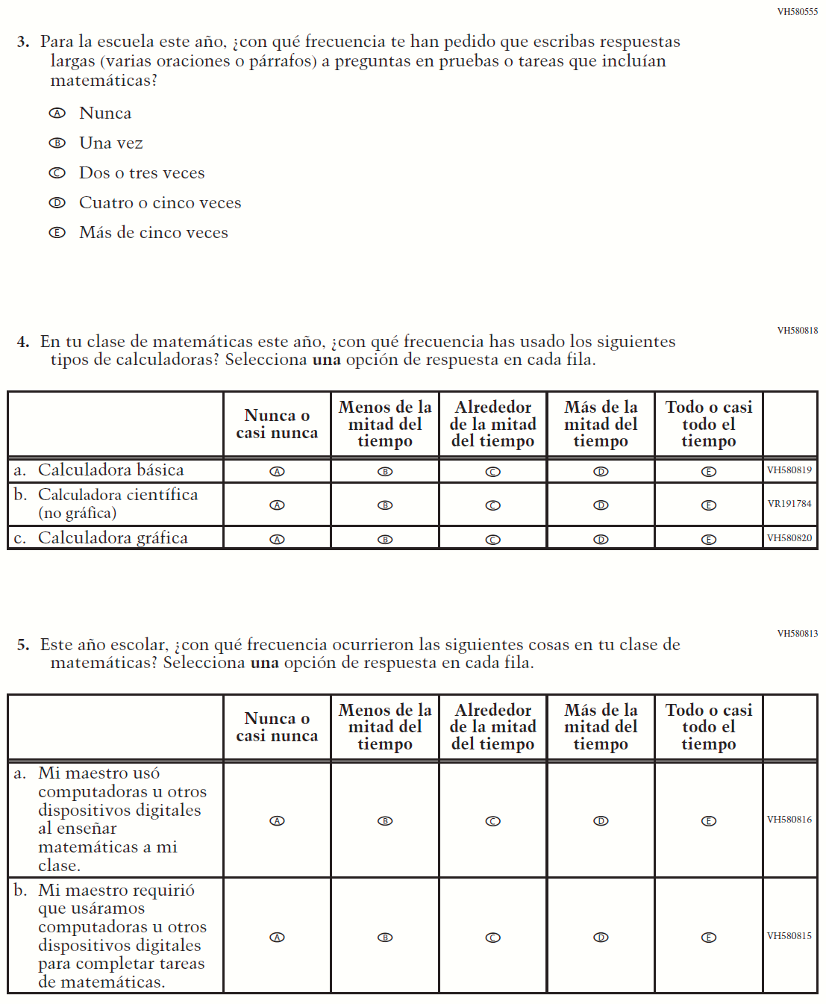

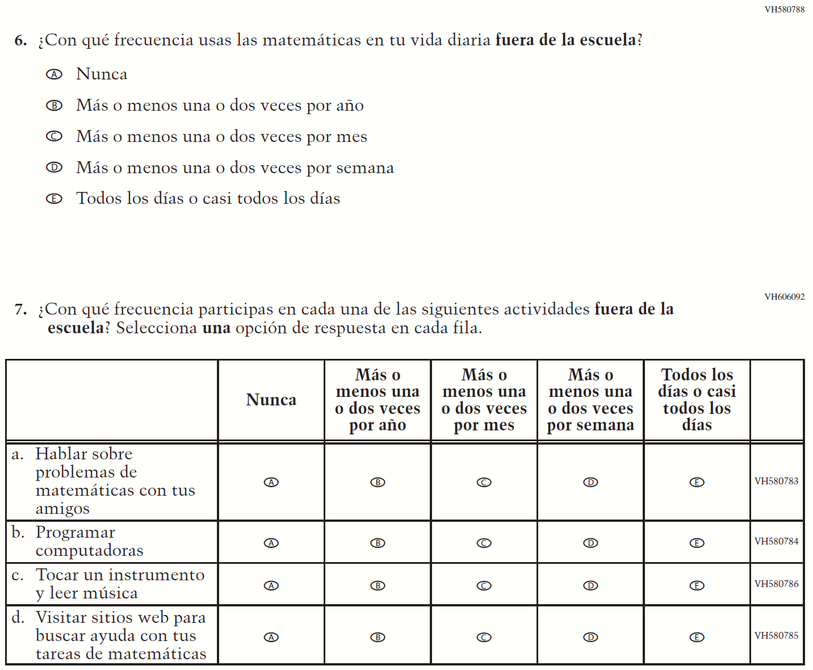

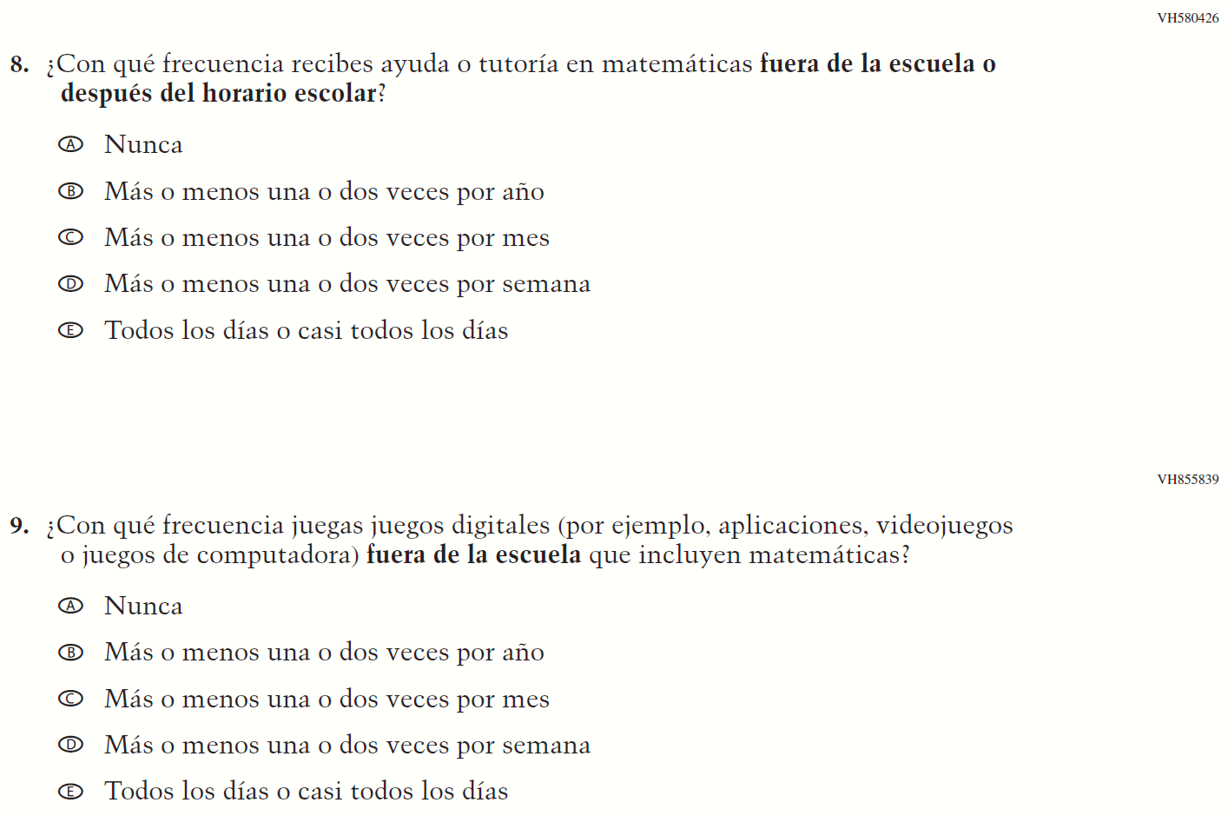

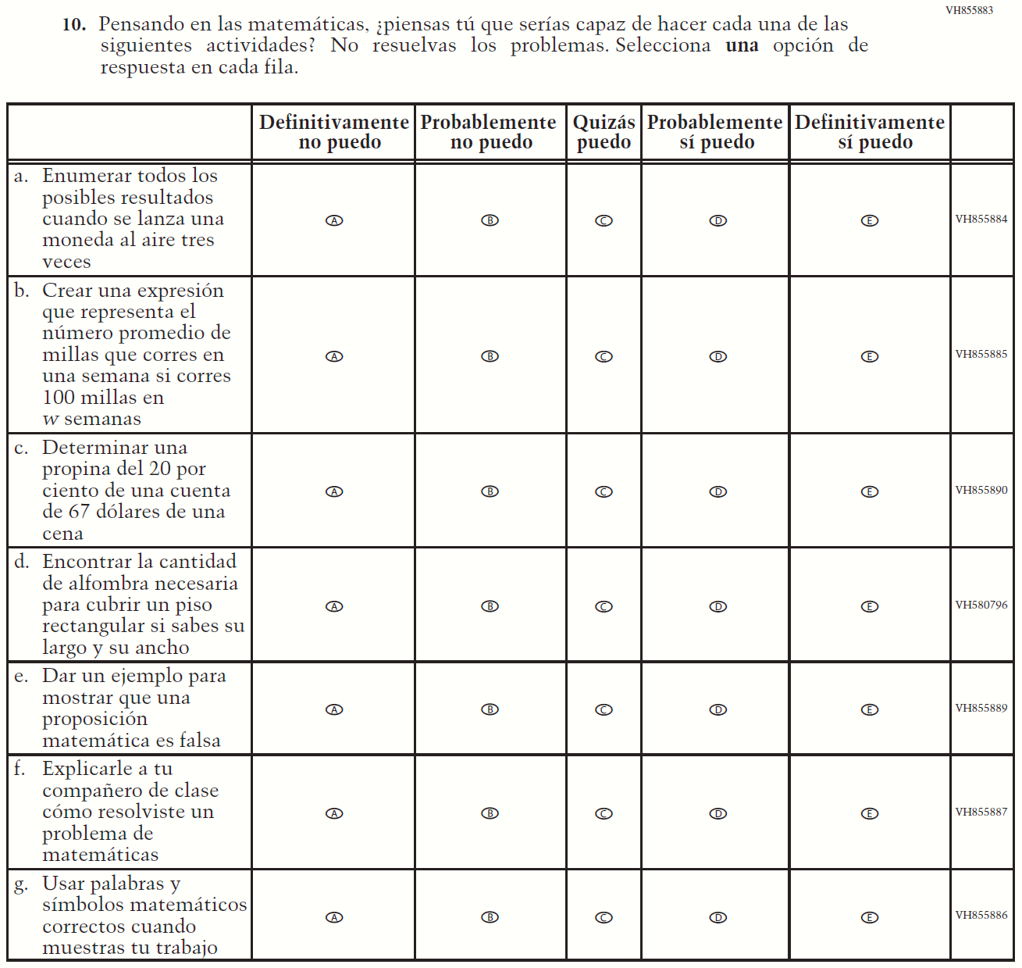

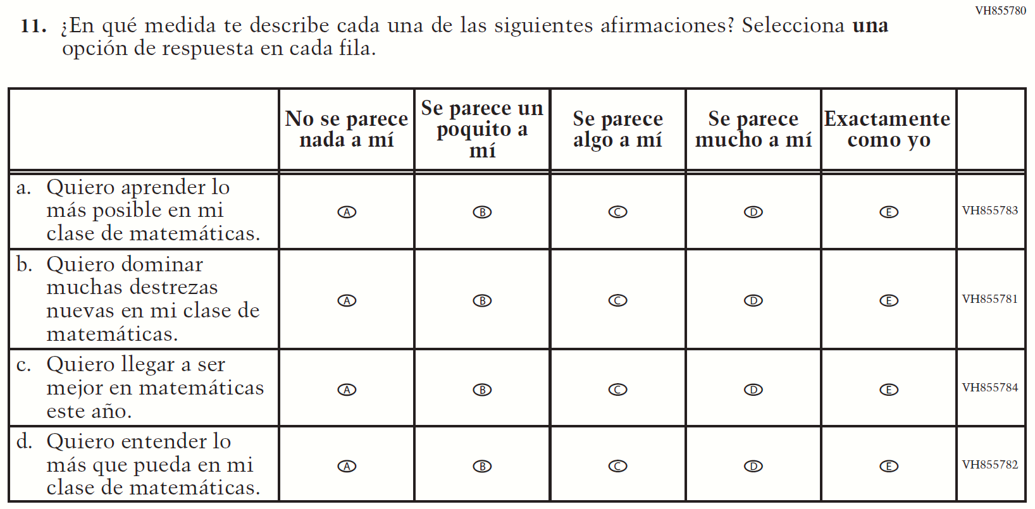

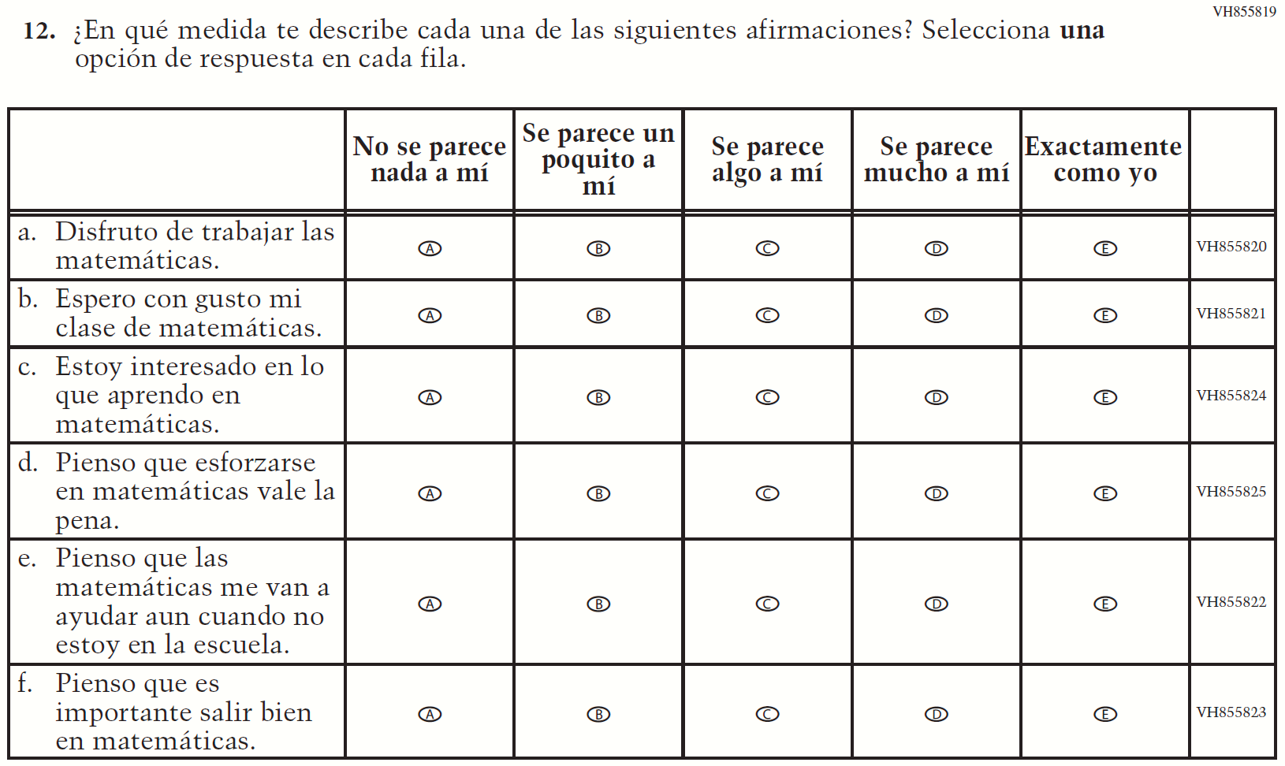

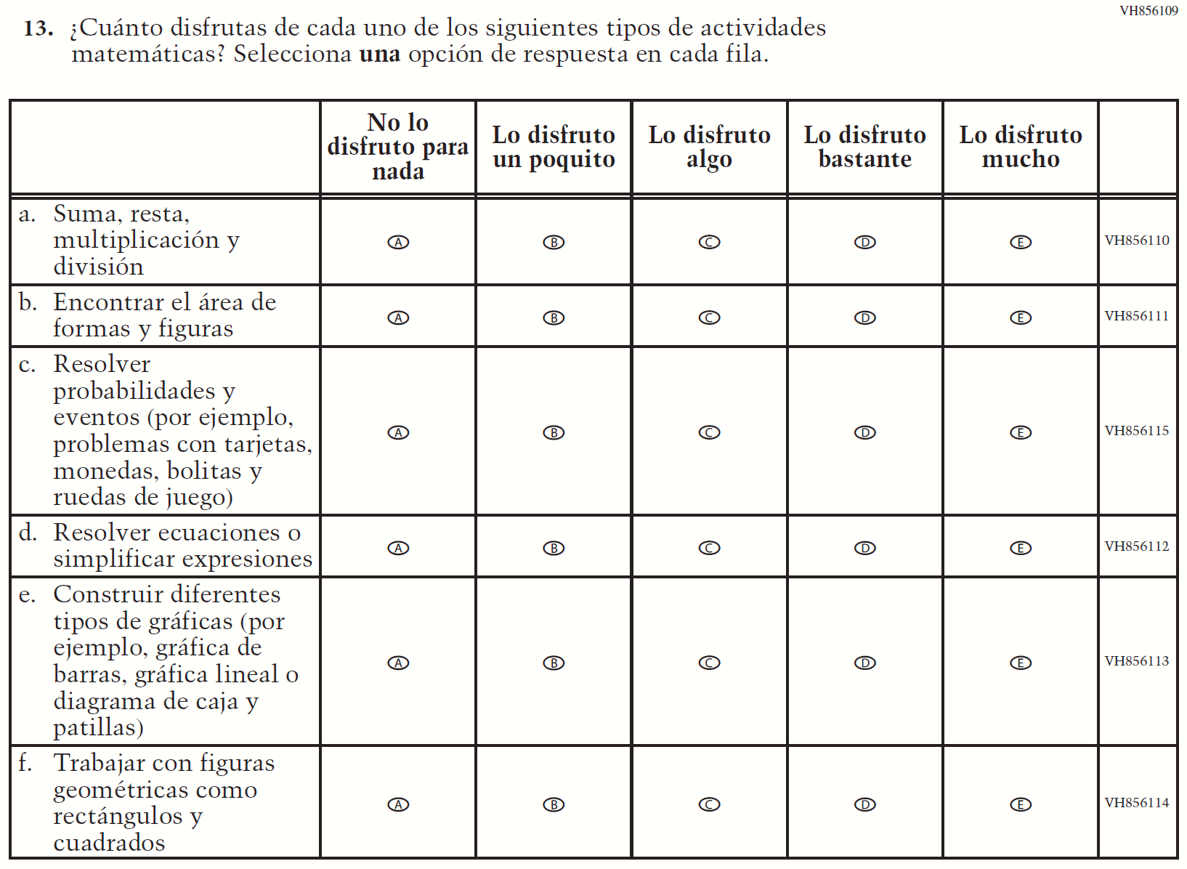

Appendix J-1h-s-PR: Operational Grade 8 Mathematics
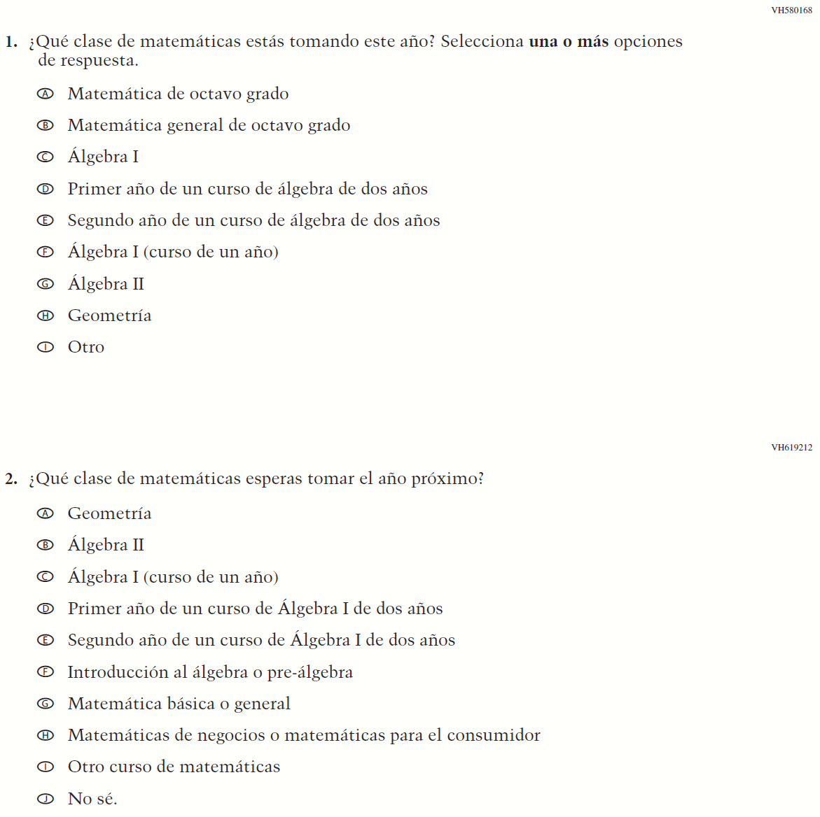

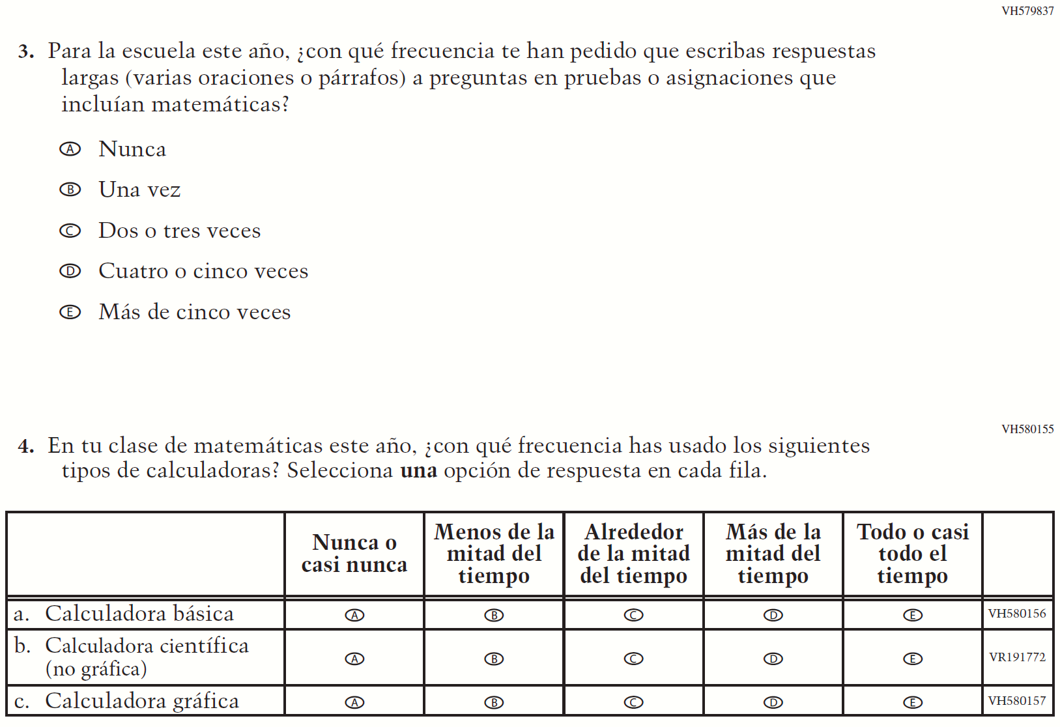

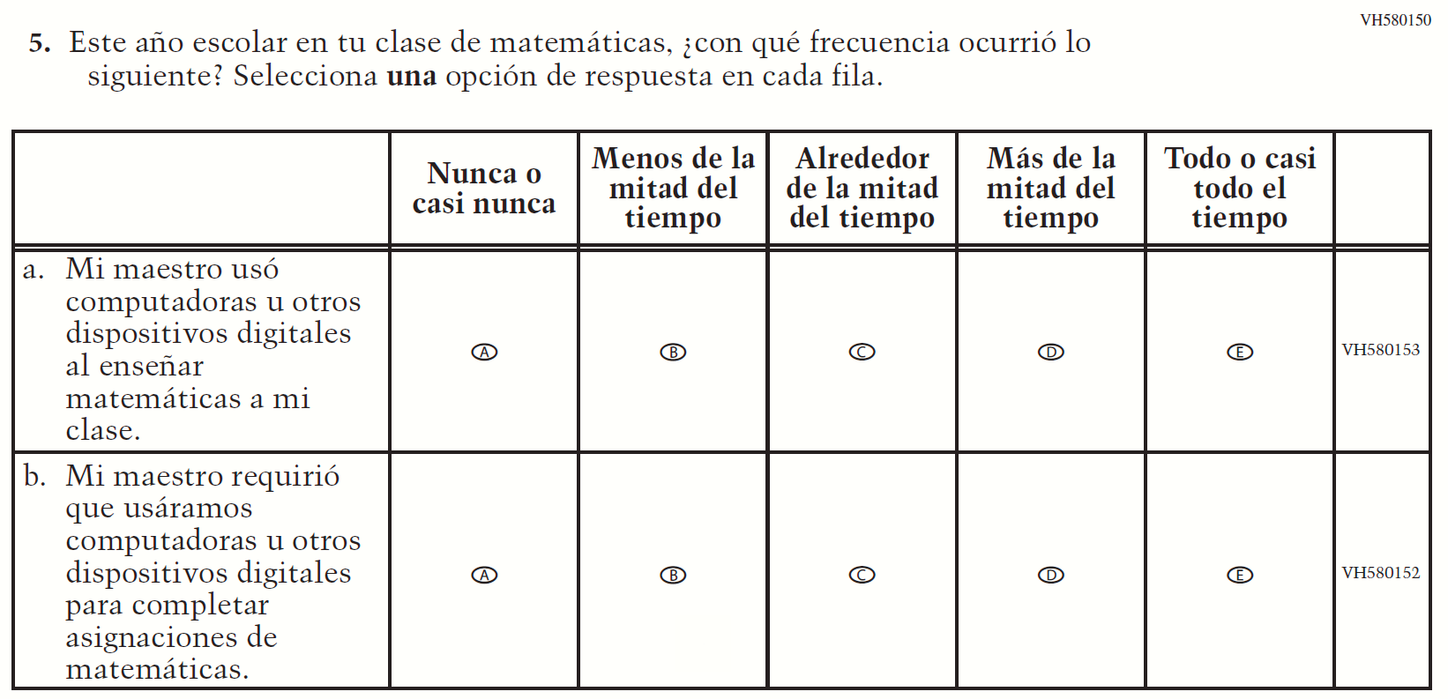

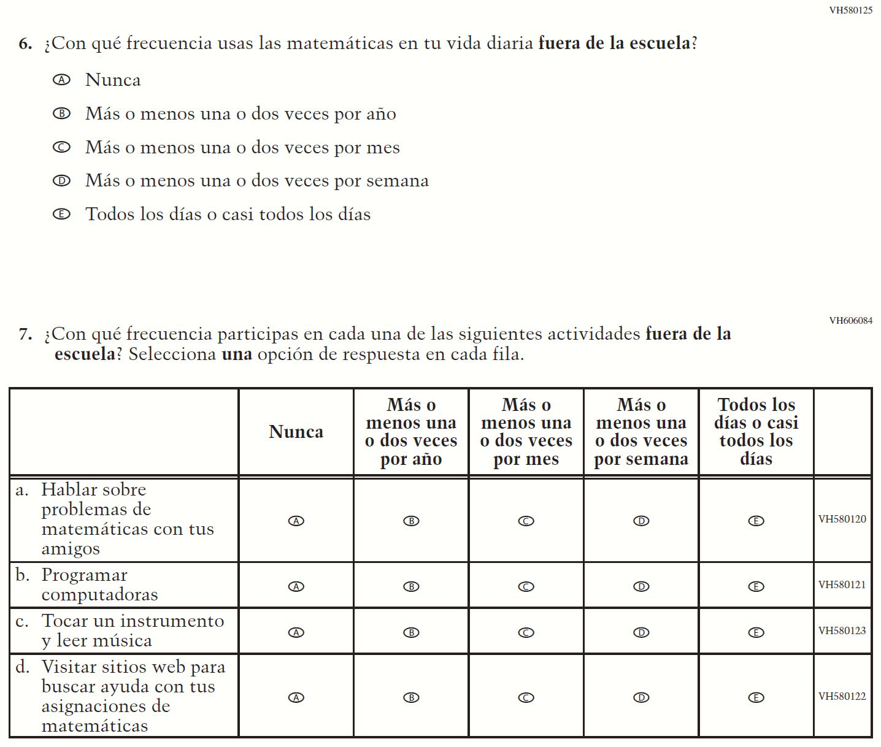

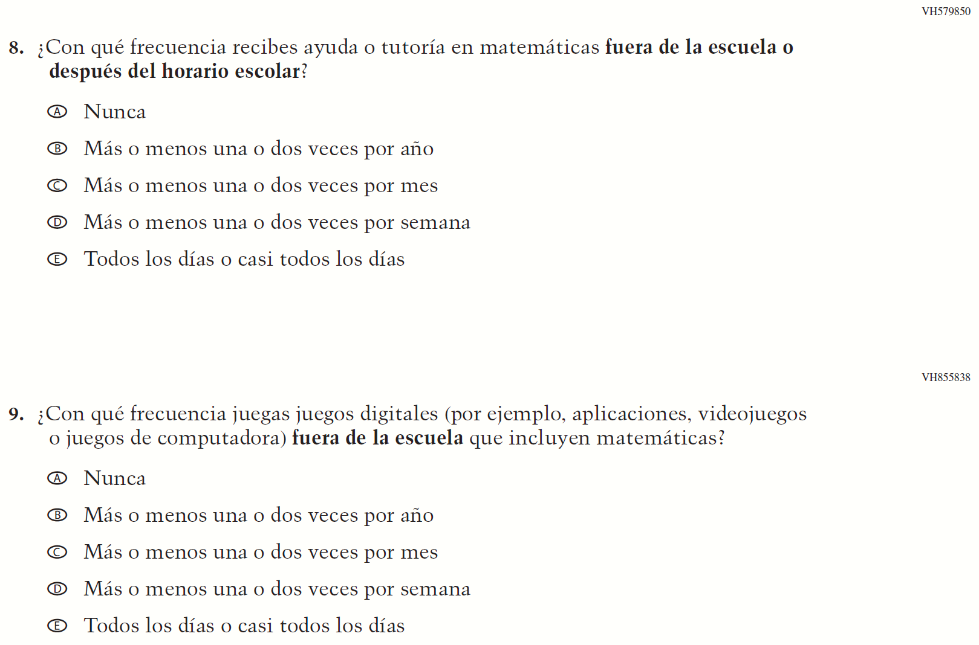

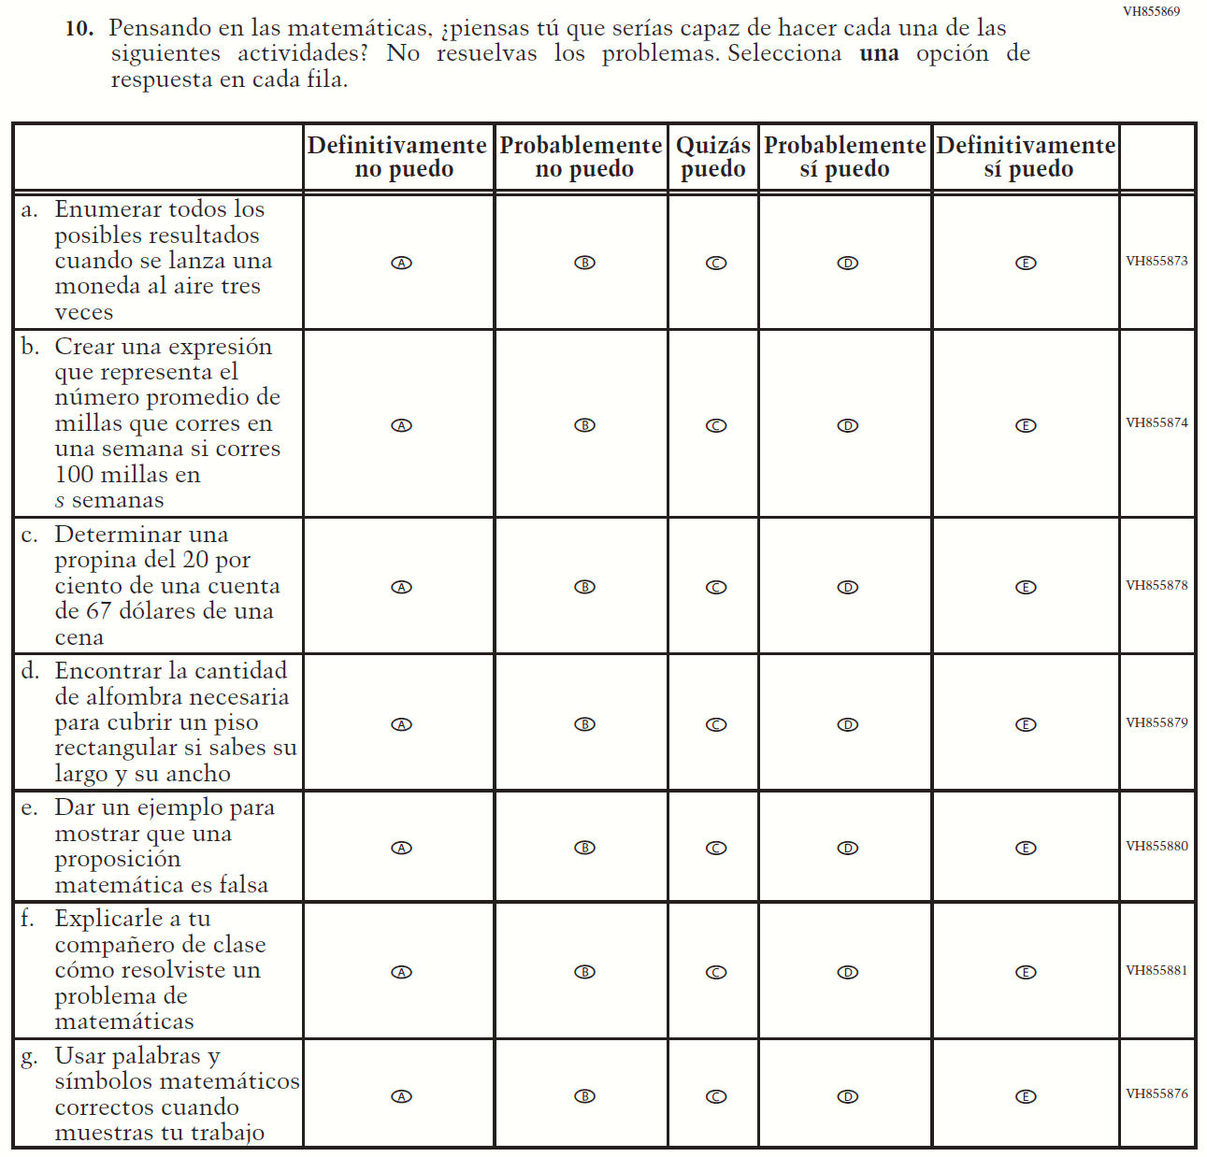

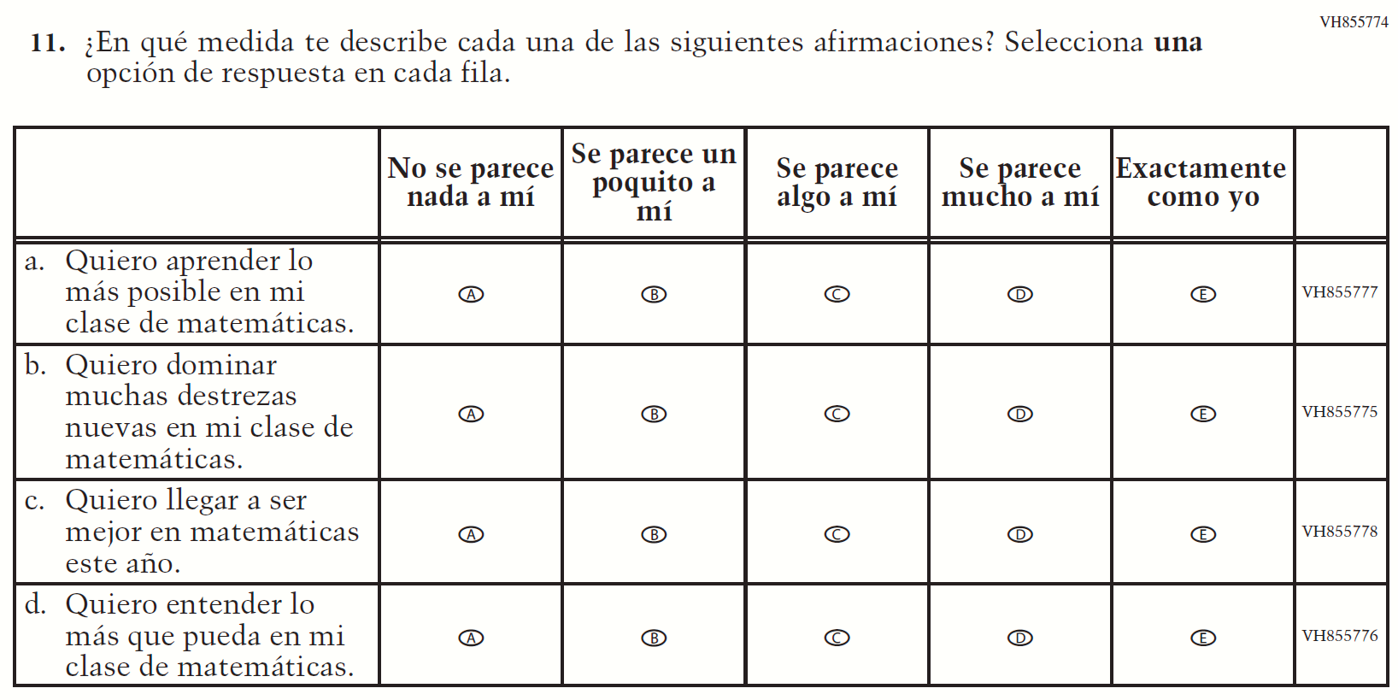

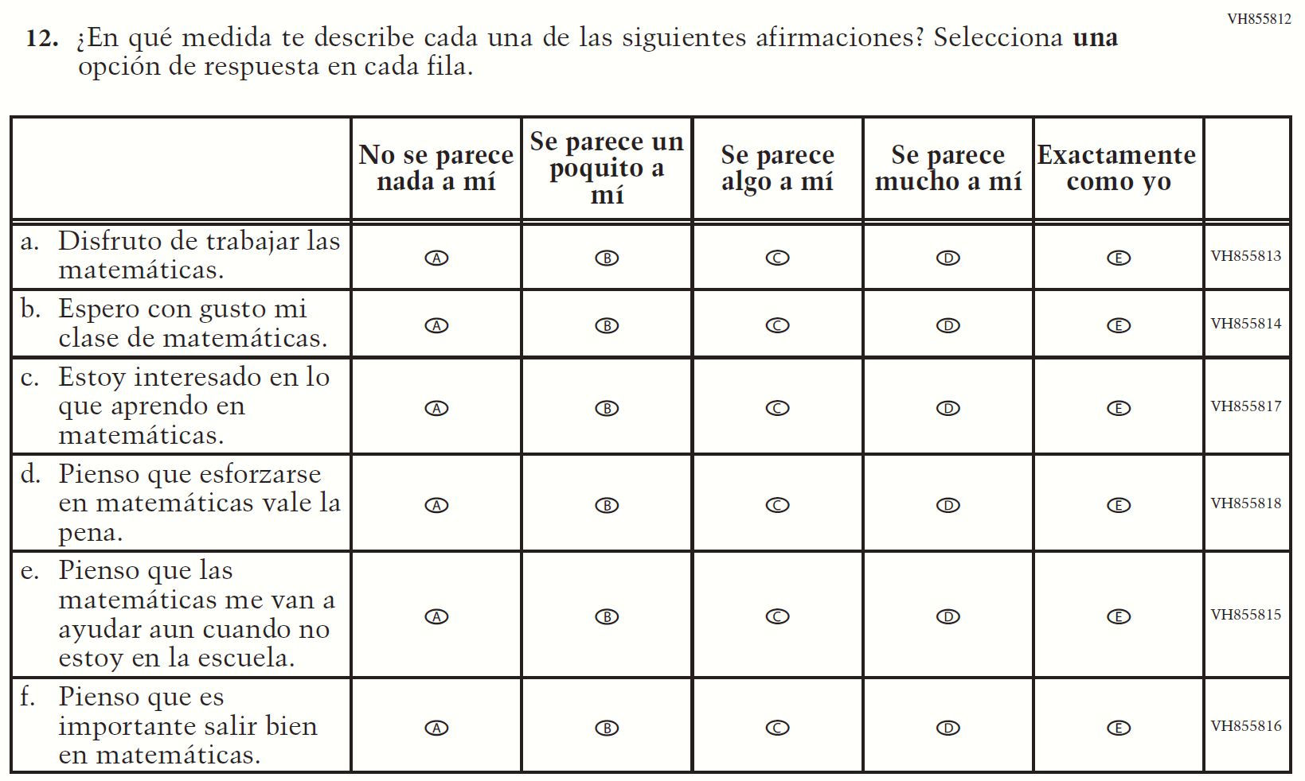

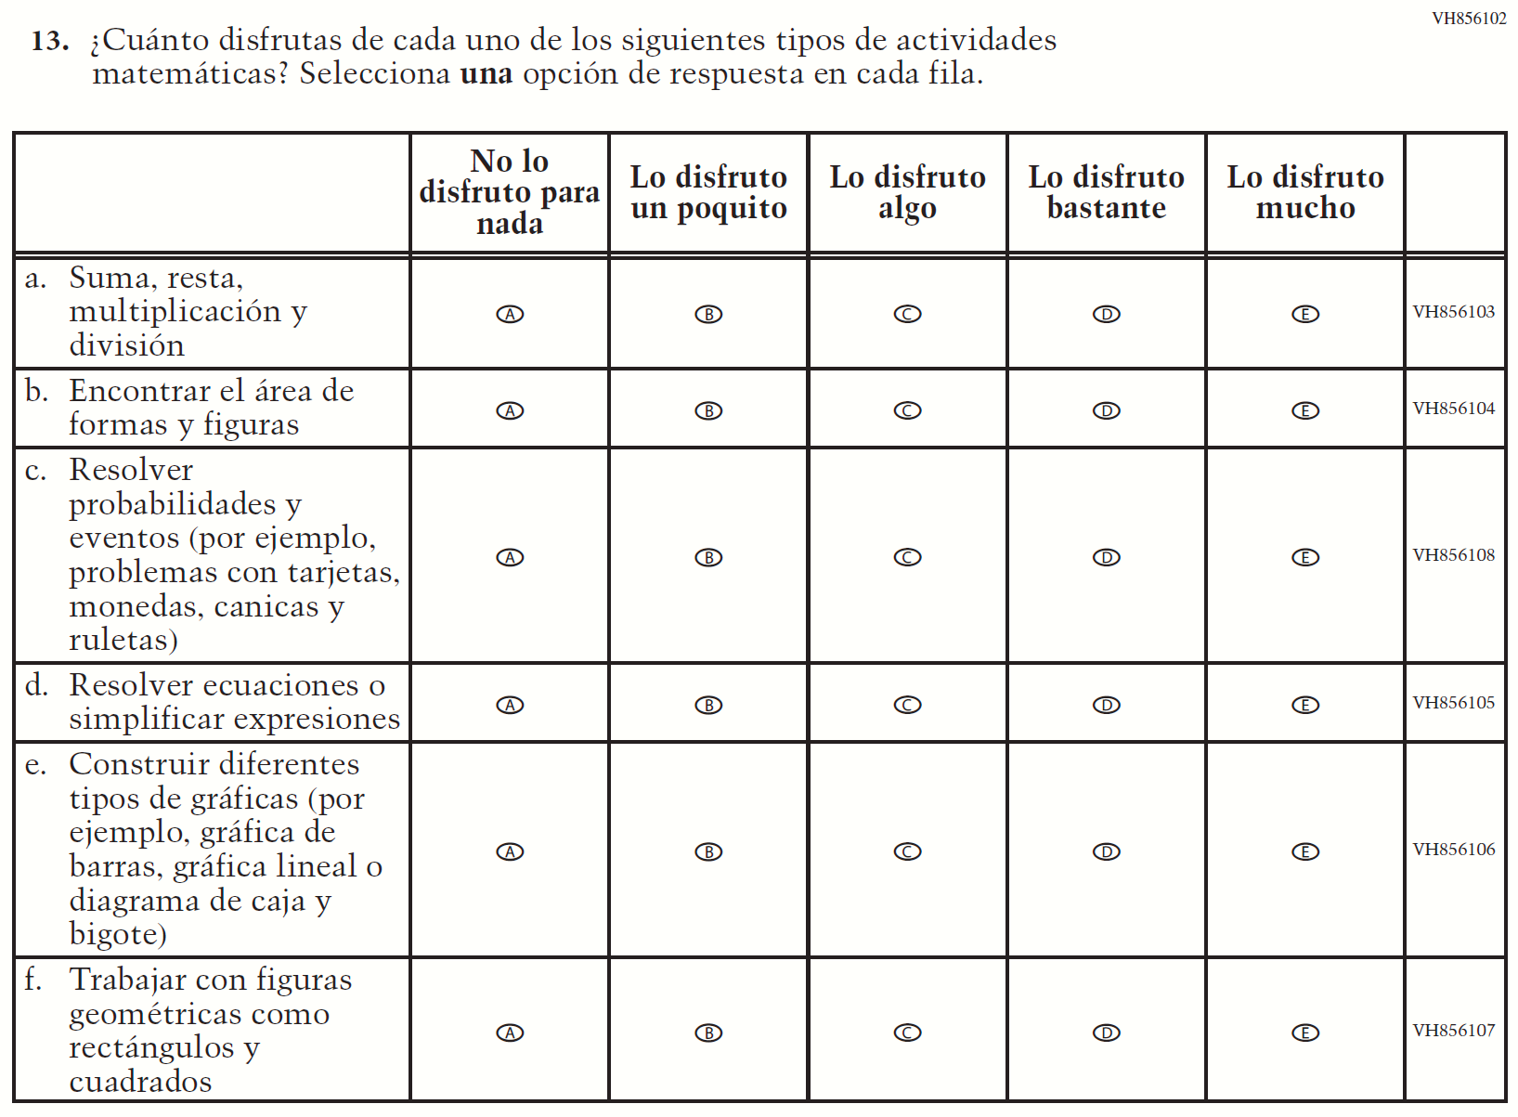

Appendix J-1i-s-BL: Operational Grade 4 Reading

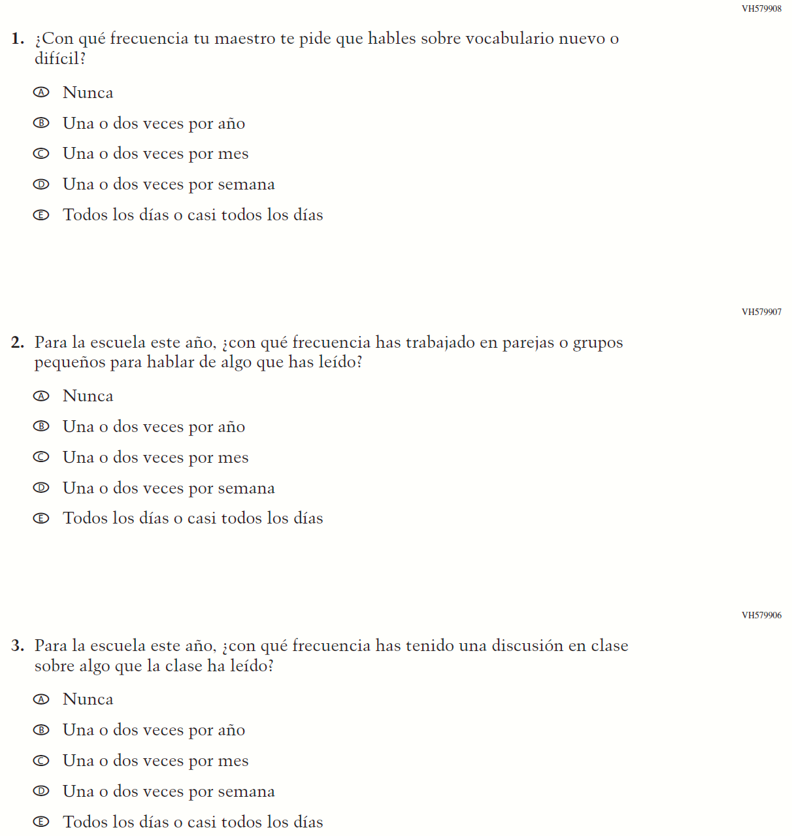

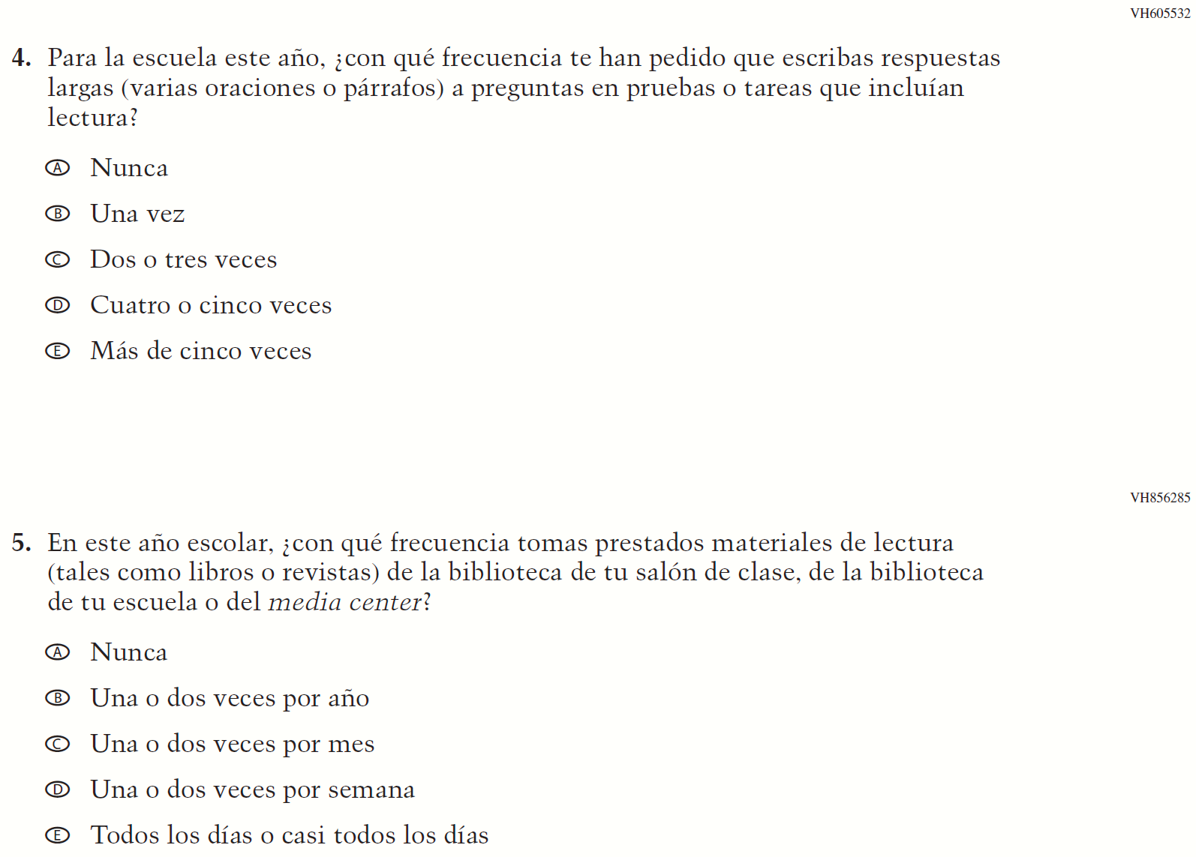

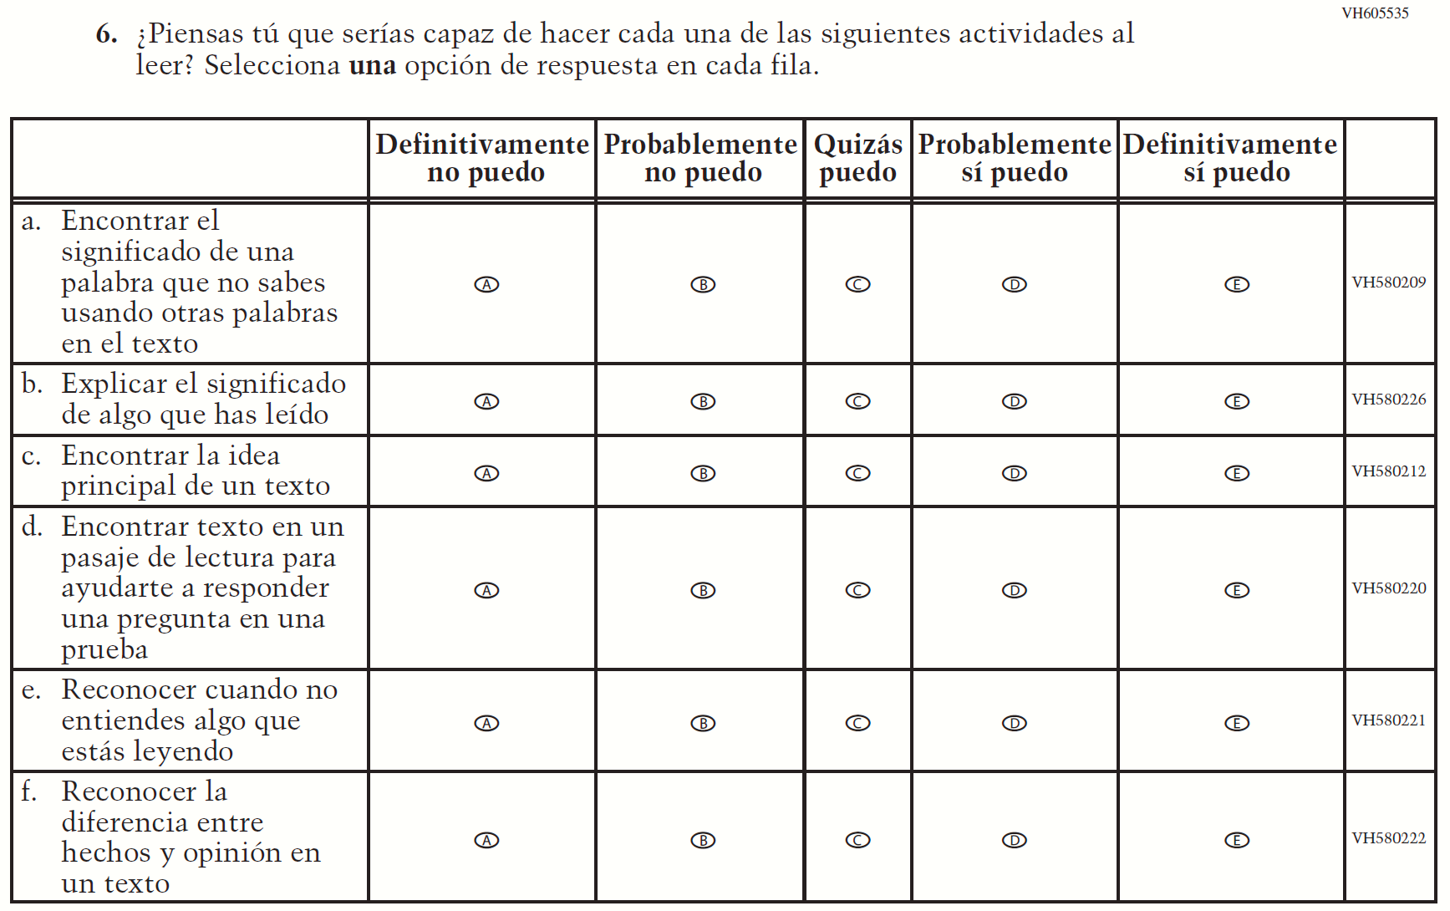

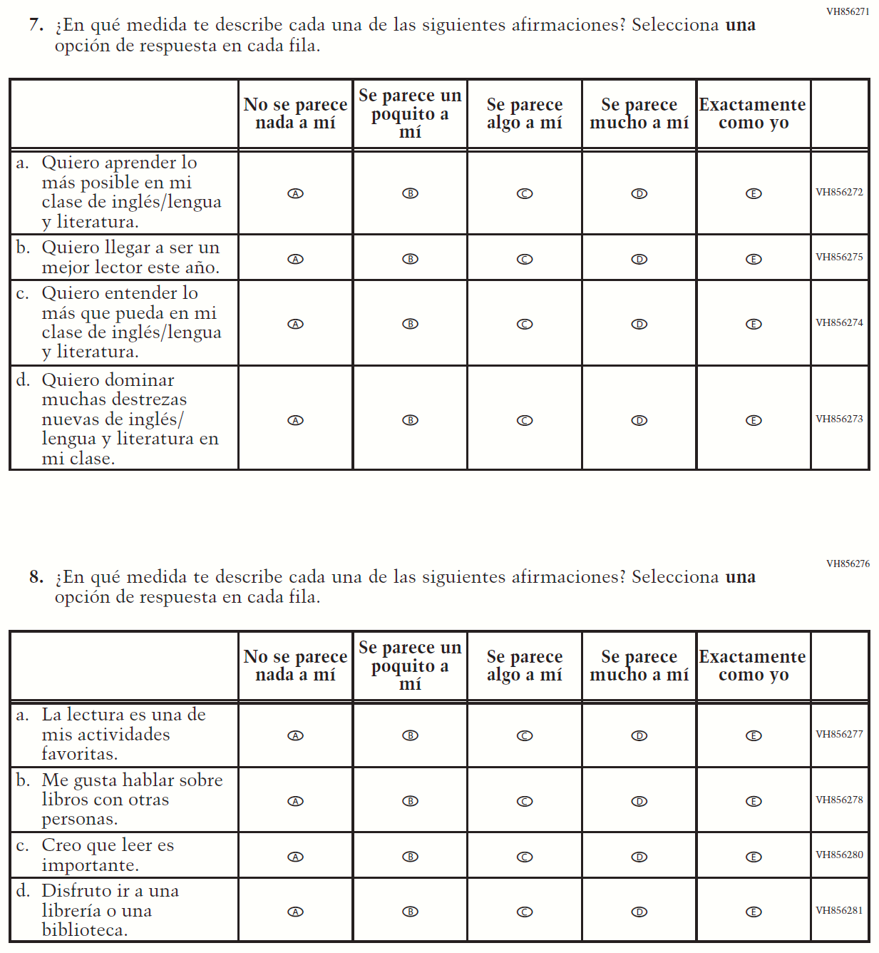

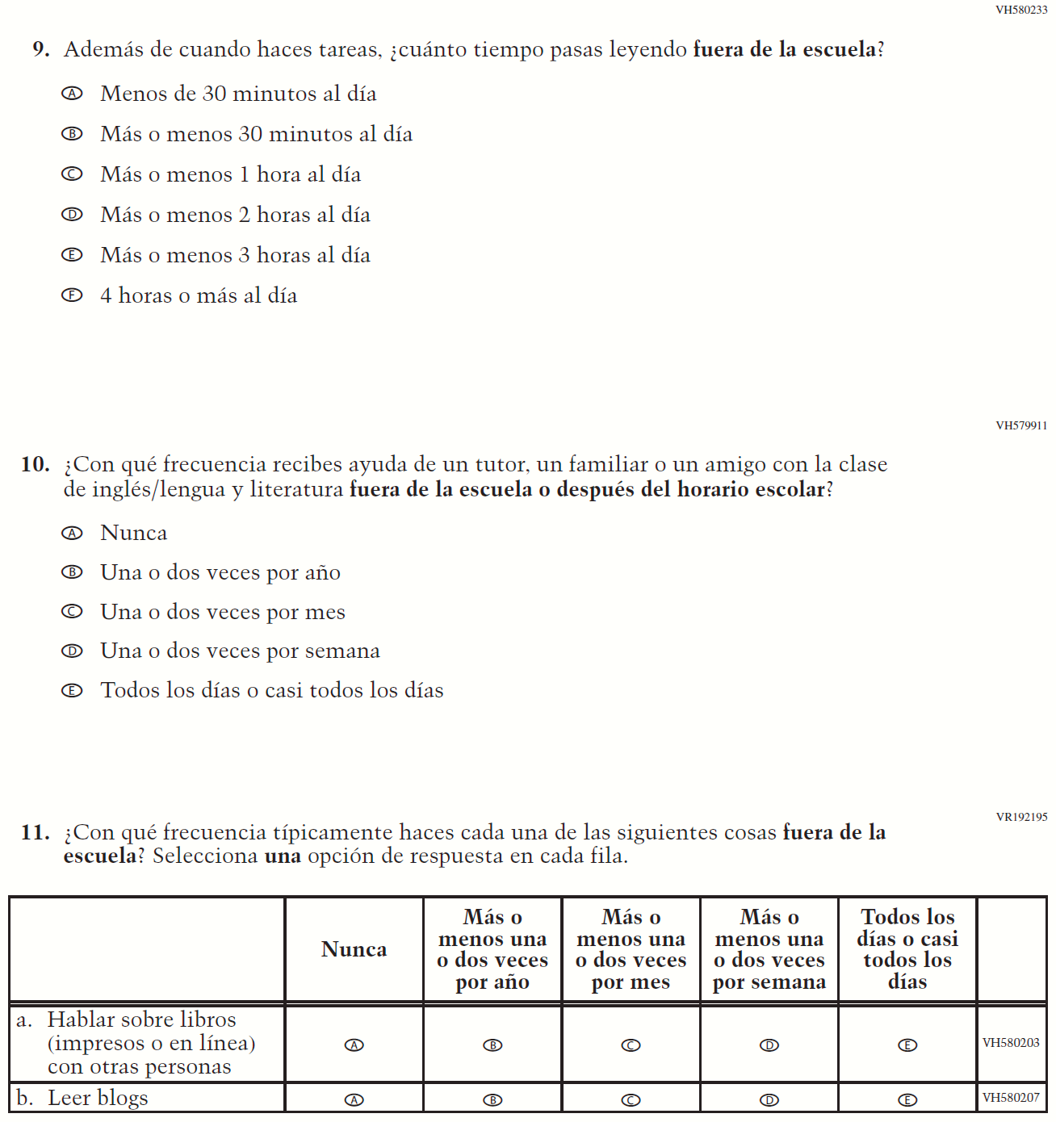

Appendix J-1j-s-BL: Operational Grade 8 Reading

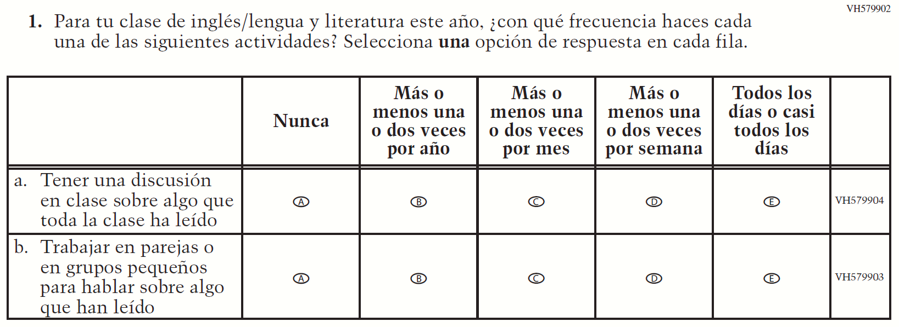

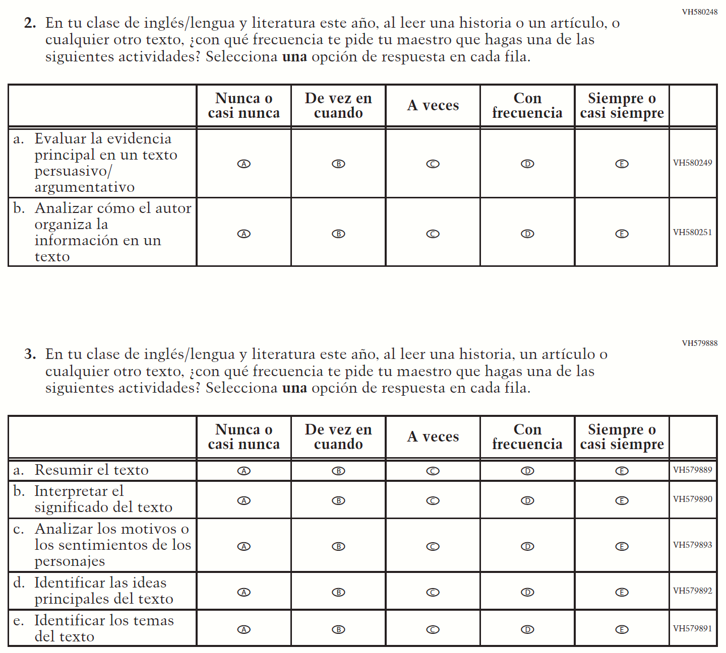

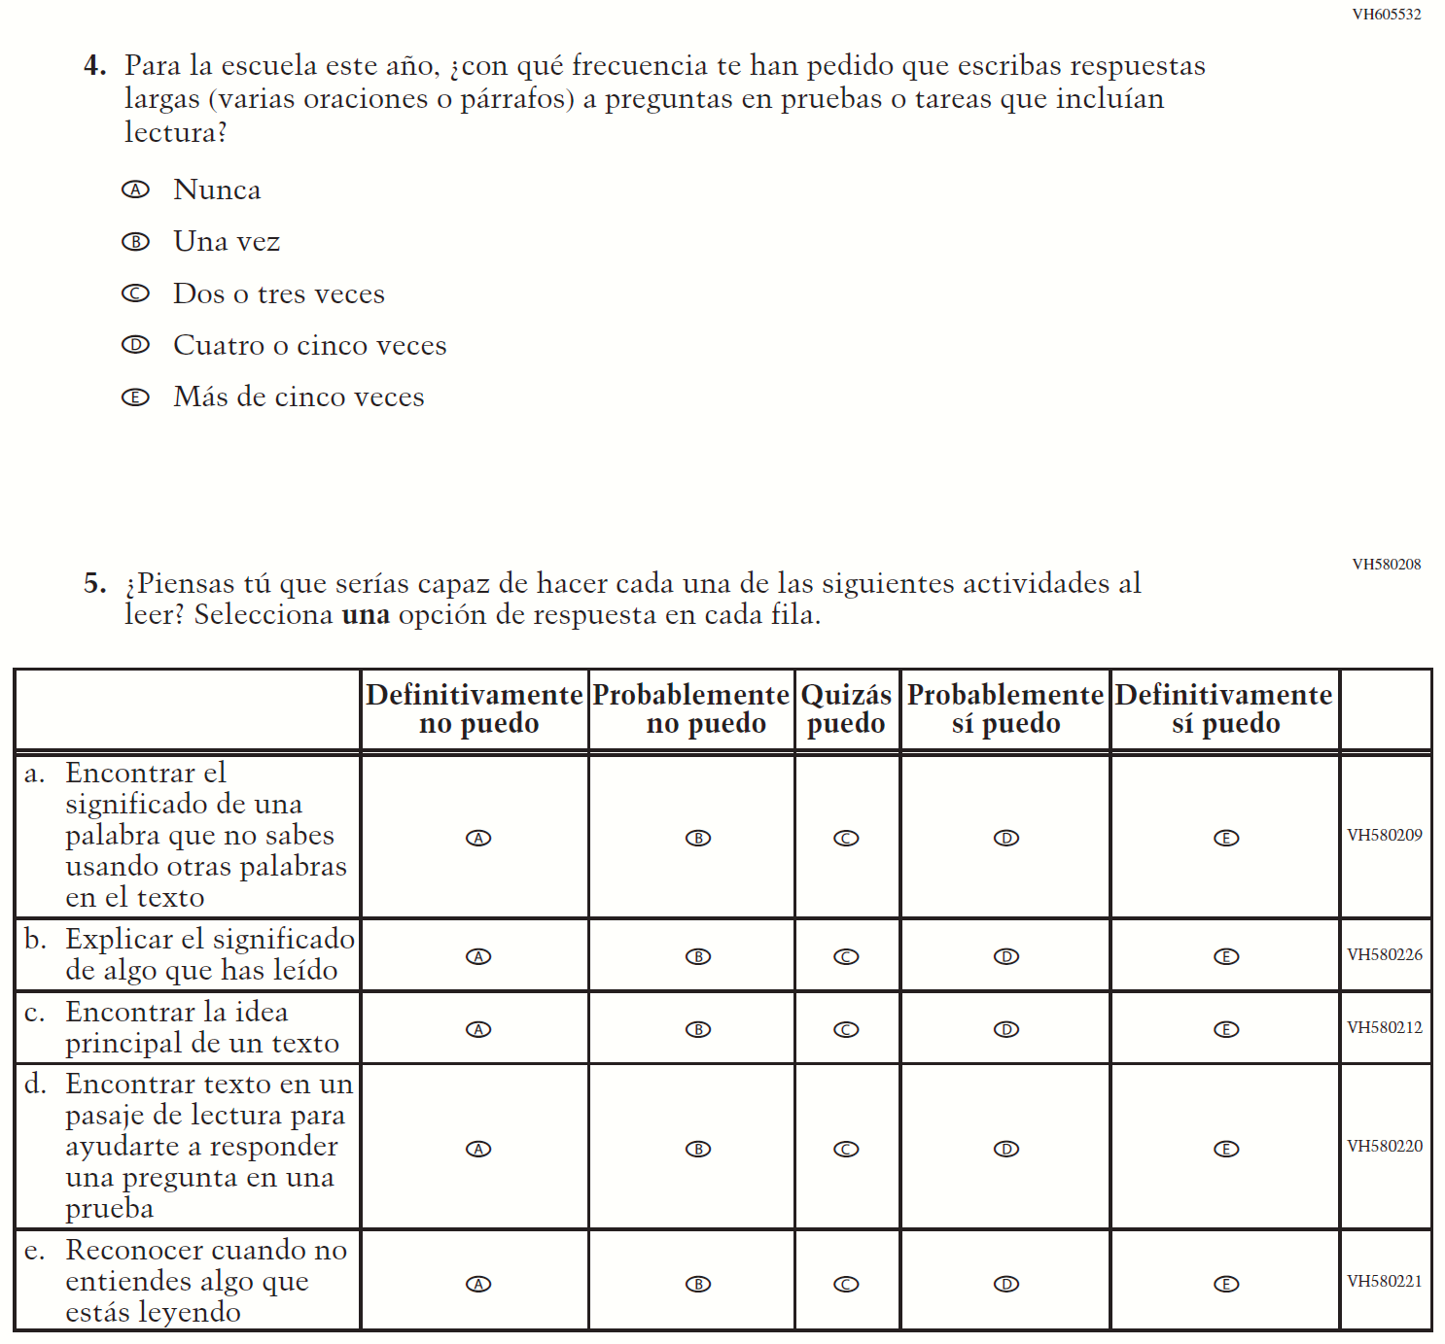

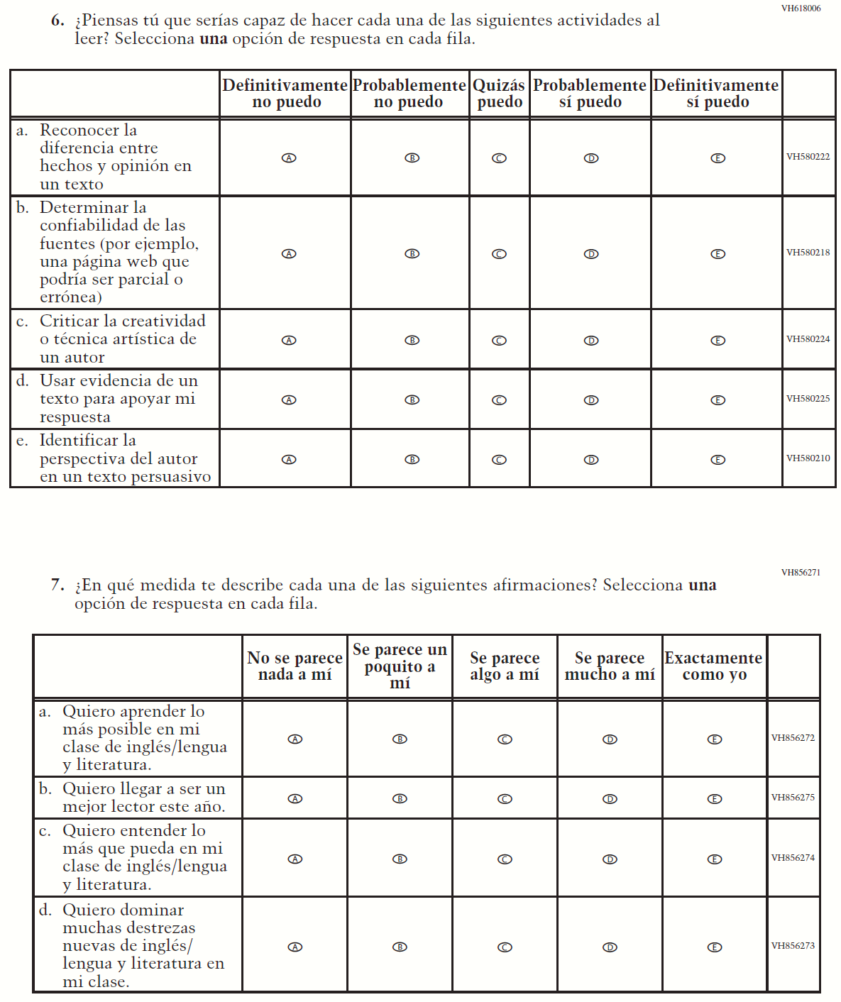

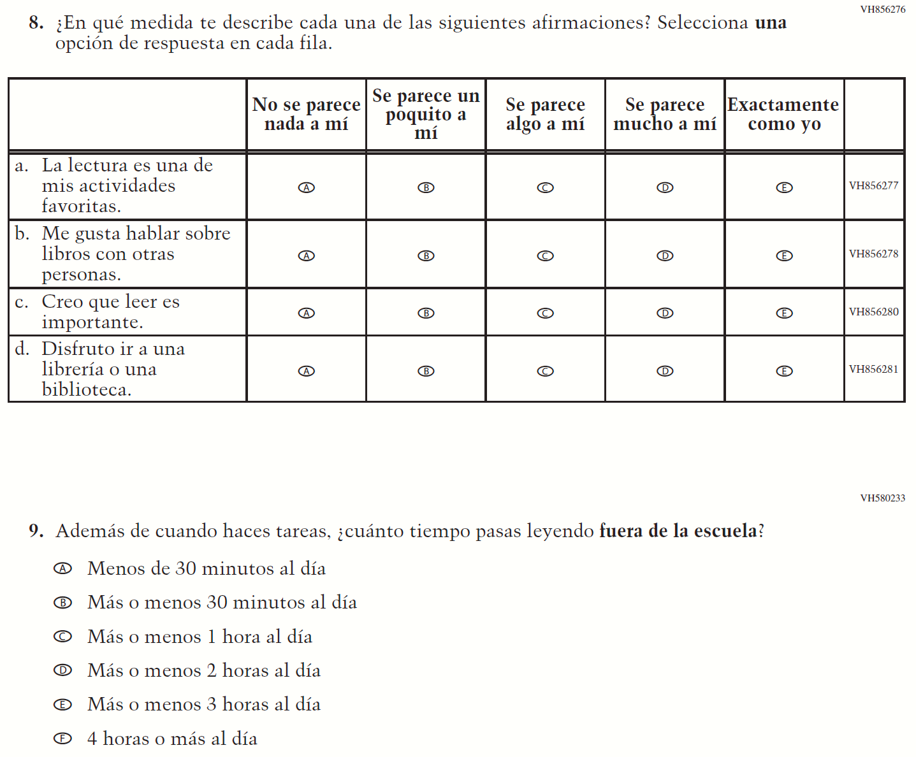

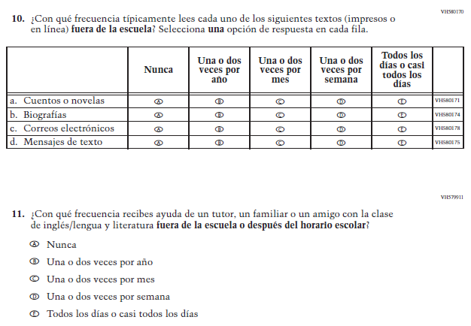

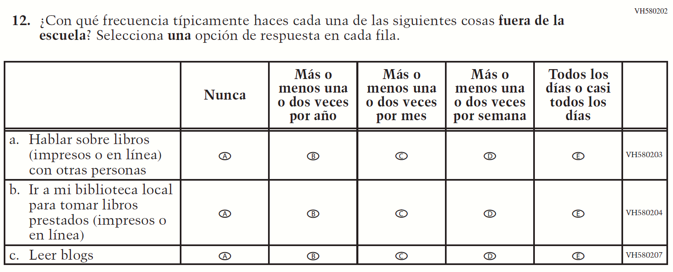

Appendix J-1k-s-BL: Operational Grade 8 Science
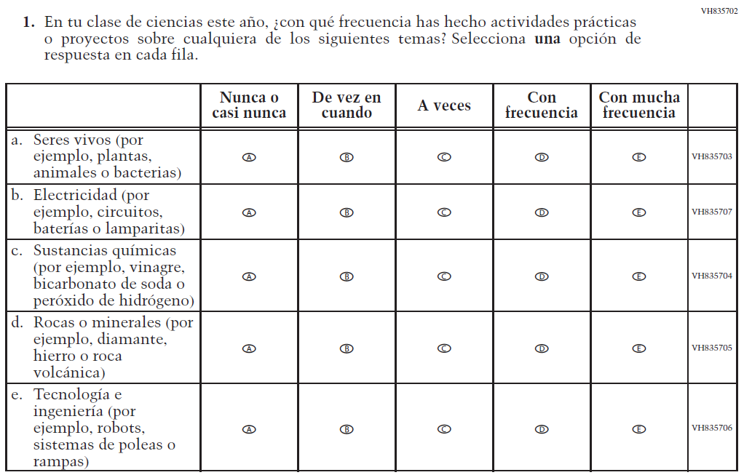

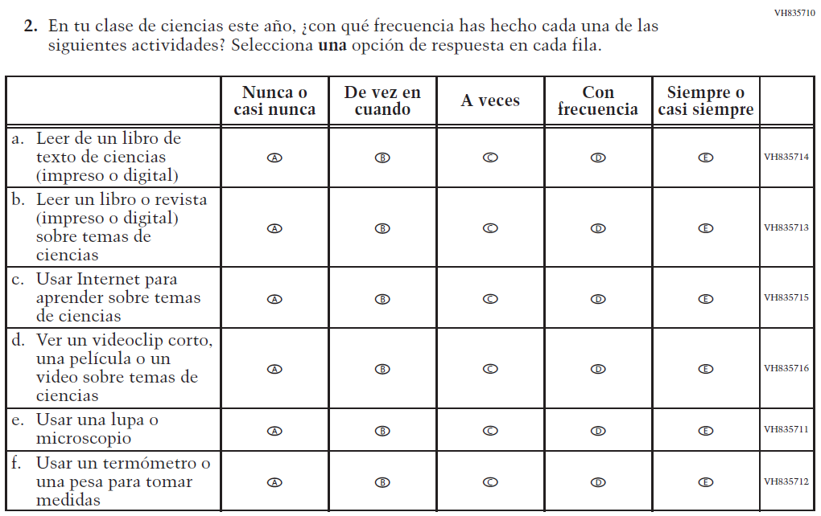

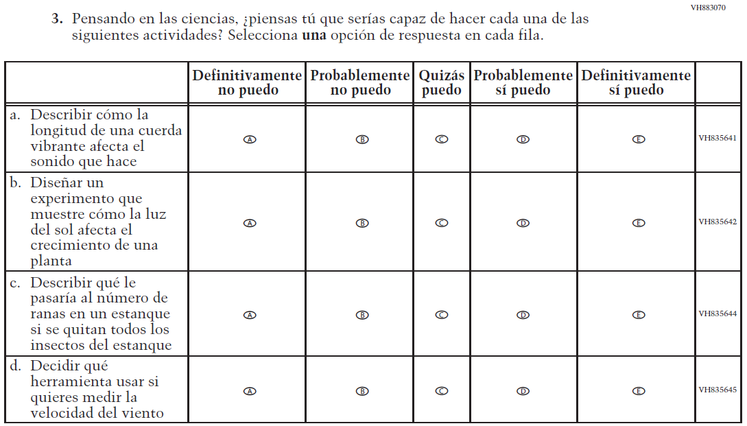

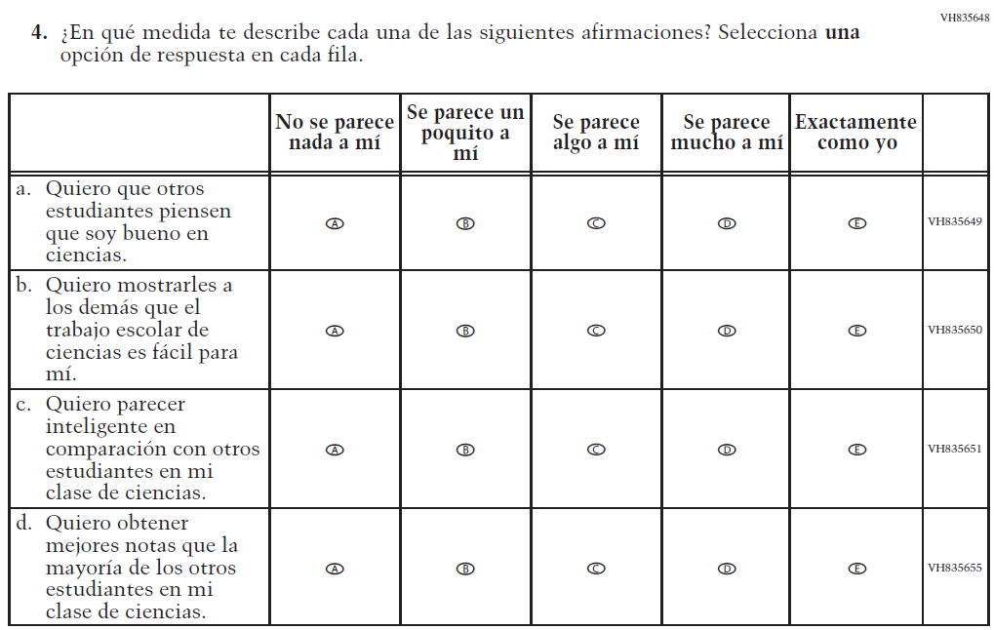

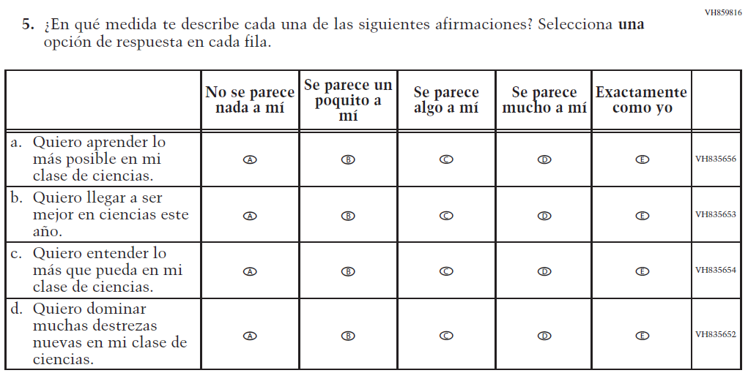

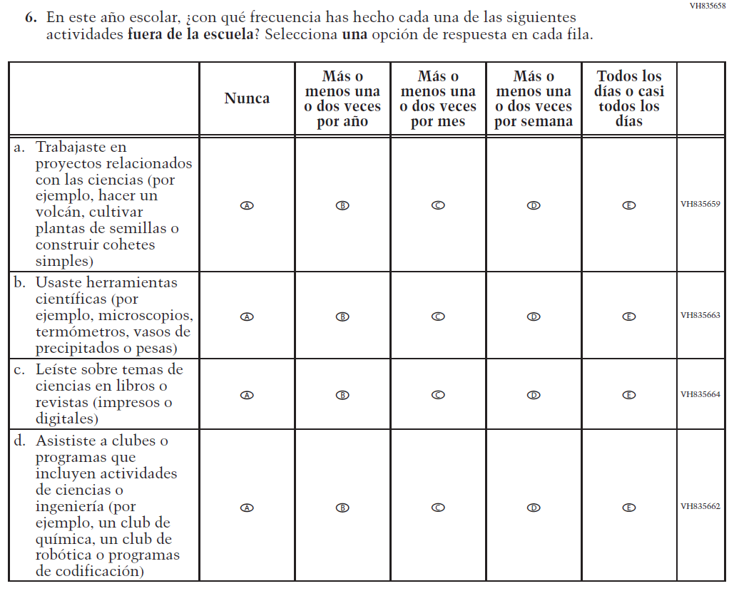

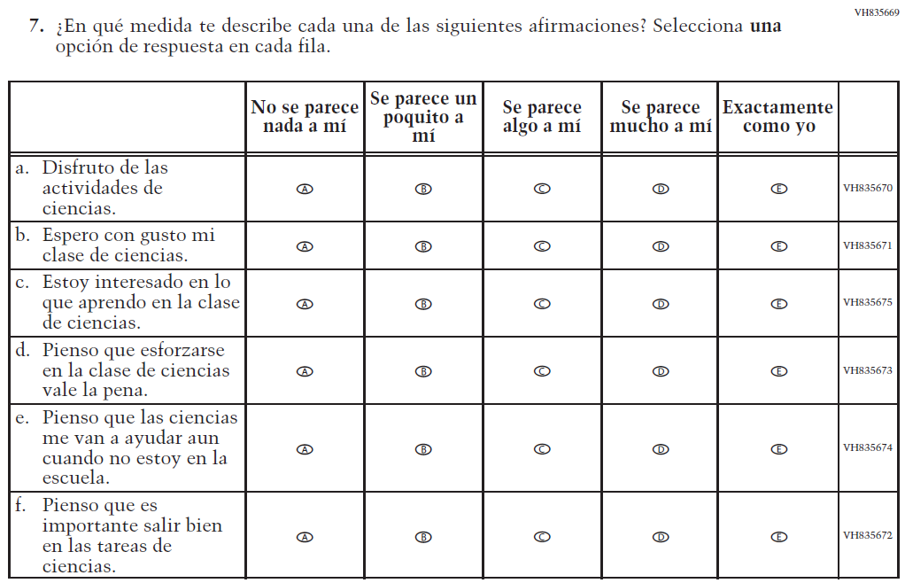

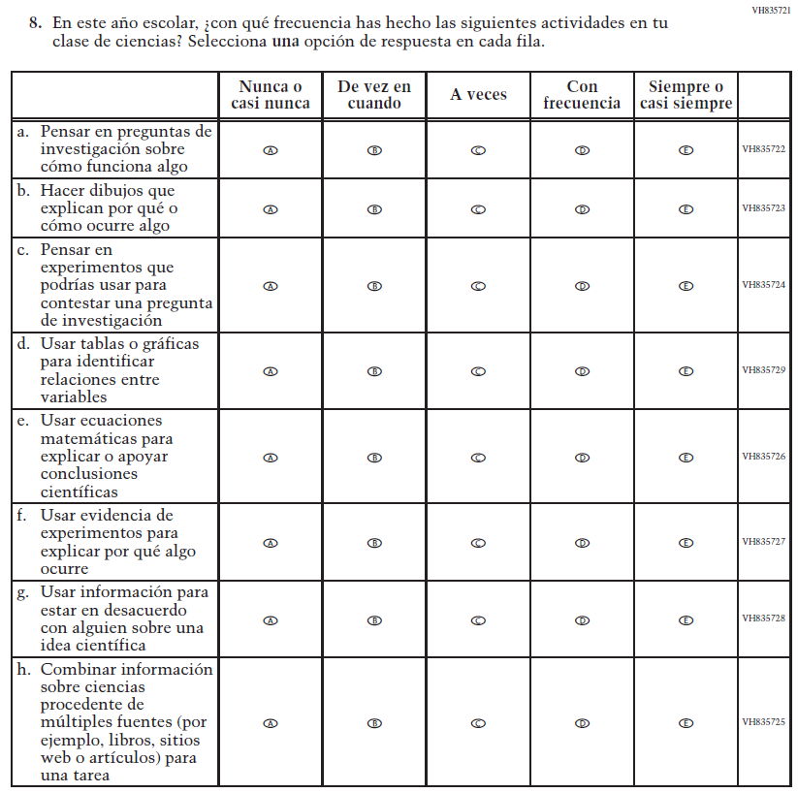

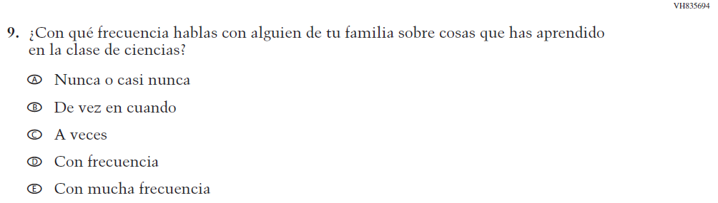

Appendix J-1l-s-BL: Operational Grade 4 Debrief
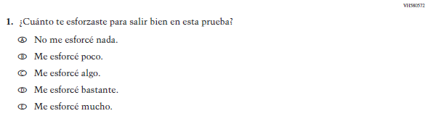

Appendix J-1m-s-PR: Operational Grade 4 Debrief
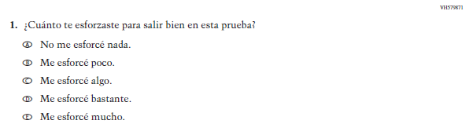

Appendix J-1n-s-BL: Operational Grade 8 Debrief
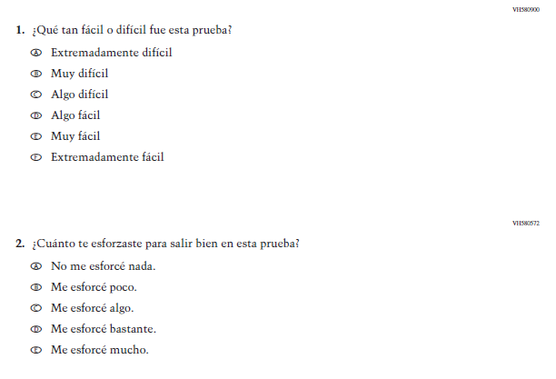

Appendix J-1n-s-PR: Operational Grade 8 Debrief
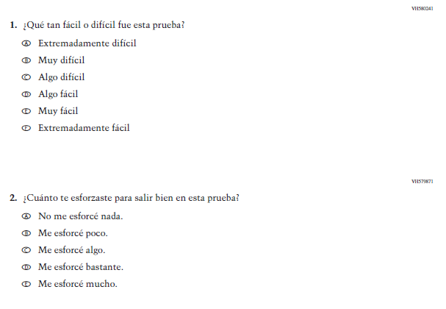

Sample Teacher Login Screen
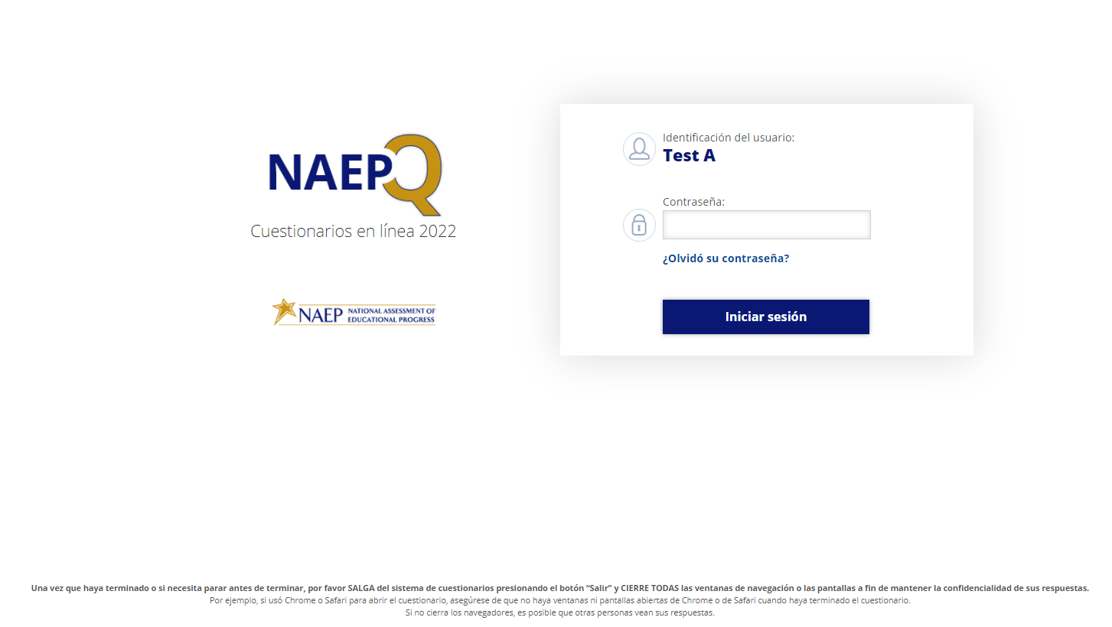

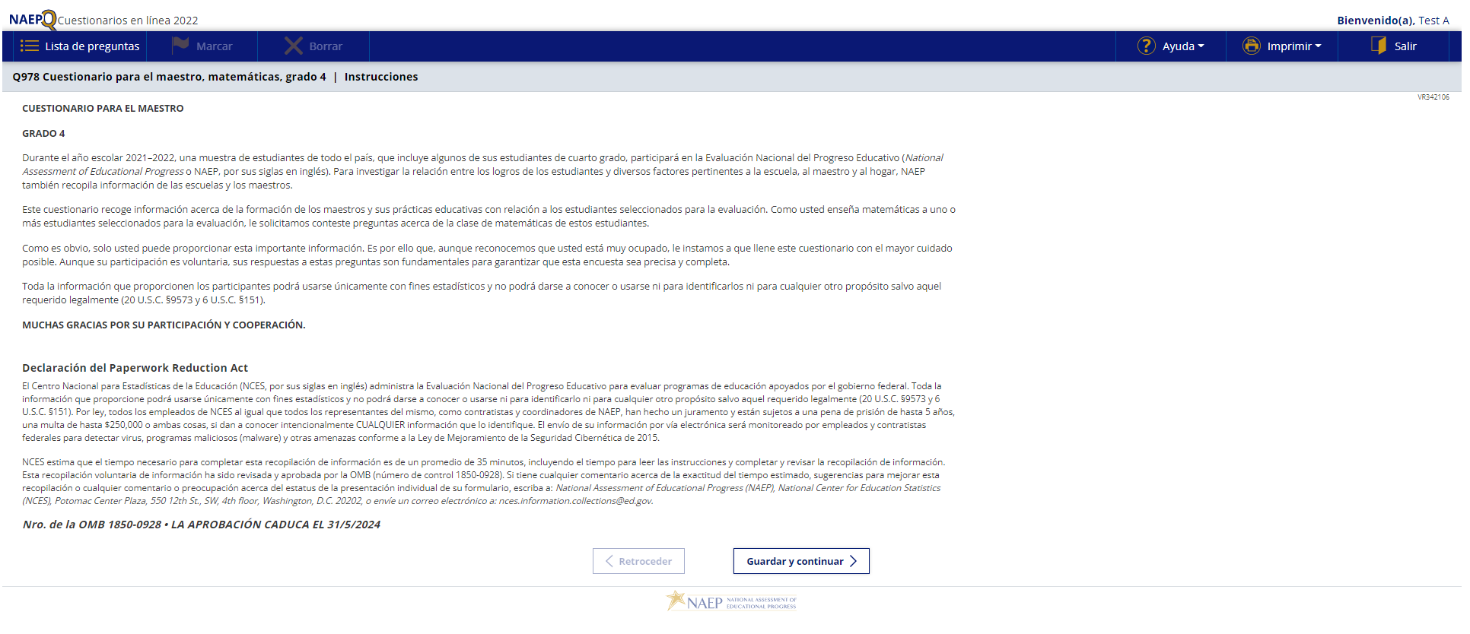

Sample Teacher Questionnaire Booklet Cover
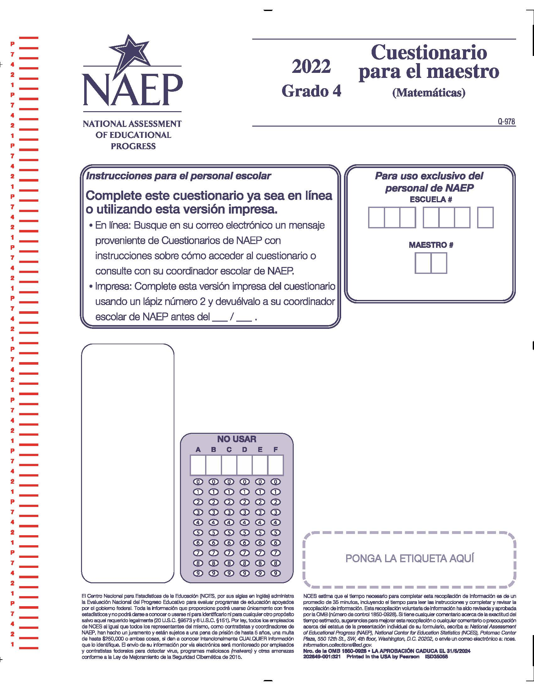

Appendix J-2-s: Spanish Translations of Teacher Questionnaires

Appendix J-2a-s-PR: Summary of Changes Operational Grade 4 CORE
2024 Operational Grade 4 Core Teacher – Puerto Rico
Previous item | 2024 item | D/A/R/NC+ | Rationale
VH319763  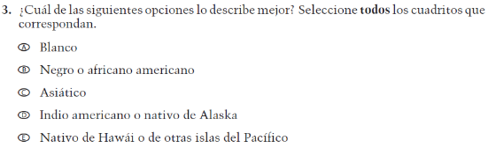  (2022 Operational Grade 4 Teacher Core – Puerto Rico) | VH319763  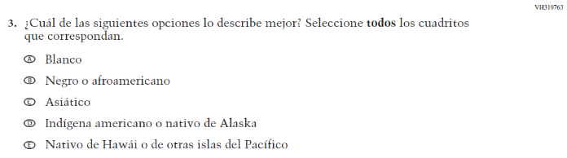  Issue: Race/Ethnicity | R | Revised options b and d to align with categories used by the 2020 Census Bureau

Appendix J-2a-s-PR: Operational Grade 4 CORE
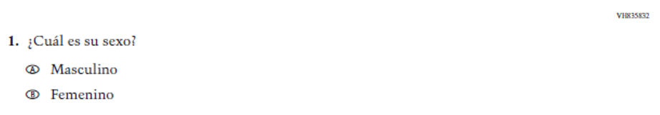

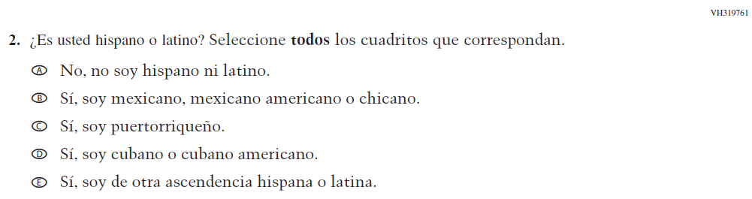

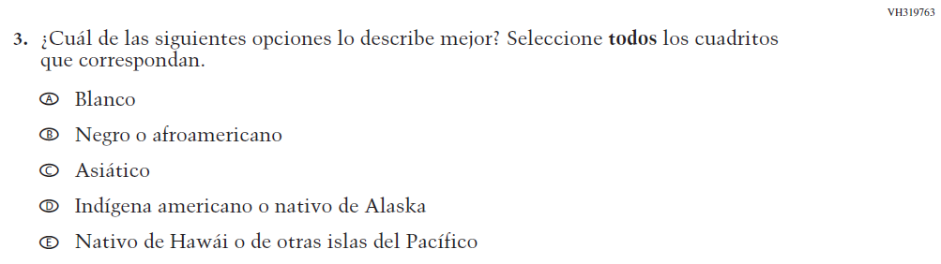

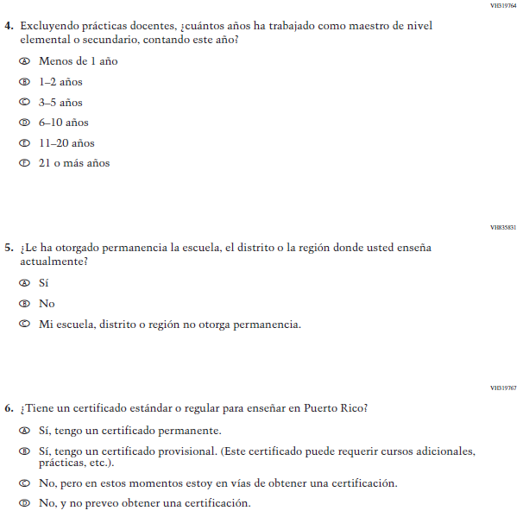

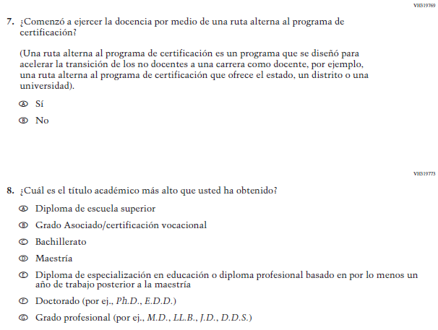

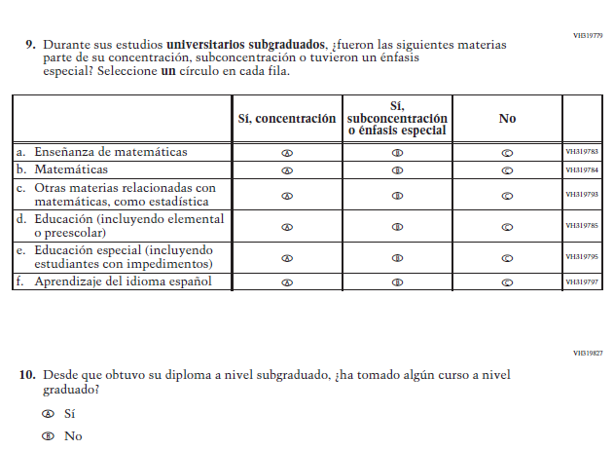

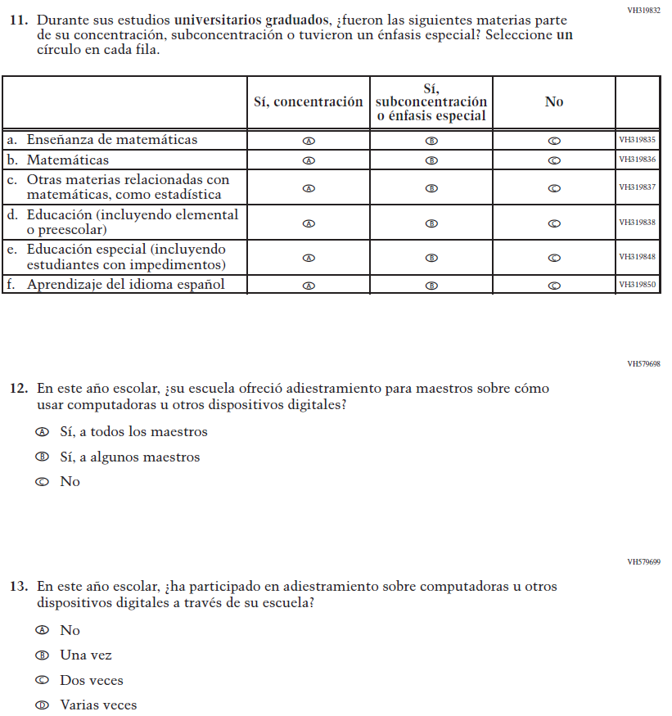

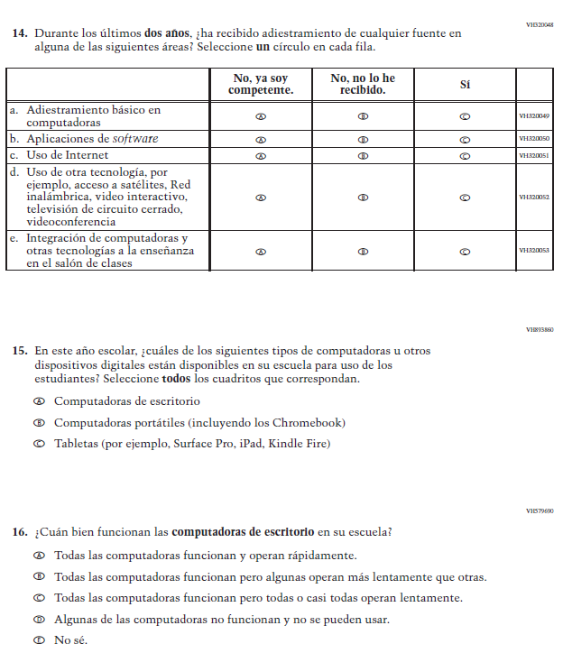

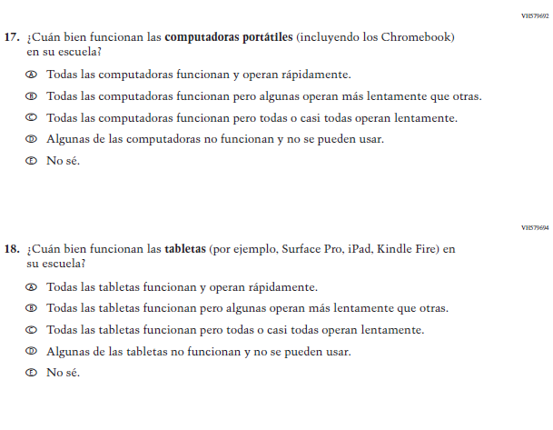

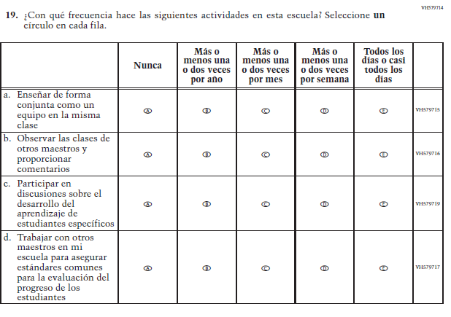

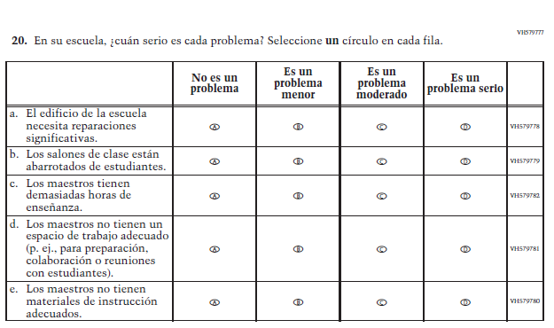

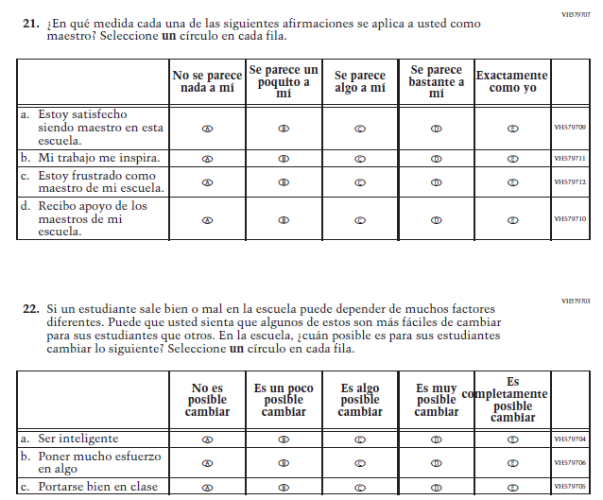

Appendix J-2b-s-PR: Summary of Changes Operational Grade 8 CORE
2024 Operational Grade 8 Core Teacher – Puerto Rico
Previous item | 2024 item | D/A/R/NC+ | Rationale
VH319763  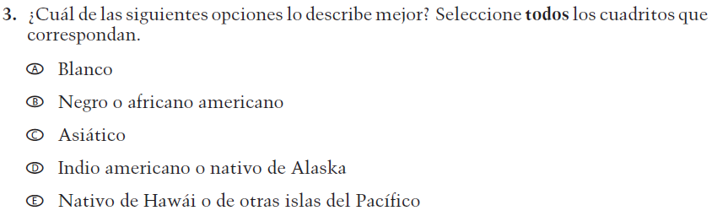  (2022 Operational Grade 8 Teacher Core – Puerto Rico) | VH319763  Issue: Race/Ethnicity | R | Revised options b and d to align with categories used by the 2020 Census Bureau

Appendix J-2b-s-PR: Operational Grade 8 CORE

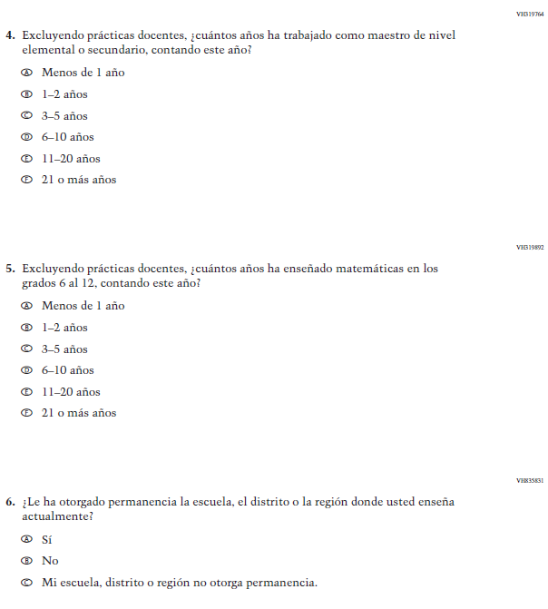

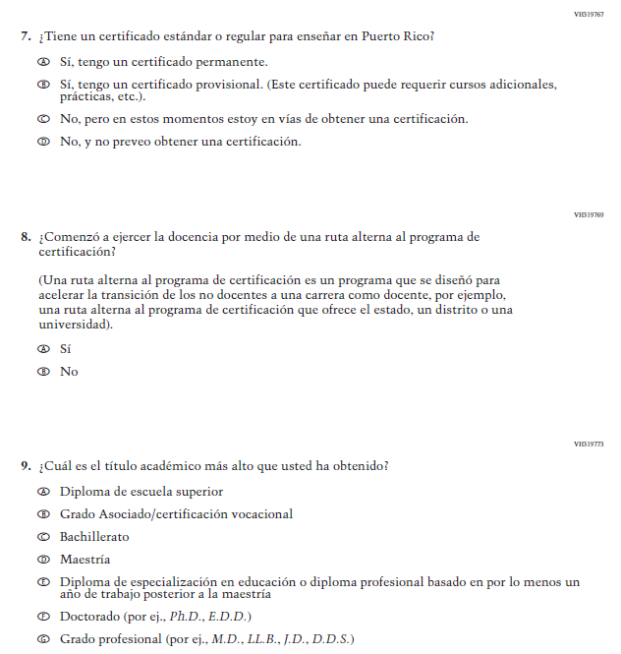

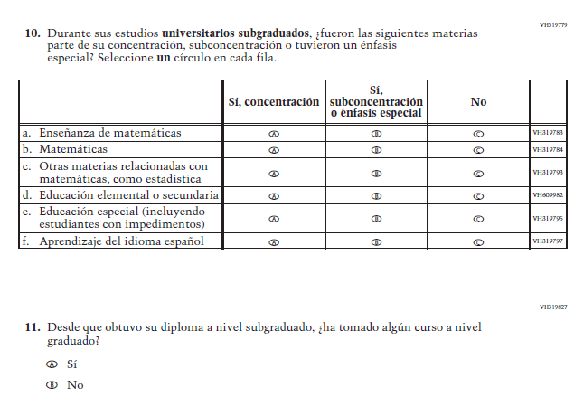

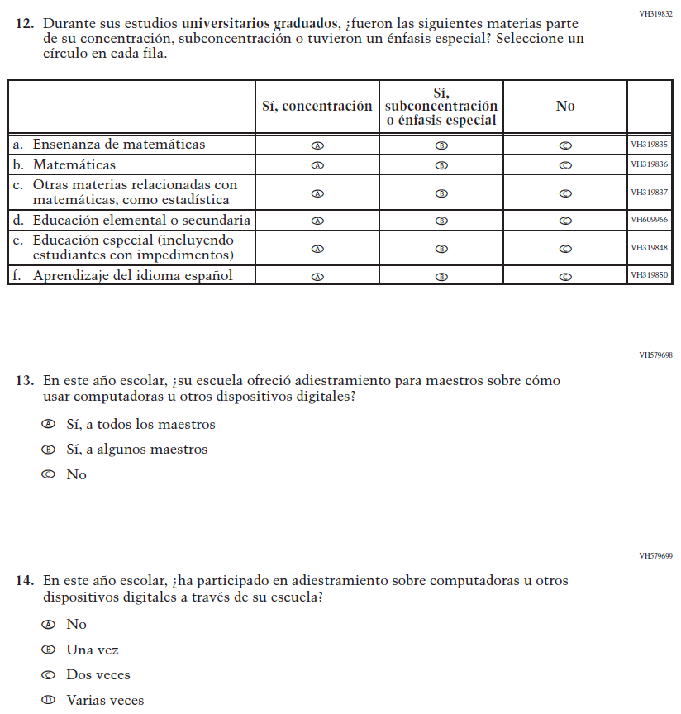

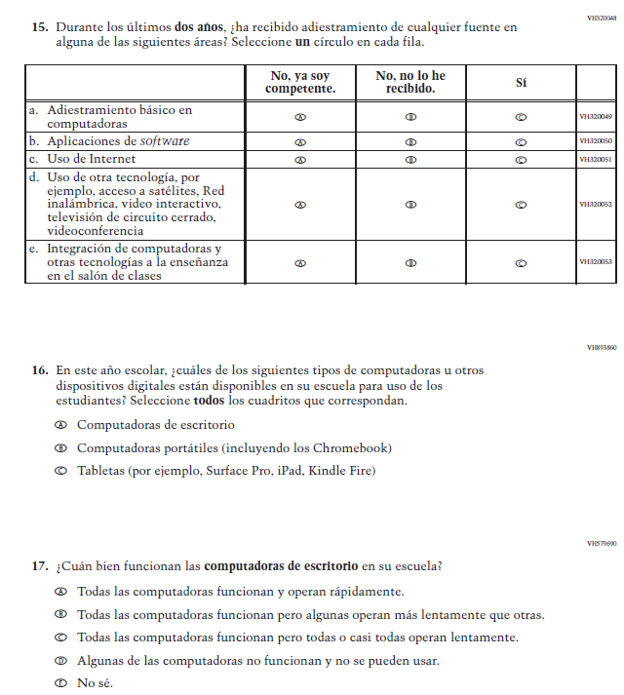

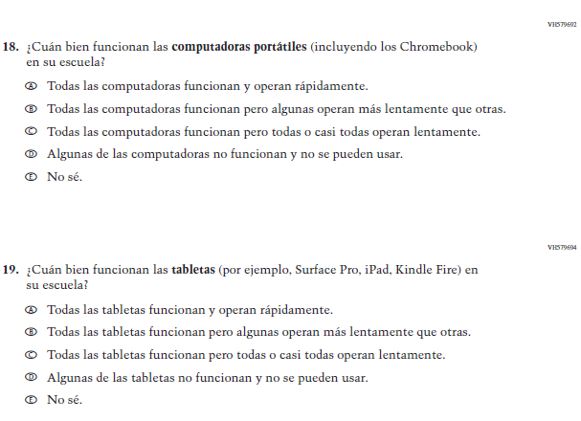

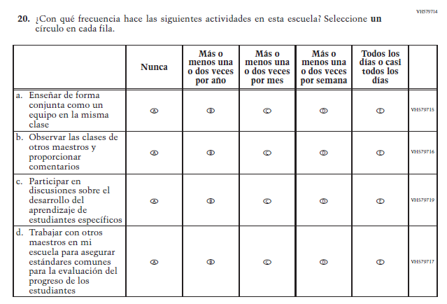

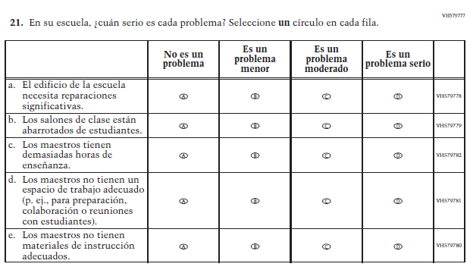

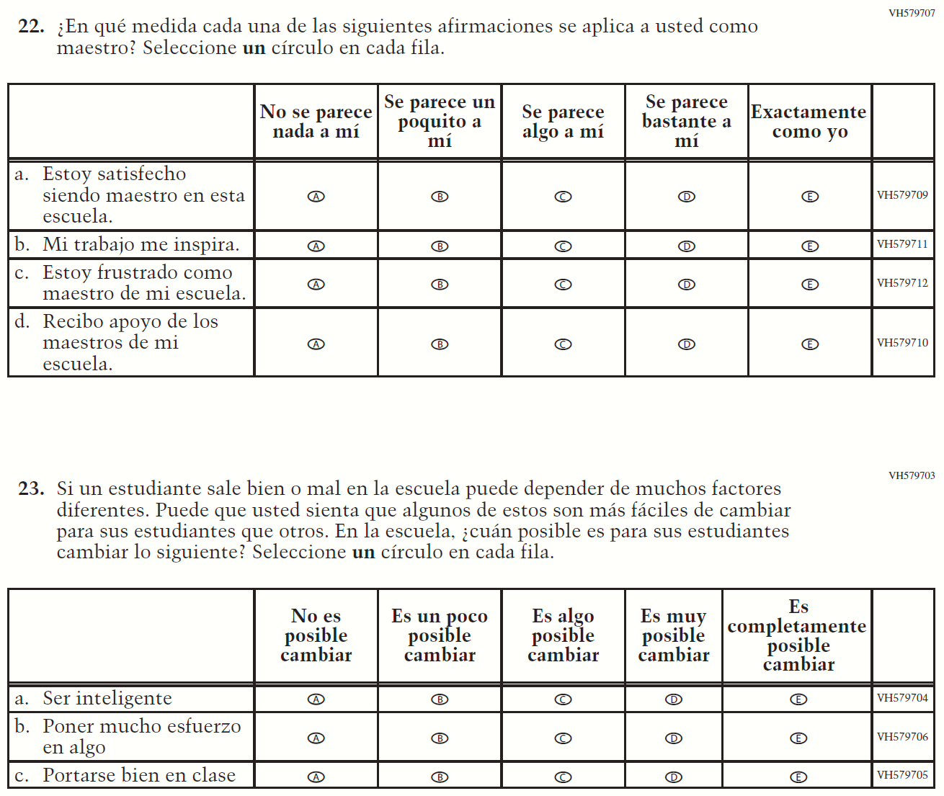

Appendix J-2c-s-PR: Operational Grade 4 Mathematics
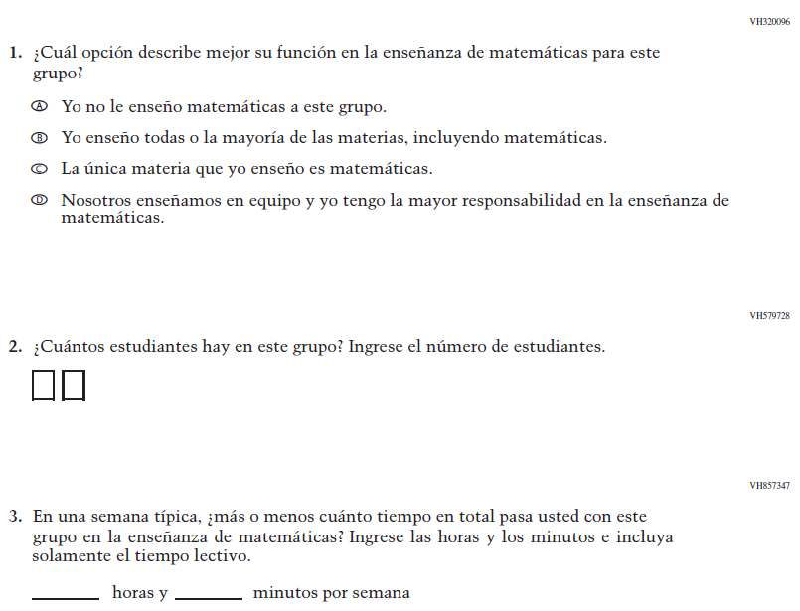
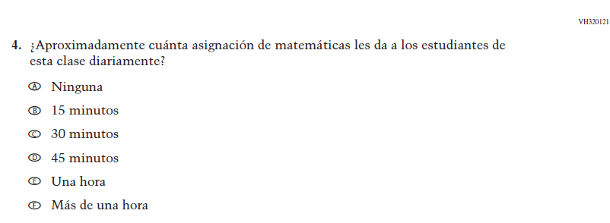

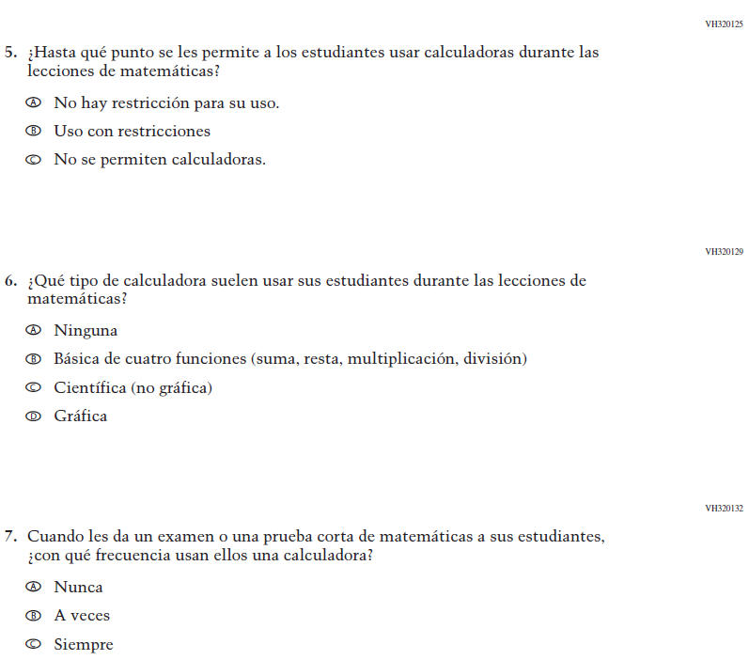

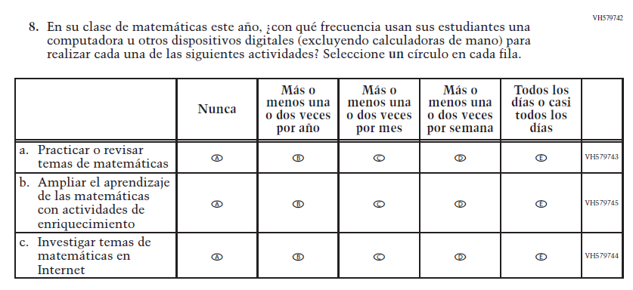

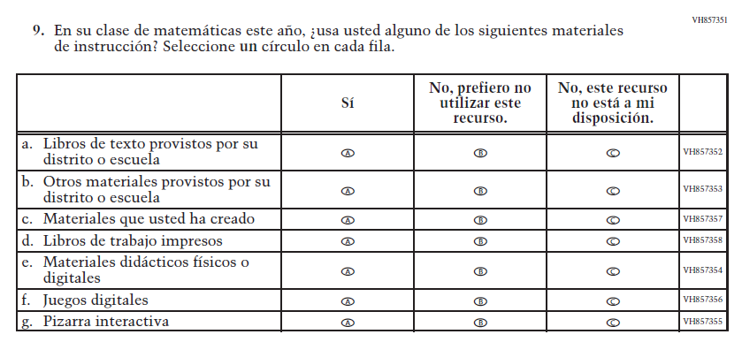

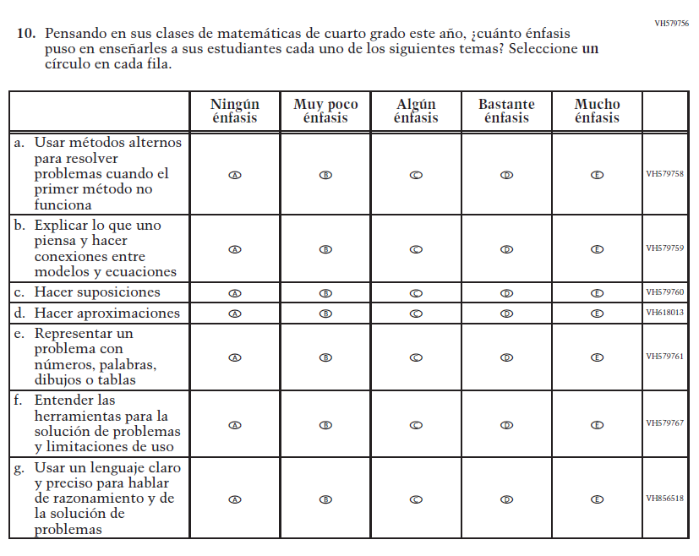

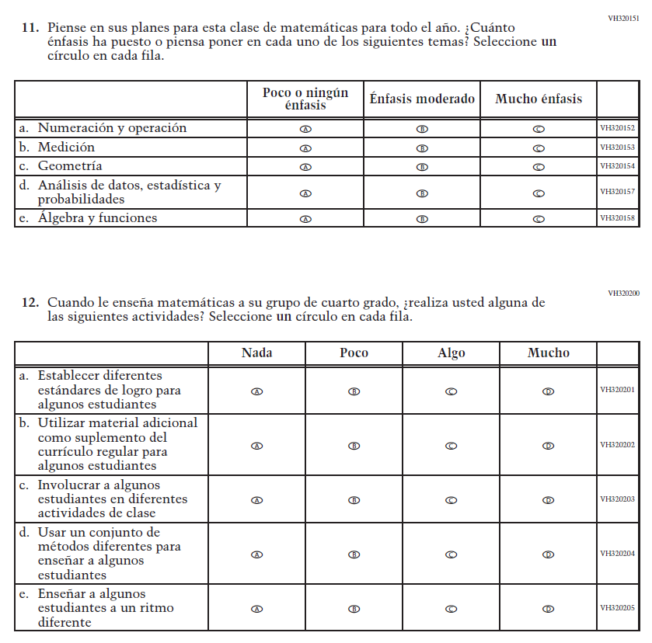

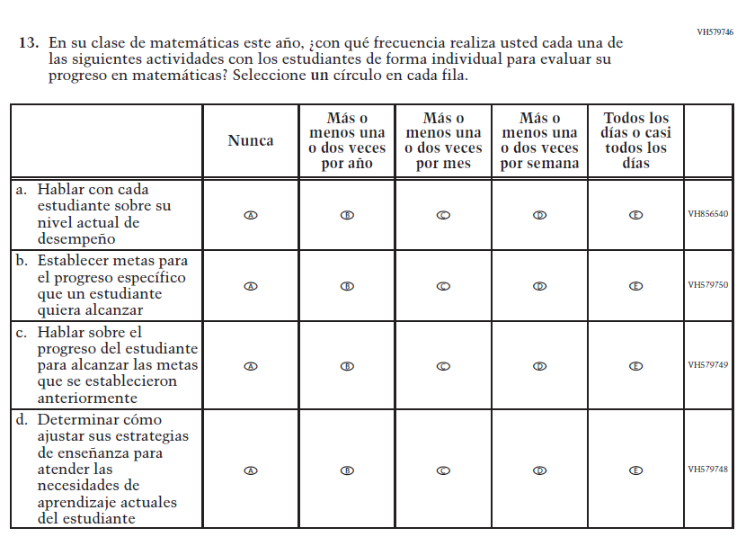

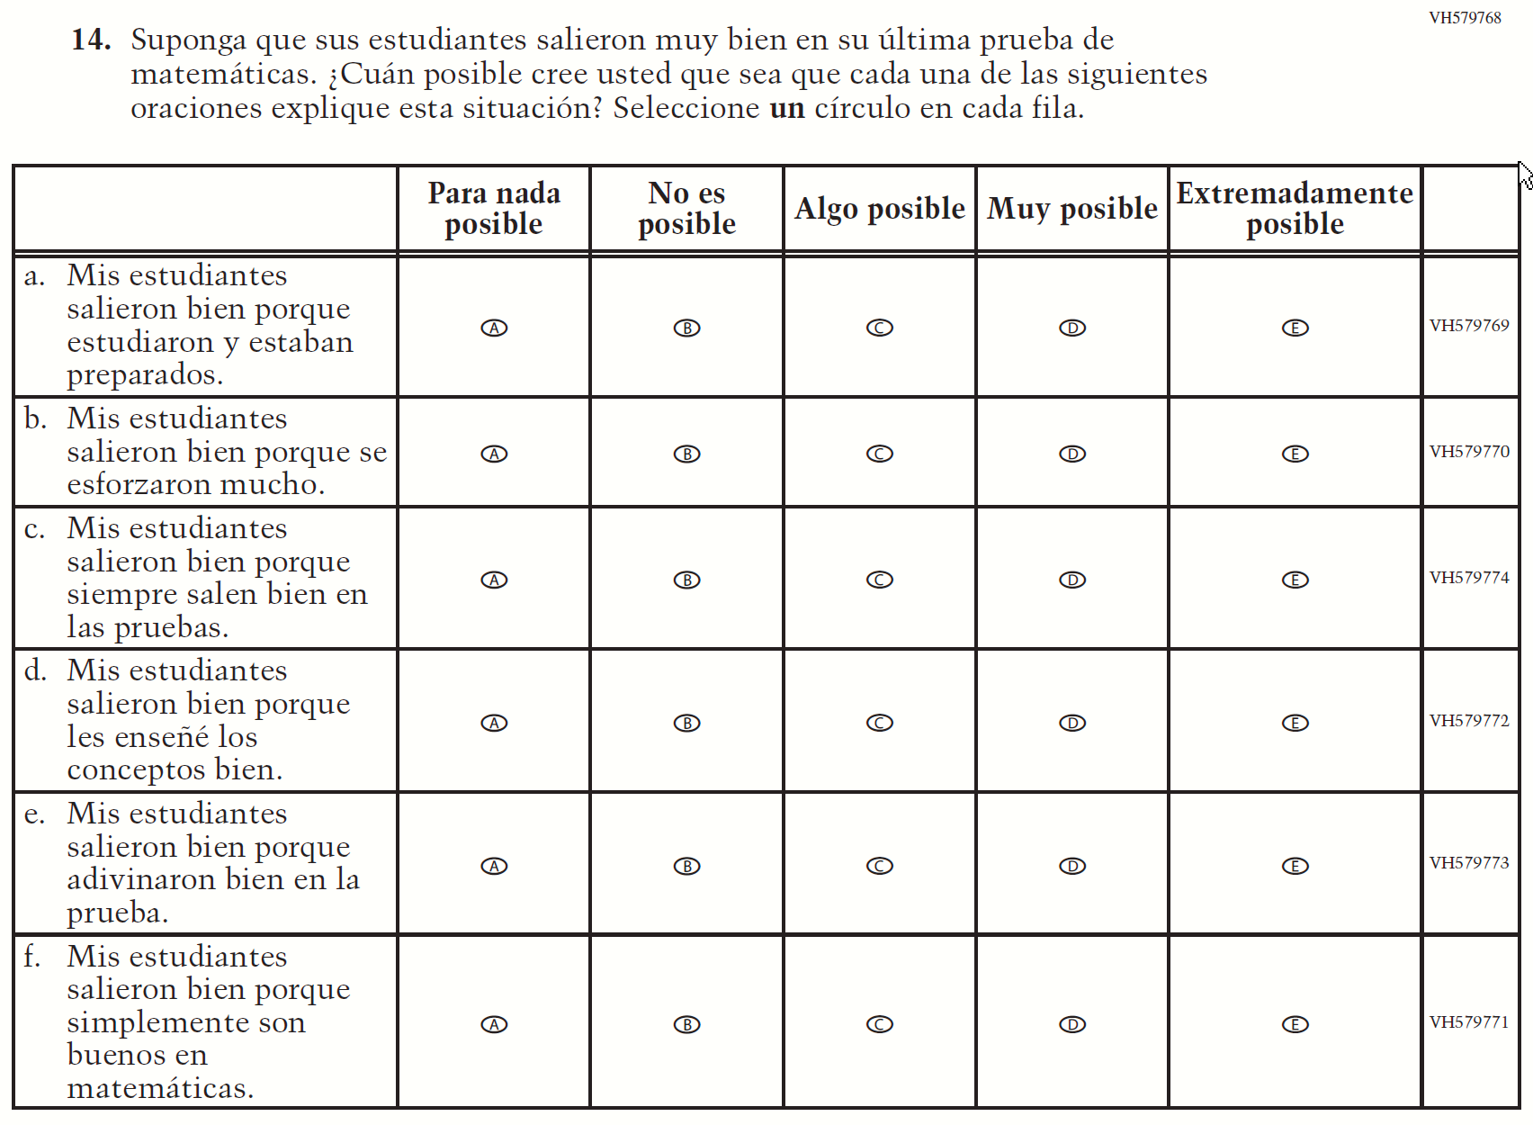
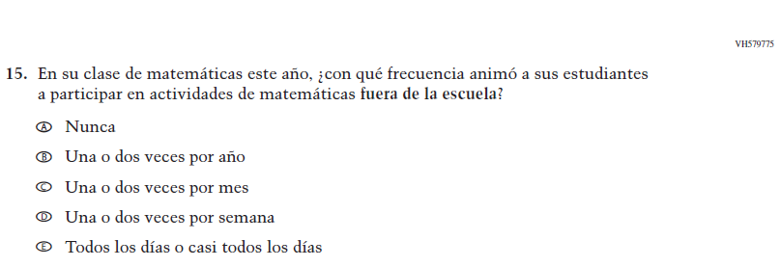

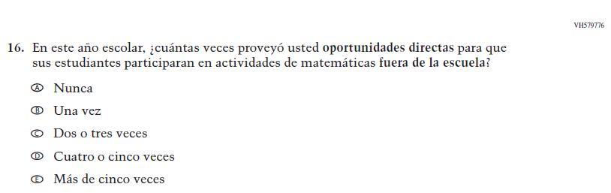

Appendix J-2d-s-PR: Operational Grade 8 Mathematics
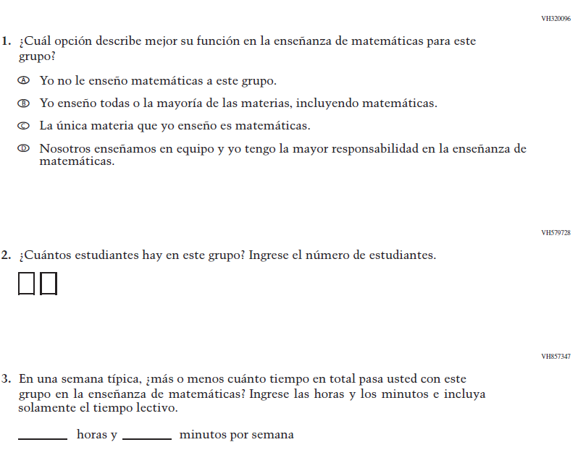
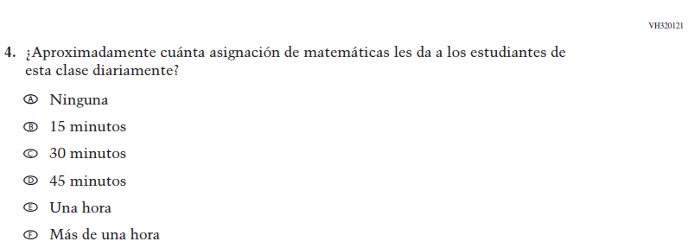
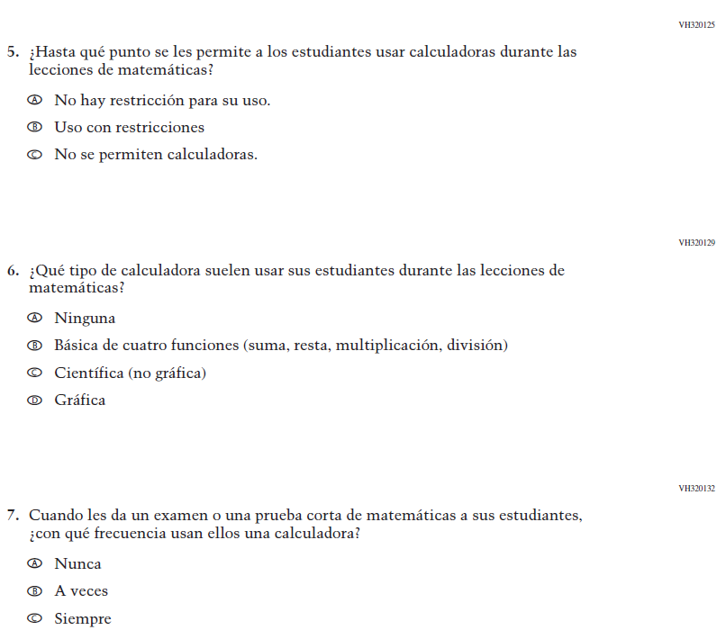

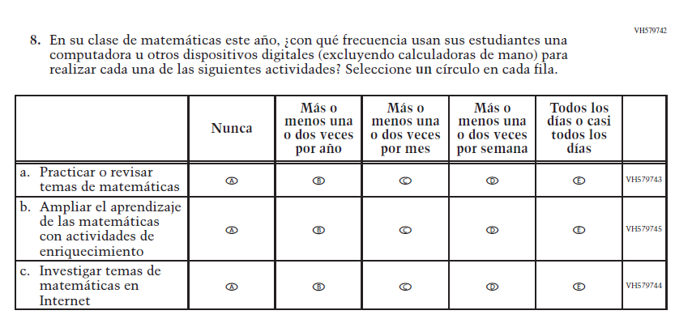

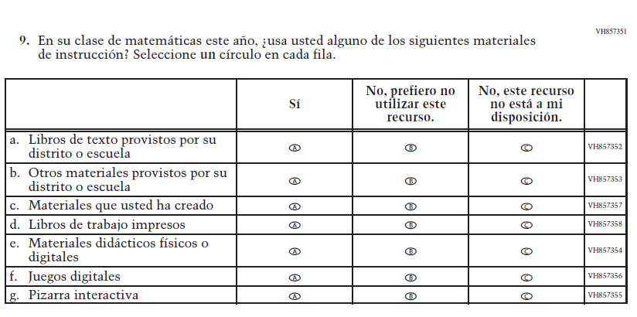

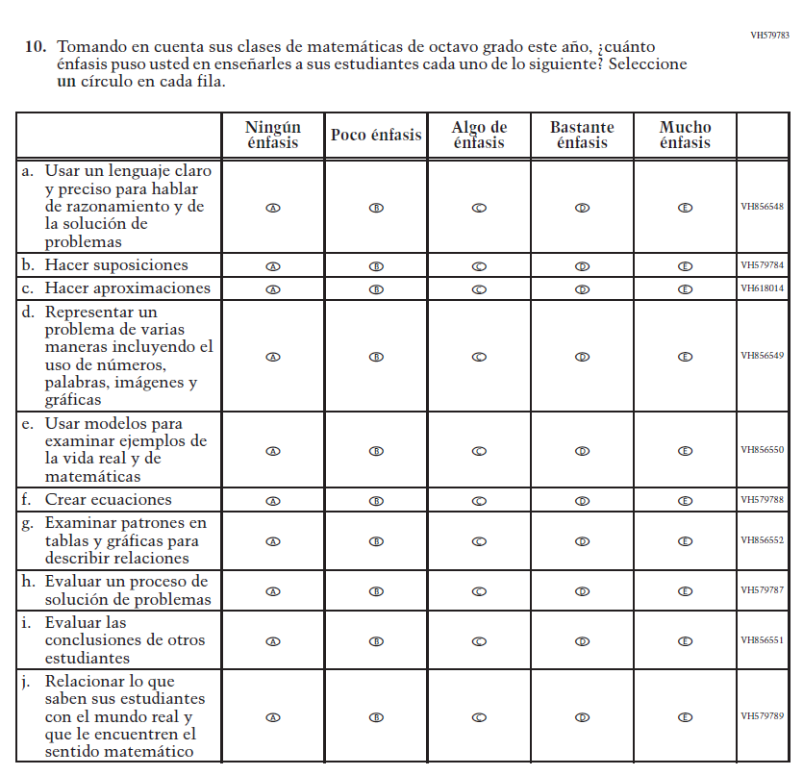

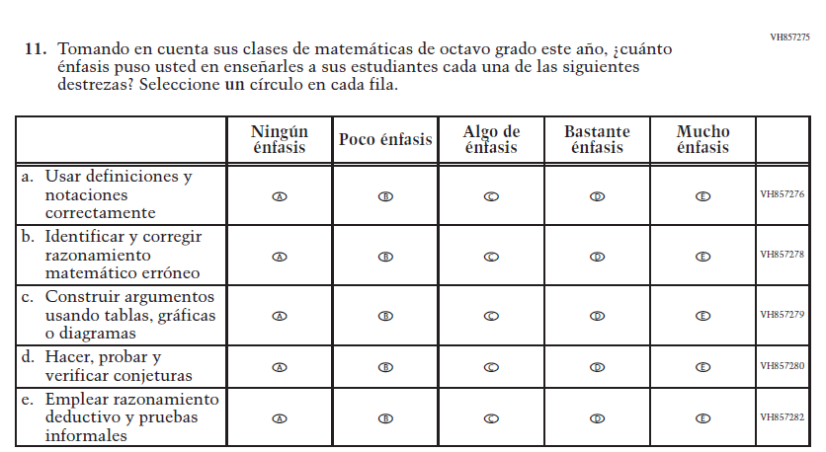

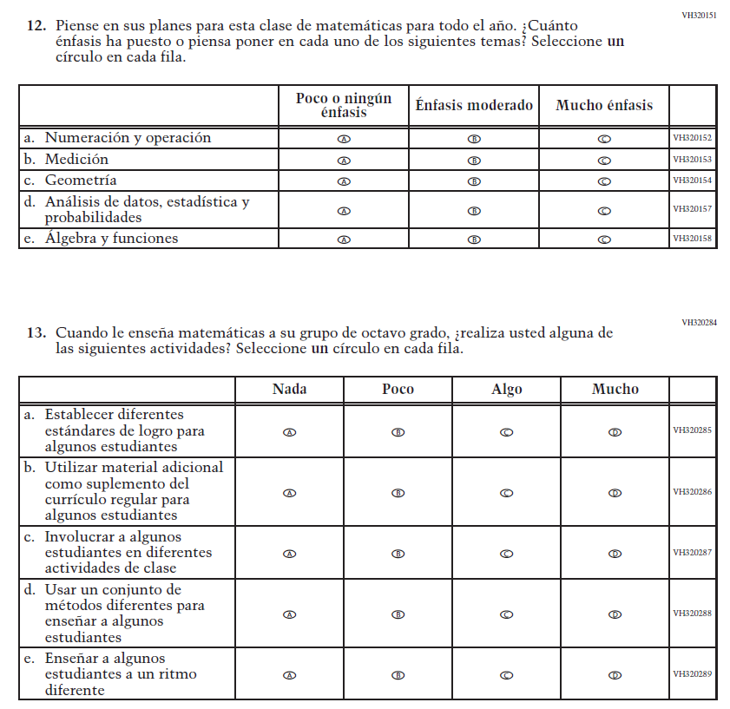

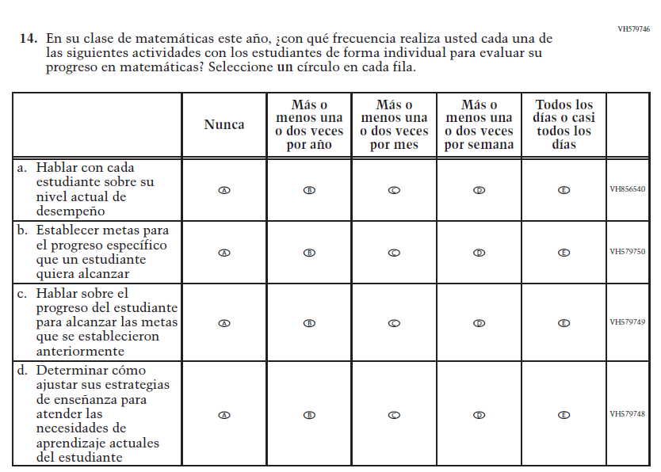

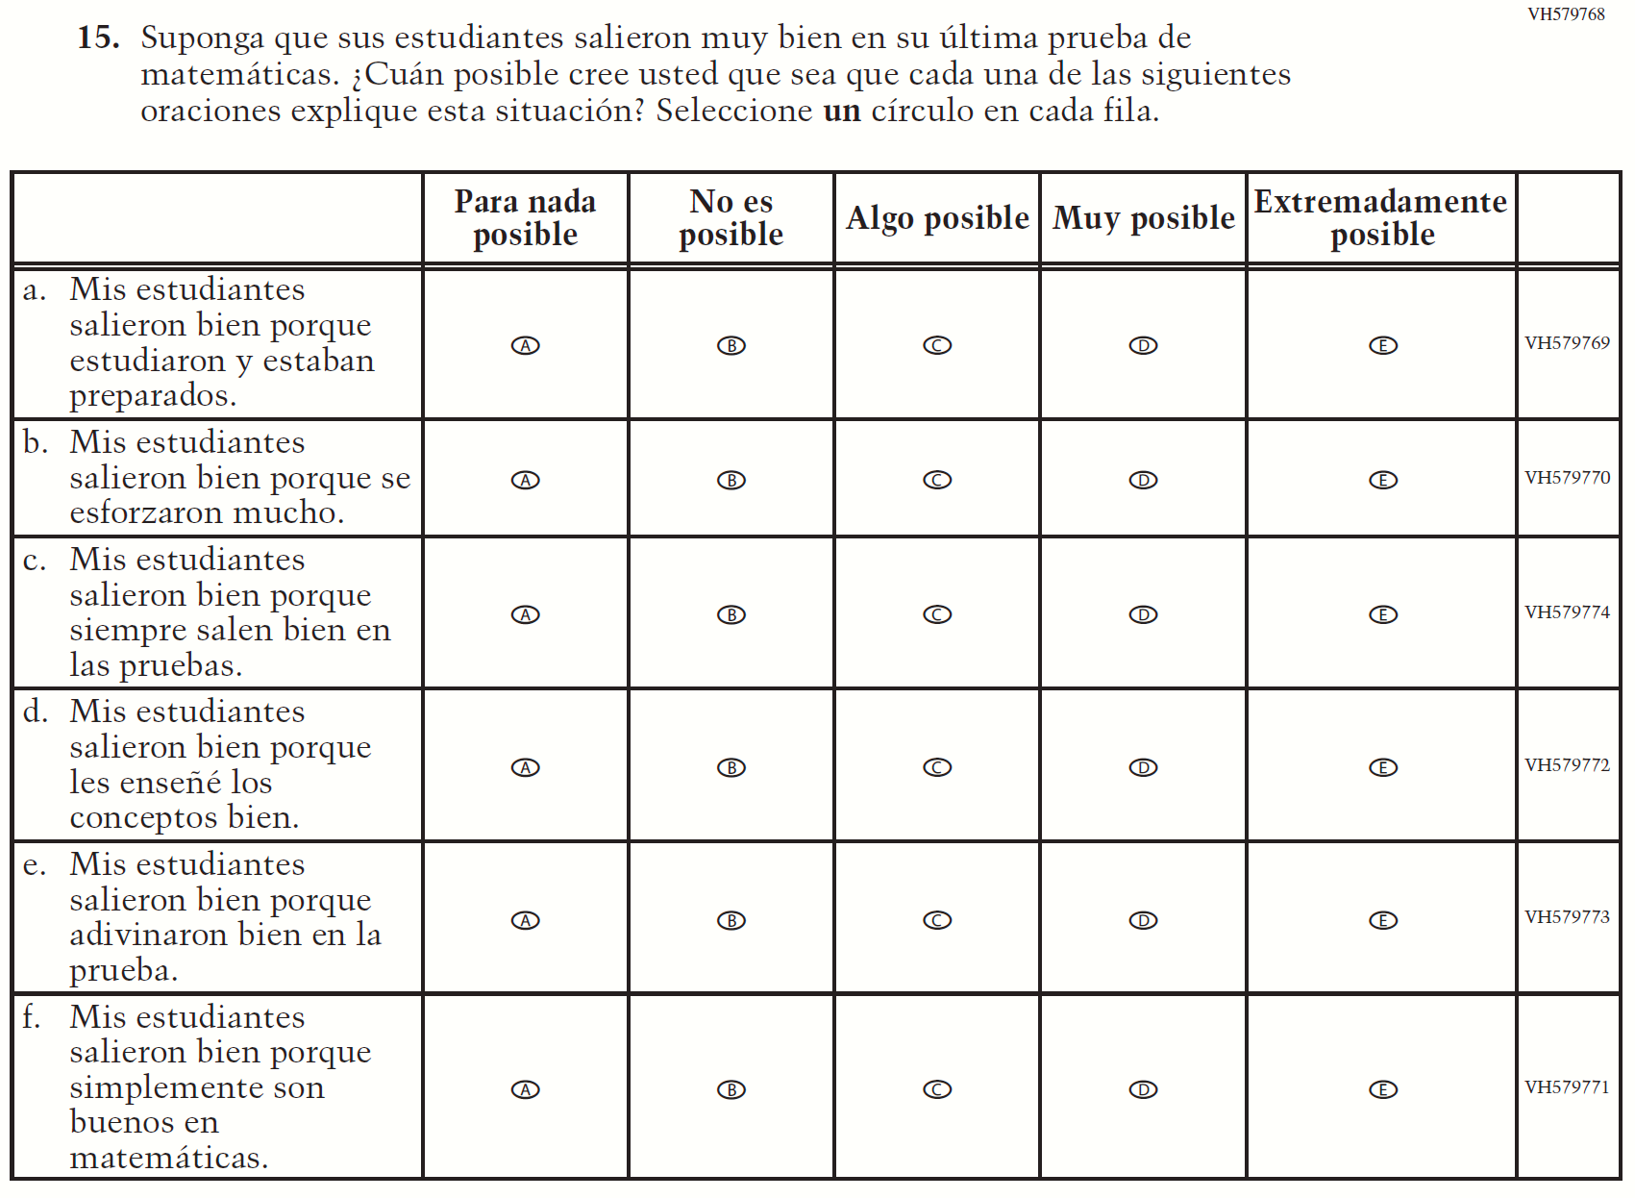

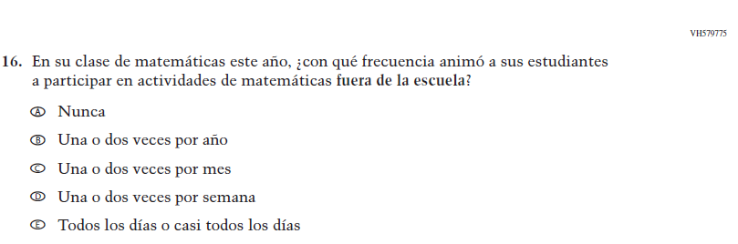

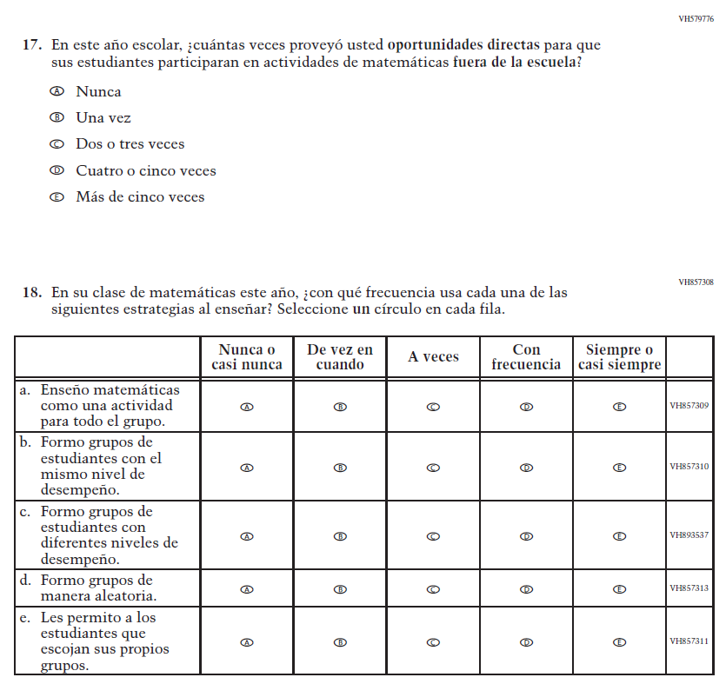

Sample School Administrator Login Screen

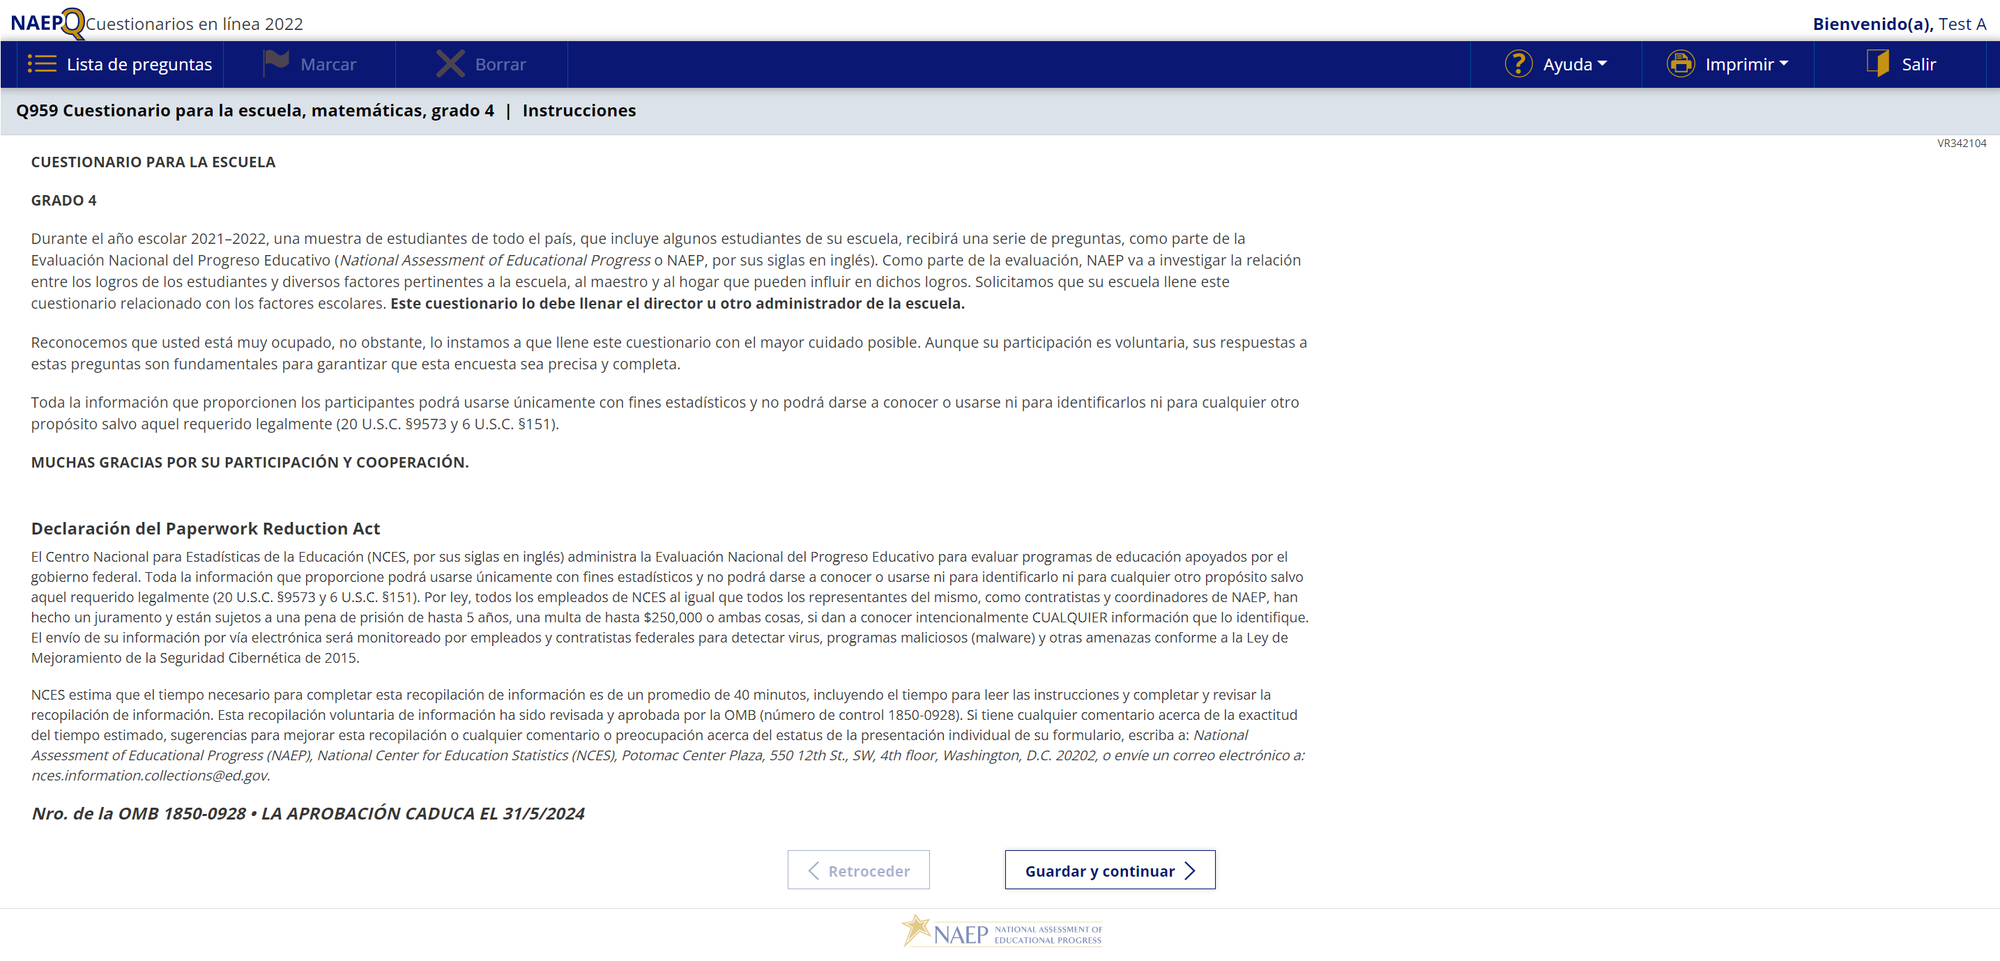

Sample School Questionnaire Booklet Covers
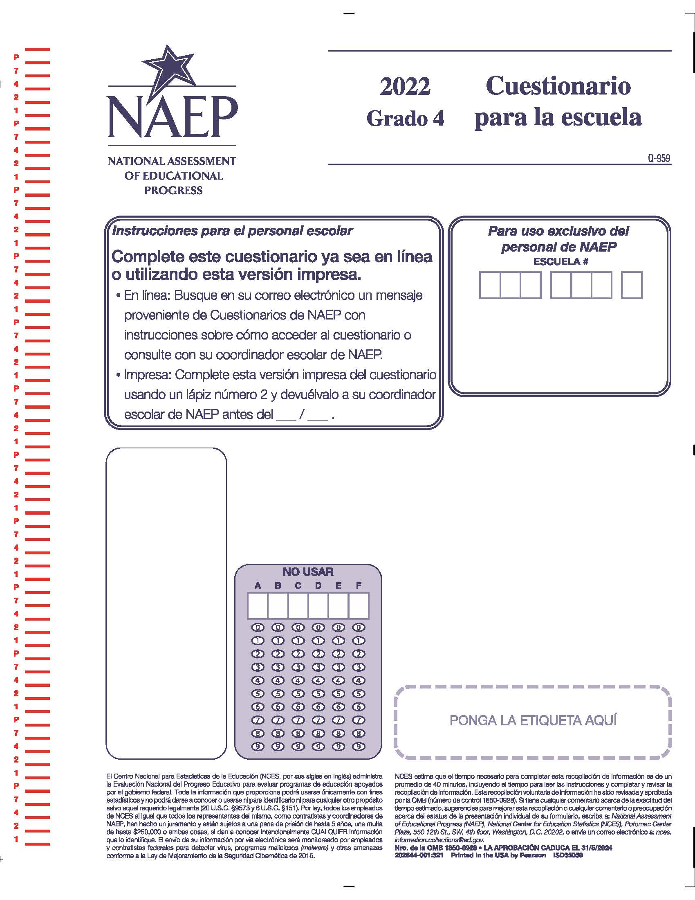

Appendix J-3-s: Spanish Translations of School Questionnaires

Appendix J-3a-s-PR: Operational Grade 4 CORE
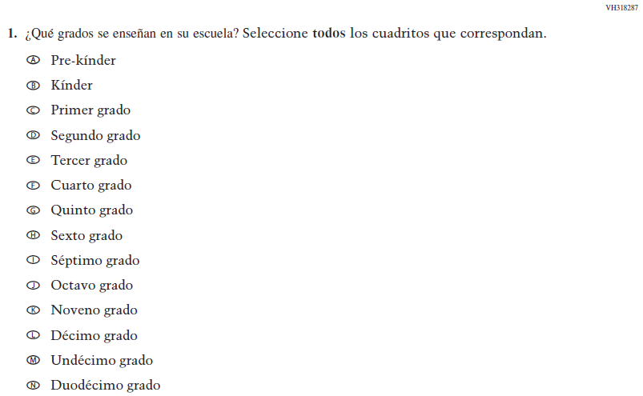

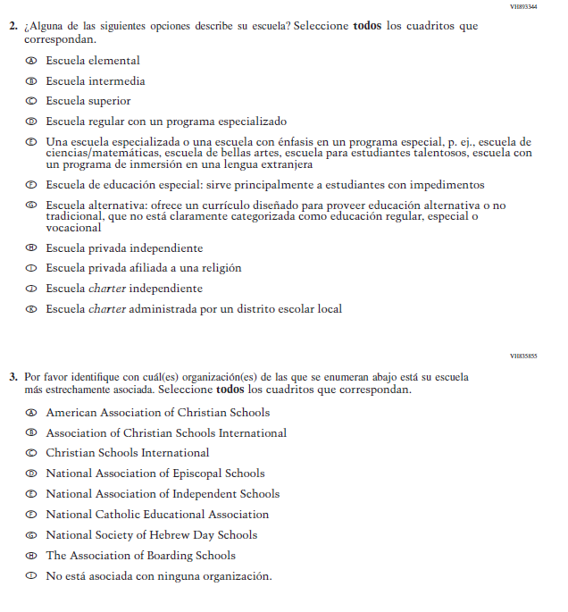

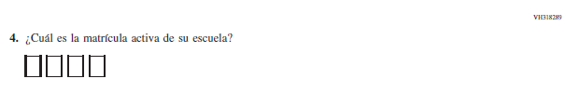

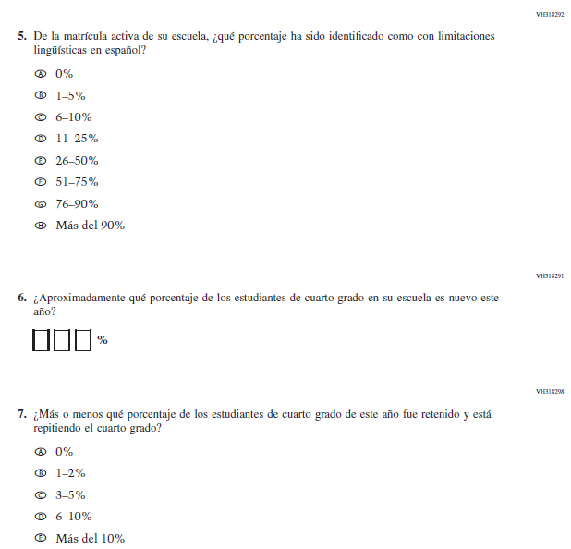

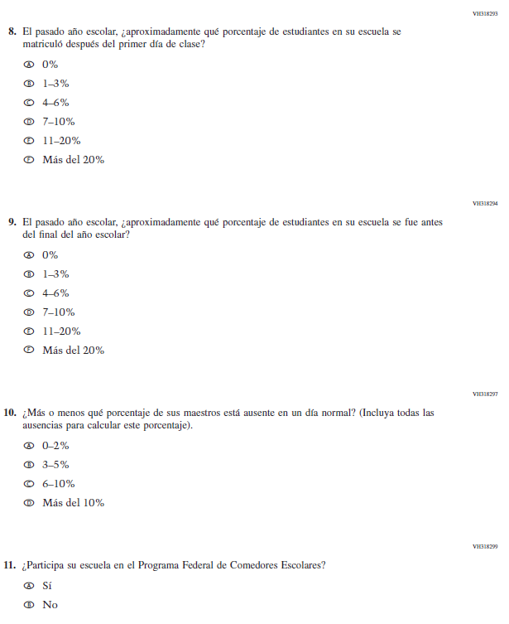

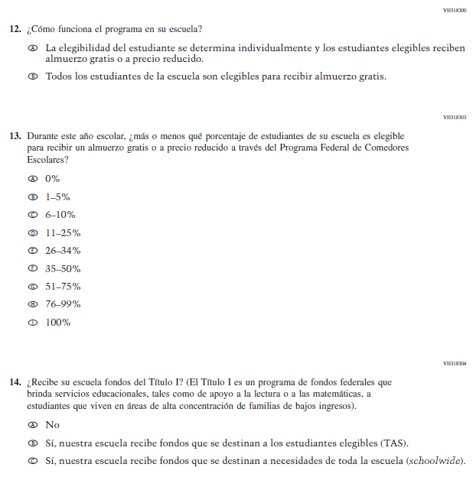

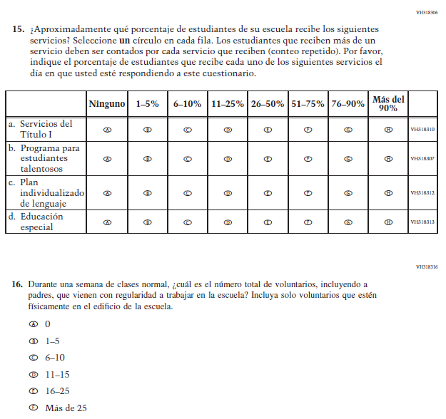

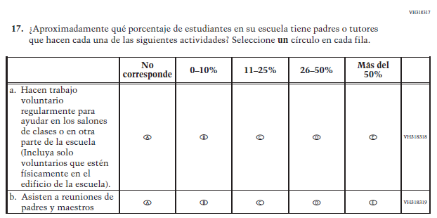

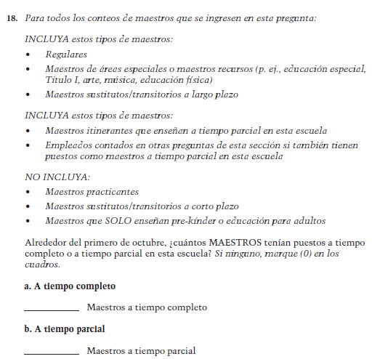
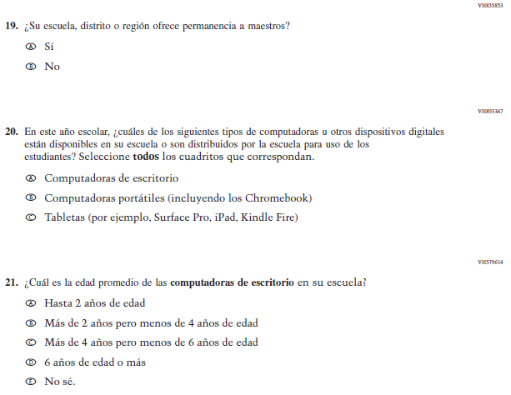

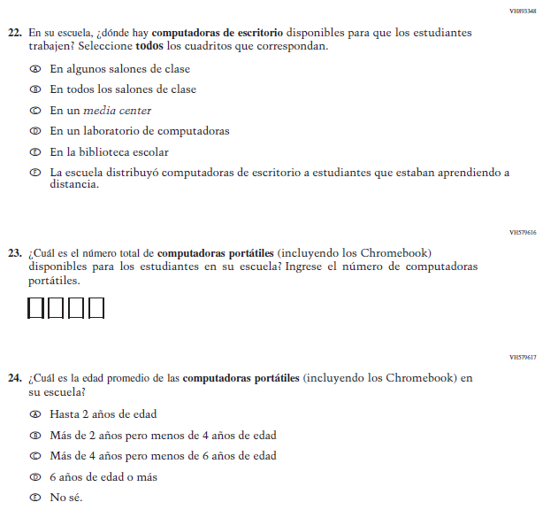

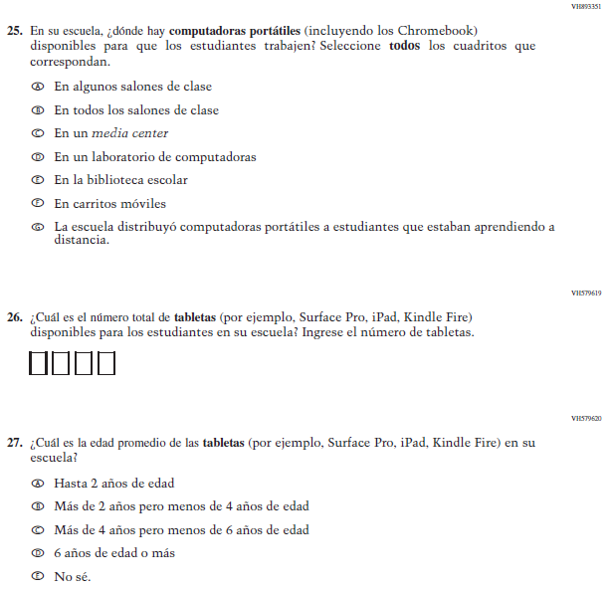

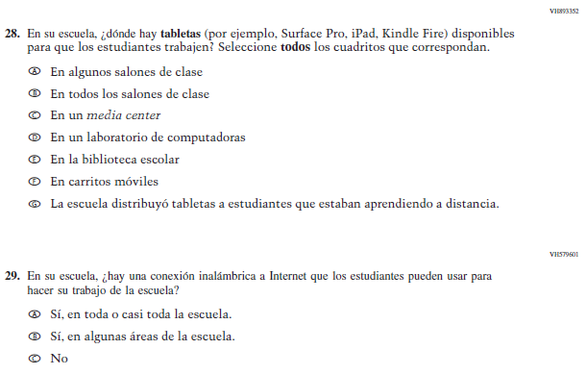

Appendix J-3b-s-PR: Operational Grade 8 CORE

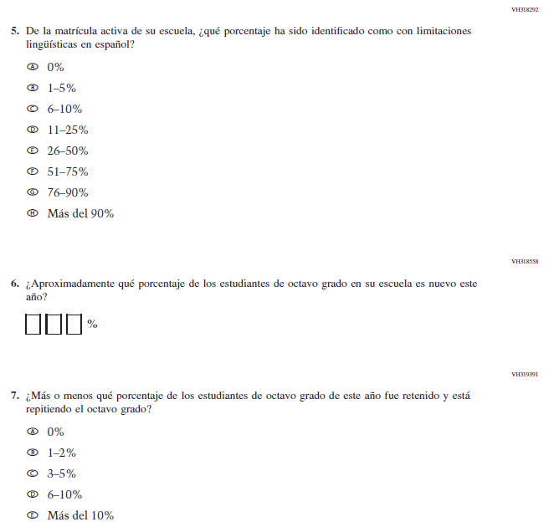

Appendix J-3c-s-PR: Operational Grade 4 Mathematics
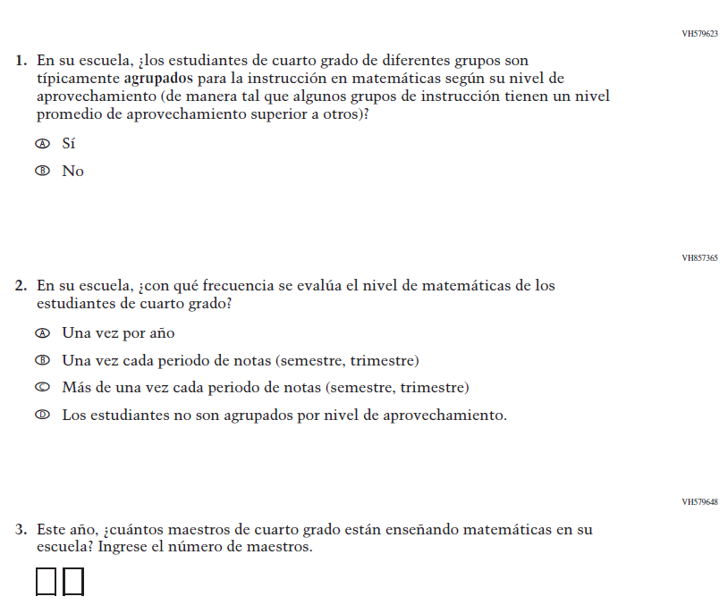

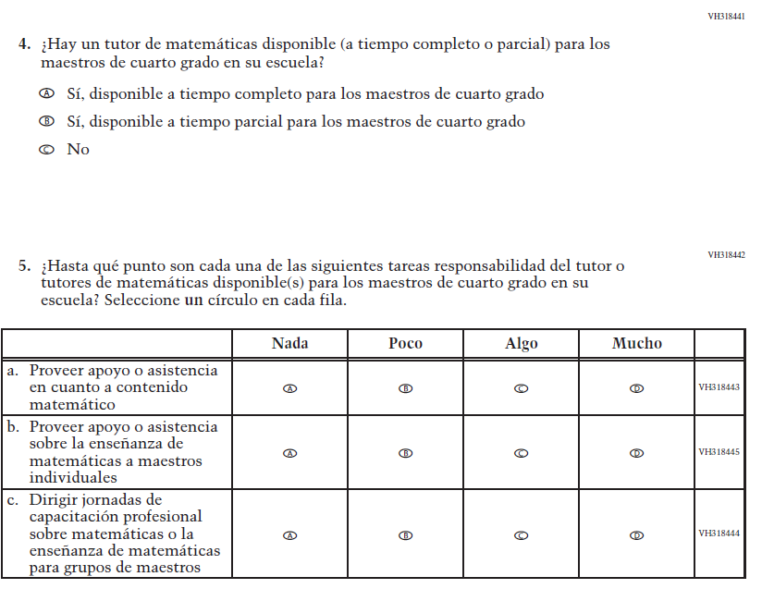
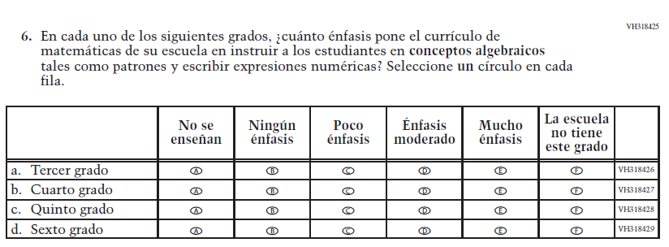

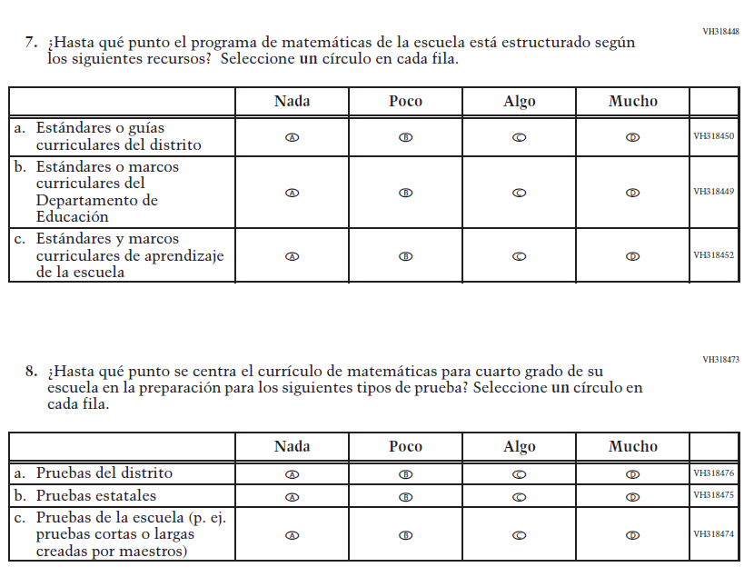

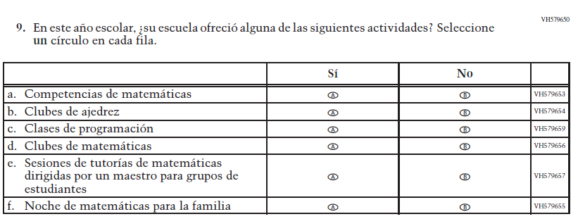

Appendix J-3d-s-PR: Operational Grade 8 Mathematics
