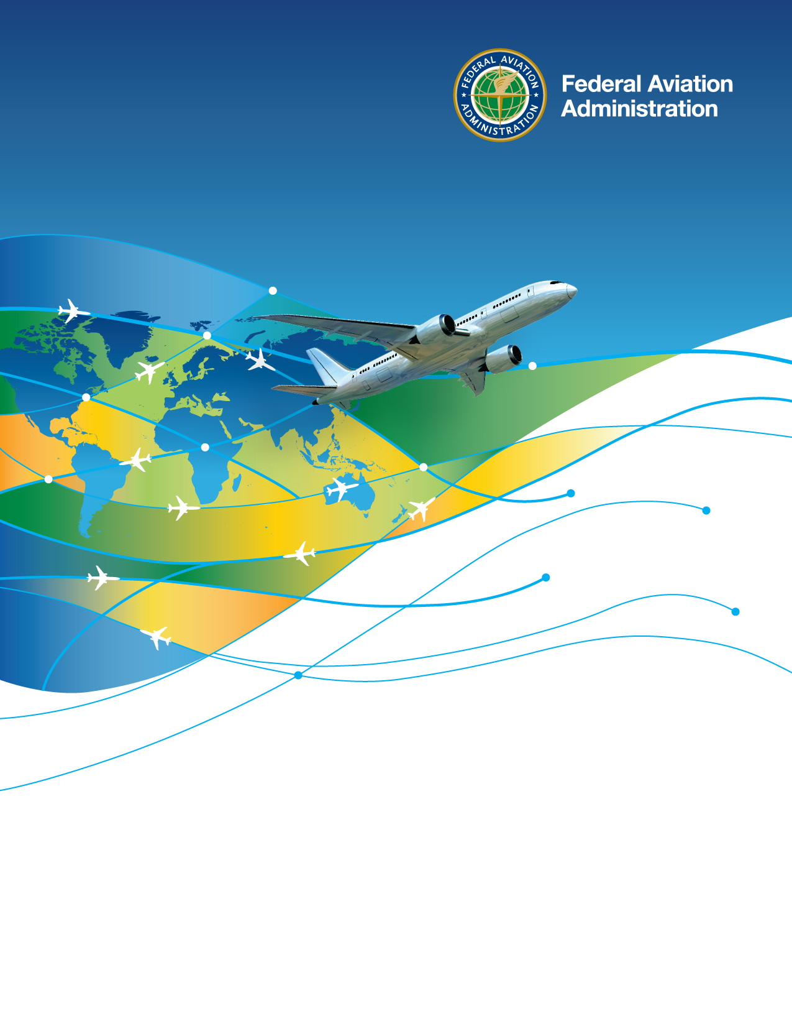

**Office of International Affairs**

**Job Aid**

Technical Assistance Requests

**Sample Questions / Survey for the Intake of Technical Assistance Requests**

1. Date the technical assistance request was received by the FAA.
2. Name of entity making the request for technical assistance.
3. In which region dose the requesting entity reside? (Africa, Europe and Middle East; Asia-Pacific; Western Hemisphere; ICAO)
4. What is the name of the point-of-contact for the technical assistance request?
5. What is the email address of the point-of-contact for the technical assistance request?
6. What is the phone number of the point-of-contact for the technical assistance request?
7. Is the requesting entity the same as the technical assistance recipient? (Yes; No)
8. Which country will host or receive the technical assistance?
9. What is the name of the point-of-contact for the host or recipient country?
10. What is the email address of the point-of-contact for the host or recipient country?
11. What is the phone number of the point-of-contact for the host or recipient country?
12. Describe the specific request being made of the FAA.
13. Describe the reason(s) for the specific request. Explain what barrier the FAA may help the foreign entity overcome through technical assistance.
14. If the request is for training, how many students are expected to participate?
15. When does the request need to be fulfilled by?
16. Attach any emails, records of conversation, or other files associated with the technical assistance request.
17. Which FAA Line of Business or Staff Office has technical responsibility for supporting the specific request? (APL-11, APT, APX, APC, AEU, APC, AWH, AJV-I, AIR-40, AFS-50, AMA-800, Other)
18. Which FAA Desk Officer is assigned responsibility for the host or recipient country?