Purpose: The Infrastructure Investment and Jobs Act and the Inflation Reduction Act make historic levels of infrastructure funding available to ports. However, the funding has domestic sourcing requirements, and much of the cargo handling equipment and other port items that ports would like to purchase with grant funds is not manufactured in the U.S. The American Association of Port Authorities (AAPA), with support from the U.S. Maritime Administration (MARAD), is seeking to develop a nationwide picture of port cargo handling equipment demand, with a long-term goal of incentivizing equipment production in the U.S. The time and attention you give to this survey will help AAPA engage with manufacturers and pursue that goal.
Confidentiality: Your responses will be kept strictly confidential. Your responses will be anonymized and aggregated into industry results presented in reports or presentations. At the end of the survey, you may choose to receive a summary of the final, aggregated results.
Preparation: The survey asks about current equipment orders, new equipment budgeted for future years, and longer-term expectations. Responding will be quicker and easier if that information is on hand.
Device: This survey has been tested to work with mobile devices, but a computer is recommended.
Accessibility: This survey has been designed to be 508-compliant and should work with a screen reader.

Draft AAPA Port Equipment Survey
Paperwork Reduction Act Notice

This request is in accordance with the Paperwork Reduction Act of 1995. The information you provide will be used to identify the demand for electric powered port equipment and items.
The estimated average burden associated with this collection of information is approximately 2 hours per response, including the time for reviewing instructions, completing, and reviewing the collection of information. All responses to this collection of information are voluntary. Comments regarding this burden estimate or any other aspect of this collection of information, including suggestions for reducing this burden to: Information Collection Clearance Officer, Maritime Administration, MAR-390, 1200 New Jersey Avenue, SE, Washington, DC 20590.
An agency may not conduct or sponsor, and a person is not required to respond to a collection of information, unless it displays a current valid Office of Management and Budget control number.
Privacy Act Statement

The following information is provided pursuant to Section 3 of the Privacy Act of 1974 (5 U.S.C. § 55a(b)93):
- Authority: This survey is being conducted through a cooperative agreement between the Maritime Administration (MARAD) and the American Association of Port Authorities (AAPA).
- Purpose: The proposed collection (Building American Production Capacity for Electric Port Equipment and Other Port Infrastructure Items) will be used to identify the demand for electrically powered port equipment and other port infrastructure items supported by a pooled procurement.
- Routine Uses: Responses will be kept strictly confidential by AAPA and its contractor. Responses will be anonymized and aggregated into industry results presented in reports or presentations.
- Disclosure: Disclosure of this information is voluntary.
- Effects of Not Supplying the Requested Information: Failure to provide the requested information will limit the accuracy of the reported results and the potential for a pooled procurement.
INTRODUCTION
AAPA seeks information on cargo handling equipment and other items to be acquired for use at U.S. ports, marine terminals and/or inland terminals and that have limited or no domestic suppliers. The survey requests details on cargo handling equipment and other port/terminal items that your organization has:
- On order, as of 2023, but not yet delivered;
- Budgeted but not yet ordered; or
- Planned or anticipated (e.g., as part of a long-term capital plan or terminal expansion), but not yet budgeted or ordered.
Responses should focus on your organization’s purchase of new cargo handling equipment and items, which increase and/or replace inventory, as opposed to previously owned equipment or items. Since equipment orders, budgets, and plans can change; we understand that your responses are the best available “snapshot” of current orders and expectations.
The survey includes an initial set of general questions, then questions about equipment for each cargo handled.
Thank you for your participation.
- Name
[___________RESPONSE BOX ___________]
- Email
[___________RESPONSE BOX ___________]
- Organization
[___________RESPONSE BOX ___________]
- My survey responses that follow are for: (please choose)
- Port
- Single terminal
- Multiple ports/terminals [___________RESPONSE BOX ___________]
- Other [___________RESPONSE BOX ___________]

PORT/TERMINAL EQUIPMENT ORDERS AND PLANS
The following sections request information on ordered, budgeted, or planned acquisition of equipment/items for handling container, break-bulk/project, Ro-Ro, dry bulk, and liquid bulk cargo. If your organization does not handle a certain type of cargo, you will be able to skip those questions.
- Do you handle containers?
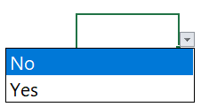
If yes: CONTINUE TO QUESTION 6 - Container Questions
If no: SKIP TO QUESTION 10 - Break Bulk/Project Cargo
- For container handling equipment, please use the drop-down boxes to indicate:
- Equipment type: the same type can be selected multiple times as needed (e.g., to indicate two STS cranes on order and four STS cranes budgeted for 3-5 years out).
- Status / Timeframe: ordered, budgeted, or planned/anticipated, and year range.
- Number of units.
- Power type: electric, diesel fuel, alternative fuel, hybrid, mix of types.
- If another organization (e.g., terminal operator) is involved in this purchase. Please indicate the organization type in the data entry box.
You can add additional rows for any equipment type as necessary. For each row:

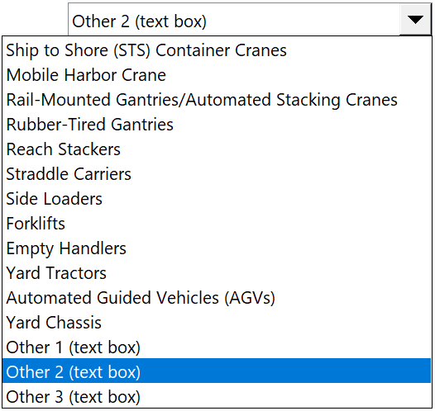
Equipment Type Status/Time Frame Units Power Type Other Entity Involved
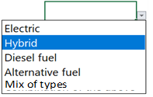
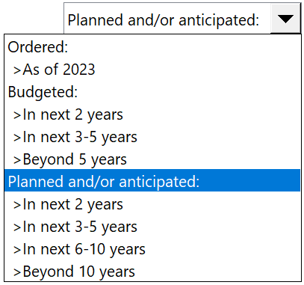
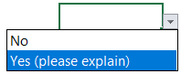
[RESPONSE]

if necessary:
[_____OTHER ENTITY RESPONSE BOX _____]

- Do you plan or hope to use Federal or state grant funds for any of those purchases?
- Federal funds
- State funds
- Both
- Neither

- How might availability of Federal or state funds affect your plans? For affected equipment types, please use the radio boxes to indicate how your plans could alter and provide details if available in the data entry box. You can add additional rows for any equipment type as necessary. If all the previously identified equipment will be affected in the same way, please select “All Previously Identified Equipment” from the drop-down box. For example, if Federal funds were available for new yard tractors and would both accelerate your purchase and allow you to purchase more units, select “Yard Tractors” from the drop-down list and select the radio buttons next to “Order sooner” and “Order more equipment”.
You can add additional rows for any equipment type as necessary. For each row:
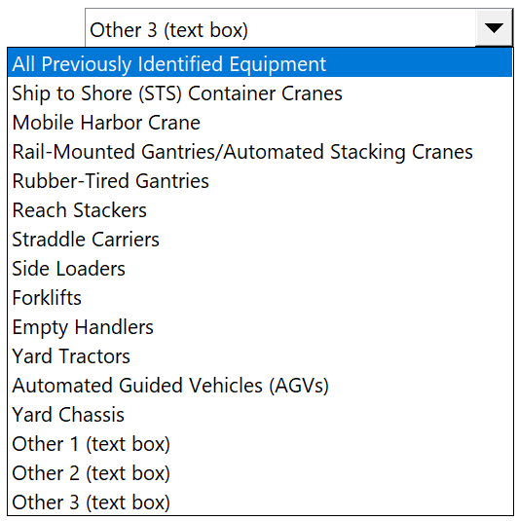
- Order sooner
- Order more equipment
- Alter equipment specification
- Purchase new rather than used or upgrade
- Other (please explain)

[_________DETAILS & OTHER RESPONSE BOX _________]

- Do you have additional comments, or is there anything else that we should know about your container handling equipment plans?
[_________RESPONSE BOX _________]

END CONTAINER QUESTIONS
- Do you handle Break Bulk/Project Cargo?
If yes: CONTINUE TO QUESTION 11 – Break Bulk/Project Cargo Questions
If no: SKIP TO QUESTION 15 Ro-Ro cargo
- For break bulk or project cargo handling equipment, please use the drop-down boxes to indicate:
- Equipment: the same equipment type can be selected multiple times as needed (e.g., to indicate two diesel forklifts on order and four hybrid forklifts budgeted for 3-5 years out).
- Status / Timeframe: ordered, budgeted, or planned/anticipated, and year range.
- Number of units.
- Power type: electric, diesel fuel, alternative fuel, hybrid, or mix of types.
- If another organization (e.g., terminal operator) is involved in this purchase. Please indicate the organization type in the data entry box.
You can add additional rows for any equipment type as necessary. For each row:

Equipment Type Status/Time Frame Units Power Type Other Entity Involved
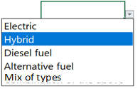
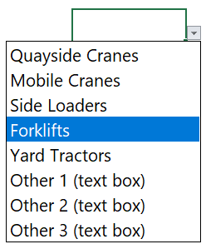
[RESPONSE]

if necessary:
[_____OTHER ENTITY RESPONSE BOX _____]

- Do you plan or hope to use Federal or state grant funds for any of those purchases?
- Federal funds
- State funds
- Both
- Neither

- How might availability of Federal or state funds affect your plans? For affected equipment types, please use the radio boxes to indicate how your plans could alter, and provide details if available in the data entry box. You can add additional rows for any equipment type as necessary. If all the previously identified equipment will be affected in the same way, please select “All Previously Identified Equipment” from the drop-down box. For example, if Federal funds were available for new forklifts and would both accelerate the purchase and allow you to purchase more units, select “Forklifts” from the drop-down list and select the radio buttons next to “Order sooner” and “Order more equipment”.

You can add additional rows for any equipment type as necessary. For each row:
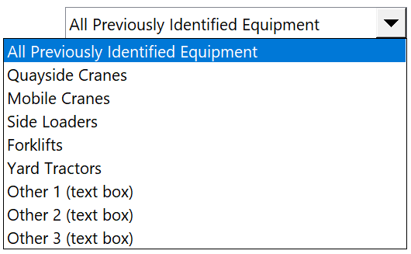
- Order sooner
- Order more equipment
- Alter equipment specification
- Purchase new rather than used or upgrade
- Other (please explain)

[_________DETAILS & OTHER RESPONSE BOX _________]

- Do you have any additional comments, or is there anything else that we should know about your break bulk or project cargo handling equipment plans?

[_________RESPONSE BOX _________]

END BREAK BULK/PROJECT CARGO QUESTIONS

- Do you handle Ro-Ro cargo?
If yes: CONTINUE TO QUESTION 16 - Ro-Ro Cargo Questions
If no: SKIP TO QUESTION 20 - Dry Bulk Cargo
- For Ro-Ro cargo handling equipment, please use the drop-down boxes to indicate:
- Equipment type: the same equipment type can be selected multiple times as needed (e.g., to indicate two R-Ro ramps on order and four ramps budgeted for 3-5 years out).
- Status / Timeframe: ordered, budgeted, or planned/anticipated, and year range.
- Number of units.
- Power type: electric, diesel fuel, alternative fuel, hybrid, mix of types.
- If another organization (e.g., terminal operator) is involved in this purchase. Please indicate the organization type in the data entry box.

You can add additional rows for any equipment type as necessary. For each row:

Equipment Status/Time Frame Amount Power Type Other Entity Involved
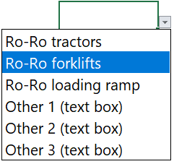
[RESPONSE]

if necessary:
[_____OTHER ENTITY RESPONSE BOX _____]

- Do you plan or hope to use Federal or state grant funds for any of those purchases?
- Federal funds
- State funds
- Both
- Neither
- How might availability of Federal or state funds affect your plans? For affected equipment types, please use the radio boxes to indicate how your plans could alter, and provide details, if available, in the data entry box. You can add additional rows for any equipment type as necessary. If all the previously identified equipment will be affected in the same way, please select “All previously identified equipment” from the drop-down box. For example, if Federal funds were available for Ro-Ro forklifts and would both accelerate the purchase and allow you to purchase more units, select “Ro-Ro Forklifts” from the drop-down list and select the radio buttons next to “Order sooner” and “Order more equipment”.

You can add additional rows for any equipment type as necessary. For each row:

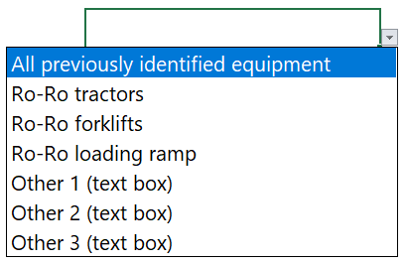
- Order sooner
- Order more equipment
- Alter equipment specification
- Purchase new rather than used or upgrade
- Other (please explain)

[_________DETAILS & OTHER RESPONSE BOX _________]

- Do you have any additional comments, or is there anything else that we should know about your Ro-Ro cargo handling equipment plans?

[_________RESPONSE BOX _________]

END RO-RO CARGO QUESTIONS

- Do you handle Dry Bulk cargo?
If yes: CONTINUE TO QUESTION 21 - Dry Bulk Cargo Questions
If no: SKIP TO QUESTION 25 - Liquid Bulk Cargo
- For dry bulk cargo handling equipment, please use the drop-down boxes to indicate:
- Equipment type: the same equipment type can be selected multiple times to reflect different status levels (e.g., to indicate two loaders on order and four loaders budgeted for 3-5 years out).
- Status / Timeframe: ordered, budgeted, or planned/anticipated, and year range.
- Number of units.
- Power type: electric, diesel fuel, alternative fuel, hybrid, mix of types.
- If another organization (e.g., terminal operator) is involved in this purchase. Please indicate the organization type in the data entry box.

You can add additional rows for any equipment type as necessary. For each row:

Equipment Type Status/Time Frame Units Power Type Other Entity Involved
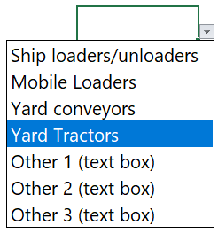
[RESPONSE]

if necessary:
[_____OTHER ENTITY RESPONSE BOX _____]

- Do you plan or hope to use Federal or state grant funds for any of those purchases?
- Federal funds
- State funds
- Both
- Neither
- How might availability of Federal or state funds affect your plans? For affected equipment types please use the radio boxes to indicate the impact and provide details if available in the data entry box. You can add additional rows for any equipment type as necessary. If all the previously identified equipment will be affected in the same way, please select “All previously identified equipment” from the drop-down box. For example, if Federal funds were available for new yard tractors and would both accelerate the purchase and allow you to purchase more units, select “Yard Tractors” from the drop-down list and select the radio buttons next to “Order sooner” and “Order more equipment”.

You can add additional rows for any equipment type as necessary. For each row:
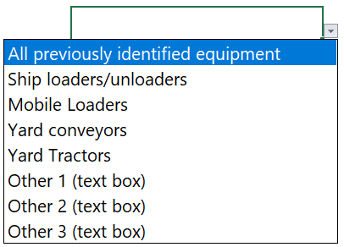
- Order sooner
- Order more equipment
- Alter equipment specification
- Purchase new rather than used or upgrade
- Other (please explain)

[_________DETAILS & OTHER RESPONSE BOX _________]

- Do you have additional comments, or is there anything else that we should know about your dry bulk cargo handling equipment plans?

[_________RESPONSE BOX _________]
END DRY BULK CARGO QUESTIONS

- Do you handle Liquid Bulk cargo?
If yes: CONTINUE TO QUESTION 26 - Liquid Bulk Cargo Questions
If no: SKIP TO QUESTION 30 - Non-cargo handling equipment
- For liquid bulk cargo handling equipment, please use the drop-down boxes to indicate:
- Equipment type: the same equipment type can be selected multiple times as needed (e.g., to indicate two ship loading arms on order and four loading arms budgeted for 3-5 years out).
- Status / Timeframe: ordered, budgeted, or planned/anticipated, and year range.
- Number of units.
- Power type: electric, diesel fuel, alternative fuel, hybrid, mix of types.
- If another organization (e.g., terminal operator) is involved in this purchase. Please indicate the organization type in the data entry box.

You can add additional rows for any equipment type as necessary. For each row:

Equipment Type Status/Time Frame Units Power Type Other Entity Involved
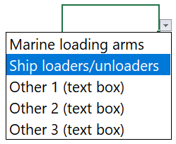
[RESPONSE]

if necessary:
[_____OTHER ENTITY RESPONSE BOX _____]

- Do you plan or hope to use Federal or state grant funds for any of those purchases?
- Federal funds
- State funds
- Both
- Neither
- How might availability of Federal or state funds affect your plans? For affected equipment types please use the radio boxes to indicate the impact and provide details if available in the data entry box. You can add additional rows for any equipment type as necessary. If all the previously identified equipment will be affected in the same way, please select “All previously identified equipment” from the drop-down box. For example, if Federal funds were available for new marine loading arms and would both accelerate the purchase and allow you to purchase an extra unit, select “Marine loading arms” from the drop-down list and select the radio buttons next to “Order sooner” and “Order more equipment”.

You can add additional rows for any equipment type as necessary. For each row:
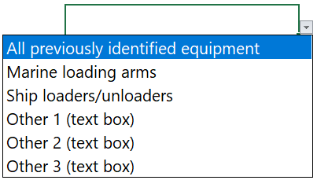
- Order sooner
- Order more equipment
- Alter equipment specification
- Purchase new rather than used or upgrade
- Other (please explain in the response box)

[_________DETAILS & OTHER RESPONSE BOX _________]

- Do you have additional comments, or is there anything else that we should know about your liquid bulk cargo handling equipment plans?

[_________RESPONSE BOX _________]

END LIQUID BULK CARGO QUESTIONS

- Do you purchase other (non-cargo handling) port/terminal equipment? Examples could include bollards and fenders, shore-power installations, rail infrastructure, etc.
If yes: CONTINUE TO QUESTION 31 - Other Type Questions
If no: SKIP TO QUESTION 35 - Planning and Funding
- For other (non-cargo handling port/terminal equipment, please use the response boxes to indicate:
- Equipment type, size (if applicable).
- Status / Timeframe: ordered, budgeted, or planned/anticipated, and year range.
- Number of units.
- Cost, if available.
- If another organization (e.g., terminal operator) is involved in this purchase. Please indicate the organization type in the data entry box.

You can add additional rows for any equipment type as necessary.

Equipment Type Size Status/Time Frame Units Cost Other Entity Involved
[__RESPONSE__] [__RESPONSE__] [__RESPONSE__] [__RESPONSE__]

if necessary:
[_____OTHER ENTITY RESPONSE BOX _____]

- Do you plan or hope to use Federal or state grant funds for any of those purchases?
- Federal funds
- State funds
- Both
- Neither

- How might availability of Federal or state funds affect your plans? For affected equipment types please use the radio boxes to indicate the impact and provide details if available in the data entry box. You can add additional rows for any equipment type as necessary. If all the previously identified equipment will be affected in the same way, please check the “All Previously identified equipment” box. For example, if Federal funds were available for new bollards and would both accelerate the purchase and allow you to purchase more units, type “Bollards” in the response box and select the radio buttons next to “Order sooner” and “Order more equipment”.

You can add additional rows for any equipment type as necessary. For each row:

Equipment Type All Previously identified equipment or Equipment type: [__RESPONSE__]
- Order sooner
- Order more equipment
- Alter equipment specification
- Purchase new rather than used or upgrade
- Other (please explain in the response box)

[_________DETAILS & OTHER RESPONSE BOX _________]

- Do you have any additional comments, or is there anything else that we should know about your other port or terminal equipment plans?

[_________RESPONSE BOX _________]

PLANNING AND FUNDING
- How does your organization typically plan for major equipment acquisitions? Please select all that apply, and provide any explanatory details in the box below.
- Annual budget
- Short term plan: 2-5 years
- Longer-term plan: 6+ years
- Based on grant availability
- Project by project
- Other [__RESPONSE BOX__]

[_________DETAILS RESPONSE BOX _________]

- Does your organization have a plan or policy for zero/ near zero-emissions equipment? (If yes, can we get a copy?)
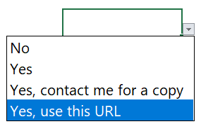
[___RESPONSE BOX FOR URL___]

- Does another organization purchase cargo handling equipment for your port/terminal(s)?
If yes:
    - Who else purchases cargo handling equipment for your port/terminal(s)? [__RESPONSE__]
    - How are costs usually shared? [__RESPONSE__]
    - What do the other parties usually purchase? [__RESPONSE__]

POOLED/GROUP EQUIPMENT PURCHASING
There are precedents for pooled or group equipment ordering and purchasing where multiple organizations need the same equipment types. These arrangements can yield cost savings or support domestic production of equipment that might otherwise have to come from foreign sources. For example, the Ports of Tacoma and Seattle cooperate under the Northwest Seaport Alliance.

- Has your organization previously explored or participated in group/pooled equipment purchase arrangements with other organizations? (i.e., with another port)
if necessary:
[_____RESPONSE BOX _____]

- Would your organization be interested in group/pooled purchase arrangements for port and terminal equipment?
[_____RESPONSE BOX_____]

SURVEY COMPLETION
- Is there anything else we should know or that you would like to add?
[___________RESPONSE BOX ___________]

- If we need to follow up or clarify responses, whom should we contact?
[___________RESPONSE BOX ___________]

- Thank you for your time. Would like a summary of the survey findings?
- Yes
- No

