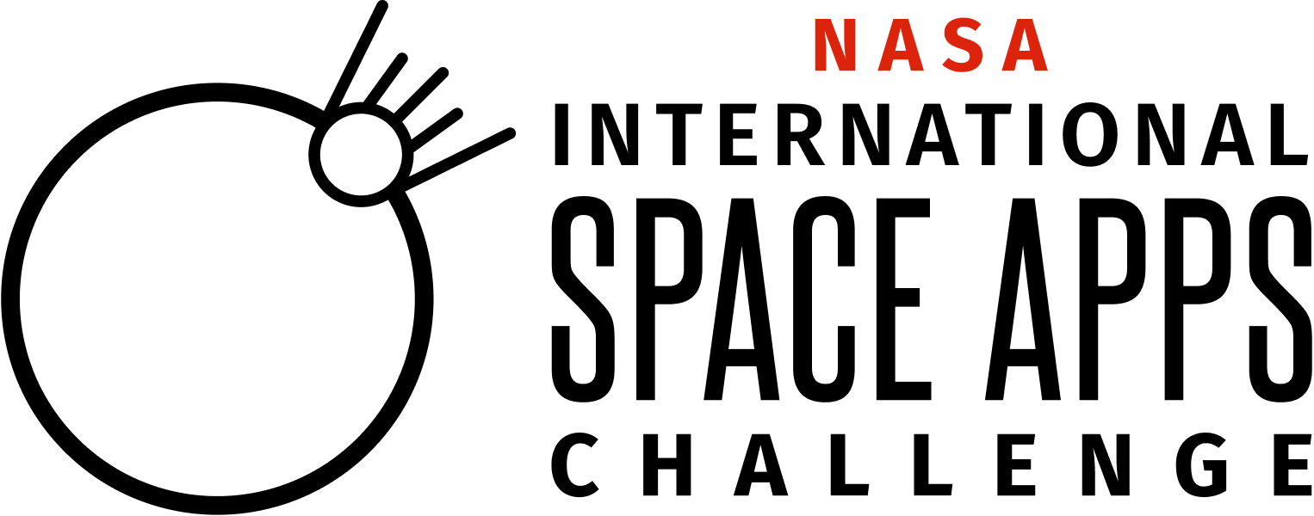
NASA International Space Apps Challenge 2023 Navigator Application - DRAFT
[INSERT RELEASE DATE]
[INSERT DUE DATE]

Paperwork Reduction Act Statement:
This information collection meets the requirements of 44 U.S.C 3507, as amended by section 2 of the Paperwork Reduction Act of 1995. You do not need to answer these questions unless we display a valid Office of Management and Budget control number. The OMB control number for this information collection is 2700-xxxx and it expires on xx/xx/xxxx. We estimate that it will take about xx minutes to read the instructions, gather the facts, and answer the questions. You may send comments on our time estimate above to _____@nasa.gov. Send only comments relating to our time estimate to this address.

Now in its 12th year, the NASA International Space Apps Challenge (“Space Apps”) is an international hackathon for coders, scientists, designers, storytellers, makers, builders, technologists, and others, where teams can engage with NASA’s free and open data to address challenges we face on Earth and in space.

Each year, NASA partners with space agencies around the world to hold Space Apps to inspire collaboration, creativity, and critical thinking that fosters interest in Earth and space science, technology, and exploration. The program leverages this interest to encourage the growth and diversity of the next generation of problem solvers and explorers.
Each year, Space Apps Navigators are recognized for their exemplary participation in NASA's International Space Apps Challenge. To be eligible to be a Navigator, applicants must have participated in Space Apps in some way (e.g., participant or Local Lead) at least 5 times, or demonstrated equivalent relevant experience in another NASA program. Space Apps Navigators will also have the option to participate in additional opportunities during the hackathon, such as:
- Responding to participant questions in Space Apps chat
- Creating a video that may be featured in the Space Apps Virtual Bootcamp
- Reviewing participant projects for quality

Navigators are Space Apps community members who have demonstrated excellence in the program or excellence in relevant fields including, but not limited to: science, data, technology, and space. By recognizing these exemplary community members as Navigators, the hackathon connects the tens of thousands of Space Apps participants with community expertise that can enhance participant problem solving.

What is the role of a Space Apps Navigator?
- The time commitment for the role of Space Apps Navigator is typically approximately 18 hours total, although it could be less. You will be expected to watch 2 hours of virtual training in order to assume the role. Typically, Navigators each participate 4-6 hours over the 2-day hackathon by supporting participants in the chat (October 7-8, 2023) and then 8-10 hours for reviewing solutions in the weeks following the hackathon, though this may vary.
- You may participate in your Navigator role virtually from the comfort of home.
- Attend the Preparation Webinars: Navigators will be invited to join two webinars. Navigators who opt to participate in reviewing participant projects will receive guidance on the reviewing process, presented in a webinar prior to the hackathon.
- Sign up for Chat Channel Coverage: A week prior to Space Apps, Navigators will be invited to sign up for shifts to participate in the chat platform where all Space Apps participants are invited to connect with one another and with challenge owners, subject matter experts, and Space Apps Navigators. The shifts are time periods of 2 hours.
- Engage with Participants in Chat Channels: Navigators engage participants in the chat channels during the two-day hackathon, supporting participants in finding resources. Navigators often flag relevant questions for the NASA challenge owners and subject matter experts as needed. As such, you’ll be in touch with these NASA challenge owners and subject matter experts throughout the weekend.
- Record a Virtual Bootcamp Video (Optional): Navigators are also invited to record a 1-2 minute video/training to present a topic relevant to Space Apps Participants (for example, previous presentations have included developing hackathon projects/solutions, engaging with tech, succeeding at a hackathon, presenting projects/solutions, engaging with open data, etc.). NASA will review all videos prior to posting, and a media waiver is required in order for your video to be uploaded and hosted on the Space Apps website, where it will premiere during the week prior to the event in our Virtual Bootcamp.

Thank you for your interest in continuing your Space Apps journey as a Space Apps Navigator! If you’d like to apply for this role, complete this application by [INSERT DUE DATE], 2023.

Required-ALL
- What is your first name? (Open Response)
- What is your last name? (Open Response)
- What is your email? (Open Response)
- What is your city of residence? (Open Response)
- What is your country or territory of residence? (Open Response)
- Are you affiliated with the Chinese government or a Chinese-owned entity and/or are you receiving funding from the Chinese government or a Chinese-owned entity? *
  - Yes
  - No
- How long have you been involved in Space Apps? (Multiple Choice)
  - This is my first year.
  - 1 year
  - 2-4 years
  - 5-7 years
  - 8-10 years
  - 10 + years
- If anything but “This is my first year is selected” the following appears:
Please select all the ways that you have participated in Space Apps (Multiple Choice - Select all that apply)
  - Participant
  - Local Lead
  - Navigator
  - Other (please list): (Open Response)
- What kinds of activities would you be interested in participating in? (Open Response)
- Please tell us a little bit about your background (Open Response)
- Why do you want to be a Space Apps Navigator? (Open Response)
- Would you be interested in recording a 1-2 minute video/training (for example, on your area of expertise) for Space Apps 2023 hackathon participants? (Yes/No)
- Please share your areas of expertise that are relevant to hackathon participants and NASA's (and/or partner space agencies’) free and open data. (Open Response)

Providing false information in connection with this application will be grounds for disqualification or termination from participation in SpaceApps.

For NASA Space Apps 2023, a Navigator is responsible for understanding the following regarding their participation in Space Apps 2023:

Participant Terms and Conditions
Navigators are participants in the NASA International Space Apps Challenge with additional privileges. First, please read and understand the Participant Terms and Conditions (click on link to read through document). Please make sure that you understand what you as a Participant are agreeing to. These Participant Terms and Conditions are separate from Navigator Terms and Conditions listed below.

Please pay close attention to the following text from the Participant Terms and Conditions:
You are solely responsible for compliance with any laws, rules, or regulations applicable to prizes or contests in your jurisdiction. NASA is not responsible for the conduct of any local International Space Apps Challenge events or for any breach or violation of any agreement between you and any Space Apps Global or Local Collaborator, or between you and any Space Apps Participant. You agree to release NASA from and hold NASA harmless against any and all claims against NASA resulting from any breach of any of the representations, warranties or obligations contained in these Navigator Terms and Conditions by you or by any participant.

You acknowledge that participation in NASA’s International Space Apps Challenge 2023 may bring some risk, and you do hereby assume responsibility for your own well-being. Accordingly, as a condition of your participation, you assume any and all risks to you associated with your participation as a Navigator in the NASA International Space Apps Challenge, and waive and release any and all claims or causes of action against NASA, the U.S. Government, and its officers, employees, and agents for any and all injury and damage of any nature whatsoever (whether existing or thereafter arising, whether direct, indirect, or consequential, and whether foreseeable or not), arising from your participation in the event.

Question/Text | Type of Answer
I have read and understood Participant Legal Terms and Conditions | Check box:  - Yes I understand

Navigator Terms and Conditions
Your Involvement in Space Apps: You may represent yourself as a “Space Apps Navigator” on social media, LinkedIn, your resume etc. (again, without use of the Insignia or other NASA identifiers as noted above). You understand that as a Navigatoryou are NOT a representative of NASA or NASA’s International Space Apps Challenge 2023 in any capacity, official or otherwise. As such, you will not negotiate nor broker any agreements (financial, promotional, or otherwise) on behalf of NASA or NASA’s International Space Apps Challenge 2023. You may not list or represent yourself as an employee or agent of NASA or imply that you work for NASA or represent NASA in any way. If you have any questions about terminology you may use, please contact the Space Apps GO Team at community@spaceappschallenge.org.

You are expected to uphold the NASA values of safety, integrity, teamwork, excellence, and inclusion, noting that NASA Space Apps will not tolerate bullying, favoritism, or similar misconduct or atmosphere which is inconsistent with our values.

Termination: In the event of any violation of the above terms and conditions, in consequence of laws, regulations or policies to which NASA is subject, or for any other reason within NASA’s reasonable discretion, NASA may rescind the offer to act as a Navigator upon notice, and in such event, You shall no longer be considered a Navigator in Space Apps. Any such actions could also result in You not being considered for participation in future Space Apps Challenges.

Publicity: Your participation as a Navigator constitutes your consent for NASA to use your name, email, location and country information, photos from your participation in Space Apps 2023 and use of the likenesses therein, and/or information about your participant for informational purposes in connection with the International Space Apps Challenge through any form of media, worldwide, without further permission, payment, or consideration. For any imagery provided by You to NASA for use by NASA, You shall provide to NASA a model release in form reasonably satisfactory to NASA which allows NASA to use such imagery as well as the likenesses of individuals featured in such imagery.*
*The Participant Terms & Conditions includes an agreement to allow use of imagery and other media, including certain rights of likeness. Participants agree to the Participants Terms & Conditions upon registration for Space Apps. As a Navigator, you also agree to the Participant Terms & Conditions by checking the box above.

Space Apps branding and logos: The Space Apps Resources page includes Space Apps branding information including logos and fonts. As a Navigator, you may use the Space Apps logo consistent with the goals and purposes of Space Apps 2023. Except for the use of “NASA” as it appears in the Space Apps logo, you shall not use “National Aeronautics and Space Administration” or “NASA” in any way that creates the impression that a product or service has the authorization, support, sponsorship, or endorsement of NASA. The NASA name and initials may be used by You in a strictly factual manner in connection with the release of general information regarding your own participation in Space Apps, but not for any promotional or advertising purpose.**
**For example, when reaching out to share about Space Apps, you may use the name NASA International Space Apps Challenge. Please refer to the section above “Your Involvement in Space Apps” on how to refer to your role. You may say that NASA is the global sponsor of the NASA International Space Apps Challenge.

NASA logo use: NASA has strict restrictions that everyone must follow regarding the use of their NASA Insignia (or “meatball” logo), NASA Logotype (or “worm” logo) and other NASA identifiers. Do not use the NASA Insignia or other NASA identifiers, or space agency partner logos, without express permission. Navigators are expected to use the Space Apps branding, and not the NASA Insignia, NASA Logotype, or other NASA mission logos. Any use of NASA imagery must conform to NASA’s Media Usage Guidelines (See https://www.nasa.gov/multimedia/guidelines/index.html). If you have any questions about logo use, please contact the Space Apps GO Team at community@spaceappschallenge.org.

Question/Text | Type of Answer | Date
I confirm I have read the above form, the Participant Legal Terms and Conditions, and the Privacy Policy. I represent and warrant that I have the legal capacity to enter into such commitments, and that all information provided is true and correct. | Signature | Date must be written or timestamped

Thank you for your interest in joining Space Apps 2023 as a Space Apps Navigator! If you are selected as a Space Apps Navigator for this year, you will receive an email from the Space Apps Team. Thank you!
*In accordance with NASA’s China funding restriction, any applicant that has affiliations with the Chinese government or a Chinese-owned entity must undergo review for prohibited bilateral activity in order to be determined eligible to participate as a Space Apps Navigator. Any determination of eligibility shall be made by NASA, in its sole discretion, and will be based on information provided by the applicant.

