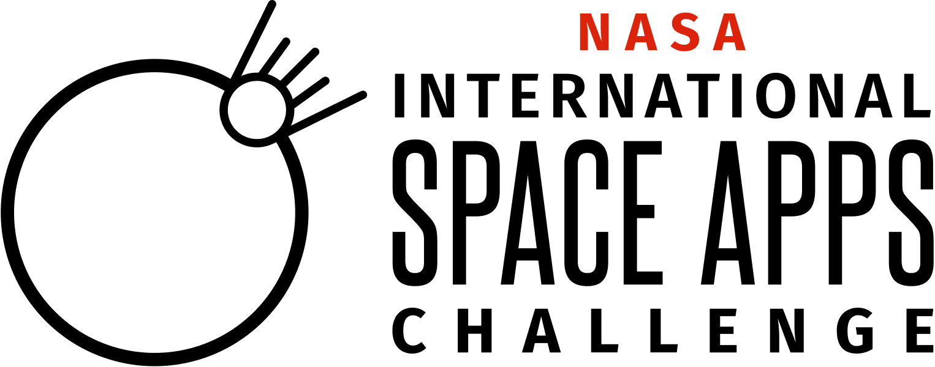
NASA International Space Apps Challenge 2023 Collaborator Application-DRAFT
[INSERT RELEASE DATE]
[INSERT DUE DATE]

Paperwork Reduction Act Statement:
This information collection meets the requirements of 44 U.S.C 3507, as amended by section 2 of the Paperwork Reduction Act of 1995. You do not need to answer these questions unless we display a valid Office of Management and Budget control number. The OMB control number for this information collection is 2700-xxxx and it expires on xx/xx/xxxx. We estimate that it will take about xx minutes to read the instructions, gather the facts, and answer the questions. You may send comments on our time estimate above to _____@nasa.gov. Send only comments relating to our time estimate to this address.

Now in its 12th year, NASA Space Apps Challenge (Space Apps) is an international hackathon for coders, scientists, designers, storytellers, makers, builders, technologists, and others, where teams can engage with NASA’s free and open data to address problems on Earth and in space. Space Apps inspires collaboration, creativity, and critical thinking that fosters interest in Earth and space science and exploration. It leverages this interest to encourage the growth and diversity of the next generation of problem solvers.

Each year organizations around the world come forth to engage with NASA’s International Space Apps Challenge. We collaborate with a selection of these organizations to:
- Increase awareness of NASA’s International Space Apps Challenge
- Attract a diversity of participants to NASA’s International Space Apps Challenge
- Provide participants with optional tools and resources that enable the creation of solutions in NASA’s International Space Apps Challenge

Thank you for your interest in being a Space Apps 2023 Collaborator! Please fill out the following information by [INSERT DUE DATE]

Required-ALL
- Your First and Last Name (Open Response)
- Your Title (Open Response)
- Company/Organization Name (Open Response)
- Where is your company/organization located? (City)(Open Response)
- Where is your company/organization located? (Country or Territory)(Open Response)
- 2-3 Sentence Description of Company/Organization (Open Response)
- Company Website URL (Open Response)
- Have you been a Space Apps Collaborator in the past? (Single Select)
  - Yes
  - No
- Is your company/organization affiliated with the Chinese government or a Chinese-owned entity and/or is your company/organization receiving funding from the Chinese government or a Chinese-owned entity? *
  - Yes
  - No
- Why are you interested in being a 2023 Space Apps Collaborator? What value does being a part of the Space Apps Community bring to your company/organization? (Open Response)
- Is your company/organization interested in becoming a Global Collaborator? (Companies/organizations who make free tools and resources available to the Space Apps Community to support the creation of Space Apps projects)
  - Yes
  - No
- Is your company/organization interested in becoming an Amplification Collaborator? (Companies/organizations who promote Space Apps to their communities in order to attract a broader diversity of participants)
  - Yes
  - No

If ‘Yes’ is Selected for Amplification Collaborator
- Approximately how many people could you spread the word to about NASA’s International Space Apps Challenge through your company/organization’s marketing efforts? (Single Select)
  - 0-1,000
  - 1,001-10,000
  - 10,001-25,000
  - 25,001-50,000
  - 50,001-100,00
  - 100,001-250,000
  - 250,001-500,000
  - 500,001-1,000,000
  - 1,000,001+
- What types of communities does your organization/company support?(Select All That Apply) *Please note this is for informational purposes and not used for the selection process
  - People who identify as women
  - LGBTQIA+ individuals
  - BIPOC individuals
  - LatinX
  - People with disabilities
  - Youth
  - Tech or tech adjacent
  - Universities/Colleges
  - Other
    - Open Response
- In what ways would your company/organization be interested in spreading the word about Space Apps? (Select All That Apply)
  - Social Media
  - Newsletter
  - Email
  - Slack Groups
  - In Person Event/Conference
  - Other
    - Open Response

If ‘Yes’ is Selected for Global Collaborator
- Name of your Company/Organization's resource or tool that you would like to offer to Space Apps participants (Open Response)
- Description of your Company/Organization's resource or tool that you would like to offer to Space Apps participants (Open Response)
- For what time period of time would this offer be available for Space Apps Participants? (Open Response)
- Please confirm that your resource or tool is available to 5 or more countries (Yes/No)
  - Yes I confirm
  - No
- Please confirm that this resource or tool may be offered free to the Space Apps Community (Yes/No)
  - Yes I confirm
  - No
- Are there any countries that can not access this tool/resource? (Single Select)
  - Yes
    - What countries (Open Response)
  - No

Providing false information in connection with this application will be grounds for disqualification or termination from participation in SpaceApps.

Disclaimer:
NASA does not endorse any non-U.S. Government entity and is not responsible for information contained on non-U.S. Government websites.
*In accordance with NASA’s China funding restriction, any applicant that has affiliations with the Chinese government or a Chinese-owned entity must undergo review for prohibited bilateral activity in order to be determined eligible to participate as a Space Apps Collaborator. Any determination of eligibility shall be made by NASA, in its sole discretion, and will be based on information provided by the applicant.
2023 Collaborator Terms and Conditions

By entering the Space Apps Collaborator Program and agreeing to these Terms and Conditions, You affirm that You have legal authority to represent your organization, and that your organization agrees to the following Terms and Conditions:

Participation: Your organization’s designation as a Space Apps Collaborator is fully voluntary. Your organization is not entitled to compensation, nor will its representatives be considered employees, agents, independent contractors, or consultants of NASA or of the United States (U.S.) Government.

Your Organization’s Involvement in Space Apps: You may represent yourself as a “NASA Space Apps Global Collaborator”, “NASA Space Apps Collaborator, or “NASA Space Apps Amplification Collaborator”. You may describe Space Apps as a “NASA-led initiative” and can indicate your organization is a “Collaborator with NASA’s International Space Apps Challenge”. You understand that as a Collaborator you are NOT a representative of NASA or NASA’s International Space Apps Challenge 2023 in any official capacity. As a NASA-led initiative, Space Apps does not accept sponsorship or have sponsors. Due to this, we request that Space Apps Collaborators use the term “Collaborator” and not “partner” or “sponsor”.

USE OF GLOBAL OFFER MATERIALS:
You are responsible for ensuring that your Global Offer materials are freely and publicly available without restriction to the Space Apps participants, and that use by the participants will not infringe the rights of any third parties. Such Global Offer materials will be available to participants, but participants have no obligation to use such materials

WARRANTIES:
You represent and warrant that (i) you have sufficient rights to authorize the use of the Global Offer materials to participants in the 2023 International Space Apps Challenge, and (ii) use of the Global Offer materials by Space Apps participants will not infringe, or constitute a misappropriation of, any intellectual property rights or confidential information of any third party.

Publicity: Your participation as a Collaborator constitutes your consent for NASA to use your company’s name and/or information about your company for informational purposes in connection with the International Space Apps Challenge through any form of media, worldwide, without further permission, payment, or consideration. For any imagery provided by You to NASA for use by NASA, You shall provide to NASA a model release in form reasonably satisfactory to NASA which allows NASA to use such imagery as well as the likenesses of individuals featured in such imagery.

Space Apps Branding and Logos: The Space Apps Resources page includes Space Apps branding information, including logos and fonts. As a Collaborator, you may use the Space Apps logo consistent with the goals and purposes of Space Apps 2023, including but not limited to adding it to the website where participants can find your Global Offer. You will also be provided with a Collaborator Communications Toolkit which includes approved images and copy that can be used for your outreach. You shall not use “National Aeronautics and Space Administration” or “NASA” in a way that creates the impression that a product or service has the authorization, support, sponsorship, or endorsement of NASA. The NASA name and initials may be used by You in a strictly factual manner in connection with the release of general information regarding your organization’s participation in Space Apps as a Collaborator, but not for any promotional or advertising purpose.

NASA Logo Use: NASA has strict restrictions that everyone must follow regarding the use of the NASA Insignia (or “meatball” logo), NASA Logotype (or “worm” logo) and other NASA identifiers. Do not use the NASA Insignia or other NASA identifiers, or space agency partner logos, without express permission. Collaborators are expected to use the Space Apps branding, and not the NASA Insignia, NASA Logotype, or other NASA mission logos. Any use of NASA imagery must conform to NASA’s Media Usage Guidelines.
(See https://www.nasa.gov/multimedia/guidelines/index.html). If you have any questions about logo use, please contact the Space Apps Collaborator Lead, Marie Mimiaga at GOTeam@spaceappschallenge.org

Collaborator Chat Channel *For Global Collaborators Only*
Global Collaborators have the opportunity to have one to three representatives from their organization in the Space Apps Collaborator Chat Channel at any given time throughout the event’s open channel dates October 7-8, 2023. Communication in this channel is limited to supporting the Space Apps participants creating their projects and/or facilitating use of your organization’s Global Offer. You are expected to use language that is professional and inclusive for the participants at all times in the Collaborator Chat Channel. The Space Apps Program encourages such practices and prohibit bullying, favoritism, or similar misconduct or atmosphere which is inconsistent with the NASA values of safety, integrity, teamwork, excellence, and inclusion.

Termination: In the event of any violation of the above Terms and Conditions, in consequence of laws, regulations, or policies to which NASA is subject, or for any other reason within NASA’s reasonable discretion, NASA may rescind the offer to act as a Collaborator upon notice, and in such event, your organization shall no longer be considered a Collaborator for Space Apps. Any such actions could also result in your organization not being considered for collaboration in future Space Apps Challenges.

Question/Text | Type of Answer
I confirm I have read the above Collaborator Terms & Conditions. I represent and warrant that I have the legal capacity to enter into such commitments, and that all information provided is true and correct. | Signature, Title, Organizational Address, & Date

