OMB CONTROL NUMBER: 3060-1273
Estimated time per response: We estimate it will take no more than one hour per month to produce the filing per respondent.

- Screenshot of homepage for Service Provider logged in to RND
- Screenshot of page to either upload monthly report or report no disconnects, as well as certification of accuracy and Green success message
- Screenshot of the template type file to upload

- Homepage after Service Provider logs into secure site- https://secure.reassigned.us/

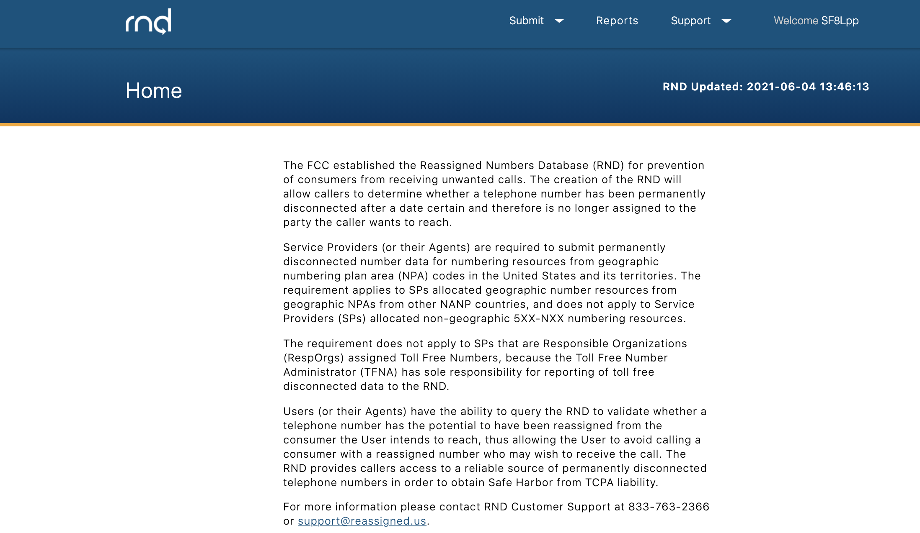

- Submitting Monthly Report or Reporting no Disconnects

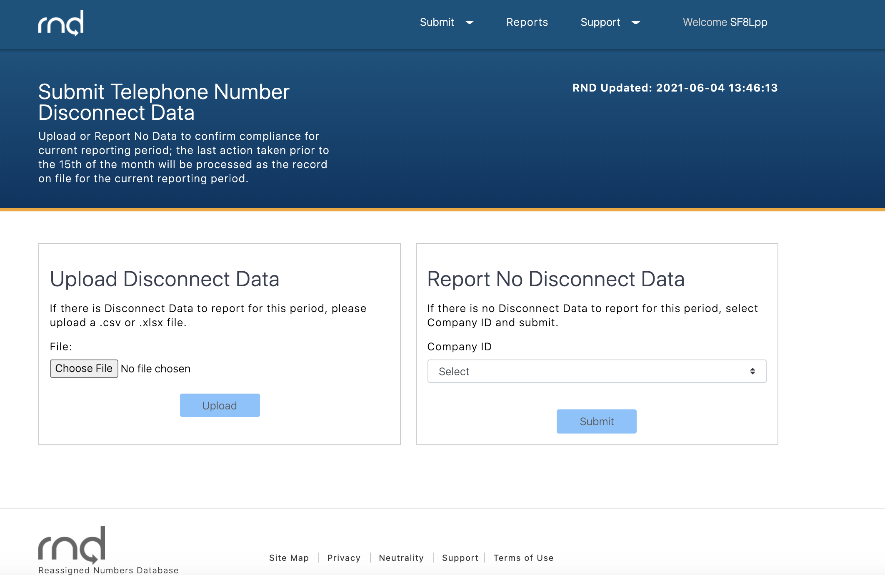

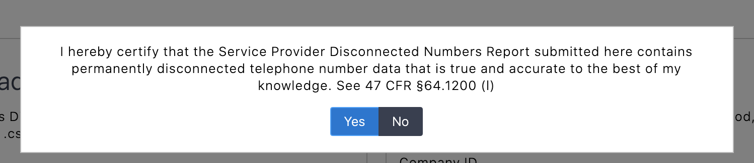
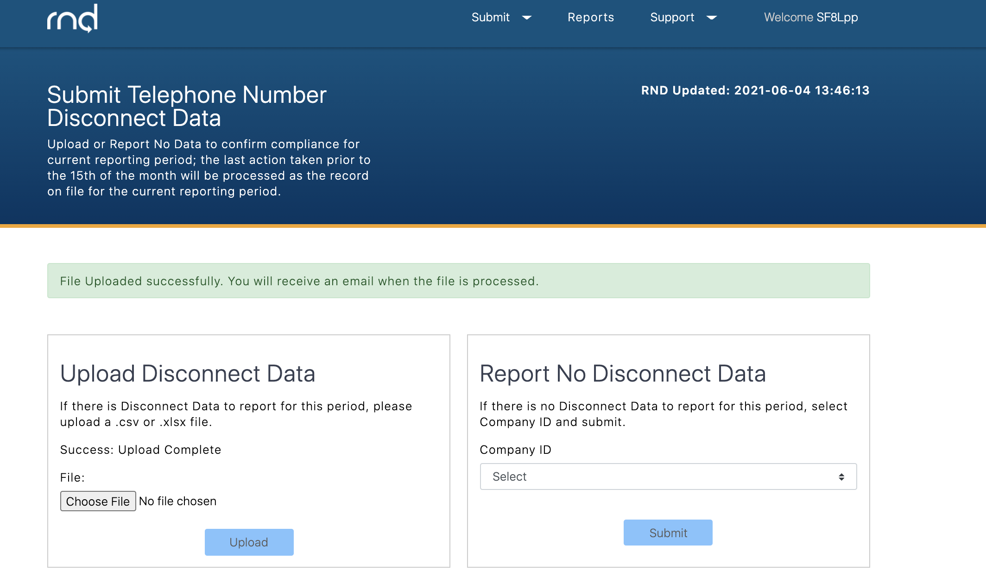

- Templates for .XLSX or .CSV file formats
The file at a minimum must contain these rows in the following order:
- CompanyID
- Telephone Number List
- Telephone Number and Disconnect Date

