Supporting Statement - Part A

CENSUS OF AQUACULTURE

OMB No. 0535-0237

A. JUSTIFICATION

This docket is being submitted to reinstate the Census of Aquaculture, a follow-on program to the Census of Agriculture. The Census of Agriculture is conducted every 5 years. The last Census of Aquaculture was conducted as follow-on to the 2017 Census of Agriculture and was conducted in 2018.

1. Explain the circumstances that make the collection of information necessary. Identify any legal or administrative requirements that necessitate the collection. Attach a copy of the appropriate section of each statute and regulation mandating or authorizing the collection of information.

The Census of Aquaculture is one of a series of special study programs that comprise the follow-on study to the Census of Agriculture and is designed to provide detailed statistics on the aquaculture industry. The primary objective of the 2023 Census of Aquaculture is to obtain a comprehensive and detailed picture of the aquaculture sector of the economy. The Census of Aquaculture is the only source of comparable and consistent data at the national and State levels for the aquaculture industry. The Census of Aquaculture will cover all operations, commercial or noncommercial, for which $1,000 or more of aquaculture products were sold or normally would have been sold during the census year. Data from the 2023 Census of Aquaculture will be tabulated to provide benchmark statistics at the U.S. and State levels. These data will provide information on the aquaculture industry necessary for policy makers to implement regulations affecting the growth of the industry and the wellbeing of the economy.

The census of agriculture is required by law under the "Census of Agriculture Act of 1997," Public Law 105-113 (Title 7, United States Code, Section 2204g). The law authorizes the Secretary of Agriculture to conduct surveys deemed necessary to furnish annual or other data on the subjects covered by the census. The 2023 Census of Aquaculture Survey will be conducted under the provisions of this section. Response to this follow-on census is required by law.

2. Indicate how, by whom, and for what purpose the information is to be used. Except for a new collection, indicate the actual use the agency has made of the information received from the current collection.

The Census of Aquaculture provides the only source of comparable, detailed, state-level data descriptive of the aquaculture production sector of the United States economy. It provides data on number of operations, freshwater and saltwater acreage used for aquaculture production, water sources used for production, methods of production, total production, sales outlets, value of aquaculture products sold and sales by aquatic species, and products distributed for conservation, recreation, or restoration purposes by species. Census data is used by the Administration, Federal agencies, and Congress to formulate and evaluate national aquaculture policies and programs. State governments use census data to evaluate and formulate appropriate local and State aquaculture programs. Aquaculture organizations and businesses use census data for making marketing decisions and assessing the aquaculture economy. Without the Census of Aquaculture, there would be no reliable source of data consistent for all 50 states. For most species, there would be no data available. The last Census of Aquaculture was conducted in 2018.

Data from the Census of Aquaculture is used by various levels of government and private industry to make decisions. For example: USDA – National Institute of Food and Agriculture uses the information within their agency when looking at areas of research and issuing grants. National Oceanic and Atmospheric Administration uses the data to complete their marine fisheries estimates. In the private sector: the Catfish Institute uses aquaculture information in making marketing decisions. The National Aquaculture Association relies on the information collected in the Census of Aquaculture because it is the only source for data for many of the species. This information allows them to see areas of growth or contraction within various species of the industry.

3. Describe whether, and to what extent, the collection of information involves the use of automated, electronic, mechanical, or other technological collection techniques or other forms of information technology, e.g., permitting electronic submission of responses, and the basis for the decision for adopting this means of collection. Also describe any consideration of using information technology to reduce burden.

Electronic data reporting (EDR) will be made available for the 2023 Census of Aquaculture respondents. Considerations for implementing EDR included a reduction in response burden and to provide consistency with the annual catfish and trout surveys conducted by NASS (OMB #0535-0150). All operations that were in either of these surveys and are still in business will be included in the census of aquaculture mail list. We estimate that around 10 percent of operations will respond via the Web.

4. Describe efforts to identify duplication. Show specifically why any similar information already available cannot be used or modified for use for the purposes described in Item 2 above.

The 2023 Census of Aquaculture is the only source of comprehensive aquaculture data for each state within the Nation. No other government agency compiles figures for all species across all states. The Census of Aquaculture report form has been designed to account for all information collected on the annual catfish and trout surveys. Therefore, the annual surveys will not be mailed this year. Information collected on the census report form will be used to generate the “Catfish Production” and “Trout Production” publications that are released in February.

5. If the collection of information impacts small businesses or other small entities (Item 5 of OMB Form 83-I), describe any methods used to minimize burden.

The 2023 Census of Aquaculture is designed to impose minimal response burden by utilizing skip instructions throughout the census form. An aquaculture production screening section is included on the face page to allow the respondent to skip the content of the questionnaire if the operation has no involvement in aquaculture. To reduce the number of contacts for catfish and trout operators who are in the annual NASS programs, the census of aquaculture report form has been designed to collect the data necessary for the census of aquaculture and the annual catfish and trout surveys. To further reduce respondent burden, screening questions have been added at the top of each section to guide the respondent to only the sections pertinent to their situation.

6. Describe the consequence to Federal program or policy activities if the collection is not conducted or is conducted less frequently, as well as any technical or legal obstacles to reducing burden.

The Census of Aquaculture is conducted as a follow-on study to the Census of Agriculture, which, by law, is conducted every 5 years. Data from the previous aquaculture census is outdated and of limited value to data users. The absence of aquaculture data would hinder Congress and State governments when evaluating and formulating aquaculture policies and programs. Since the last Census of Aquaculture was conducted, many hurricanes have occurred in the Gulf of Mexico and a measure of the impact of these events on the aquaculture industry is largely unknown.
.

7. Explain any special circumstances that would cause an information collection to be conducted in a manner inconsistent with the general information guidelines in 5 CFR 1320.5.

There are no special circumstances associated with this information collection.

8. Provide a copy and identify the date and page number of publication in the Federal Register of the agency's notice, required by 5 CFR 1320.8 (d), soliciting comments on the information collection prior to submission to OMB. Summarize public comments received in response to that notice and describe actions taken by the agency in response to these comments.

The Notice soliciting comments on this information collection was published in the Federal Register, Volume 88, number 32, on February 16, 2023, on page 10077-10078. NASS did not receive any public comments in response to this notice for this reinstatement.

Describe efforts to consult with persons outside the agency to obtain their views on the availability of data, frequency of collection, the clarity of instructions and recordkeeping, disclosure, or reporting format (if any), and on the data elements to be recorded, disclosed, or reported.

NASS Regional Field Offices (RFOs) maintain industry contacts within their respective regions. Government agencies contacted include the Department of Commerce, Foreign Agricultural Service, the National Institute of Food and Agriculture, Food Safety and Inspection Service, the Agricultural Marketing Service, and the National Oceanic and Atmospheric Administration. Other groups contacted to keep a well-rounded perspective of the aquaculture industry include the Catfish Farmers of America, the Catfish Institute, the National Aquaculture Association, the U.S. Trout Farmers Association, and the Interagency Working Group on Aquaculture. The Interagency Working Group on Aquaculture is made up of representatives of the Department of Agriculture, Department of Commerce, Department of Interior, Department of Energy, Department of Health and Human Services, Environmental Protection Agency, Army Corps of Engineers, Small Business Administration, the Farm Credit Administration, the Department of State, and the Smithsonian Institution.

Three of the individuals that we have spoken with are:

Caird Rexroad, III, Caird.RexroadIII@usda.gov
Paul W. Zajicek, paul@thenaa.net
Jonathan van Senten, jonat86@vt.edu

(Caird Rexroad, III is the National Program Leader for Aquaculture. Paul Zajicek is the Executive Director of the National Aquaculture Association. Jonathan van Senten is an Assistant Professor based out of the Virginia Seafood Agriculture and Experiment Station in Hampton, Virginia. All are on a working team with Jean N. Porter, Section Head of NASS Livestock Branch, Poultry and Specialty Commodities Section.)

9. Explain any decision to provide any payment or gift to respondents.

There are no payments or gifts to respondents.

10. Describe any assurance of confidentiality provided to respondents and the basis for the assurance in statute, regulation, or agency policy.

Questionnaires include a statement that individual reports are confidential. U.S. Code Title 18, Section 1905; U.S. Code Title 7, Section 2276; and the Confidential Information Protection and Statistical Efficiency Act of 2018, Title III of Pub. L. No. 115-435, codified in 44 U.S.C. Ch. 35 and other applicable Federal laws. All employees of NASS and all enumerators hired and supervised under a cooperative agreement with the National Association of State Departments of Agriculture (NASDA) must read the regulations and sign a statement of compliance.

The following CIPSEA Pledge statement will appear on all future NASS questionnaires.

The information you provide will be used for statistical purposes only. Your responses will be kept confidential and any person who willfully discloses ANY identifiable information about you or your operation is subject to a jail term, a fine, or both. This survey is conducted in accordance with the Confidential Information Protection and Statistical Efficiency Act of 2018, Title III of Pub. L. No. 115-435, codified in 44 U.S.C. Ch. 35 and other applicable Federal laws. For more information on how we protect your information please visit: https://www.nass.usda.gov/confidentiality.

Response to this survey is required by law under Title 7 USC 22014(g) Public Law 105-113.

11. Provide additional justification for any questions of a sensitive nature.

There are no questions of a sensitive nature.

12. Provide estimates of the hour burden of the collection of information. The statement should indicate the number of respondents, frequency of response, annual hour burden, and an explanation of how the burden was estimated. If this request for approval covers more than one form, provide separate hour burden estimates for each form and aggregate the hour burdens in Item 13 of OMB Form 83-I. Provide estimates of annualized cost `to respondents for the hour burdens for collections of information, identifying and using appropriate wage rate categories.

The table below shows the total burden calculated for the Census of Aquaculture. The questionnaires will be mailed out in December of 2023 and the data collection will be completed by March 2024. The total projected burden of 3,326 hours will be a onetime occurrence, rather than an annual average.

In 2018 when the Census of Aquaculture was last conducted NASS achieved a 87.0% response rate. The burden below is based on an overall response rate of 90%.

Cost to the public of completing the questionnaire is assumed to be comparable to the hourly rate of those requesting the data. Reporting time of 3,326 hours are multiplied by $40.51 per hour for a total cost to the public of $ 134,736.26.

NASS uses the Bureau of Labor Statistics’ Occupational Employment Statistics (most recently published on April 25, 2023 for the previous May) to estimate an hourly wage for the burden cost. The May 2022 mean wage for bookkeepers was $22.81. The mean wage for farm managers was $40.29. The mean wage for farm supervisors was $28.28. The mean wage of the three is $30.46. To calculate the fully loaded wage rate (includes allowances for Social Security, insurance, etc.) NASS will add 33% for a total of $40.51 per hour.

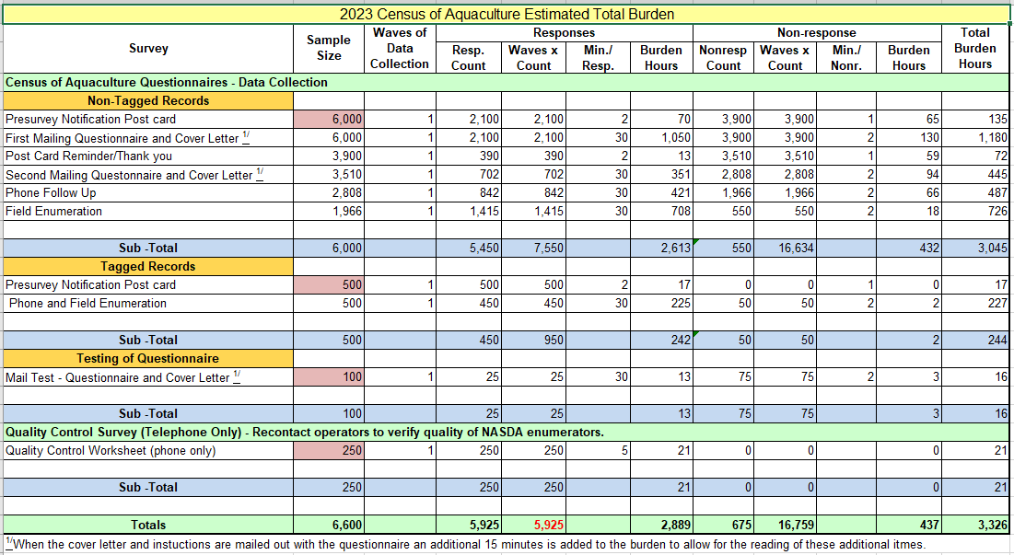

13. Provide estimates of the total annual cost burden to respondents or record keepers resulting from the collection of information, (do not include the cost of any hour burden shown in items 12 and 14). The cost estimates should be split into two components: (a) a total capital and start-up cost component annualized over its expected useful life; and (b) a total operation and maintenance and purchase of services component.

There are no capital/start-up or ongoing operation/maintenance costs associated with this information collection.

14. Provide estimates of annualized cost to the Federal government; provide a description of the method used to estimate cost which should include quantification of hours, operational expenses (equipment, overhead, printing, and staff), and any other expense that would not have been incurred without this collection of information.

Cost to the Federal Government for the 2023 Census of Aquaculture is included in the Census of Agriculture Program appropriations for fiscal year 2024. The total cost is estimated at $1,700,000. About $1,500,000 of the total is for Federal salaries, $130,000 for telephone and field enumeration by NASDA (National Association of State Departments of Agriculture) enumerators, and $70,000 for printing, postage, data processing, etc.

15. Explain the reasons for any program changes or adjustments reported in Items 13 or 14 of the OMB Form 83-I (reasons for changes in burden).

Since the Census of Aquaculture information collection is a reinstatement, there is no current inventory of burden hours. From the calculations in A.12, we estimate that 3,326 respondent burden hours will be needed. Respondent burden for non-response along with attempting multiple contacts is included in this calculation.

16. For collections of information whose results will be published, outline plans for tabulation and publication. Address any complex analytical techniques that will be used. Provide the time schedule for the entire project, including beginning and ending dates of the collection of information, completion of report, publication dates, and other actions.

The initial mail-out of report forms will occur on December 18, 2023. Tabulations will be generated at the State and National levels for all data items on the report form. The layout of the publication will be similar to the 2018 census publication, which is available on-line at:

https://www.nass.usda.gov/Publications/AgCensus/2017/Online_Resources/Aquaculture/index.php.

The 2023 publication will include data from the 2018 publication for items that are comparable.

The following chart provides a timetable for the entire survey process.

Timetable for the 2023 Census of Aquaculture

Questionnaire design July – March 2023
Systems Development March - Dec 2023
Publication Tables Drafted Apr - Dec 2023
Initial Mail-out Mid-Dec 2023
Second Mail-out Mid Jan 2024
Telephone, Personal Interviews Jan - Feb 2024
Review, Process, Tabulate Data Jan - May 2024
Review Tables May - mid August 2024
Prepare Publication and Review mid-August - November 2024
Publish Report ……………………. December 2024

To aid telephone and field follow-up by enumerators, each will receive an Enumerator’s Manual. To aid statisticians in the edit and analysis of reported data, Field Offices will receive a Census Administration Manual.

17. If seeking approval to not display the expiration date for OMB approval of the information collection, explain the reasons that display would be inappropriate.

There is no request for approval of non-display of the expiration date.

18. Explain each exception to the certification statement identified in Item 19, “Certification for Paperwork Reduction Act Submissions” of OMB Form 83-I.

There are no exceptions to the certification statement.

April, 2023

