Appendix D.2. Web-based Household Survey Instrument in Spanish

## INTRO1

## INTRO2

## A_1_INTRO

## A_1_

## A_2_

## A_3_

## A_4_

## A_5_

## A_6_

## A_7_MATRIX

## A_8_MATRIX

## A_9_MATRIX

## A_10_

## B_1_INTRO

## B_1_

## B_2_

## B_3_

## B_4_INTRO

## B_4_

## B_5_

## B_6_

## B_7_

## B_8_

## B_9_INTRO

## B_9_

## B_10_

## B_11_

## B_12_INTRO

## B_12_

## B_13_

## B_14_

## B_15_

## C_1_MATRIX

## C_2_MATRIX

## C_3_

## C_3A_MATRIX

## C_4_INTRO

## C_4_

## C_5_

## C_6_

## C_7_

## C_8_

## C_9_

## C_10_

## C_11_INTRO

## C_11_

## C_11_A

## C_12_MATRIX

## C_13_INTRO

## C_13_MATRIX

## D_1_1

## D_1_2

## D_1_3

## D_2_

## D_2A_

## D_3_

## D_4_

## D_5_

## D_5_A1

## D_6_MATRIX

## D_7_

## D_8_

## D_9_

## E_1_INTRO

## E_1_

## E_1_A_1

## E_1_B_

## E_1_C_

## E_1_D_

## E_1_E_

## E_2_MATRIX

## F_1_INTRO

## F_1_1

## F_1_2

## F_1_3

## F_2_

## F_2A_

## F_3_

## F_3A_1

## F_3A_2

## F_3A_3

## F_4_

## F_5_

## F_6_

## F_7_MATRIX

## G_1_MATRIX

## G_2_

## G_3_

## G_4_MATRIX

## G_5_

## G_6_

## G_7_

## G_8_

## H_1_

## H_2_

## H_3_

## H_4_

## H_5_

## H_6_

## I_2_

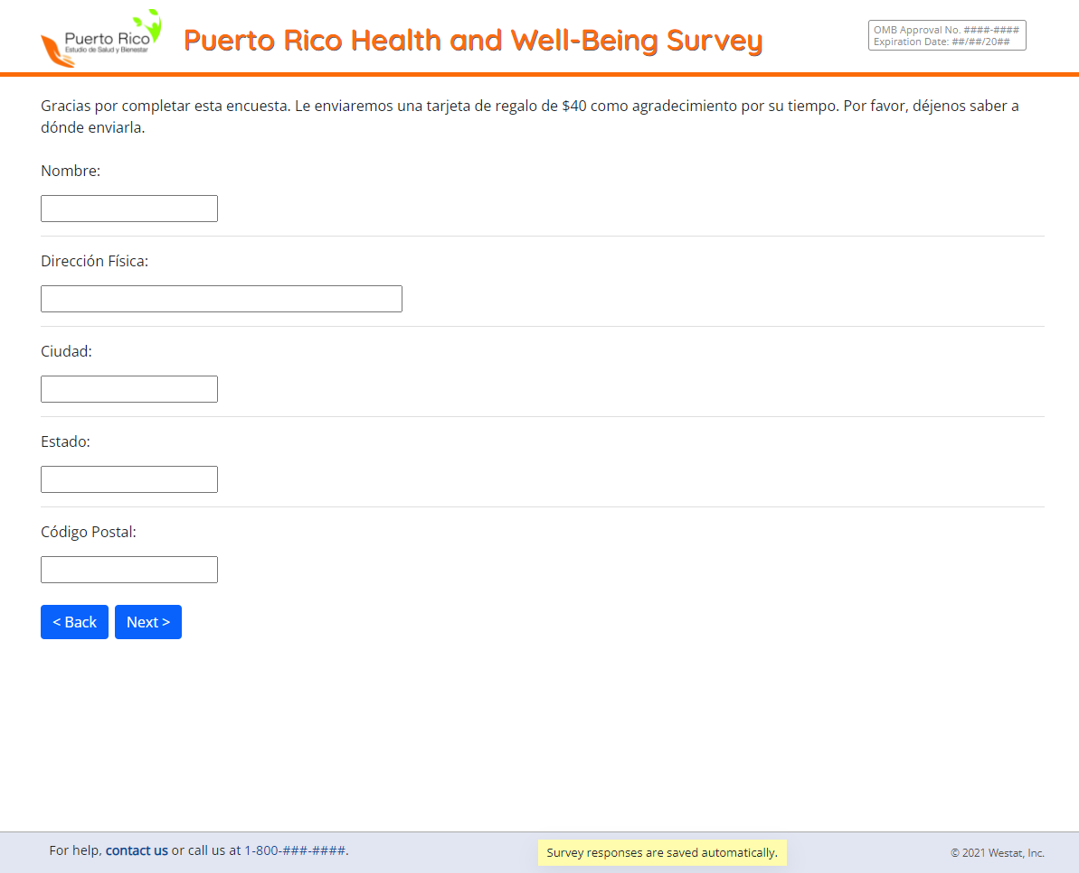

## I_4_

## I_5_

## I_6_