Offshore Wind Energy and the Oregon Coast

[Wrapped image]

To be completed by the adult (age 18 and over) in your household who has the next upcoming birthday.

A joint survey by NOAA and XXX

[logos]

Public Burden Statement

A Federal agency may not conduct or sponsor, and a person is not required to respond to, nor shall a person be subject to a penalty for failure to comply with an information collection subject to the requirements of the Paperwork Reduction Act of 1995 unless the information collection has a currently valid OMB Control Number. The approved OMB Control Number for this information collection is 0648-0744. Without this approval, we could not conduct this information collection. Public reporting for this survey is estimated to be approximately 15 minutes per response, including the time for reviewing instructions, searching existing data sources, gathering and maintaining the data needed, and completing and reviewing the information collection. All responses to this information collection are voluntary. Send comments regarding this burden estimate or any other aspect of this information collection, including suggestions for reducing this burden to: noaa.nccos.sstex@noaa.gov 240-621-1999.

Floating offshore wind energy has recently been proposed off Oregon’s southern coast (see map below) by the Bureau of Ocean Energy Management (BOEM). This survey is one of several studies funded by BOEM to collect information to inform their decision-making process. We are interested in learning about your opinions related to floating offshore wind energy. Your responses will help BOEM understand the potential human and social impacts from floating offshore wind energy development off the Oregon Coast.
This research study is being conducted by the XXX on behalf of the National Oceanic and Atmospheric Administration (NOAA). Your address was one of 20,000 randomly selected from all addresses on the Oregon Coast, and we hope to get as many responses as possible.
By completing the survey, you are consenting to participate in this research. Although we hope that you will answer every question, you are free to skip any questions. Your participation is voluntary, and you may withdraw your consent and discontinue participation at any time. The survey will take approximately 10-15 minutes to complete. You will not be individually identified and your responses will be used for statistical purposes only.

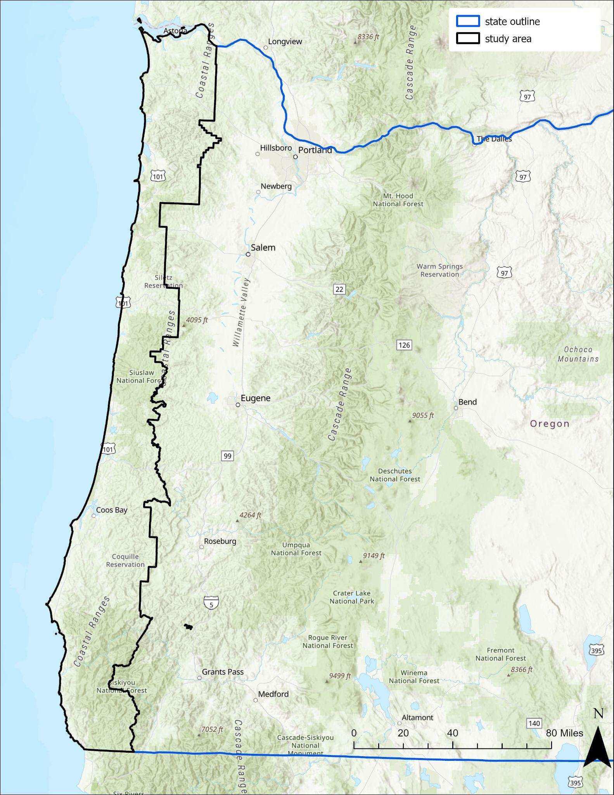

- Before today, had you heard about the potential for offshore wind energy off the Oregon Coast?
- Yes
- No, but I had heard about offshore wind energy, in general
- No, and I hadn’t heard about offshore wind energy before today
- How knowledgeable do you feel about offshore wind energy off the Oregon Coast?
- Not at all knowledgeable
- Somewhat knowledgeable
- Very knowledgeable
- Extremely knowledgeable
- Given what you currently know about offshore wind energy, have you formed an opinion about its potential off the Oregon Coast?
- I support offshore wind energy off the Oregon Coast 🡪 SKIP to Q5
- I oppose offshore wind energy off the Oregon Coast 🡪 SKIP to Q5
- I have not yet made up my mind 🡪 CONTINUE to Q4
- [IF Q3=3] Even though you have not yet made up your mind about offshore wind energy off the Oregon Coast, which way are you leaning?
- To support development
- To oppose development
- I don’t know
- Given what you currently know about offshore wind energy, do you think offshore wind energy off the Oregon Coast will have an impact on the following items for Oregonians?
 | Very negative impact | Negative  impact | No  impact | Positive  impact | Very positive impact | Not  Sure
Electricity rates
Reliable electricity grid
Access to commercial fishing grounds
Coastal community livelihoods
Marine recreation
Views of the ocean
Marine life
Seabirds
Coastal Habitats
Tribal Lifeway

- Looking at the same list of items, please tell us how important each item is to you in terms of your quality of life off the Oregon Coast.
 | Not at all  important | Somewhat  important | Very  important | Extremely  important
Electricity rates
Reliable electricity grid
Access to commercial fishing grounds
Coastal community livelihoods
Marine recreation
Views of the ocean
Marine life
Seabirds
Coastal Habitats
Tribal Lifeway

- How important do you think it is to pursue offshore wind energy off the Oregon Coast?
- Not at all important
- Somewhat important
- Very important
- Extremely important
- How important is it for the electricity generated from offshore wind to stay…
 | Not at all important | Somewhat important | Very important | Extremely important
in Oregon?
on the Oregon Coast?

- Which of the following fuel sources would you prefer to produce electricity? (select all that apply)
  - Hydro (dams)
- Natural gas
- Offshore wind
- Land-based wind
- Solar
- Biomass (wood/wood waste)
- Other
- No Preference

- Do you believe that climate change is happening?
- Yes CONTINUE to Q11
- No SKIP to Q12
- I don’t know SKIP to Q12
- Do you believe climate change is mainly caused by human activities or natural forces?
- Human activities
- Natural forces
- I don’t know
- Do you believe offshore wind energy could be an effective way to reduce climate change?
  - Yes
  - No
  - I don’t know

The next several questions will ask about your past experiences, intentions, and preferences related to public participation in local issues on the Oregon Coast.
- In the last 12 months, have you done any of the following in response to either any environmental issue off the Oregon Coast or offshore wind energy off the Oregon Coast?
 | Any environmental issue on the Oregon Coast | Offshore wind energy off the Oregon Coast | Neither
Signed a petition
Written a letter to the editor
Contacted a public official
Joined or renewed membership to an advocacy group
Attended a public meeting sponsored by a government agency
Attended a public meeting sponsored by an advocacy group
Attended a demonstration sponsored by an advocacy group
Contributed money to an organization
Voted in a federal, state, or local election
Displayed your position, such as with a bumper sticker, clothing, or yard sign
Tried to change a friend’s or relative’s mind
Tried to influence others using social media

- In the next 12 months, how likely are you to do any of the following in response to offshore wind energy off the Oregon Coast?
 | Not at all likely | Somewhat likely | Very likely | Extremely likely
Sign a petition
Write a letter to the editor
Contact a public official
Join or renew membership to an advocacy group
Attend a public meeting sponsored by a government agency
Attend a public meeting sponsored by an advocacy group
Attend a demonstration sponsored by an advocacy group
Contribute money to an organization
Vote in a federal, state, or local election
Display your position, such as with a bumper sticker, clothing, or yard sign
Try to change a friend’s or relative’s mind
Try to influence others using social media

- How important to you are the following goals of public participation?
 | Not at all important | Somewhat important | Very important | Extremely important
Identify what is most important to the public
Incorporate public preferences into decisions
Create opportunities for fair discussion
Allow all interested individuals to have a say
Enlighten decision makers to public needs
Provide information to the public
Incorporate Indigenous knowledge into decisions
Identify public preferences for potential solutions
Incorporate local knowledge into decisions

- How important is it for members of the public to provide input on offshore wind energy off the Oregon Coast?
- Not at all important
- Somewhat important
- Very important
- Extremely important
- How influential do you think public input is on offshore wind energy off the Oregon Coast?
- Not at all influential
- Somewhat influential
- Very influential
- Extremely influential
- I don’t know
- How influential do you think the results of this survey will be on offshore wind energy off the Oregon Coast?
- Not at all influential
- Somewhat influential
- Very influential
- Extremely influential
- Are you aware that the Bureau of Ocean Energy Management (BOEM) has hosted public meetings or asked for public comments related to offshore wind energy development off the Oregon Coast?
- Yes
- No

This is the final section of the survey. The following questions ensure that all groups are fairly represented. All answers are confidential.

- What is your sex?
- Male
- Female
- Other, please specify __________
- Prefer not to say
- In what year were you born? __________
- Are you Hispanic or Latino?
- Yes
- No
- What is your race? (select all that apply)
- White/Caucasian
- Black/African American
- Asian
- Native Hawaiian/other Pacific Islander
- American Indian/Alaskan Native
- Other, please specify __________
- Is English your primary language?
- Yes
- No
- What is the highest level of education you have completed?
- Less than 9th grade
- 9th to 12th grade, no diploma
- High school graduate (includes equivalency)
- Some college, no degree
- Occupational, technical, or vocational program
- Associate's degree
- Bachelor's degree
- Graduate or professional degree
- Are you a seasonal or year-round resident of the Oregon Coast?
- Seasonal resident (I live on the Oregon Coast only part of the year)
- Year-round resident (I live on the Oregon Coast all year)
- How many years have you been a resident of the Oregon Coast? __________
- Do you own or rent this residence (where this survey was mailed to)?
- Own
- Rent
- Other
- How many people, including yourself, live in your household? __________
- How many of these people are at least 18 years old? __________
- Which best describes your current employment status? (select all that apply)
- Unemployed
- Employed full-time
- Employed part-time
- Retired
- Student
- Homemaker
- Are you or anyone in your household currently employed in one of the following industries? (select all that apply)
- Fishing or fishing related (such as seafood preparation or wholesalers)
- Generation, transmission, or distribution of renewable electric power (such as wind, solar, or hydroelectric)
- Generation, transmission, or distribution of non-renewable electric power (such as coal)
- Distribution of natural gas
- Marine construction
- Utility systems construction
- Real estate, rental, or leasing
- None of the above
- What was your annual household income in 202X?
- Less than $25,000
- $25,000 to $49,999
- $50,000 to $74,999
- $75,000 to $149,999
- $150,000 or more

Please use the space below for additional comments.

Thank you!
Please place in the enclosed postage paid envelope and return as soon as possible.
[Wrapped image]

