ATTACHMENT 18: Social Media Recruitment Ads

Instagram | Instagram Stories | Facebook
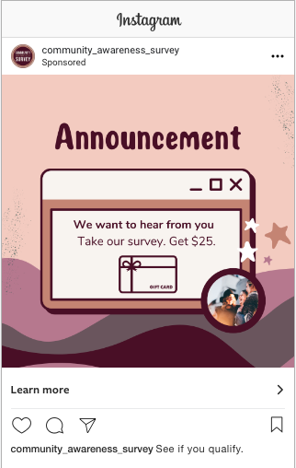 | 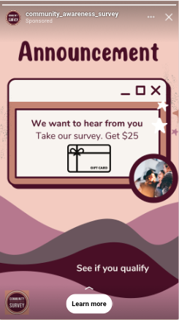 | 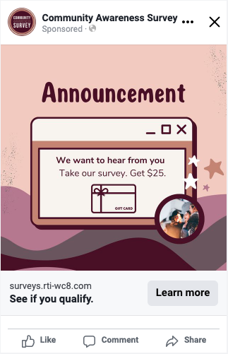
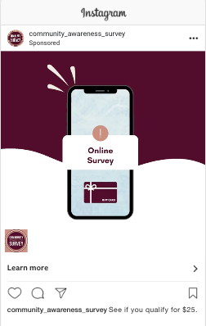 | 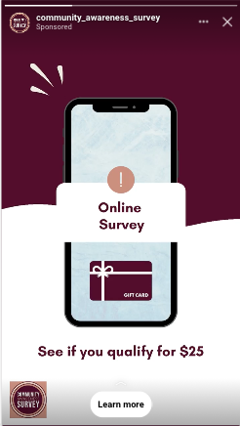 | 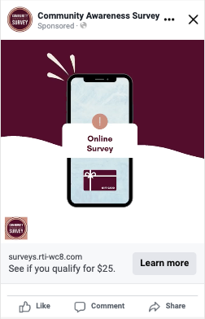

OMB No: [FILL NUMBER] Expiration Date: [FILL DATE]
Paperwork Reduction Act Statement: The public reporting burden for this collection of information has been estimated to average 1 minute per response. Send comments regarding this burden estimate or any other aspects of this collection of information, including suggestions for reducing burden to PRAStaff@fda.hhs.gov.

