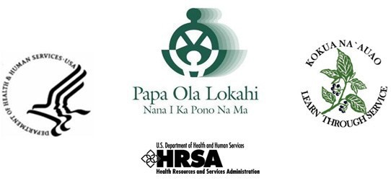

As an applicant to the Native Hawaiian Health Scholarship Program (NHHSP), I, (print) First Name Middle Initial Last Name

*Form D* **- AUTHORIZATION TO RELEASE INFORMATION**

hereby authorize the College/University where I am/was enrolled, to disclose information to NHHSP, Papa Ola Lokahi, Inc. (POL) and the U.S. Department of Health and Human Services (DHHS), pertaining to my enrollment while participating in NHHSP. “Information pertaining to my school enrollment” includes, but not limited to, my college transcript and grades, academic standing, enrollment and degree status, curriculum and examination requirements for graduation, tuition and fees, and leave-of-absence, withdrawal, or dismissal from school.

If I become a participant in the NHHSP, I also authorize any post-degree training program for which I received a deferment from the NHHSP to disclose to POL and DHHS information pertaining to my participation in the post-degree program including, but not limited to, my curriculum, status in the program, completion date, examination requirements, and my leave- of-absence, withdrawal or dismissal from the program.

The above authorizations take effect on the date indicated below with my signature.

In addition, I hereby authorize POL and DHHS, to release my name, addresses and social security number to see if I appear on the Excluded Parties List System. This authorization takes effect on the date I sign this release form. If I do not become an NHHSP participant, this **authorization shall remain in effect until {Insert Date}.**

If I become an NHHSP participant, all of the above authorizations shall remain in effect until the date my NHHSP scholarship commitment has been fulfilled or these authorizations have been revoked by me in writing.

Applicants’ Signature Date

**Public Burden Statement**: The purpose of the NHSC SP, NHSC S2S LRP, and the NHHSP is to provide scholarships or loan repayment to qualified students who are pursuing primary care health professions education and training. In return, students agree to provide primary health care services at approved facilities located in designated Health Professional Shortage Areas (HPSAs) once they are fully trained and licensed health professionals. An agency may not conduct or sponsor, and a person is not required to respond to, a collection of information unless it displays a currently valid OMB control number. The OMB control number for this information collection is 0915-0146 and it is valid until XX/XX/202X. This information collection is required to obtain or retain a benefit (NHSC SP: Section 338A of the PHS Act and Section 338C-H of PHS Act; NHSC S2S LRP: Section 338B of the PHS Act and Section 331(i) of the PHS Act; NHHSP: The Native Hawaiian Health Care Improvement Act of 1992, as amended [42 U.S.C. 11709]. Public reporting burden for this collection of information is estimated to average xx hours per response, including the time for reviewing instructions, searching existing data sources, and completing and reviewing the collection of information. Send comments regarding this burden estimate or any other aspect of this collection of information, including suggestions for reducing this burden, to HRSA Reports Clearance Officer, 5600 Fishers Lane, Room 14N136B, Rockville, Maryland, 20857 or [paperwork@hrsa.gov](mailto:paperwork@hrsa.gov).