OMB Number: 0915-0146
Expiration Date: XX/XX/20XX

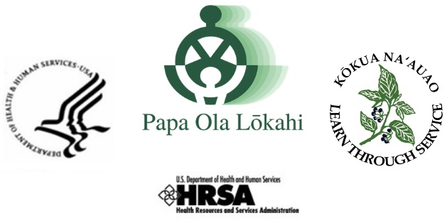

CHANGE in PROGRAM CURRICULUM INSTRUCTIONAL
NHHSP keeps record of a Scholar’s entire Program Curriculum via the ‘Course Curriculum Worksheet’ that was submitted during the application process. This ‘Course Curriculum Worksheet’ remains in the Scholar’s file and is verified at the beginning of every academic period via the Scholar Enrollment Verification Form (SEVF).

In the event there are ANY changes to your program curriculum that is currently on file with NHHSP, such changes need to be reported to your Program Coordinator as soon as possible.

If your new course schedule does not align with the original ‘Course Curriculum Worksheet,’ the following process is required:

- Scholar is to complete and submit a Change in Program Curriculum (CPC) document
- Scholar is to request that the school verifies the new registration via an updated (SEVF) and attach the supplemental documentation, i.e., revised course schedule
- Scholar must have Academic Advisor’s ‘concur’ signature on Page 1.

To successfully complete the CPC report, indicate the semester and year in which the changes occurred. List all registered courses prior to the change in course schedule. A thorough explanation of the changes is required. Also, list below your revised course schedule in its entirety. Some examples of when this Form is needed, include:

- When a scholar has already registered and verified his/her enrollment, but there was a proceeding class change made before the Add/Drop Date.
- When a scholar is taking coursework that is out of sequence from what was projected on the original program ‘Course Curriculum Worksheet’ document.

Please communicate with your Program Coordinator if you have any questions or concerns about updates to your program Course Curriculum, and/or regarding the process of completing a CPC Form.
NOTE: Your completed Change in Program Curriculum (CPC) form must be submitted to NHHSP with an updated copy of the Scholar Enrollment Verification Form (SEVF).
U. S. Department of Health and Human Services HEALTH RESOURCES & SERVICES ADMINISTRATION
Bureau of Health Workforce PAPA OLA LŌKAHI
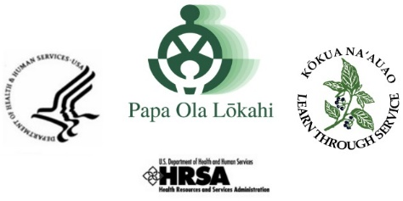
Title 42 Chapter 122 Section 11709– Native Hawaiian Health Scholarship Program
Change in Program Curriculum
NAME | NHHSP Cohort Year:
COLLEGE / UNIVERSITY | PROJECTED Graduation MO/YR
In the event there are changes to your Program Curriculum, report the new course schedule below. This form MUST BE ACCOMPANIED with an updated Scholar Enrollment Verification Form (SEVF).

Indicate your course schedule (prior to change):

Fall Winter Spring Summer YEAR:

COURSE NUMBER COURSE TITLE CREDIT HOURS

Please explain the change:

Indicate your REVISED course schedule:

Fall Winter Spring Summer YEAR:

COURSE NUMBER COURSE TITLE CREDIT HOURS

Comments (if any):
Academic Advisor SIGNATURE |  | DATE

Indicate your remaining course schedule:

Fall
Winter
Spring
Summer YEAR:

COURSE NUMBER COURSE TITLE CREDIT HOURS

Fall
Winter
Spring
Summer YEAR:

COURSE NUMBER COURSE TITLE CREDIT HOURS

Fall
Winter
Spring
Summer YEAR:

COURSE NUMBER COURSE TITLE CREDIT HOURS

Fall
Winter
Spring
Summer YEAR:

COURSE NUMBER COURSE TITLE CREDIT HOURS

Scholar:

Public Burden Statement: The purpose of the NHSC SP, NHSC S2S LRP, and the NHHSP is to provide scholarships or loan repayment to qualified students who are pursuing primary care health professions education and training. In return, students agree to provide primary health care services at approved facilities located in designated Health Professional Shortage Areas (HPSAs) once they are fully trained and licensed health professionals. An agency may not conduct or sponsor, and a person is not required to respond to, a collection of information unless it displays a currently valid OMB control number. The OMB control number for this information collection is 0915-0146 and it is valid until XX/XX/202X. This information collection is required to obtain or retain a benefit (NHSC SP: Section 338A of the PHS Act and Section 338C-H of PHS Act; NHSC S2S LRP: Section 338B of the PHS Act and Section 331(i) of the PHS Act; NHHSP: The Native Hawaiian Health Care Improvement Act of 1992, as amended [42 U.S.C. 11709]. Public reporting burden for this collection of information is estimated to average xx hours per response, including the time for reviewing instructions, searching existing data sources, and completing and reviewing the collection of information. Send comments regarding this burden estimate or any other aspect of this collection of information, including suggestions for reducing this burden, to HRSA Reports Clearance Officer, 5600 Fishers Lane, Room 14N136B, Rockville, Maryland, 20857 or paperwork@hrsa.gov.

