Form Approved
OMB No. 0920-XXXX
Exp. Date XX/XX/XXXX

Actigraph Training

Participants will wear wrist actigraph devices throughout their time in the study to measure sleep timing and quantity. Actigraphy is a minimally obtrusive, validated approach to assessing sleep/wake patterns. The ReadibandTM actigraph, produced by Fatigue Science (see Figure 1) will be selected for the study. This actigraph technology wirelessly transmits movement data to the smartphone for uplink. Participants will be instructed to wear the actigraph devices on their wrists during the data collection periods to measure sleep timing and quantity. The rechargeable battery lasts 7‒14 days with wireless transmit mode enabled. Each participant will receive a universal serial bus charger with an alternating current wall adapter and 12-volt cigarette lighter adapter to enable charging in the vehicle. Devices take approximately 2 hours to charge. Participants will be instructed to remove and charge the actigraph device once per week (e.g., every Wednesday). As the data are uplinked in near-real-time (i.e., daily), the study team will be aware of any problems with the device, such as a dead battery, and contact the participant promptly to troubleshoot the problem.
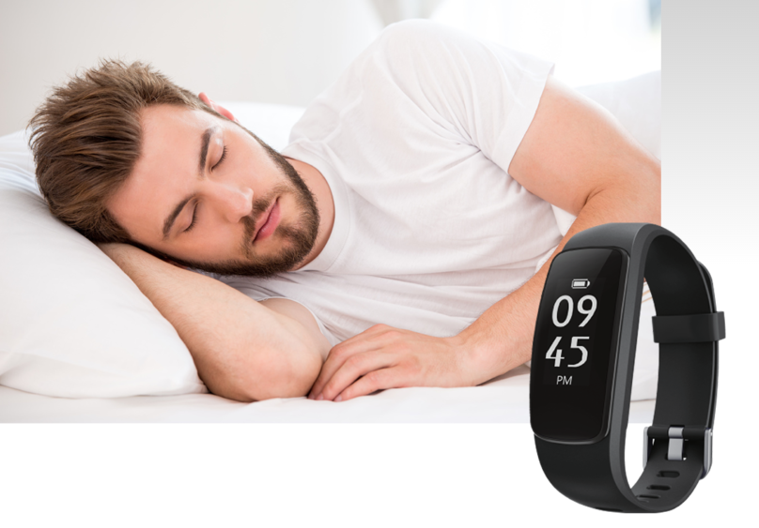
Figure 1. Image. Wrist Actigraph ReadibandTM, produced by Fatigue Science.
Public reporting burden of this collection of information is estimated to average 10 minutes per response, including the time for reviewing instructions, searching existing data sources, gathering and maintaining the data needed, and completing the collection of information. An agency may not conduct or sponsor, and a person is not required to respond to a collection of information unless it displays a currently valid OMB control number. Send comments regarding this burden estimate or any other aspect of this collection of information, including suggestions for reducing this burden to CDC/ATSDR Information Collection Review Office, 1600 Clifton Road NE, MS D-74, Atlanta, Georgia 30333; ATTN: PRA (0920-XXXX).

