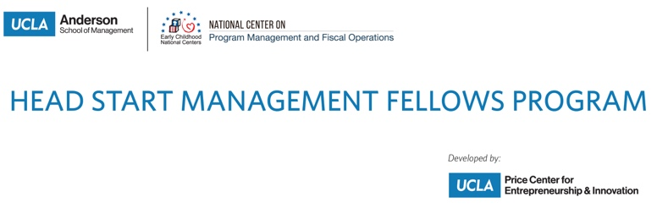
OMB Control Number: 0970-0401
Expiration Date: 6/30/2024

Head Start Management Fellows Program

End-of-Session Feedback Survey

Thank you for participating in the Head Start Management Fellows (HSMF) Program, conducted by the UCLA Anderson School of Management. To help ensure the quality of our services, we ask that you complete the following feedback survey about this HSMF Program session. This brief survey is voluntary and all feedback will be kept private. To further protect your privacy, please refrain from including personally identifiable information in open-ended responses.

PAPERWORK REDUCTION ACT OF 1995 (Pub. L. 104-13) STATEMENT OF PUBLIC BURDEN: Through this information collection, we are gathering feedback to improve service delivery. Public reporting burden for this collection of information is estimated to average 3 minutes per respondent, including the time for reviewing instructions, gathering and maintaining the data needed, and reviewing the collection of information. This is a voluntary collection of information. An agency may not conduct or sponsor, and a person is not required to respond to, a collection of information subject to the requirements of the Paperwork Reduction Act of 1995, unless it displays a currently valid OMB control number. If you have any comments on this collection of information, please contact [contact info to be added based on cohort].

Individual Session Evaluation

For the following questions, please think about the session’s presenters and materials.

Q1. The presenters were…
 | Strongly agree | Agree | Disagree | Strongly disagree | Don't know / NA
a. Knowledgeable in the content area(s).
b. Responsive to participants’ questions.
c. Effective in engaging participants.
d. Effective in communicating key information.

Q2. The session content was…
 | Strongly agree | Agree | Disagree | Strongly disagree | Don't know / NA
a. Relevant to my work
b. Free from stereotype or bias.
c. Useful
d. Easy to understand

Q3. The content of the session was…
- Too advanced
- About right
- Too simple

Q4. Before this session, my knowledge of the content/topics addressed can be best described as…
- No knowledge
- Minimal knowledge
- Moderate knowledge
- A high level of knowledge

Q5. How much did the session increase your knowledge of the topic(s) presented?
- No Increase
- Small Increase
- Moderate Increase
- Large Increase

Q6. I learned something during this session that I plan to use in my work.
- Yes
- No
- I’m not sure

[This question will only be displayed for those that indicate “yes” to Q6.]
Q7. Think about the concepts and skills you learned during this session. Please name one or two action steps you will take as a result of what you learned.

Q8. How satisfied were you with the overall quality of this session?
- Very satisfied
- Satisfied
- Dissatisfied
- Very dissatisfied

Q9. How can we improve this session?

Q10. Other comments:

