PBGC’s E-filing Portal for Special Financial Assistance
Main Log in Screen:
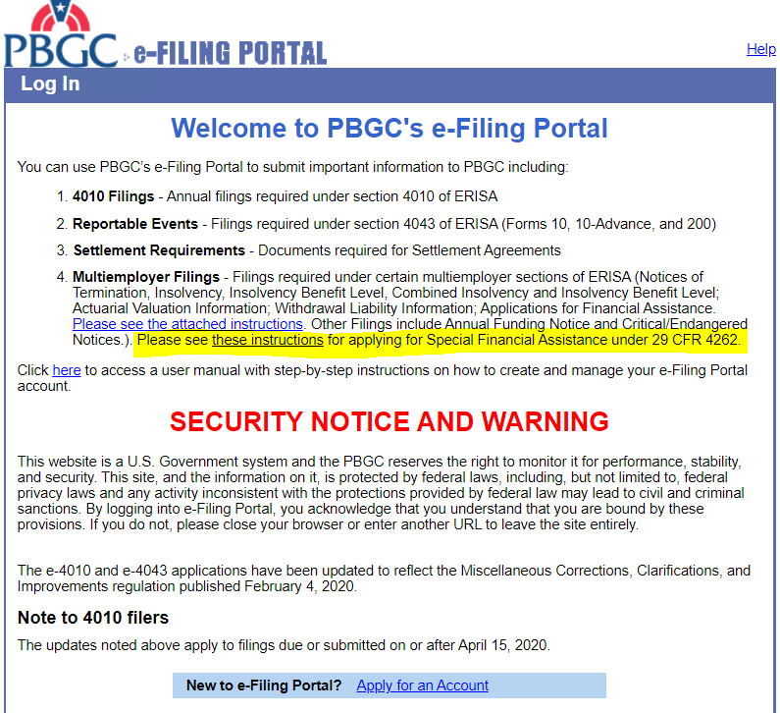

Screen to Select Filing Type after plan administrator selects “Create New Filing” after logging in:
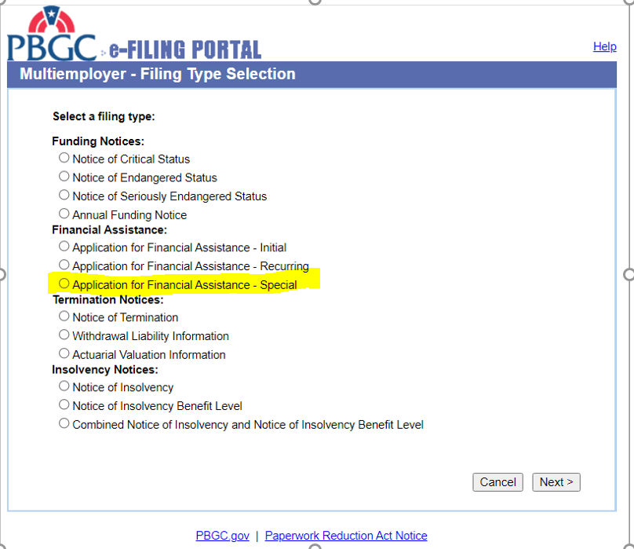
Basic Information Screen:
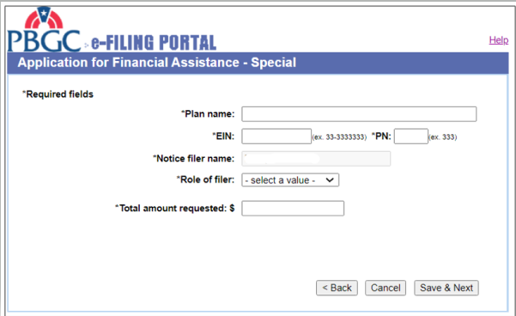

Document Uploading Page (partial – the full list of document types is shown in following screen shot, next page):
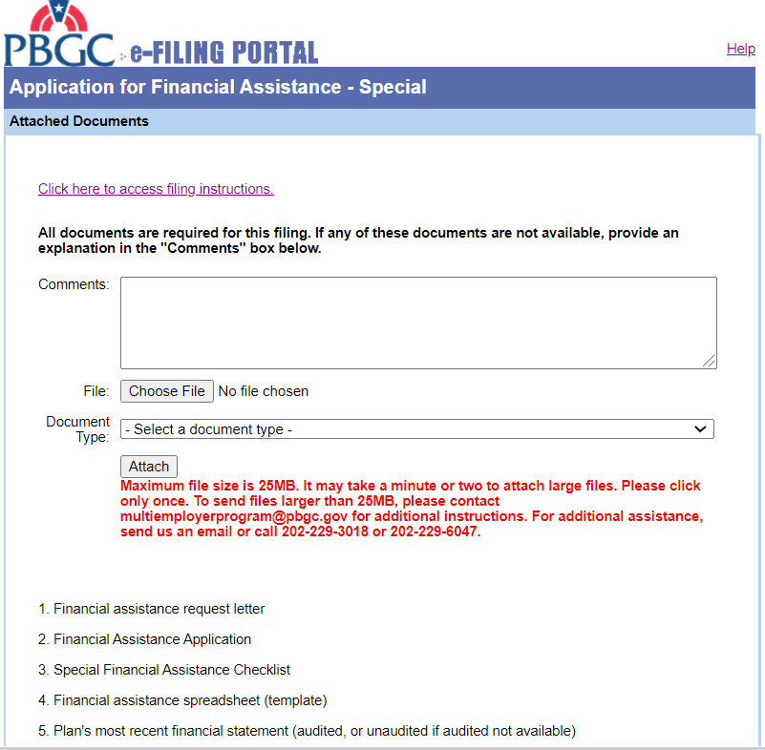
List of Document Types:
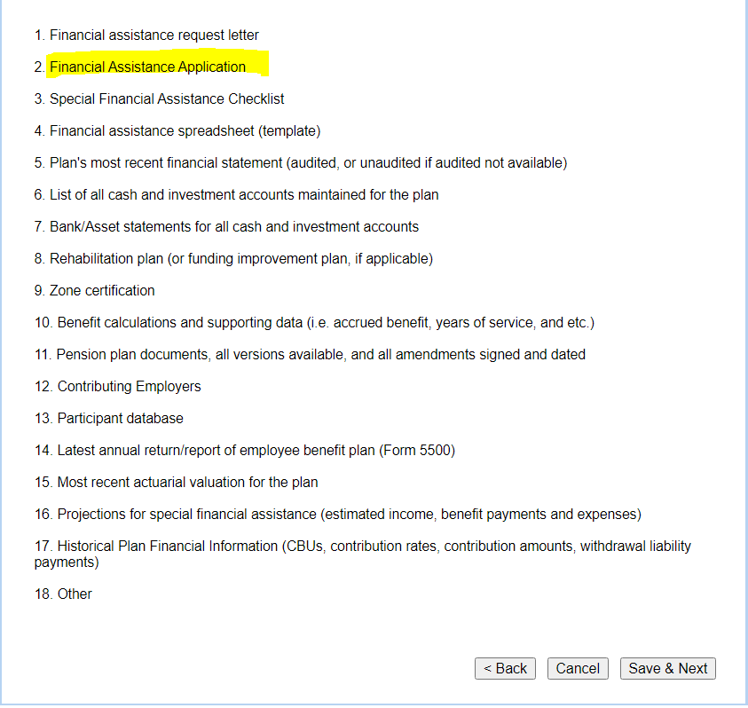

If you click on the “Help” button, you see this screen:
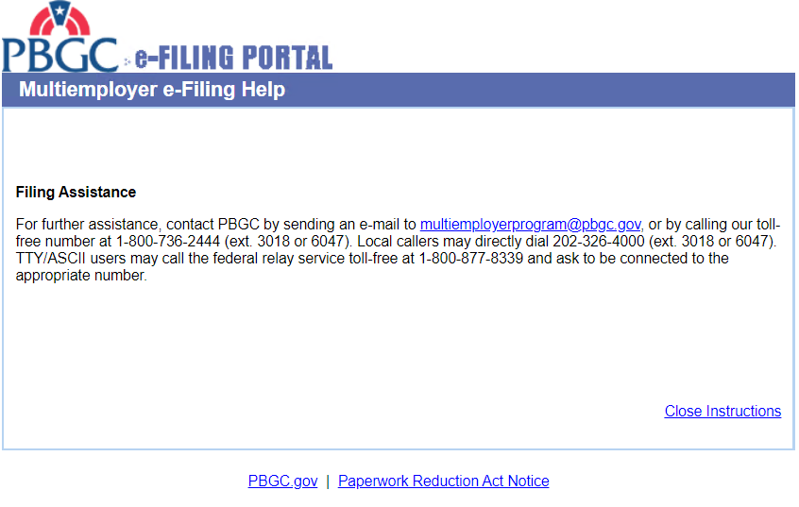

When the PBGC is not accepting applications, the radio button for Special Financial Assistance will not be visible:
